Benjamin Northrop

8/3/24

CS5310

Summer 24

****The PDF version does not support animated gifs, so you’ll only see a single image. The word document (same file name) has the animated gif for reference. These images are annotated with (gif) in the title****

**Introduction**

Project 9 introduces us lighting and shading, which gives us the ability to create more realistic color modeling with 3D images.

**Projects**

**Test9a**

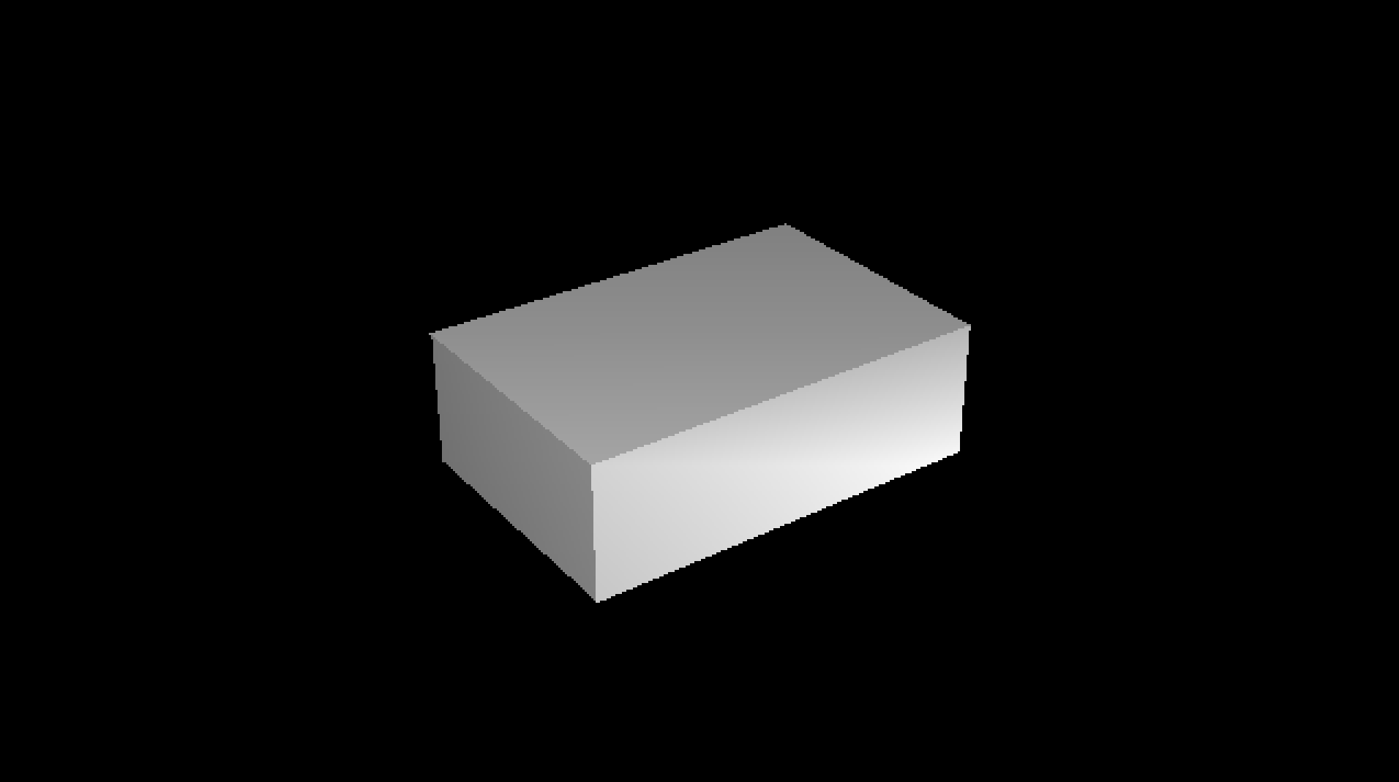

The first test function was the block from test9a. I struggled for a long time getting the color intercepts incorporated correctly, as well as getting the surface normals into the polygon correctly that I wasn’t able to spend as much time on further implementations.

**Test9b**

The x-wings also turned out pretty good for once the cube was figured out. I was able to use this to assist with some future troubleshooting.

**Test9c (attempt)**

An unfortunate attempt at the ply files, and the reason I decided to go back to previous built models for the creative images. I wasn’t able to get the ply file to render correctly. I noted 2 places to change from float to double in the source code, but I’m unsure why only a couple parts of the body didn’t want to render. I doubt there’s time for feedback on my code, but I would love to see if anyone else had this issue and was able to fix it!

**Test9d**

Test9d was the first image I got figured out. The lighting portion was pretty straight forward when I really focused on the lecture notes and instructions from the specification document. This was one of the things that made me confident that my lighting wasn’t completely messed up when the images weren’t coming out as expected.

**Creative 1: Spheres and Gouraud Shading**

This first creative image was a bit rushed, as I was only able to complete it after I finished troubleshooting the zBuffer algorithm. However, I was able to get my sphere model to incorporate the surface normals so that it took minimal changes from homework 8 to incorporate lighting into this image. This image uses both ambient light, a point light source at the viewer point, and gouraud shading. However, you can see some of the mach banding in the spheres since they are built with various resolutions of triangle mesh.

The terrain generating algorithm was also fun, and this image takes a little bit of imagination. The lighting makes it seem like you have a scattered or broken cloud layer that is blocking most of the sunlight, but the surface normal reflect portions that highlight certain areas to simulate sunshine. The surface normal are generated automatically as the terrain builds itself, using the points of a triangle to calculate the surface normal.

**Creative 3: Great pyramids**

Another repeat from the previous homework. Again, by incorporating the surface normals into my module_pyramid, I was able to create this image. It also includes a sphere as the moon, though in this case, the lighting make it truly look like a sphere than a circle like in the sky.

**Extensions**

No extensions requested in this case – even with travel days I don’t think I made it in time.

**Reflection**

I was kind of bummed that I got my butt kicked so bad by this homework. The cIntercept portion really got me, and unfortunately I just couldn’t get my work schedule to align with office hours sufficiently to get this done in time. As a result, I’ve been set back significantly for the final homework.

**Acknowledgements**

I borrowed a lot from the previous homework, and modeled the lighting after the test files lighting system. Given some more time, I’d like to place multiple lights elsewhere and see how that changes the appearance. Maybe I’ll be able to incorporate this with shadows.