Britney Le Project 2

1. Travel – South Korea
2. 15 images (greater than 2000px wide)
   1. 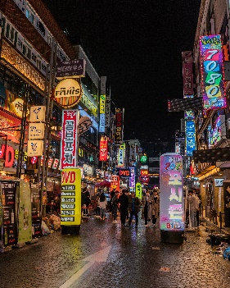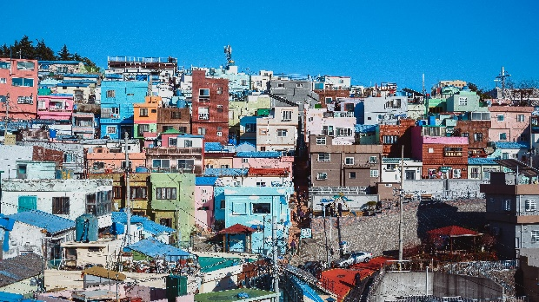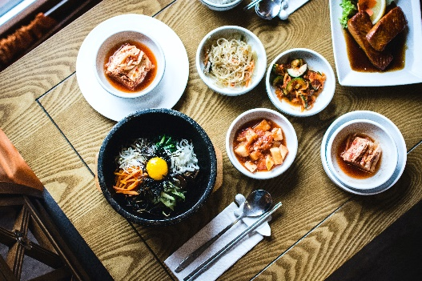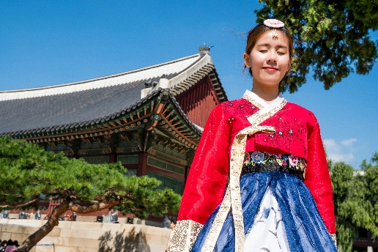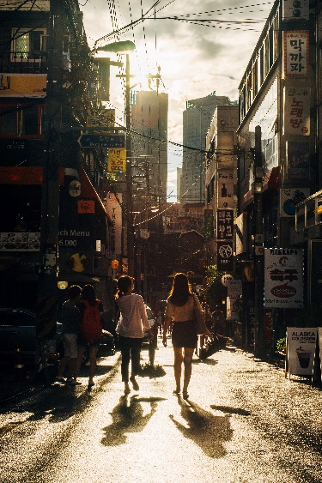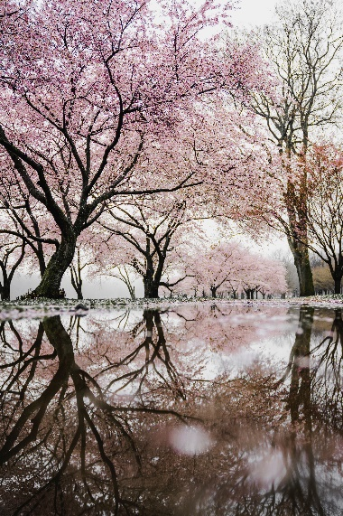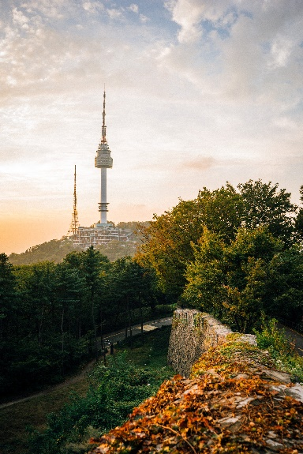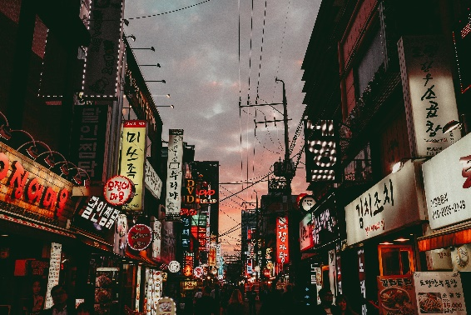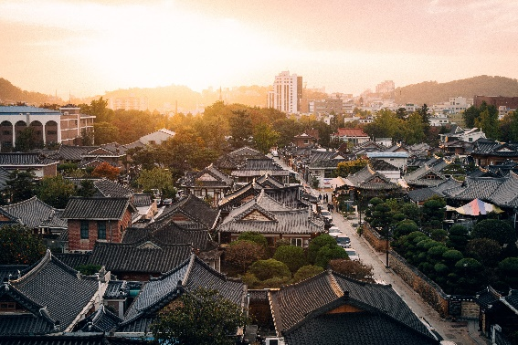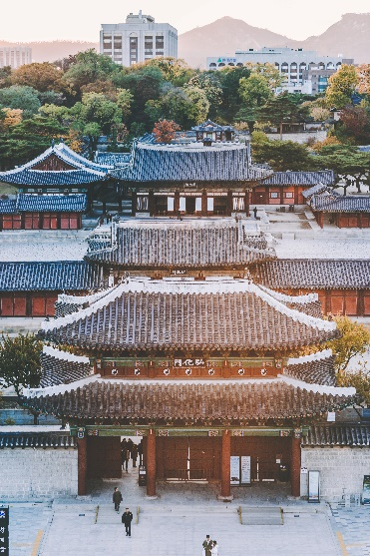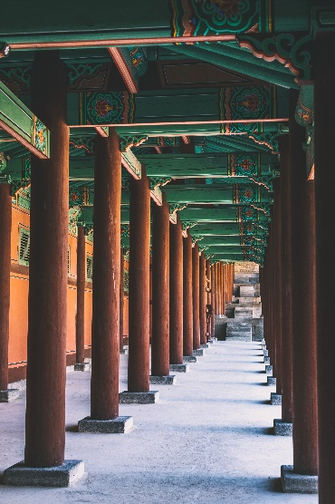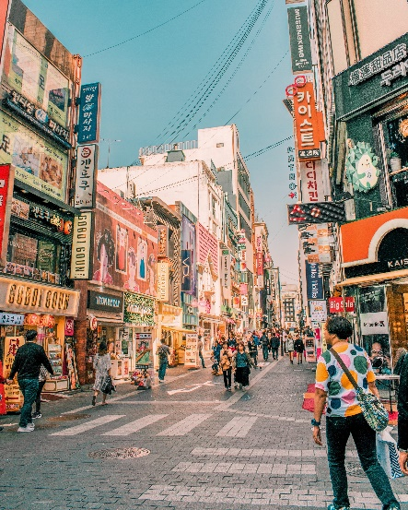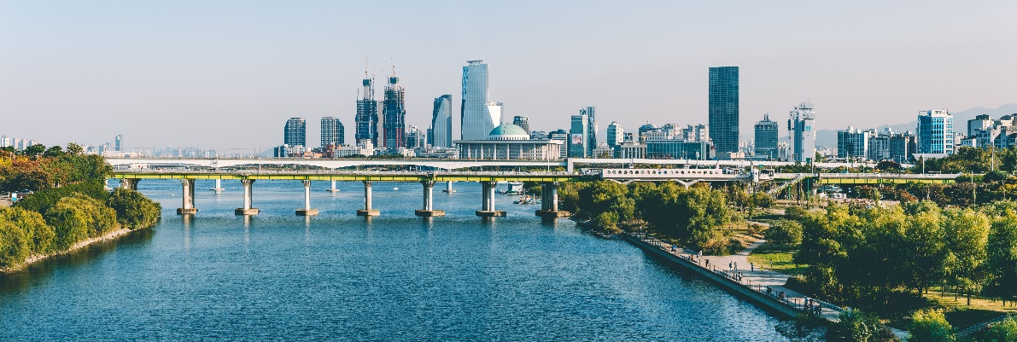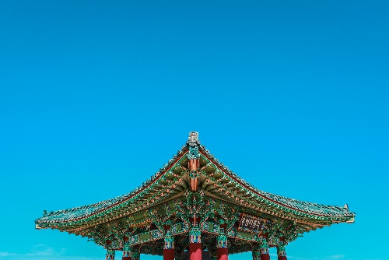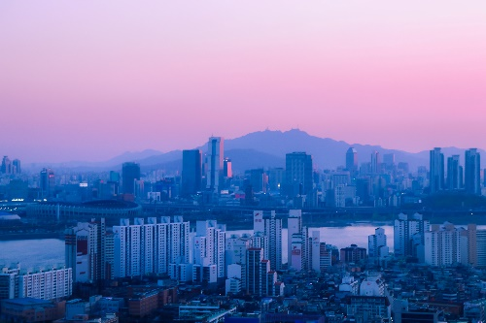
3. Text content for each page
   1. Home (<https://www.lonelyplanet.com/south-korea>)
      1. Welcome to South Korea
      2. Split by a hair-trigger border, the Korean peninsula offers the traveler a dazzling range of experiences, beautiful landscapes and 5000 years of culture and history.
      3. Welcoming Hospitality: Decorum plays a major role in Korean people’s generosity to outsiders, and their instinctive graciousness possesses a highly endearing quality. Helpfulness abounds, whether it’s at a tourist office, asking someone for directions or finding yourself deep in a conversation with a stranger. Time-honoured Confucian principles have set a template for strong civic pride in a society that is introspective, perhaps, but also decorous and affirmative. You may pass glorious landscapes and gaze out across dazzling seas but don't forget, half of your travel journey will be about the people, and the Korean tribe are a joy to be among.
      4. Urban Buzz: Korea might be known as the Land of the Morning Calm, but dive into its capital Seoul, the powerhouse of Asia’s third-largest economy, and serenity may be the last thing you’ll perceive. This round-the-clock city is constantly in motion, with a work-hard, play-hard mentality that epitomises the nation’s indefatigable, can-do spirit. You can hardly turn a corner without stumbling across a helpful tourist information booth, a bustling subway station or a taxi in this multifaceted metropolis where meticulously reconstructed palaces rub shoulders with teeming night markets and dramatically modern architecture.
      5. Idyllic Countryside: South Korea’s compact size and superb transport infrastructure mean that tranquillity is always within easy reach of urban sprawl. Hike to the summits of craggy mountains – some of which transform into ski slopes come winter – enveloped within densely forested national parks. Get further off the beaten path than you thought possible by sailing to remote islands, where farming and fishing folk welcome you into their homes or simple seafood cafes. Gaze up at the distant stars from serene villages surrounded by rice fields, sleeping in rustic hanok (traditional wooden house) guesthouses.
      6. Festivals & Food: Rest  assured the ROK also knows how to rock. A packed calendar of festivals and events means there’s almost always a celebration of some sort to attend wherever you are – it might be Boryeong for its mud fest, or Gwangju for its Biennale or its annual salute to that most Korean of foods: kimchi. Koreans are proud of their culinary culture and rightly so – there's a tantalising array of dishes, flavours, aromas and textures in the local cuisine, to be washed down with plenty of toasting involving a head-spinning array of alcoholic concoctions.
   2. About (<https://www.lonelyplanet.com/articles/best-things-to-do-in-seoul>)
      1. Seoul’s 25 districts, each with its own district personality, make up this booming 24-hour megacity that is at once a vision of the past and the future. From the world-class food to mountain-hiking trails on your doorstep, South Korea’s capital has something for everyone.
      2. Etc.
   3. Sights (<https://www.roughguides.com/destinations/asia/south-korea/where-to-go/>)
      1. Korea is still something of an unknown territory, and more than half of all its visitors get no further than **Seoul**. One of the largest and most technically advanced cities in the world, the capital regularly confounds expectations by proving itself steeped in history. Here, fourteenth-century palaces, imperial gardens, teeming markets and secluded tearooms continue to exude charm among a maze of skyscrapers and shopping malls. From Seoul, anywhere in the country is reachable within a day, but the best day-trip by far is to the [**DMZ**](https://www.roughguides.com/destinations/asia/south-korea/gyeonggi-gangwon/demilitarized-zone/), the strip of land that separates the two Koreas from coast to coast.
      2. [**Gyeonggi**](https://www.roughguides.com/destinations/asia/south-korea/gyeonggi-gangwon/), the province that surrounds Seoul, is a largely unappealing area dissected by the roads and railways that snake their way into the capital, but two of its cities certainly deserve a visit: [**Suwon**](https://www.roughguides.com/destinations/asia/south-korea/gyeonggi-gangwon/suwon-around/), home to a wonderful UNESCO-listed fortress dating from the late eighteenth century; and cosmopolitan [**Incheon**](https://www.roughguides.com/destinations/asia/south-korea/gyeonggi-gangwon/incheon/), where you can eat some of the best food in the country before making your way to the [**islands of the West Sea**](https://www.roughguides.com/destinations/asia/south-korea/gyeonggi-gangwon/west-sea-islands/). By contrast, the neighbouring province of [**Gangwon**](https://www.roughguides.com/destinations/asia/south-korea/gyeonggi-gangwon/) is unspoilt and stuffed full of attractions – in addition to a number of national parks, of which craggy **[Seoraksan](https://www.roughguides.com/destinations/asia/south-korea/gyeonggi-gangwon/seoraksan-national-park/" \o "Seoraksan National Park)** is the most visited, you can head to the unspoilt beaches and colossal caves that surround the small city of **[Samcheok](https://www.roughguides.com/destinations/asia/south-korea/gyeonggi-gangwon/samcheok-around/" \o "Samcheok and around)**, or peek inside a genuine American warship and North Korean submarine north of the sleepy fishing village of **[Jeongdongjin](https://www.roughguides.com/destinations/asia/south-korea/gyeonggi-gangwon/jeongdongjin/" \o "Jeongdongjin)**.
      3. Stretching down from Gangwon to the South Sea lie the markedly traditional **[Gyeongsang](https://www.roughguides.com/destinations/asia/south-korea/gyeongsang/" \o "Gyeongsang)** provinces, home to some of the peninsula’s most popular attractions. Foremost among these is gorgeous **[Gyeongju](https://www.roughguides.com/destinations/asia/south-korea/gyeongsang/gyeongju/" \o "Gyeongju)**; capital of the Silla dynasty for almost a thousand years, and extremely laid-back by Korean standards, it’s spotted with the grassy burial tombs of the many kings and queens who ruled here. There’s enough in the surrounding area to fill at least a week of sightseeing – most notable are **[Namsan](https://www.roughguides.com/destinations/asia/south-korea/gyeongsang/gyeongju/namsan-park/" \o "Namsan Park)**, a small mountain area peppered with trails, tombs and some intriguing Buddhas, and the sumptuously decorated **[Bulguksa](https://www.roughguides.com/destinations/asia/south-korea/gyeongsang/gyeongju/bulguksa-and-around/" \o "Bulguksa and around)** temple, another sight on the UNESCO World Heritage list. Although less picturesque as a town, **[Andong](https://www.roughguides.com/destinations/asia/south-korea/gyeongsang/andong-around/" \o "Andong and around)** is almost as relaxed as Gyeongju, and a superb base from which to access[**Dosan Seowon**](https://www.roughguides.com/destinations/asia/south-korea/gyeongsang/andong-around/dosan-seowon/), a remote Confucian academy, and the charmingly dusty village of **[Hahoe](https://www.roughguides.com/destinations/asia/south-korea/gyeongsang/andong-around/hahoe-folk-village/" \o "Hahoe Folk Village)**, a functioning showcase of traditional Korean life. The region’s rustic charm is actually best appreciated offshore on the windswept island of **[Ulleungdo](https://www.roughguides.com/destinations/asia/south-korea/gyeongsang/ulleungdo/" \o "Ulleungdo)**, an extinct volcanic cone that rises precipitously from the East Sea, and where tiny fishing settlements cling barnacle-like to its coast. Thrills with a more urban flavour can be had in [**Busan**](https://www.roughguides.com/destinations/asia/south-korea/gyeongsang/busan/), Korea’s second city, which has an atmosphere markedly different from Seoul; as well as the most raucous nightlife outside the capital, it has the best fish market in the country, and a number of excellent beaches on its fringes.
      4. Even more characterful are the **[Jeolla](https://www.roughguides.com/destinations/asia/south-korea/jeolla/" \o "Jeolla)**provinces, which make up the southwest of the peninsula. Left to stagnate by the government while Korea’s economy kicked into gear, they have long played the role of the renegade, though this energy is now being rechannelled. Violent political protests took place in regional capital [**Gwangju**](https://www.roughguides.com/destinations/asia/south-korea/jeolla/gwangju-around/) as recently as 1980, though the city has reinvented itself to become one of the artiest and most business-savvy in the land. **[Jeonju](https://www.roughguides.com/destinations/asia/south-korea/jeolla/jeonju/" \o "Jeonju)** has a similar feel, plus a delightful district of traditional hanok housing, and is justly famed for its wonderful, flavoursome cuisine. Earthy [**Mokpo**](https://www.roughguides.com/destinations/asia/south-korea/jeolla/mokpo/) is the hub for ferry trips to a mind-boggling number of West Sea islands, dotted with fishing communities where life has changed little in decades, while inland there are a number of excellent national parks.
      5. The [**Chungcheong**](https://www.roughguides.com/destinations/asia/south-korea/chungcheong/) provinces at the centre of the country are bypassed by many travellers, but this is a shame, as they contain some fine sights. The old Baekje capitals of **[Gongju](https://www.roughguides.com/destinations/asia/south-korea/chungcheong/baekje-capitals/gongju/" \o "Gongju)** and **[Buyeo](https://www.roughguides.com/destinations/asia/south-korea/chungcheong/baekje-capitals/buyeo/" \o "Buyeo)** provide glimpses of a dynasty long dead, **[Daecheon beach](https://www.roughguides.com/destinations/asia/south-korea/chungcheong/coastal-chungnam/daecheon-beach/" \o "Daecheon beach)**hosts a rumbustious annual mud festival that may well be Korea’s most enjoyable event, and there are temples galore – the gigantic golden Buddha at **[Beopjusa](https://www.roughguides.com/destinations/asia/south-korea/chungcheong/songnisan-national-park/beopjusa/" \o "Beopjusa)** is surrounded by 1000m-high peaks, while the meandering trails and vivid colour schemes at **Guinsa** make it the most visually stimulating temple in the land.
      6. Lying within a ferry ride of the mainland’s southern shore is the island of **[Jeju](https://www.roughguides.com/destinations/asia/south-korea/jeju-island/" \o "Jeju Island)**, a popular honeymoon destination for Koreans. While it’s undoubtedly a touristy place, it has its remote stretches and anyone who has climbed the volcanic cone of **[Hallasan](https://www.roughguides.com/destinations/asia/south-korea/jeju-island/hallasan-national-park/" \o "Hallasan National Park)**, walked through the lava tubes of **[Manjanggul](https://www.roughguides.com/destinations/asia/south-korea/jeju-island/eastern-jeju/manjanggul/" \o "Manjanggul)** or watched the sun go down from **[Yakcheonsa](https://www.roughguides.com/destinations/asia/south-korea/jeju-island/jungmun/yakcheonsa-temple/" \o "Yakcheonsa temple)**temple will tell you the trip is more than worthwhile.
      7. And finally, of course, there’s **North Korea**. A visit to one of the world’s most feared and most fascinating countries will instantly earn you kudos – even experienced travellers routinely put the DPRK at the top of their “most interesting” list. Visits don’t come cheap and can only be made as part of a guided tour, but the country’s inaccessibility brings an epic quality to its few officially sanctioned sights.
   4. 24 Hours (<https://www.howdareshe.org/one-day-seoul/>)
      1. One Day is Seoul - Whether it’s a long layover or just a quick stop – Seoul can’t be missed when in Asia. Even if you only have one day in Seoul, here’s what you can’t miss about the city, how to get there, what to be sure to eat and where to stay if you are going to overnight. Everything mentioned can be done on your own, or if you prefer to book tickets in advance or book guides, there are links to do that too
4. 3 Website Inspo:
   1. <https://colorlib.com/preview/theme/beyond/>
   2. <https://colorlib.com/preview/theme/fantasy/>
   3. <https://colorlib.com/preview/theme/adventure/>
5. 1 paragraph describing the content, goals, and the audience of your website:
   1. My website targets people interested in traveling to South Korea. Online travel guides are needed to accommodate the drastic increase in visitors as the South Korean culture becomes globally popular. My website will aid travelers to plan the best trip possible as well as have other related resources, such as, articles about the food, traditions, pop culture, etc.