Message from the SIGCSE Chair

It is my pleasure to welcome you to the 43rd SIGCSE Technical Symposium on Computer Science Education (SIGCSE 2012). With a diverse technical program and over 1100 attendees from around the world, you are participating in the premiere technical conference on computer science education. I hope that you will find this event an opportunity to hear influential keynote addresses, to learn about new resources and pedagogy, to renew friendships, to meet future collaborators, and to have fun and learn a lot.
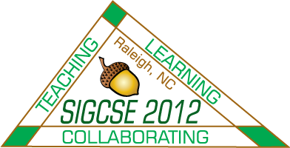
SIGCSE 2012 is sponsored by the ACM Special Interest Group on Computer Science Education (the SIGCSE organization). The SIGCSE organization consists of approximately 2600 members, whose interests in improving computer science education are probably similar to your own. Many of these members are also volunteers who carry out the various activities associated with the SIGCSE organization. Chief among the volunteers responsible for the SIGCSE 2012 symposium are Laurie Smith King and Dave Musicant, symposium co-chairs, who have worked for over two years on this conference. Laurie and Dave selected and steered a committee of 27 colleagues in organizing all aspects of this event. Included in the organizing committee are members, on whom we depend year in and year out, to handle conference registration (Lynn Degler, Cary Laxer, and Larry Merkle), to manage the conference database (John Dooley and Henry Walker) and to coordinate with exhibitors and sponsors (Susan Rodger). On behalf of the SIGCSE organization I thank all of the members of the committee for their countless contributions.

I also thank all of the conference supporters and exhibitors, who enhance this event by their presence. Without their participation, this conference would not be as memorable.

I encourage you, the reader, to consider becoming more involved in the SIGCSE community and the workings of the SIGCSE organization. I encourage you to attend in the annual SIGCSE Business meeting on Friday afternoon, from 5:10 to 5:55p.m., in room 302A. This is an opportunity to meet the members of the SIGCSE board: Daniel Joyce (vice chair), Doug Baldwin (treasurer), Susan Rodger (secretary) and at-large members Tiffany Barnes, Mark Guzdial and Amber Settle. Most importantly, it is an opportunity to learn more about how the organization works – a first step in becoming more involved.
Enjoy the conference!
Renée McCauley
College of Charleston
SIGCSE Chair, 2010-2013

