**Plan of action for the modeling / analysis for the first lot of viscosities**

Ben and Ilona, 20.6.

**Some random ideas on what to do:**

* Look at the data with fresh eyes and identify
* Compare the water activity to different activity models (Fig. 1 of this document)
* Compare the viscosities to the Stokes-Einstein approach
* Make first calculations on where atmospheric impacts / relevance is expected (i.e. look at the mixing time scales of particles of different sizes)
  + From Shiraiwa figure: The initial viscosity (~106 Pa s) leads to mixing timescales from 10 ms to 1 month for particle diameters from 1 nm to 10 μm, respectively.
  + The liquid-like viscosity (~10 Pa s) leads to timescale at most 1 s for 10 μm particle.
* FLOW for first calculations

1. Investigate the water activity / non-ideality of the mixture (Fig. 6 from Murray) by comparing data to UNIFAC and ideal mixture assumption
2. Calculate the expected composition as a function of temperature with a multicomponent evaporation / equilibrium model to interpret viscosity measurements – i.e. to convert the temperature axis to a composition axis
   1. Ideal mixture
   2. UNIFAC
   3. Something else
3. Compare to Cappa et al. etc. Are we seeing the melting of the mixture? Is there phase separation upon the addition of water?

**Future?:**

1. **First thoughts / observations on the data**

* Equimolar mixtures of C3-C10 + C12 dicarboxylic acids

*Temperature-dependent viscosity (Fig. 1-2)*

* Below ~40 ºC the viscosity of the mixture is stable between 106 and 107 Pa s between 40-0 ºC the viscosity drops to about 105 Pa s, and above ~70 ºC, it drops rapidly to < 102 Pa s
* Comparing to the Fig. in Shiraiwa et al.: < 40ºC ”semi-solid”, 40-70ºC ”semi-solid”, >70ºC
* Comparing to the Cappa et al. paper:
  + Our results indicate that the temperatures of the Cappa et al. paper might be too high to be representative of the atmospheric mixture – below 40 ºC the mixture is certainly a solid – check the generation method
  + Our data incidate that the deviation at <C6 evaporation might not be because of the non-ideality but instead that the mixture is a solid / melting, i.e. that there are some mass transfer limitations for the evaporating molecules to ”get out” of the mixture
  + Deviations at > C8 might be due to non-ideality
* Can we confirm something about the melting point of the solution? Is there hysteresis in the temperature-dependence?
* Can we be sure that we have an equimolar mixture and the high temperatures? Don’t the more volatile compounds evaporate from the mixture?
* What is driving the phase change? Is it melting or evaporation or both?
* TO DO: Modeling how the composition in the experimental system is changing the temperature due to potential evaporation of the more volatile species. This should be done to correctly interpret the T-dependent viscosity measurements.

*Effect of water on viscosity (Figs. 3-5)*

* At room temperature, the viscosity decreases with a factor of 10 at Xw = 0.8
* Water plays a lot smaller role than temperature
* What is happening at 70-90 ºC at low water mole fractions? Does it make sense that adding water seems to increase the viscosity? The values are in the range of semi-solid – can we explain why adding water would make the stuff more viscous? Can it be a sign of phase separation – i.e. the formation of a more viscous aqueous phase and a less viscous organic phase. Which one determines the viscosity?
* TO DO: Look into the theory of viscous liquids + interpretation of the results.

*Water activitity (Fig. 6)*

* Water activity (RH) increases with increasing water mole fraction
* TO DO: Comparison to UNIFAC predictions and ideal mixture prediction on water activity. This can be done with e.g. the E-AIM website or Ivica’s code. Test both cases: 1) letting only water equilibrate (assuming equimolar mixture of the acids) or 2) letting everything equilibrate.
* Temperature – what was it exactly? Room temperature? Is this equimolar mixture of the acids OR is it the equilibrium mixture at room temperature?

| Temperature  *- t - (oC)* | [Dynamic Viscosity](http://www.engineeringtoolbox.com/dynamic-absolute-kinematic-viscosity-d_412.html)  *- µ - (Pa s, N s/m2) x 10-3* | [Kinematic Viscosity](http://www.engineeringtoolbox.com/dynamic-absolute-kinematic-viscosity-d_412.html)  *- ν - (m2/s) x 10-6* |
| --- | --- | --- |
| 0 | 1.787 | 1.787 |
| 5 | 1.519 | 1.519 |
| 10 | 1.307 | 1.307 |
| 20 | 1.002 | 1.004 |
| 30 | 0.798 | 0.801 |
| 40 | 0.653 | 0.658 |
| 50 | 0.547 | 0.553 |
| 60 | 0.467 | 0.475 |
| 70 | 0.404 | 0.413 |
| 80 | 0.355 | 0.365 |
| 90 | 0.315 | 0.326 |
| 100 | 0.282 | 0.29 |

*DSC thermograms*

* Pure organic mixture: Some phase transitions around 20, (40), 50 and 70 ºC – can these be related to 1) evaporation the acids; 2) melting of the mixture; 3) phase separation?
  + According to Cappa et al., none of the acids boils yet at 20 ºC – so this is likely to be some other phase change?
  + TO DO: Simulate the DSC data of the pure acid mixture with a multicomponent evaporation model to tease out the heat capacity change that is due to evaporation only. Link to Fig. 1. Are the phase changes seen in the pure mixture due to evaporation or condensed phase changes?
  + For Xw,mass > 0.25 the water transitions (melting < 0 and boiling at 100 C) are clearly seen
  + Are the DSC thermograms comparable in magnitude?
  + Is the extra black curve 0.75 water mole fraction?

1. **Questions to the Machester guys**

* Uncertainty of the measurements?
* Generation of the sample? Was it formed from liquid methanol solutions of what?
* Have you repeated the viscosity vs. temperature measurements for both up- and downward temperature ramps? Have you checked whether there is temperature-hysteresis in the viscosity?
* Input about the experimental procedure to aid with the evaporation calculations?
* What are the experimental timescales – are we likely to probe equilibrium composition or is it dynamically changing with time / temperature? If it is changing, what is the time axis corresponding to the temperature axis?
* What is the temperature in Fig. 6?
* In the water activitiy measurements, is it possible that some acids have equilibrated with the gas phase (= evaporated)?
* What are the two black curves in Fig. 7?
* The exact interpretation / raw data of the DSC – what was actually measured (I assume the heating power?) and with what kind of time and temperature resolution? How was the temperature changing in time?
* Has the mass of the sample during heating been measured? If so, how did it behave?

1. **Links to literature data / observations / reference material**

* See e.g. Shiraiwa and Seinfeld, Shiraiwa et al., the Koop group papers, the Kuopio group (Annele Virtanen) recent papers,
* Cappa et al.
  + Particles generated form methanol solutions – wouldn’t you expect them for collapse into perfect mixtures upon drying
  + Argument: ”the aerosol seems to be perfectly mixed throughout evaporation so it must be liquid” (i.e. there seems to be no mass transfer limitation to the surface when material is evaporating form the particle)
  + Evaporation temperatures: from about 300-320 K to about 360 K
  + I would expect that after drying, the reorganization to solid mixture would take time too – similar to the timescale needed for the solid state mixing (which the authors state takes long)
  + I also think that it makes sense that the binary and ternary mixtures reach their crystal structure faster after drying since it is much more likely that they meet a partner with which they
  + I am not sure which mixing / reorganization time scale is relevant there:

1. Liquid methanol solution → drying + collapsing into a mixed diacid particle → reorganization to the pure mixed (solid) diacid particle (final equilibrium state)

OR

1. Liquid methanol solution → drying + collapsing into a mixed ”liquidlike” diacid particle (final equilibrium state)

**Figures**

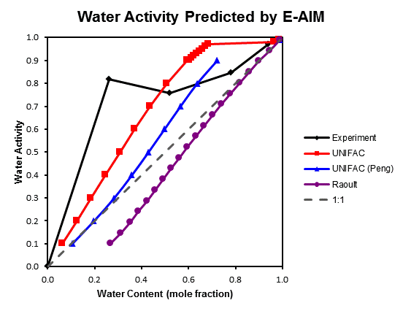

**Figure1.** Water activity predictions for different thermodynamic models. Sub-cooled liquid mixture is assumed for the condensed hydrophobic phases. The Raoult model is updated with activity for water (so it is not technically ideal), but the organics follow ideal behavior.

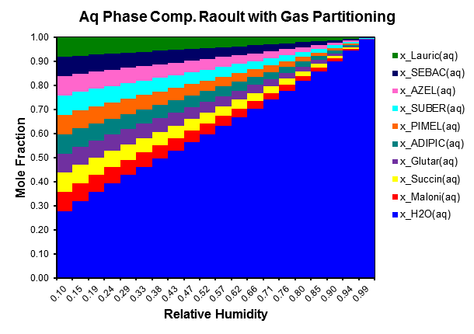

**Figure 2.** Composition of aqueous phase with Raoult partitioning assumed.

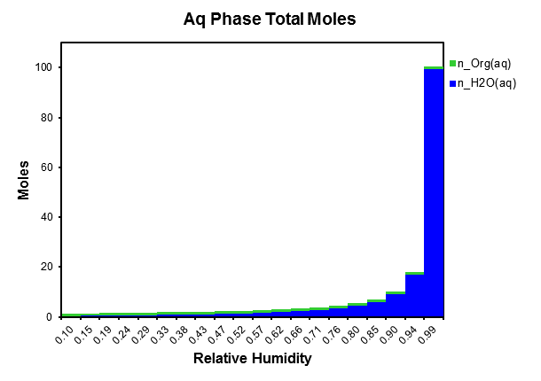

**Figure 3.** Total moles in solution as a function of RH.

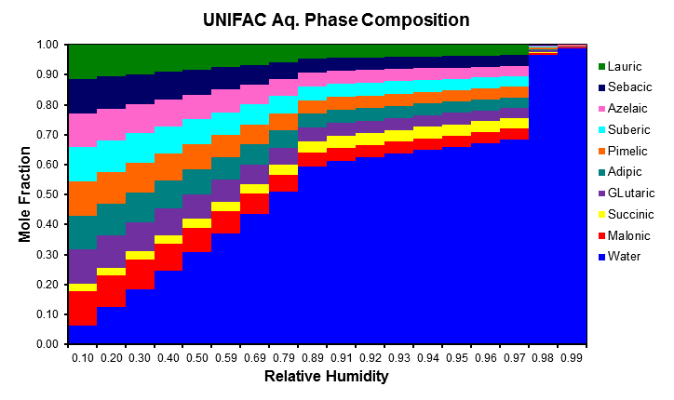

**Figure 4.** Composition in the **Aqueous** phase predicted by UNIFAC.

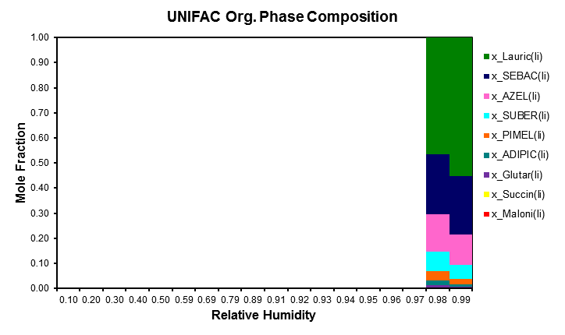

**Figure 5.** Composition in the **Hydrophobic** phase predicted by UNIFAC.

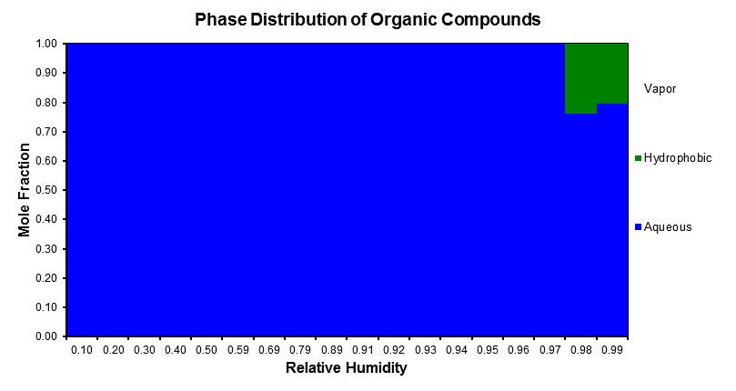

**Figure 6.** Distribution of organic moles throughout the three phases (aqueous, hydrophobic, and vapor). Predictions are from the UNIFAC model.