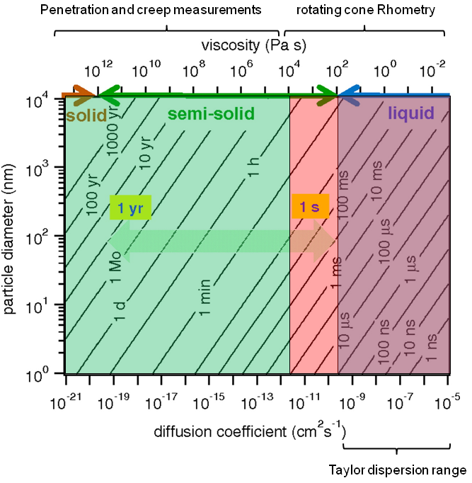

Figure Shiwara visc& diffusion & paritcle size

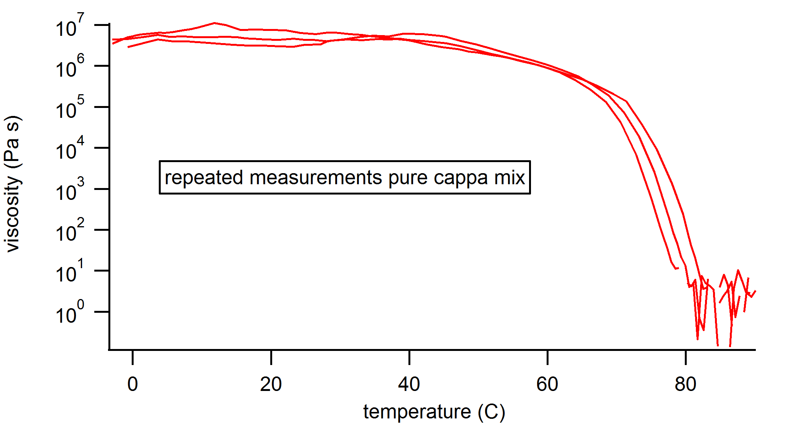

Figure Repeated measurements of Cappa mix

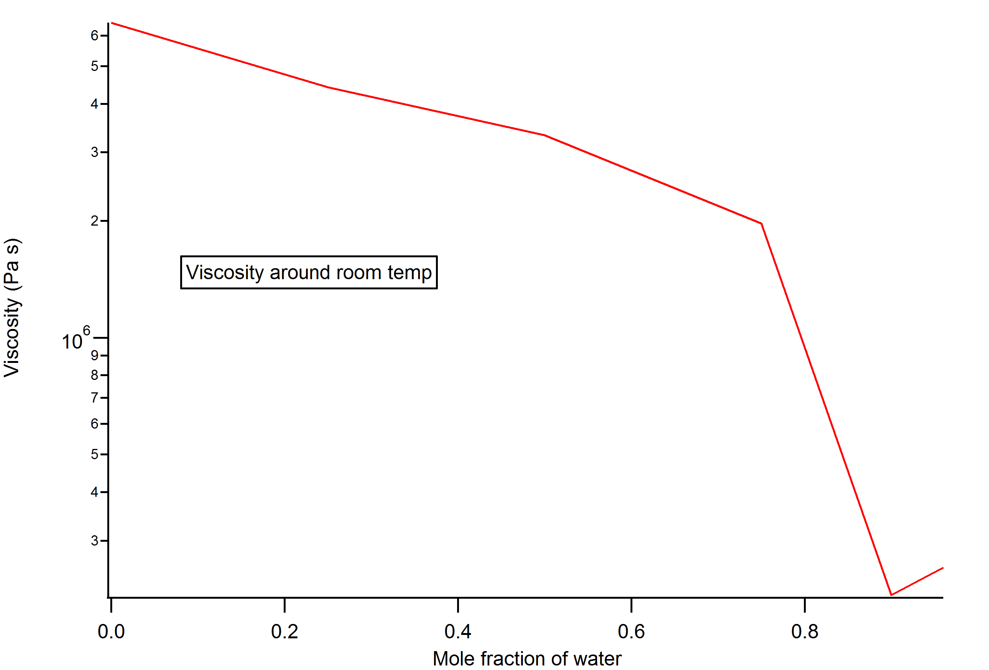

Figure Cappa mix viscosity with increasing water mole fraction

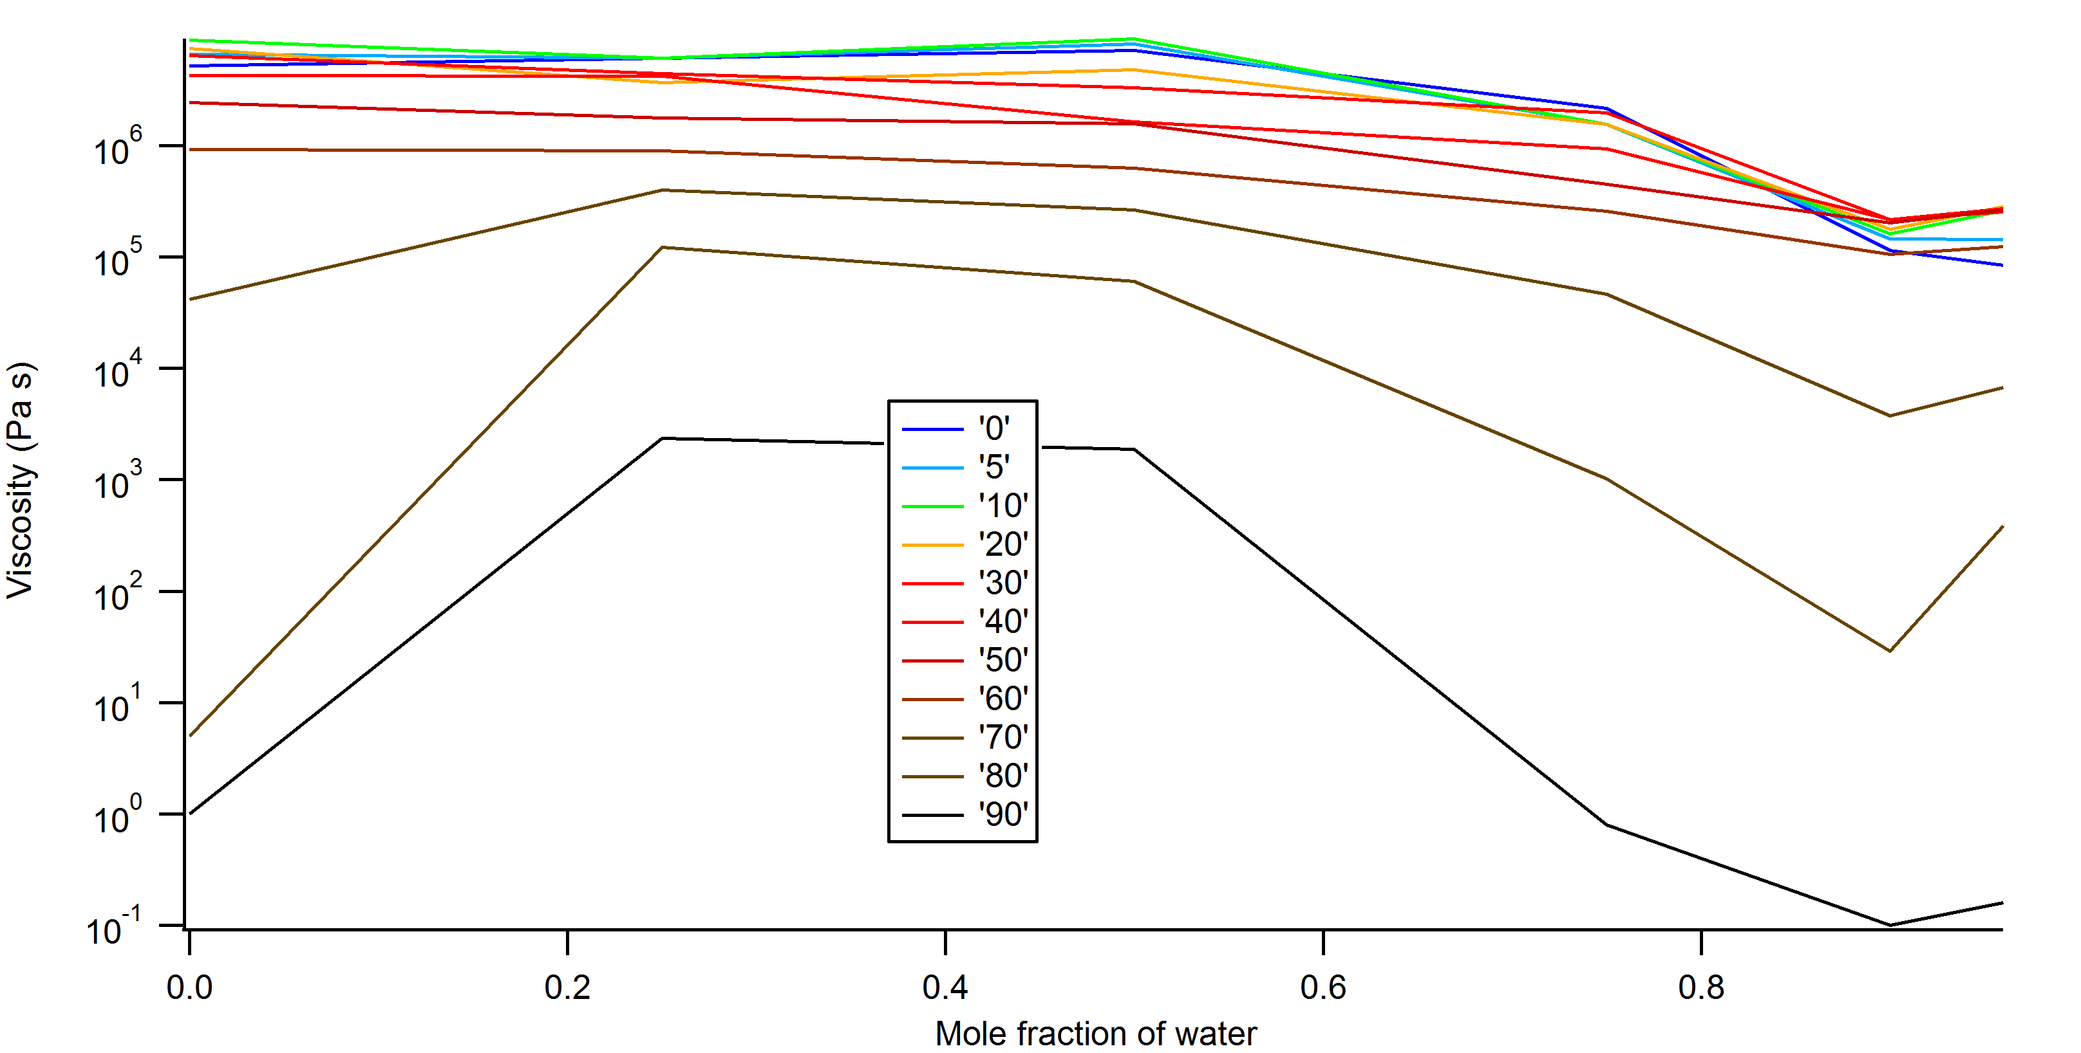

Figure Viscosity as function of water mole fraction for the different temperatures

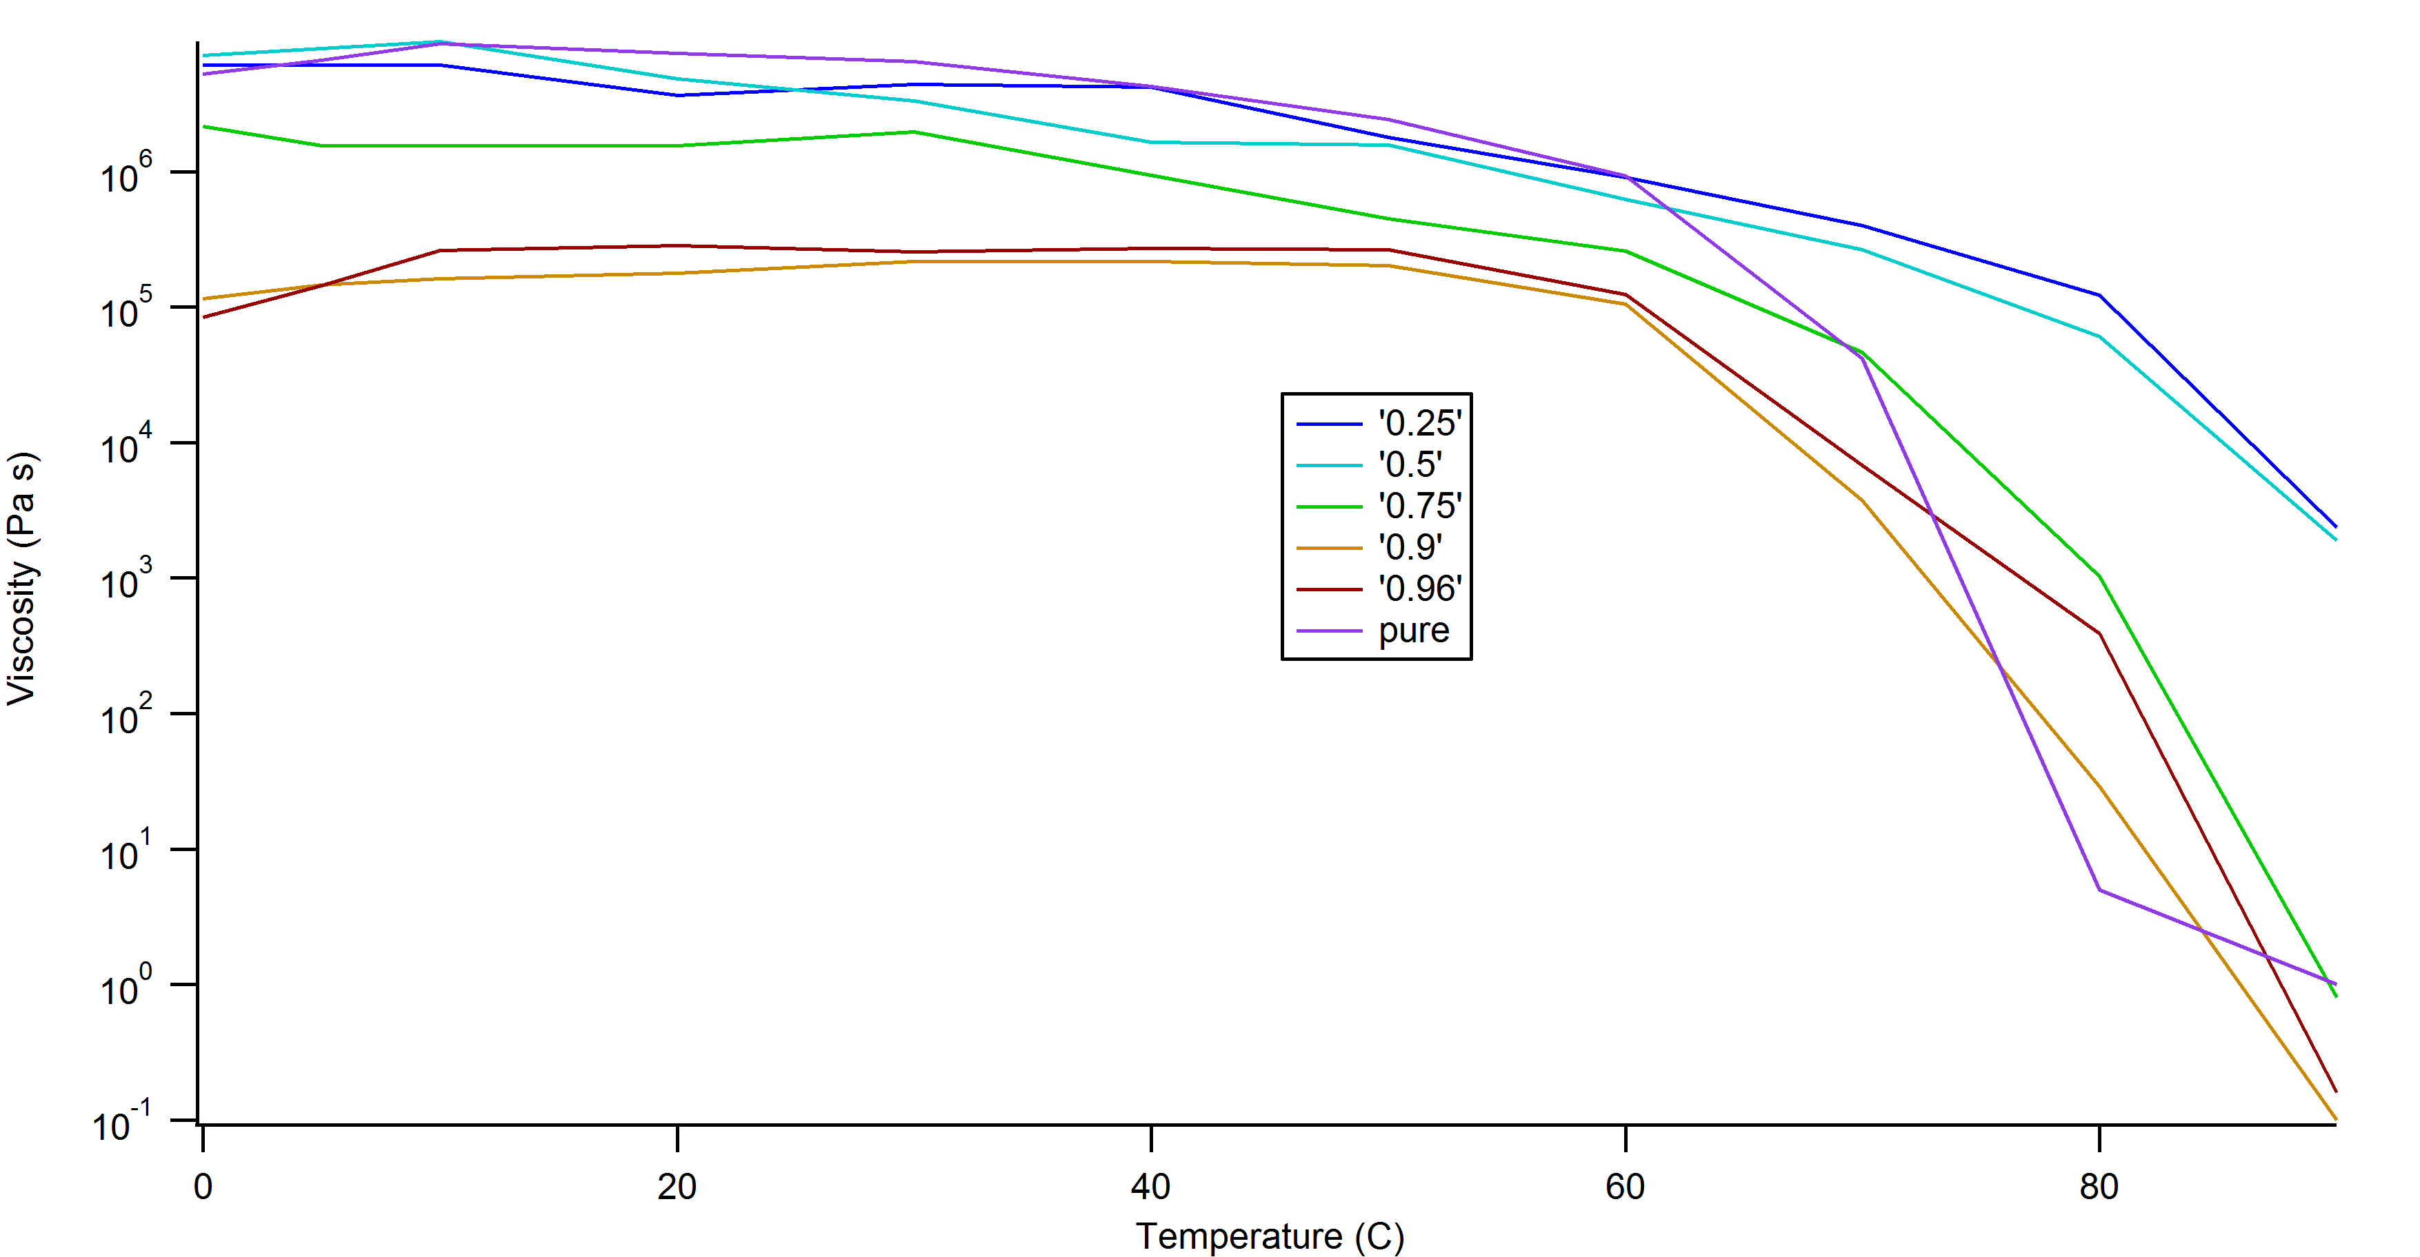

Figure 5 viscosity as function of temperature for different water mole fractions

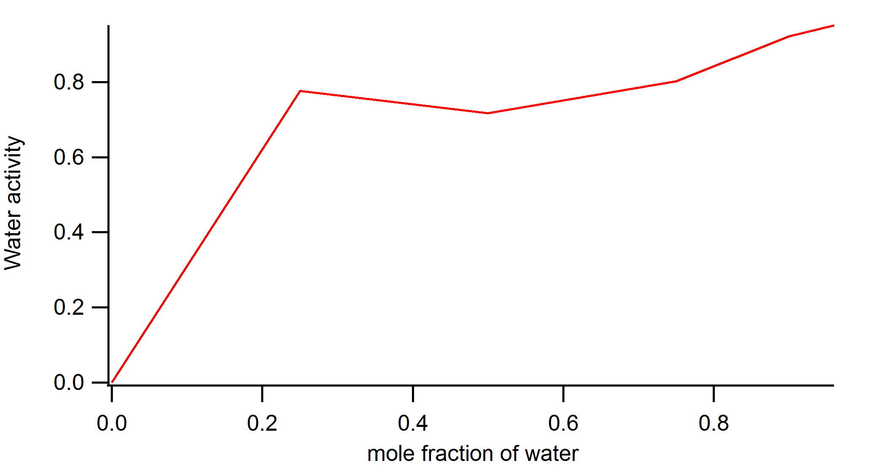

Figure 6 water activity as function of water mole fraction

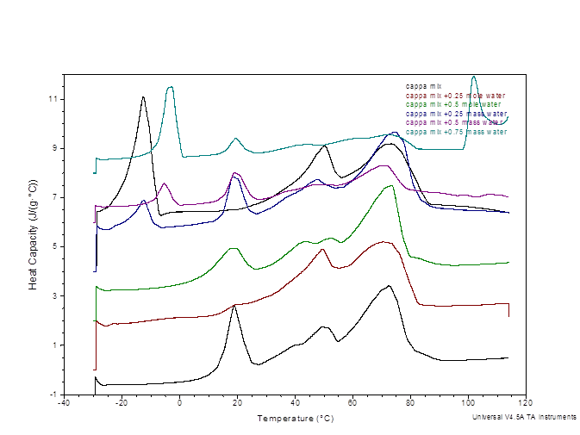

Figure DSC thermograms of cappa mix with difference water mole fractions