# solr安装配置手册

## 环境说明

### 机器列表

本次安装使用到3台主机

10.1.4.51  
10.1.4.52  
10.1.4.53

### JDK

主机安装jdk1.8

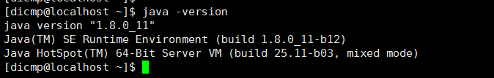

### Zookeeper

完成zookeeper 3.4.12 release版本安装并启动zookeeper

### 操作系统

主机操作系统版本为REDHAT_7.4

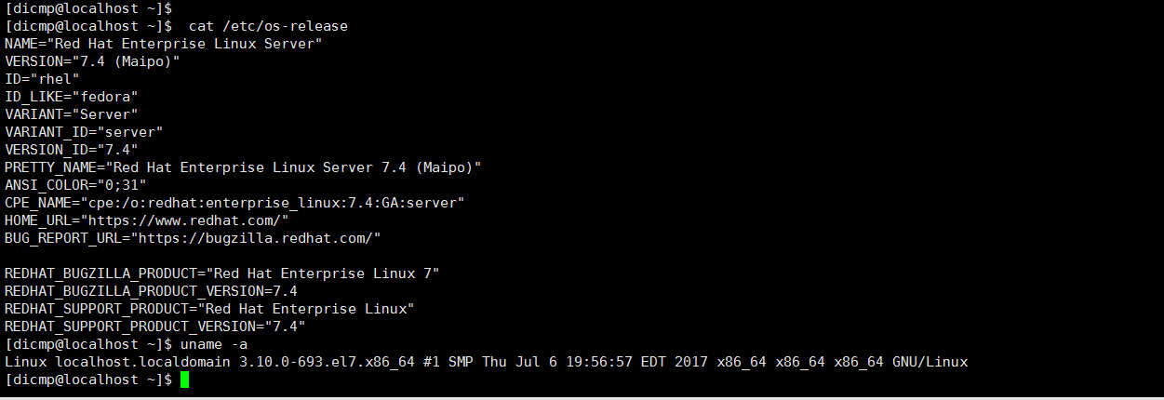

## 安装&配置

目录准备

分别在三台主机上创建如下目录

创建solr主目录

mkdir /opt/aspire/product/dicmp/solr

安装包下载

本次安装solr-7.3.1版本

<http://mirror.bit.edu.cn/apache/lucene/solr/7.3.1/solr-7.3.1.tgz>

### 安装

将solr-7.3.1.tgz上传到10.1.4.51机器/opt/aspire/product/dicmp/solr，并执行解压命令

tar –zxvf solr-7.3.1.tgz

到这里单机版的一个solr就已经安装完成了，

执行如下命令启动

/opt/aspire/product/dicmp/solr/solr-7.3.1/bin/solr

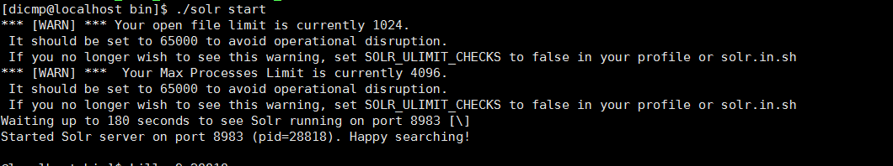

浏览器打开<http://10.1.4.53:8983/solr>

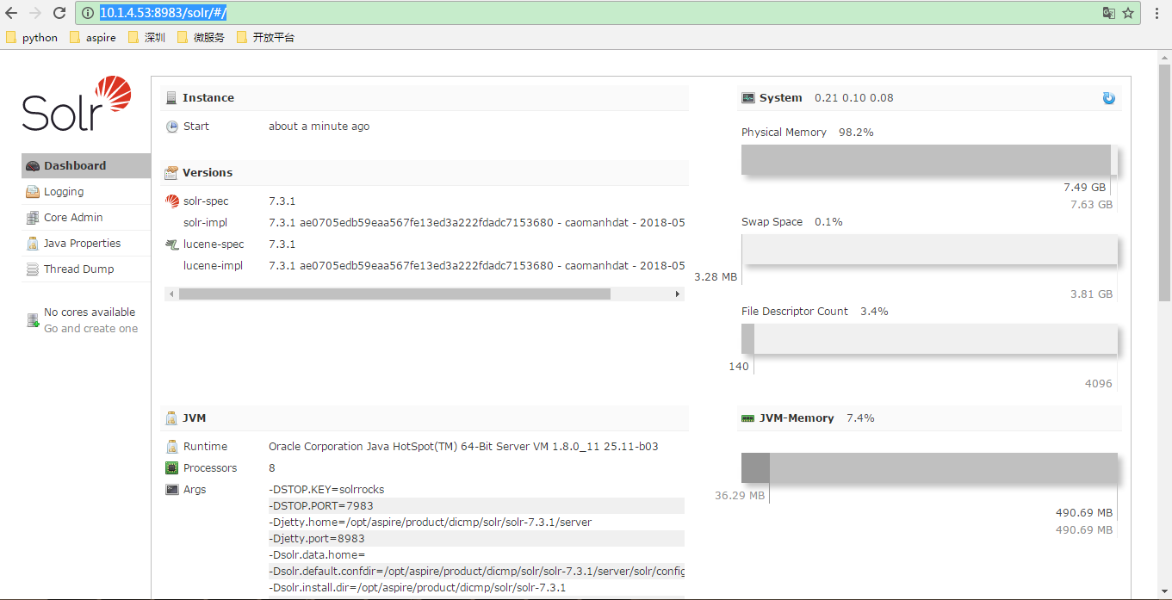

### 配置

vi /opt/aspire/product/dicmp/solr/solr-7.3.1/bin/solr.in.sh

修改如下配置

SOLR_HOST="10.1.4.53"

SOLR_TIMEZONE="UTC+8"

注意：这里的SOLR_HOST需要设置为机器的ip

### Cloud配置

进入solr的bin目录执行./solr -e cloud进入交互式配置页面，黄色标记的为交互过程用户输入的内容

[dicmp@localhost bin]$ ./solr -e cloud

*** [WARN] *** Your open file limit is currently 1024.

It should be set to 65000 to avoid operational disruption.

If you no longer wish to see this warning, set SOLR_ULIMIT_CHECKS to false in your profile or solr.in.sh

*** [WARN] *** Your Max Processes Limit is currently 4096.

It should be set to 65000 to avoid operational disruption.

If you no longer wish to see this warning, set SOLR_ULIMIT_CHECKS to false in your profile or solr.in.sh

Welcome to the SolrCloud example!

This interactive session will help you launch a SolrCloud cluster on your local workstation.

To begin, how many Solr nodes would you like to run in your local cluster? (specify 1-4 nodes) [2]:

2

Ok, let's start up 2 Solr nodes for your example SolrCloud cluster.

Please enter the port for node1 [8983]:

18983

Please enter the port for node2 [7574]:

28983

Solr home directory /opt/aspire/product/dicmp/solr/node3/example/cloud/node1/solr already exists.

/opt/aspire/product/dicmp/solr/node3/example/cloud/node2 already exists.

Starting up Solr on port 18983 using command:

"/opt/aspire/product/dicmp/solr/node3/bin/solr" start -cloud -p 18983 -s "/opt/aspire/product/dicmp/solr/node3/example/cloud/node1/solr"

*** [WARN] *** Your open file limit is currently 4096.

It should be set to 65000 to avoid operational disruption.

If you no longer wish to see this warning, set SOLR_ULIMIT_CHECKS to false in your profile or solr.in.sh

*** [WARN] *** Your Max Processes Limit is currently 4096.

It should be set to 65000 to avoid operational disruption.

If you no longer wish to see this warning, set SOLR_ULIMIT_CHECKS to false in your profile or solr.in.sh

Waiting up to 180 seconds to see Solr running on port 18983 [\]

Started Solr server on port 18983 (pid=3930). Happy searching!

Starting up Solr on port 28983 using command:

"/opt/aspire/product/dicmp/solr/node3/bin/solr" start -cloud -p 28983 -s "/opt/aspire/product/dicmp/solr/node3/example/cloud/node2/solr" -z 10.1.4.53:21810,10.1.4.53:31810,10.1.4.53:41810/solr

*** [WARN] *** Your open file limit is currently 4096.

It should be set to 65000 to avoid operational disruption.

If you no longer wish to see this warning, set SOLR_ULIMIT_CHECKS to false in your profile or solr.in.sh

*** [WARN] *** Your Max Processes Limit is currently 4096.

It should be set to 65000 to avoid operational disruption.

If you no longer wish to see this warning, set SOLR_ULIMIT_CHECKS to false in your profile or solr.in.sh

Waiting up to 180 seconds to see Solr running on port 28983 [\]

Started Solr server on port 28983 (pid=4188). Happy searching!

INFO - 2018-06-06 18:31:26.934; org.apache.solr.client.solrj.impl.ZkClientClusterStateProvider; Cluster at 10.1.4.53:21810,10.1.4.53:31810,10.1.4.53:41810/solr ready

Now let's create a new collection for indexing documents in your 2-node cluster.

Please provide a name for your new collection: [gettingstarted]

gettingstarted

How many shards would you like to split gettingstarted into? [2]

2

How many replicas per shard would you like to create? [2]

1

Please choose a configuration for the gettingstarted collection, available options are:

_default or sample_techproducts_configs [_default]

_default

Created collection 'gettingstarted' with 2 shard(s), 1 replica(s) with config-set 'gettingstarted'

Enabling auto soft-commits with maxTime 3 secs using the Config API

POSTing request to Config API: http://localhost:18983/solr/gettingstarted/config

{"set-property":{"updateHandler.autoSoftCommit.maxTime":"3000"}}

Successfully set-property updateHandler.autoSoftCommit.maxTime to 3000

SolrCloud example running, please visit: http://localhost:18983/solr

[dicmp@localhost bin]$ ls

如果希望简化该过程可以使用bin/solr -e cloud -noprompt

命令，默认值创建cloud，不进入交互页面

### 启动

进入solr的bin目录执行如下命令

./solr start

### 停止

进入solr的bin目录执行如下命令

./solr stop -all

### 验证

在浏览器中请求<http://10.1.4.53:18983/solr/#/~cloud>

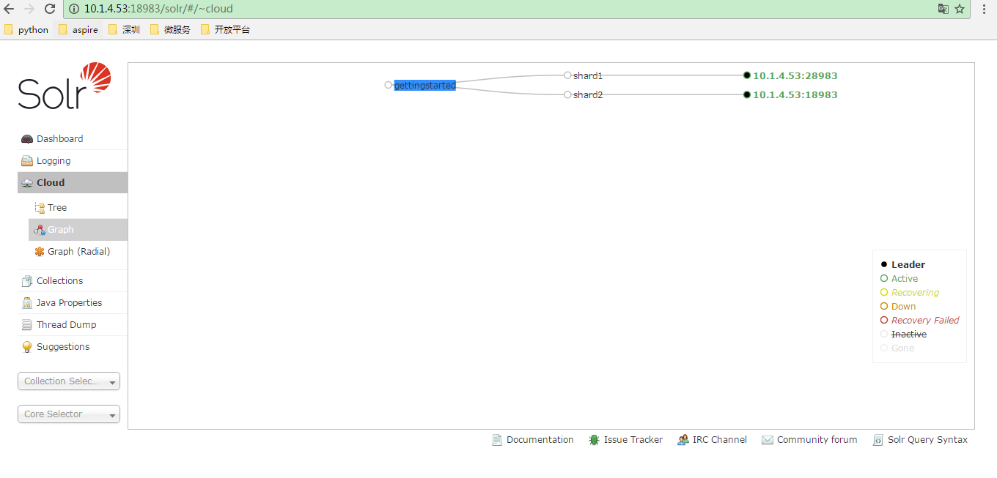

单机版本效果

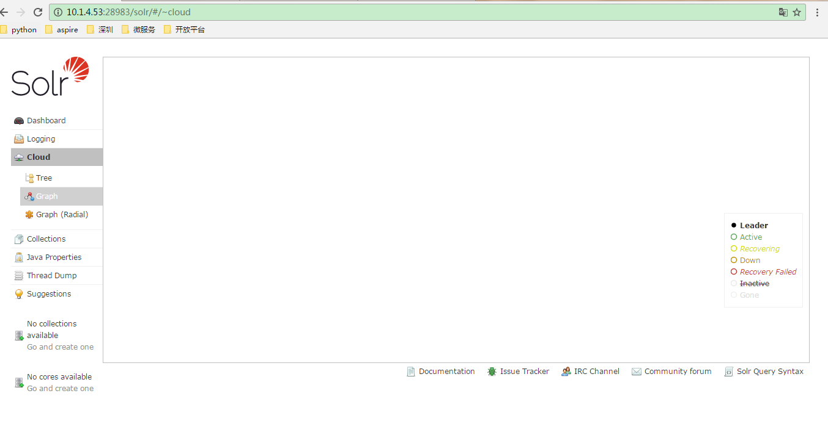

## 参考文档

Solr clound配置官方指导手册

http://lucene.apache.org/solr/guide/7_3/getting-started-with-solrcloud.html#restarting-nodes