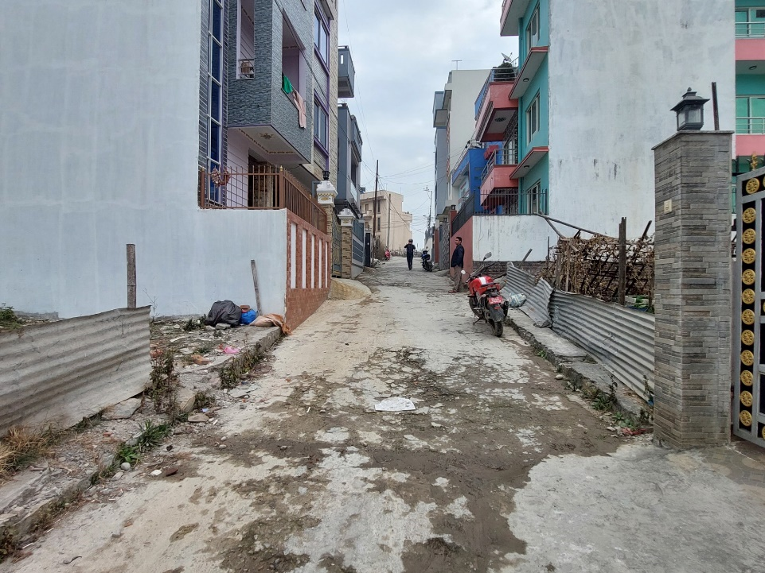  Figure 1:13ft wide Concrete Slab Road at South side of the Considered Property. | 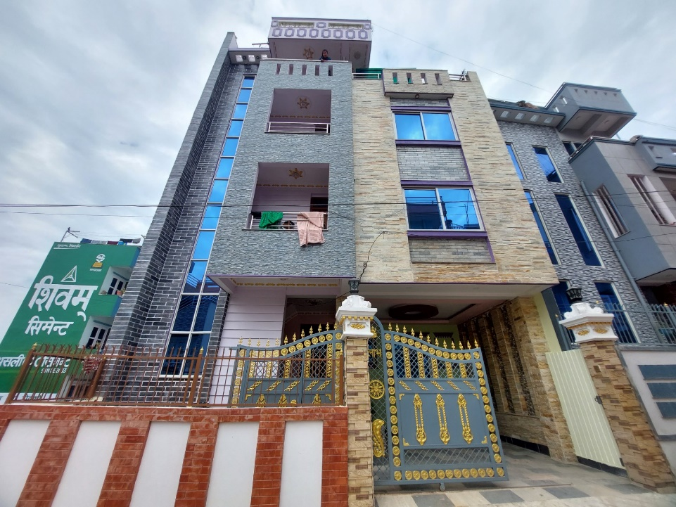  Figure 2: South side view of the Considered Property.
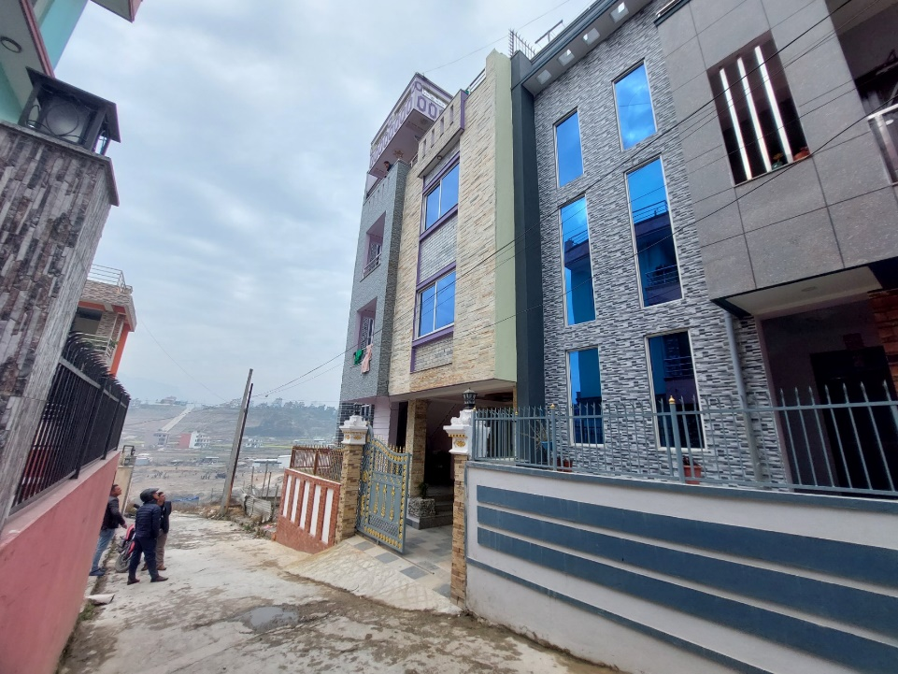  Figure 3: South-East side view of the Considered Property. | 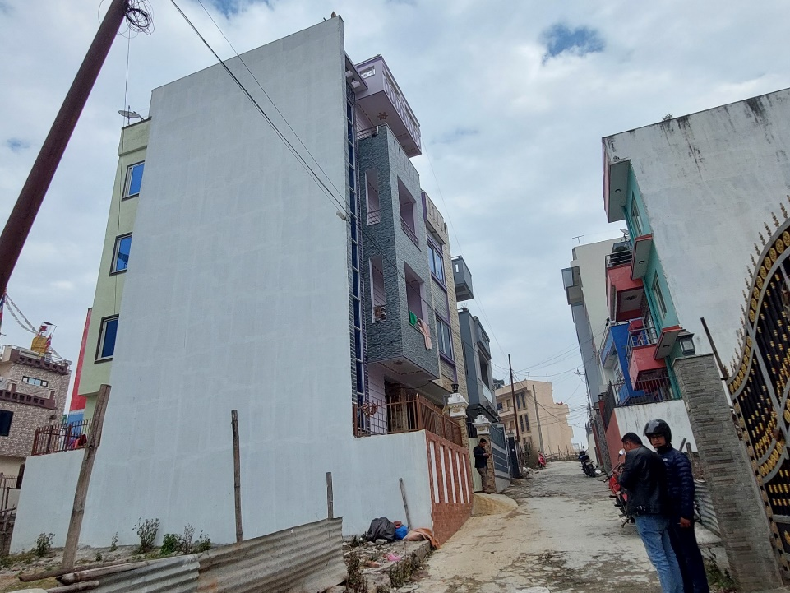  Figure 4: South-West view of the Considered Property.
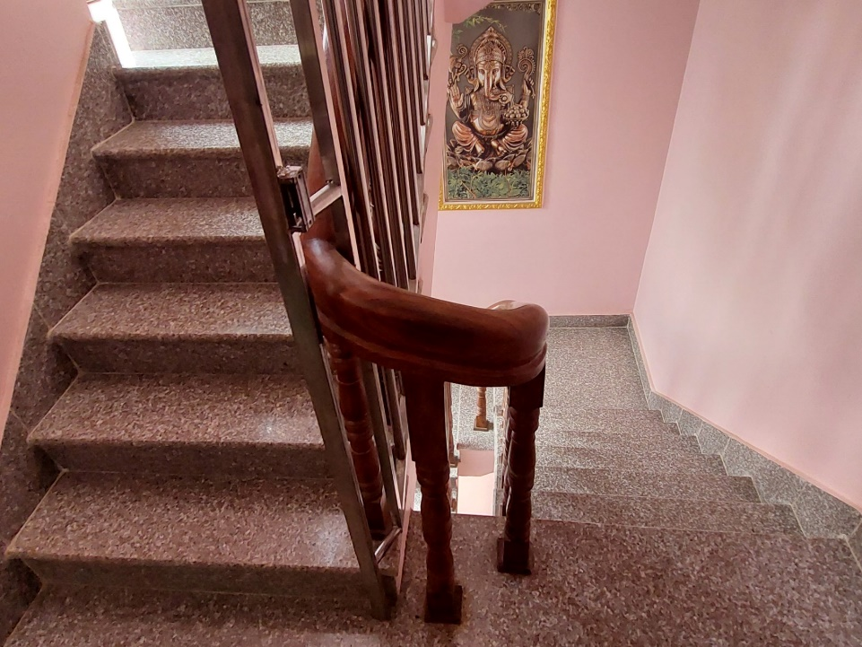  Figure 5: Staircase view of the Considered Property. | 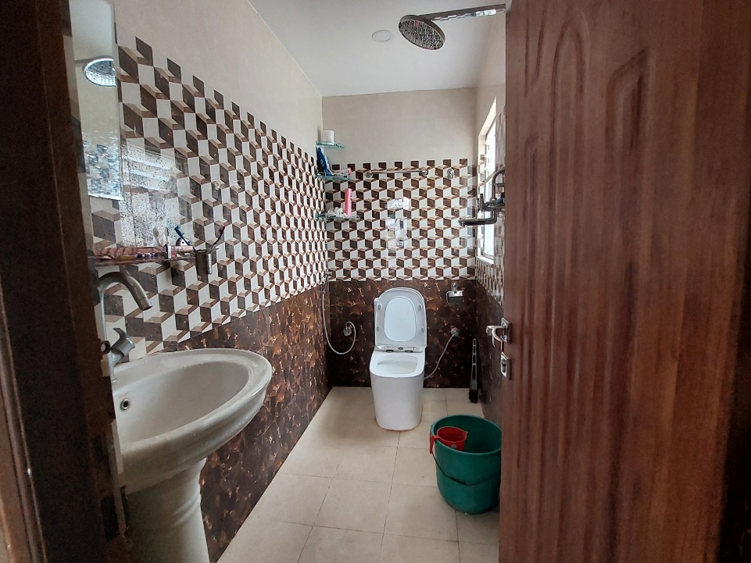  Figure 6: T&B of the Considered Property.
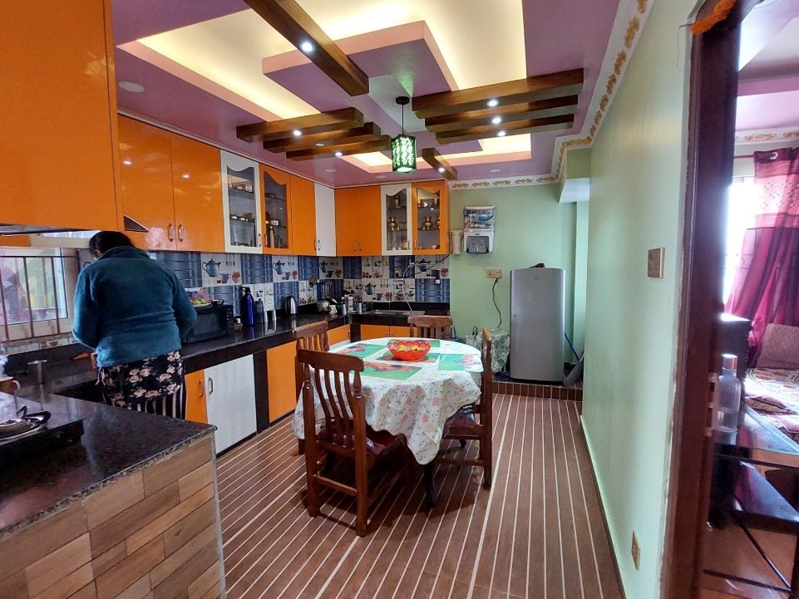  Figure 7: Kitchen of the Considered Property. | 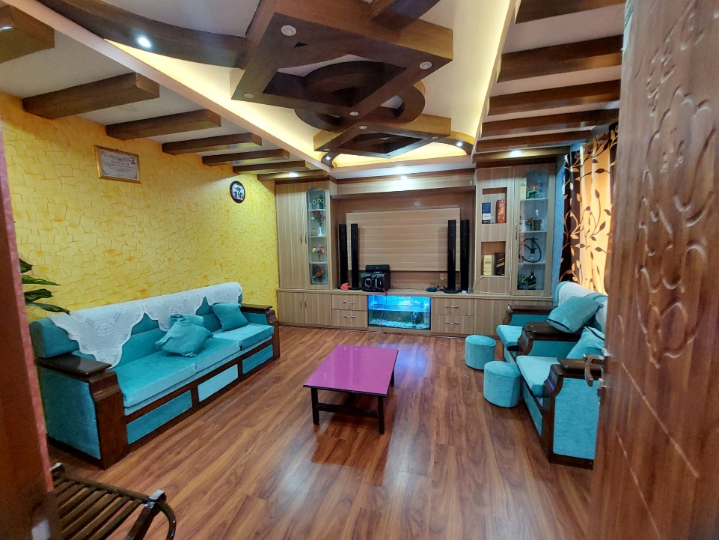  Figure 8: Livingroom of the Considered Property.

