Bryan Nonni  
Lab 10 – Part I – In Lab  
  
1) reverse.c  
#include <stdio.h>  
#define N 50  
int main(){  
 int arr[N] = {0},i=0;  
 char c;  
 printf("Enter a message: ");  
 while((c = getchar()) != '\n'){  
 arr[i] = c;  
 i++;  
 }  
 printf("Reversal is: ");  
 for(i = N - 1; i >= 0; i--){  
 putchar(arr[i]);  
 }  
printf("\n");  
return 0;  
}  
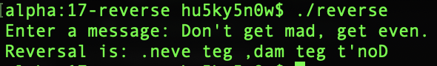

2) reverseP.c  
#include <stdio.h>  
#define N 30  
int main(){  
 int arr[N], \*p;  
 p=&arr[0];  
 char c;  
 printf("Enter a message: ");  
 while((c = getchar()) != '\n'){  
 \*p = c;  
 p++;  
 }  
printf("Reversal is: ");  
while(p != arr-1){  
 putchar(\*p);  
 p--;  
}  
printf("\n");  
return 0;  
}

