**Visualization Activity**

Get into groups of 3-4 and on one computer go to Google My Maps, <https://www.google.com/mymaps>. Create a new map and search for “Poughkeepsie, NY”.

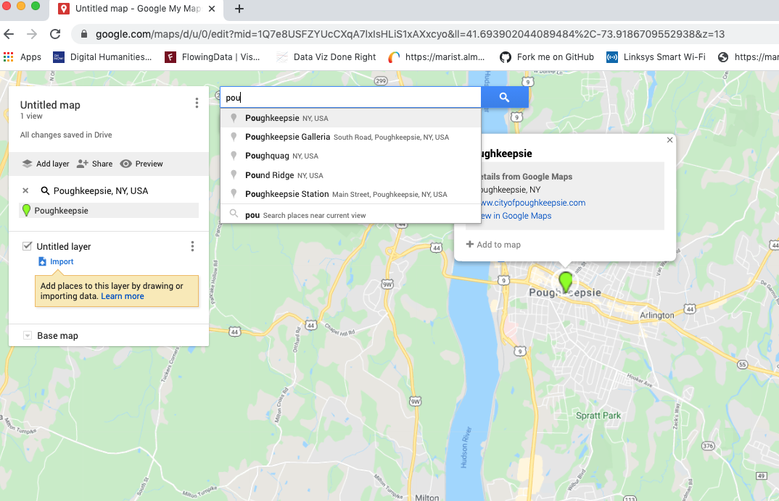

Watch the [tutorial](https://marist.hosted.panopto.com/Panopto/Pages/Viewer.aspx?id=fc05227f-82a2-46fd-adbf-ac52017a7e71) on Google My Maps, then use the polygon and point features to create layers to highlight information Google put on the map. Make sure to zoom in on the map to see and highlight new information.

As a group decide:

* What layers to create and what information to put in each layer
* When to use polygons, points, and icons to distinguish the different information on the map

Once you have finished your map, compose a 300-word discussion post that explains how you organized your map and why. Then explain how your map exposes how Google tries to influence peoples’ ideas about place. How does Google Maps suggest people interact with the city through features like “points of interest”, it’s symbology, and adding new layers of information upon zooming closer into the map?