Code Documentation

I Web Resources

Matlab
The software suite used to develop and execute the K-Means experiments.
http://www.mathworks.com/products/matlab/

Intlab
Interval Labratory. Adds support for interval data to Matlab.
http://www.ti3.tu-harburg.de/rump/intlab/

Extrema
Finds the local maxima of a set of data points. A required dependency of the Interval
Cluster Project
http://www.mathworks.com/matlabcentral/fileexchange/12275

Modiﬁed Fundamental Clustering Problem Suite Data
Contains the FCPS data used in the second experiment
https://github.com/downloads/bnordin/intervalcluster/data.zip

Interval Cluster Project Code
Contains the source code and HTML documentation for the second experiment.

Github Project
https://github.com/bnordin/intervalcluster

Version 1.2 Download
https://github.com/downloads/bnordin/intervalcluster/intervalcluster-1.2.zip

II Environment Setup
- Install Matlab
- Install Intlab
  - Install path is INTLAB (substitute INTLAB with the real path)
  - Modify INTLAB/startup.m, set the “cd” path to INTLAB
  - In matlab, add INTLAB to the path (File→Set Path). Save the path.
  - Restart matlab and wait... it will ask you to press Enter to start, but it seems to always freeze, so kill matlab and restart
- Place the source in INTERVALCLUSTER (substitute INTERVALCLUSTER with the real path)
- In matlab, add INTERVALCLUSTER/src and INTERVALCLUSTER/lib to the path
  - (File→Set Path). Save the path.
- Download extrema and place in INTERVALCLUSTER/lib/
- Download the FCPS data
- If you wish to use the run scripts, set the appropriate values in INTERVALCLUSTER/src/+ikmeans/setupGlobal.m

III Run Flow

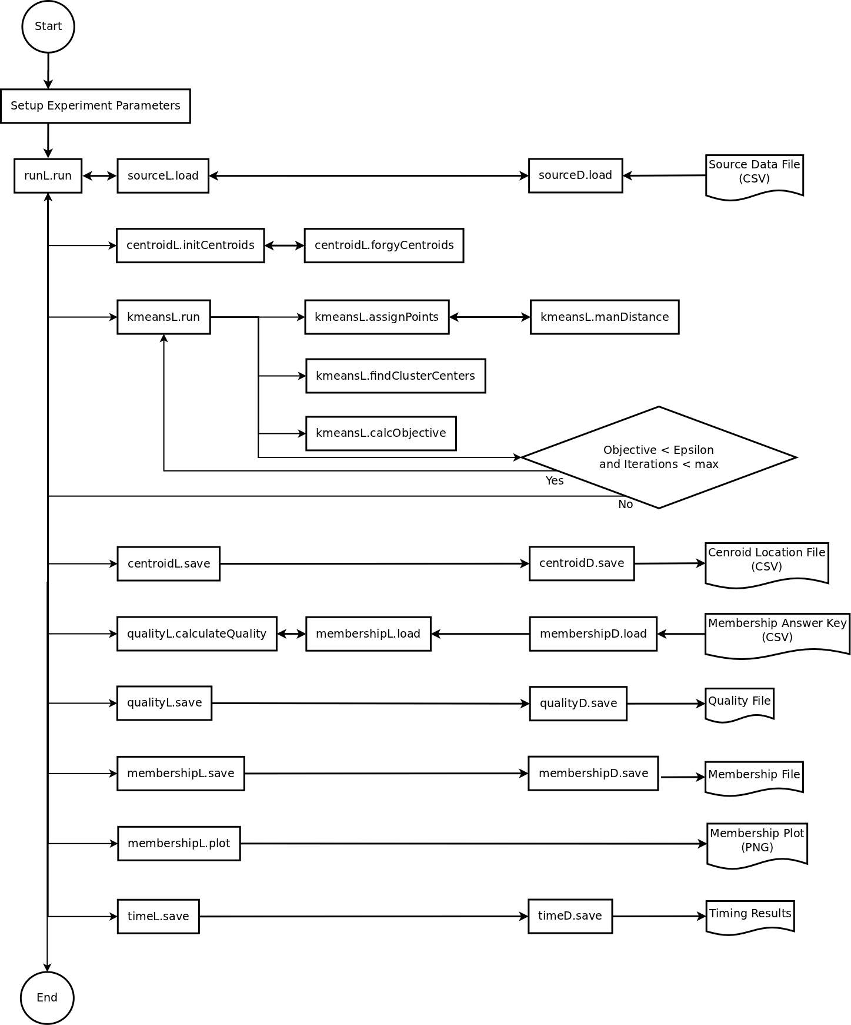
Execution ﬂow for a single K-Means run

IV File List and Description
For complete documentation, download the source and open:
intervalcluster/doc/html/index.html

