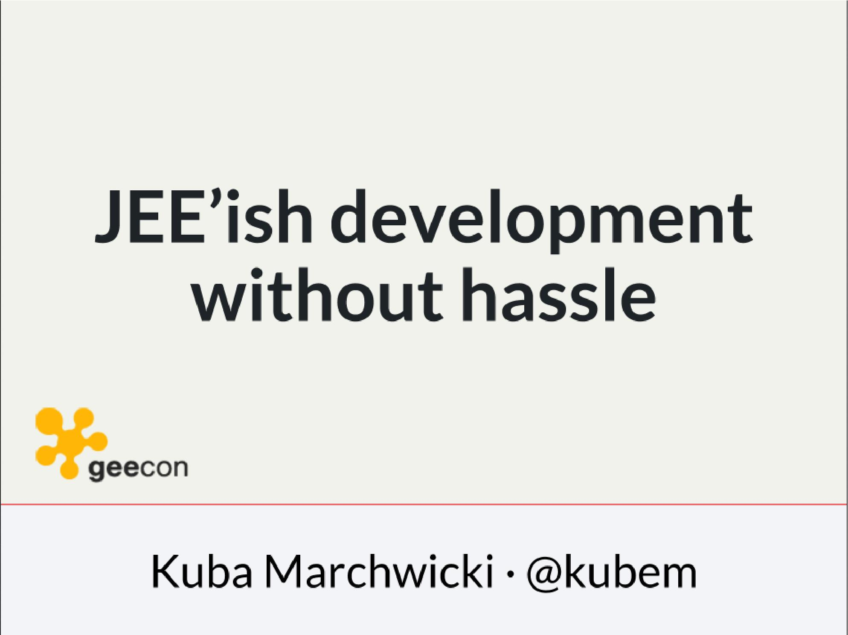

Who am I?
- YDP - Education Publisher
- Most of examples are from YDP experience
- But not all
- I wasn't actually implementing many of those, unfortunately
- I don't claim this ideas perfect. It was good enough in context
- I'm happy to discuss it and ritualy dissent them
- I'm not my ideas
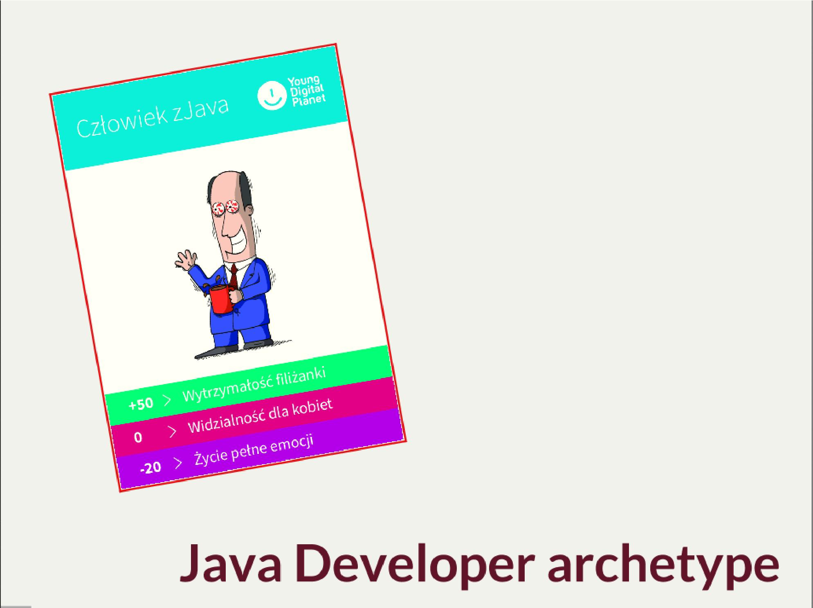

- Well, that doesn’t surprise me
- I’ve recently met a company that was bragging about embracing annotation in their code
- SRSLY! it’s 2014. Java5 EOL was in October 2009
- This is a sad life of software engineer.

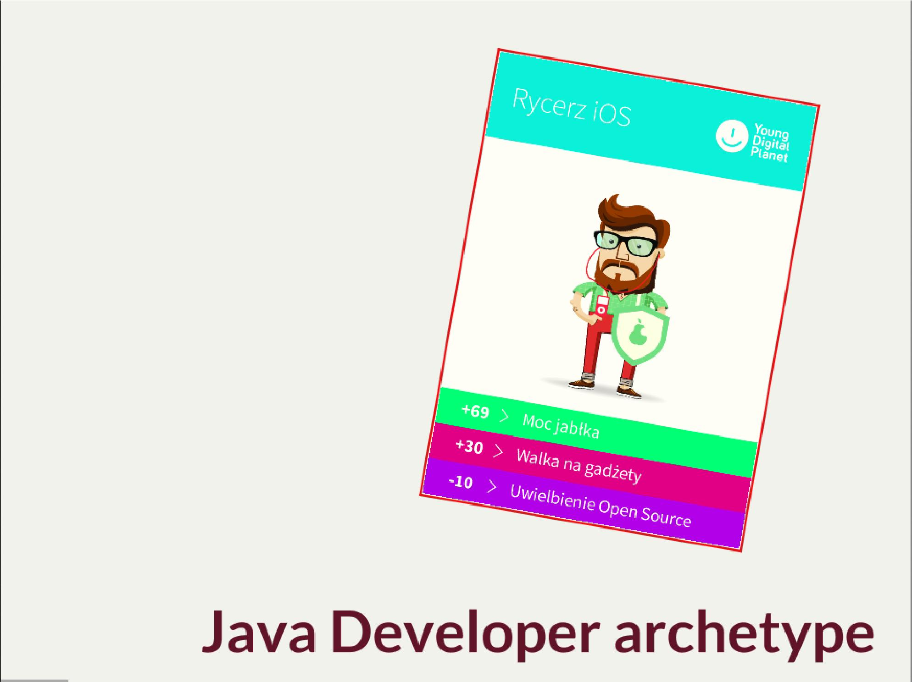

- I pewnie wielu z nas marzy się taka hipsterska praca
- Do some haskell coding, or swift
- Or at least some closures
- But the reality is EJB 3.0 (if we are lucky)

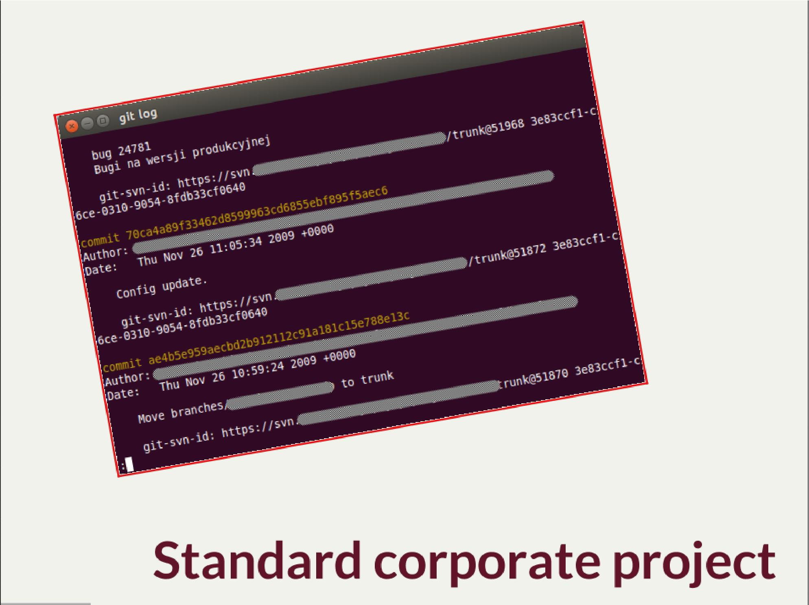

- Have a look on the commit dates
- I wonder if anybody have hope for their new greenfield project
- This is a project which existed before you joined the company and will be there log after your leave
- So… you ended up joining such a project

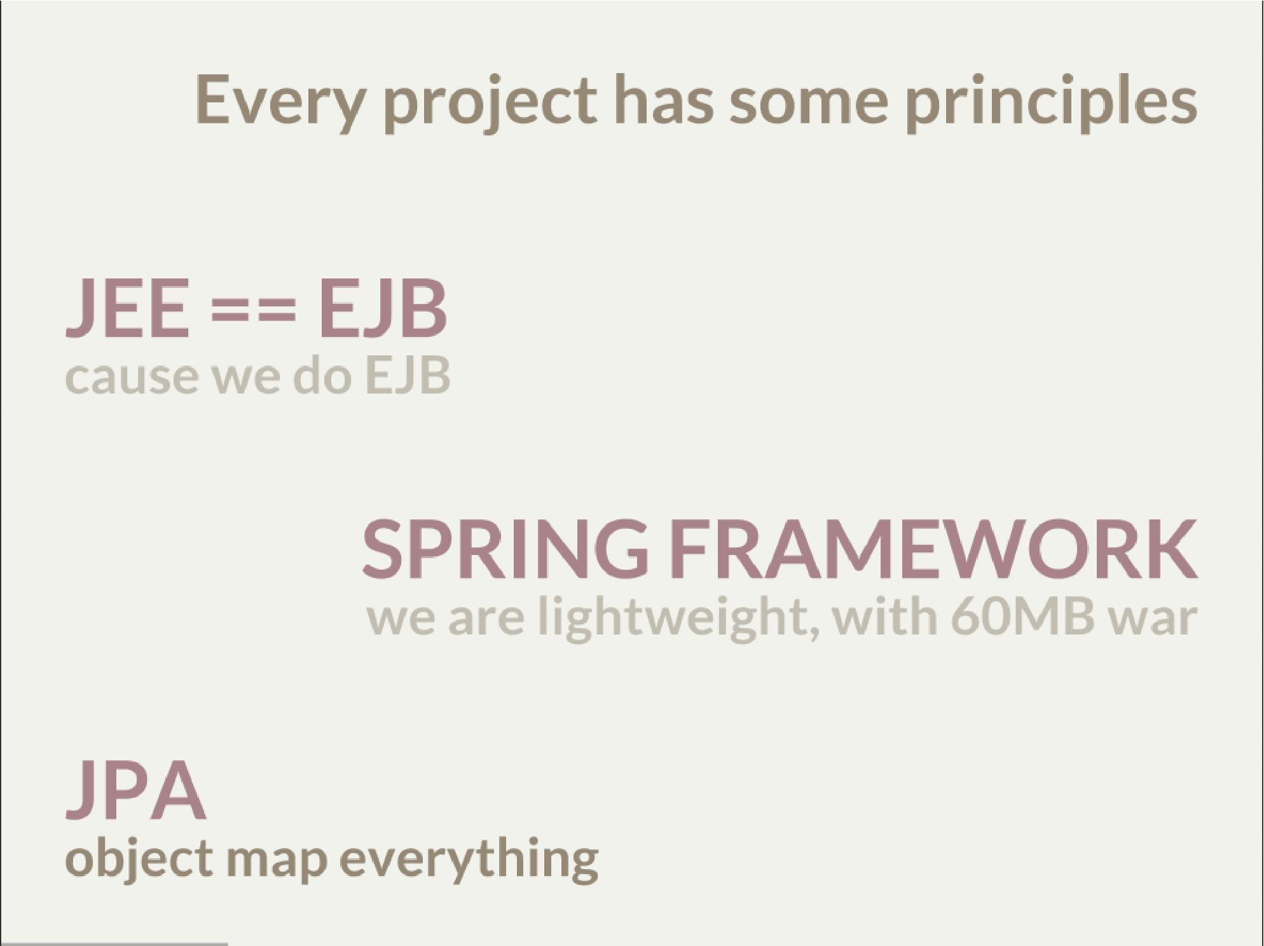
- Of course it has
- We use JEE for such a long time noone knows why
  - Monkey and bannanas experiment
- Spring Framework was lightweight w 2006
  - JEE6 was marketed as Spring alternative, cause spring become too heavy
  - Cause 80% of applications it was ORM + DI + View Components (JPA + EJB + JSF, JPA + Spring + Spring MVC)
- JPA - map everything as objects. Event if it doen’t make sense (raporting)
- I don’t want to say these assumptions are wrong. They are wonderful, in certain contexts
  - However, aligning with them causes us not to think about context
  - Met a company you made their own hibernate-special-dao for some project few years ago
    - They still use it even though spring-data does pretty much the same
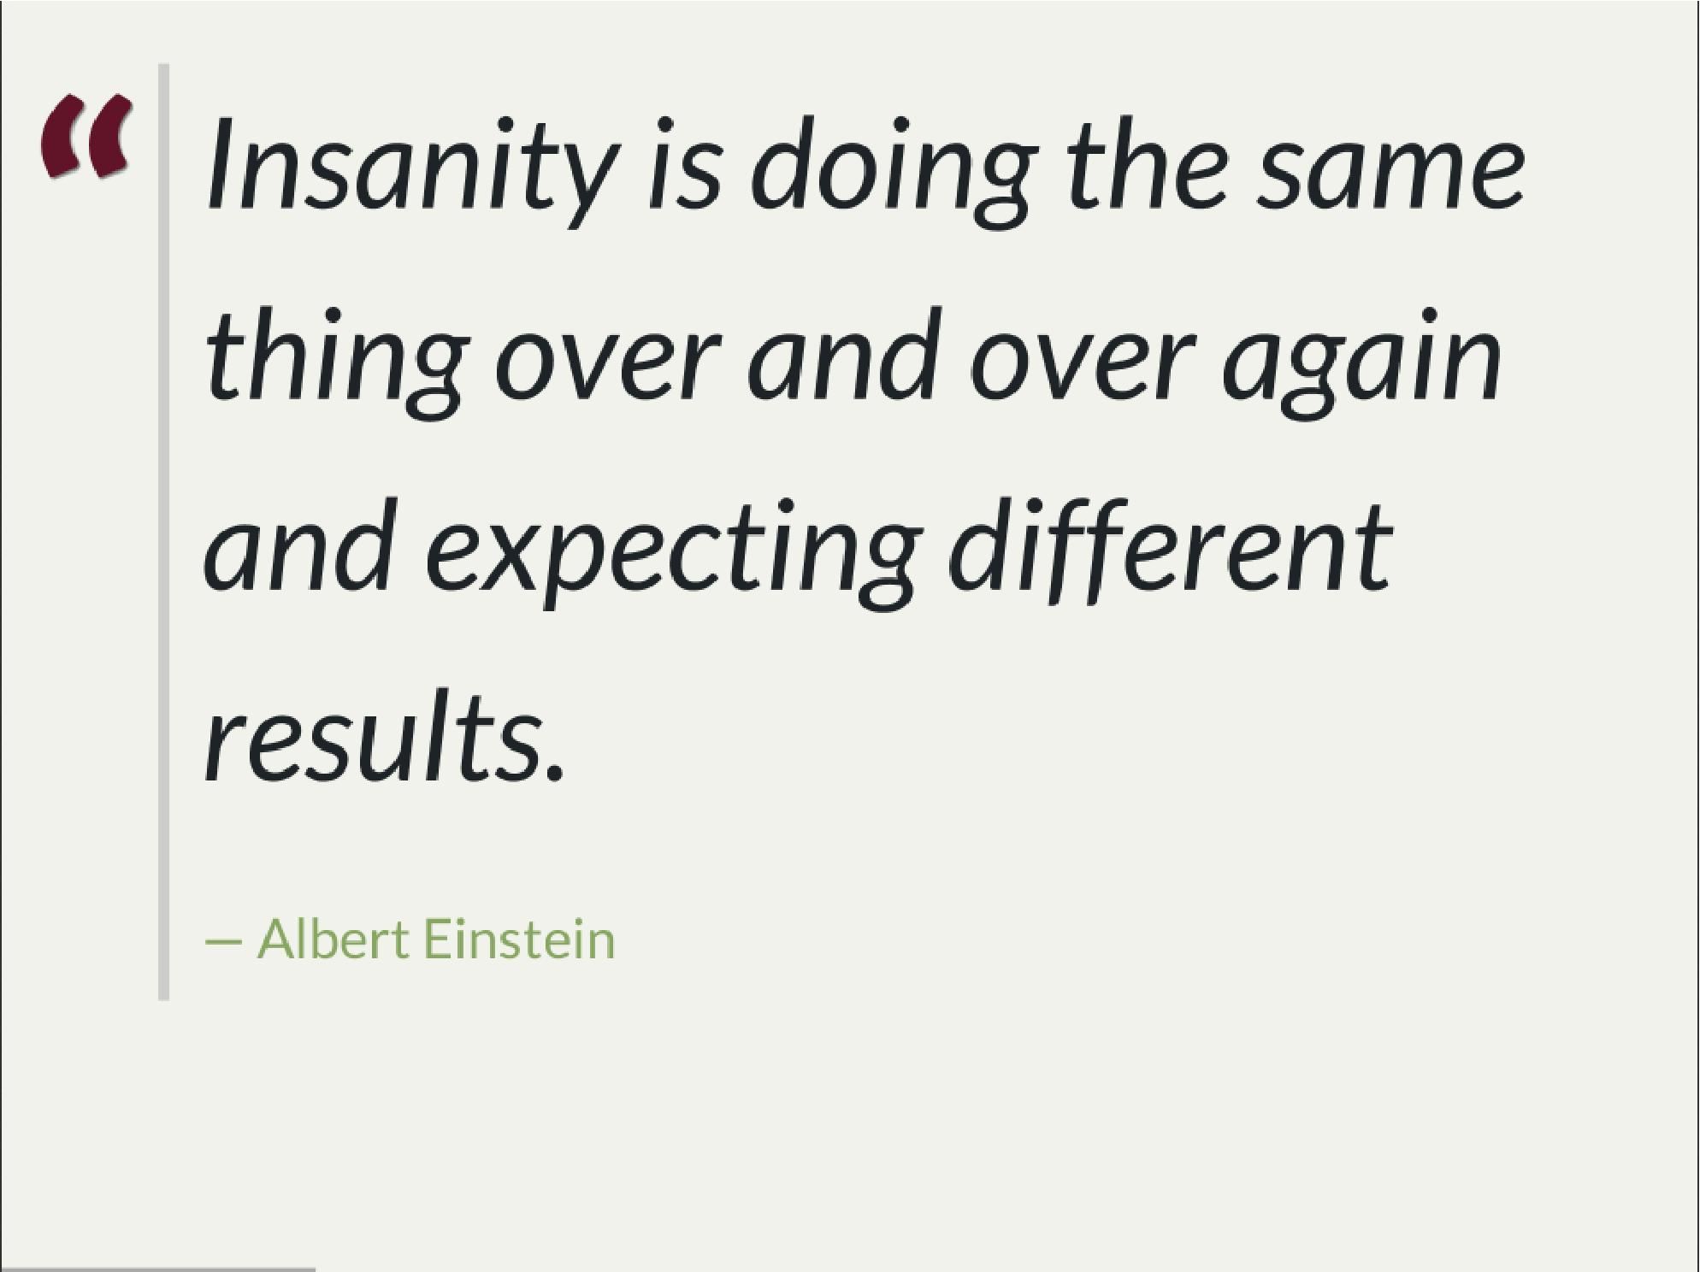

- Strange side projects
  - Mobile, responsive frontend for webservices layer
  - Temporary eshop for photos and assets repository
  - Automation of some processes
  - Additional thingies which make human based processes more effective
- Whenever on the project, I remember having such "opportunity"
- I’ll use an example of such side project: TodoMVC
  - Because we all know Todo application is an ultimate goal for everything
  - And number 42
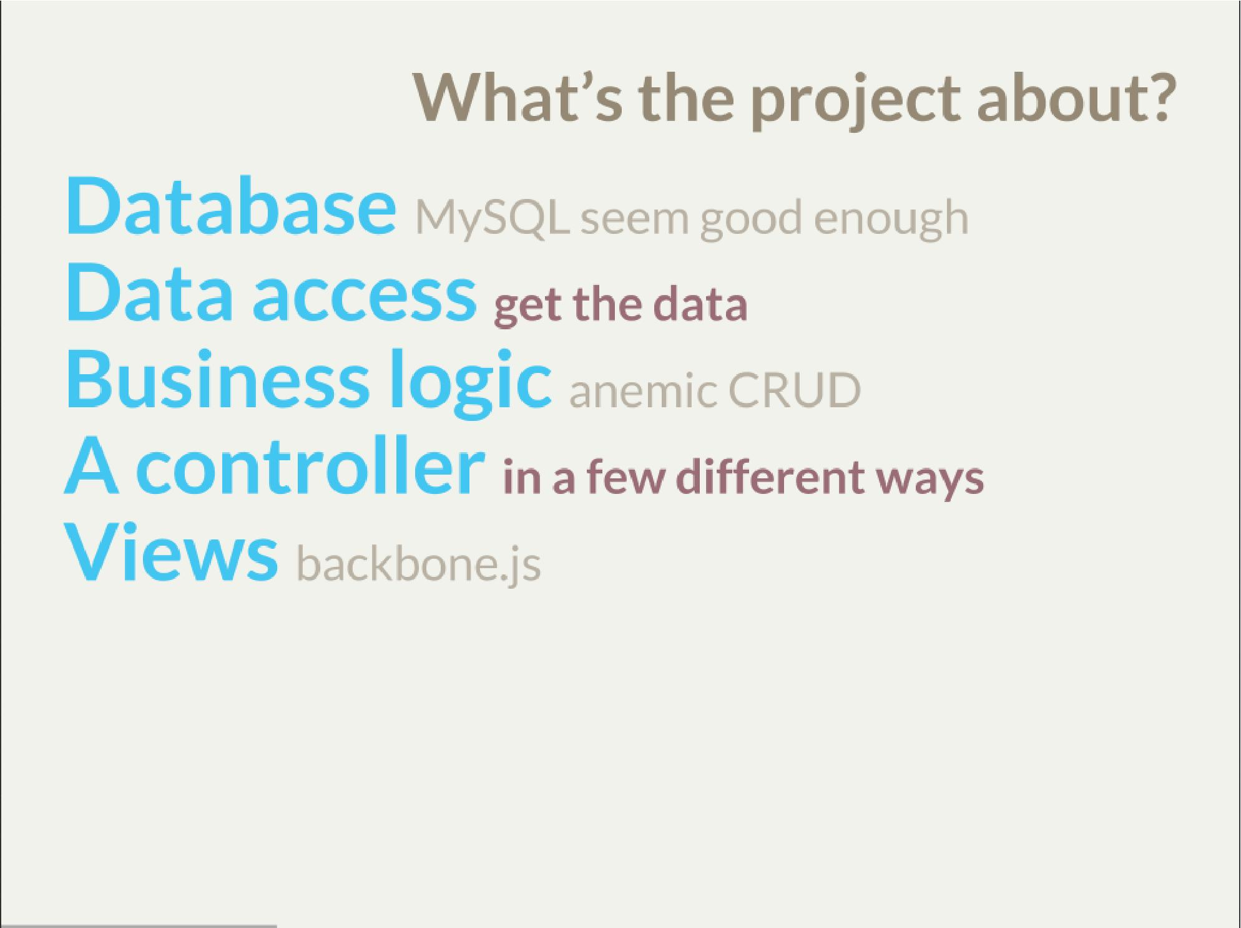

- we tend to use exactly the same tools as always
- if we have an JEE application, any web-related stuff is done in JSF
- situation I had with web view for webservices
  - shang bang - we got JSF
- So we again are unhappy with choices, as always
- but haven’t done much to change it
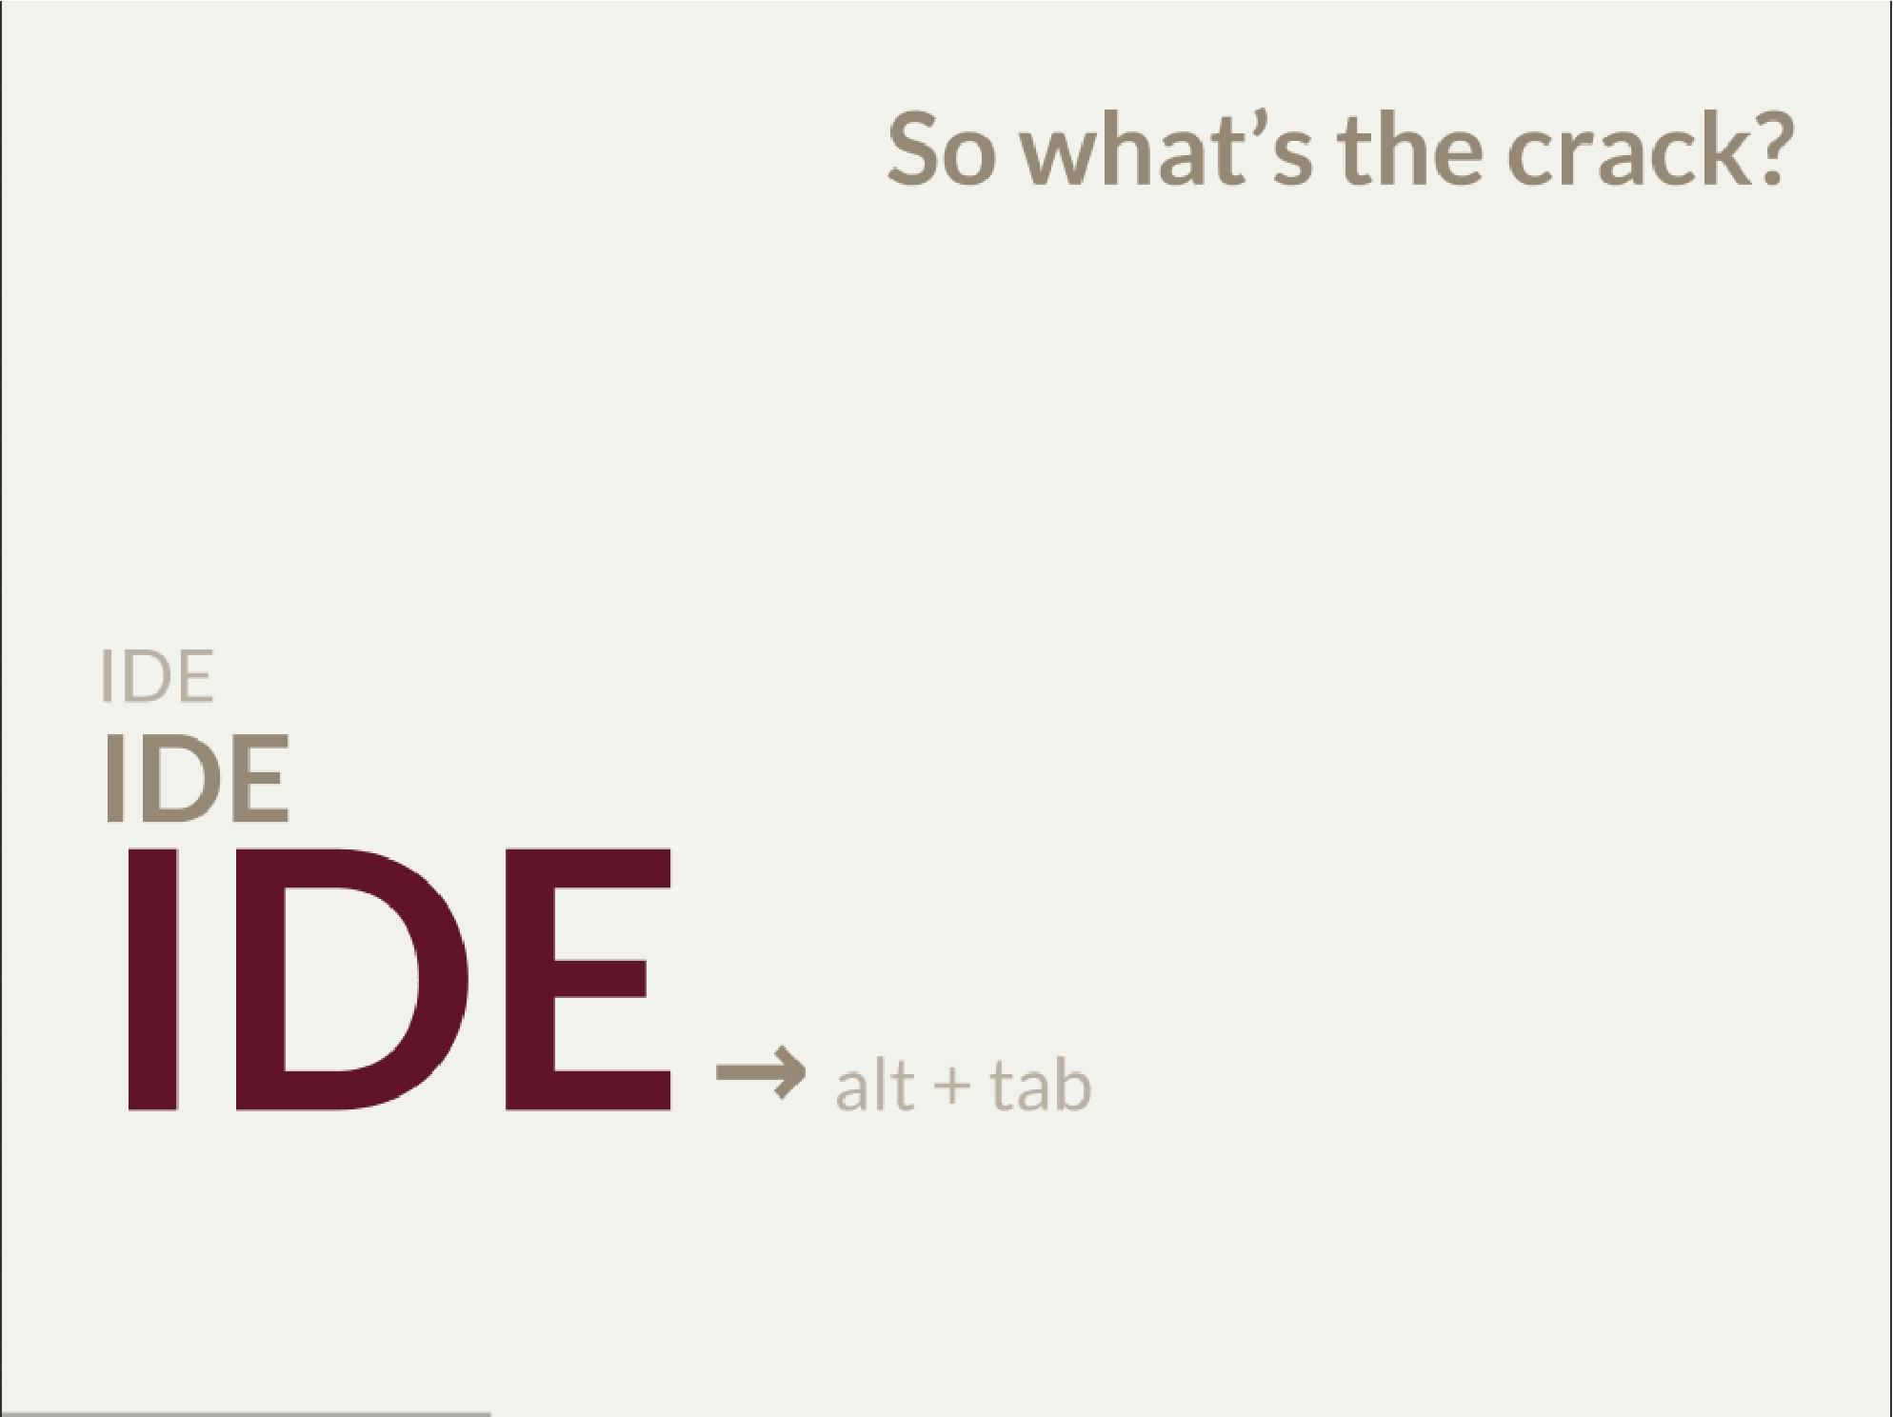

- There is not much of philosophy in here.
  - Just ordinary everyday stuff
  - It allows to focus on certain things
- So what can we do with such a surprise /side in a project

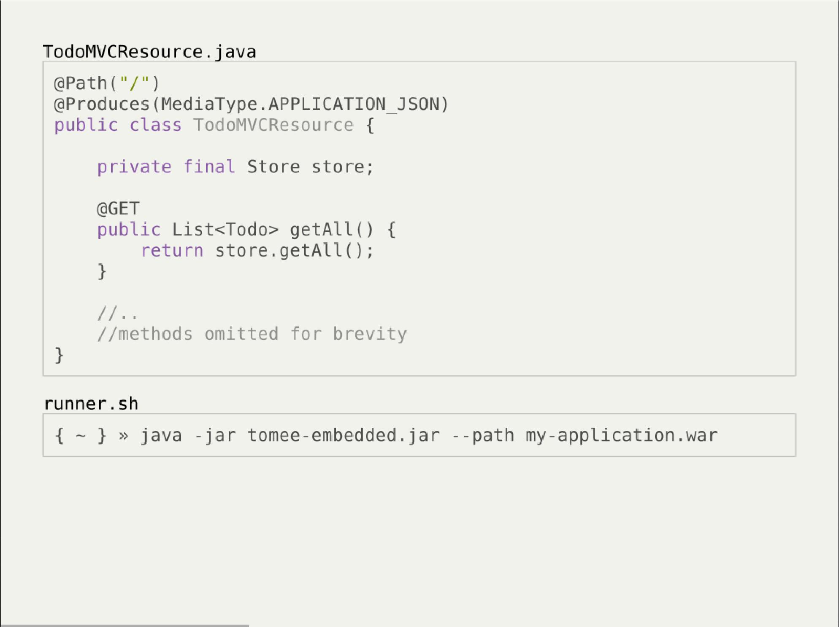
- This is how it might have looked like with JEE
- + adding just small pom.xml dependency
  - two to be precise
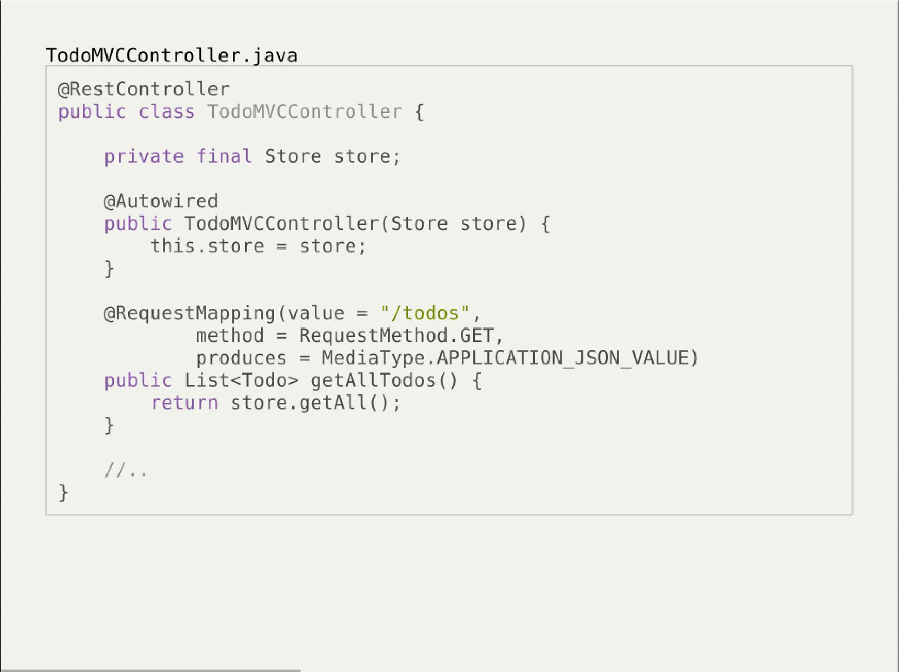

- And that would have been Spring
- It looks legit - we got a single jar
- Nearly microserwis
- Fair chance we havent touched the original application
  - Which is quite important. Especially when you work with legacy
- Have a look into the IDE
- IDE IDE IDE IDE (boot configuration, spring data - automagic)

- Spring did the job for me
- Am I a happy deveoper?
  - I can go and play xbox, fusbal
- I don’t want to rant about using JEE, Spring
  - But these framework tend to do things for you, which make a developer lazy
  - And all together; we don’t need a lawnmower to handle 1m^2 of grass

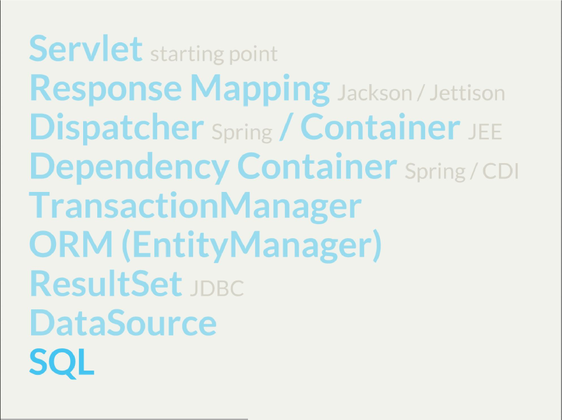

- Let’s have a look what Spring Boot / Data or TomEE did for us? What’s under the hood
- Some layers that are implicit, not always needed
- Can we get closer to the bare metal?
  - So that in case of exception we know what’s the crack no need to google it
  - Close to http i SQL (cause that’s the technology we are using)

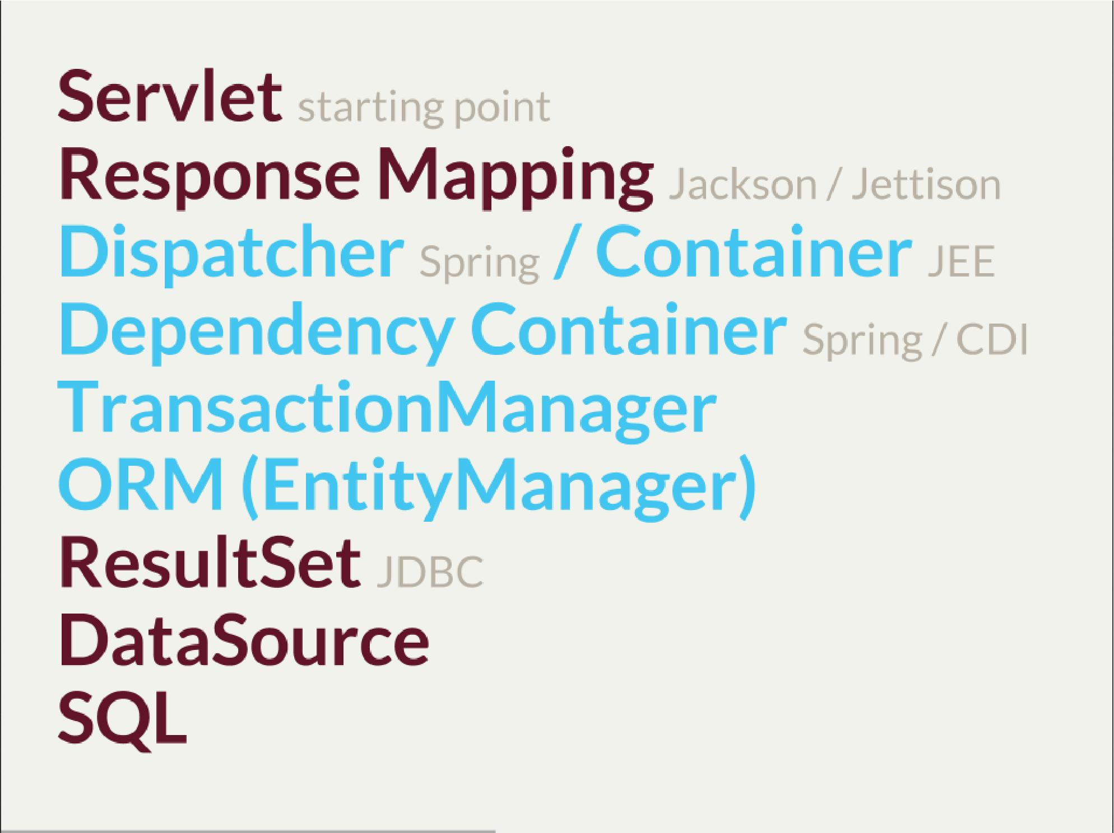

- And what we actually need in this simplistic application?
- 50% is a cargo cult. Overengineering
- Can it be done easier? more robust?
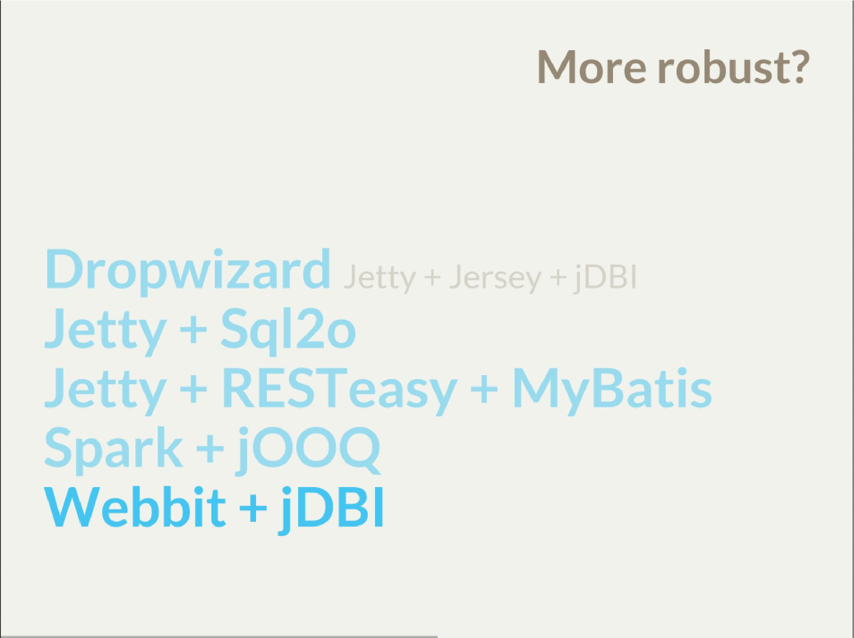

- My intention is not to cover the frameworks in details
  - Touch the subject - due to time
  - Honestly, I don’t know all the details as well
  - So if you used that on a project - you prolly know more than I do
  - But framework is not the goal
- It’s about approach
  - Libraries over frameworks.
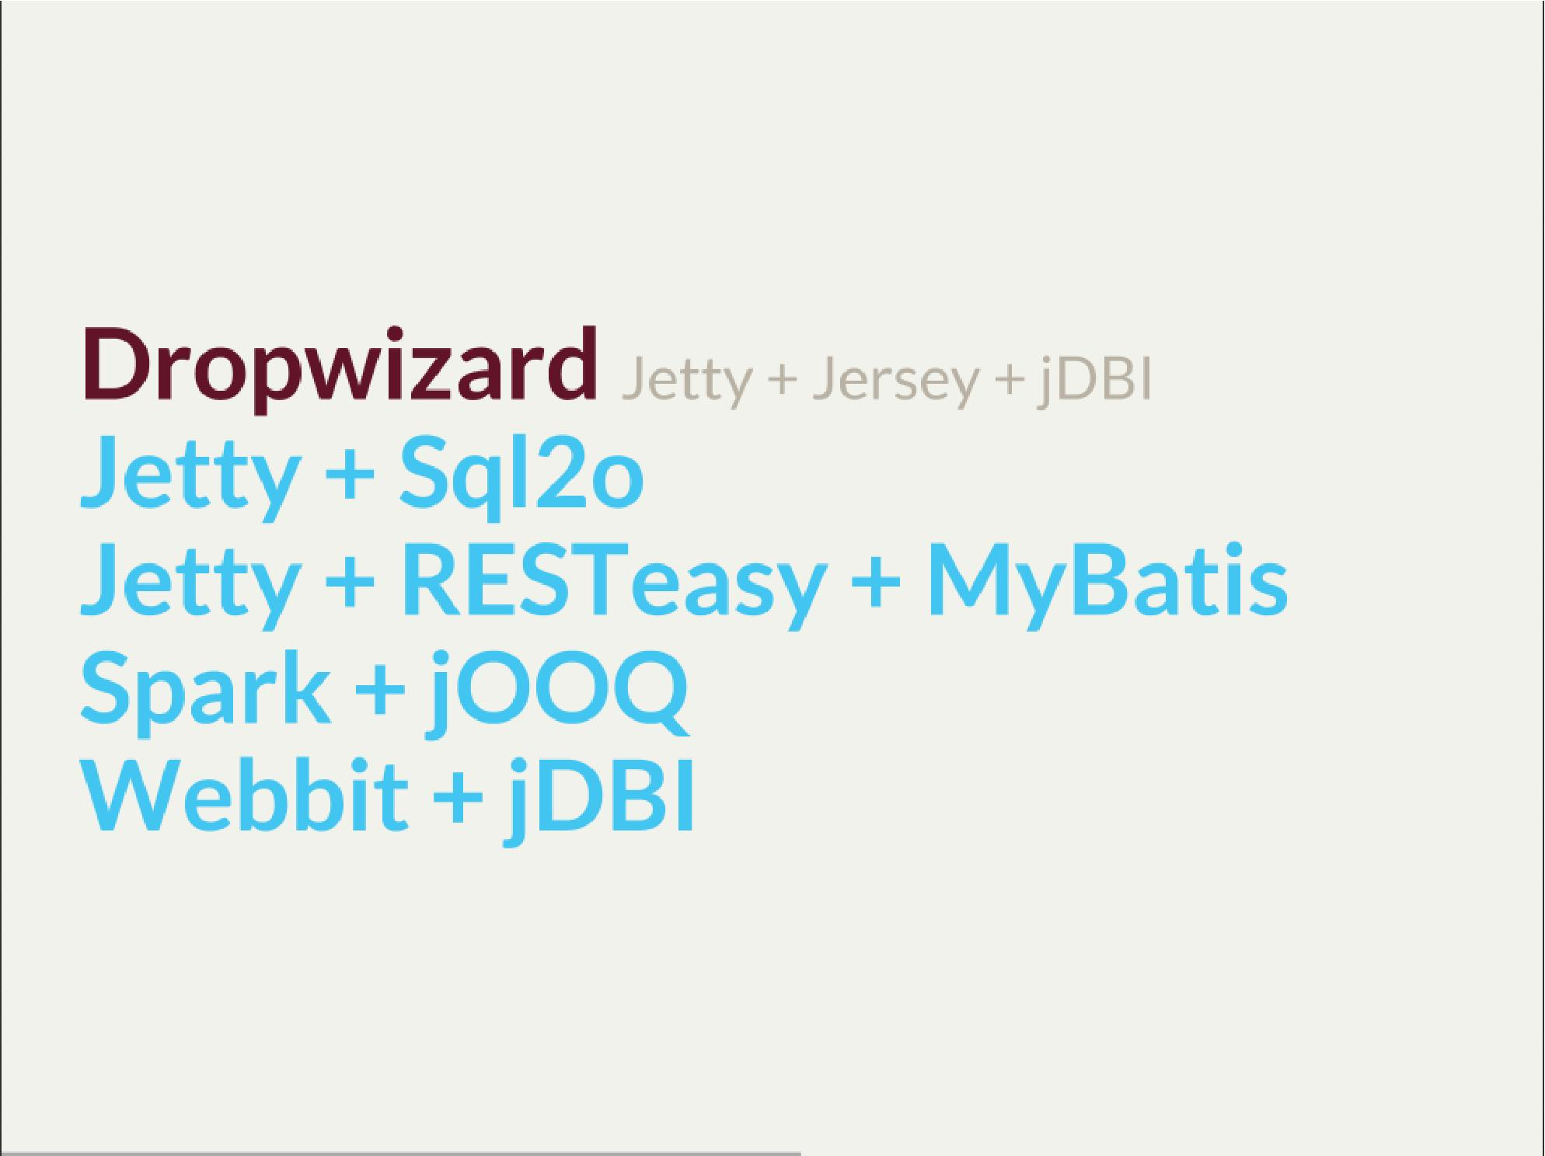

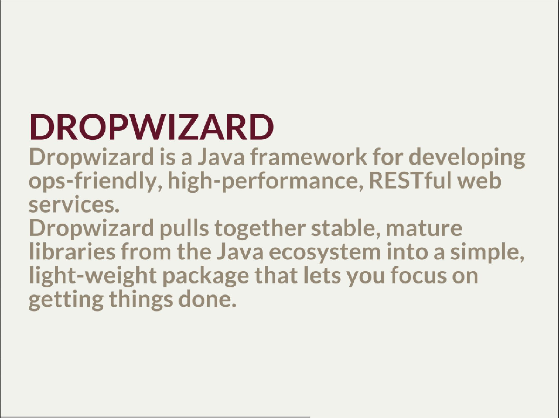
- A bit of marketing jargon
  - Dropwizard started as an extra-simple non framework
  - It was originated for linkedin.
  - There was a big change between 0.6 and 0.7. Quite a lot has been added to address everybody’s needs
  - It was no longer maintained by codahale - the original author
- I’ll focus on Jetty + Jersey + jDBI
  - dropwizard gives nice plumbing i API for many internal objects
  - allows automagic hook for container’s api - which simplifies many things
    - For example: Menaged Resources (Managed Objects for database access)
  - I won’t cover neaty gritty details - afterall it’s quite popular framework
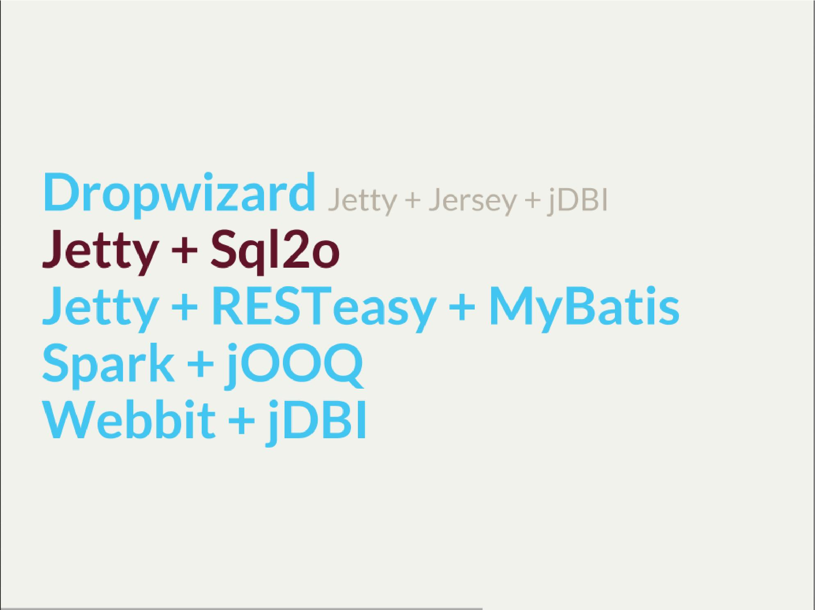

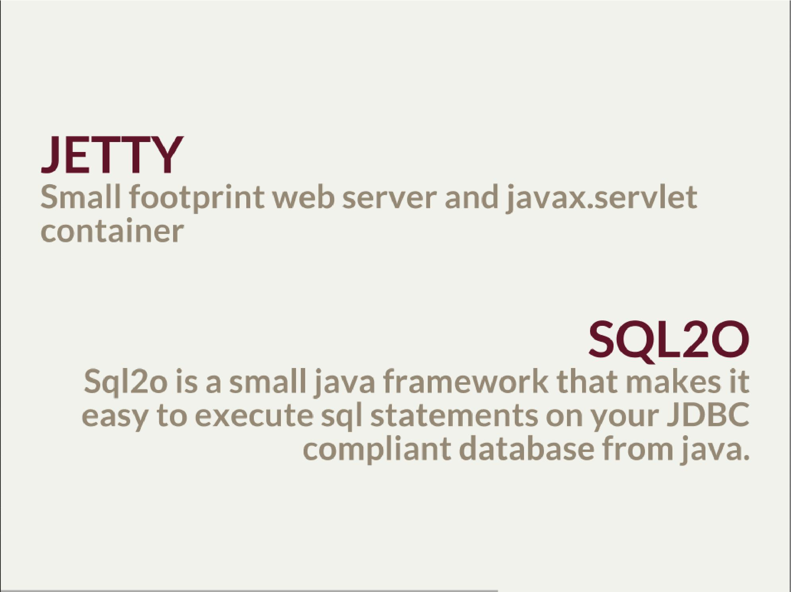

- So while Jetty is quite straight forward, Sql2o seem wierd
- IDE IDE IDE IDE
- Have you evered wondered about performance of each db access library.
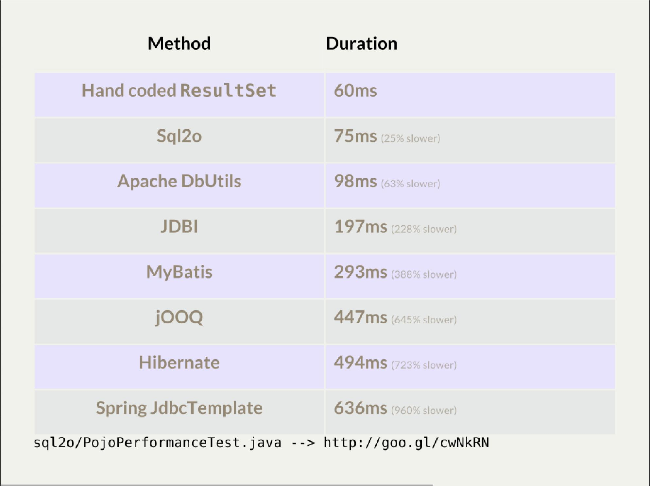
- 1000 SELECT statements against a DB and map the data returned to a POJO
- Of course we can discuss methodology - which is good
- Besides the peformance increase we have one other thing
  - if something happens we exactly know where it happended and why

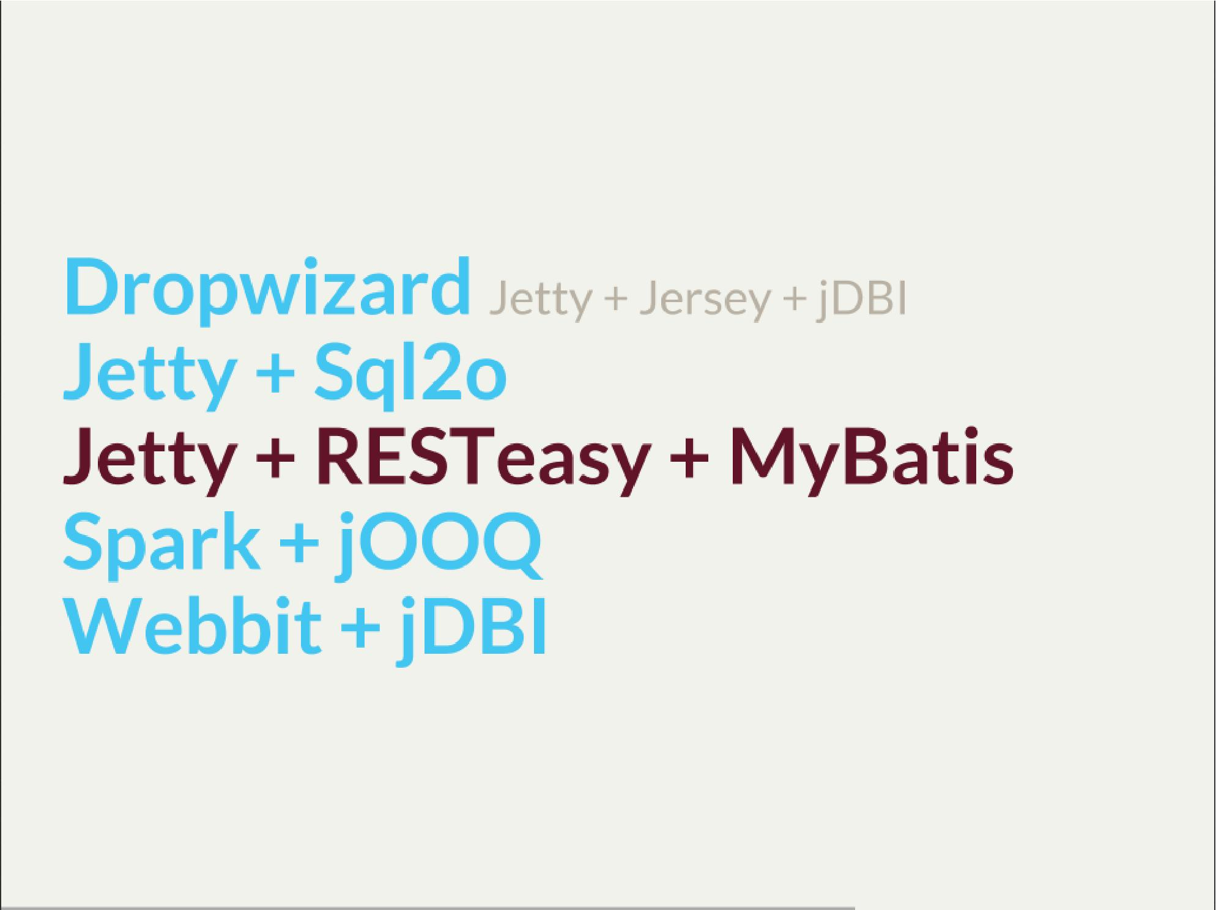

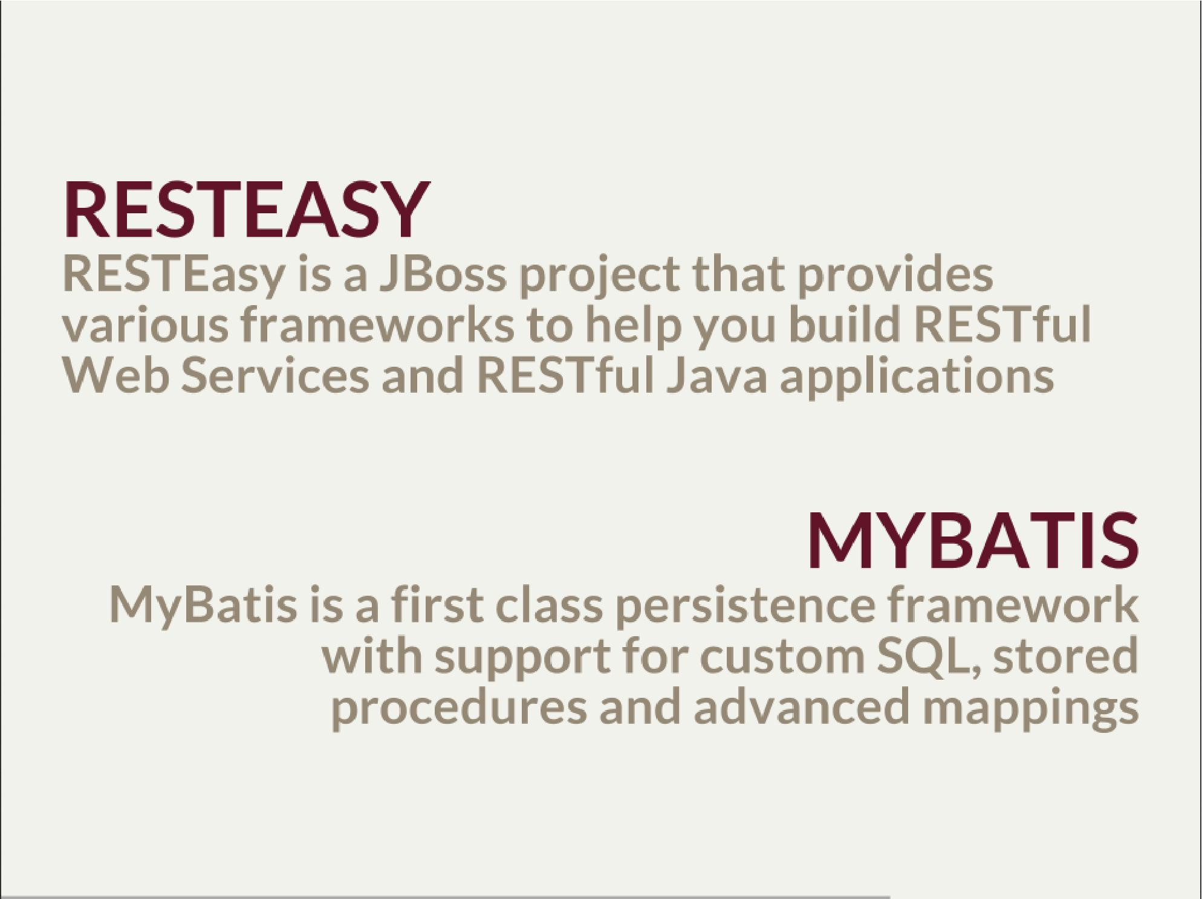
- RESTeasy is fairly well known, but myBatis might be a bit hipster’ish
- With sql2o we kept SQL statements in code, which is generally considered a bad practice
  - myBatis "externalize them" in a single place (XML or annotation based interface)
- Most important point is to consciously make a decision which abstraction to use
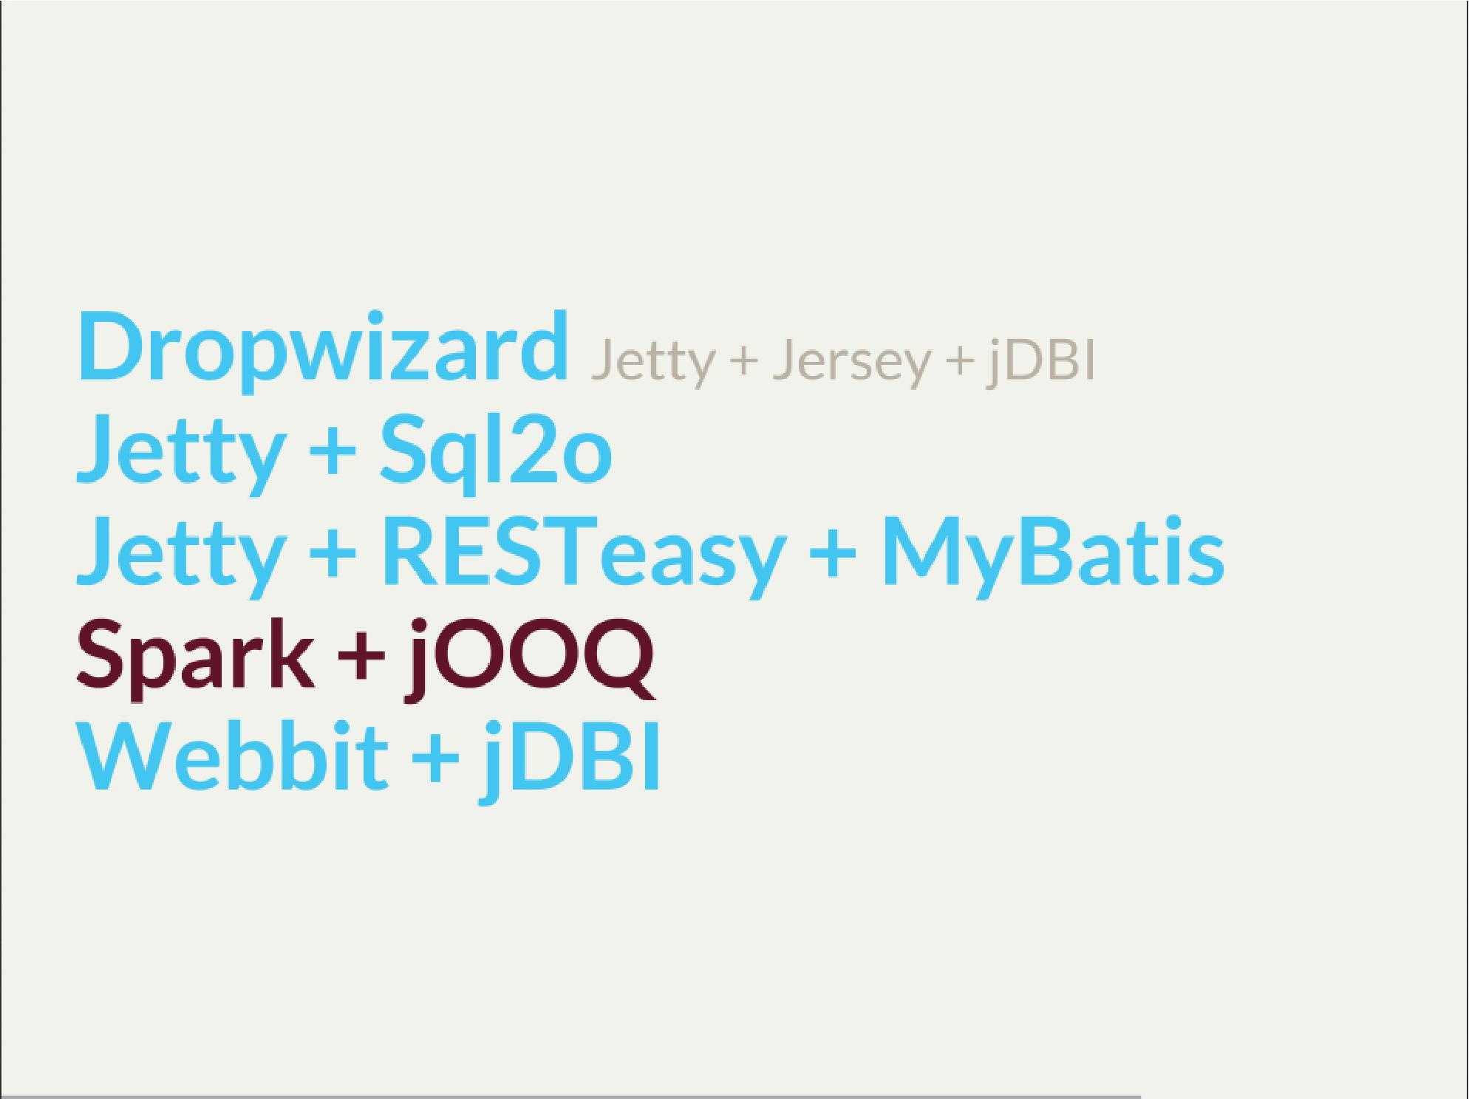

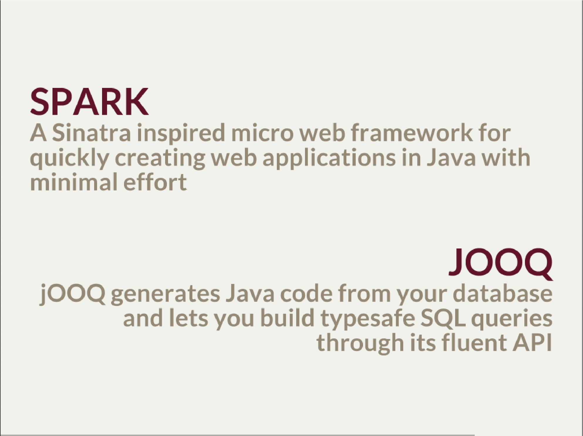

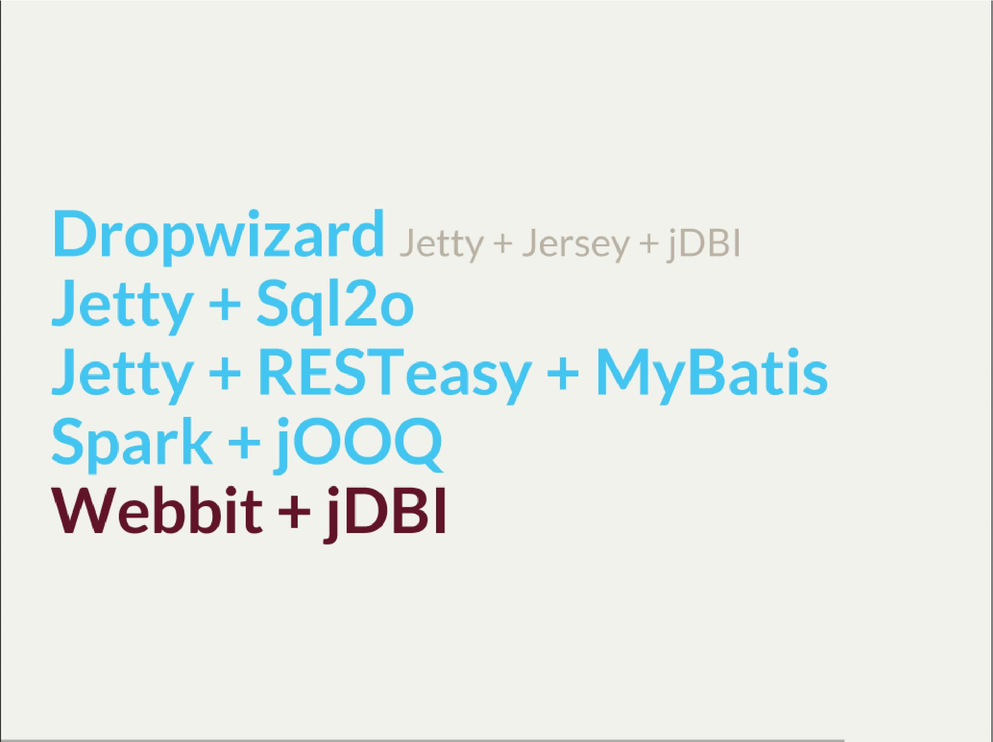

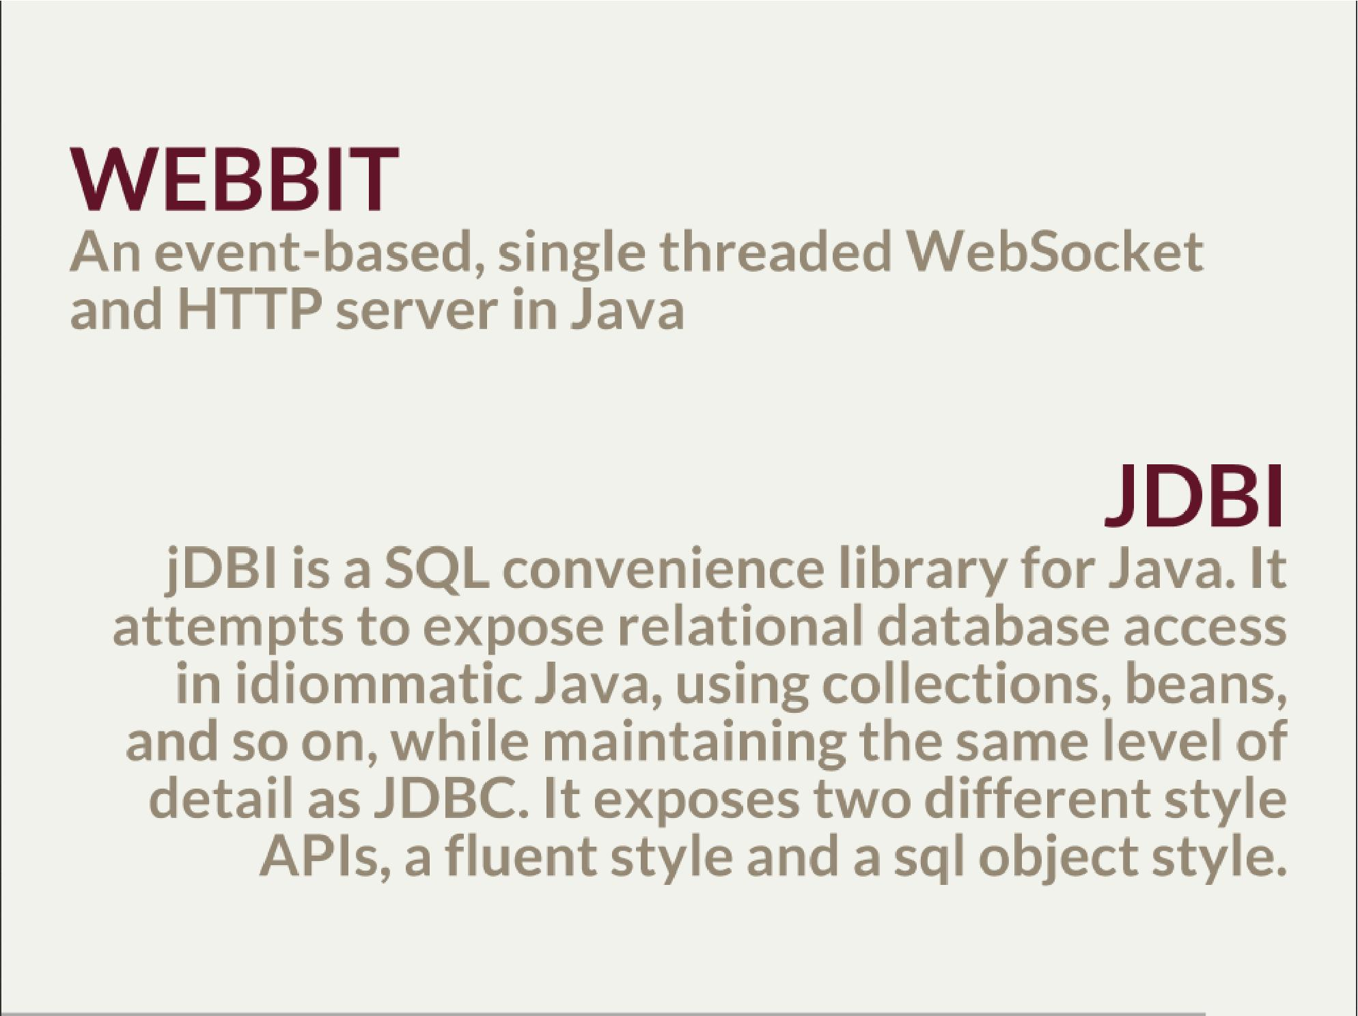
- webbit - uses netty
  - similarity with node.js is more than sure
  - most of such ultra-fast things were made for trading companies
  - DRW trading tego od Dana Northa i Joe Wales'a
- mentioning vert.x sound like a must - be we run out of time
  - I’ll put it out of scope

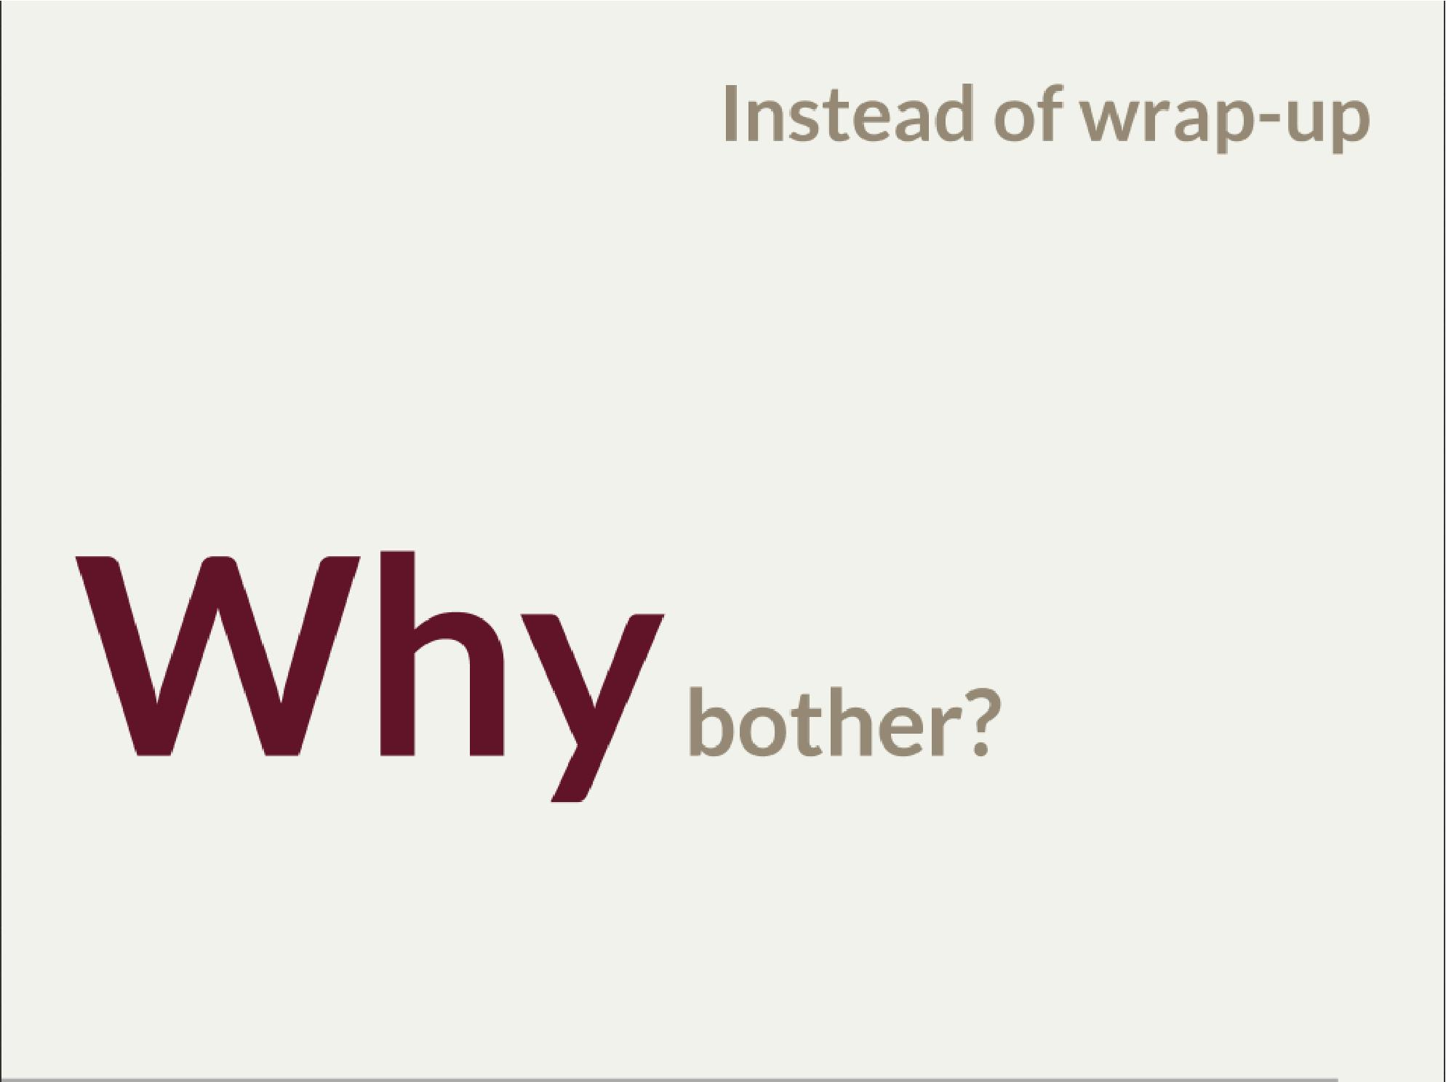
- Marry Poppendieck was talking Sharpening the Saw
  - We practice when it’s fairly safe
- There was a great video, lecture about innovation by John Cleese
  - Space (separeted), Time (for certain amout of time, timeboxed), Time (to get creative, not operational), confidence (small chunk, we can get to Spring back), Fun (why, because we can ad we are nerds)
- We try to understand the nature of the thing, not to do what always was done
  - Like no dependecy injection, bacause wasn’t needed
  - It’s a bit like between engineer and code. After coputer science and programming course

