
BANDAI NAMCO PHILIPPINES, INC.
Human Resources Information System
User Manual
For every person who uses HRIS: employees, team managers, HR staff, HR managers, time keepers, and system administrators.
Version 1.0 · August 2026
Internal use · Follow the on-screen names exactly as shown in this guide

Version History
Version | Date | What changed | Prepared for
1.0 | 20 August 2026 | First complete user manual covering sign-in, every role, and each menu people actually see in Bandai HRIS. | All Bandai Namco Philippines users

Table of Contents
Right-click the table below in Microsoft Word and choose Update Field if page numbers need refreshing.

How Work Flows Through HRIS
HRIS is the company’s daily workplace for people, time, pay, documents, and requests. One person’s action on the shop floor or in the office becomes a record that HR, a manager, and payroll can all see.

The everyday cycle
- A person clocks in and out at a time terminal using a fingerprint, face, or card. The terminal records the time.
- HRIS shows that time on My Attendance for the person, and on Attendance for HR.
- If a punch is missing or wrong, the person files an Attendance Request. HR reviews it. When HR finishes the review, the day is corrected.
- If extra hours were worked, the person files an Overtime Request with hours and minutes. HR approves it before those hours can be paid.
- At the end of a cutoff, HR reviews timesheets, then runs payroll. People later open My Payroll to view their pay record.
- Leave, documents, schedule changes, and resignation follow the same idea: the person submits a request, the right reviewer acts, then HRIS updates the record.

Responsibility matrix
Use this table to know who does what. If a menu is not on your left sidebar, your account is not meant to do that work.
Work | Employee | Team Manager | HR User | HR Manager | System Administrator
Sign in and keep a password | Yes | Yes | Yes | Yes | Yes
View own profile, attendance, and pay | Yes | Yes | Yes | Yes | If linked to a person record
File leave, overtime, attendance, document, or resignation requests | Yes | Yes | Yes | Yes | No
See My Team and the organization chart | Yes | Yes | Yes | Yes | No
Approve team requests | No | Yes | Yes | Yes | No
Open the company employee directory | No | No | Yes | Yes | Yes, under Configuration
Review attendance for the whole site | No | Team only | Yes | Yes | No
Run payroll and manage benefits | No | No | Usually view / support | Yes | Sets rules only
Recruitment and tickets | No | Job requisition only | Yes | Yes | No
Company setup, users, devices, holidays, and rules | No | No | Limited | Limited | Yes
Time kiosk clock in / clock out screen | Uses a terminal | Uses a terminal | Uses a terminal | Uses a terminal | Sets devices; Time Keeper uses the kiosk
Important
HRIS never pays overtime from extra punches alone. Extra time is only a candidate until an Overtime Request is approved by HR, or HR applies an approved overtime workbook to the timesheet. Payroll uses approved timesheets.

Introduction
This manual is written for people who use Bandai Namco Philippines HRIS, not for technicians. Every name below matches a button, menu, or label on the screen.

What this system is for
- Keep one official record of each person: personal details, job, schedule, documents, leave, and pay.
- Show daily time: who is scheduled, who clocked in, who is late, who left early, and who is absent.
- Let people ask for leave, overtime, attendance corrections, documents, schedule changes, and resignation.
- Let managers and HR review those requests in one place.
- Help HR run regular payroll and special payroll after timesheets are approved.
- Give administrators a place to set up the company, users, calendars, devices, and rules.

Intended users
Who you are | What you will see after signing in | Start here in this manual
Employee — a regular staff member | Dashboard, then General: My Profile, My Team, My Payroll, My Attendance, My Requests, My Benefits | Chapter: Employee
Team Manager — a people manager | The same personal menus, plus My Approvals and more of My Team | Chapter: Team Manager
HR User — HR staff | Working Space for employees, timekeeping, payroll, recruitment, reports, plus personal menus | Chapter: HR User
HR Manager — HR lead | The same Working Space as HR User, with payroll run, benefits, and broader approvals | Chapter: HR Manager
Time Keeper | A dedicated clock-in / clock-out screen | Chapter: Time Keeper
System Administrator | Admin Dashboard, Configuration, Rules & Policies, and Loggings | Chapter: System Administrator

Training accounts
Your real Employee ID or company email is issued by HR or the system administrator. Training copies of the system may use practice names. Never share your password. On first sign-in, HRIS may ask you to change the password and finish onboarding before the Dashboard opens.

Signing In
Open the Bandai HRIS address provided by the company. You will see the company logo on the left and the sign-in card on the right.
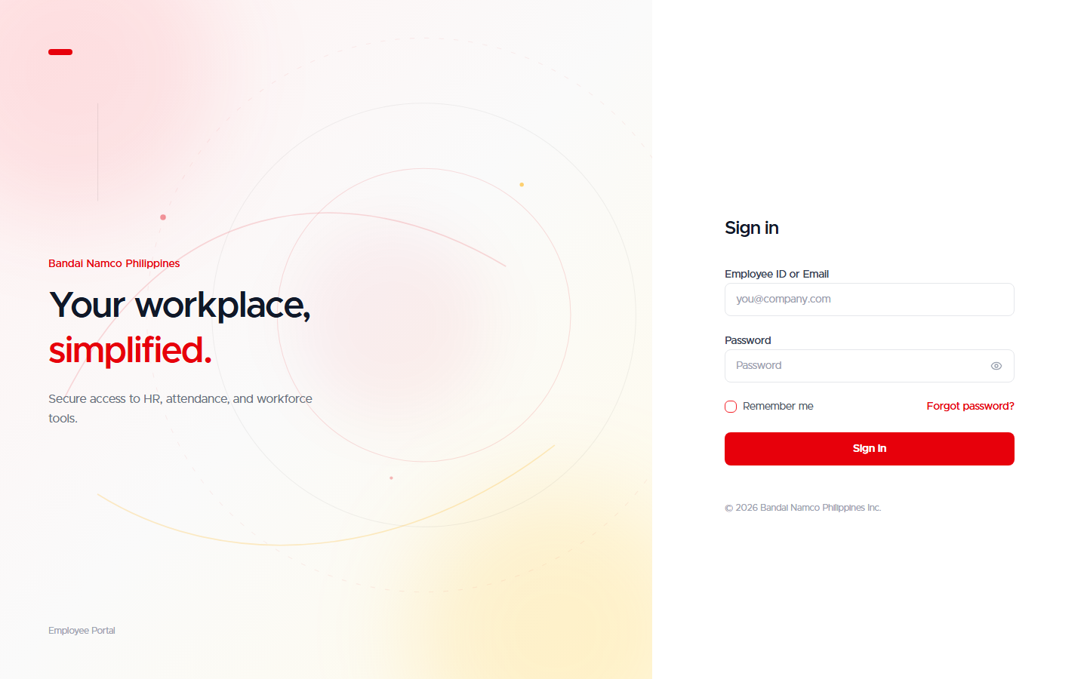
Figure 1. Sign-in screen with Employee ID or Email and Password.

What you will see
- Employee ID or Email — type either your employee number or your company email.
- Password — type your password. Use the eye icon if you need to check what you typed.
- Remember me — leave this on if you are on your own computer.
- Forgot password? — use this if you cannot sign in. Follow the on-screen instructions, or ask HR if you never received a reset.
- Sign in — the red button that opens your workspace.

Step by step
- Open HRIS in your browser.
- Click Employee ID or Email.
- Type your employee number (for example EMP-SW-DEV-001) or your email.
- Click Password and type your password.
- Click Sign in.
- Wait for Redirecting / Finalizing access. Do not close the tab.
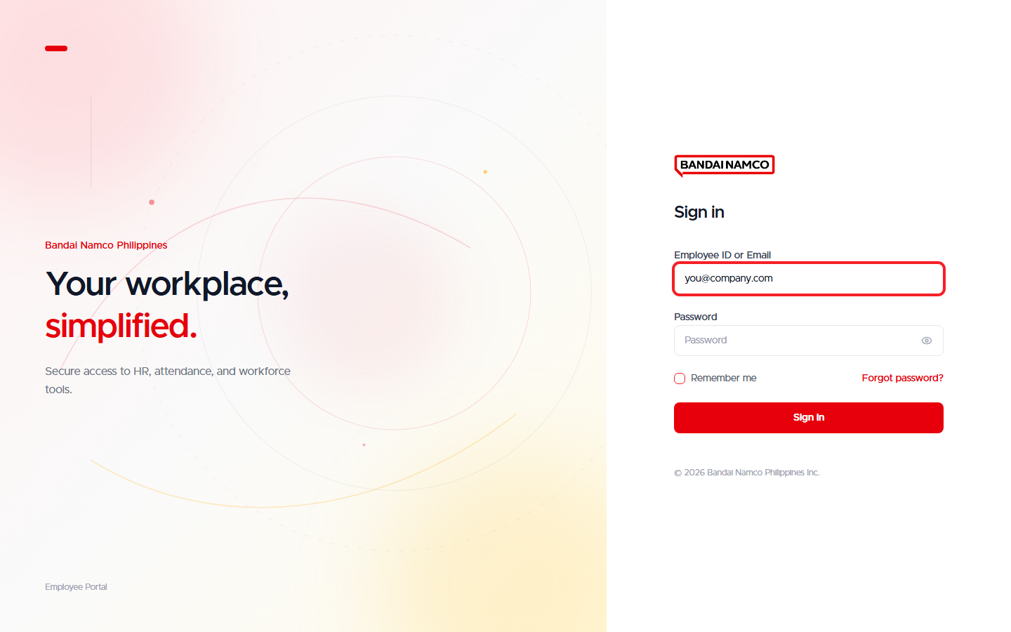
Figure 2. Employee ID or Email filled in, ready for the password and Sign in.

If this is your first time
- HRIS may open Change Your Password. Enter a New Password and Confirm Password.
- The new password must be at least 8 characters and include an uppercase letter, a lowercase letter, and a number.
- If the company still requires onboarding, a welcome checklist opens. Complete the required personal details and documents, then continue.
- After that, your Dashboard opens.
If sign-in fails
Read the red message under Password. Typical causes are a mistyped Employee ID, a wrong password, or an account that is not yet active. Try once more carefully. If it still fails, contact HR. Do not keep guessing.

Finding Your Way Around
After sign-in, every non-administrator screen has the same layout: company logo at the top left, your name and job under it, menus in the left sidebar, and the page in the middle. The top bar has notifications and your profile.

The three menu groups
Group on the left | What it holds | Who sees it
Working Space | The work of your role. Employees mainly see Dashboard here. HR sees Employees, Timekeeping, Payroll, Recruitment, Reports. | Everyone sees Dashboard. Extra items depend on role.
General | My Profile, My Team, My Approvals (managers and HR), My Payroll, My Attendance, My Requests, My Benefits. | Employees, managers, and HR. Administrators do not see this group.
Personal | Settings. | Employees, managers, and HR.

How menus behave
- A menu with a small chevron opens a submenu. Click the parent name to expand or collapse it.
- The active page is highlighted in orange, with a short orange bar on the left.
- Orange number badges mean something needs attention (pending requests, documents, or approvals).
- Your photo (or initials), name, job title, and department appear under the logo. Click that block to open My Profile.
- The bell in the top bar opens notifications.
- On a phone or a narrow window, use the menu icon to open the sidebar.
Orange highlight
Orange is the company’s action color in HRIS. The item that is orange is the page you are on. Buttons that submit or save often use the same family of color. Destructive actions such as Sign in on the login card and resignation use red.

Employee
This chapter is for a regular employee. After you sign in you land on Dashboard. Everything you need for yourself lives under General: My Profile, My Team, My Payroll, My Attendance, My Requests, and My Benefits.
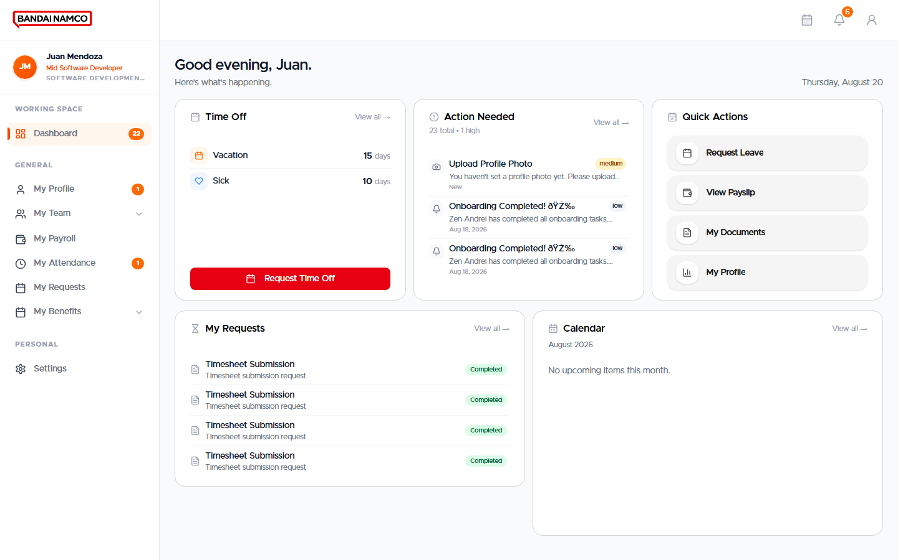
Figure 3. Employee Dashboard after sign-in at the Bandai HRIS (Juan Mendoza).

Dashboard
The Dashboard is your home. Typical cards include:
- Time off — a snapshot of remaining leave.
- Action needed — documents or tasks waiting on you.
- Quick actions — Request Leave, View Payslip, My Documents, My Profile.
- My requests — recent items you filed, with status.
- Calendar — upcoming days and company dates.
- After sign-in, confirm you are on Dashboard (it is the first Working Space item).
- Read Action needed first. If a document or password change is listed, finish it before other work.
- Use a Quick action when you already know what you want (for example Request Leave).
- Use the left menus when you need the full page, not just a shortcut.

My Profile
My Profile is your 201-style record. Open it from General → My Profile, or by clicking your name under the logo. Tabs across the top switch the section. The tab you are on is highlighted.

Personal
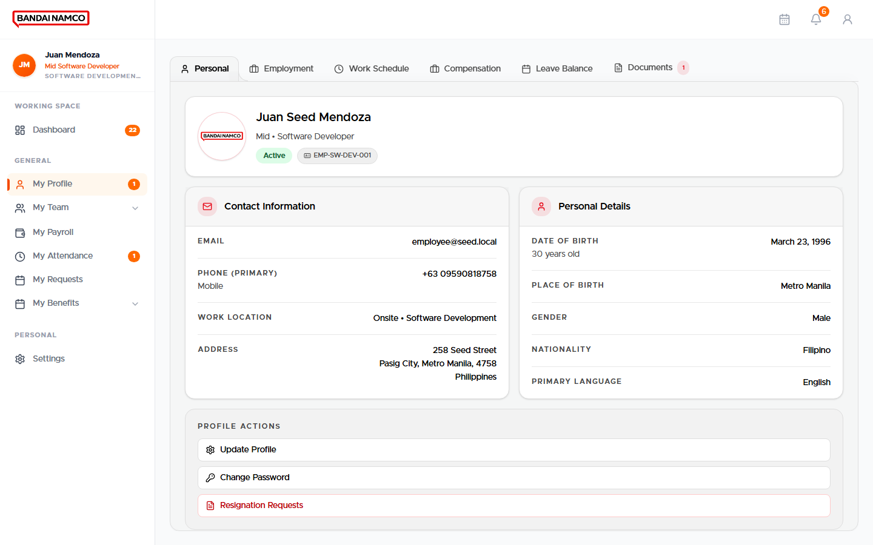
Figure 4. My Profile — Personal tab.
Here you review your name, photo, contact details, and civil information. If a field is locked, ask HR to update it. Keep your mobile number and email current so notifications reach you.

Employment
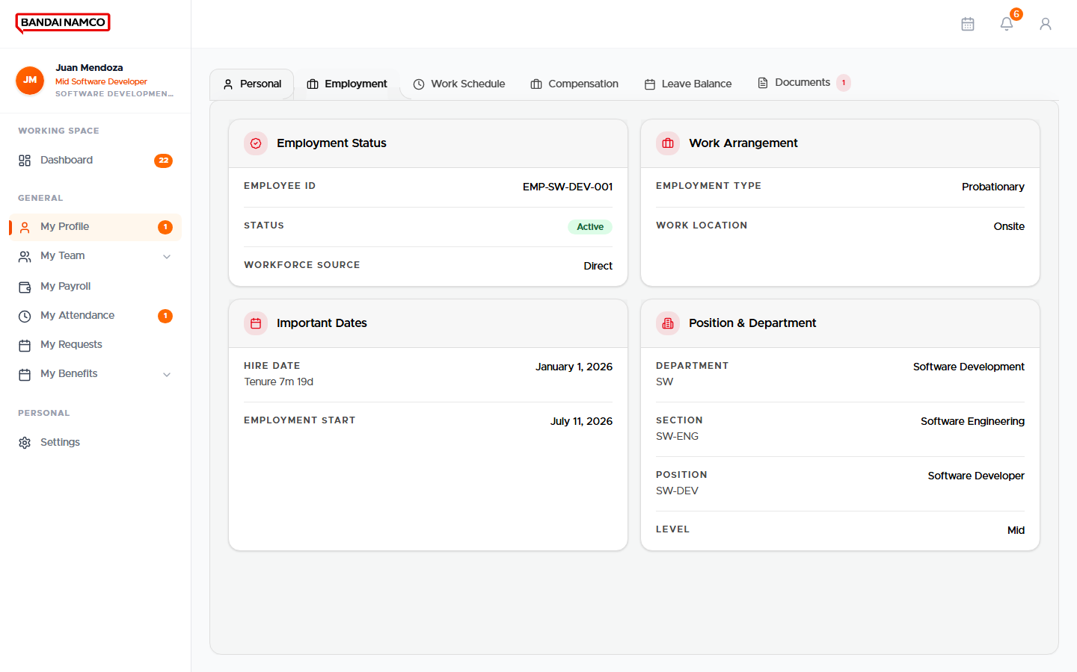
Figure 5. My Profile — Employment tab.
This tab shows your employee number, department, section, position, level, status, and who you report to. This is the official job record used by attendance and payroll.

Work Schedule
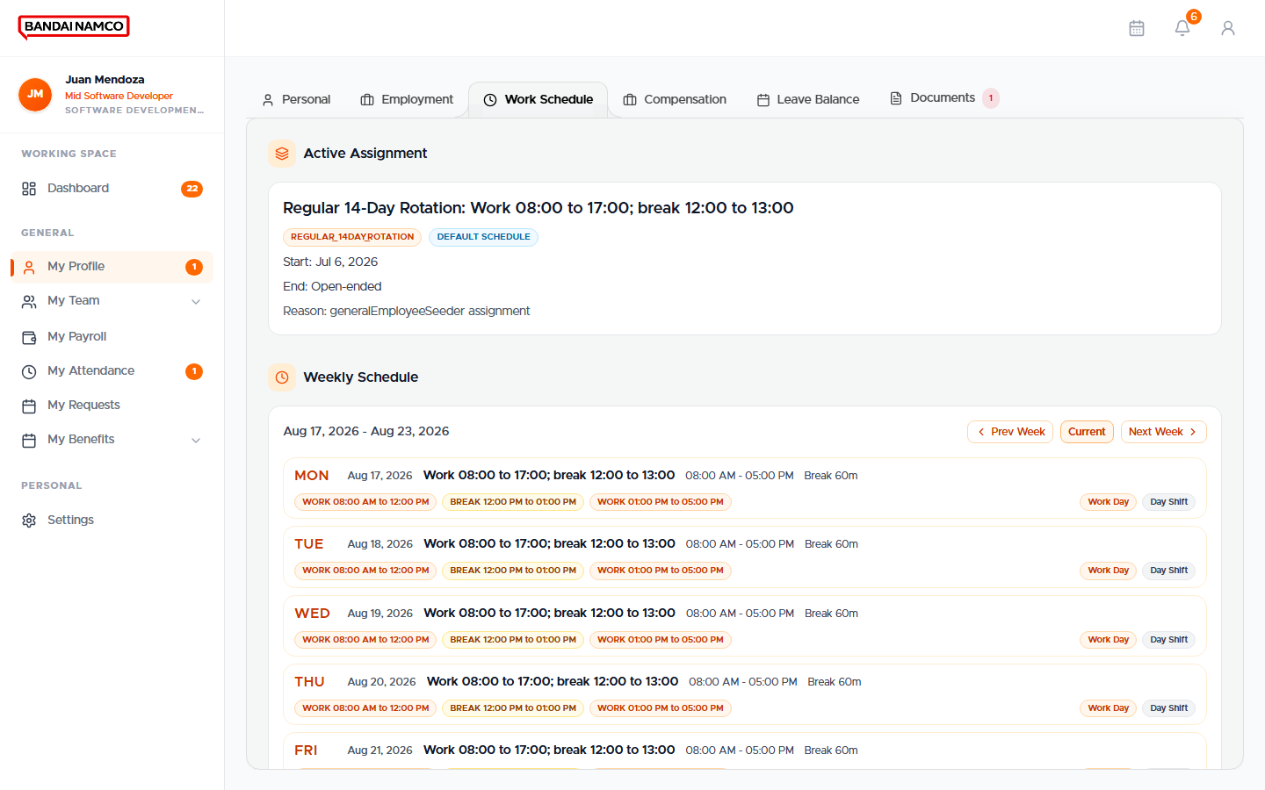
Figure 6. My Profile — Work Schedule tab.
Your assigned work days and hours live here. Late, undertime, and rest days are judged against this schedule, not against a guess. If Monday looks like a rest day and you were supposed to work, tell HR before the cutoff closes.

Compensation
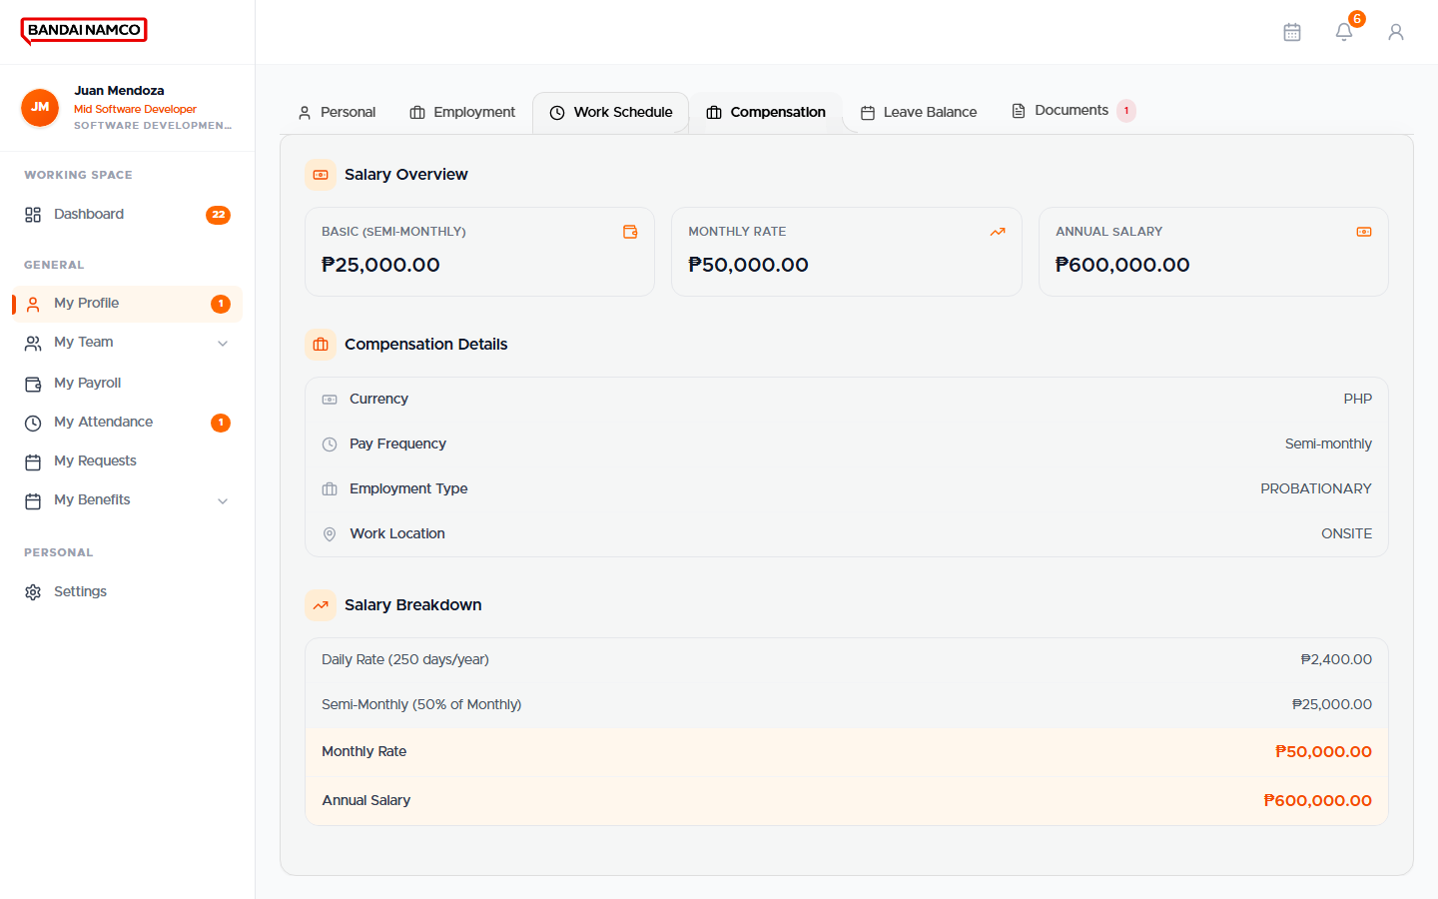
Figure 7. My Profile — Compensation tab.
This tab shows how you are paid (for example semi-monthly) and related pay information. It is not a payslip. Use My Payroll for actual period amounts.

Leave Balance
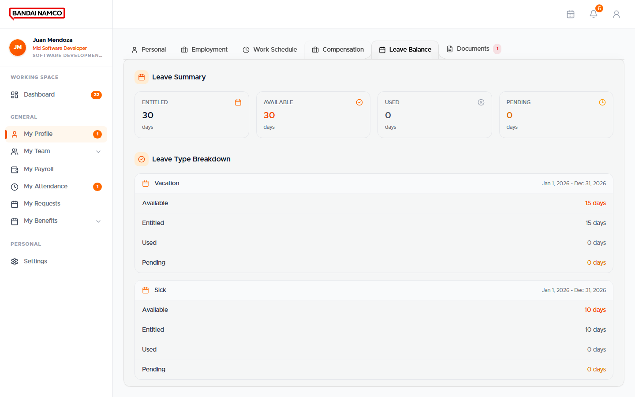
Figure 8. My Profile — Leave Balance tab.
Each leave type lists what you still have. The leave request form uses these balances. If a type is missing, contact HR — you cannot request a leave type that has no balance.

Documents
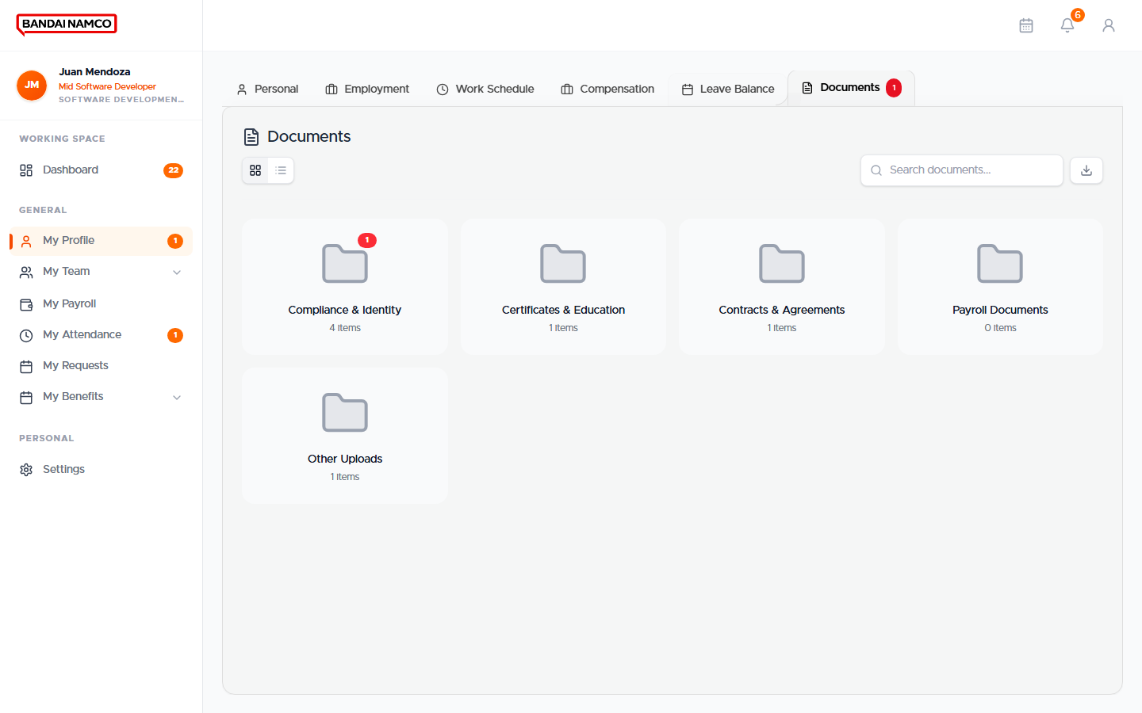
Figure 9. My Profile — Documents tab.
This is your 201 file. Required papers show as needing action until you upload them and HR accepts them. An orange badge on My Profile or Documents means something is still outstanding.
- Open My Profile.
- Click Documents.
- Find the item marked as needed or pending.
- Upload a clear scan or photo of the document.
- Wait for HR review. You will see the status change when HR accepts or returns it.

My Attendance
My Attendance is your own time record. It is the employee view of what the terminals captured and what HR later corrected.
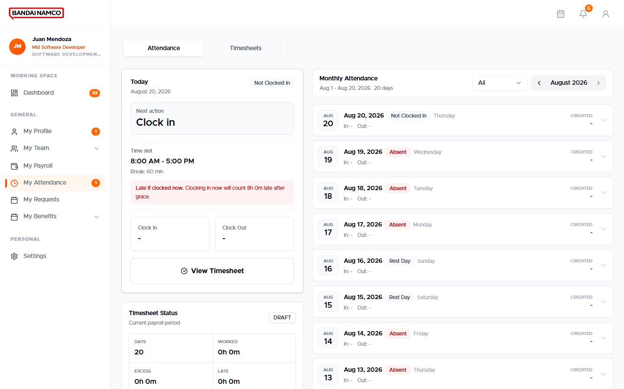
Figure 10. My Attendance — your daily time record.

How to read a day
What you see | What it means | What you should do
Clocked In | There is a time in, and no time out yet. | Clock out at the terminal when your shift ends. Choose Check Out on the panel if the terminal asks.
Present | There is both a time in and a time out. | Nothing, unless Late or UT looks wrong.
Clocked Out | There is a time out but no time in. | File an Attendance Request for the missing time in. This is not treated as a full Present day.
Absent | You were scheduled and there is no punch. | If you truly worked or were on approved leave, file the matching request. Otherwise the day stays absent.
Late | Time in is after the scheduled start (beyond grace, if any). | Check the clock on the terminal next time. File a request only if the punch is wrong.
On time / Grace | Time in is on or before start, or still inside grace. | Nothing.
UT | Time out is before the scheduled end. | If you had permission, keep your supporting request. If the punch is wrong, file an Attendance Request.
Hours | Worked time after you clocked out. | Use this to check a short or long day.
HOL / LEAVE / REST | The day is a holiday, approved leave, or rest day. | Do not expect a regular work punch unless you were required to work.

Using the time terminal
- At the start of your shift, go to the assigned entrance terminal.
- If the screen shows Select Status, choose Check In (not Break or Overtime unless that is truly what you are doing).
- Present your fingerprint, face, or card and wait for the success message.
- At the end of your shift, choose Check Out, then present the same credential.
- Open My Attendance later the same day and confirm Time In and Time Out.
Check In versus Check Out
The terminal does not always guess in versus out for you. If you choose Check In every time, HRIS keeps those as time in and will not close the day as a check-out. Pick Check Out when you are leaving.

My Payroll
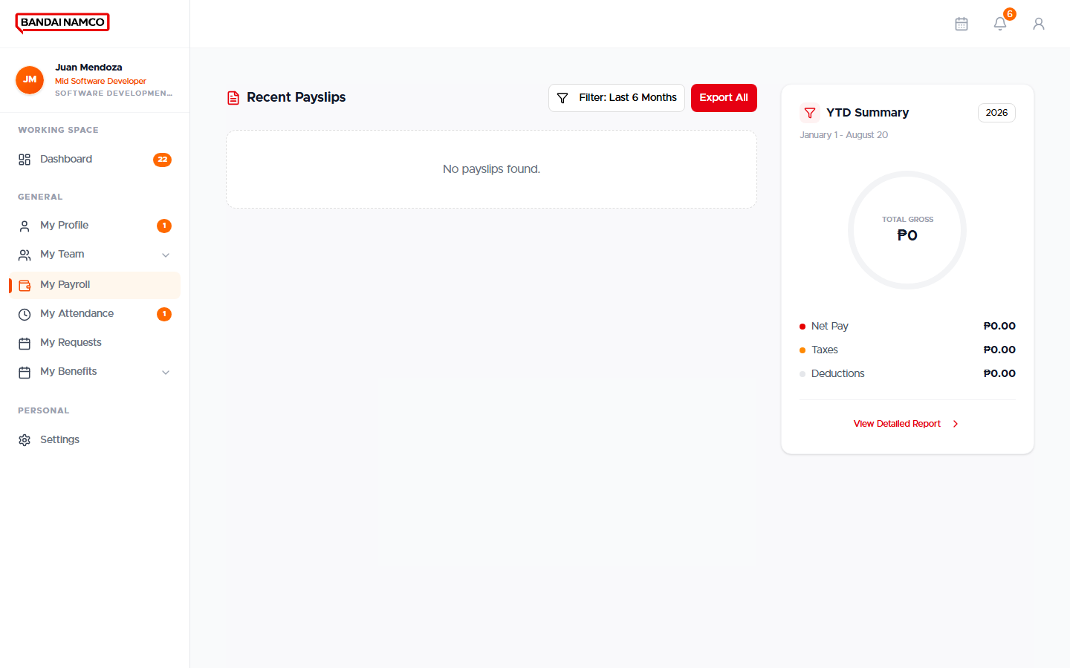
Figure 11. My Payroll — your pay records by period.
My Payroll lists pay periods that have already been processed for you. Open a row to see the breakdown: basic, additions, deductions, and net. A Special Payroll badge means a one-time run, separate from regular cutoff pay.
- Click My Payroll.
- Find the cutoff dates you care about.
- Open the record.
- Read the summary first (gross, deductions, net), then the line details.
- If a line looks wrong, do not edit it yourself. File a question with HR or a payroll correction request if that option is offered.
Payslips appear after HR has actually produced them for that period. A period can exist as a payroll record before a printable slip is ready.

My Requests
My Requests is the inbox of everything you filed. Status and the current step (for example HR Review) are visible on each row. Use New Request (or the matching quick action) to start something new.
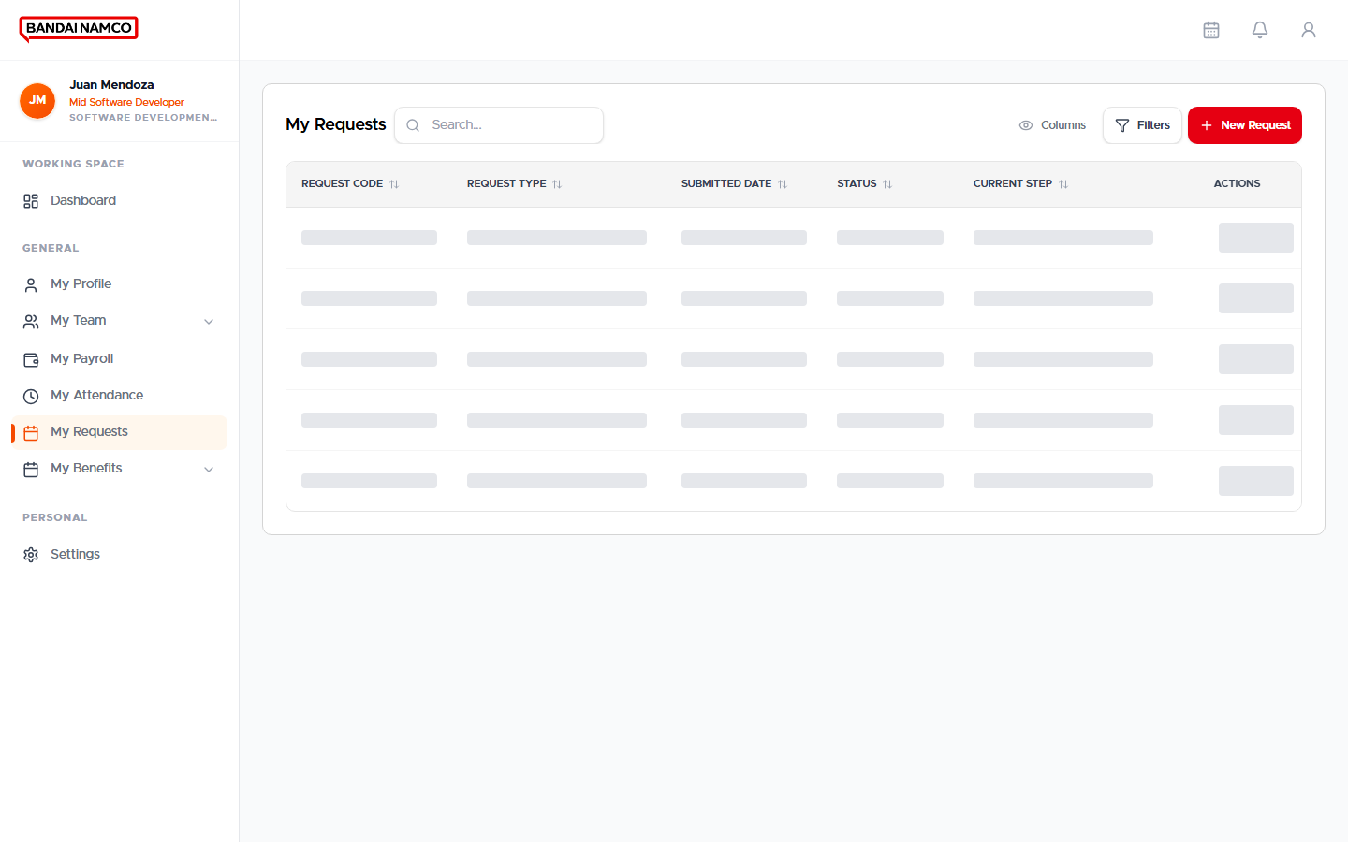
Figure 12. My Requests — list of items you have filed.
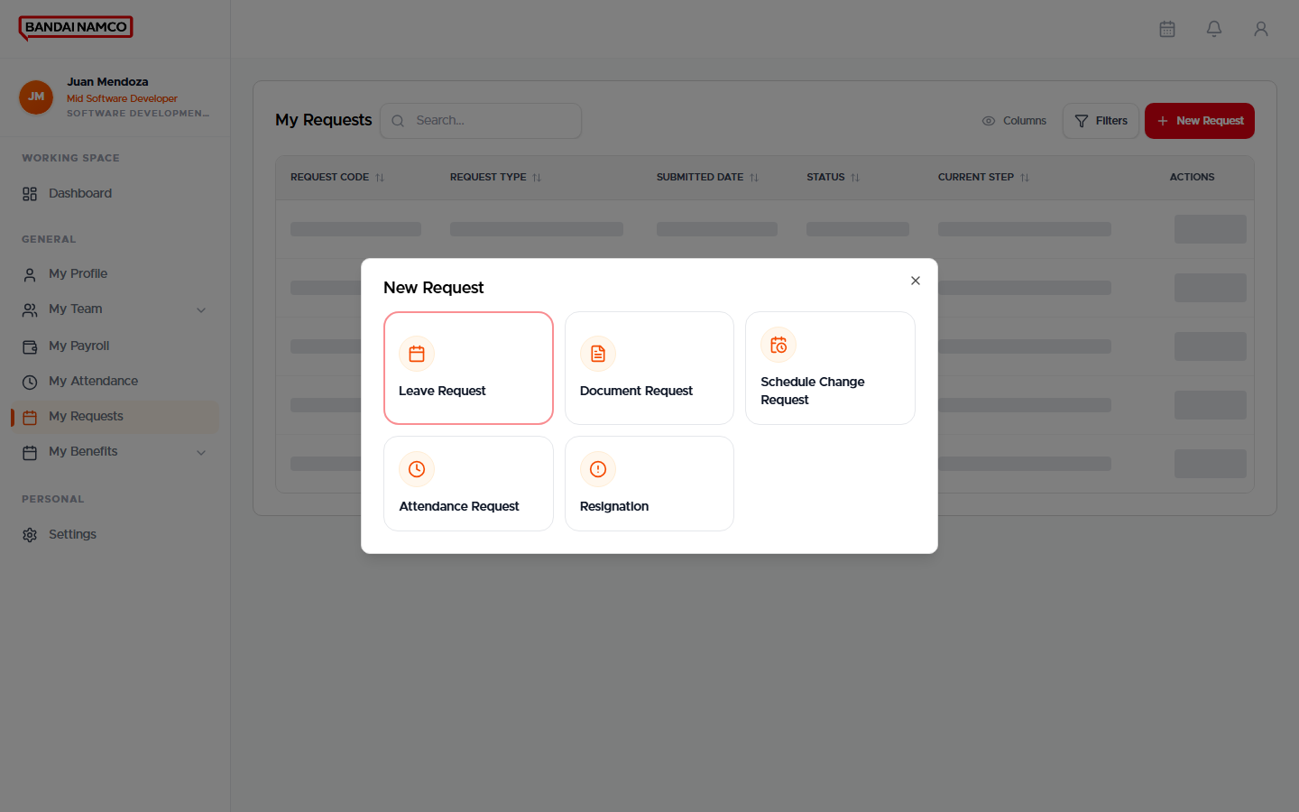
Figure 12b. New Request picker: Leave, Document, Schedule Change, Attendance, or Resignation.

Request types an employee can file
Request | When to use it | What you fill in | What happens next
Leave Request | You need a day or half day off and still have balance. | Leave Type, Duration Type (Full Day or Half Day), Session if half day, Start Date, End Date, reason. | Goes for review. Balance is used when the request is accepted.
Overtime Request | You worked extra time that should be paid. | Date, Hours, Minutes (example 2 hours 50 minutes), reason. | HR reviews. Paid overtime is written only after HR approves.
Attendance Request | A punch is missing or wrong (missed clock in, missed clock out, or whole day). | The date, what is wrong, and the correct times. | HR Review must be completed. A missed whole day is written back onto your attendance when the request is finished.
Document Request | You need a certificate, copy, or similar paper from HR. | The document and any notes. | HR prepares or approves the document.
Schedule Change Request | Your work days or hours need a one-time or planned change. | The date and the requested change. | Reviewer accepts or declines. Your schedule updates when accepted.
Resignation | You intend to leave the company. | Last day and remarks, following the on-screen resignation steps. | Manager and HR process exit. You cannot file a second one while one is in progress.

File a leave request
- Open Dashboard and click Request Leave, or open My Requests and choose Leave Request.
- Wait until balances, schedule, and policy dates finish loading.
- Choose Leave Type. The remaining days for that type appear under Current Balance.
- Choose Duration Type: Full Day or Half Day. Some types allow full day only.
- For half day, choose Session (AM or PM). Half day uses your scheduled work slots.
- Pick Start Date and End Date. Holidays, rest days, and too-soon dates may be blocked.
- Type a short reason.
- Submit. Confirm the new row in My Requests.
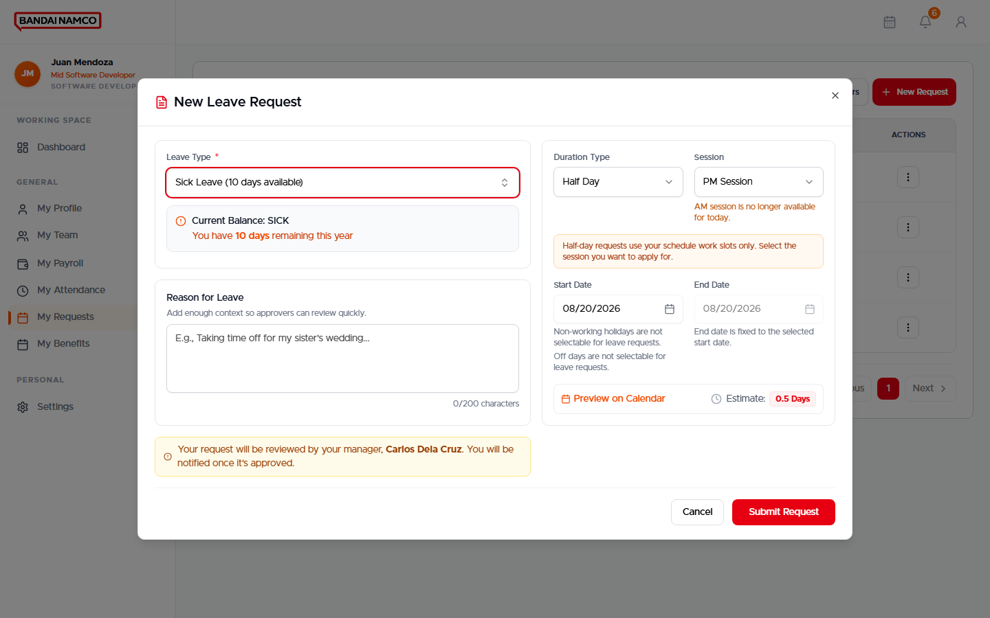
Figure 13. New Leave Request form.
Figure 14. Leave request fields after choosing Leave Request from My Requests.

File an overtime request
- Open My Requests and start an Overtime Request (or open time requests and choose Overtime).
- Pick the Date using the date picker — do not type a random number.
- Enter Hours and Minutes separately. Example: 2 hours and 50 minutes is 2 and 50, not 2.5.
- Type why the overtime was needed.
- Submit. Watch the status until HR finishes.
- After approval, the payable hours appear on the timesheet for that day. Raw extra punches alone do not pay.
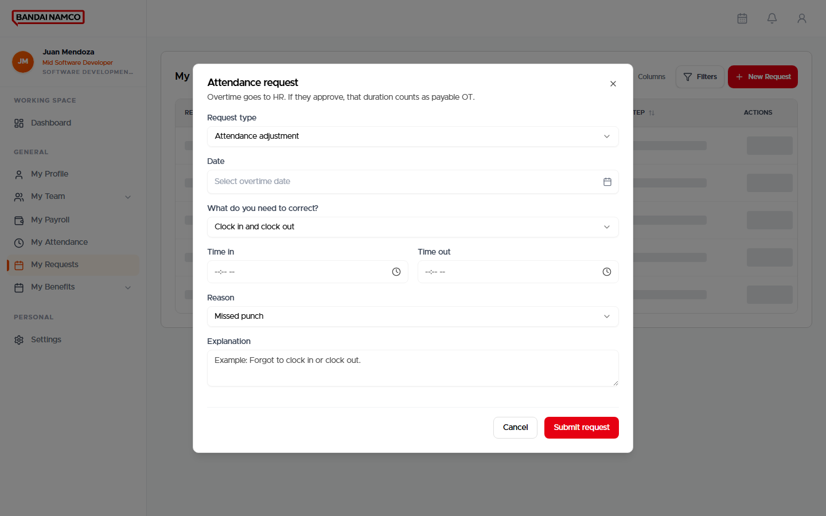
Figure 15. Attendance request form. Extra hours that should be paid are sent to HR from here.

File an attendance request
- Open My Attendance and note the date that is wrong.
- Open My Requests and choose Attendance Request.
- Select the date and explain the missing or wrong punch.
- Enter the correct clock in and/or clock out in local work time.
- Submit and wait. If your manager is also HR, review can finish in one pass. Otherwise HR still has to complete HR Review.
- Return to My Attendance. The day should no longer show as a blank absent if the request completed.
Figure 16. Attendance Request form.

File a document request
- Open My Requests and choose Document Request.
- Choose the paper you need.
- Add notes (purpose, copies, date needed).
- Submit and watch the status.
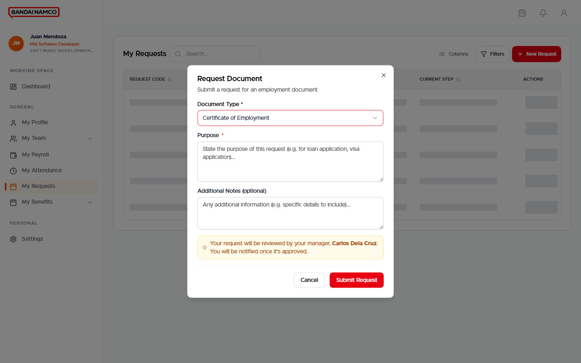
Figure 17. Document Request form.

Withdraw or follow a request
If a request is still waiting and the screen offers Withdraw, you may take it back. After it is approved, completed, or rejected, you cannot silently edit it. Open the row to read comments from the reviewer.

My Benefits
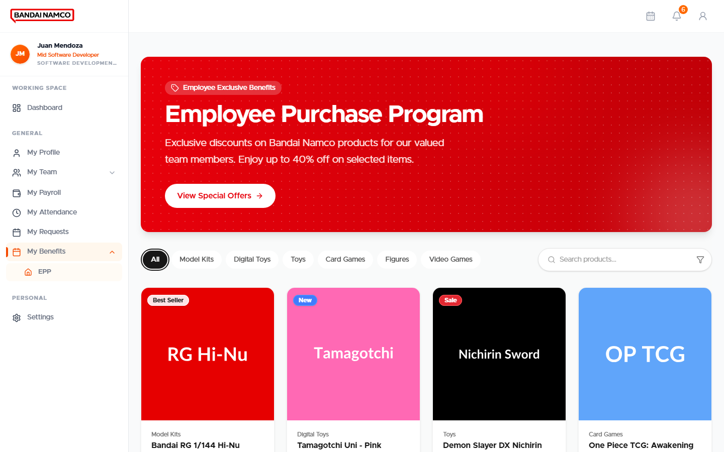
Figure 18. My Benefits.
My Benefits opens your enrolled benefits. EPP is listed here as a storefront-style catalog. Company benefits such as meal allowance are enrolled by HR; you will see them once HR has enrolled you. You do not enroll yourself in meal allowance from this page.

My Team
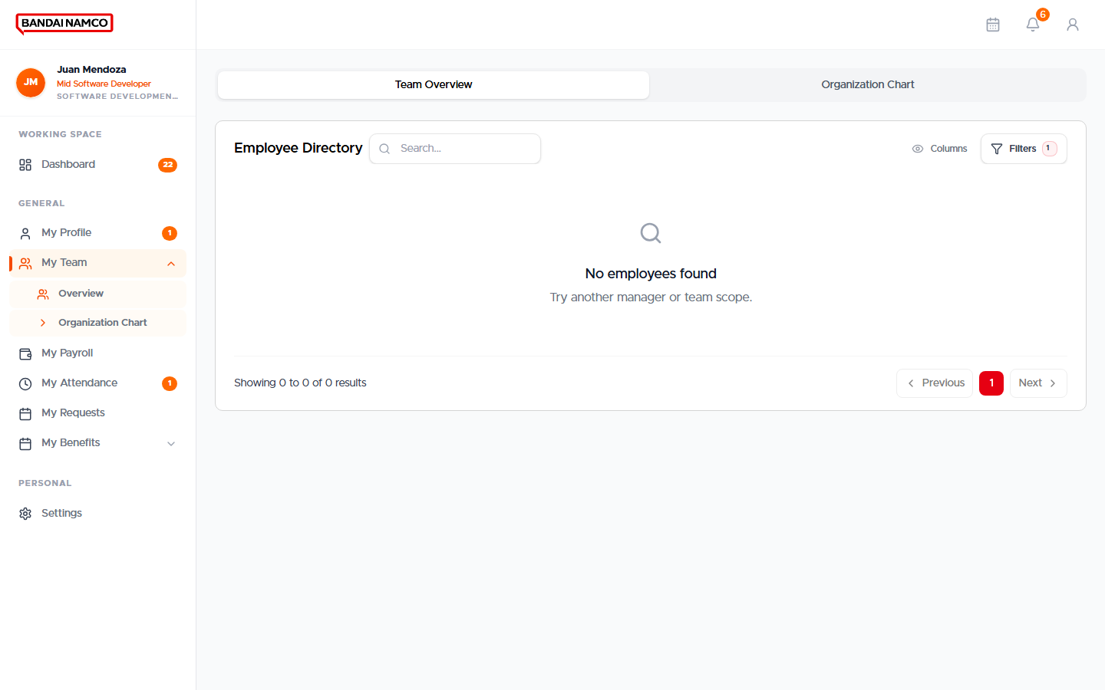
Figure 19. My Team — Overview.
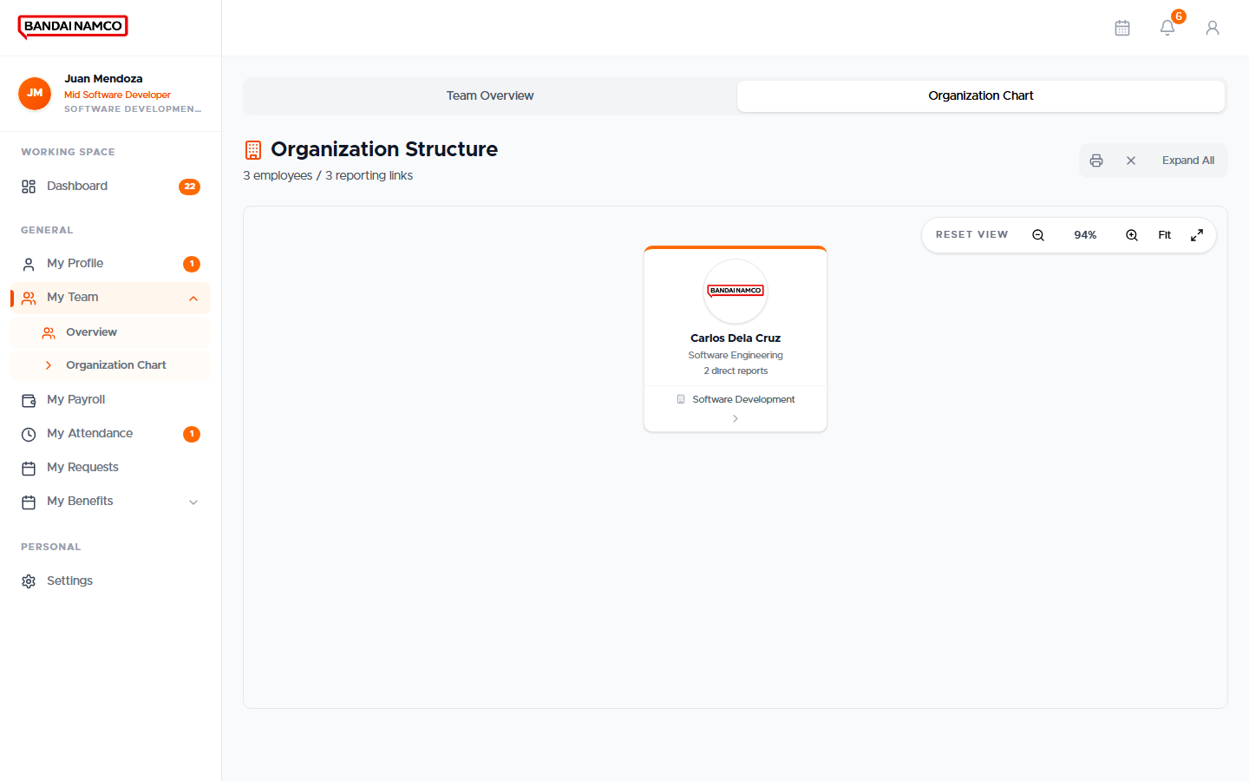
Figure 20. My Team — Organization Chart.
Overview shows people around you. Organization Chart shows the reporting tree. This is a view, not the HR employee directory. You cannot edit other people’s records from here.

Notifications
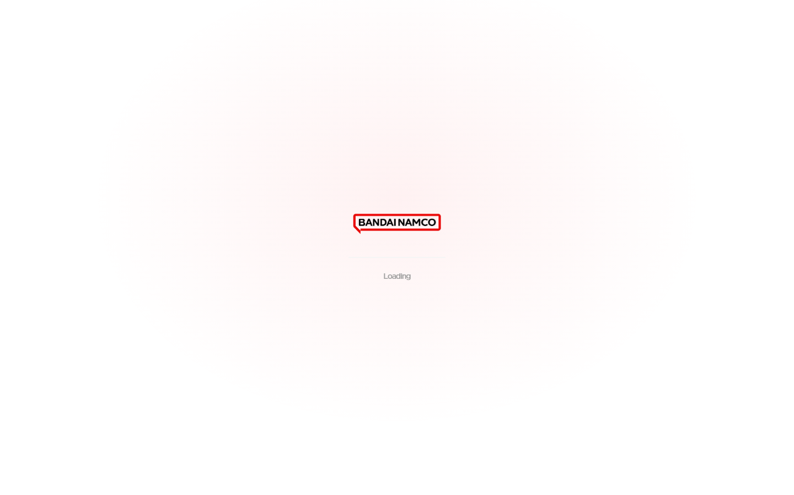
Figure 21. Notifications.
- Click the bell in the top bar, or open Notifications from Settings.
- Unread items are marked until you open them.
- Click a notification to go to the related request, document, or celebration.

Settings and password
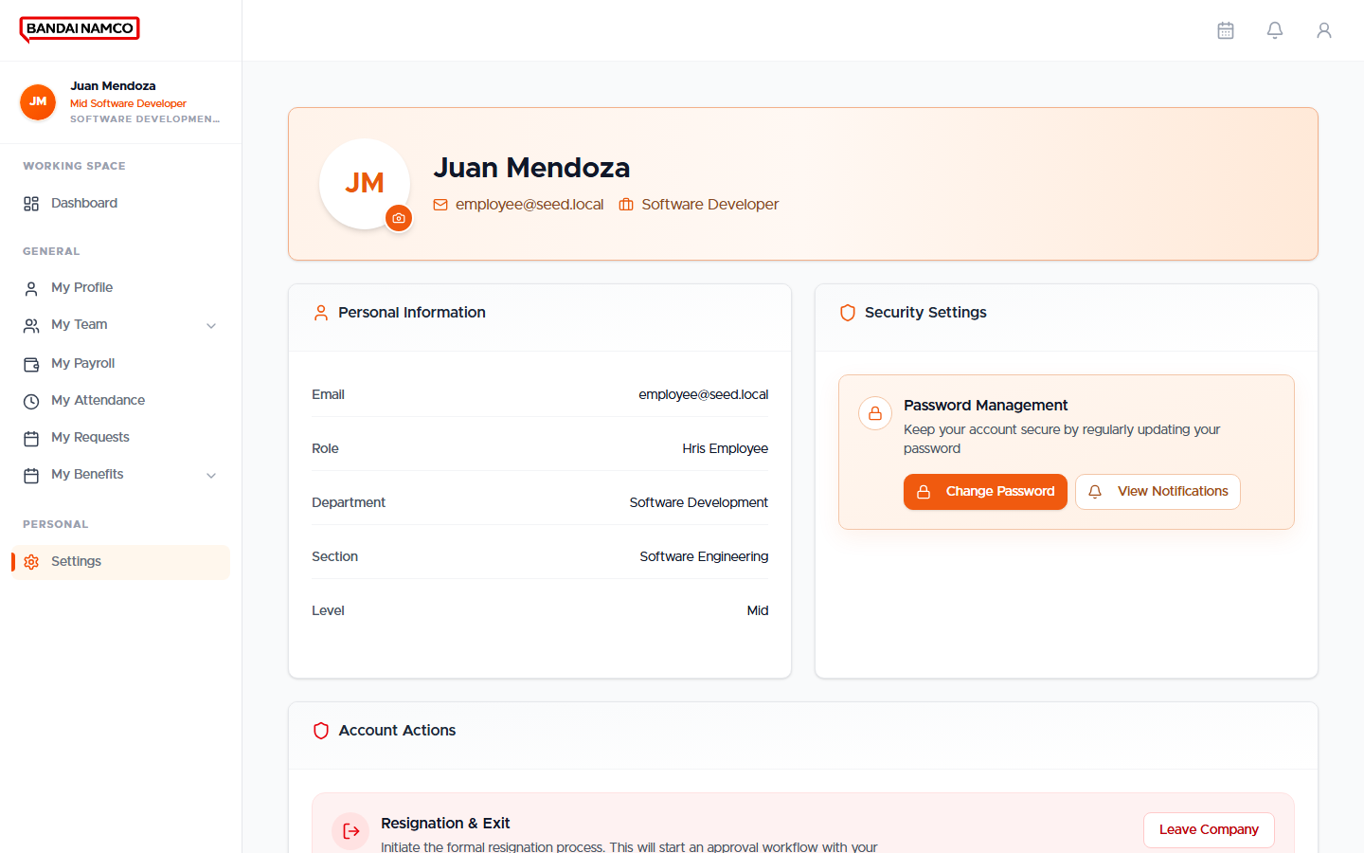
Figure 22. Settings — Password Management and account actions.
- Open Personal → Settings.
- Under Password Management, click Change Password.
- Enter the new password twice. Use at least 8 characters with upper, lower, and a number.
- Save. Sign in next time with the new password.
The same Settings page has Resignation & Exit. Use it only when you truly intend to resign. If a resignation is already in progress, the button is disabled.

Employee checklist
Task | Where | Done when
Sign in | Sign-in screen | Dashboard opens
Change first password | Change Your Password | Dashboard or onboarding continues
Finish required documents | My Profile → Documents | No pending document badge
Confirm today’s punches | My Attendance | Time In / Time Out match the terminal
File leave before the date | My Requests → Leave Request | Status is no longer Draft
File overtime the same cutoff | Overtime Request | HR has approved
Read pay | My Payroll | You opened the period and the amounts make sense

Team Manager
A team manager has everything an employee has, plus My Approvals and a richer My Team. You still file your own leave and overtime the same way. You also act on requests from people who report to you.
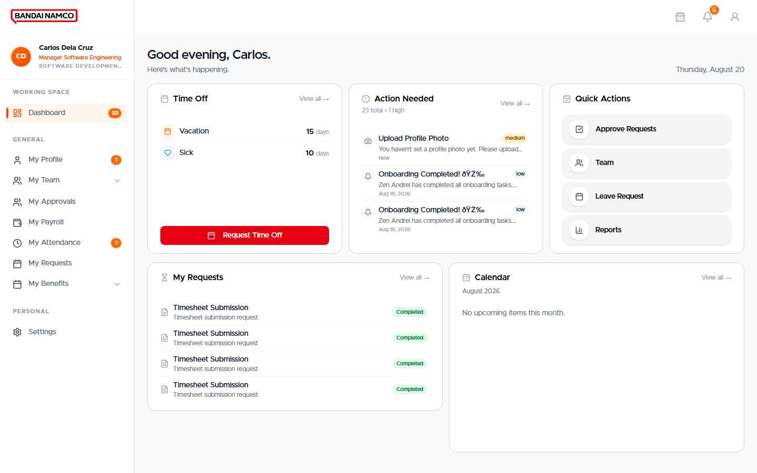
Figure 23. Team Manager Dashboard.

My Approvals
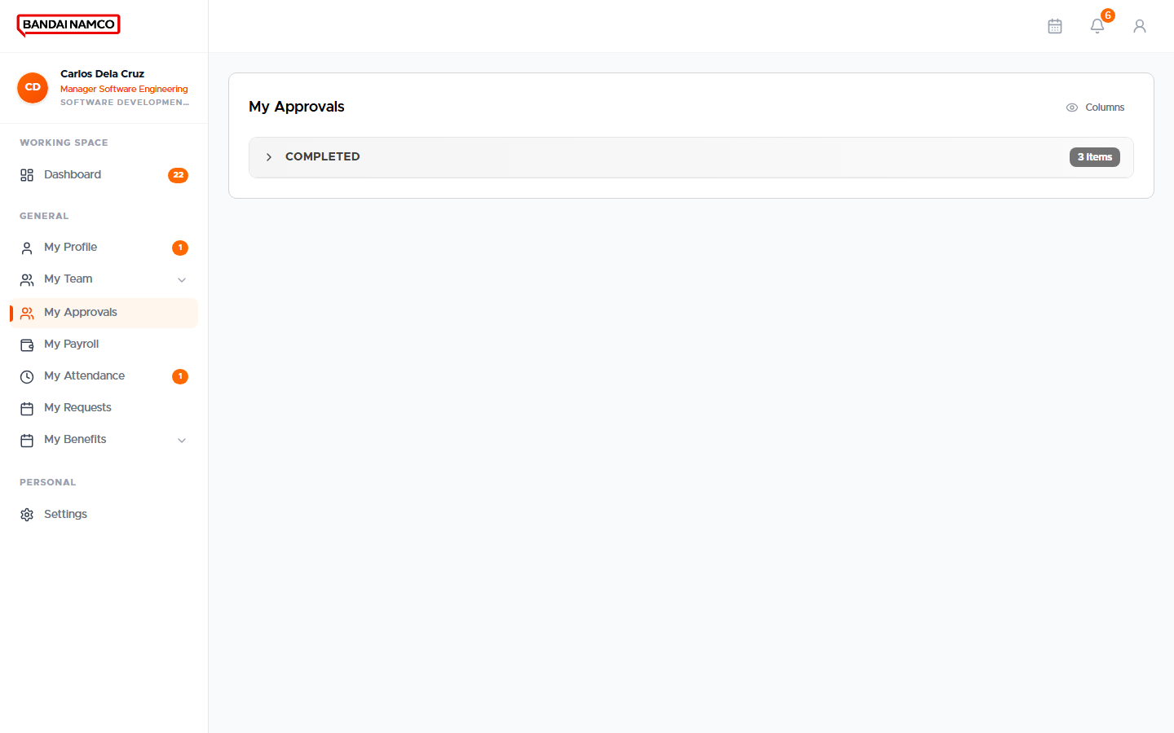
Figure 24. My Approvals — items waiting for you.
- Open General → My Approvals.
- Open a row. Read the person, dates, and reason.
- Approve or reject. Add a short comment when you reject.
- For overtime, remember that HR still confirms payable hours.
- For attendance, HR Review must finish before the day is rewritten. If you are also HR, the system can complete that review for you.

My Team
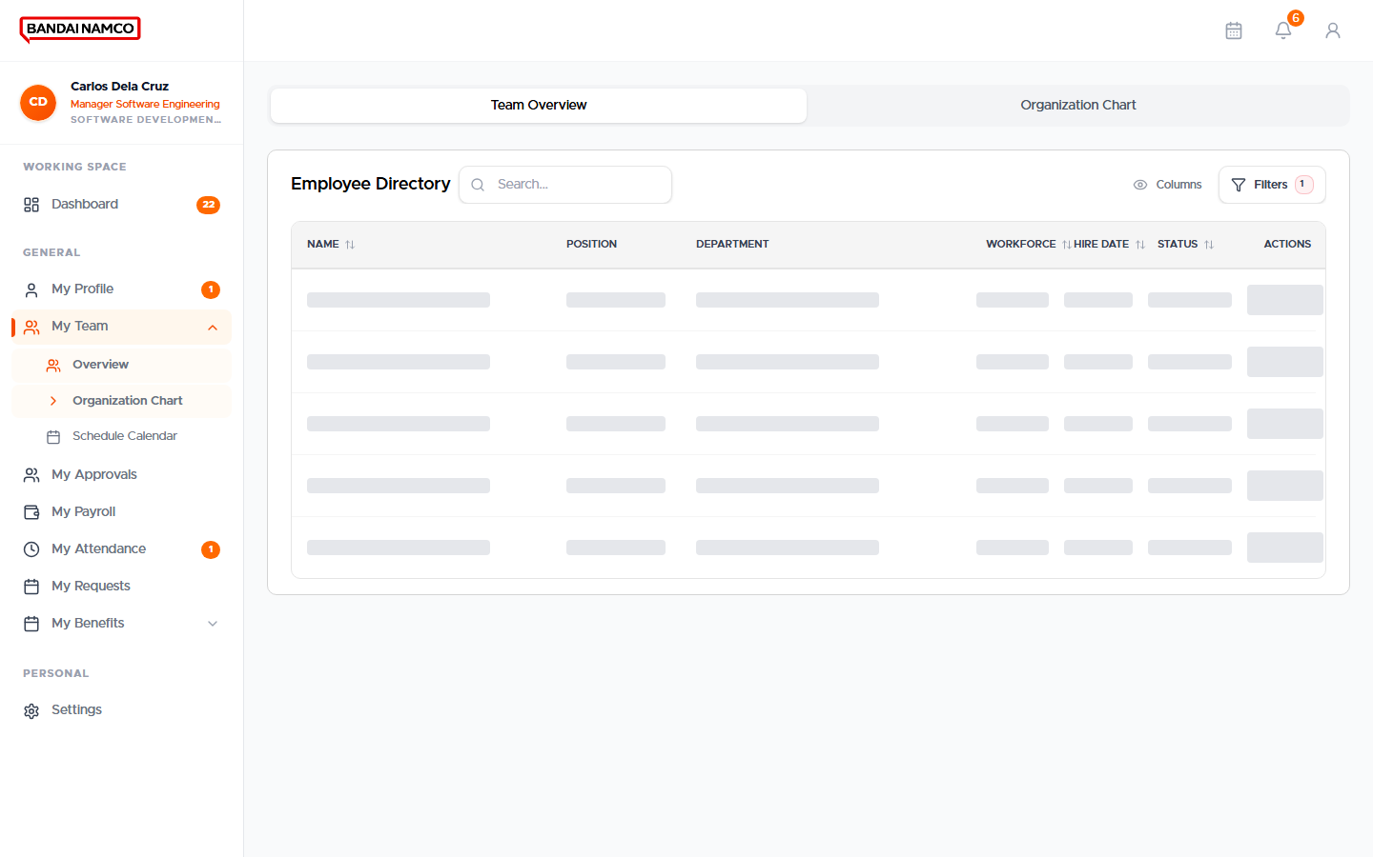
Figure 25. Team overview for a manager.
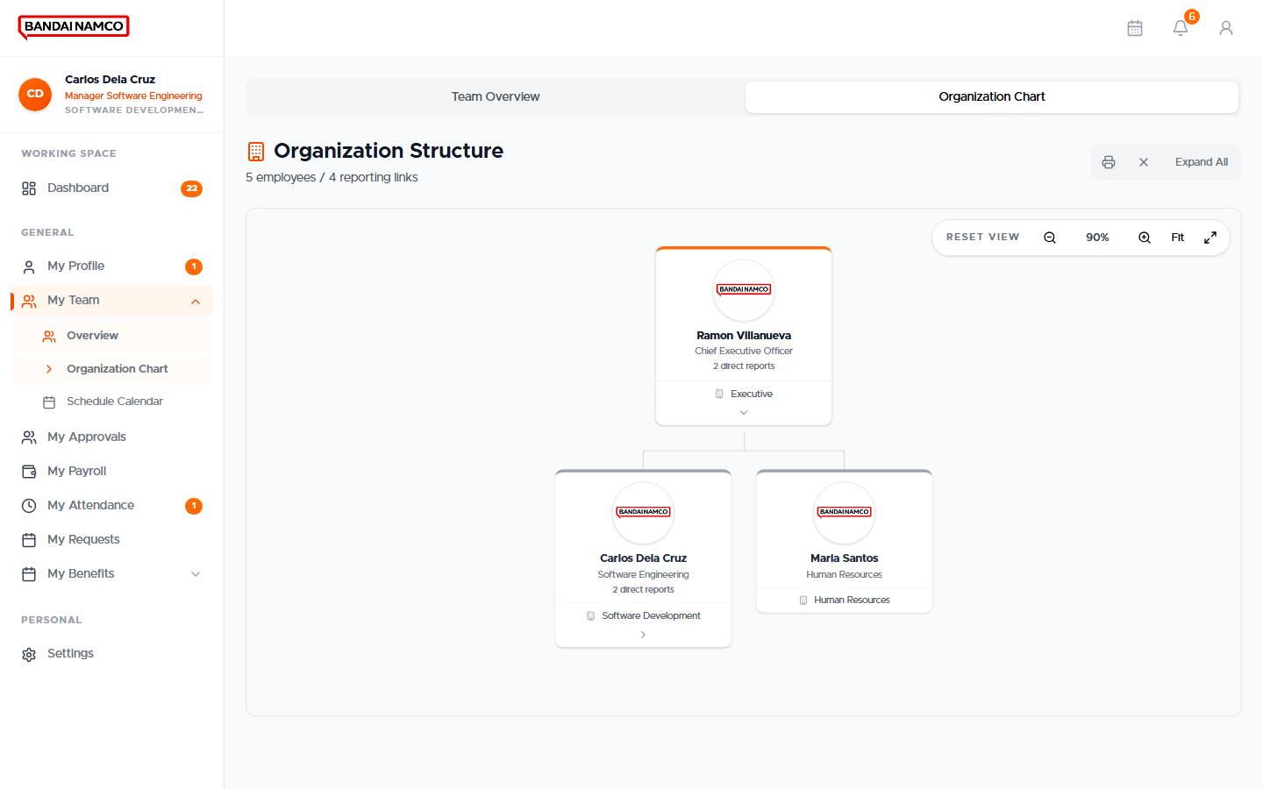
Figure 26. Organization chart from a manager account.
Department managers also get Schedule Calendar under My Team, to see who is supposed to work. Use it for planning, not as a substitute for HR Attendance.

Requests only a manager can start
From My Requests, managers can also start people-action items that regular staff cannot: Regularization, Promotion, Transfer, and Job Requisition. Fill the person, the intended change, and the reason. HR completes the rest.

Team manager checklist
- Clear My Approvals every morning.
- Do not leave overtime sitting — people cannot be paid for it until the request is finished.
- Use My Team to confirm who is at work; use Attendance Request only for true punch errors.
- Never approve a request you have not opened.

HR User
An HR User sees Working Space menus for day-to-day HR work, plus the same personal menus as an employee. You support the directory, attendance, tickets, tasks, and reviews. Running the company-wide payroll cutoff is usually the HR Manager’s action; you still need to understand the screens because you will open them.
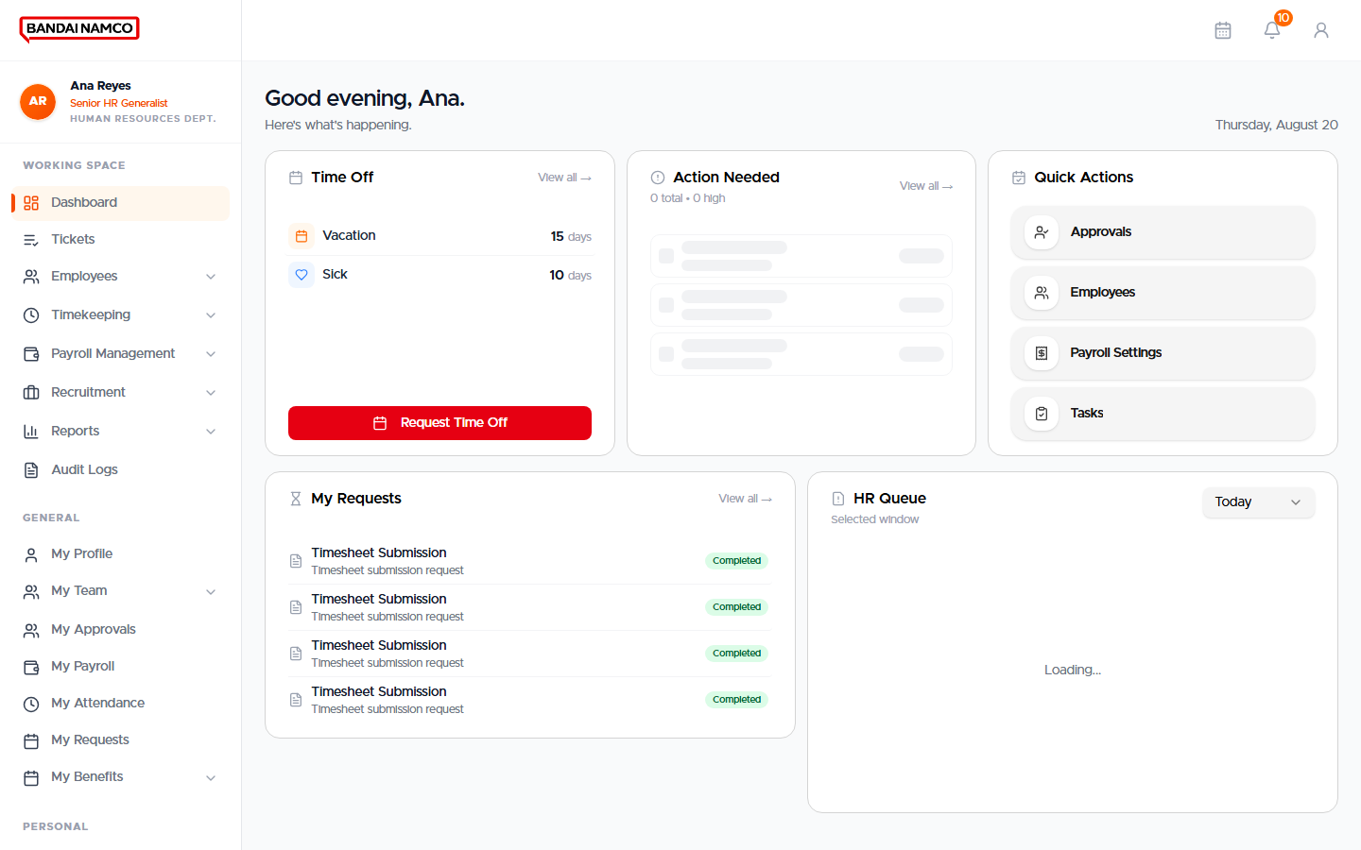
Figure 27. HR User Dashboard, including the operational queue.

Working Space for HR
Menu | Opens | Use it to
Tickets | HR tickets | Handle staff tickets that are not a standard leave or overtime form.
Employees → Directory | Employee list | Search people, open a profile, start a new hire if you have the button.
Employees → 201 Compliance | Document compliance | See whose 201 papers are missing or waiting.
Employees → Employment Eligibility | Status changes | Track regularization and similar eligibility changes.
Employees → Tasks | HR tasks | Finish assigned onboarding or review tasks.
Employees → Birthdays | Birthday list | See upcoming birthdays.
Timekeeping → Attendance | Attendance overview | See who is scheduled, present, late, undertime, or absent.
Timekeeping → Timesheets | Timesheets | Open, check, and approve cutoff timesheets.
Timekeeping → Attendance Corrections | Correction inbox | Process punch corrections.
Payroll Management | Run Payroll / records / benefits | Support payroll and enrollments.
Recruitment | Candidates | Move applicants through hiring.
Reports | Attendance, workforce, payroll, turnover, compliance, billings | Print or export management reports.
Audit Logs | HR audit log | See who changed what.
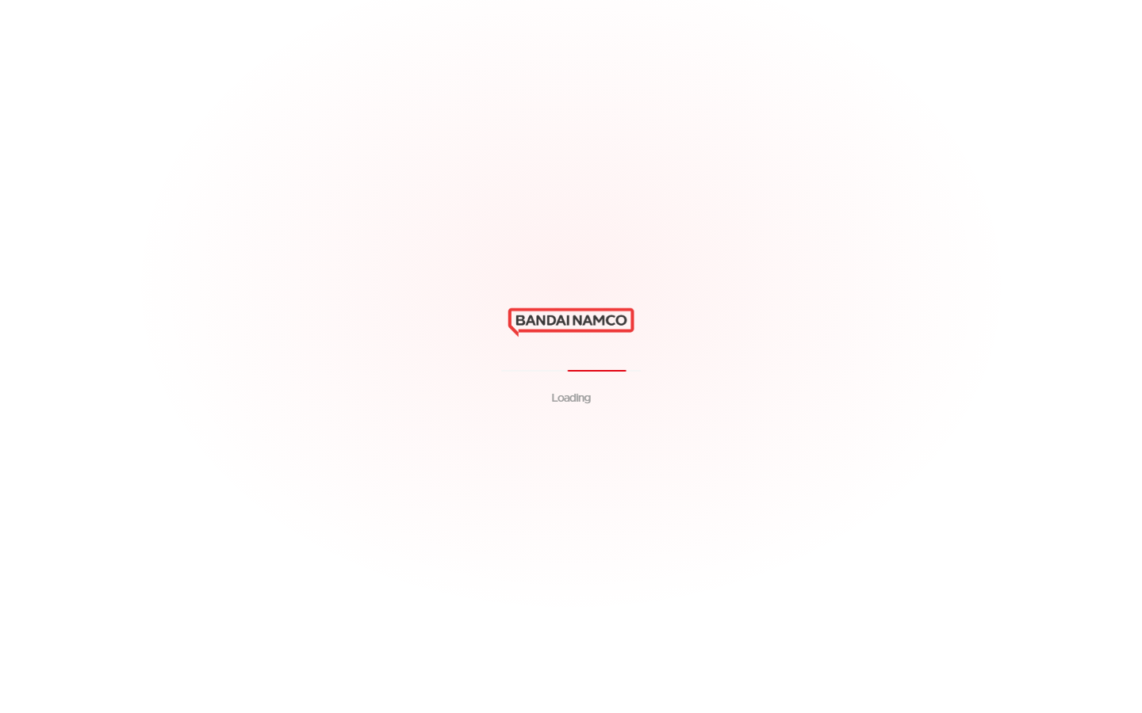
Figure 28. Employees Directory for an HR User.
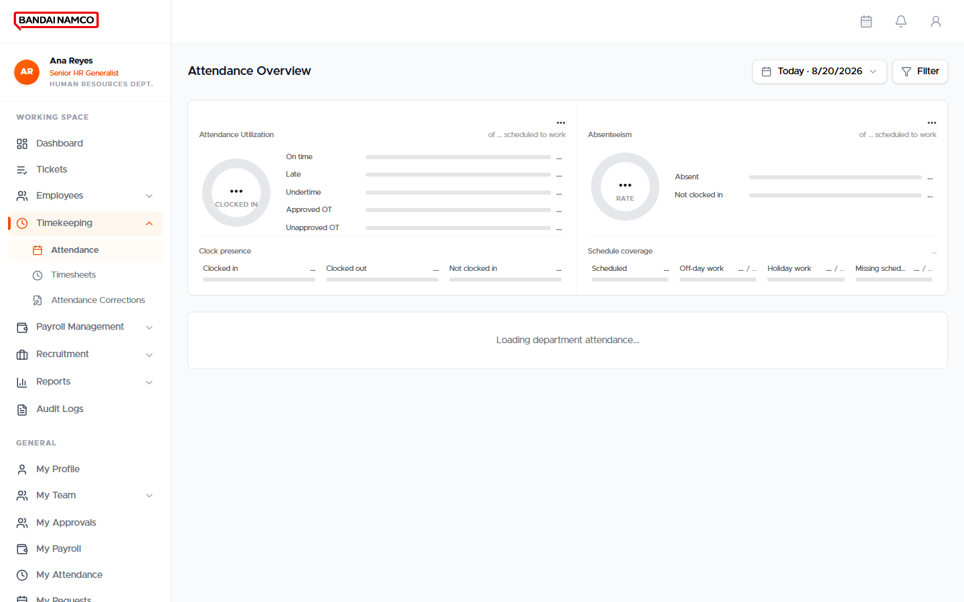
Figure 29. Attendance overview for an HR User.
Figure 30. HR Approvals.
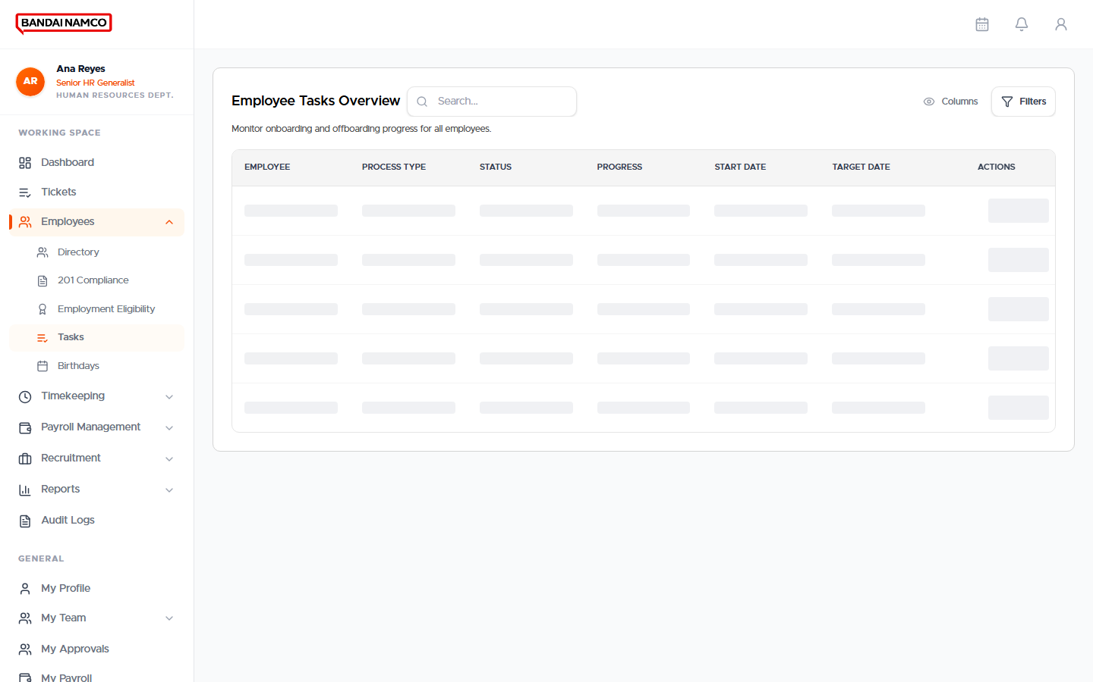
Figure 31. HR Tasks.
Follow the HR Manager chapter for the detailed clicks on Directory, Attendance, Timesheets, Corrections, Payroll, Benefits, Recruitment, and Reports. The screens are the same; the HR Manager typically owns Start Payroll and company-wide policy decisions.

HR Manager
The HR Manager owns the people cycle: hire and maintain the directory, keep time honest, approve exceptions, enroll benefits, run payroll, recruit, and report. You also have the personal menus of an employee.
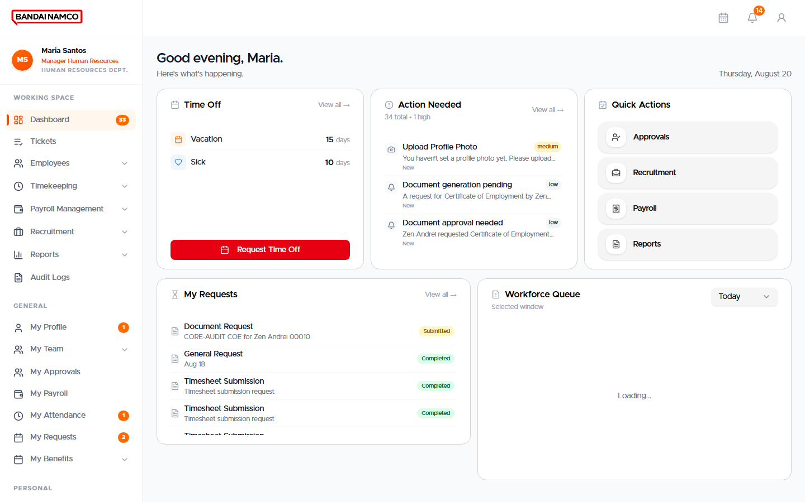
Figure 32. HR Manager Dashboard.

Employees Directory
Working Space → Employees → Directory is the company people list (this is the Employee Masterdata screen). Search by name or employee number. Open a row for the full profile. Use New when hiring.
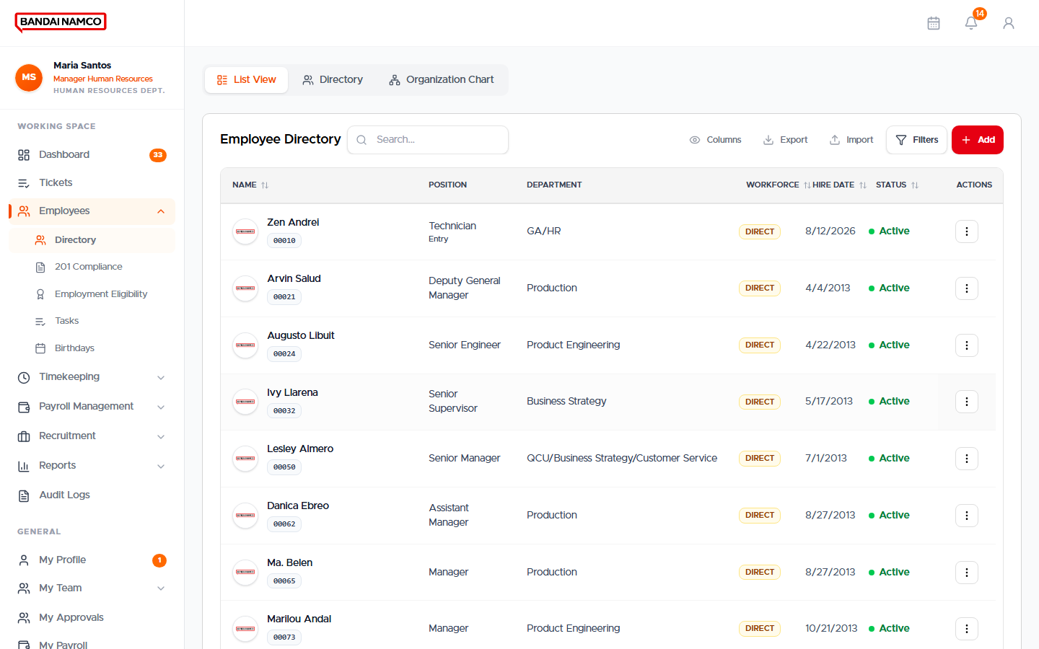
Figure 33. Employees Directory.
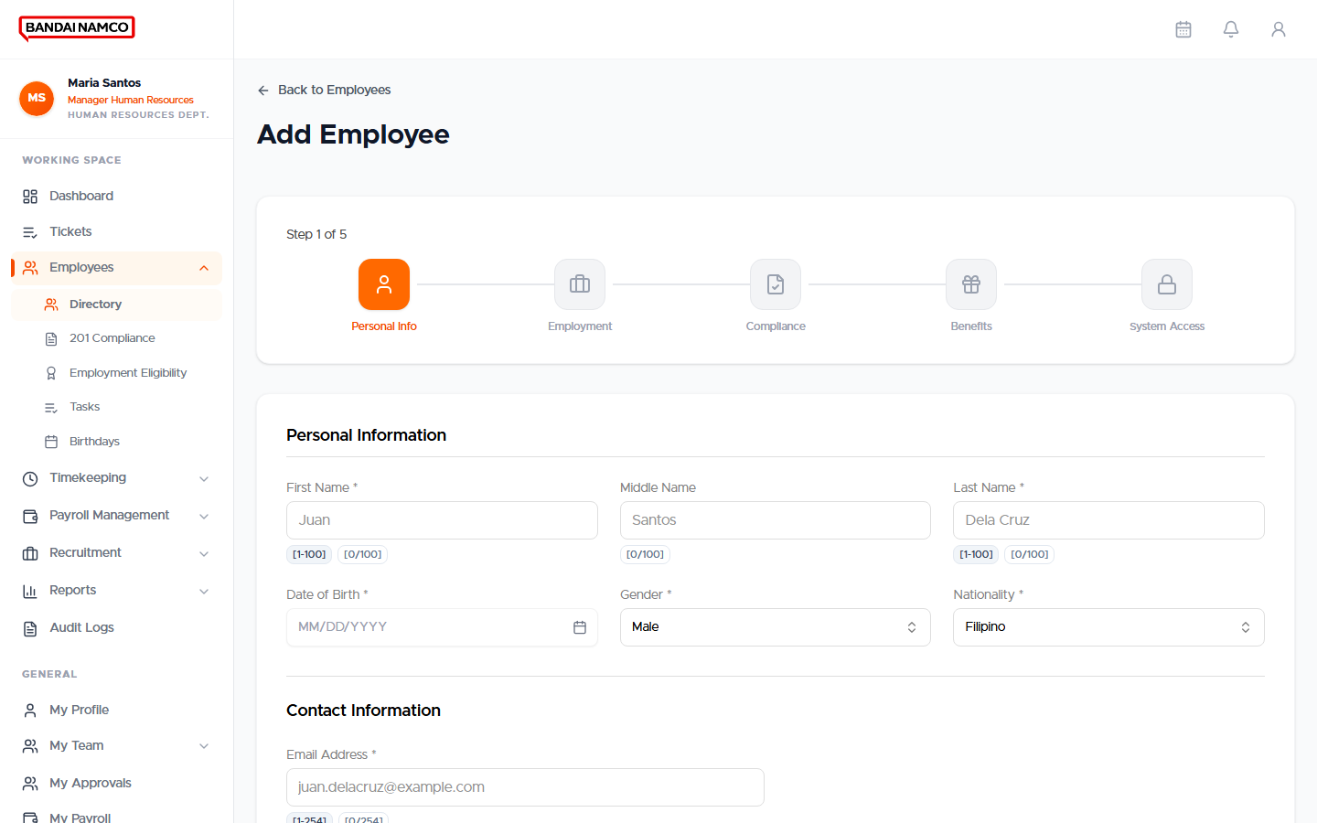
Figure 34. New employee form.

Add a person
- Open Employees → Directory.
- Click the control to add or create an employee.
- Fill personal information, then employment (department, section, position, level, status, start date).
- Assign the work schedule. Without a regular-day schedule, the person will not appear in today’s scheduled attendance count.
- Save. Tell the person their Employee ID or Email and that the first sign-in may require a password change.

Open and maintain a profile
- Search the directory.
- Open the person.
- Use the same tabs the employee sees: Personal, Employment, Work Schedule, Compensation, Leave Balance, Documents.
- Correct locked or official fields here rather than asking the employee to guess.
- When you change an active schedule, attendance for the affected dates is recomputed so Attendance does not keep an old Off Day.

201 Compliance
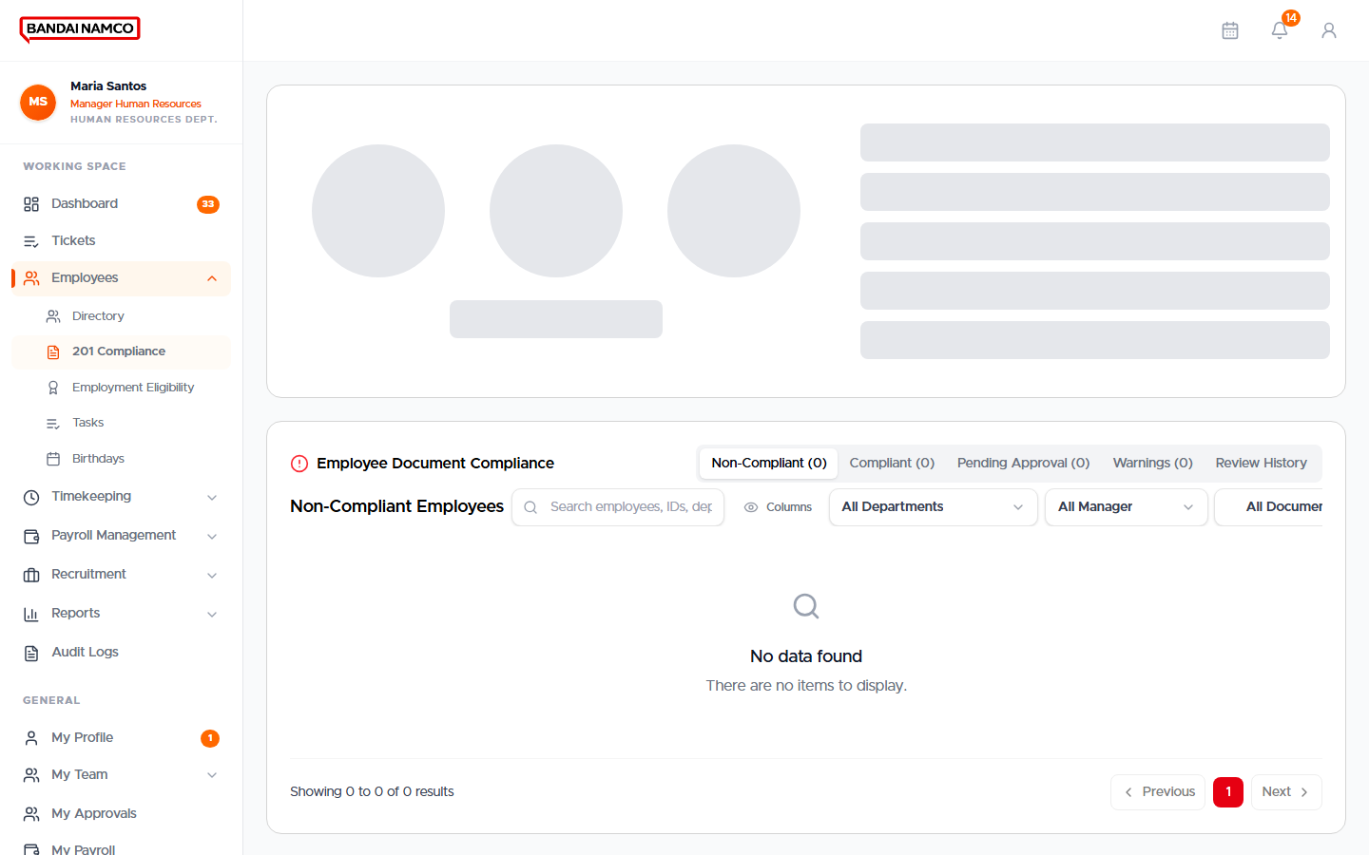
Figure 35. 201 Compliance — documents still due or in review.
- Open Employees → 201 Compliance.
- Filter to pending or incomplete.
- Open a person, review the file, and accept or return it with a note.
- Do not leave required papers sitting in pending through a cutoff if the person cannot be completed.

Employment Eligibility
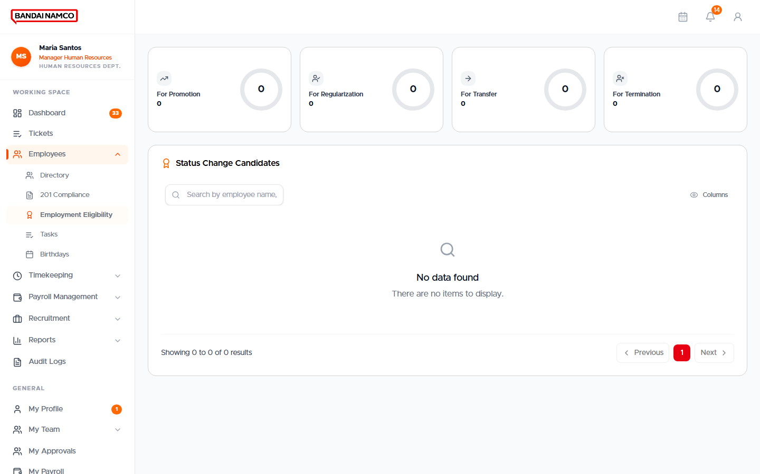
Figure 36. Employment Eligibility / status changes.
Use this list for regularization and similar status movements. Open a row, confirm dates and documents, then complete the change so the person’s employment status matches real life.

Tasks and Birthdays
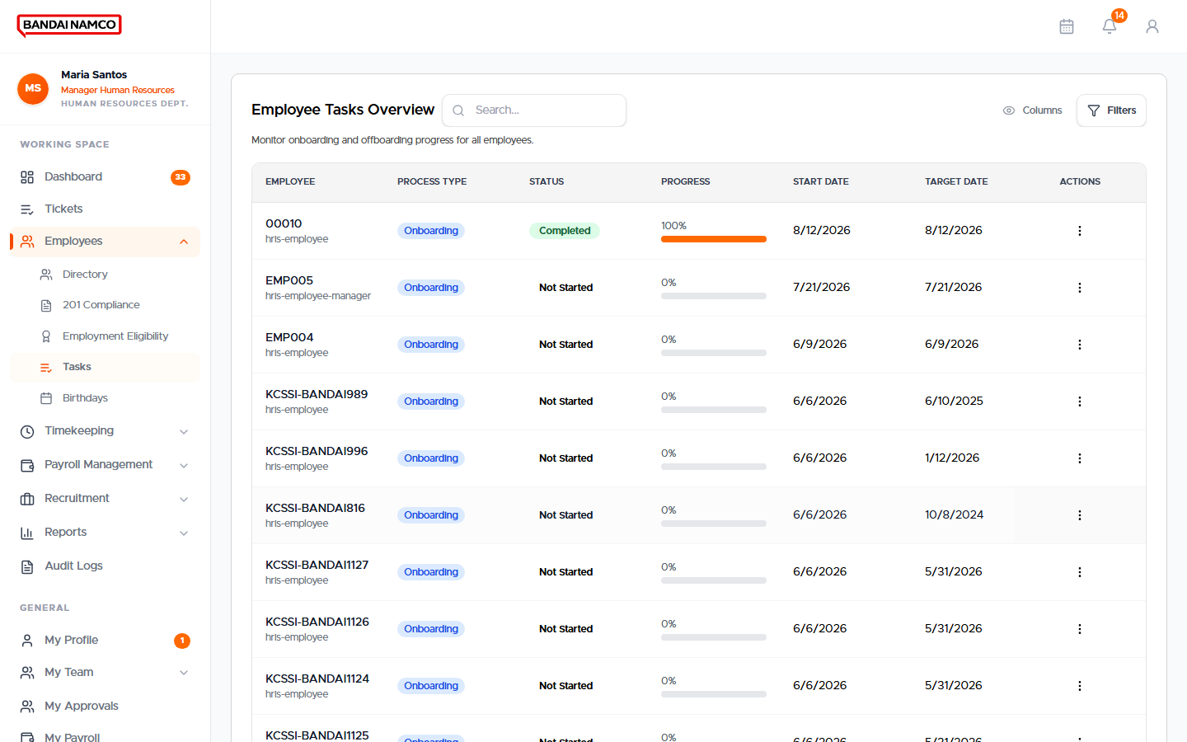
Figure 37. HR Tasks.
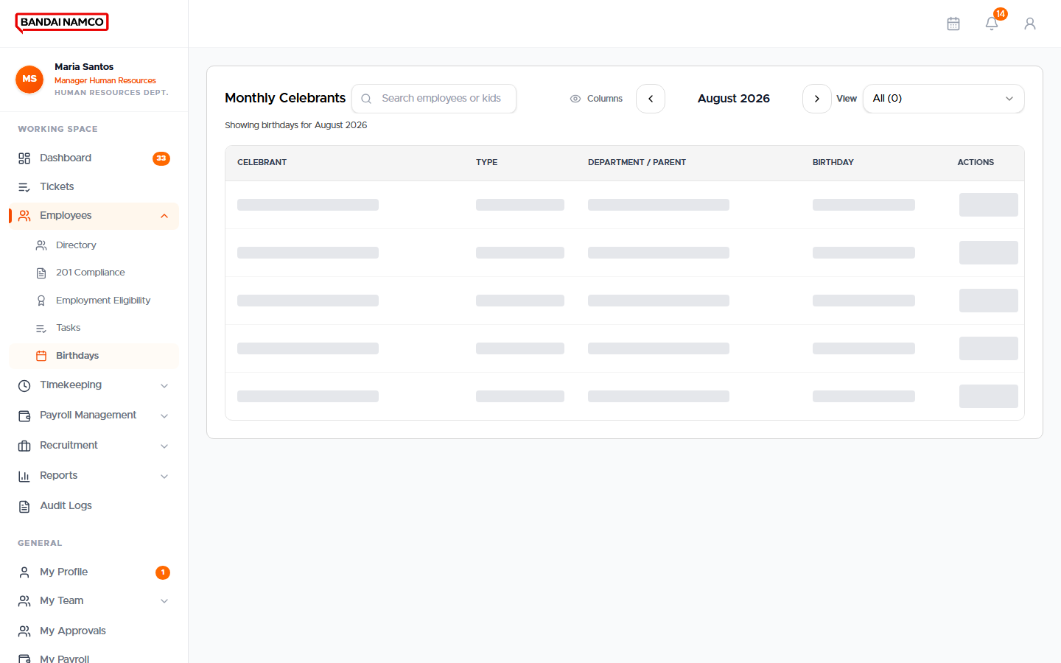
Figure 38. Birthdays.
Tasks are work items assigned to HR (onboarding steps, reviews). Birthdays is a simple celebration list — it is not a payroll screen.

Attendance
Timekeeping → Attendance is the live picture of who should work and who actually punched. Cards at the top are counts. The table underneath is the same style of record whether you click Clocked In, Absent, or All Statuses.
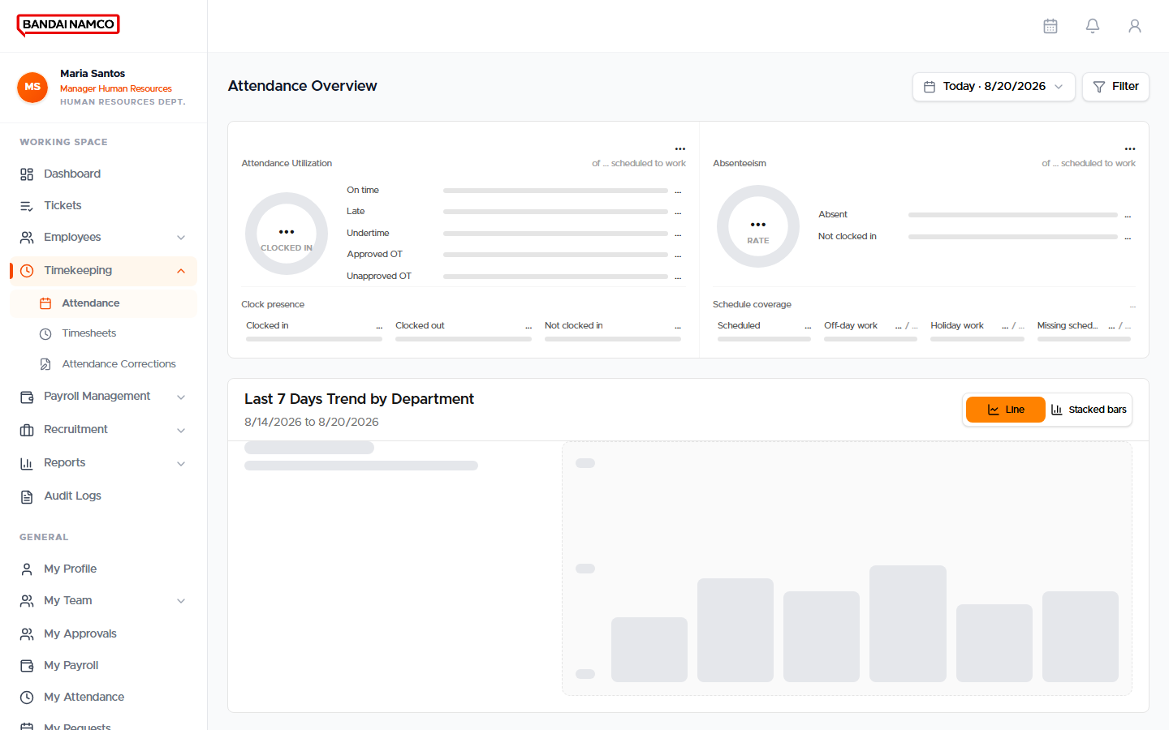
Figure 39. Attendance overview — scheduled versus clocked in.

How to read the overview
Card or column | Meaning
Scheduled to work | People whose work schedule says this is a regular work day. Rest days are not in this number.
Clocked in | People in that scheduled group who have a time in.
Not clocked in | Scheduled people with no punch. This is scheduled minus clocked in minus absent.
Late / On time | Among people who clocked in, whether time in beat the start (with grace).
Undertime | Among people who clocked out, whether time out was early.
Absent | Scheduled people with no attendance for the day.
PRES on a department row | How many people in that department have a time in.
SCHED / LATE / UT / ABS on a range | Day totals for the selected period, one row per person when you expand.

Open a list, then come back
- On the overview, click a card such as Clocked In.
- You land on Attendance Records. The employee name stays visible if you scroll sideways.
- Read Clock In, Late, Clock Out, UT, Hours, and Indicators (HOL, LEAVE, REST, ACTION).
- Click Back to Attendance (or click the same card again) to return to the overview. The date range is kept.
- Click Attendance in the sidebar to clear a stuck list filter.
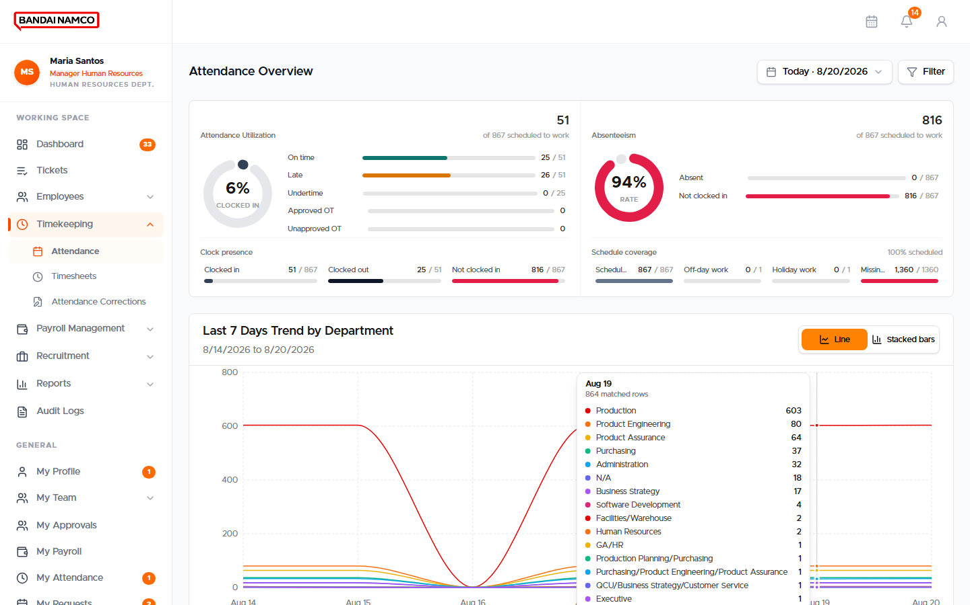
Figure 40. Attendance Records after clicking Clocked In.
Clocked Out is not Present
A row with Clock Out but no Clock In is Clocked Out, not a green Present day, and it does not earn a full-day undertime as if the person had worked from start. Ask for an Attendance Request if the time in was missed.

Timesheets
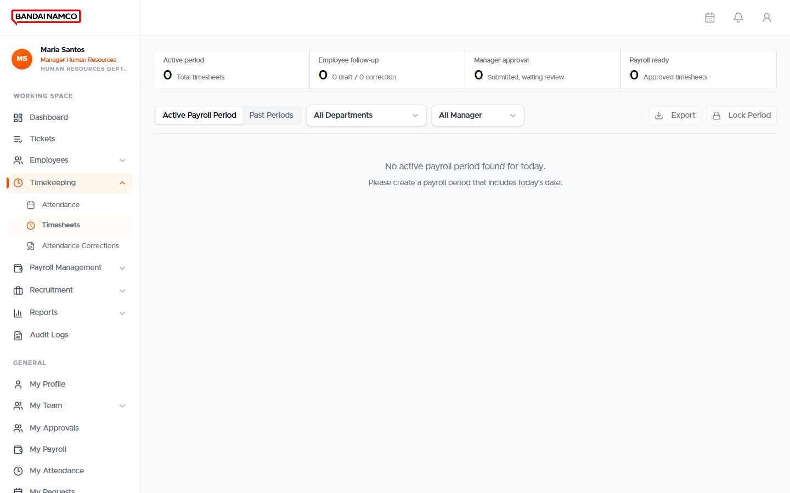
Figure 41. Timesheets for the cutoff.
Payroll will not generate from missing or still-draft timesheets. Each person needs an approved timesheet for the period, with a line per scheduled day.
- Open Timekeeping → Timesheets.
- Select the payroll period.
- Open a person and confirm days: present, late, undertime, absent, rest, leave.
- Approve only when the lines match Attendance and any approved overtime.
- If a new hire has no timesheet yet, create or sync it from the period tools before trying to generate pay.

Attendance Corrections
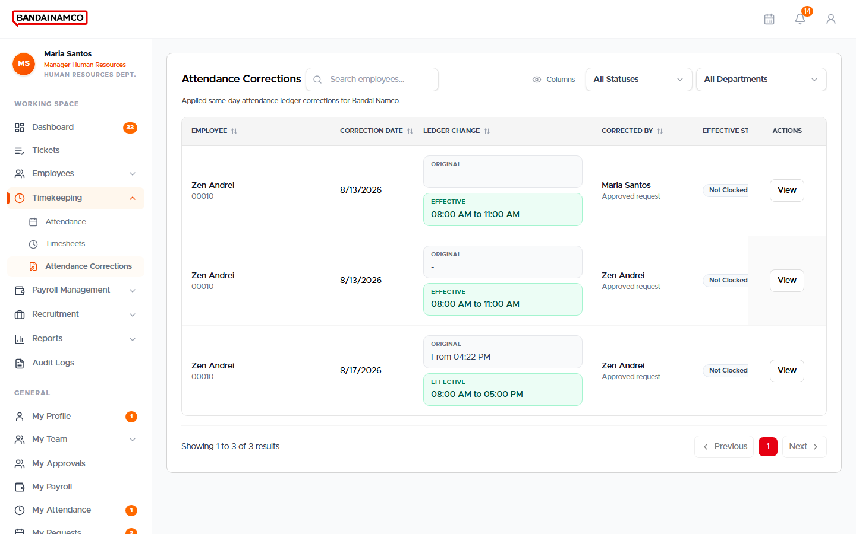
Figure 42. Attendance Corrections inbox.
- Open Timekeeping → Attendance Corrections (or the matching request under Approvals).
- Open the request. Confirm the date and the requested times.
- Complete HR Review. Approving as a manager is not enough if HR Review is still a task.
- For a missed whole day, completion writes a real attendance record. Check My Attendance for that person afterwards.

Approvals
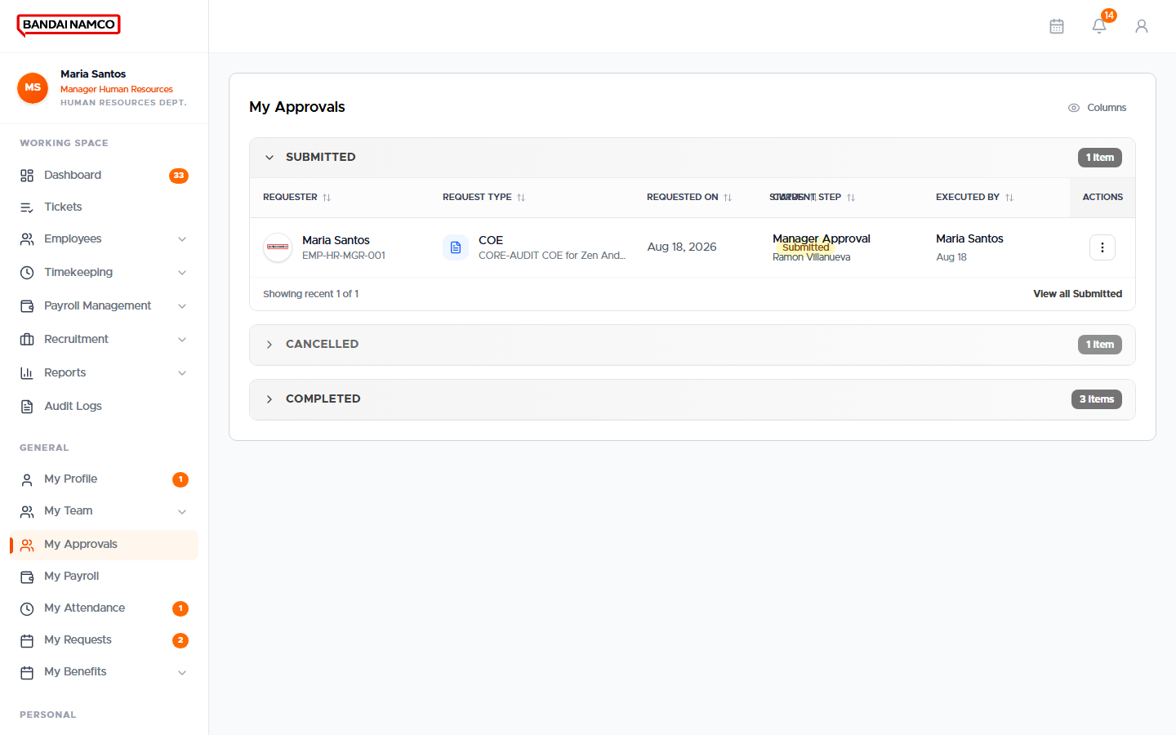
Figure 43. HR Approvals — employee requests and lifecycle items.
Tabs group Employee Requests, lifecycle items, compensation, and access. Open a request, read it, then Complete Task when the step is a review task. Overtime that you approve is written as payable hours on the timesheet (hours and minutes, such as 2:50).

Tickets
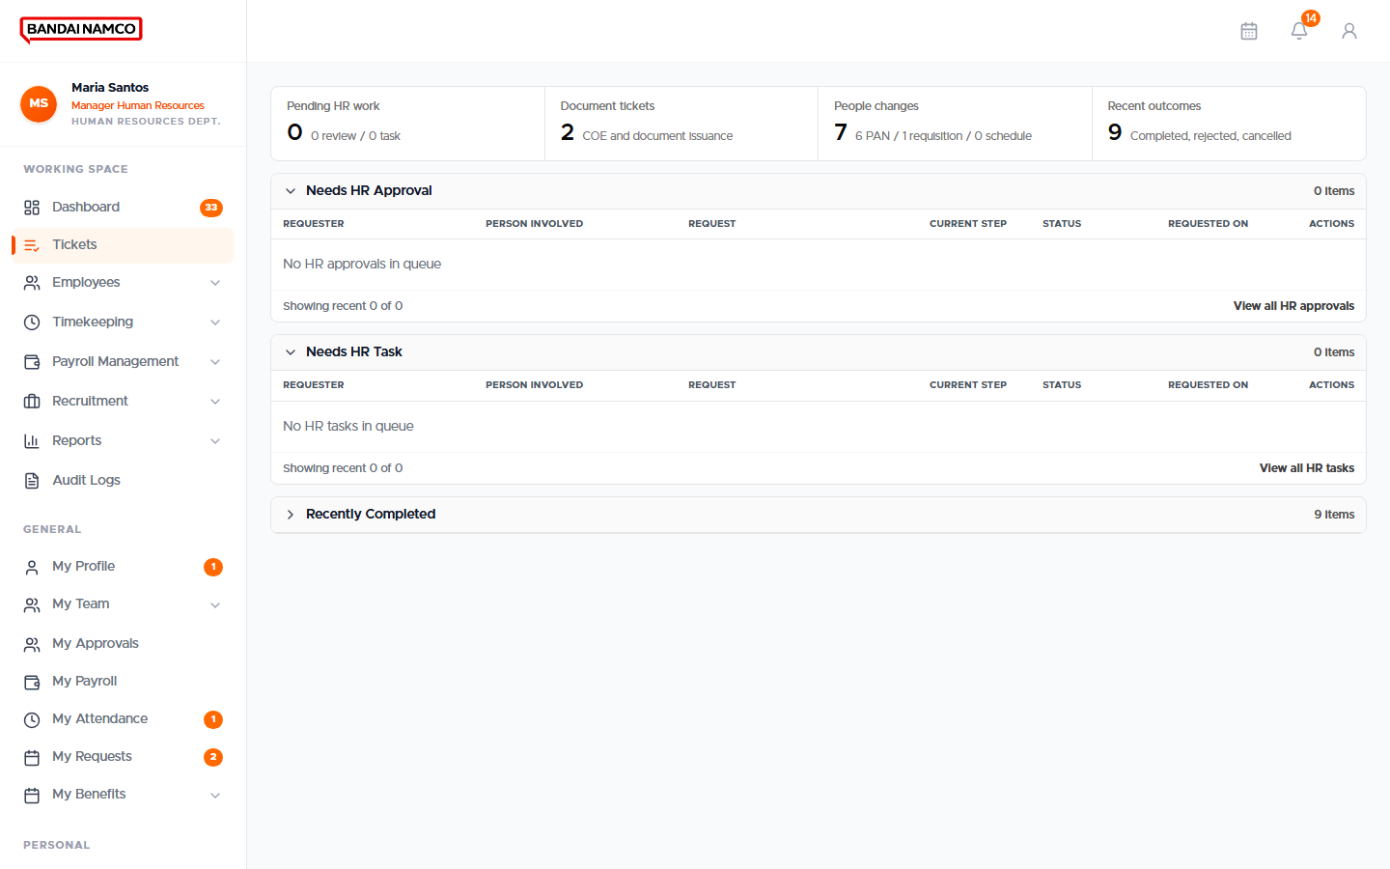
Figure 44. HR Tickets.
Tickets catch items that are not a standard leave or overtime form. Open, respond, and close them so they do not sit beside unanswered requests.

Run Payroll
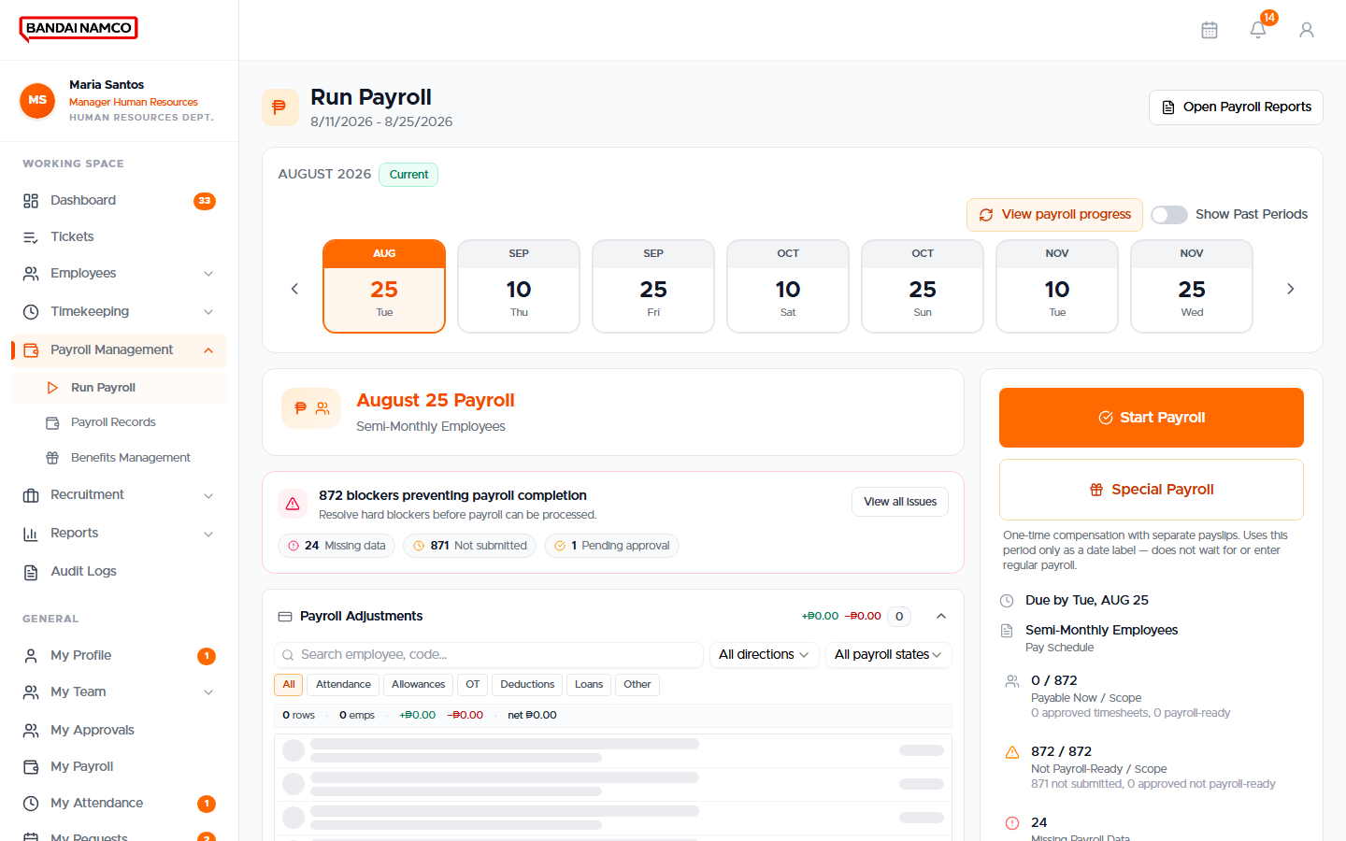
Figure 45. Run Payroll — current period and actions.

Before you start
- The cutoff period is open.
- Timesheets for the people in scope are approved.
- Approved overtime is already on the timesheet lines.
- Standing benefits (for example meal allowance) and loans that should apply this cutoff are already enrolled. Not every amount comes from a mass-upload file.

Preview first
- On Run Payroll, click Preview Payroll.
- Confirm the period on Start Payroll Preview.
- Wait while Preview running finishes. This does not create payslips and does not change the period.
- On Payroll Preview, read Basic, Gross, Deductions, and Net.
- Click View Details for anyone who looks off. The detail is marked Preview.
- Close, or continue to a real run only after the preview looks right.

Start the real payroll
- Click Start Payroll (not Preview).
- Confirm the same period and people.
- Watch the job until it finishes. Do not start a second run on the same period while one is going.
- Open Payroll Records and spot-check people.
- Use View Payroll Report when the period is completed. The button sits above Special Payroll.

Special Payroll
Special Payroll is a separate one-time run (manual entry or spreadsheet upload). It does not replace regular cutoff payroll. Released special slips show a Special Payroll badge on the person’s pay history.

Payroll Records
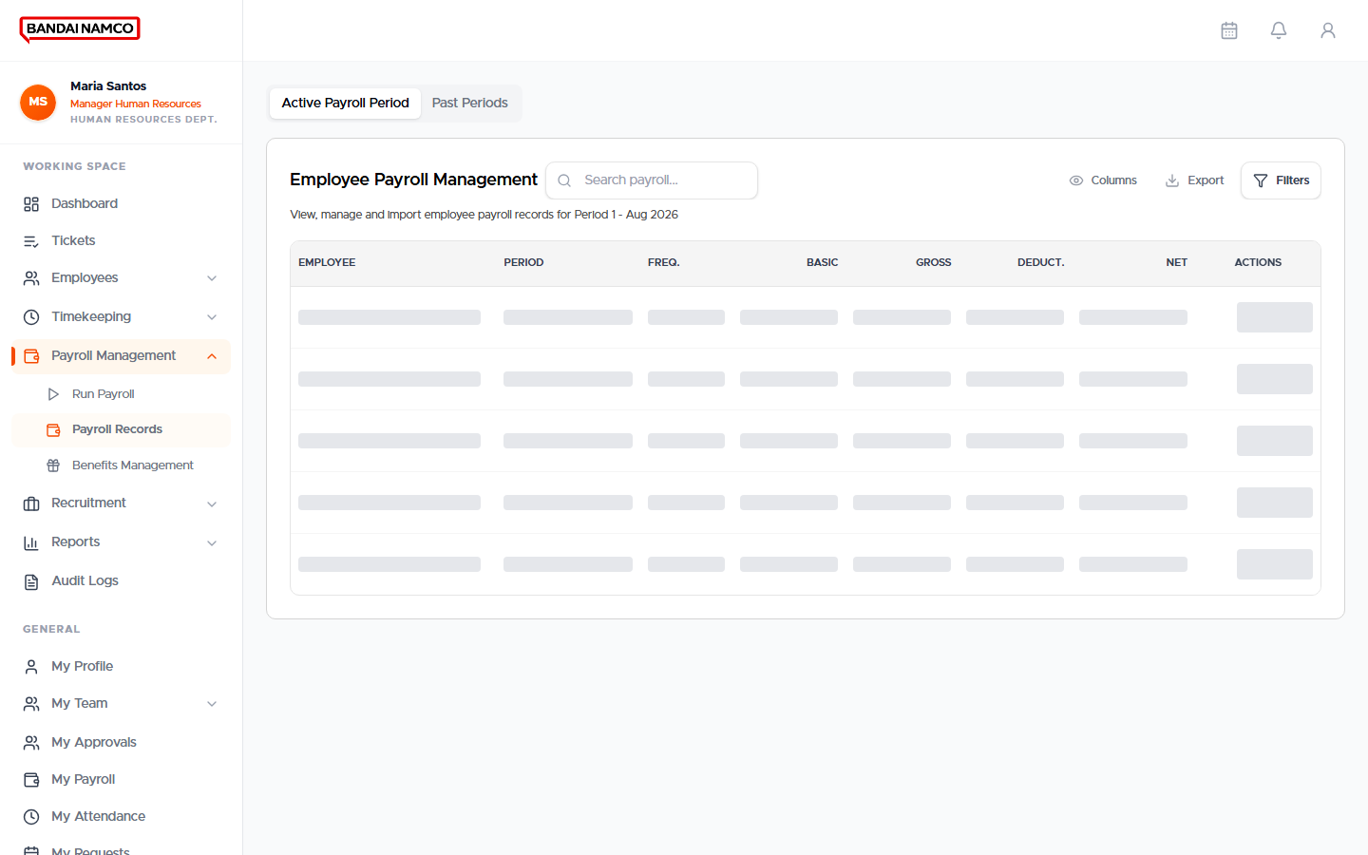
Figure 46. Payroll Records.
This is the register of generated employee payrolls. Open a person and period to see lines. Absence of a printable slip means the file was not produced yet, even if the money record exists.

Benefits Management
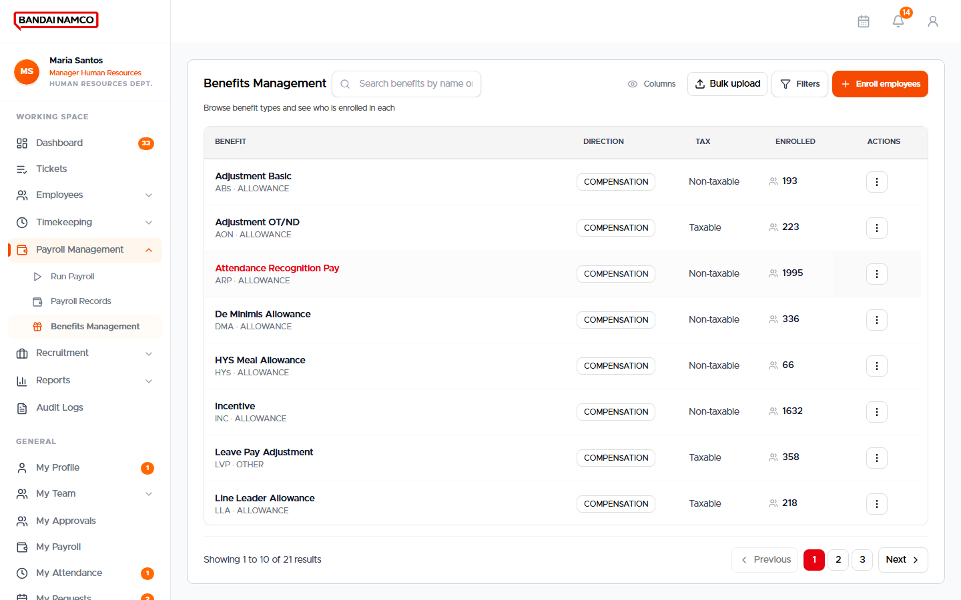
Figure 47. Benefits Management — types and enrolled counts.
- Open Payroll Management → Benefits Management.
- Each row is a benefit type. Enrolled is the true number of people, not a sample.
- Open a type to see who is enrolled.
- Click Enroll employees. Search for people — the list is larger than the first page, so type the name or employee number.
- Select people, confirm dates, and save.
- Meal allowance is expected for every Bandai employee, but HRIS will not invent it. Enroll it on purpose.

Recruitment
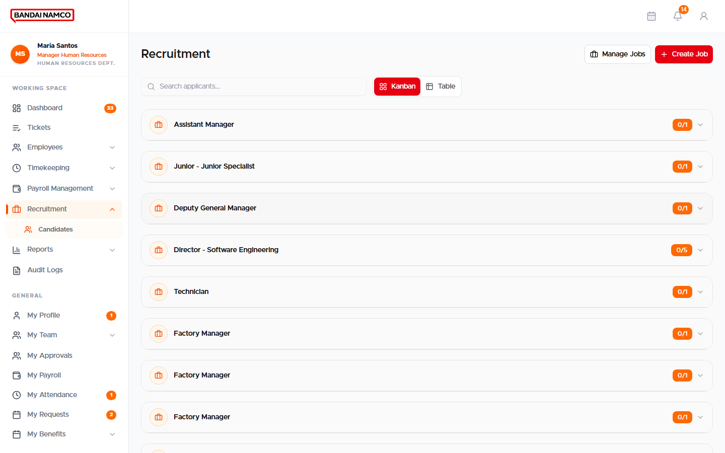
Figure 48. Recruitment — Candidates.
Move applicants from application to offer using the candidate board. Public applicants use the careers page. Do not create a second employee record if the person already exists in Directory — convert or link them.

Reports
Working Space → Reports holds Attendance Reports, Workforce Analytics, Payroll Reports, Turnover & Attrition, Compliance Reports, and Billings. Each report has its own date and department filters. Export from the report page when you need a file for finance or government.
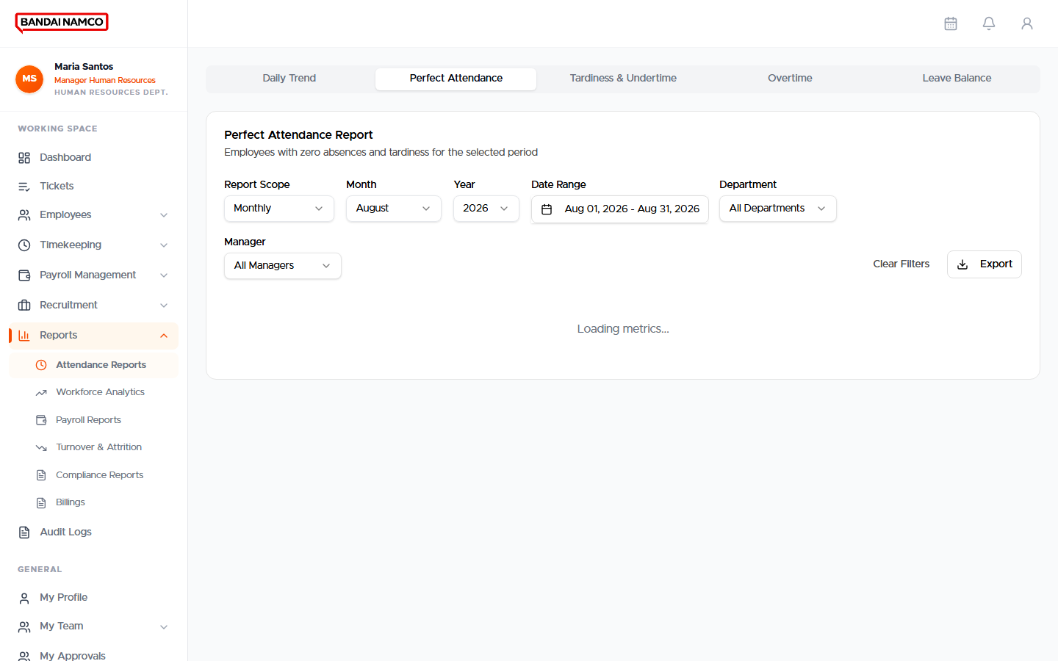
Figure 49. Attendance Reports.
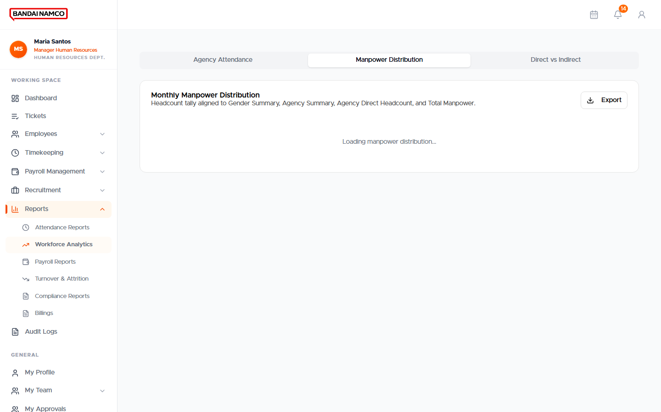
Figure 50. Workforce Analytics.
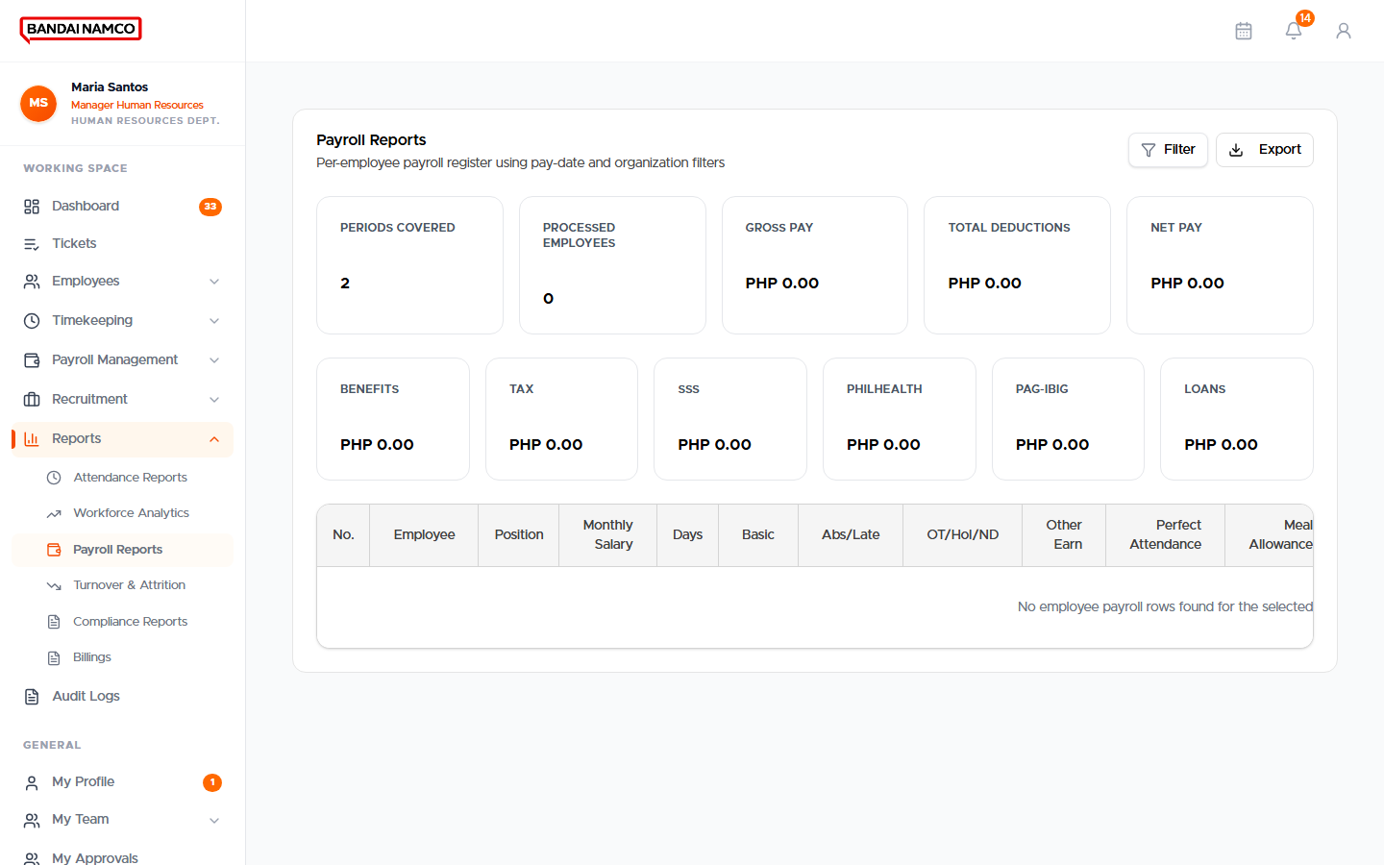
Figure 51. Payroll Reports.
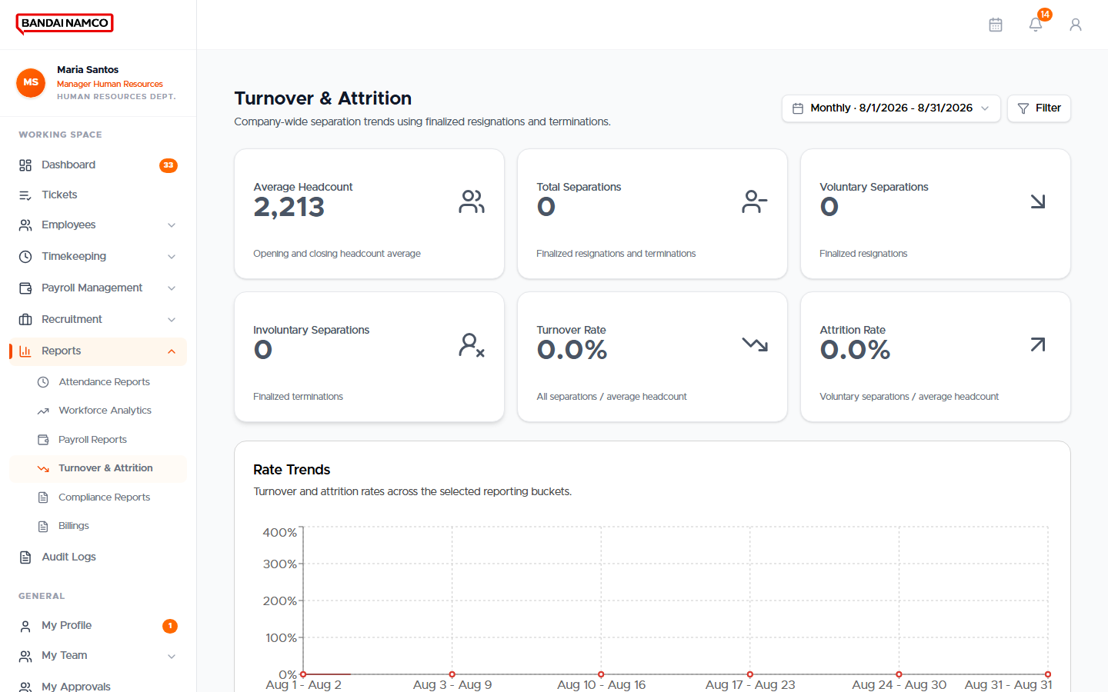
Figure 52. Turnover & Attrition.
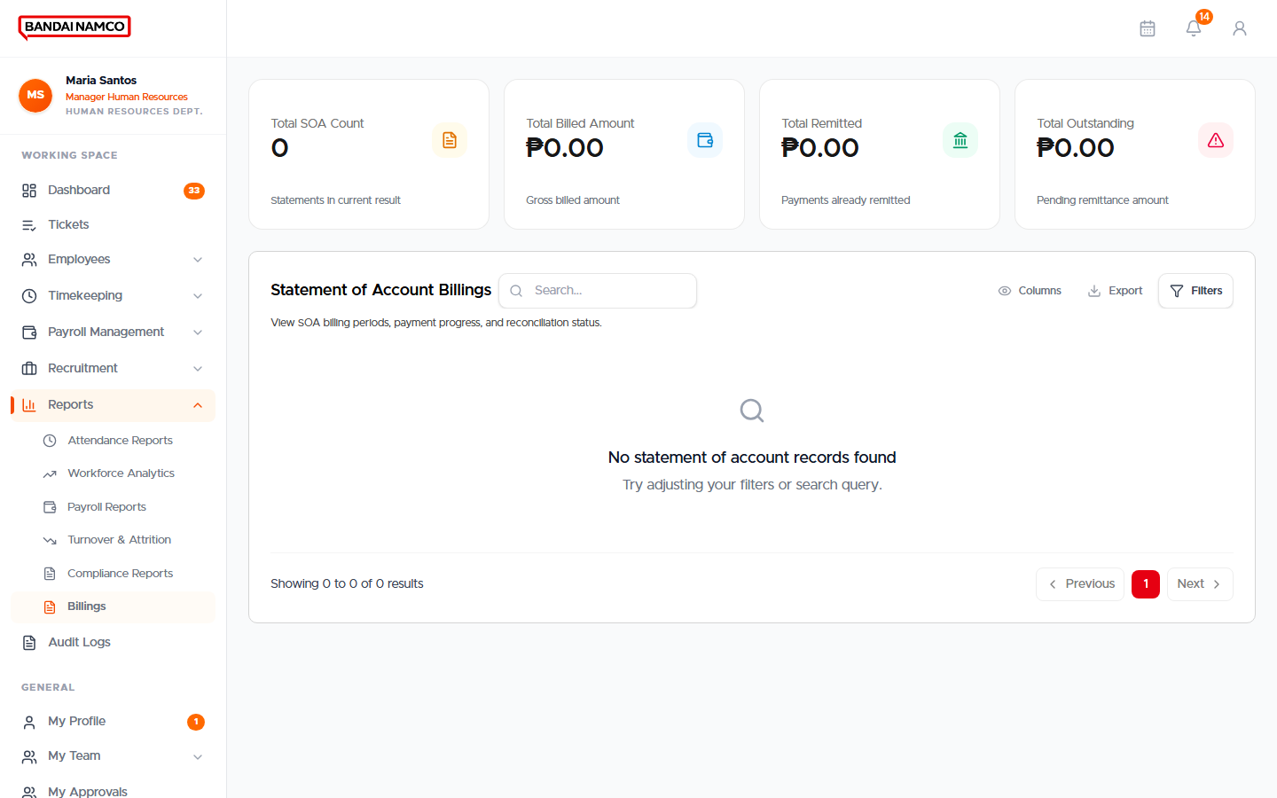
Figure 53. Billings.
Attendance report family includes daily trend, tardiness and undertime, overtime, perfect attendance, agency attendance, daily manpower, and related workforce views. Open the tab you need rather than exporting everything.

Audit Logs
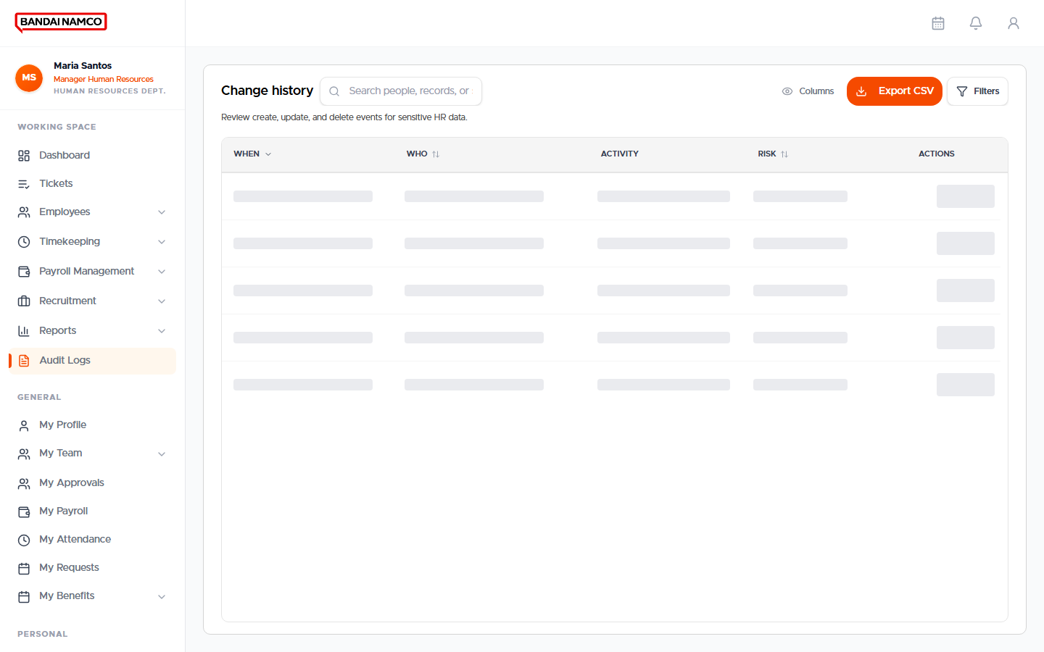
Figure 54. HR Audit Logs.
Use Audit Logs when someone asks who changed a record. Filter by date and person. This is a history, not an editor.

HR Manager checklist for a cutoff
- Confirm holidays and the payroll period.
- Confirm schedules are assigned.
- Clear attendance corrections and overtime approvals.
- Approve timesheets.
- Confirm benefits and loans that should apply this cutoff.
- Preview Payroll.
- Start Payroll and wait until it finishes.
- Spot-check Payroll Records and notify people that My Payroll is ready.

Time Keeper
A Time Keeper account opens a dedicated clock screen instead of the office Dashboard. Use it at a guarded desk or kiosk, not as a substitute for the fingerprint terminals at the door.
- Sign in with the Time Keeper account.
- Choose Clock In or Clock Out.
- Identify the person by the method on screen (face or code), then confirm the name before saving.
- If the name is wrong, cancel and start again. A wrong clock cannot be silently swapped later — HR will need an Attendance Request.

System Administrator
The system administrator workspace is separate. After sign-in you land on Admin Dashboard. The left menu has Working Space (Dashboard), then Configuration, Rules & Policies, and Loggings. There is no employee General group on this sidebar.
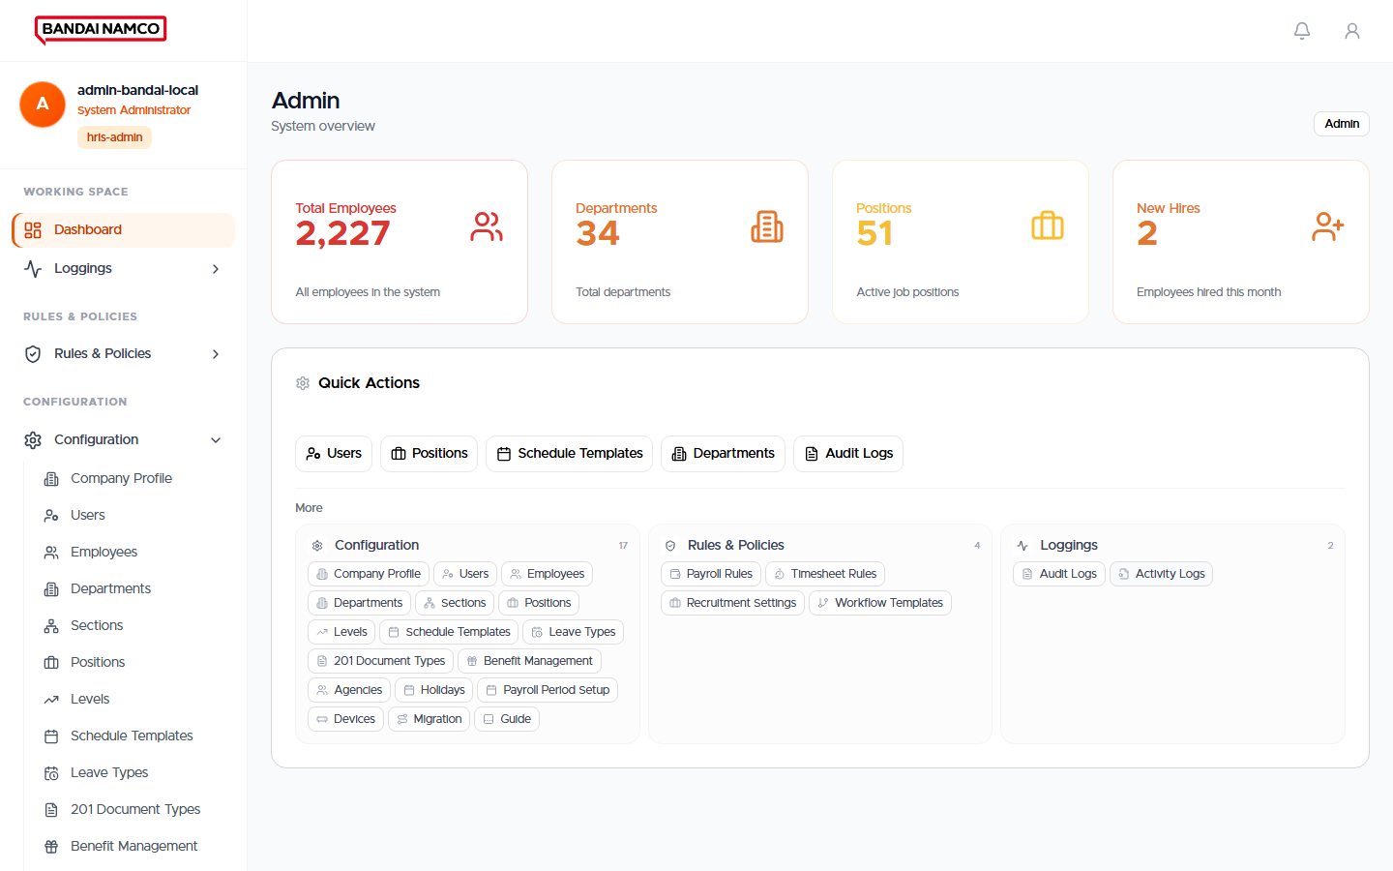
Figure 55. System Administrator Dashboard.

Configuration
Open each item from Configuration. These records drive what HR and employees see.

Company Profile
Company name, logo, and header identity. Keep the Bandai logo here so every screen stays branded.
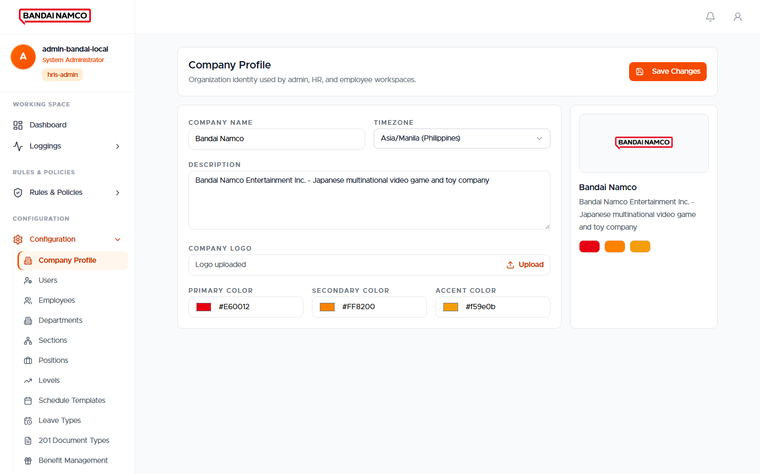
Figure. Company Profile.

Users
Sign-in accounts and roles. A person cannot open HR menus until the account role matches the job.
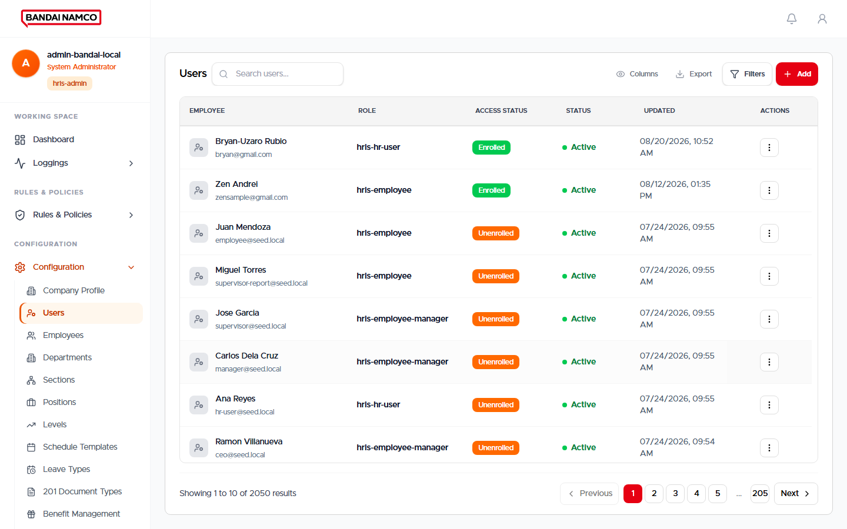
Figure. Users.

Employees
Administrator copy of the people list. HR’s daily list is Employees Directory; use this when you are configuring rather than doing HR casework.
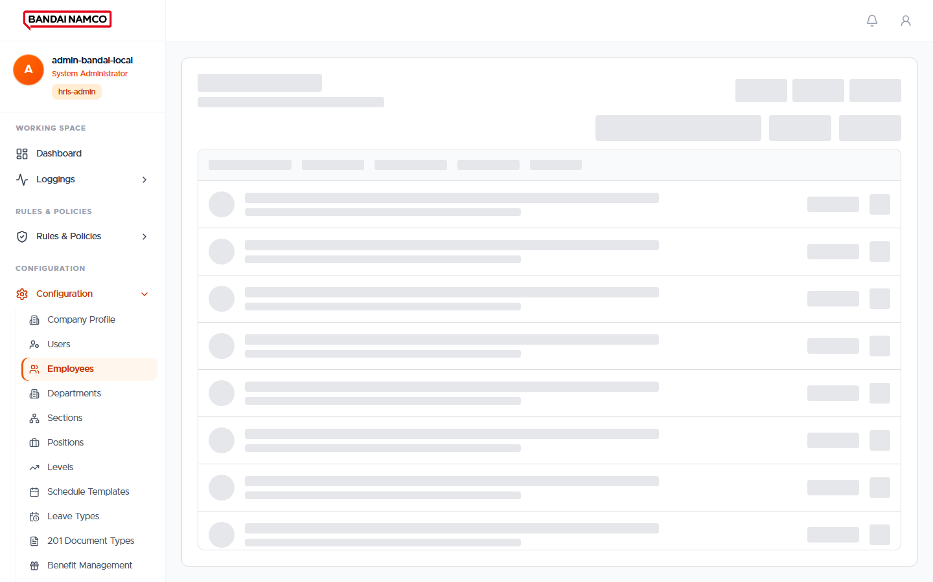
Figure. Employees.

Departments
Department names used on profiles, attendance grouping, and reports.
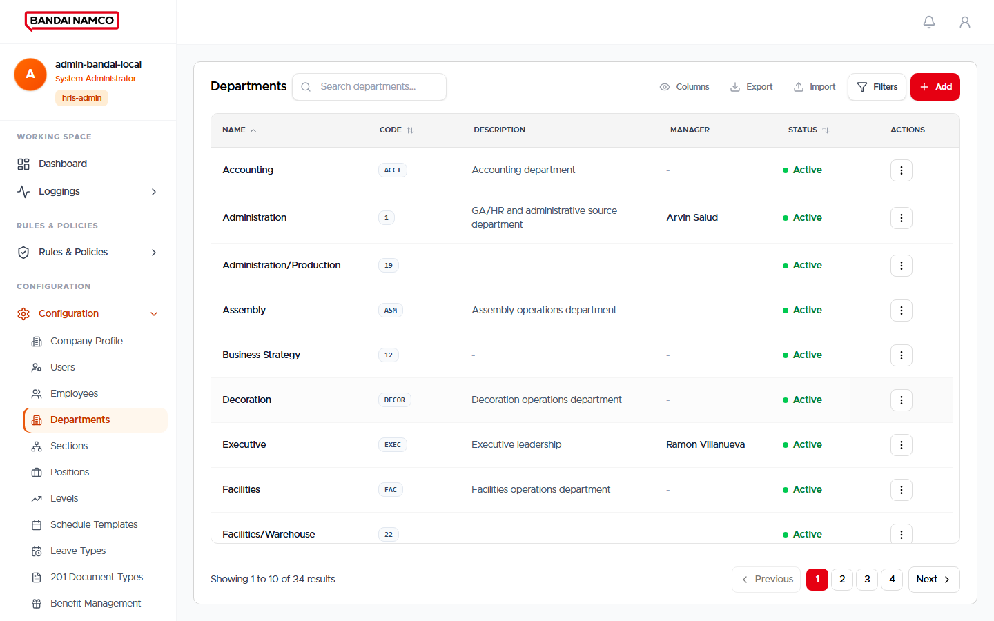
Figure. Departments.

Sections
Sections under departments.
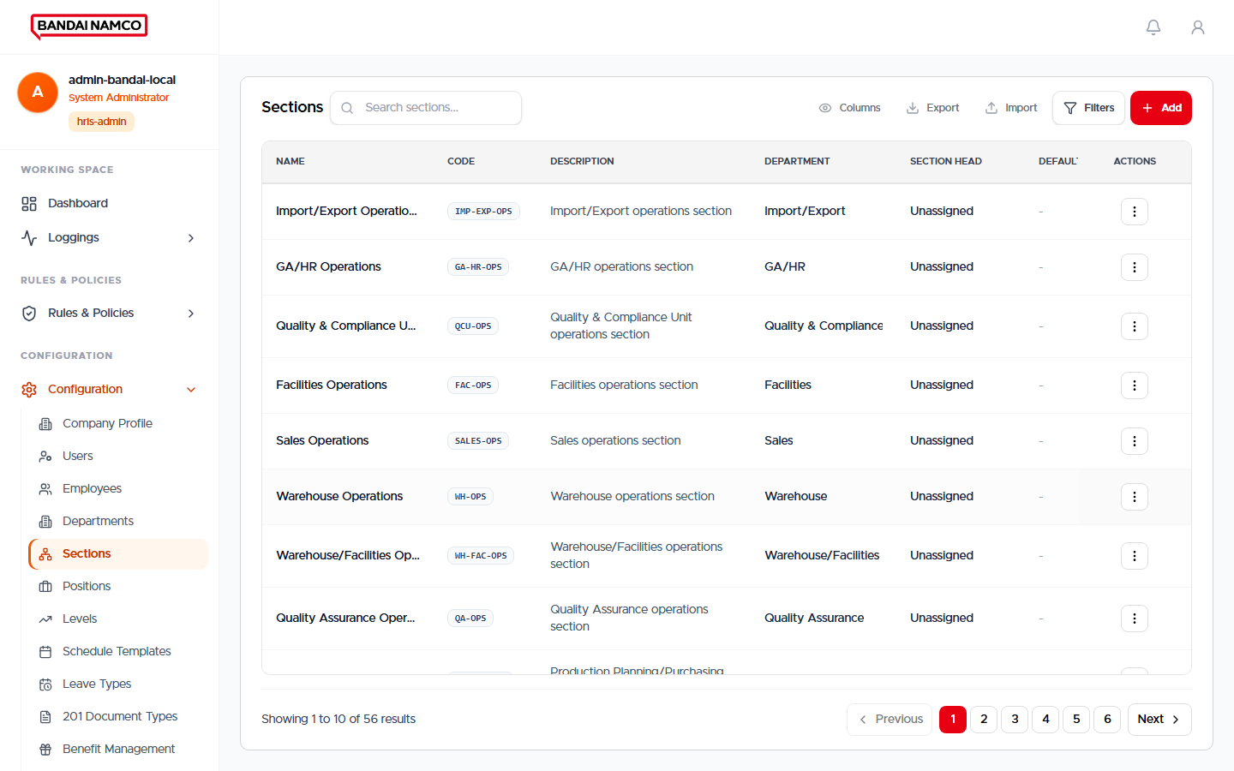
Figure. Sections.

Positions
Job titles.
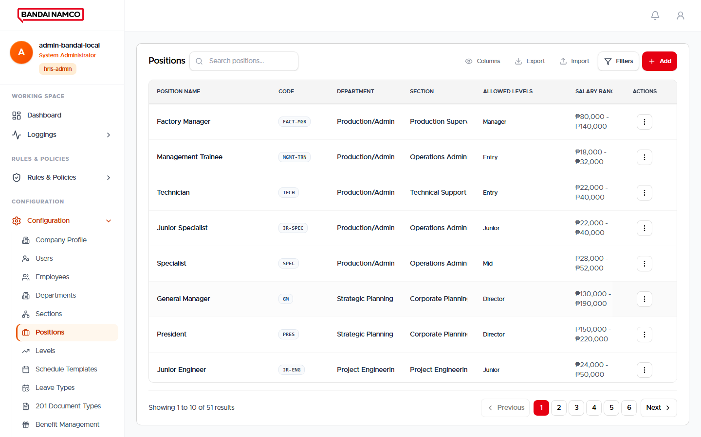
Figure. Positions.

Levels
Job levels.
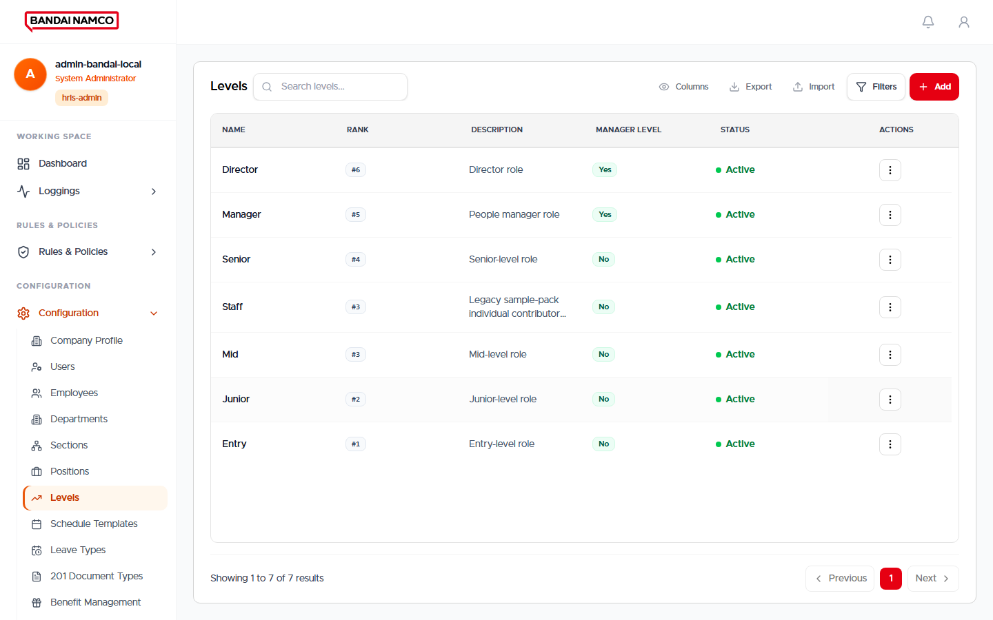
Figure. Levels.

Schedule Templates
Reusable work-week patterns. Assign a template to a person so Attendance knows regular days versus rest days.
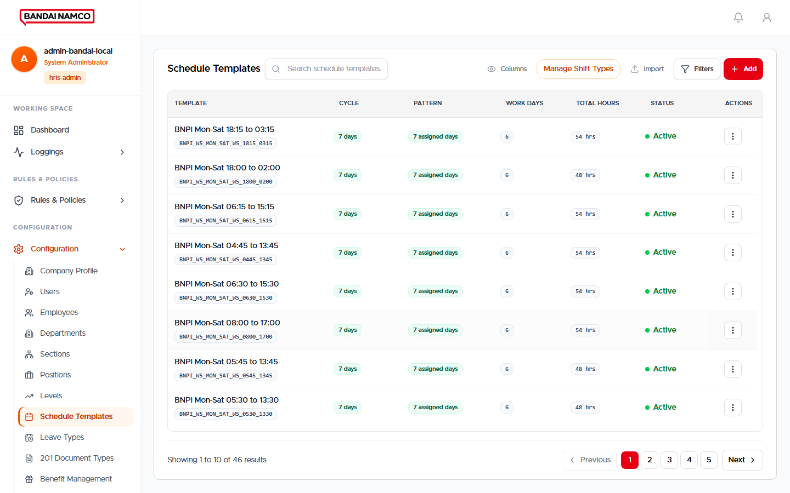
Figure. Schedule Templates.

Leave Types
Vacation, sick, and other leave names, and whether half day is allowed.
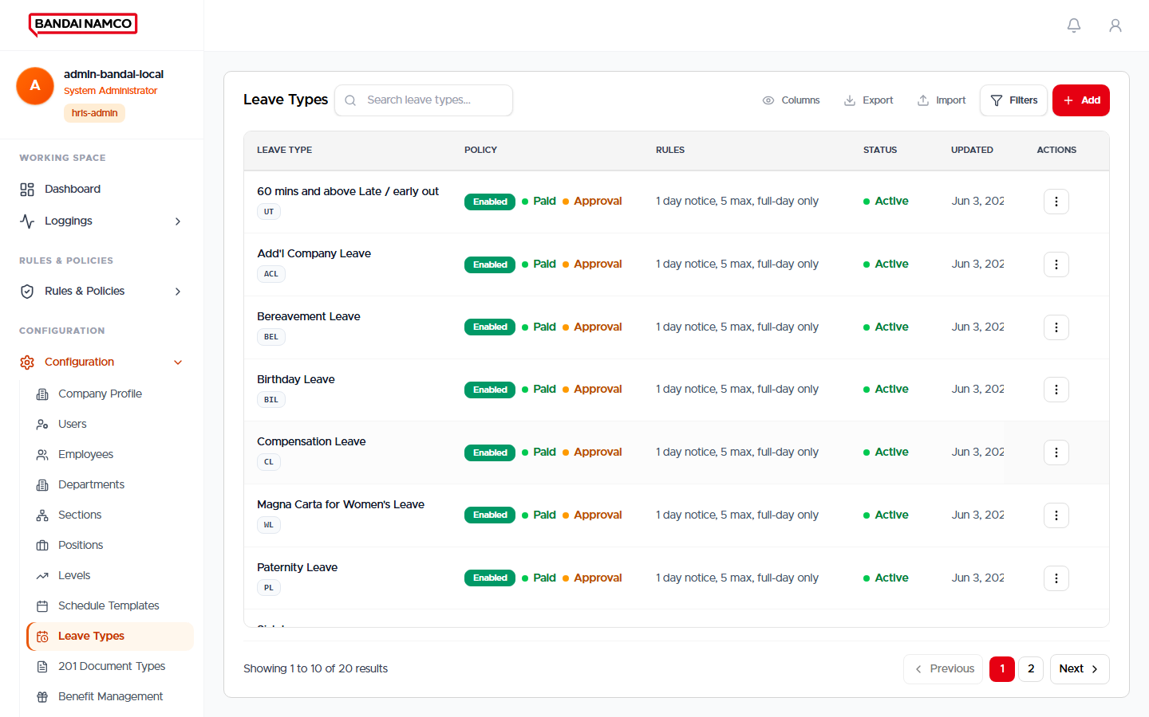
Figure. Leave Types.

201 Document Types
The checklist of papers each person must submit.
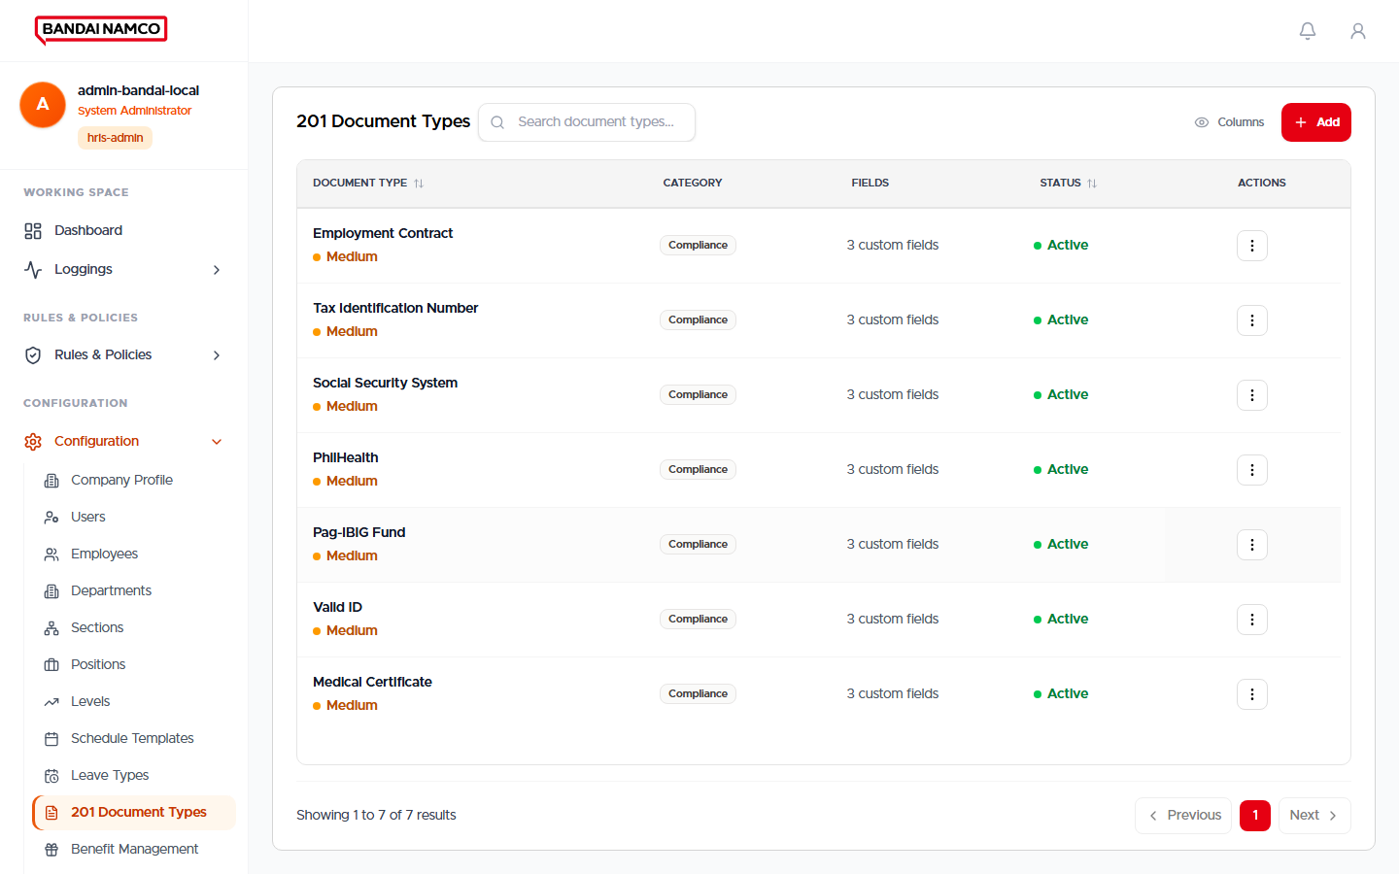
Figure. 201 Document Types.

Benefit Management
Benefit catalog that HR later enrolls people into.
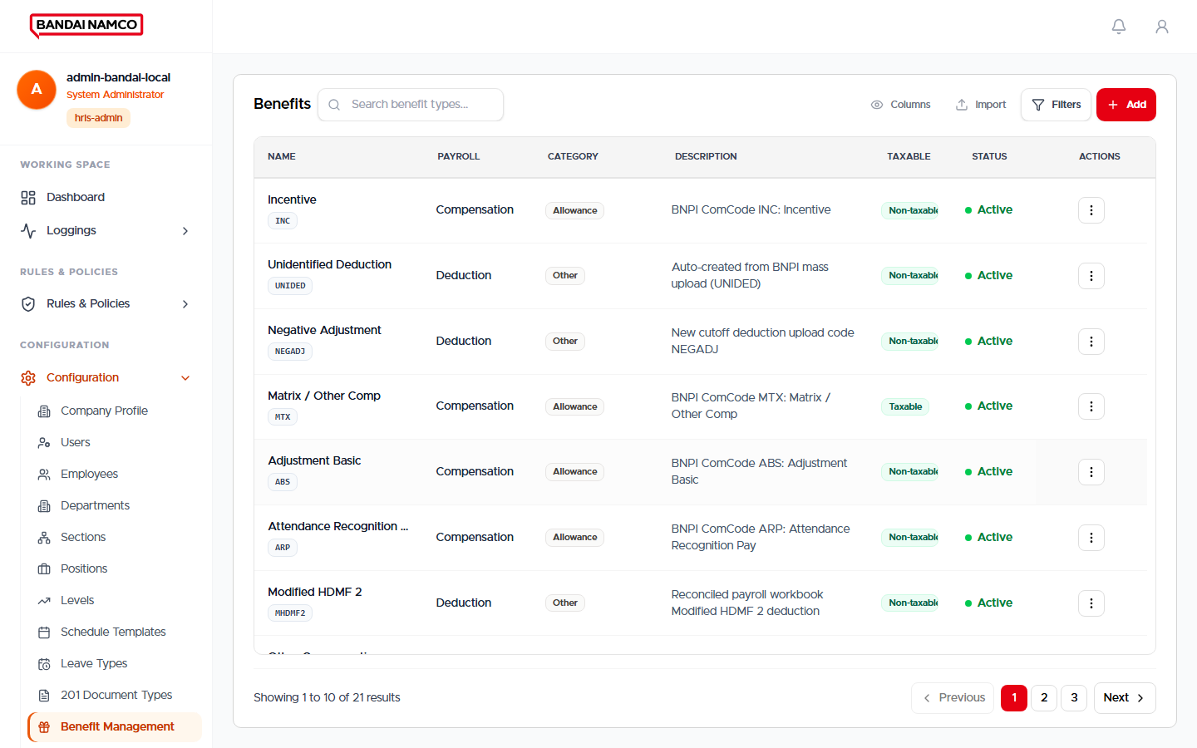
Figure. Benefit Management.

Agencies
Agency employers for contracted people.
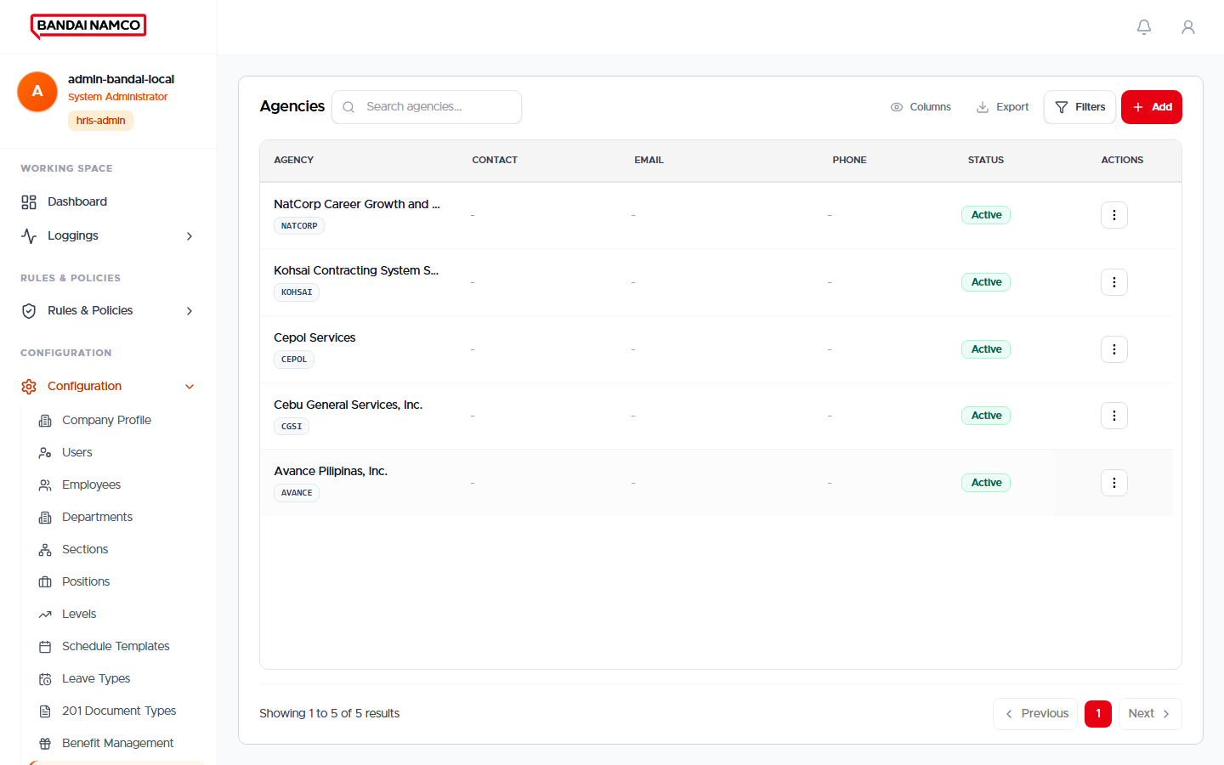
Figure. Agencies.

Holidays
Company holidays. Attendance and leave both read this calendar.
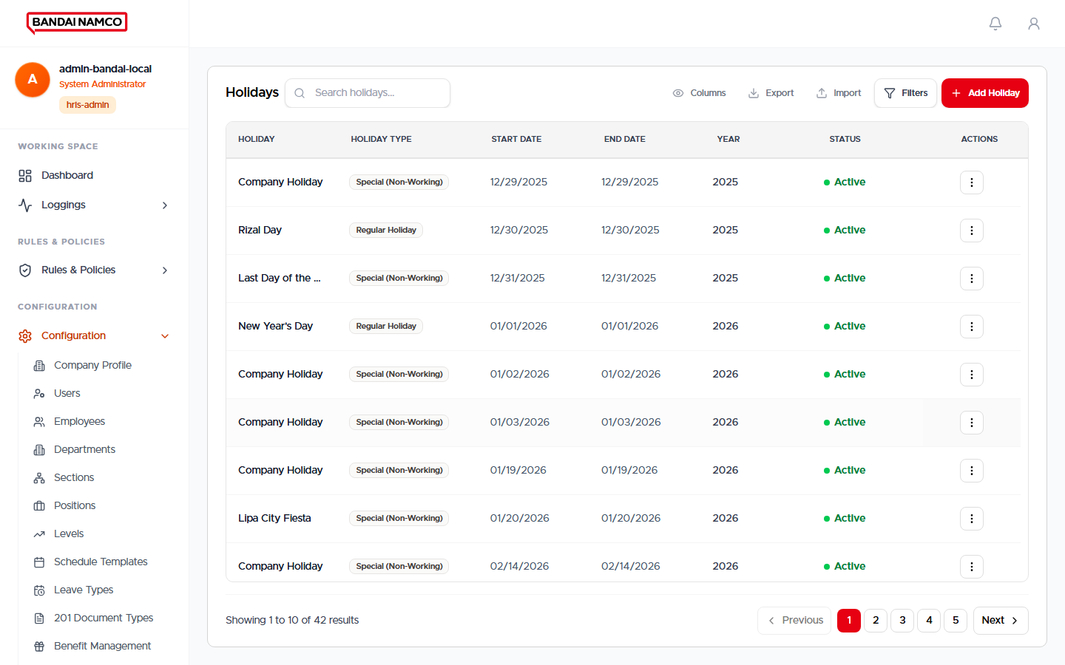
Figure. Holidays.

Payroll Period Setup
Cutoff start and end dates. HR runs payroll against these periods.
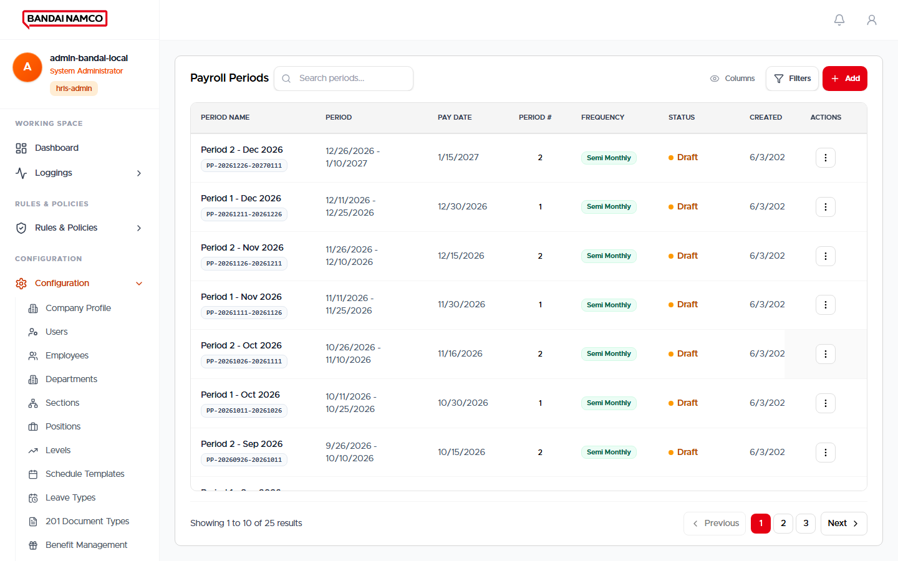
Figure. Payroll Period Setup.

Devices
Time terminals. Health here is whether the terminal can be reached, which is not the same as “someone just tapped.”
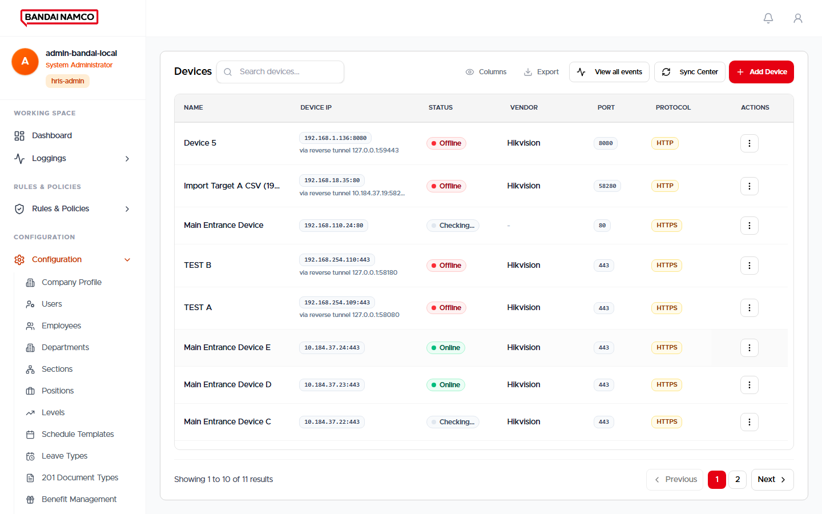
Figure. Devices.

Migration
Guided load of company workbooks (people, time, overtime, compensation). Use only with an agreed file and a preview before applying.
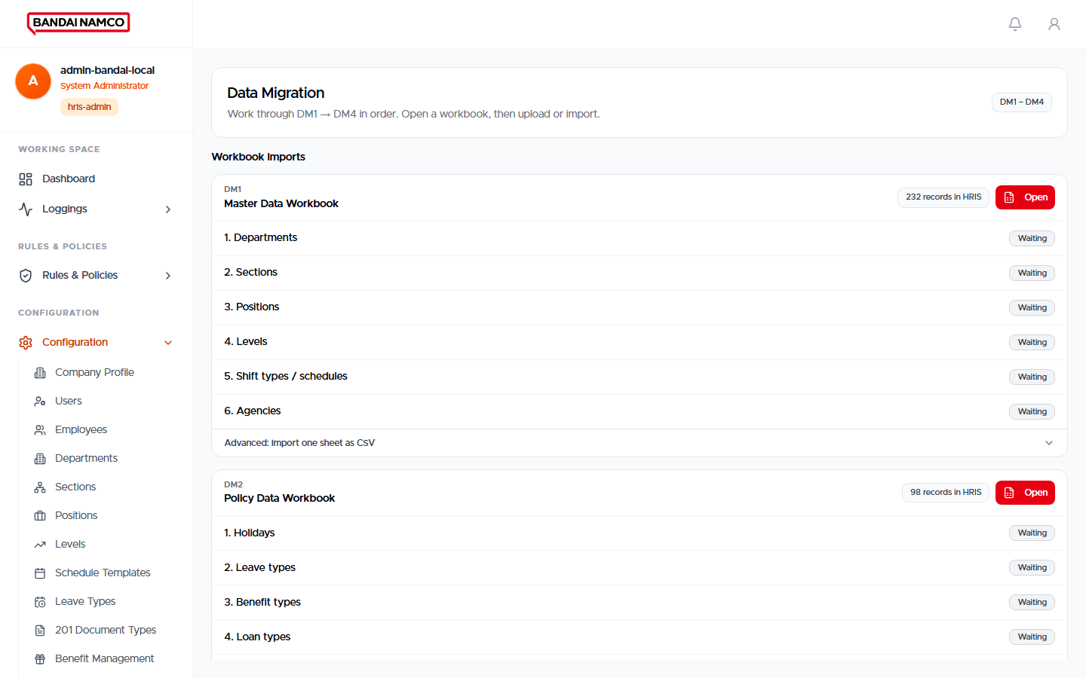
Figure. Migration.

Devices — Events and people on the terminal
From Devices you can open the live terminals, the saved event list, and the people enrolled on each terminal.
Figure 56. Devices list.
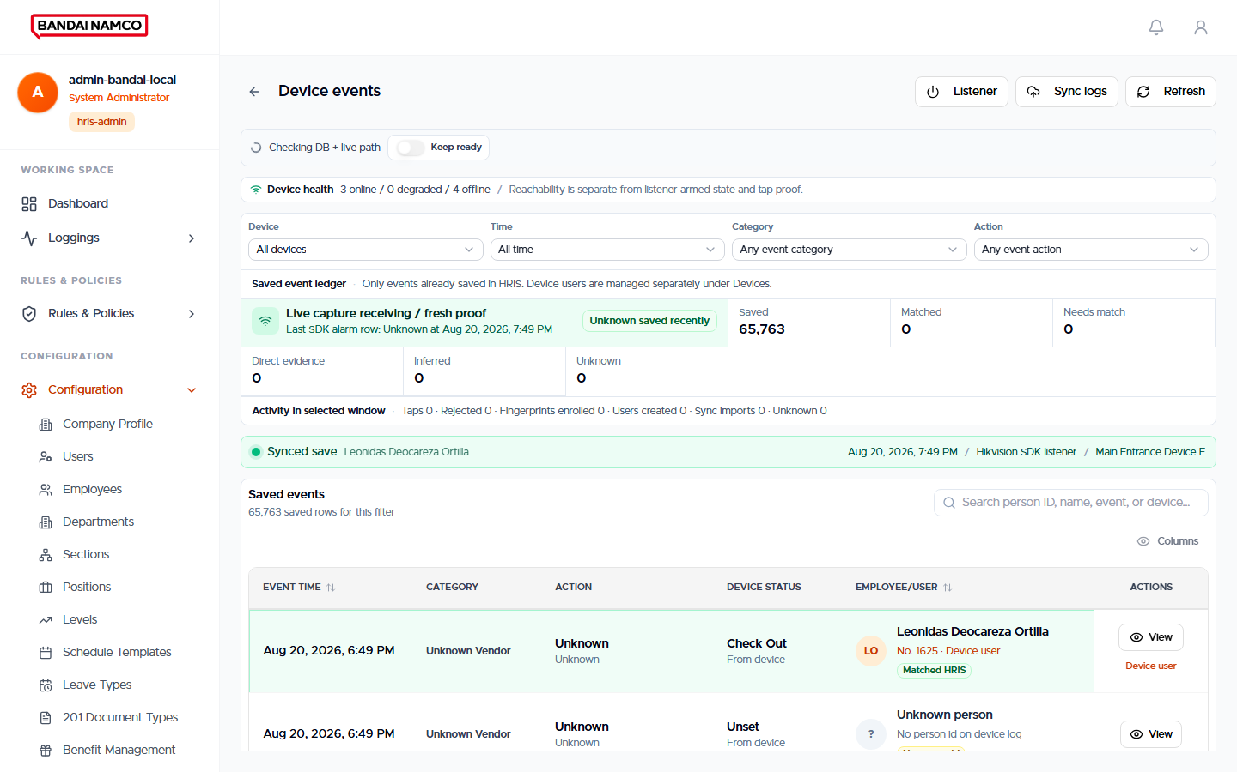
Figure 57. Device Events — saved punches and other terminal events.
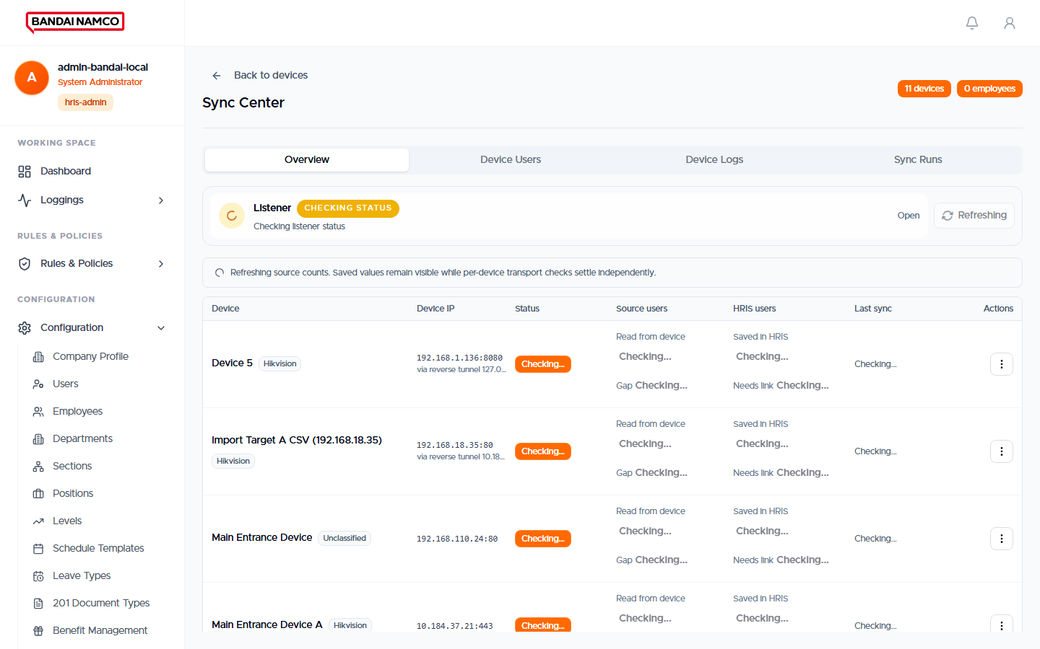
Figure 58. Device Users — people enrolled on the terminals.
- Device Events is the history of what the terminal reported (taps, enrollments, and other events). A tap should show the person and whether attendance was updated.
- Device Users is the current list of people living on the terminal, which you can link to an employee in HRIS.
- Preview time / Update time sets the terminal clock. Attendance uses the terminal’s own punch time, so wrong clocks break pairing of in and out.
- Reachable, ready for a tap, and actually receiving a tap are three different lights. Do not call a terminal “working” from a green ping alone.

Rules & Policies

Payroll Rules
Controls how pay is computed (including whether overtime needs approval). Change these only with HR written agreement; they affect the next generate.
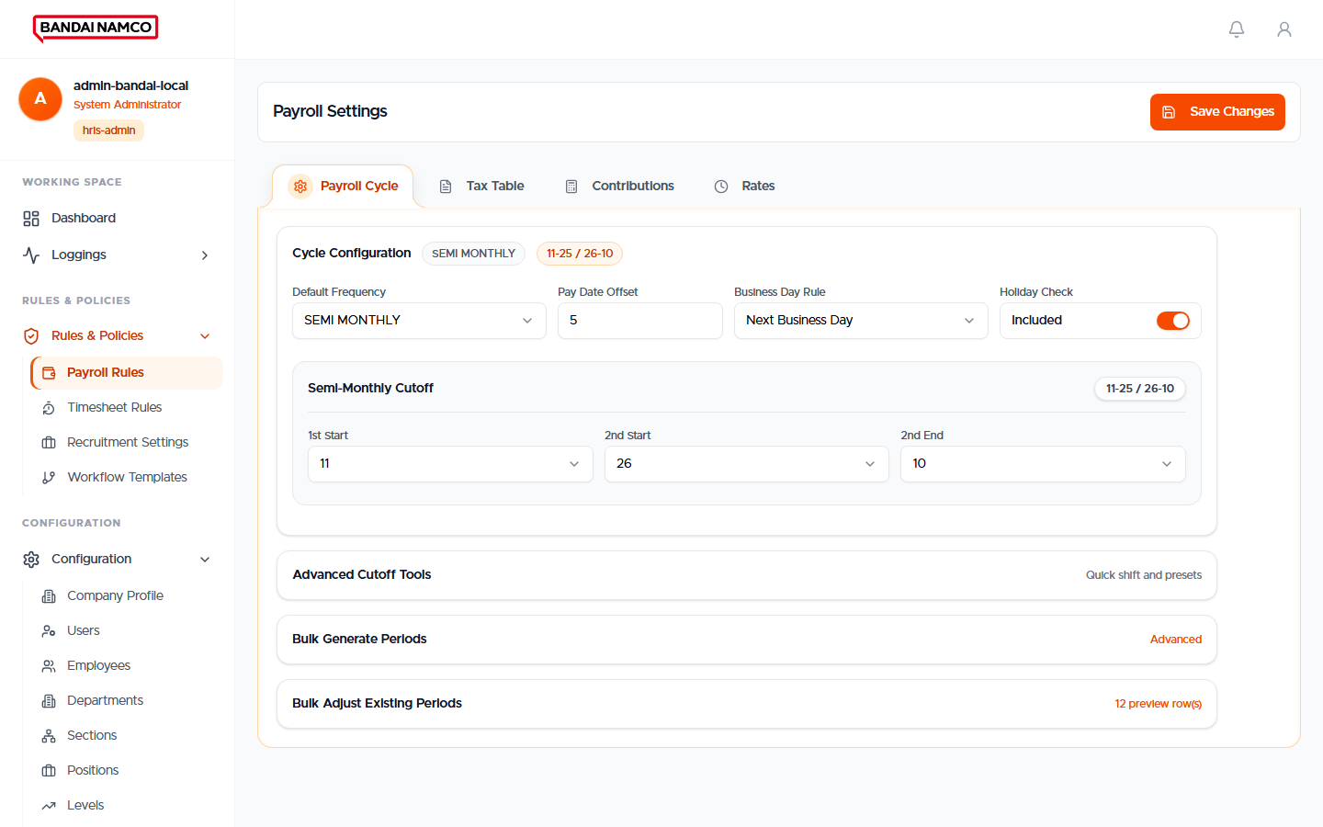
Figure 59. Payroll Rules.

Timesheet Rules
Controls how timesheets treat overtime flags and auto-approval. If manager-approved overtime is required, extra punches stay unpaid until a request or an approved overtime file is applied.
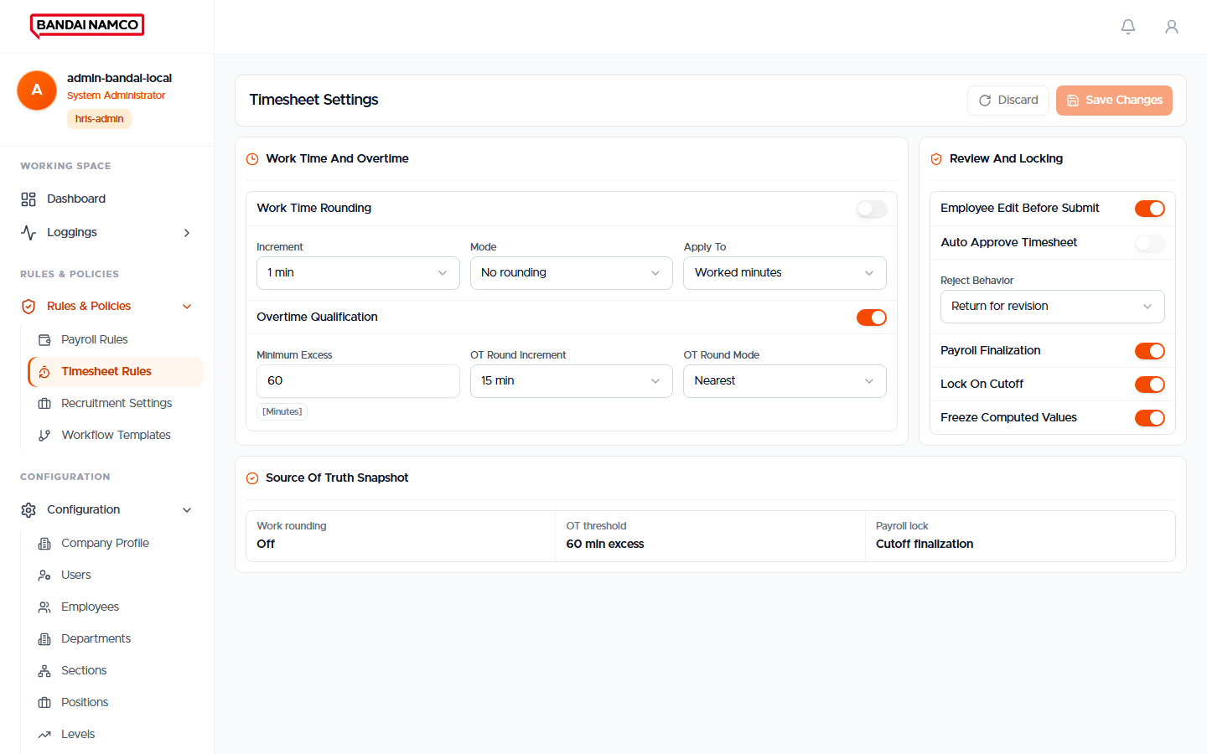
Figure 60. Timesheet Rules.

Recruitment Settings
Careers page and hiring options.
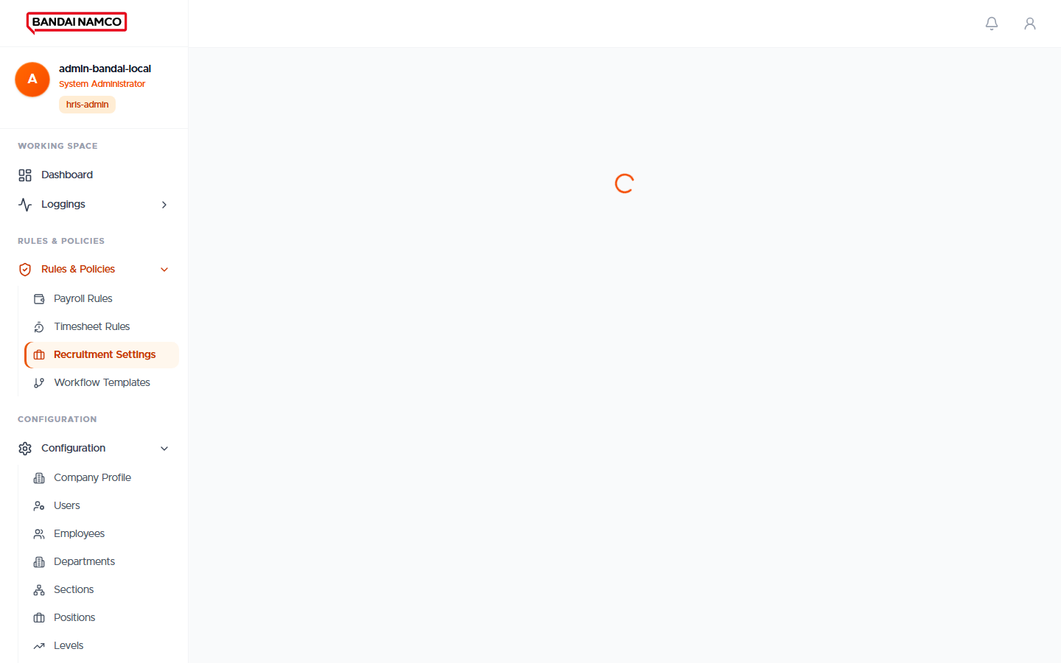
Figure 61. Recruitment Settings.

Workflow Templates
The path a request follows (for example employee → HR → done). Overtime in this company goes to HR. Do not shorten a path without telling HR, or reviews will sit in the wrong inbox.
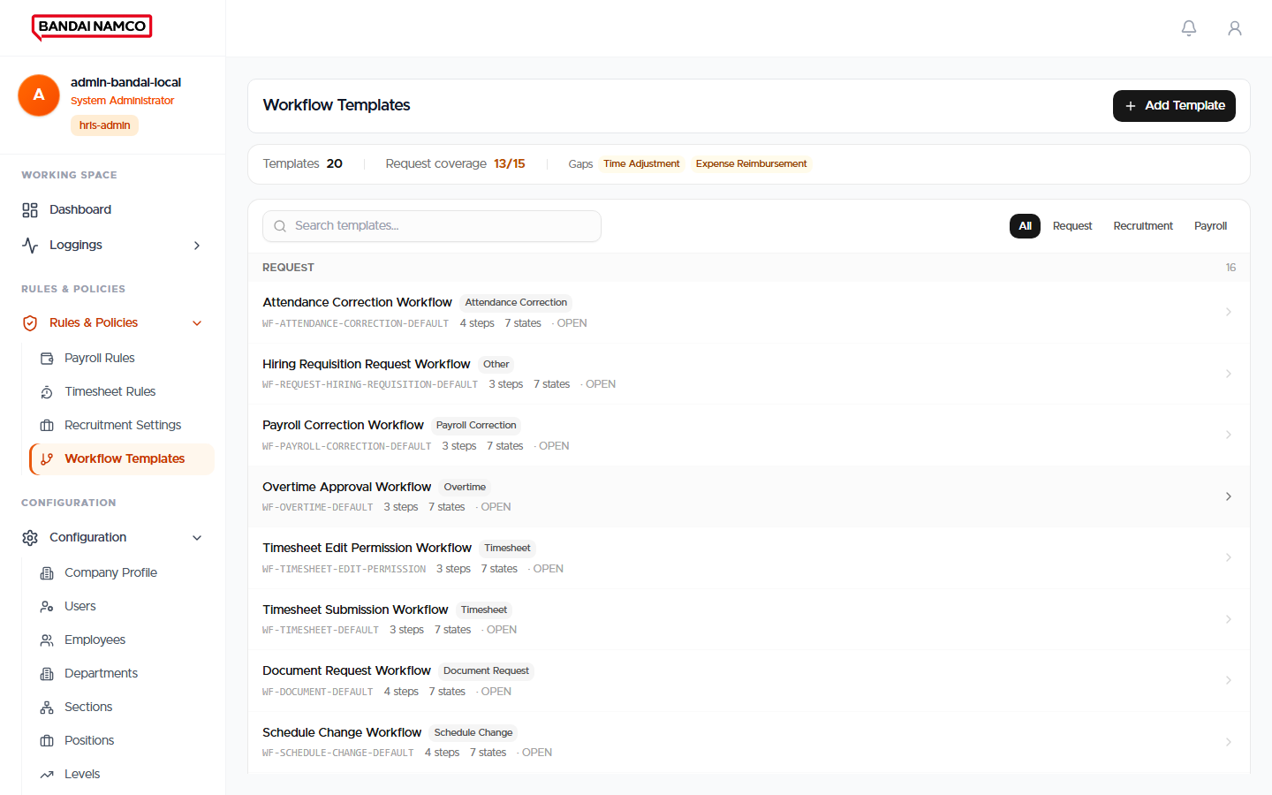
Figure 62. Workflow Templates.

Loggings
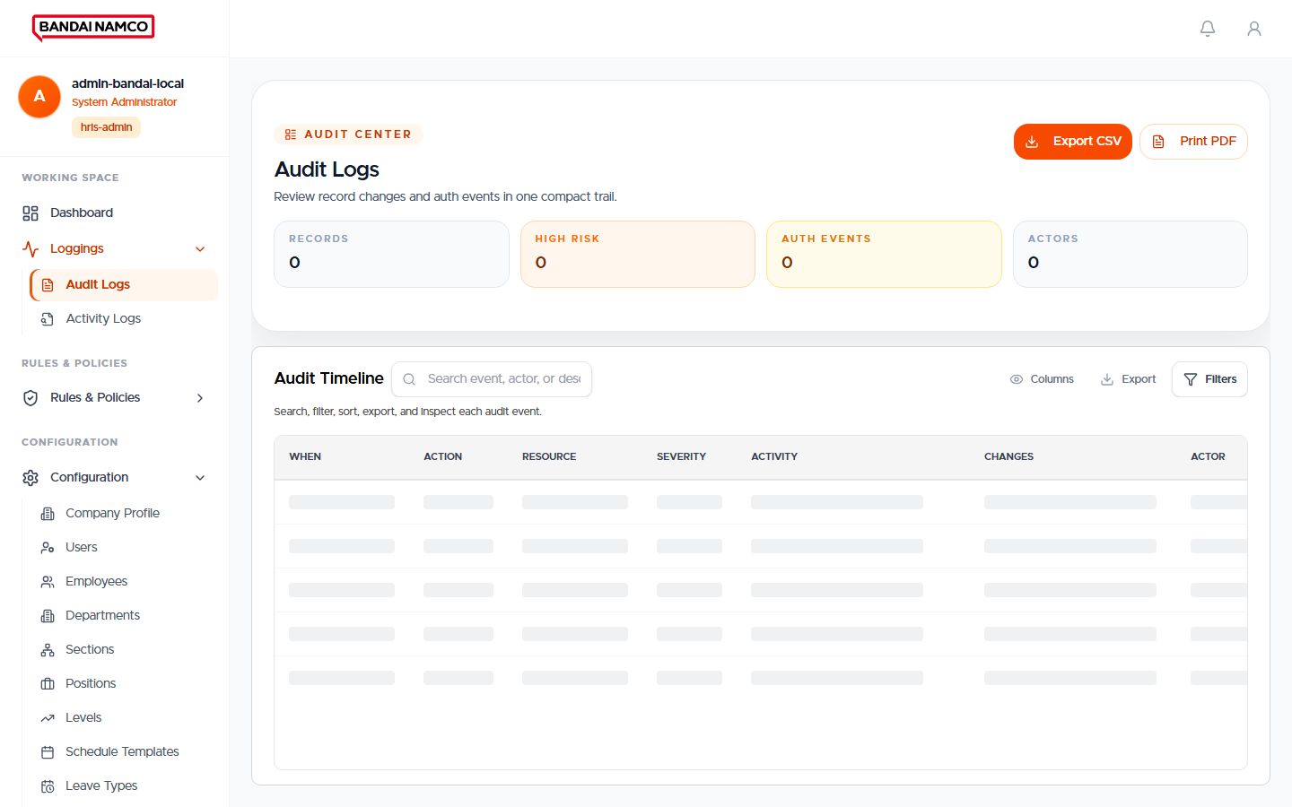
Figure 63. Administrator Audit Logs.
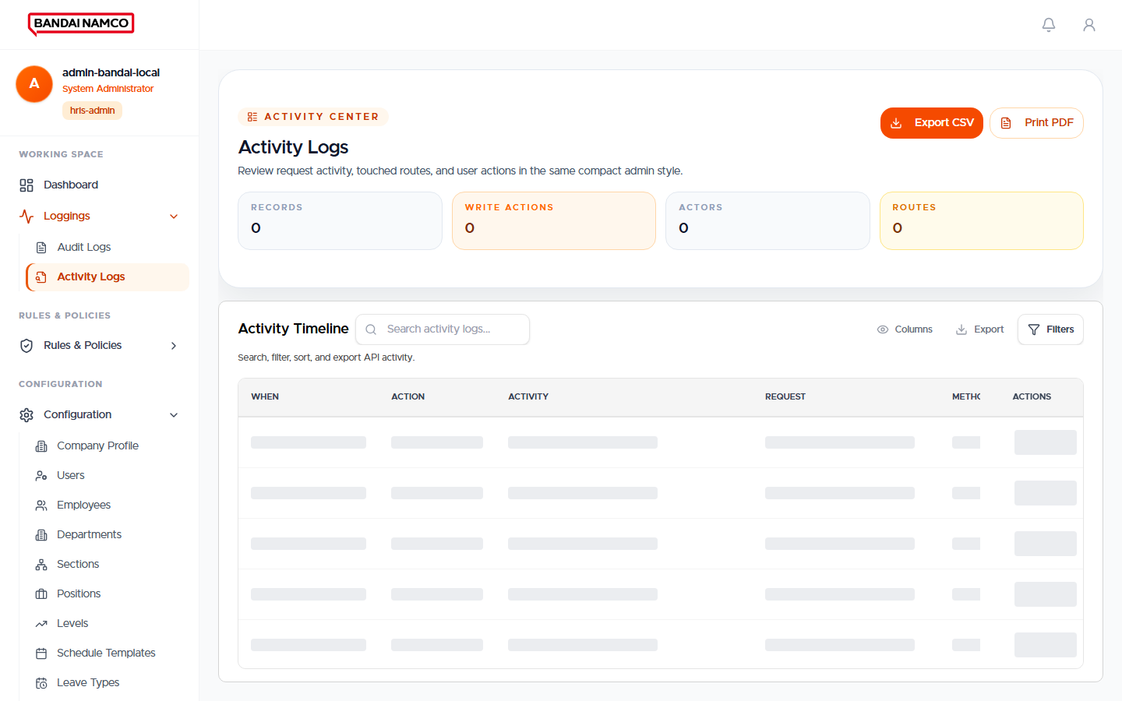
Figure 64. Activity Logs.
Audit Logs are official changes. Activity Logs are broader trail items. Use them when reconstructing who did what; never as a place to edit data.

Users and roles
Role you assign | Where the person lands | Menus they receive
Employee | Dashboard | Personal + General only
Employee Manager | Dashboard | Employee menus plus My Approvals and team tools
HR User | Dashboard | HR Working Space plus personal menus
HR Manager | Dashboard | Full HR Working Space plus personal menus
Time Keeper | Clock screen | Kiosk clock in / out
Administrator | Admin Dashboard | Configuration, rules, logs
Role must match the job
If someone in HR cannot see Employees Directory, the account is still an Employee role. If a regular staff member can open Attendance for the whole company, the account was given an HR role by mistake. Fix the role; do not teach people to bookmark hidden screens.

Administrator checklist
- Company Profile shows the Bandai logo.
- Departments, sections, positions, levels, and holidays are current.
- Payroll periods exist before HR tries to run a cutoff.
- Schedule templates exist before HR assigns them to people.
- Devices are reachable and clocks match Philippine time.
- New users receive the smallest role that still lets them do their job.

Shared Habits That Keep Records Honest

Time
- The company works on Philippine time.
- Your attendance day follows the terminal time, not the time your browser later received the punch.
- If two terminals disagree by a minute, in and out pairing can look late or undertime. Report clock drift to an administrator.

Requests versus punches versus pay
Thing | Is it pay? | Who confirms it
Fingerprint or face tap | No — it is time evidence | The person, then HR if disputed
Approved attendance correction | It repairs the day that payroll will read | HR Review completed
Approved overtime request | Yes — hours and minutes on the timesheet | HR
Approved timesheet | Yes — payroll will not run without it | HR
Standing benefit (for example meal allowance) | Yes, when enrolled and active for the cutoff | HR enrollment
Preview Payroll | No — display only | HR reviews numbers, then starts the real run

Searching lists
Large lists (employees, enrollments, device people) do not load every name at once. Type the employee number or a unique part of the name. If the page says you are seeing only part of the total, keep searching rather than assuming the person does not exist.

If Something Looks Wrong
What you see | Likely meaning | What to do
Cannot sign in | Wrong ID or password, or account not active | Retry once, then ask HR. Do not keep guessing.
Dashboard never appears; password screen stays | First sign-in password change is required | Set a new password that meets the rules.
A menu from this manual is missing | Your role does not include it | Ask HR or an administrator to check your role. Do not use someone else’s account.
My Attendance is blank but you worked | No punch stored, or the day is a rest day on your schedule | Confirm the terminal success message, then file an Attendance Request.
Present with no Clock In | Should not happen; Clocked Out is the honest label for out-only | Ask HR to review that day.
Overtime not in My Payroll | Request not approved, or timesheet not approved, or payroll not yet run | Check My Requests, then ask HR.
Leave type missing on the form | No remaining balance for that type | Ask HR to set the entitlement.
HR Preview looks empty | No approved timesheets in the period | Approve timesheets first.
Employee not in today’s scheduled count | No regular-day schedule, or the person is treated as separated | Assign a schedule; check employment dates.
Terminal tap did not show a name | The person is not enrolled or not linked | Ask an administrator to enroll and link the person on the terminal.

Quick Reference

Employee at a glance
- Sign in with Employee ID or Email.
- Dashboard → Action needed first.
- My Attendance every day you work.
- My Requests for leave, overtime, punch errors, documents, resignation.
- My Payroll after HR finishes the cutoff.
- Settings to change password.

HR at a glance
- Directory is the people list.
- Attendance is who should work and who punched.
- Corrections and overtime must be finished before timesheets.
- Approved timesheets before Preview Payroll, then Start Payroll.
- Enroll benefits on purpose; the generate step will not invent meal allowance.

Administrator at a glance
- Configuration is the company skeleton.
- Rules change how HR’s buttons behave.
- Devices need correct time and a linked person for every tap.
- Give each account only the role it needs.

Document Control
Item | Detail
Title | Bandai Namco Philippines, Inc. — HRIS User Manual
Audience | Employees, team managers, HR users, HR managers, time keepers, system administrators
Language | Everyday workplace English. Screen names match the product.
Pictures | Captured from the live Bandai HRIS screens. Your numbers and names will differ.
Version | 1.0 — 20 August 2026
Owner | Human Resources, Bandai Namco Philippines, Inc.
This manual describes the screens as they exist in the Bandai HRIS used by the company. If a label on your screen differs, follow the screen and ask HR to refresh this document.

