

The Sign in button and Sign up button are present on the top right of the home website (<https://www.github.com>). Clicking on the Sign up button will take you through a step by step process of creating an account. Github repositories are good for providing with employers a history of projects and contributions to other coding projects one person has made.

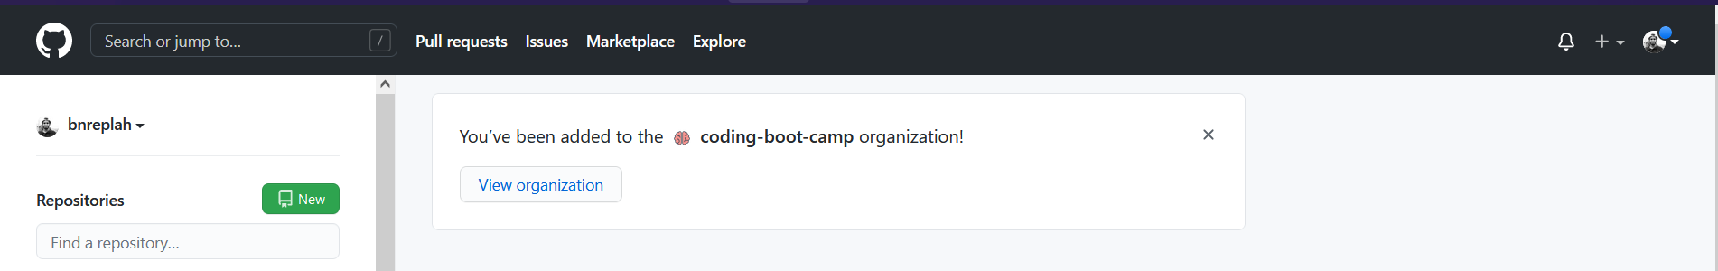

Your view may be different slightly, but generally in the top right is a plus sign, in which you would create new repositories. You can create and upload files here pretty simply.

If you click on the icon in the top right corner, a drop-down menu will appear with various option regarding your account. If you click on profile and repositories to see your profile and repository and make edits to them.