CASE STUDY
Text Mining - Project-Centric Analysis
Project Title: FaultTrace-RAG
Student Name: ________________________________
Register Number: _____________________________
Course / Section: ____________________________

1. Project Context
FaultTrace-RAG is a research project for finding the cause of wrong answers in analytical Retrieval-Augmented Generation (RAG). It divides the system into three stages: retrieval (selecting relevant records), extraction (reading facts from the records), and aggregation (calculating the final count, mean, comparison, ranking, or trend).
Textual data is important because the input question, retrieved passages, extracted facts, trace messages, and certificate reasons are all expressed as text. Mining this text can provide an early indication of which stage is likely to have failed.

Text documents selected for the case study
Document | Project example | Use
Query | Mean revenue for verified North-region records in Q2 | States the required scope and calculation
Retrieved text | Record R017: North; verified; revenue 84.2 | Provides evidence for extraction
Trace message | Missing record ID; scope coverage 0.76 | Signals a possible retrieval fault
Certificate reason | Aggregation replay mismatch | Signals a possible calculation fault

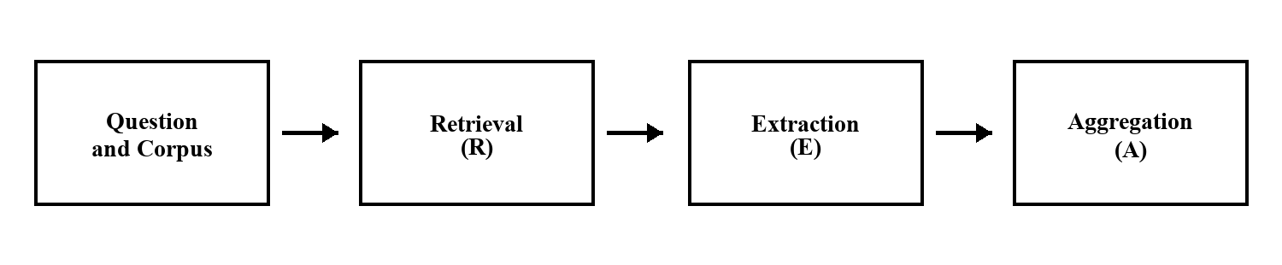
Figure 1. Main stages of FaultTrace-RAG.

2. Text Representation
The selected documents are converted into terms after lower-casing, tokenization, and removal of unimportant stop words. Project phrases such as missing record, scope coverage, fact fidelity, and replay mismatch should be kept as bigrams because their combined meaning is useful.
Measure | Meaning | Use in FaultTrace-RAG
Term Frequency (TF) | Number of times a term appears in one document | Highlights repeated local signals
Document Frequency (DF) | Number of documents containing the term | Shows whether the term is common
TF-IDF | TF multiplied by inverse document frequency | Gives more weight to distinctive fault terms

Important terms and features
Term / phrase | Likely meaning | Related stage
missing record | Relevant evidence was not selected | Retrieval
scope coverage | Completeness of the selected records | Retrieval
invalid field | A value could not be extracted correctly | Extraction
fact fidelity | Extracted value does not match the source | Extraction
wrong denominator | Incorrect value used in a proportion | Aggregation
replay mismatch | Recalculation does not reproduce the answer | Aggregation

Simple TF-IDF example
Assume there are 100 trace documents. The phrase replay mismatch appears in only 5 documents, while record appears in 90 documents. Replay mismatch receives a higher inverse document frequency and therefore a higher TF-IDF weight. It is more useful for identifying an aggregation fault than the common word record.
Term | Documents containing term | Expected TF-IDF importance
replay mismatch | 5 of 100 | High - distinctive
record | 90 of 100 | Low - common

Selected representation: word and bigram TF-IDF vectors created from the query, evidence summary, trace messages, and certificate reasons.

3. Feature Selection
Mutual Information (MI) is selected from the suggested methods. MI measures how strongly a term is associated with a class label. It is suitable because fault terms are sparse: a rare phrase such as replay mismatch can be very informative even when it occurs in only a small number of documents.
Example feature | Expected class | Reason for selection
missing record | Retrieval | Directly indicates incomplete evidence
invalid field | Extraction | Indicates a parsing or schema problem
replay mismatch | Aggregation | Indicates that the final calculation is inconsistent

4. Naive Bayes Classification
A Multinomial Naive Bayes classifier can use the MI-selected TF-IDF features. Its input is the combined text associated with one pipeline run. Its output is the most likely fault class. The method is appropriate for a small, sparse text dataset and produces an easily understood probability for each class.
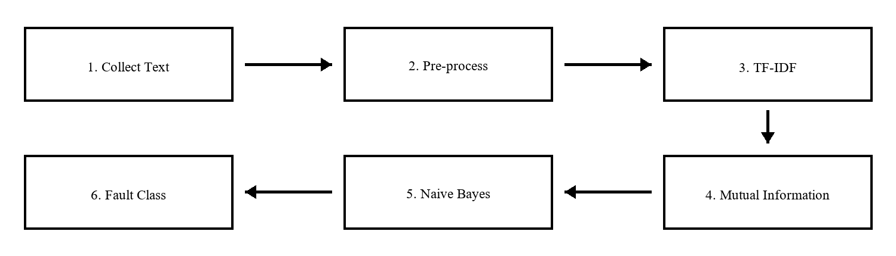
Figure 2. Proposed text-mining workflow.
Class | Expected input signals | Expected outcome
Retrieval fault | missing record; low scope coverage | Check query interpretation and retriever
Extraction fault | invalid field; low fact fidelity | Check parsing, schema, or model output
Aggregation fault | wrong denominator; replay mismatch | Check calculation and reducer
Clean / compound | no fault signal or several stage signals | Accept clean run or request deeper analysis

5. Project Insight
The proposed text-mining approach would act as a first-level diagnostic tool. It would not replace FaultTrace-RAG's counterfactual analysis. Instead, it would quickly identify the stage that should be inspected first and show the words or phrases supporting that decision.
Project benefit | Expected improvement
Faster fault triage | Direct failed runs to retrieval, extraction, or aggregation review
Explainable output | Display the important terms and the predicted class
Failure monitoring | Count recurring fault classes after system or data changes
Human review | Prioritize uncertain or compound cases for detailed analysis

Limitation / Challenge
Challenge | Effect | Control
Vocabulary shift | Real model errors may use different words from synthetic traces | Evaluate on external text and update the vocabulary
Class imbalance | Rare fault classes may be predicted poorly | Use balanced training data and class-aware evaluation
Compound faults | One run may contain signals from several stages | Send uncertain cases to full counterfactual diagnosis
Limited guarantee | Text similarity cannot prove that an answer is correct | Keep certification separate from classification

Expected Outcome
For every failed run, the system would produce a predicted class, a probability, and a short list of important terms. For example: Aggregation fault - 0.82 probability - important terms: replay mismatch and wrong denominator.

Conclusion
TF-IDF can represent FaultTrace-RAG text, Mutual Information can select the most useful terms, and Naive Bayes can classify the likely fault stage. This provides a simple and explainable support tool for the project, while detailed counterfactual replay remains the final diagnostic method.

Project Sources
Source | Information used
FaultTrace-RAG README and Architecture | Project objective, stages, and data flow
FaultTrace-RAG manuscript and verified results | Fault types, evaluation boundary, and terminology

