1. **描述性綱目**
2. **事件條列式**

|  |  |
| --- | --- |
| 描述性綱目 | 事件條列式 |
| 1. 使用者（買、賣家）登入，由系統進行驗證身份之後，若符合（使用者設定中的）賣家身份，可切換至賣家身份。 | 使用者+登入+應用程式  應用程式+傳送+登入請求  伺服器+接收+登入請求  伺服器+驗證+使用者名稱、密碼  伺服器+登錄+登入狀態  伺服器+回傳+登入結果  應用程式+接收+登入結果  應用程式+顯示+登入結果  使用者+傳送+切換身份請求  應用程式+傳送+切換請求  伺服器+接收+切換請求  伺服器+查詢+使用者設定  伺服器+更新+使用者登入狀態 |
| 1. 賣家可瀏覽今日銷售記錄、單個商品銷售記錄 | 賣家+發送+瀏覽請求  應用程式+接收+瀏覽請求  應用程式+發送+瀏覽請求  伺服器+接收+瀏覽請求  伺服器+回傳+銷售記錄資料  應用程式+接收+銷售記錄資料  應用程式+顯示+銷售記錄 |

1. **環境圖**

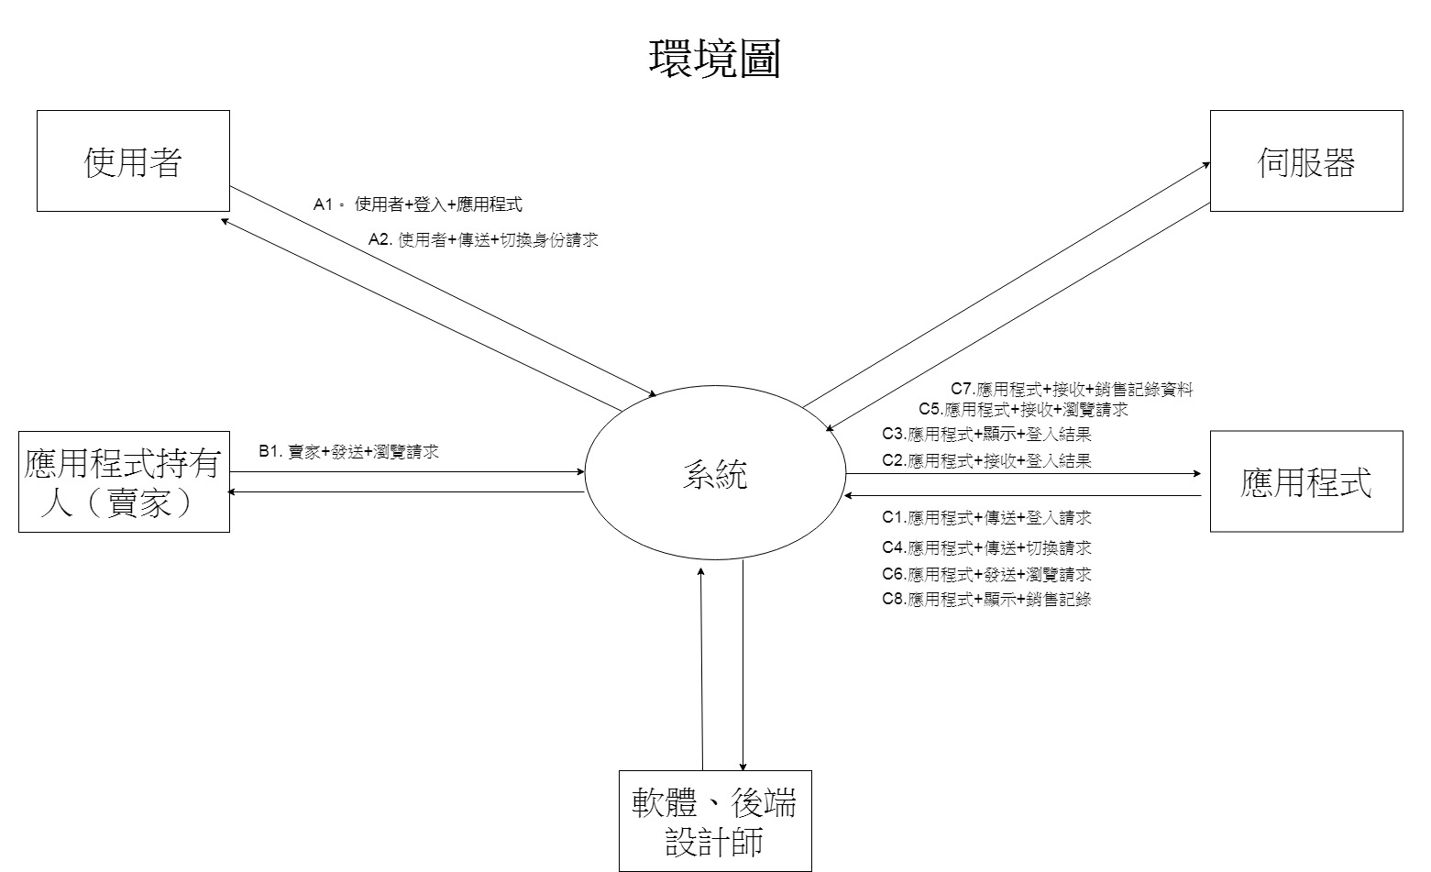

1. **流程圖  
   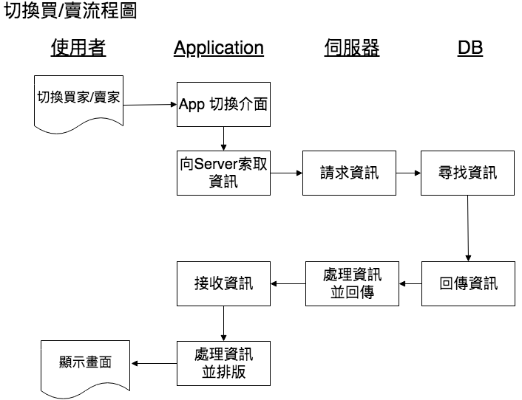**

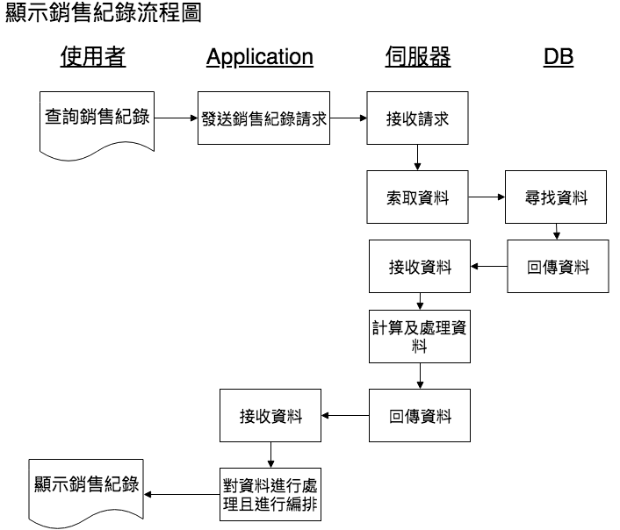

1. **藍圖**

|  |  |  |  |  |  |  |  |  |  |
| --- | --- | --- | --- | --- | --- | --- | --- | --- | --- |
| 賣家 | |  | |  | |  |  |  |  |
| 總銷售紀錄 | | | | | | | | | |
| 日期： | A | | | |  |  | 商店單位： | B | |
|  | |  |  |  | |  |  |  |  |
| **產品種類** | | **類型** | | **單位** | | **數量** | **金額** | **成本** | **盈利/亏损** |
| C | | D | | E | | F | G | H | G - H |
| 洗車液 | | 清潔用品 | | 個 | | 100 | $150,000.00 | $50,000.00 | $ 100,000.00 |
| 望後鏡 | | 汽車裝飾 | | 面 | | 30 | $12,000.00 | $6,900.00 | $ 5,100.00 |
| 汽车轮毂盖 | | 輪 | | 套 | | 20 | $40,000.00 | $23,000.00 | $ 17,000.00 |
| 汽車輪轂 | | 輪 | | 套 | | 40 | $320,000.00 | $125,000.00 | $ 195,000.00 |
| 汽車輪胎 | | 輪 | | 個 | | 12 | $12,000.00 | $4,000.00 | $ 8,000.00 |
| 汽車音響 | | 音響/喇叭 | | 個 | | 60 | $90,000.00 | $52,000.00 | $ 38,000.00 |
| 汽車音樂播放器 | | 音響/喇叭 | |  | | 30 | $120,000.00 | $30,000.00 | $ 90,000.00 |
| 汽車窗 隔熱膜 | | 全車套裝 | | 套 | | 80 | $900,000.00 | $325,000.00 | $ 575,000.00 |
| 總盈利/亏损 | | | | | | | | | $1,028,100.00 |

|  |  |  |  |  |  |  |  |  |  |  |  |  |  |  |  |  |  |  |  |  |  |  |
| --- | --- | --- | --- | --- | --- | --- | --- | --- | --- | --- | --- | --- | --- | --- | --- | --- | --- | --- | --- | --- | --- | --- |
|  | 單種商品的銷售 | | | | | | | | | | | | | | | | | | | | | |
| 產品種類： | | | A | | | |  | | | 商店單位： | | | | | | B | | | | | |
|  | | |  |  | | | | | | | |  |  |  | | | |  | | | | | |  |  |
| 產品類型： | | | C | | | |  | | | 單位： | | | | | | D | | | | | |
|  | |  | | |  |  | |  |  | | | | | |  | | | |  | |  |
| Receipt No. | | **日期** | | | **產品ID** | **產品名稱** | | 顧客 | | | **單價** | | | | | | **數量** | | | **金額** | |
| E | | F | | | G | H | | I | | | J | | | | | | K | | | L | |
| 00099 | | 2007/01/01 | | | 00115 | Pioneer AVH-4200NEX | | 林XX | | | $18,520.00 | | | | | | 2 | | | $37,040.00 | |
| 00105 | | 2007/01/03 | | | 00114 | Pioneer DEH-X6900BT | | 吳XX | | | $6,000.00 | | | | | | 1 | | | $6,000.00 | |
| 00109 | | 2007/01/03 | | | 00113 | Pioneer MVH-S405BT | | 姜XX | | | $8,500.00 | | | | | | 2 | | | $17,000.00 | |
| 00201 | | 2007/01/07 | | | 00121 | BOSS AUDIO BV9967B | | James | | | $9,200.00 | | | | | | 2 | | | $18,400.00 | |
| 00210 | | 2007/01/10 | | | 00111 | Pioneer MVH-S105UI | | 輪XX | | | $5,200.00 | | | | | | 1 | | | $5,200.00 | |
| 00222 | | 2007/01/15 | | | 00112 | Pioneer MVH-S105UI | | 林XX | | | $5,150.00 | | | | | | 3 | | | $15,450.00 | |
| 00230 | | 2007/01/20 | | | 00101 | Kenwood DPX502BT | | 陳XX | | | $4,430.00 | | | | | | 2 | | | $8,860.00 | |
| 00231 | | 2007/01/21 | | | 00131 | Sony XAV-AX100 | | John | | | $12,050.00 | | | | | | 1 | | | $12,050.00 | |
| 總盈利/亏损 ( M ) | | | | | | | | | | | | | | | | | | | | $120,000.00 | |

1. **資料流程圖（兩層即可）**
2. **建構圖**