学术报告
报告题目：A systematic approach to untwine the signaling
pathways and gene regulatory networks in fission yeast

时间：9月9日(周三) 16:00

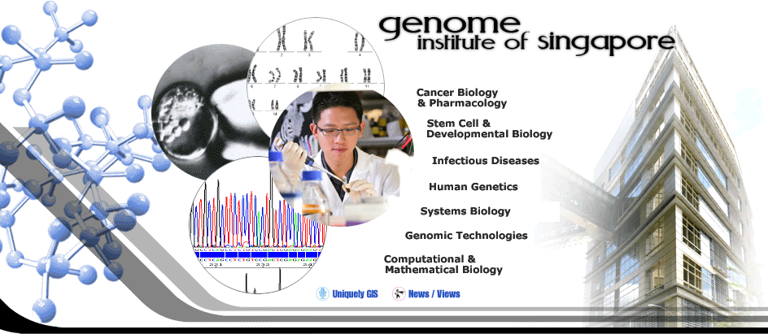
地点：生科院机房
报 告 人：Jianhua Liu, Ph.D.
报告人简介：
Dr. Jianhua Liu is a Group Leader, Head of the Systems Biology Laboratory at the Genome Institute of Singapore and is an Associate Professor (adjunct) at the Department of Biochemistry, the National University of Singapore. He earned a Bachelor’s degree from Fudan University, Shanghai, China and a Ph. D. degree from the Free University of Brussels, Belgium. He did his post-doc training in the National Cancer Institute, National Institutes of Health at Bethesda, Maryland, USA. His current researches are focused on the analysis of protein kinase-mediated signaling pathways and gene-regulatory networks in a unicellular model organism Schizosaccharomyces pombe.

