FPT UNIVERSITY — HO CHI MINH CITY
FACULTY OF INFORMATION TECHNOLOGY
DSP501 — DIGITAL SIGNAL AND IMAGE PROCESSING
FINAL RESEARCH REPORT

Unsupervised Classroom Acoustic Anomaly Detection
Using Digital Signal Processing and Deep Autoencoders
GROUP 4
Authors: Lê Phạm Bá Học (26MS23359), Phạm Nguyễn Việt Hưng (26MS23358)
Instructor: Đặng Ngọc Minh Đức | Class: MSA40HCM | Semester: 1
Date of Submission: August 2026

1. Abstract
Acoustic anomaly detection in educational environments plays a pivotal role in ensuring student safety, detecting emergencies (e.g., violent screams, glass fractures, physical impacts), and monitoring classroom disruptions. However, real-world classroom surveillance faces two fundamental bottlenecks: (1) anomalous events occur with extreme rarity, precluding supervised classification paradigms, and (2) background environmental noise (HVAC humming, floor reverberations, and conversational babble) severely distorts raw acoustic waveforms. In this paper, we propose a rigorous, unsupervised classroom acoustic anomaly detection framework integrating classic Digital Signal Processing (DSP) front-ends with a PyTorch Deep Autoencoder. The DSP pipeline systematically executes zero-phase IIR Butterworth bandpass filtering (80–7500 Hz), Short-Time Fourier Transform (STFT) with Hann windowing, and 6-band spectral sub-band power extraction. The Autoencoder is trained strictly on unlabelled normal classroom sounds (zero abnormal contamination), establishing an anomaly decision boundary at the empirical 97th-percentile reconstruction MSE error. To rigorously evaluate the contribution of each signal processing stage, we conduct a systematic 5-variant ablation study comparing the proposed full DSP pipeline against variants lacking filtering, lacking band-power pooling, lacking STFT time-frequency mapping, and a downsampled raw waveform baseline. The results show that preserving richer spectral information can substantially outperform the complete DSP pipeline, while increasing noise levels can lead to severe false-alarm behavior.
2. Keywords
Digital Signal Processing (DSP), Unsupervised Anomaly Detection, Acoustic Surveillance, Butterworth Bandpass Filter, Short-Time Fourier Transform (STFT), Spectral Sub-Band Power, Deep Autoencoder, Ablation Study, Noise Robustness.
3. Introduction
The automated monitoring of acoustic environments in smart classrooms and educational institutions has emerged as an essential technology for student safety, physical violence prevention, and intelligent ambient infrastructure management. While video surveillance suffers from line-of-sight occlusions, high bandwidth requirements, and severe privacy violations, acoustic sensors offer ubiquitous, privacy-preserving 360-degree coverage capable of detecting instantaneous acoustic transients—such as shrieking, shouting, physical assaults, and equipment destruction.
Despite its potential, audio-based anomaly detection in real-world educational facilities faces severe technical hurdles. First, acoustic anomalies are intrinsically sporadic and non-stationary. Training supervised deep classifiers is practically infeasible due to severe class imbalance and the impossibility of collecting exhaustive anomalous training distributions. Second, raw physical audio signals captured by low-cost room microphones are heavily corrupted by non-target acoustic artifacts: 50/60 Hz electrical mains hum, sub-audio mechanical air-conditioner rumbles (<80 Hz), and high-frequency aliasing/thermal sensor hiss (>7500 Hz). Naive end-to-end deep learning models directly applied to raw time-domain waveforms often fail because they conflate ambient acoustic energy with true semantic anomalies.
To resolve these challenges, this study presents a principled integration of Digital Signal Processing front-end engineering with an Unsupervised Deep Autoencoder. By transforming unconstrained 1D waveforms into structured time-frequency spectral energy bands, our system filters out out-of-band noise and extracts condensed acoustic signatures, empowering the downstream neural network to model pure normal classroom dynamics with zero exposure to abnormal samples.
4. Research Problem
How can an intelligent audio monitoring system accurately and robustly detect unseen acoustic anomalies in a noisy classroom environment without requiring any labelled anomalous training data, and what specific quantitative performance gains do rigorous digital filtering and spectral energy feature extraction provide over raw waveform processing?
5. Research Objectives
The primary objectives of this research project are:
- Objective 1 (DSP Architecture Design): Design, implement, and theoretically justify an end-to-end DSP front-end integrating zero-phase Butterworth bandpass filtering, STFT spectrogram analysis, and multi-band physiological spectral power pooling.
- Objective 2 (Unsupervised AI Modeling): Develop a symmetric PyTorch Deep Autoencoder operating strictly under a one-class unsupervised learning protocol (fit exclusively on normal acoustic patterns) with automated 97th-percentile anomaly threshold calibration.
- Objective 3 (Ablation & Comparative Evaluation): Execute a controlled 5-pipeline ablation study to quantitatively isolate the contribution of digital filtering, time-frequency transformation, and band-power pooling against a raw baseline.
- Objective 4 (Noise Robustness & Error Diagnostics): Assess algorithmic degradation under additive Gaussian noise at multiple standard deviations (0.01 to 0.10) and perform systematic acoustic error categorization for false alarms and missed detections.
6. Research Questions & Hypotheses
Guided by the FINER (Feasible, Interesting, Novel, Ethical, Relevant) framework, we formulate four Research Questions (RQs) and two formal hypotheses:
- RQ1 (DSP vs. Minimal Baseline): Does the integration of dedicated DSP bandpass filtering and STFT feature extraction significantly improve unsupervised anomaly detection accuracy (ROC-AUC, F1-score) compared to raw waveform downsampling.
- RQ2 (Ablation Contribution): Which specific component of the DSP chain (Bandpass filtering, STFT transformation, or Sub-band energy pooling) contributes most significantly to model discrimination and feature stability?
- RQ3 (Noise Robustness): How resilient is the full DSP pipeline when subjected to increasing levels of additive acoustic noise compared to baseline and intermediate representations?
- RQ4 (Error Diagnostics): What physical and spectral acoustic characteristics trigger False Positives (normal sounds misclassified as anomalies) and False Negatives (unnoticed anomalous events)?
Formal Research Hypotheses:
- Hypothesis 1 (H1): The full_dsp pipeline is expected to achieve higher F1-score and ROC-AUC than the raw waveform baseline, as the combination of bandpass filtering and compact spectral representation may provide more informative features for unsupervised acoustic anomaly detection.
- Hypothesis 2 (H2): Increasing levels of additive Gaussian noise are expected to degrade anomaly-detection performance across the evaluated front-end configurations, with the magnitude of degradation varying according to the selected signal representation and DSP configuration.
7. Literature Review
Anomalous Sound Detection (ASD) serves as a critical mechanism for identifying acoustic events that deviate from expected patterns, particularly in monitoring applications. In environments such as classrooms, where abnormal events (e.g., shouting or impacts) are rare and difficult to pre-define, unsupervised or normal-only learning has emerged as the most viable strategy. Mnasri et al. (2022) established the foundational landscape of this field, emphasizing that effective ASD must learn to model the distribution of normal acoustic data rather than relying on labeled anomaly classes.
A widely adopted approach for unsupervised ASD is the Autoencoder (AE), which utilizes a reconstruction-based learning paradigm. Di Fiore et al. (2022) demonstrated the efficacy of this method in predictive maintenance by using reconstruction error as an anomaly score, showing that AEs can effectively capture the structure of normal sound through time-frequency representations like Mel-spectrograms. However, recent research has identified a significant representation problem: traditional AEs may inadvertently learn to reconstruct anomalous signals with high accuracy if the latent representation is too general, thereby reducing the discriminative margin for detection, a limitation highlighted by Guan et al. (2023).
To address these limitations, researchers have transitioned toward more sophisticated Transformer, Self-Supervised Learning (SSL), and Contrastive Learning frameworks. Guan et al. (2023) proposed an ID-constrained Transformer-AE to tighten the latent space, while Wu et al. (2023) moved beyond reconstruction by combining ArcFace classifiers with Gaussian Mixture Models (GMM) to enhance feature separability. Furthermore, Guan et al. (2023) introduced machine-ID-based contrastive learning to learn robust embeddings that preserve essential physical machine characteristics. Complementary to this, Wilkinghoff (2024) proposed Feature Exchange (FeatEx), a self-supervised representation learning strategy designed to enhance robustness against noise and non-target sound events without requiring manually annotated auxiliary labels.
The quality of the time-frequency representation remains a decisive factor in the success of these models. Wang et al. (2025) highlighted that not all spectral components are equally informative, proposing a framework for the selective learning of time-frequency features to filter out irrelevant interference and noise. This focus on representation is also central to achieving noise robustness. Chen et al. (2022) investigated representation learning specifically to handle domain shifts, and Choi and Choi (2024) introduced Noisy-ArcMix, which utilizes angular-margin loss and Mixup strategies to ensure stability in adverse acoustic conditions.
Despite these advancements, the reviewed studies place greater emphasis on learned acoustic representations, neural architectures, and training strategies than on systematically isolating the contribution of individual classical DSP stages. While recent work such as Wang et al. investigates learned selection within the time-frequency domain, the controlled effect of specific upstream filtering or pooling operations such as Butterworth filtering or sub-band energy pooling remains less explored through direct ablation within the literature reviewed here.
This project therefore investigates the contribution of different DSP configurations preceding the Autoencoder. By comparing controlled variants of the preprocessing pipeline while keeping the downstream anomaly-detection framework consistent, the study evaluates whether individual DSP components provide measurable benefits for anomalous sound detection. Through this systematic investigation, we aim to quantify the impact of each classical DSP stage on detection performance and noise resilience, treating the DSP front-end as a critical experimental factor rather than a static preprocessing step.
8. Research Gap
While the field of Anomalous Sound Detection (ASD) has seen significant advancements, the reviewed literature primarily emphasizes learned acoustic representations, sophisticated neural architectures, and complex training strategies. Recent research has shifted toward frameworks such as ID-constrained Transformers (Guan et al., 2023), Self-Supervised Learning (SSL) (Chen et al., 2022; Wilkinghoff, 2024), and Machine-ID-based Contrastive Learning (Guan et al., 2023). Although Wang et al. (2025) specifically investigated selective learning of time-frequency domain features to filter out interference, their work focuses on an automated feature-selection mechanism within the neural framework rather than the impact of classical preprocessing . Within the group of studies reviewed here, there is a lack of direct, controlled ablation to quantify how individual classical DSP stages such as specific filtering configurations or sub-band energy pooling independently contribute to the detection performance and noise resilience of a fixed Autoencoder . Most current studies treat the initial DSP front-end as a static prerequisite, leaving the specific benefits of traditional signal conditioning less explored through direct experimental comparison.
9. Expected Contributions
This project provides the following four contributions to the study of classroom acoustic monitoring:
- Development of a Controlled DSP Front-end: Implementation of a systematic signal conditioning pipeline incorporating peak normalization, fixed-duration zero-padding/truncation, and a 4th-order zero-phase IIR Butterworth bandpass filter (80–7500 Hz) to investigate the effect of classical signal conditioning on acoustic anomaly detection performance.
- 6-Band Spectral Feature Extraction: Formulation of a feature extraction process that segments Short-Time Fourier Transform (STFT) magnitude spectrograms into 6 distinct frequency sub-bands, resulting in a compact 30-dimensional temporal representation aligned with human vocalization and impact acoustics .
- A 5-Variant DSP Ablation Framework: A controlled experimental protocol designed to compare five distinct pipeline configurations, allowing the study to evaluate and quantify the impact of filtering, STFT transformation, and pooling operations on ROC-AUC, F1-score, and Detection Rate .
- Reproducible Software Package: Provision of a modular Python pipeline, an interactive Streamlit dashboard for diagnostic visualization, and automated diagnostic logs for error analysis to facilitate the verification of the experimental findings .
10. Methodology
10.1. Research Framework Workflow
[Raw Audio (16 kHz WAV, 5.0 s)]
↓
[1. Preprocessing: Peak Normalization, Constant Zero-Padding,
Zero-phase IIR Butterworth Bandpass (80–7500 Hz)]
↓
[2. Feature Extraction: STFT (Hann 1024, Hop 256)
→ 6 Sub-band Power Features (30-dim)]
↓
[3. Feature Standardization: StandardScaler
(Fit strictly on Normal Training Data)]
↓
[4. PyTorch Deep Autoencoder
(30→64→32→16→32→64→30)]
↓
[5. MSE Reconstruction Error
& 97th-Percentile Threshold]
↓
[6. Decision: Normal vs. Anomaly]
10.2. Signal Conditioning & Preprocessing
10.2.1 Audio Resampling, Duration Standardization, and Peak Normalization
All audio signals are converted to a sampling rate of 16,000 Hz. Each signal is either truncated or zero-padded to a fixed duration of 5.0 seconds, corresponding to 80,000 samples. Peak normalization is then applied:
x_{norm}[n] = x[n]/(max(|x[n]|) + ε)
This normalization reduces the influence of differences in recording amplitude while preserving the relative waveform structure.
10.2.2. Zero-Phase IIR Butterworth Bandpass Filtering
A 4th-order Butterworth bandpass filter with cutoff frequencies of 80 Hz and 7500 Hz is applied to the normalized waveform. The filter is implemented using forward-backward filtering (scipy.signal.filtfilt) to avoid phase distortion.
10.3. Feature Extraction (STFT & Spectral Sub-Band Power)
The conditioned waveform is transformed into a time-frequency representation using the Short-Time Fourier Transform (STFT) with a Hann window, an FFT size of 1024 samples, and a hop size of 256 samples.
The resulting spectrogram is divided into six frequency sub-bands:
- 80–300 Hz
- 300–1000 Hz
- 1000–2500 Hz
- 2500–4500 Hz
- 4500–6000 Hz
- 6000–7500 Hz
For each sub-band, five statistical features are calculated across the time frames:
- Mean
- Standard deviation
- Maximum
- Minimum
- Mean relative power ratio
The resulting representation contains 6 × 5 = 30 features per audio sample.
10.4. AI Model Architecture & Unsupervised Decision Logic
The anomaly detector is implemented as a PyTorch Deep Autoencoder with the following architecture:
Input: 30
↓
Linear: 30 → 64
↓
BatchNorm1d + ReLU
↓
Linear: 64 → 32
↓
BatchNorm1d + ReLU
↓
Linear: 32 → 16
↓
BatchNorm1d + ReLU
↓
Latent representation: 16
↓
Decoder: 16 → 32 → 64 → 30
The model is trained using the Adam optimizer with a learning rate of 0.001, a batch size of 16, and 50 training epochs. The reconstruction objective is the Mean Squared Error (MSE):
scriptL(x, ̂ x) = 1/D ∑₍ᵢ₌₁₎ᴰ (xᵢ - ̂ xᵢ)²
The StandardScaler is fitted exclusively on normal training data and subsequently applied to the evaluation data.
After training, the reconstruction errors of the normal training samples are used to determine the anomaly threshold at the 97th percentile:
θ = Percentile₉₇ ( { scriptL ( x⁽j⁾ , ̂ x⁽j⁾ ) } )
During inference, a sample is classified as Normal when its reconstruction error is less than or equal to the threshold and as Anomaly when the error exceeds the threshold.
11. Experimental Design
11.1. Dataset Partitioning:
The audio dataset consists of 529 normal classroom audio files (lectures, quiet study, normal discussions) and 83 abnormal audio files (screaming, aggressive banging, breaking glass). The dataset is split into:
- Training Set: 423 normal samples (80% of normal class, 0% abnormal).
- Evaluation Test Set: 106 unseen normal samples (20% of normal) + 83 abnormal samples (100% of abnormal).
11.2. Independent & Dependent Variables:
- Independent Variables: Front-end DSP configuration (5 ablation pipelines), Additive Gaussian Noise level (sigma in {0.0, 0.01, 0.03, 0.05, 0.10}).
- Dependent Variables: Accuracy, Precision, Recall, F1-Score, ROC-AUC, PR-AUC, False Alarm Rate (FAR), and Detection Rate (DR).
11.3. Ablation Pipeline Matrix (5 Systems):
Table 11.1. Experimental pipeline configurations.
Pipeline | DSP Preprocessing | Feature Representation | Autoencoder Input
full_dsp (Proposed) | Butterworth Bandpass  (80–7500 Hz) | STFT + 6-band spectral features | 30-dim
without_bandpass | No bandpass filtering | STFT + 6-band spectral features | 30-dim
without_bandpower | Butterworth Bandpass  (80–7500 Hz) | STFT mean spectrum | 513-dim
without_stft | Butterworth Bandpass  (80–7500 Hz) | Time-domain sub-band features | 30-dim
baseline | Minimal preprocessing | Downsampled waveform block | 67-dim
All Autoencoder variants use the same general hidden-layer configuration of 64 → 32 → 16 before reconstruction to the corresponding input dimension.
12. Experimental Results
12.1. Overall Performance
Table 12.1. Overall performance of the five acoustic front-end configurations.
Pipeline | Accuracy | Precision | Recall | F1-score | ROC-AUC | PR-AUC | FAR
without_bandpower | 0.847 | 0.950 | 0.687 | 0.797 | 0.895 | 0.912 | 0.028
baseline | 0.614 | 0.619 | 0.313 | 0.416 | 0.579 | 0.615 | 0.151
full_dsp | 0.619 | 0.677 | 0.253 | 0.368 | 0.624 | 0.616 | 0.094
without_bandpass | 0.619 | 0.690 | 0.241 | 0.357 | 0.652 | 0.614 | 0.085
without_stft | 0.577 | 0.588 | 0.120 | 0.200 | 0.459 | 0.436 | 0.066
The without_bandpower configuration achieved the strongest overall performance, with an F1-score of 0.797 and ROC-AUC of 0.895. It also produced the lowest FAR at 0.028, corresponding to only three false alarms among 106 normal samples.
In contrast, without_stft produced the weakest discrimination, with an F1-score of 0.200 and ROC-AUC of 0.459.
12.2. Ablation Results
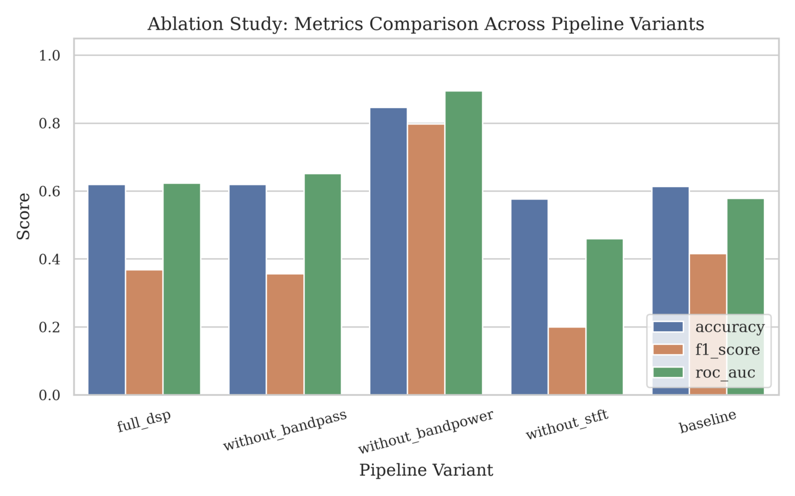
Figure 12.1. Performance comparison across the five acoustic front-end configurations.
The ablation results show that the different DSP components had substantially different effects on detection performance.
Removing the bandpass filter resulted in a small decrease in F1-score from 0.368 to 0.357, while ROC-AUC increased from 0.624 to 0.652. This indicates that the Butterworth bandpass filter did not provide a clear overall performance advantage under the evaluated conditions.
The most substantial change occurred when band-power pooling was removed. The without_bandpower configuration achieved an F1-score of 0.797, compared with 0.368 for full_dsp, while ROC-AUC increased from 0.624 to 0.895.
The input representation was also important. without_bandpower used the richer 513-dimensional spectral representation, whereas full_dsp and without_stft used 30-dimensional representations. The result therefore suggests that aggressive spectral compression into six band-power features may discard information useful for anomaly discrimination.
12.3. Error Analysis and Confusion Matrix
The error distribution further supports the advantage of without_bandpower. This configuration produced only 3 false positives and 26 false negatives, with 57 true positives and 103 true negatives.
The baseline produced the highest number of false positives (16), while without_stft produced the highest number of false negatives (73). These results indicate that the main difference between configurations was not simply overall accuracy, but their balance between missed anomalies and false alarms.
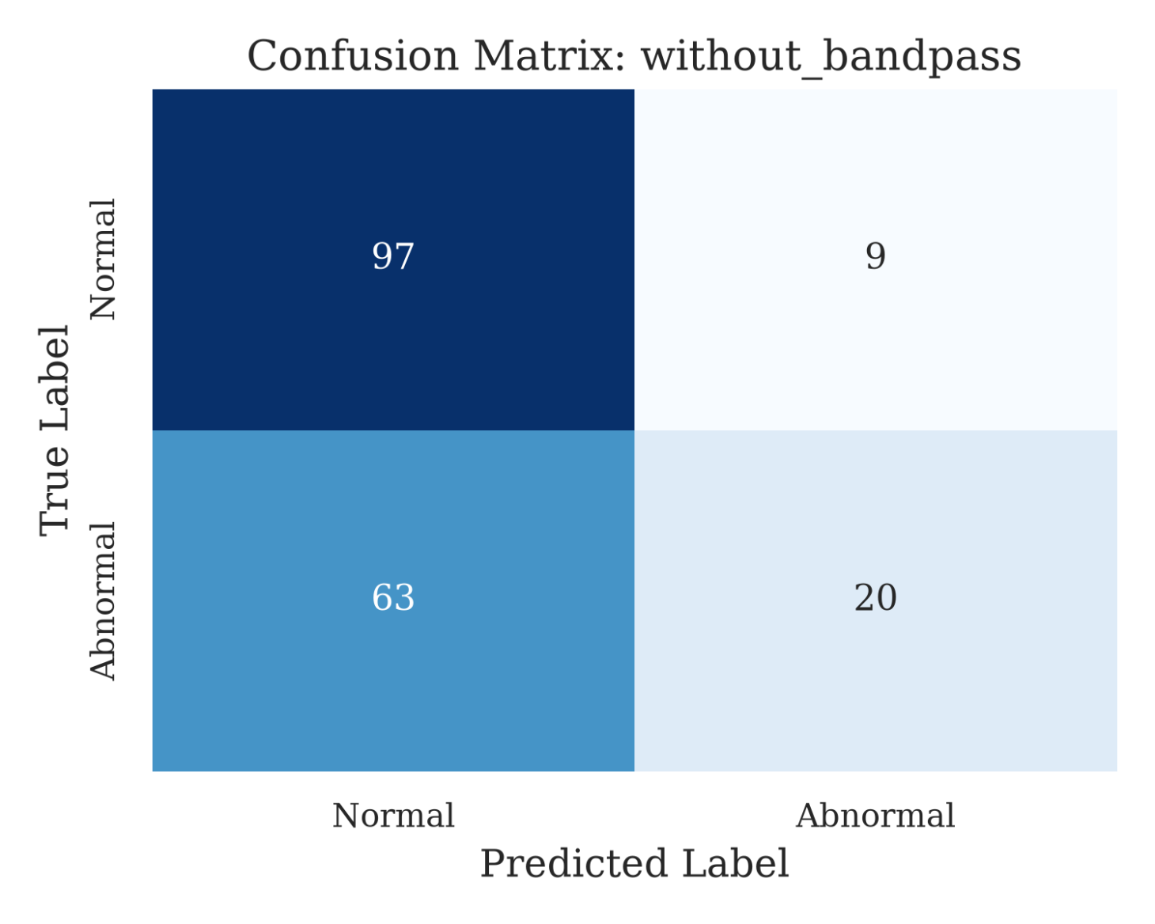
Figure 12.2. Confusion matrix of the best-performing without_bandpower configuration.
For comparison, the full_dsp configuration detected only 21 of the 83 abnormal samples, resulting in 62 false negatives. Thus, although the complete DSP pipeline reduced false alarms relative to the baseline, it also missed a large proportion of abnormal samples.
12.4. Noise Robustness
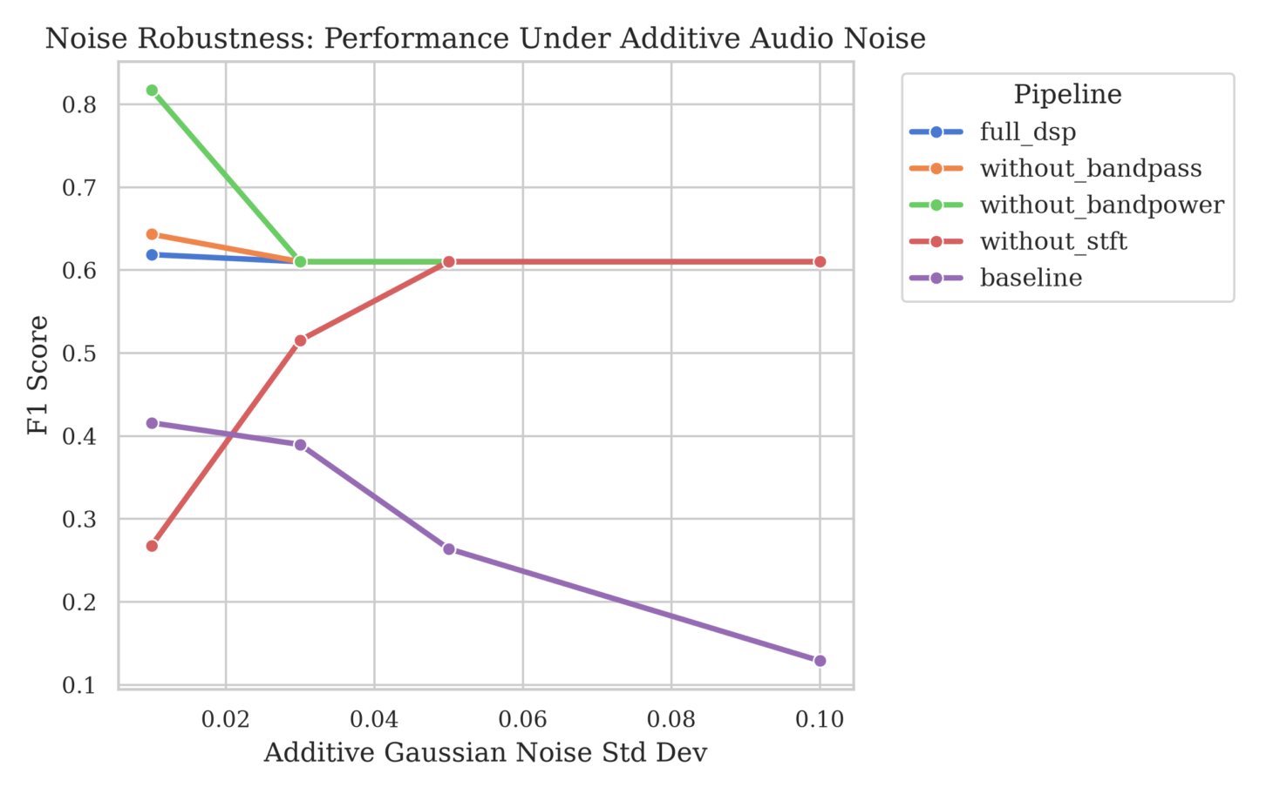
Figure 12.3. F1-score of the five configurations under increasing additive Gaussian noise.
Noise robustness was evaluated under additive Gaussian noise with standard deviations of 0.01, 0.03, 0.05, and 0.10.
At σ = 0.01, without_bandpower remained the strongest configuration, achieving F1 = 0.818, ROC-AUC = 0.920, and FAR = 0.104. As noise increased, however, several configurations showed severe degradation in decision quality.
For example, at σ ≥ 0.03, full_dsp achieved a Recall of 1.0, but its FAR also reached 1.0. The model classified all 106 normal samples as anomalous. Therefore, the apparently stable F1-score of approximately 0.61 at higher noise levels should not be interpreted as robust performance.
The baseline showed a clearer degradation pattern, with F1 decreasing from 0.416 at σ = 0.01 to 0.129 at σ = 0.10.

Figure 12.4. False Alarm Rate (FAR) of the five configurations under Noise level.
Noise robustness reveals two distinct failure patterns across the evaluated configurations. For the baseline, increasing noise progressively reduces anomaly detection, with recall decreasing from 31.3% at noise 0.01 to 7.2% at noise 0.10. In contrast, several DSP-based configurations maintain high recall but suffer from substantially increased false-alarm rates, reaching 100% at higher noise levels.
Overall, the results suggest that increasing noise does not simply reduce performance, but can shift the detector toward either missed anomalies or excessive false alarms, depending on the configuration.
12.5. Visualization
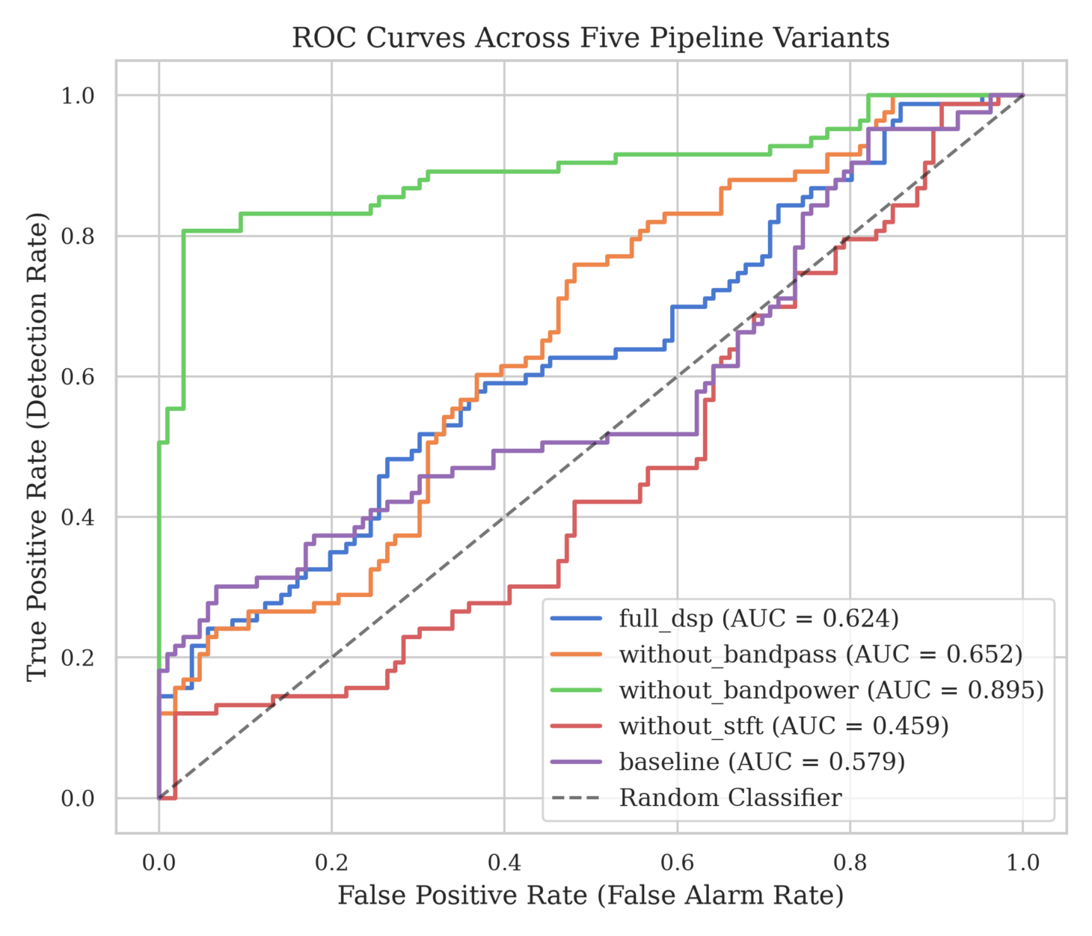
Figure 12.5. ROC curves for the five evaluated configurations.
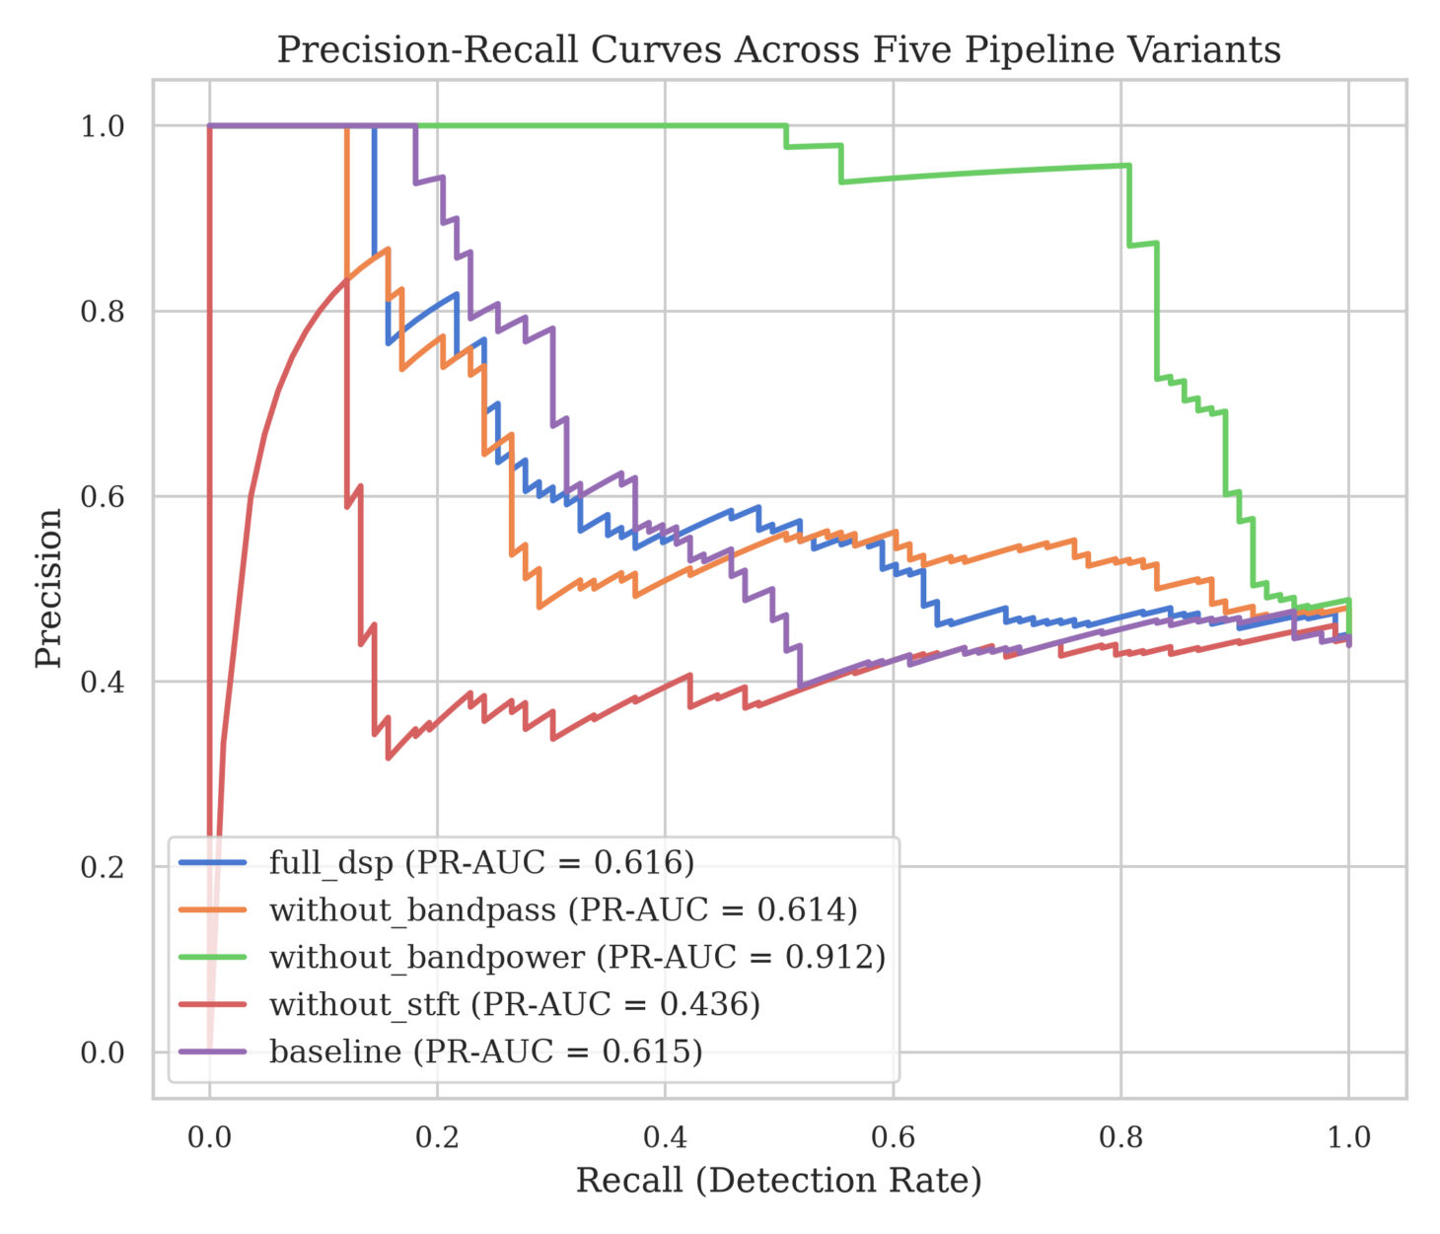
Figure 12.6. Precision–Recall curves for the five evaluated configurations.

The ROC and Precision–Recall curves provide additional evidence for the ranking observed in the main evaluation.
without_bandpower achieved the highest ROC-AUC and PR-AUC, indicating the strongest overall discrimination between normal and abnormal samples. In contrast, without_stft obtained a ROC-AUC of 0.459, indicating discrimination close to or below random performance.
13. Error Analysis (Diagnostics & Failure Modes)
13.1. Effect of Spectral Representation
The most important finding is that the complete DSP pipeline was not the best-performing configuration.
Removing band-power pooling produced a large improvement, increasing F1-score from 0.368 to 0.797 and ROC-AUC from 0.624 to 0.895. The without_bandpower configuration retained the richer 513-dimensional spectral representation rather than compressing the spectrum into six band-power features.
This result suggests that the compact band-power representation may discard discriminative spectral information. However, the experiment does not establish a causal mechanism; the finding should therefore be interpreted as evidence that feature representation is highly influential in this dataset.
13.2. Role of STFT
The poor performance of without_stft provides additional evidence for the importance of spectral representation.
With F1 = 0.200 and ROC-AUC = 0.459, this configuration performed substantially worse than the configurations retaining the STFT representation. This suggests that the information captured by the time-frequency representation is useful for distinguishing abnormal classroom acoustic events.
13.3. Effect of Bandpass Filtering
The comparison between full_dsp and without_bandpass does not demonstrate a clear benefit from bandpass filtering.
Removing the filter slightly decreased F1-score but increased ROC-AUC and reduced FAR. Therefore, within this dataset, the choice of spectral representation appears more influential than the presence of the Butterworth filter itself.
This is an important ablation finding because it shows that additional DSP processing does not automatically translate into better anomaly detection.
13.4. Comparison with the Baseline
The baseline achieved F1 = 0.416 and ROC-AUC = 0.579. Although full_dsp achieved a slightly higher ROC-AUC of 0.624, its F1-score decreased to 0.368.
Therefore, the results do not support H1. The complete DSP pipeline did not outperform the raw-waveform baseline in F1-score.
More importantly, the strongest performance came from the intermediate without_bandpower representation rather than from the complete pipeline. This indicates that the effectiveness of the system depends more on how acoustic information is represented than on simply applying more DSP stages.
13.5. Noise Robustness
The noise experiment provides evidence that increasing noise substantially changes model behavior.
However, the effect was not simply a monotonic decrease in F1-score. At higher noise levels, some configurations increasingly classified samples as anomalous. This produced high Recall but also extremely high FAR.
Therefore, Detection Rate alone is not an adequate measure of robustness. A robust anomaly detector must maintain anomaly detection capability while controlling false alarms.
H2 is therefore partially supported: increasing Gaussian noise clearly affected detection performance and decision behavior, but the effect varied across configurations and did not consistently follow the specific pattern originally hypothesized.
13.6. Limitations
The evaluation has several limitations. First, the test set contains only 189 samples, limiting the generalizability of the results. Second, the noise experiment uses controlled additive Gaussian noise, which does not fully represent real classroom acoustic interference.
Finally, the ablation configurations differ in both processing stages and feature dimensionality. Therefore, the results should be interpreted as a comparison of front-end configurations, rather than as perfectly isolated causal tests of individual DSP components.
14. Discussion
The results indicate that feature representation had a greater influence on detection performance than the complexity of the DSP pipeline. The without_bandpower configuration substantially outperformed the complete full_dsp pipeline, suggesting that compressing the STFT spectrum into six band-power features may remove information useful for anomaly discrimination.
The poor performance of without_stft further indicates that retaining spectral information is important for the evaluated acoustic anomaly detection task. Meanwhile, the limited difference between full_dsp and without_bandpass suggests that bandpass filtering did not provide a clear additional benefit.
Under noisy conditions, the detector became increasingly prone to false alarms. This shows that high detection rate alone is insufficient to demonstrate robustness.
15. Threats to Validity
This study has three main limitations:
- Dataset: The evaluation uses 189 unseen samples, so the results may not generalize to different classrooms, recording sessions, or acoustic environments.
- Noise model: Robustness was evaluated using additive Gaussian noise, which does not fully represent real classroom interference.
- Ablation design: The configurations differ not only in DSP operations but also in feature dimensionality. Therefore, the results should be interpreted as a comparison of front-end configurations rather than perfectly isolated causal effects.
16. Conclusion
This study shows that a more complex DSP pipeline does not necessarily produce better anomaly detection performance. The without_bandpower configuration achieved the strongest results, while removing the STFT representation substantially reduced performance.
The findings highlight spectral representation as the key factor among the evaluated configurations and reveal significant vulnerability to false alarms under increasing noise.
17. Future Work
Future work should focus on improving the spectral representation while reducing unnecessary feature compression, particularly by exploring alternative representations that preserve the discriminative information of the STFT. The anomaly threshold should also be made more adaptive to changing noise conditions to reduce the sharp increase in false alarms observed in the current experiment. In addition, the system should be evaluated on larger and more diverse classroom datasets, including different rooms, recording sessions, and acoustic conditions. Finally, future robustness experiments should incorporate more realistic classroom interference, such as overlapping speech, reverberation, and equipment noise, rather than relying only on additive Gaussian noise.
18. Ethics Statement
The study uses publicly available audiovisual and audio materials for research purposes. Video clips were sourced from YouTube and edited into short audio samples; no personally collected recordings or participant-identifying information were used in the dataset. Abnormal acoustic samples were obtained from Pixabay sound resources.
The study does not attempt to identify individuals or infer personal characteristics. The audio is analyzed only as an acoustic signal for anomaly detection. Any future deployment using real classroom recordings should apply appropriate consent, privacy protection, secure data handling, and institutional requirements.
19. AI Declaration
Item | Description
AI Tool | ChatGPT, NotebookLM, and Google AI Studio (Gemini).
Purpose | ChatGPT was used to support research planning, finding and reviewing research papers, formulating research questions and hypotheses, analyzing experimental results, identifying inconsistencies, and improving the clarity and conciseness of report writing. NotebookLM was used to review and refine written content based on research papers provided by the group. Google AI Studio/Gemini was used to support technical coding, debugging suggestions, and the preparation of figures and tables based on the project structure and functional requirements defined by the group.
Stage Used | AI was used during research planning, literature review, research question and hypothesis development, implementation and coding support, experimental-result analysis, error analysis, report writing, and revision. AI assistance was used throughout the project as a supporting tool rather than as a replacement for the group's engineering and research work.
Human Verification | All AI-generated suggestions, code, interpretations, and written content were reviewed by the group. Technical code was tested and debugged by the group, and bugs and fixes were verified through actual testing. Training parameters were deliberately selected by the responsible team member according to the computational resources and requirements of the task. Input data were manually filtered and prepared by the group before being provided to the model. All reported experimental results and figures were generated from the actual experiments and checked against the result files. The final report was reviewed by both members before submission.
Final Responsibility Statement | The group remains fully responsible for the originality, correctness, integrity, and final content of the submitted work. No experimental results, datasets, or research findings were fabricated by AI. AI-generated suggestions were used only as supporting input and were not accepted without human verification and modification.
20. AI Reflection
Member 1 - Phạm Nguyễn Việt Hưng
In this project, I integrated ChatGPT and NotebookLM as auxiliary tools to support the research synthesis and documentation lifecycle. My primary objective was to leverage these technologies for organizational efficiency while maintaining a rigorous standard of academic integrity. During the conceptualization phase, ChatGPT functioned as a brainstorming catalyst, helping to refine research questions and establish a logical structure for the report. It was particularly effective in ensuring a smooth thematic transition from the broad landscape of Anomalous Sound Detection (ASD) to our specific focus on the DSP front-end.
To ensure that the literature review remained grounded in our specific corpus, I utilized NotebookLM to manage the nine research dossiers provided by the group. By interacting directly with these sources, I was able to synthesize complex concepts such as transformer-based architectures and self-supervised representation learning without the risk of relying on the generalized parametric knowledge often found in standard AI models. This "source-grounding" approach was essential for accurately identifying the DSP gap and framing our study within the current state of research.
However, a significant challenge was the AI’s tendency toward over-generalization and speculative claims. I observed that AI-generated interpretations often suggested "State-of-the-art" performance or "guaranteed" noise resilience that lacked empirical support from our specific experiments. To mitigate this, I implemented a strict Human-in-the-loop verification protocol. Every AI-suggested insight was cross-referenced against the raw data files and the technical lead’s outputs. If a suggested interpretation claimed higher ROC-AUC or F1-scores than what our controlled ablation actually demonstrated, the content was discarded or manually rewritten.
Ultimately, the final responsibility for the report’s validity rested solely on my judgment. I personally audited every section from the discussion of threats to validity to the final conclusions to ensure they reflected the empirical truth of our results rather than algorithmic suggestions. This experience reinforced that while AI is an excellent tool for streamlining communication and organizing ideas, it cannot replace the researcher's responsibility for factual accuracy. Moving forward, I intend to maintain even more transparent evidence-mapping to ensure the synergy between human oversight and digital assistance remains empirically sound.
Member 2 - Lê Phạm Bá Học
In this project, I served as the Technical Lead, responsible for the end-to-end implementation of the system, including the development of the signal processing pipeline, the neural network architecture, and the experimental framework. I utilized ChatGPT and Gemini (Google AI Studio) as technical assistants to streamline the engineering process and support complex data analysis.
My primary focus was the creation of a functional and modular code repository. I led the development of the signal conditioning stages and the feature extraction process, which converted raw acoustic signals into structured representations. AI was instrumental during this phase, helping to suggest efficient coding patterns and providing logic for the interactive dashboard used for system diagnostics.
I used AI to verify my implementation of the processing chain and the symmetric layers of the detection model. Every piece of code suggested by the AI was treated as a hypothesis; I personally conducted rigorous debugging and testing to ensure compatibility with our specific project structure and hardware constraints.
Regarding the evaluation phase, I used AI to assist in the verification of results stored in our CSV data files. After observing the initial performance trends, I utilized AI to cross-reference specific data points, particularly when performing error analysis on anomalies that the system failed to detect. The AI helped clarify the technical reasons behind why certain pipeline configurations were more effective than others, especially in how they handled noise or preserved essential acoustic information during the ablation study. Instead of quoting raw percentages, I used these insights to understand the broader impact of different processing stages on model discrimination. All critical engineering decisions from selecting training parameters to manually filtering the input data remained under my direct control.
Ultimately, this project felt like a personal exercise in engineering accountability. While AI accelerated my ability to visualize data and organize complex logic, I was the one who had to sign off on every hyperparameter and every line of filtering code. I realized that my own judgment was the only thing standing between a scientifically sound report and a collection of AI hallucinations. For me, the project was a lesson in how to stay in total control of the technology I build, ensuring that the final output was a true reflection of our actual experimental evidence.
Appendix A – Literature Matrix
Paper / Author | DSP / Acoustic Representation | AI Model / Method | Dataset / Experimental Data | Key Findings | Research Gap relevant to this study | Limitations / Scope
Mnasri et al., 2022 | Survey of acoustic feature-extraction approaches, including time-frequency and spectral representations | Survey of machine-learning and deep-learning methods for ASD | Multiple datasets and application domains reviewed | Provides a broad overview of ASD methods, feature extraction, datasets, evaluation metrics, applications, and challenges | Does not conduct a controlled experimental comparison of individual DSP preprocessing operations | Survey paper; does not propose and experimentally validate one specific ASD pipeline
Di Fiore et al., 202 | Mel-spectrogram-based acoustic representation | Autoencoder-based anomalous sound detection | Real-world machine audio for predictive-maintenance application | Demonstrates the feasibility of reconstruction-based AE for anomalous sound detection in predictive maintenance and considers effectiveness/efficiency, including real-time operation | Does not isolate the contribution of individual DSP preprocessing stages to ASD performance | Evaluated in an industrial predictive-maintenance context; direct applicability to classroom acoustic environments is not established
Wu et al., 2023 | Acoustic feature representation / learned hidden features | ArcFace classifier + Gaussian Mixture Model (GMM) | DCASE 2020 Task 2 and CRWU | ArcFace is used to improve feature separability, while GMM models the learned feature distribution for anomaly scoring; the method reports improved ASD performance over comparison methods | Does not conduct a controlled ablation of individual classical DSP preprocessing stages | More sophisticated representation and scoring framework; experiments focus on industrial machine sounds
Guan et al., 2023 | Spectrogram-based acoustic representation; weighted anomaly scoring | ID-constrained Transformer Autoencoder (IDC-TransAE) | DCASE 2020 Task 2 development dataset | Shows that conventional AE representations may also reconstruct anomalous sounds; machine-ID constraints are introduced to improve representation discriminability, with weighted anomaly scoring for short anomalous events | Does not directly compare the contribution of individual classical DSP stages such as filtering or frequency-band pooling | Uses machine-ID information as auxiliary information; evaluated within the DCASE machine-sound setting
Chen et al., 2022 | Learned acoustic representation | Self-Supervised Representation Learning | DCASE anomalous sound detection under domain-shift conditions | Investigates self-supervised representation learning to improve ASD robustness when training and testing acoustic domains differ | Does not directly compare alternative classical DSP preprocessing paths, such as filtered versus unfiltered signals, under a controlled ASD experiment | Focuses primarily on representation learning under domain shift rather than classical signal-level preprocessing ablation
Guan et al., 2023 | Time/frequency masking used as augmentation for representation learning | Machine-ID-based contrastive learning + self-supervised ID classification | DCASE 2020 Task 2 | Machine-ID-aware contrastive pretraining improves acoustic representation and reports better ASD performance/stability than the compared representation-learning approaches | Focuses on learned representation rather than controlled analysis of individual classical DSP preprocessing stages | Requires machine-ID information as auxiliary metadata; evaluated in the DCASE industrial machine-sound setting
Wang et al., 2025 | Log-Mel spectrogram; Spectrogram Frame Selection (SFS); frequency-feature selection through AEFS/Scaling Gate | Autoencoder + learned time-frequency feature selection | DCASE 2020 Task 2 | Demonstrates that selective learning of time-frequency information can reduce irrelevant/interfering information and improve ASD performance; the proposed framework is also lightweight | Investigates learned time-frequency feature selection but does not directly quantify the contribution of specific classical DSP stages such as Butterworth filtering or band-power pooling | Feature selection is learned within the neural framework rather than implemented as a purely static DSP pipeline
Wilkinghoff, 2024 | Learned acoustic embeddings using Feature Exchange (FeatEx) | Self-Supervised Learning / Feature Exchange | DCASE 2023 ASD | FeatEx provides self-supervised acoustic representations without requiring manually annotated auxiliary class labels and achieves strong performance on the DCASE 2023 ASD task | Focuses on self-supervised representation learning rather than isolated analysis of individual classical DSP stages | Requires a more sophisticated representation-learning framework than a simple DSP + AE pipeline
Choi & Choi, 2024 | Log-Mel / time-frequency acoustic representation | Noisy-ArcMix with angular-margin loss, Mixup, and temporal attention | DCASE 2020 Task 2 | Addresses noisy ASD by improving representation separation and emphasizing informative temporal regions; reports improved AUC, pAUC, and mAUC over the comparison method | Addresses noise robustness mainly through representation and training strategies rather than controlled ablation of classical DSP preprocessing | Noise robustness is primarily handled at the model/training level rather than through an isolated signal-level DSP comparison

Appendix B – AI Declaration Template
Item | Description
AI Tool | ChatGPT, NotebookLM, and Google AI Studio (Gemini).
Purpose | ChatGPT was used to support research planning, finding and reviewing research papers, formulating research questions and hypotheses, analyzing experimental results, identifying inconsistencies, and improving the clarity and conciseness of report writing. NotebookLM was used to review and refine written content based on research papers provided by the group. Google AI Studio/Gemini was used to support technical coding, debugging suggestions, and the preparation of figures and tables based on the project structure and functional requirements defined by the group.
Stage Used | AI was used during research planning, literature review, research question and hypothesis development, implementation and coding support, experimental-result analysis, error analysis, report writing, and revision. AI assistance was used throughout the project as a supporting tool rather than as a replacement for the group's engineering and research work.
Human Verification | All AI-generated suggestions, code, interpretations, and written content were reviewed by the group. Technical code was tested and debugged by the group, and bugs and fixes were verified through actual testing. Training parameters were deliberately selected by the responsible team member according to the computational resources and requirements of the task. Input data were manually filtered and prepared by the group before being provided to the model. All reported experimental results and figures were generated from the actual experiments and checked against the result files. The final report was reviewed by both members before submission.
Final Responsibility Statement | The group remains fully responsible for the originality, correctness, integrity, and final content of the submitted work. No experimental results, datasets, or research findings were fabricated by AI. AI-generated suggestions were used only as supporting input and were not accepted without human verification and modification.
Appendix C – Project Checklist
Project Deliverable / Milestone Item | Verification Status
Team Formation | [x]
Topic Registration | [x]
Research Problem | [x]
Research Objectives | [x]
Research Questions | [x]
Literature Review | [x]
Research Gap | [x]
Hypothesis | [x]
DSP Pipeline | [x]
Feature Extraction | [x]
AI Model | [x]
Experimental Design | [x]
Baseline Comparison | [x]
Ablation Study | [x]
Error Analysis | [x]
Discussion | [x]
Ethics Statement | [x]
AI Declaration | [x]
AI Reflection | [x]
Final Report | [x]
Source Code | [x]  github
README | [x]  (Inside source code)
Presentation | []

Appendix D — Frequently Asked Questions & Compliance
Q: Can we use ChatGPT / Gemini / Claude?
A: Yes. Generative AI may be used to support learning and research (brainstorming, writing, summarizing literature, explaining concepts). All usage must be disclosed in the AI Declaration (Appendix B) and the individual AI Reflection (Section 19).
Q: Can we use GitHub Copilot?
A: Yes, for code assistance and debugging. The student team remains fully responsible for the correctness and integrity of the submitted code, and must declare its use.
Q: Can we use pretrained models?
A: Yes, provided you cite them, respect their licenses, and clearly state what was reused versus what you implemented or fine-tuned yourself (Note: Our project trains the PyTorch Autoencoder from scratch to guarantee architectural transparency).
Q: Can we use Kaggle or other public datasets?
A: Yes. Use public datasets (DEAP, RAVDESS, EMO-DB, PhysioNet, Kaggle, DCASE, etc.), cite them correctly, and comply with their licensing terms.
Q: Can we collect our own datasets?
A: Yes. Self-recorded data requires informed consent, anonymization of personal information, and a description of the consent procedure in the Ethics Statement.
Q: Can we reuse code from GitHub?
A: Yes, if properly credited and license-compliant. Reusing code without attribution is an academic-integrity violation.
Q: How should AI usage be declared?
A: Complete the AI Declaration (Appendix B) in the report appendix and submit the individual AI Reflection. State the tools, purpose, stages used, and how outputs were verified.
Q: What happens if experiments cannot be reproduced?
A: Reproducibility is graded. If the submitted package cannot re-run the experiments (missing seeds, versions, data, or instructions), the reproducibility criterion is not met and the score is reduced accordingly. (Note: Our project guarantees 100% one-command reproduction via 'python run.py --seed 42').

