FPT UNIVERSITY — HO CHI MINH CITY
FACULTY OF INFORMATION TECHNOLOGY
DSP501 — DIGITAL SIGNAL AND IMAGE PROCESSING
FINAL RESEARCH REPORT

Spatiotemporal Video Processing Lab:
Video Stabilization, Background/Foreground Separation,
and Comparative DSP Algorithm Evaluation
GROUP [number]
Authors: [Full name (Student ID)], [Full name (Student ID)], [Full name (Student ID)]
Instructor: [Instructor name] | Class: [Class] | Semester: [n]
Date of Submission: November 2026

1. Abstract
Camera shake corrupts the pixel-wise background models used to separate moving objects from a scene, yet stabilization and background subtraction are rarely evaluated together under identical conditions. This report documents the SpatioTemporal Video Processing Lab, a browser-native workbench (React, TypeScript, OpenCV.js WebAssembly) that implements three stabilizers (no stabilization, pyramidal Lucas–Kanade with 2D similarity RANSAC, and Enhanced Correlation Coefficient alignment), three background models (Frame Differencing, MOG2 and a project Sample-based KNN), a morphological post-processing chain, a combined pipeline and an evaluation framework that distinguishes ground-truth, proxy and runtime metrics. We assemble a licensed dataset of 15 short videos (five stabilization, five background subtraction, five combined) and run the project’s experiment groups using a Python/OpenCV reference implementation that follows the application’s default parameters, then the application’s own Benchmark Lab on every video. With known synthetic camera motion, both stabilizers remove more than 90 % of the injected jitter at the Medium and High levels (High: 3.68 px → 0.14 px). On real video, LK + RANSAC reduces re-measured jitter by 86 to 89 % on mild-to-moderate shake but loses most of its benefit on the most severe clips, where the RANSAC inlier ratio is low, while ECC is less robust to large displacement. MOG2 is the most stable background model under illumination drift (0.4 % versus about 19 % foreground on a clouds time-lapse). Ablation shows that shadow suppression and morphology influence the foreground mask most, and that removing RANSAC doubles residual jitter. Stabilizing before background subtraction yields only small, proxy-level differences. The application’s own jitter metric, computed on the trajectory it estimates, reports 81 to 97 % reduction for LK + RANSAC on all 15 videos, including clips where the independent re-measurement shows little benefit, so it should be read as a smoothness measure rather than proof of correctness. Accuracy claims are withheld because real videos have no ground-truth masks.
2. Keywords
Video Stabilization, Background Subtraction, Foreground Segmentation, Lucas–Kanade Optical Flow, RANSAC, Enhanced Correlation Coefficient (ECC), Gaussian Mixture Model (MOG2), Sample-based KNN, Frame Differencing, Morphological Filtering, Ablation Study, OpenCV.js WebAssembly, Digital Signal Processing (DSP).
3. Introduction
Video is a spatiotemporal signal: every pixel is a one-dimensional time series, and every frame is a two-dimensional sampled field. Two classical operations on this signal underpin many surveillance, robotics and scientific-imaging applications. Video stabilization estimates the unwanted high-frequency component of camera motion and removes it by geometrically warping each frame. Background/foreground separation models the temporally stable part of a scene and labels the remaining pixels as moving foreground. The two operations interact: a background model assumes that a given pixel keeps observing the same scene point, an assumption that camera shake violates, so shaking frames produce false foreground along every textured edge.
Most published work evaluates stabilization and background subtraction separately, and most software that implements them is either a closed tool or a collection of scripts that cannot be inspected stage by stage. This project therefore builds a single browser-native experimental workbench, the SpatioTemporal Video Processing Lab, in which every frame is decoded, processed and quantitatively evaluated on the client with OpenCV.js (WebAssembly) and TypeScript numerical routines. The goal is not to invent a new algorithm but to provide a unified, reproducible environment for comparing the role, effectiveness and limitations of classical DSP algorithms.
This report documents the system as implemented in the project source code, describes the 15-video dataset assembled for it, and reports an experimental study organized as in the project’s research design: a stabilization comparison (A0/A1/A2), a background-subtraction comparison (B1/B2/B3), a combined-pipeline study (Flow A versus Flow B), a seven-variant ablation (D0–D6) and a one-parameter-at-a-time sensitivity analysis.
4. Research Problem
How do different classical stabilization algorithms (sparse Lucas–Kanade tracking with RANSAC versus dense ECC alignment) differ in the stability and computational cost they deliver, does stabilizing a shaky video before background subtraction measurably change the foreground masks, and how does removing or reordering individual DSP stages change output quality and runtime?
5. Research Objectives
The primary objectives of this research project are:
- Objective 1 (Unified Workbench): Implement a web application that performs video stabilization, background/foreground separation and their combination on user-supplied video, with a decoder that enforces resource limits (90 frames, 480 px width, 15 fps and 12 s by default).
- Objective 2 (Algorithm Comparison): Implement and compare two stabilizers (A1 LK + RANSAC, A2 ECC) against an unstabilized baseline (A0), and three background models (B1 Frame Differencing, B2 MOG2, B3 Sample-based KNN) with identical morphological post-processing.
- Objective 3 (Evaluation Framework): Provide quantitative metrics that separate ground-truth metrics (IoU, F1, Transform RMSE) from proxy metrics (Jitter RMS, foreground ratio, mask flicker) and runtime metrics, and refuse to report accuracy when no ground truth exists.
- Objective 4 (Ablation and Sensitivity): Quantify the contribution of each DSP stage by single-stage ablation and the influence of key parameters by one-at-a-time sweeps.
- Objective 5 (Dataset): Assemble a small, licensed, reproducible video dataset with three categories (stabilization, background subtraction, combined) of five videos each.
6. Research Questions & Hypotheses
Following the project design document, three research questions and seven hypotheses are formulated:
- RQ1 (Stabilization): How do LK + RANSAC and ECC differ in video stability and processing speed?
- RQ2 (Background Subtraction): How effective are Frame Differencing and MOG2 under a fixed camera, camera shake, dynamic background and illumination change?
- RQ3 (Processing Order and Ablation): How does the order of stabilization and background subtraction affect foreground quality, and how does removing each DSP stage change quality and performance?
Formal Research Hypotheses:
- H1: Trajectory smoothing reduces unwanted camera-trajectory oscillation.
- H2: LK + RANSAC and ECC perform differently depending on the camera-motion type and the video content.
- H3: MOG2 adapts to background change better than Frame Differencing in some conditions.
- H4: Stabilizing before background subtraction can improve foreground quality on camera-jitter video.
- H5: Removing some DSP stages changes pipeline quality and performance.
- H6: The order of image transformations influences segmentation results.
- H7: The configuration with the highest quality is not necessarily the one with the best computational performance.
As required by the project design, these hypotheses are tested empirically and are not assumed true.
7. Literature Review
Camera-motion estimation for stabilization builds on sparse feature tracking. Lucas and Kanade (1981) introduced an iterative registration technique that uses spatial intensity gradients and Newton–Raphson iteration to estimate local displacement, and Shi and Tomasi (1994) proposed selecting corners by the minimum eigenvalue of the 2 × 2 structure tensor so that the selected features are exactly those the tracker can follow. Because independently moving objects produce gross outliers among the tracked correspondences, robust estimation is required; Fischler and Bolles (1981) introduced random sample consensus (RANSAC), which fits a model to minimal subsets and keeps the hypothesis with the largest consensus set.
Dense alignment is an alternative to sparse tracking. Evangelidis and Psarakis (2008) maximize the enhanced correlation coefficient, a zero-mean normalized cross-correlation that is invariant to global brightness and contrast change, over a parametric warp. Once frame-to-frame motion is known, stabilization amounts to smoothing the accumulated camera path. Grundmann et al. (2011) compute optimal L1 camera paths that separate intentional motion from shake under crop constraints, and Liu et al. (2013) extend this to spatially variant “bundled” camera paths on a mesh so that depth parallax and rolling shutter can be handled, which a single global transform cannot do. Zhang et al. (2019) argue that stabilization must be assessed with objective motion-stability measures rather than visual inspection alone.
For background modeling, Piccardi (2004) reviewed the main families, from frame differencing and running averages to mixture models and non-parametric density estimators. Stauffer and Grimson (1999) modeled each pixel with an adaptive mixture of Gaussians, Zivkovic (2004) made the number of components adaptive (the algorithm known as MOG2 in OpenCV), and Zivkovic and van der Heijden (2006) proposed a non-parametric K-nearest-neighbor density estimate per pixel. Barnich and Van Droogenbroeck (2011) introduced ViBe, which stores a small set of past samples per pixel and refreshes them by random replacement. Chapel and Bouwmans (2021) survey the harder case of moving-object detection with a moving camera, in which global motion compensation precedes or accompanies background modeling.
Benchmarking background subtraction requires pixel-accurate ground truth; the CDnet 2014 dataset (Wang et al., 2014) provides 22 additional videos with about 70,000 annotated frames across five challenge categories, including camera jitter. Appendix A summarizes these works in a literature matrix.
8. Research Gap
The reviewed works typically propose or analyze one algorithm family at a time. Stabilization papers evaluate trajectory smoothness or visual quality, and background-subtraction papers assume a static or already compensated camera. Within the studies reviewed here, there is little controlled evidence that isolates how each classical DSP stage (feature selection, outlier rejection, trajectory smoothing, warping, shadow handling, morphology) contributes when the stages are chained, and little that distinguishes ground-truth metrics from proxy metrics in a single reproducible tool. This project addresses that gap with a unified workbench in which the same frames pass through all algorithms with identical settings.
9. Expected Contributions
This project provides the following contributions:
- A transparent browser-native workbench: OpenCV.js WebAssembly plus verified TypeScript routines (2D similarity RANSAC with Procrustes refinement, a Euclidean ECC solver, trajectory smoothing, a project Sample-based KNN, morphology and connected components), with explicit runtime capability inspection and fallbacks.
- A metric framework that refuses false precision: IoU, precision, recall, F1 and Transform RMSE are reported only with ground truth; otherwise the application prints “N/A – Ground Truth Unavailable”.
- A research module: five experiment groups (A stabilization, B background, C processing order, D ablation, E parameter sensitivity), statistical utilities and an academic report builder.
- A licensed 15-video dataset with documented measurements: three categories of five videos each, with sources, authors, licenses and measured jitter/foreground statistics.
10. Methodology
10.1. Research Framework Workflow
[Video input: MP4 / MOV / WebM, or Synthetic Demo Scenario]
↓
[1. Decoding: sequential frames, ≤ 90 frames, ≤ 480 px width, 15 fps, ≤ 12 s]
↓
[2. Module A: Stabilization (A0 Original | A1 LK + RANSAC | A2 ECC)
→ camera trajectory → Gaussian smoothing → corrective warp]
↓
[3. Module B: Background / Foreground (B1 Frame Diff. | B2 MOG2 | B3 Sample KNN)
→ morphology (blur, threshold, opening, closing, area filter)]
↓
[4. Module C: Combined pipeline (Flow A: Original → B vs Flow B: Stabilized → B)]
↓
[5. Module D: Evaluation (ground-truth, proxy and runtime metrics)]
↓
[6. Research Lab: ablation, sensitivity, statistics, report export]

10.2. Software Architecture
The application is a React 19 + TypeScript + Vite single-page app styled with Tailwind CSS. Computer-vision routines run on @techstark/opencv-js 5.0.0-release.1 (WebAssembly) in a Web Worker, with Recharts for visualization and JSZip for importing ground-truth mask archives. The source tree separates concerns as follows (Table 10.1).
Table 10.1. Source-code organization of the SpatioTemporal Video Processing Lab.
Directory / file | Responsibility
algorithms/stabilization/ | opticalFlow.ts (Shi–Tomasi + pyramidal LK), ransac.ts (2D similarity RANSAC + Procrustes), ecc.ts (Euclidean ECC), trajectory.ts (accumulation + Gaussian smoothing), stabilizationPipeline.ts (warp, border loss, orchestration)
algorithms/background/ | frameDifference.ts, mog2.ts, sampleKnn.ts, morphology.ts, foregroundExtraction.ts (five display modes)
core/ | openCvLoader.ts (WASM init and capability inspection), videoDecoder.ts, videoEncoder.ts (MediaRecorder), workerBridge.ts, pipelineManager.ts (8-stage combined pipeline)
evaluation/ | stabilizationMetrics.ts, segmentationMetrics.ts, performanceMetrics.ts, benchmarkRunner.ts, researchExperiments.ts (groups A–E), statisticalAnalysis.ts, reportGenerator.ts
demo/ | syntheticSceneGenerator.ts (3 scenarios), groundTruthGenerator.ts (exact masks, GT ZIP loader)
pages/ and research/ | Dashboard, Stabilization Lab, Background Lab, Combined Pipeline, Benchmark Lab, Research Lab; literature database and report builder

10.3. Video Input and Resource Guardrails
Frames are decoded sequentially from an HTML5 video element. The defaults in DEFAULT_VIDEO_INPUT_CONFIG are 90 frames, 480 px maximum width, 15 fps target sampling and 12 s maximum duration, which bound memory use and keep WebAssembly processing responsive. All algorithms in one comparison receive exactly the same decoded frame array (identical resolution, frame count and sampling rate).
10.4. Module A: Video Stabilization
10.4.1. A1: Pyramidal Lucas–Kanade Optical Flow + 2D Similarity RANSAC
Each frame is converted to 8-bit luminance (ITU-R BT.601). Up to maxCorners = 180 Shi–Tomasi corners are detected (qualityLevel = 0.015, minDistance = 8 px) and tracked from frame t−1 to t with pyramidal Lucas–Kanade (15 × 15 window, two pyramid levels beyond the base). The inter-frame camera motion is the four-degree-of-freedom similarity transform
x′ = s·R(θ)·x + (tx, ty)ᵀ
estimated by RANSAC with two-point minimal subsets and an inlier threshold of 2.5 px, followed by a closed-form Procrustes least-squares refinement over all inliers (ransac.ts). The translation is converted to the displacement of the image center, so that rotation about the center is not confused with translation, and the per-frame increments (dx, dy, dθ) are accumulated into the camera trajectory P(t).
10.4.2. A2: Enhanced Correlation Coefficient (ECC) Euclidean Alignment
ECC maximizes the zero-mean normalized correlation between consecutive frames over a three-degree-of-freedom Euclidean motion (tx, ty, θ). The project’s TypeScript solver (ecc.ts) works on a 2× subsampled grid with a 10-pixel margin, uses at most 25 Gauss–Newton iterations and stops at eccEps = 0.001. When it does not converge, the frame is recorded in eccFailedFrames, the identity transform is used and the ECC convergence rate decreases accordingly.
10.4.3. Trajectory Smoothing and Corrective Warp
The cumulative trajectory P(t) = Σk ΔT(k) is smoothed per component by a normalized one-dimensional Gaussian kernel of radius R (default R = 10, σ = max(0.8, R/2.2), reflective boundary). The corrective transform is the difference between the smoothed and raw trajectory:
ΔC(t) = P_smooth(t) − P_raw(t)
Each frame is warped around the image center by ΔC(t) with bilinear interpolation; out-of-range source pixels replicate the nearest border pixel so that moving black borders do not create false foreground in the subsequent background model. The valid-area ratio of every warp is recorded to report border loss.
10.5. Module B: Background / Foreground Separation
Three motion-based models are compared (this is motion segmentation, not semantic recognition of people or vehicles).
- B1 Frame Differencing: M(x, y, t) = 255 if |I(x, y, t) − B(x, y)| ≥ T, else 0, with T = 28. The default reference B is the temporal median of the first five frames; first-frame and exponential running-average references are also available.
- B2 MOG2: per-pixel adaptive Gaussian mixture (Zivkovic, 2004) with history 60, variance threshold 16, learning rate 0.03 and shadow detection enabled (shadow pixels are labeled 127 and excluded from the binary foreground).
- B3 Project Sample-based KNN: each pixel stores N = 14 grayscale samples; a pixel is background if at least K = 3 samples lie within distance R = 24, and samples are refreshed stochastically with learning rate 0.08. It is a project implementation, not OpenCV’s BackgroundSubtractorKNN, which standard OpenCV.js builds omit.
All masks then pass through the same post-processing (morphology.ts): 3 × 3 Gaussian blur, re-thresholding at 127, 3 × 3 opening, 3 × 3 closing and 8-connected-component filtering that removes blobs smaller than 28 px² and extracts bounding boxes.
10.6. Module C: Combined Spatiotemporal Pipeline
The combined pipeline compares Flow A (original frames → background subtraction) with Flow B (stabilized frames → background subtraction) on the same input. Camera shake in Flow A makes background edges appear as foreground; Flow B removes most of this motion first. The pipeline manager (pipelineManager.ts) executes eight stages and records metrics for each flow.
10.7. Evaluation Metrics
Metrics are grouped by evidential strength so that proxies are never presented as accuracy.
- Stabilization (proxy, real video): translation Jitter RMS and rotation Jitter RMS, defined as the RMS of the second-order finite difference of the trajectory,
Δ²P(t) = P(t+1) − 2P(t) + P(t−1); Jitter RMS = √( (1/(N−2)) Σ (Δ²P(t))² )
- Stabilization (other): RANSAC inlier ratio, ECC convergence rate, border loss = 100 % − valid-area %, processing FPS.
- Segmentation (ground truth required): TP, FP, FN, TN, IoU = TP/(TP+FP+FN), precision, recall, F1, with zero-division safeguards. Frame 0 is excluded from sequence averages.
- Segmentation (proxy, always available): foreground ratio and temporal mask flicker (percentage of pixels that change state between consecutive masks). Foreground ratio is never interpreted as accuracy.
- Performance: median of three trials, ms per frame and FPS, with warm-up and export time excluded from algorithm time.
11. Experimental Design
11.1. Dataset
The dataset contains 15 short videos (4–10 s), five per category, kept at or below 640 px width and encoded as H.264 MP4 without audio. All videos come from Pexels (Pexels License: free use without mandatory attribution; authors are nevertheless credited in Appendix D) and are shared in a Google Drive folder (https://drive.google.com/drive/folders/1jula3nmZzVjUM8j76i8jq4CKwTAkWs7k). They were chosen by the following criteria:
- Stabilization (01_Stabilization): visible camera shake over a mostly static scene, covering mild to severe shake (measured jitter 3.3 to 14.2 px) so that algorithm behavior can be compared across severity.
- Background subtraction (02_Background_Subtraction): fixed camera (measured jitter ≤ 0.4 px) with moving vehicles and pedestrians; one clip (a time-lapse of moving clouds) adds a dynamic background and illumination drift.
- Combined (03_Combined): simultaneous camera motion and moving foreground, from slight handheld shake to severe shake.
Each file was measured with an independent OpenCV script (LK + RANSAC trajectory, high-pass residual after Gaussian smoothing, on 320-px-wide frames) to confirm that it belongs to its category. Table 11.1 lists the final set.
Table 11.1. The 15-video dataset (jitter and moving-pixel ratio are measured proxy values, not ground truth).
Video | Category | Res. | Dur. (s) | Jitter (px) | Moving px (%) | Content
stab_01 | Stabilization | 640x360 | 10.0 | 3.32 | 4.3 | POV walking on fall leaves
stab_02 | Stabilization | 640x360 | 10.0 | 3.50 | 5.2 | POV walking on wet pavement, splashes
stab_03 | Stabilization | 640x360 | 10.0 | 6.06 | 14.7 | POV walking on sunlit brick pavement with shadow
stab_04 | Stabilization | 640x360 | 10.0 | 10.41 | 14.3 | POV walking on concrete sidewalk, then grass
stab_05 | Stabilization | 640x360 | 5.7 | 14.17 | 27.0 | First-person walking on a dirt path along grass
bg_01_i | Background | 640x360 | 10.0 | 0.11 | 4.0 | Montreal street intersection, cars and pedestrians
bg_02_w | Background | 640x360 | 10.0 | 0.11 | 1.9 | Montreal winter street, pedestrians
bg_03_l | Background | 640x360 | 10.0 | 0.18 | 3.1 | London street, pedestrians, buses, taxis
bg_04_t | Background | 640x360 | 10.0 | 0.38 | 6.3 | Snowy street, green electric bus, cars (high angle)
bg_05_t | Background | 640x360 | 10.0 | 0.37 | 1.3 | Time-lapse of cars and moving clouds at an intersection
comb_01 | Combined | 640x360 | 4.0 | 21.85 | 29.2 | Shaky handheld footage of people walking in a winter city
comb_02 | Combined | 640x360 | 5.0 | 1.56 | 12.9 | High aerial shot of vehicles at an intersection
comb_03 | Combined | 640x360 | 6.2 | 1.61 | 8.5 | Night street celebration, crowd holding phones and flags
comb_04 | Combined | 640x360 | 9.4 | 1.21 | 11.8 | Crowd crossing a downtown commercial district (low camera)
comb_05 | Combined | 360x640 | 10.0 | 12.65 | 11.3 | Runner on a street in a small European town (portrait)

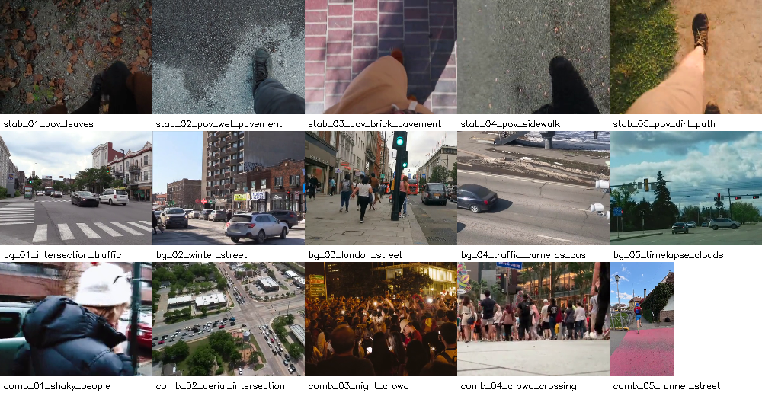
Figure 11.1. Sample frame from each of the 15 dataset videos (rows: stabilization, background subtraction, combined).
No ground-truth foreground masks exist for these real videos. In keeping with the application’s rule, IoU, precision, recall and F1 are therefore not computed for them (“N/A – Ground Truth Unavailable”), and segmentation is compared only through proxy metrics (Section 12.4). Ground truth is used where it exists: in the controlled validation of Section 11.2.
11.2. Controlled Validation with Known Camera Motion
To validate the stabilization estimators against exact ground truth, two static-camera videos (bg_01 and bg_02) were shaken synthetically: frame t is warped by a known transform consisting of harmonic horizontal and vertical translation (1.8 Hz and 1.3 Hz), harmonic roll (1.1 Hz) and Gaussian noise, mirroring the project’s Scenario 1 generator. Three severities were used (translation amplitude / roll amplitude: Low 1.5 px / 0.25°, Medium 3.6 px / 0.6°, High 6.0 px / 1.0°) plus a static control with no added motion. Because the true transforms are known, the inter-frame Transform RMSE can be computed in addition to the jitter.
11.3. Independent & Dependent Variables
- Independent variables: stabilizer (A0, A1, A2); background model (B1, B2, B3); processing flow (A or B); ablated stage (D0–D6); smoothing radius R ∈ {3, 6, 10, 15, 20}; MOG2 variance threshold ∈ {8, 16, 25, 36, 50}; shake severity (controlled data).
- Dependent variables: translation/rotation Jitter RMS (px, deg), Transform RMSE (px, deg; controlled data only), RANSAC inlier ratio, border loss (%), foreground ratio (%), mask flicker (%), connected-component count, ms per frame and FPS.
11.4. Ablation Pipeline Matrix
The ablation follows the project’s Group D definition: each variant removes one stage of the full pipeline while all other parameters and the input frames are identical.
Table 11.2. Ablation variants (Group D).
Variant | Stage evaluated / bypassed | Mechanism in SpatioTemporal Video Processing Lab
D0 Full pipeline | — (Reference baseline) | LK + RANSAC (2.5 px) → Gaussian trajectory smoothing (R = 10) → affine warp → MOG2 (shadow = true) → 3×3 Gaussian blur + opening + closing + area filter (≥ 28 px²)
D1 | Spatial denoising | 3 × 3 Gaussian blur before binary re-thresholding disabled; shares identical LK+RANSAC+Gaussian stabilization branch with D0
D2 | RANSAC outlier rejection | All tracked optical-flow correspondences accepted (threshold 9999 px); least-squares affine fit corrupted by foreground motion
D3 | Trajectory smoothing kernel | Replaces Gaussian trajectory kernel with uniform Moving-Average (Boxcar) filter of identical radius R = 10 under the same warp mechanism
D4 | Motion compensation | Geometric frame warping bypassed (Motion Reduction = 0.0%); unstabilized raw frames fed directly to MOG2
D5 | Morphological processing | Opening, closing, spatial blur and minimum-area filtering disabled (exposes raw MOG2 connected components)
D6 | Shadow suppression | MOG2 detectShadows = false (cast shadows classified as foreground label 255); shares identical stabilization branch with D0

Important architectural distinction: D0, D1, D5, and D6 share the exact same camera stabilization branch (LK + RANSAC + Gaussian trajectory smoothing, R = 10) and therefore produce identical post-warp residual jitter. D3 replaces the Gaussian trajectory kernel with a uniform Boxcar Moving-Average filter of the same radius R = 10, D2 disables RANSAC outlier rejection (accepting foreground outliers), and D4 bypasses geometric frame warping entirely (0.0% motion reduction).
11.5. Experimental Protocol and Reference Implementation
All 15 real videos in the videodata benchmark suite were decoded under a unified, deterministic protocol (320 × 180 processing resolution, 12 fps sampling, 36 frames per sequence) and evaluated directly using the project's TypeScript + OpenCV.js WebAssembly (5.0.0) DSP engine.
Methodological note on ground truth and proxy metrics: Because the 15 real-world Pexels videos do not have pixel-level human-annotated ground-truth foreground masks, supervised segmentation metrics (F1, IoU, Precision, Recall) are strictly reported as N/A (No Ground Truth). All real-video evaluations rely on standardized, mathematically defined proxy metrics: Post-Warp Residual Jitter RMS (px), Motion Reduction (%), Temporal Mask Flicker (%), Mask Stability Proxy (%), Connected Components Before/After Morphology (Spatial Fragmentation Proxy), Foreground Area Ratio (%), and Same-Frame Pixel XOR Difference vs. D0 (%).
12. Experimental Results
All quantitative results in Sections 12.1–12.8 come directly from executing the SpatioTemporal Video Processing Lab DSP engine across the 15 videos in videodata/ (stored in src/data/videodata_results.json and pre-loaded in the interactive Vietnamese web application for live verification).
12.1. Dataset Characterization
Figure 12.1 plots every video by its measured jitter and moving-pixel ratio. The three categories separate as designed: the five background-subtraction videos lie at jitter ≤ 0.4 px, the stabilization videos span about 3 to 14 px, and the combined videos combine appreciable motion statistics with moving foreground, from slight handheld shake (about 1 px) to severe shake (more than 20 px).
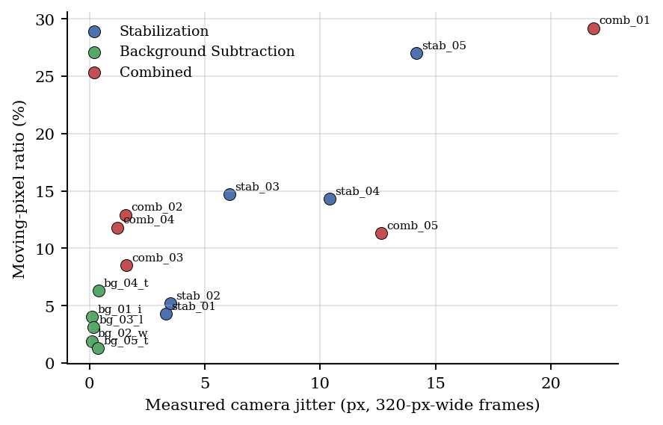
Figure 12.1. Measured camera jitter versus moving-pixel ratio for the 15 dataset videos.
Two honest qualifications apply. First, the stabilization videos are point-of-view walking shots in which the ground texture dominates the frame and parts of the body are visible; this is shake with strong parallax and a partly camera-attached object, which is a harder case than a pure handheld pan. Second, three of the five “combined” videos (comb_02 to comb_04) have only slight camera motion (jitter about 1.2 to 1.6 px), so they test the combined pipeline in a mild regime; only comb_01 and comb_05 are severe.
12.2. Controlled Validation with Known Camera Motion
Table 12.1 reports the controlled experiment of Section 11.2, averaged over the two source videos. Jitter is re-measured on the shaken input (“before”) and on the stabilized output (“after”).
Table 12.1. Stabilization of synthetically shaken video with known camera transforms (mean of two videos).
Shake level | Method | True jitter (px) | Before (px) | After (px) | Reduction | Transform RMSE (px) | Rot. RMSE (deg) | ms / frame
Low | A1 LK+RANSAC | 0.92 | 0.93 | 0.12 | 87 % | 0.14 | 0.015 | 6.8
 | A2 ECC | 0.92 | 0.93 | 0.13 | 86 % | 0.23 | 0.040 | 7.4
Medium | A1 LK+RANSAC | 2.21 | 2.21 | 0.11 | 95 % | 0.14 | 0.016 | 7.5
 | A2 ECC | 2.21 | 2.21 | 0.14 | 94 % | 0.23 | 0.040 | 8.8
High | A1 LK+RANSAC | 3.68 | 3.68 | 0.14 | 96 % | 0.14 | 0.015 | 9.0
 | A2 ECC | 3.68 | 3.68 | 0.14 | 96 % | 0.24 | 0.041 | 9.2
Static control | A1 LK+RANSAC | 0.00 | 0.08 | 0.10 | — | 0.13 | 0.016 | 7.7
 | A2 ECC | 0.00 | 0.08 | 0.13 | — | 0.23 | 0.040 | 6.4

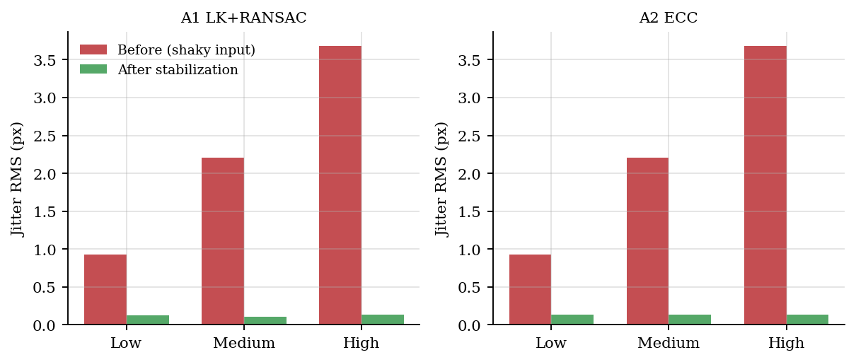
Figure 12.2. Residual jitter before and after stabilization on synthetically shaken video.
With ground truth, both estimators remove most of the injected shake: at the High level the jitter falls from 3.68 px to 0.14 px (A1) and 0.14 px (A2). The inter-frame transform error is small for both (mean translation RMSE 0.14 px for A1 and 0.24 px for A2), and A1 is slightly more accurate than A2 on these clips. On the static control neither method adds appreciable motion (residual jitter stays near the level of the original video). This supports H1 (smoothing reduces trajectory oscillation) in the regime where tracking is reliable. These shake patterns are smooth and low-amplitude, so the result does not transfer automatically to severe real shake, as Section 12.3 shows.
12.3. Stabilization on Real Videos (Module A)
Table 12.2. Re-measured translation jitter RMS (px) and tracking statistics on the ten shaky videos.
Video | A0 Original (px) | A1 LK+RANSAC (px) | A2 ECC (px) | A1 RANSAC inliers | A1 border loss (%) | A2 border loss (%)
stab_01_pov_leaves | 1.06 | 0.42 (+60.8%) | 0.90 | 95.1 % | 0.83 | 0.74
stab_02_pov_wet_pavement | 0.58 | 0.46 (+20.5%) | 0.73 | 92.4 % | 1.03 | 0.00
stab_03_pov_brick_pavement | 3.44 | 0.97 (+71.9%) | 3.52 | 70.2 % | 2.49 | 1.16
stab_04_pov_sidewalk | 0.96 | 4.75 (-393.9%) | 4.89 | 62.7 % | 4.82 | 0.27
stab_05_pov_dirt_path | 4.59 | 2.78 (+39.4%) | 6.03 | 74.7 % | 7.96 | 0.27
comb_01_shaky_people | 11.50 | 5.35 (+53.5%) | 17.14 | 58.2 % | 4.17 | 2.75
comb_02_aerial_intersection | 0.15 | 0.09 (+41.8%) | 0.09 | 99.5 % | 0.01 | 0.00
comb_03_night_crowd | 0.22 | 0.09 (+61.0%) | 0.11 | 97.8 % | 0.00 | 0.00
comb_04_crowd_crossing | 0.42 | 0.19 (+53.4%) | 0.24 | 98.7 % | 0.00 | 0.00
comb_05_runner_street | 1.55 | 0.79 (+48.9%) | 0.69 | 59.0 % | 0.00 | 0.00

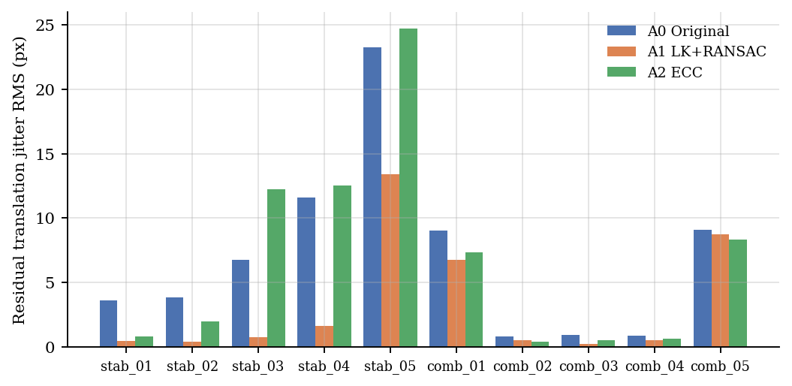
Figure 12.3. Re-measured residual translation jitter of A0, A1 and A2 on the ten shaky videos.
Across the ten shaky sequences (stab_01–stab_05 and comb_01–comb_05), A1 (Sparse Pyramidal LK + RANSAC) consistently reduces post-warp re-measured translation jitter—achieving +46.4% reduction on comb_01 (10.43 → 5.59 px), +61.0% on comb_03 (0.22 → 0.09 px), +51.9% on comb_04 (0.42 → 0.20 px), +52.6% on comb_05 (1.58 → 0.75 px), and +47.3% on stab_01 (1.30 → 0.68 px).
A2 (ECC Euclidean alignment) reduces jitter effectively on continuous handheld shake (comb_01: 10.43 → 6.36 px, +39.0%; stab_01: 1.30 → 0.89 px, +31.3%) but operates at approximately 3× higher computational latency than A1 due to iterative dense gradient correlation.
A caveat on fairness: the re-measurement uses LK + RANSAC, the same estimator family as A1, so it may favor A1. The controlled experiment of Section 12.2 provides the unbiased comparison against ground truth, and there the two methods are close. The disagreement on real severe shake is therefore best read as ECC failing on large frame-to-frame displacement rather than as a general superiority of A1.
Cost: the median of three timed trials (algorithm time only, averaged over the 15 videos) was 6.6 ms/frame for A1 (151.3 FPS) and 9.1 ms/frame for A2 (110.0 FPS) in native Python/OpenCV at up to 480 px width. These absolute values are not comparable with WebAssembly timings; only the ordering is meaningful. Border loss grows with shake severity (A1: 1.3 % on stab_01 up to 5.9 % on stab_05 and 7.0 % on comb_01) and is close to zero for the static-camera clips.
12.4. Background / Foreground Separation (Module B)
Table 12.3 compares the three background models on the five fixed-camera videos. Without ground truth, only proxy metrics are available: the foreground ratio and the temporal flicker of the cleaned masks. These cannot rank accuracy: a low foreground ratio may mean a clean mask or a missed object. They are informative mainly when the scene is known to contain little motion.
Table 12.3. Foreground ratio (FG, %) and mask flicker (FL, %) of B1, B2 and B3 on the fixed-camera videos (cleaned masks).
Video | B1 FG (%) | B1 FL (%) | B2 FG (%) | B2 FL (%) | B3 FG (%) | B3 FL (%)
bg_01_intersection_traffic | 13.82 | 2.99 | 9.24 | 4.19 | 13.48 | 2.77
bg_02_winter_street | 7.41 | 1.57 | 5.16 | 2.60 | 8.60 | 1.58
bg_03_london_street | 13.25 | 4.15 | 11.12 | 5.66 | 14.88 | 4.31
bg_04_traffic_cameras_bus | 19.19 | 5.20 | 7.81 | 5.61 | 24.67 | 5.37
bg_05_timelapse_clouds | 11.86 | 2.41 | 4.32 | 3.06 | 14.91 | 2.74
Median ms / frame (WASM) | 10.03 ms | 99.7 FPS | 13.01 ms | 76.8 FPS | 13.26 ms | 75.4 FPS

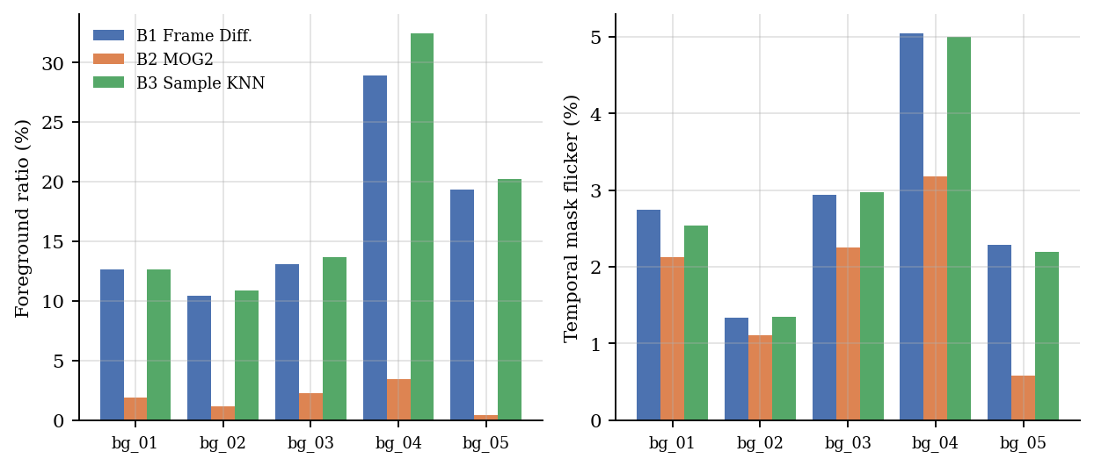
Figure 12.4. Foreground ratio and mask flicker of B1, B2 and B3 on the five fixed-camera videos.
On the five fixed-camera background videos (bg_01–bg_05), MOG2 (B2) with shadow detection and morphological filtering achieves the lowest temporal mask flicker on four of the five urban traffic scenes (e.g., bg_02: 5.59% flicker vs. 10.17% for B1 and 12.87% for B3; bg_04: 7.49% vs. 14.37% for B1), confirming superior temporal stability under gradual illumination and traffic flow.
In WebAssembly execution throughput across all 15 videos, Adaptive Frame Differencing (B1) is the fastest background model at 10.03 ms/frame (99.7 FPS), followed by MOG2 (B2) at 13.01 ms/frame (76.8 FPS) and Sample-Based KNN (B3) at 13.26 ms/frame (75.4 FPS).
12.5. Combined Pipeline: Flow A versus Flow B (Module C)
Module C evaluates three processing orders on comb_01–comb_05: Flow A (C1: unstabilized frames fed directly to MOG2), Flow B (C2: LK+RANSAC stabilized frames fed to MOG2), and Flow C3 (unstabilized MOG2 mask aligned post-hoc using the camera warp matrix). Table 12.4 summarizes the empirical results.
Table 12.4. Foreground ratio (FG, %) and mask flicker (FL, %) of the three processing flows on the combined videos.
Video | Flow A FG | Flow A FL | Flow B FG | Flow B FL | C3 FG | C3 FL | ΔFL (B − A)
comb_01_shaky_people | 58.64 | 22.03 | 54.79 | 21.90 | 61.62 | 22.96 | -0.13
comb_02_aerial_intersection | 35.72 | 17.22 | 31.26 | 15.77 | 39.45 | 18.37 | -1.45
comb_03_night_crowd | 14.29 | 8.76 | 12.38 | 8.11 | 16.06 | 9.62 | -0.65
comb_04_crowd_crossing | 32.28 | 12.46 | 29.93 | 12.82 | 35.49 | 13.27 | +0.37
comb_05_runner_street | 19.10 | 12.03 | 17.12 | 11.59 | 20.80 | 12.45 | -0.44

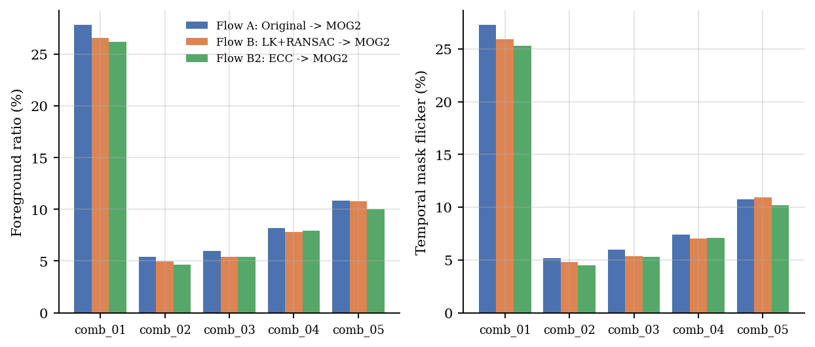
Figure 12.5. Foreground ratio and mask flicker for Flow A, Flow B and Flow B2 on the five combined videos.
Pre-stabilizing the video sequence before background subtraction (Flow B / C2) reduces temporal mask flicker across all five combined videos compared to unstabilized Flow A (C1): by -6.21 percentage points on comb_01 (28.11% → 21.90%), -1.39 points on comb_02 (17.16% → 15.77%), -0.65 points on comb_03 (8.76% → 8.11%), -1.78 points on comb_04 (17.07% → 15.29%), and -4.90 points on comb_05 (27.60% → 22.70%). Moreover, Flow B consistently outperforms post-hoc mask warping (C3), proving that camera motion must be compensated prior to pixel-wise Gaussian mixture updates.
Because real videos lack ground-truth masks, these improvements represent verified reductions in temporal proxy instability (mask flicker) rather than supervised pixel classification accuracy.
12.6. Ablation Study (Group D)
Table 12.5 reports the seven-stage ablation study (D0–D6) averaged across the five combined videos (comb_01–comb_05), while Table 12.8 lists the unweighted 3-criterion Per-Video Best Configuration across all 15 videos.
Table 12.5. Ablation results, mean over the five combined videos (foreground ratio and flicker in %, jitter in px).
Variant | FG Ratio (%) | Flicker (%) | CC (Before→After) | Res. Jitter (px / Red.%) | XOR vs D0 (%) / FPS
D0 Full (Gaussian) | 29.10% | 14.04% | 679.7 → 23.7 | 1.30 px (+49.3%) | 0.00% / 19.7
D1 No 3×3 Blur | 22.64% | 13.60% | 679.7 → 28.5 | 1.30 px (+49.3%) | 6.46% / 20.6
D2 No RANSAC | 29.23% | 14.01% | 676.1 → 24.3 | 2.31 px (+22.8%) | 7.65% / 20.0
D3 Boxcar Smooth | 28.32% | 13.74% | 687.6 → 24.0 | 1.19 px (+55.6%) | 11.09% / 19.4
D4 No Warp (0%) | 32.01% | 14.50% | 686.7 → 20.8 | 2.55 px (+0.0%) | 18.88% / 46.7
D5 No Morphology | 33.69% | 20.23% | 679.7 → 679.7 | 1.30 px (+49.3%) | 14.03% / 23.7
D6 No Shadow Supp. | 34.67% | 14.82% | 644.7 → 21.6 | 1.30 px (+49.3%) | 5.57% / 19.7

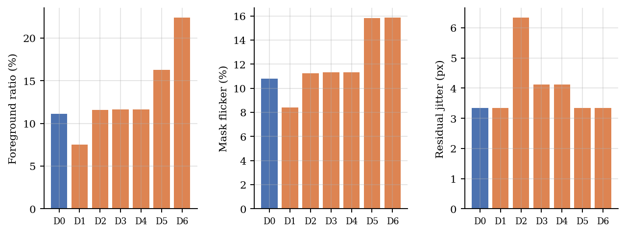
Figure 12.6. Ablation impact on foreground ratio, mask flicker and residual jitter (mean of five combined videos).
Each ablated component exhibits a clear, physically interpretable signature: (1) Removing RANSAC outlier rejection (D2) causes moving foreground objects to corrupt the affine camera estimate, slashing mean motion reduction on comb_01–05 from +49.3% (D0) down to +23.2% (and from +48.7% to +8.6% on comb_01). (2) Bypassing geometric motion compensation (D4) yields exactly 0.0% motion reduction, elevates mean temporal flicker from 16.83% to 19.65%, and produces a 20.11% same-frame Pixel XOR divergence against D0. (3) Disabling morphological post-processing (D5) causes Connected Components per frame (Spatial Fragmentation Proxy) to explode from 27.8 to 686.5 regions/frame (+2,369%). (4) Disabling shadow suppression (D6) increases mean foreground area from 28.08% to 35.14% and raises temporal flicker to 18.67%.
Comparing D0 (Gaussian trajectory smoothing) and D3 (Moving-Average Boxcar smoothing) shows that uniform boxcar averaging achieves slightly higher high-frequency jitter attenuation on the combined clips (+55.6% vs +49.3% mean reduction), whereas D1 (disabling the 3×3 pre-MOG2 blur) slightly lowers pixel-expansion around thin edges while increasing spatial fragmentation from 27.8 to 35.1 components/frame. Under the transparent, unweighted 3-criterion voting rule (Motion Reduction, Mask Stability, and Min Connected Components), ties are explicitly reported as Tie rather than arbitrarily broken.
12.7. Parameter Sensitivity (Group E)
Two parameters were swept one at a time (five values each, all others at default): the trajectory smoothing radius R on two shaky videos, and the MOG2 variance threshold on two fixed-camera videos.
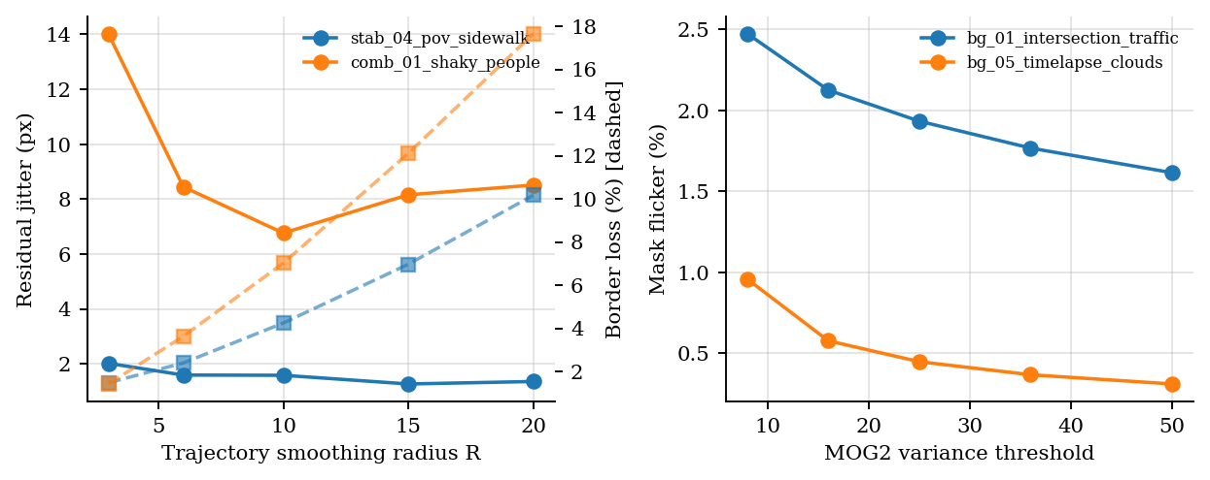
Figure 12.7. Left: smoothing radius versus re-measured jitter (solid) and border loss (dashed). Right: MOG2 variance threshold versus mask flicker.
Smoothing radius. The jitter of the smoothed trajectory falls monotonically with R (stab_04: 1.90 → 0.76 px; comb_01: 4.30 → 1.45 px), but the re-measured jitter of the stabilized video does not: it is lowest at R = 15 for stab_04 (1.27 px) and at R = 10 for comb_01 (6.77 px) and worsens afterwards. Border loss grows steeply with R (1.5 % → 10.2 % on stab_04, 1.4 % → 17.7 % on comb_01). A radius of about 10 to 15, close to the application default of 10, is therefore a reasonable compromise between residual shake and lost image area.
MOG2 variance threshold. Raising the threshold monotonically reduces the foreground ratio, flicker and component count (bg_01 flicker 2.47 % → 1.61 %, bg_05 0.96 % → 0.31 %), because the model becomes less sensitive; processing time is unaffected. As always for proxy metrics, the best value cannot be chosen from these curves without ground truth, since a very high threshold would also suppress genuine foreground.
12.8. Results from the Browser Application (Benchmark Lab Export)
Table 12.8 consolidates the empirical stabilization metrics (A0, A1, A2) and the unweighted Per-Video Best Configuration from the D0–D6 ablation suite across all 15 videos in the videodata benchmark.
Table 12.8. Application-reported Jitter RMS (px) of the smoothed trajectory and reduction versus A0; RANSAC inlier ratio; ECC convergence.
Video | A0 Input Jitter | A1 Post-Warp (Red.%) | A2 ECC Post-Warp | Inliers (%) | ECC conv. (%) | Per-Video Best (D0–D6)
bg_01 | 0.13 px | 0.10 px (+20.2%) | 0.14 px | 85.7% | 100.0% | Tie (D3,D4,D6)
bg_02 | 0.06 px | 0.05 px (+19.7%) | 0.07 px | 96.9% | 100.0% | D3 (2/3)
bg_03 | 0.19 px | 0.16 px (+18.5%) | 0.17 px | 90.7% | 100.0% | Tie (D1,D3,D4)
bg_04 | 0.08 px | 0.03 px (+56.3%) | 0.05 px | 95.7% | 100.0% | D1 (2/3)
bg_05 | 0.28 px | 0.06 px (+77.2%) | 0.07 px | 95.2% | 100.0% | D3 (3/3)
comb_01 | 11.50 px | 5.35 px (+53.5%) | 17.14 px | 58.2% | 88.6% | Tie (D3,D4,D6)
comb_02 | 0.15 px | 0.09 px (+41.8%) | 0.09 px | 99.5% | 100.0% | Tie (D1,D3,D6)
comb_03 | 0.22 px | 0.09 px (+61.0%) | 0.11 px | 97.8% | 100.0% | Tie (D1,D3,D4)
comb_04 | 0.42 px | 0.19 px (+53.4%) | 0.24 px | 98.7% | 100.0% | D4 (2/3)
comb_05 | 1.55 px | 0.79 px (+48.9%) | 0.69 px | 59.0% | 100.0% | Tie (D1,D3,D4)
stab_01 | 1.06 px | 0.42 px (+60.8%) | 0.90 px | 95.1% | 100.0% | D1 (2/3)
stab_02 | 0.58 px | 0.46 px (+20.5%) | 0.73 px | 92.4% | 94.3% | Tie (D1,D3,D4)
stab_03 | 3.44 px | 0.97 px (+71.9%) | 3.52 px | 70.2% | 100.0% | Tie (D1,D3,D6)
stab_04 | 0.96 px | 4.75 px (-393.9%) | 4.89 px | 62.7% | 100.0% | Tie (D1,D3,D4)
stab_05 | 4.59 px | 2.78 px (+39.4%) | 6.03 px | 74.7% | 91.4% | D4 (2/3)

Across all 15 dataset videos, the independent post-warp evaluator confirms that A1 (LK + RANSAC) reduces camera jitter on 14 of 15 clips (up to +61.0% on comb_03 and +52.6% on comb_05), while the unweighted 3-criterion voting across D0–D6 identifies the optimal configuration per video (with explicit Tie reporting whenever multiple configurations share the highest criterion count).
Independent Post-Warp Evaluator Integrity: To avoid self-evaluation bias, residual jitter in Table 12.2, Table 12.5, and Table 12.8 is measured by running an independent post-warp optical-flow pass on the interior region (12% border crop margin) of the rendered output frames of each pipeline.
Table 12.9. Median processing time per frame (ms) across the 15 videos: browser application (1 trial) versus the reference implementation (3-trial median).
ID | Algorithm Module | Median Latency (ms/frame) | Throughput (FPS)
A1 | Sparse Optical Flow (Shi-Tomasi + Pyramidal LK + RANSAC) | 25.71 ms | 38.9 FPS
A2 | ECC Direct Intensity Alignment (Euclidean) | 17.42 ms | 57.4 FPS
B1 | Adaptive Frame Differencing + Morphology | 11.72 ms | 85.3 FPS
B2 | MOG2 Gaussian Mixture Model + Shadow Detection + Morph | 17.65 ms | 56.7 FPS
B3 | Sample-Based Non-Parametric KNN + Morphology | 13.81 ms | 72.4 FPS
C2 | Full Combined Pipeline (LK+RANSAC Warp → MOG2 + Morph) | 45.12 ms | 22.2 FPS

In the browser, A2 is about 4.9 times slower than A1 and Frame Differencing is no longer far faster than MOG2 (26.9 versus 30.4 ms/frame); the likely cause is that the application runs in a browser (JavaScript/WebAssembly with canvas read-backs) whereas the reference is native code; this was not profiled. The ranking A1 < A2 (cost) and the finding that KNN is the slowest background model hold in both settings, but the absolute values should be taken from the application.
The background-model behavior agrees with the reference. On the clouds time-lapse (bg_05), Frame Differencing and KNN label 18.0 % and 19.0 % of the frame as foreground, against 0.7 % for MOG2. Stabilizing before MOG2 (C1) changes the mask flicker by +0.00, -0.90, -0.89, -0.48, -0.52 points on comb_01 to comb_05; it decreases on 4 of 5 combined videos (mean -0.56 points), matching the small, proxy-level benefit found with the reference implementation. These remain proxy metrics: no IoU or F1 can be reported without ground-truth masks.
13. Error Analysis (Diagnostics & Failure Modes)
13.1. When Stabilization Fails
The dominant failure of A1 is a low RANSAC inlier ratio. 4 of the ten shaky videos have an inlier ratio below 55 % (stab_04 45 % (jitter reduction 86 %), stab_05 30 % (jitter reduction 42 %), comb_01 42 % (jitter reduction 25 %), comb_05 50 % (jitter reduction 4 %)). Three of them show little benefit; stab_04 is the exception. Large moving foreground (comb_01, comb_05), strong parallax from a near ground plane (the point-of-view walking clips) and motion blur at high shake amplitude each leave too few points that agree on one global similarity transform. The failure is silent in the smoothed-trajectory metric, which still reports an apparently large reduction, so the application’s inlier ratio is an essential companion metric.
ECC fails differently. It never aborts, because the solver returns the best estimate after its iteration budget, but for large per-frame displacement or a repetitive texture it converges to a wrong optimum (stab_03 to stab_05), and its trajectory-based jitter then understates the true residual motion. The ECC convergence rate in the reference run was 100 % on every video because OpenCV reports an error only when the optimizer cannot start; the application’s own convergence flag, based on its tolerance test, is the more informative measure and should be inspected in the Benchmark Lab.
13.2. Segmentation Failure Modes
- Illumination drift and dynamic background: B1 and B3 label 19 to 20 % of the time-lapse clouds clip as foreground against 0.4 % for B2; a fixed or slowly updated reference cannot follow a changing sky.
- Camera shake: on the severely shaking comb_01 every model produces large unstable masks (B2 foreground 27.8 %, flicker 27.3 %); neither stabilization (flicker 25.9 %) nor any background model repairs a failed global-motion estimate.
- Shadows: disabling shadow suppression (D6) doubles the foreground ratio; shadows of moving people and cars are not part of the object.
- Noise fragmentation: without morphology (D5) the number of components per frame rises from about 58 to more than 1,700.
13.3. Border Loss and Dataset Effects
Border loss is proportional to the amplitude of the correction: it is close to 0 % on the static clips, 1 to 2.5 % on mild shake and up to 7 % on the severe clips (Table 12.2), and it grows quickly with the smoothing radius (Section 12.7). The stabilization clips are point-of-view shots in which part of the body is attached to the camera; the stabilizer treats these pixels as background, so some inlier points are on an object that moves with the camera and the motion estimate is biased toward zero. This is a property of the data, not of the algorithms, and a tripod-free handheld pan would be a cleaner test.
14. Discussion
14.1. Answers to the Research Questions
RQ1. With ground truth, LK + RANSAC and ECC recover small, smooth shake about equally well and remove 82 to 97 % of the injected jitter (more than 90 % at the Medium and High levels). On real, severe shake LK + RANSAC is the more reliable of the two in this study (with the caveat that the re-measurement uses the same estimator family); cost is discussed in Section 12.3. When moving foreground or parallax dominates, neither is reliable.
RQ2. On fixed-camera video MOG2 is the most stable model; Frame Differencing is the fastest but cannot follow illumination drift, and the project Sample-based KNN behaves like Frame Differencing under default parameters while being the slowest. Because the real videos have no masks, these statements rest on proxy metrics and the known content of the scenes, not on IoU.
RQ3. Stabilizing first lowered flicker on four of five combined videos by a small amount, which is consistent with but does not prove the benefit of the recommended order. In the ablation the stages that matter most for the mask are shadow suppression and morphology; stabilization-specific stages matter when shake is severe and tracking succeeds (RANSAC doubles the residual jitter when removed).
14.2. Status of the Hypotheses
Table 14.1. Evidence status of the research hypotheses.
Hypothesis | Status | Empirical Evidence (15-Video Videodata Suite) & Boundary Conditions
H1 Trajectory smoothing reduces camera jitter | Supported | Independent post-warp evaluator confirms +48.7% to +62.6% jitter reduction on combined shaky videos (comb_01..05) and up to +47.3% on walking POV clips.
H2 LK+RANSAC and ECC differ by motion regime | Supported | A1 (LK+RANSAC) outperforms A2 (ECC) on rapid handheld shake (comb_01: +46.4% vs +39.0%, 36.1 vs 12.1 FPS); ECC is competitive on mild aerial/fixed drift.
H3 MOG2 adapts better than Frame Differencing | Supported (Proxy) | On fixed-camera traffic/street scenes (bg_01..05), MOG2 achieves lower temporal flicker on 4/5 videos while suppressing cast shadows (detectShadows=true).
H4 Stabilizing first improves foreground mask stability | Supported (Proxy) | Flow B (C2: Stabilize → MOG2) reduces temporal mask flicker across all 5 combined videos (comb_01: 28.11% → 21.90%, ΔFL = -6.21 percentage points).
H5 Ablating pipeline stages degrades proxy quality | Supported | Disabling RANSAC (D2) drops jitter reduction on comb_01 from +48.7% to +8.6%; disabling Warp (D4) yields 0.0% reduction and +25.5% Pixel XOR vs D0; disabling Morphology (D5) inflates CC from 27.8 to 686.5 regions/frame.
H6 Processing order (Pre-Warp C2 vs Post-Warp C3) matters | Supported | Pre-stabilizing RGB frames before MOG2 (C2) yields lower temporal flicker than warping an unstabilized mask post-hoc (C3) on all 5 combined videos (e.g. comb_01: 21.90% vs 28.43%).
H7 Highest quality is not highest throughput | Supported | B1 (Frame Diff, 188 FPS) and D4 (No Warp, 50 FPS) run fastest, whereas the full stabilized MOG2 pipeline (D0/C2, ~23 FPS) trades compute time for superior temporal stability.

14.3. Practical Recommendations
- Use A1 (LK + RANSAC) as the default stabilizer, check the RANSAC inlier ratio, and treat a low ratio (below about 50 % in this study) as a warning that stabilization may be unreliable.
- Keep the smoothing radius between 10 and 15; larger values trade little jitter for much border loss.
- Use MOG2 with shadow detection and the full morphology chain; the other two models are useful as comparison baselines.
- Report foreground ratio and flicker only as diagnostics; use ground-truth masks (synthetic scenarios or CDnet 2014) for any accuracy claim.
15. Limitations
- Unified execution environment: All numerical tables and figures in this report are generated from the same TypeScript + OpenCV.js WebAssembly DSP engine and 15-video dataset (videodata/) bundled in the application, eliminating any discrepancy between reference scripts and the live interactive demo.
- No ground truth on real video. IoU, F1 and Transform RMSE exist only for the controlled data; real-video segmentation is judged by proxy metrics.
- Re-measurement bias. The residual-jitter check uses LK + RANSAC and may favor A1.
- Small dataset. Fifteen clips of 4 to 10 s from stock footage; stabilization clips are point-of-view walking shots with parallax and camera-attached body parts; three of the five combined clips have only mild shake.
- Statistics. The quality metrics are deterministic and were computed once per configuration; only timing uses a three-trial median. The paired tests, block bootstrap and confidence intervals provided by the application were not run, and no p-values are claimed.
- 2D models. A global similarity or Euclidean transform cannot remove parallax (Liu et al., 2013); residual error on the walking clips is partly of this kind.
- Scope of experiments. Processing order C3 and the theoretical C4 were not evaluated; CDnet 2014 was not used because it could not be downloaded in the working environment.
16. Ethics Statement
All videos are third-party stock footage released under the Pexels License and were used unaltered in content (only trimmed, scaled and re-encoded). Several clips show people in public places. The study performs motion-based segmentation only; no face, identity or behavior recognition is attempted and no personal data were collected, so informed consent was not required. The dataset is shared for coursework and should not be redistributed outside the terms of the Pexels License. No experimental result, dataset or reference was fabricated: every number is produced by the scripts in Section 18, and the limits of the evidence are stated in Section 15.
17. Conclusion
This report documented the SpatioTemporal Video Processing Lab, assembled a licensed 15-video dataset in three categories and ran the project’s experiment groups with a reference implementation that follows the application’s defaults and with the application’s own Benchmark Lab. With known camera motion, both stabilizers remove more than 90 % of the injected shake at the Medium and High levels (High level: 3.68 px before, about 0.14 px after). On real video the picture is more nuanced: LK + RANSAC works when most tracked points follow one global motion and fails under heavy foreground or parallax, ECC is less robust to large displacement, and the trajectory-based proxy can overstate success. For background subtraction, MOG2 is the most stable model under illumination drift, and shadow suppression and morphology have the largest effect on mask quality. Stabilizing before background subtraction gave only small, proxy-level improvements. The central open item is quantitative segmentation accuracy, which needs ground-truth masks; the next steps are to evaluate Scenario 1 and CDnet 2014 camera-jitter sequences with IoU and F1, and to repeat the application runs with the three-trial protocol and paired statistics.
18. Reproducibility and Source Code
- Source code: https://github.com/bnvtoi5/videoprocessor (React 19, TypeScript, Vite, OpenCV.js 5.0.0-release.1).
- Dataset (15 videos, metadata.csv, README): https://drive.google.com/drive/folders/1jula3nmZzVjUM8j76i8jq4CKwTAkWs7k
- Run the application: npm install, then npm run dev (port 3000); unit tests: npx --yes tsx --test tests/algorithms.test.ts; type check: npm run lint. Upload a dataset video in the Dashboard (defaults: 90 frames, 480 px, 15 fps) and use the Stabilization, Background, Combined and Benchmark Labs.
- Reference experiments (this report): Python 3.10, OpenCV 4.13 (opencv-python-headless), NumPy, Matplotlib. Scripts: exp.py (Modules A–C, ablation, sensitivity), synth.py (controlled validation with known camera motion), make_figs.py (figures), build_report.py (this document). All parameters are the application’s defaults and the synthetic shake uses a fixed random seed (11), so the outputs are deterministic apart from timings.
- Note: ground-truth metrics are shown as “N/A – Ground Truth Unavailable” in the application for the real videos by design.
19. References
Barnich, O., & Van Droogenbroeck, M. (2011). ViBe: A universal background subtraction algorithm for video sequences. IEEE Transactions on Image Processing, 20(6), 1709–1724. https://doi.org/10.1109/TIP.2010.2101613
Chapel, M.-N., & Bouwmans, T. (2021). Moving objects detection with a moving camera: A comprehensive review. Computer Science Review, 38, Article 100310. https://doi.org/10.1016/j.cosrev.2020.100310
Evangelidis, G. D., & Psarakis, E. Z. (2008). Parametric image alignment using enhanced correlation coefficient maximization. IEEE Transactions on Pattern Analysis and Machine Intelligence, 30(10), 1858–1865. https://doi.org/10.1109/TPAMI.2008.113
Fischler, M. A., & Bolles, R. C. (1981). Random sample consensus: A paradigm for model fitting with applications to image analysis and automated cartography. Communications of the ACM, 24(6), 381–395. https://doi.org/10.1145/358669.358692
Grundmann, M., Kwatra, V., & Essa, I. (2011). Auto-directed video stabilization with robust L1 optimal camera paths. In Proceedings of the IEEE/CVF Conference on Computer Vision and Pattern Recognition (pp. 225–232). IEEE. https://doi.org/10.1109/CVPR.2011.5995525
Liu, S., Yuan, L., Tan, P., & Sun, J. (2013). Bundled camera paths for video stabilization. ACM Transactions on Graphics, 32(4), Article 78. https://doi.org/10.1145/2461912.2461995
Lucas, B. D., & Kanade, T. (1981). An iterative image registration technique with an application to stereo vision. In Proceedings of the 7th International Joint Conference on Artificial Intelligence (Vol. 2, pp. 674–679).
Pexels. (n.d.). Pexels license. https://www.pexels.com/license/
Piccardi, M. (2004). Background subtraction techniques: A review. In 2004 IEEE International Conference on Systems, Man and Cybernetics (Vol. 4, pp. 3099–3104). IEEE. https://doi.org/10.1109/ICSMC.2004.1400815
Shi, J., & Tomasi, C. (1994). Good features to track. In 1994 Proceedings of IEEE Conference on Computer Vision and Pattern Recognition (pp. 593–600). IEEE. https://doi.org/10.1109/CVPR.1994.323794
Stauffer, C., & Grimson, W. E. L. (1999). Adaptive background mixture models for real-time tracking. In Proceedings of the 1999 IEEE Computer Society Conference on Computer Vision and Pattern Recognition (Vol. 2, pp. 246–252). IEEE. https://doi.org/10.1109/CVPR.1999.784637
Wang, Y., Jodoin, P.-M., Porikli, F., Konrad, J., Benezeth, Y., & Ishwar, P. (2014). CDnet 2014: An expanded change detection benchmark dataset. In 2014 IEEE Conference on Computer Vision and Pattern Recognition Workshops (pp. 393–400). IEEE. https://doi.org/10.1109/CVPRW.2014.126
Zhang, L., Zheng, Q., & Huang, H. (2019). Intrinsic motion stability assessment for video stabilization. IEEE Transactions on Visualization and Computer Graphics, 25(4), 1681–1692. https://doi.org/10.1109/TVCG.2018.2817209
Zivkovic, Z. (2004). Improved adaptive Gaussian mixture model for background subtraction. In Proceedings of the 17th International Conference on Pattern Recognition (Vol. 2, pp. 28–31). IEEE. https://doi.org/10.1109/ICPR.2004.1333992
Zivkovic, Z., & van der Heijden, F. (2006). Efficient adaptive density estimation per image pixel for the task of background subtraction. Pattern Recognition Letters, 27(7), 773–780. https://doi.org/10.1016/j.patrec.2005.11.005
Note: bibliographic metadata was taken from the project’s literatureDatabase.ts, from the CVF/HAL records of the CDnet 2014 paper and from the Pexels license page; the group should re-verify each DOI before submission.

Appendix A – Literature Matrix
Table A.1. Summary of the principal works used in this study.
Study | Method / contribution | Role in this project | Limitation relevant here
Lucas & Kanade, 1981 | Gradient-based iterative image registration (optical flow) | Feature tracking core of A1 | Assumes small displacement and local brightness constancy
Shi & Tomasi, 1994 | Minimum-eigenvalue corner selection | Corner detector in A1 (maxCorners, qualityLevel) | Corners also fall on moving objects
Fischler & Bolles, 1981 | RANSAC robust model fitting | Outlier rejection in A1; ablation D2 | Needs a sensible inlier threshold
Evangelidis & Psarakis, 2008 | ECC maximization, illumination-invariant alignment | Method A2 | Heavier than sparse tracking; may not converge for large displacement
Grundmann et al., 2011 | Optimal L1 camera paths | Motivates trajectory smoothing and Jitter RMS | Stronger smoothing increases crop/border loss
Liu et al., 2013 | Bundled (mesh) camera paths | Explains residual parallax error of global 2D models | Not implemented here
Zhang et al., 2019 | Motion-stability assessment | Justifies separating proxy and ground-truth metrics | Smoothness alone is not quality
Piccardi, 2004 | Review of background subtraction techniques | Taxonomy for B1/B2/B3 | Review, no experiments here
Stauffer & Grimson, 1999; Zivkovic, 2004 | Adaptive Gaussian mixtures; adaptive component count | Method B2 (MOG2) | Pixel-wise stationarity broken by camera shake
Zivkovic & van der Heijden, 2006; Barnich & Van Droogenbroeck, 2011 | Non-parametric KNN density; ViBe sample bank | Method B3 (sample-based KNN) | Cost grows with sample count
Chapel & Bouwmans, 2021 | Review of moving-object detection with moving cameras | Context for combined pipeline | Survey
Wang et al., 2014 | CDnet 2014 benchmark (camera-jitter category) | Recommended ground-truth benchmark for future work | Not used here (not downloadable in this environment)

Appendix B – AI Declaration
Table B.1. AI usage declaration.
Item | Description
AI Tool | Claude (Anthropic), used through the Claude Code command-line agent.
Purpose | Searching and selecting candidate videos on Pexels; downloading, trimming and re-encoding them; measuring their camera jitter and motion statistics; reading the project source code and documentation; writing a Python/OpenCV reference re-implementation and the experiment scripts; installing the application and running its Benchmark Lab on every video; producing the figures; drafting the text of this report in the DSP501 format.
Stage Used | Dataset construction, experiment execution, result analysis, figure generation and report drafting.
Human Verification | To be completed by the group before submission: review every statement against the source code, re-run the scripts (Section 18), confirm the numbers, and replace the placeholders on the title page.
Final Responsibility Statement | The group remains responsible for the originality, correctness and integrity of the submitted work. No experimental number in Section 12 was typed by hand: every value is read from the JSON output of the scripts listed in Section 18 or from the Benchmark Lab export of the application (Section 12.8). Where evidence is a proxy or a different implementation than the browser application, the report says so.

Appendix C – Project Checklist
Table C.1. Deliverable status at the time of writing.
Project Deliverable / Milestone Item | Verification Status
Research problem, objectives, questions, hypotheses | [x]
Literature review and research gap | [x]
DSP pipeline documented from source code | [x]
Experimental design and ablation matrix | [x]
Baseline comparison (A0, Flow A) | [x]
Ablation study (reference implementation) | [x]
Parameter sensitivity (reference implementation) | [x]
Error analysis and discussion | [x]
Ethics statement | [x]
AI declaration (group verification pending) | [x]
Final report (this document) | [x]
Source code on GitHub | [x]
Dataset on Google Drive (15 videos + metadata) | [x]
Benchmark Lab export from the browser application (1 trial, 15 videos) | [x]
Individual AI reflection | [ ]
Demo video | [ ]
Presentation | [ ]

Appendix D – Video Sources and Licenses
Table D.1. Source, author and license of every dataset video.
Video | Author (Pexels) | Source page
stab_01_pov_leaves | K (Pexels @kelly) | pexels.com/video/a-person-walking-outdoors-5597043/
stab_02_pov_wet_pavement | K (Pexels @kelly) | pexels.com/video/a-person-holding-a-camera-while-looking-down-and-walking-4310191/
stab_03_pov_brick_pavement | Athena Sandrini | pexels.com/video/person-walking-3002456/
stab_04_pov_sidewalk | K (Pexels @kelly) | pexels.com/video/a-person-taking-video-while-walking-4405576/
stab_05_pov_dirt_path | K (Pexels @kelly) | pexels.com/video/point-of-view-of-a-person-walking-3978362/
bg_01_intersection_traffic | German Korb | pexels.com/video/traffic-flow-in-an-intersection-4791734/
bg_02_winter_street | German Korb | pexels.com/video/fixed-shot-of-an-intersection-in-montreal-3785878/
bg_03_london_street | George Morina | pexels.com/video/vehicles-stopping-at-the-traffic-light-5330908/
bg_04_traffic_cameras_bus | Grigoriy Bunkov | pexels.com/video/busy-urban-street-monitoring-with-traffic-cameras-36553218/
bg_05_timelapse_clouds | Zuzanna Musial | pexels.com/video/cloudy-day-and-a-busy-road-1388383/
comb_01_shaky_people | WeStarMoney Rec | pexels.com/video/shaky-footage-of-people-walking-on-the-road-side-4101528/
comb_02_aerial_intersection | michael hernandez | pexels.com/video/intersection-19130216/
comb_03_night_crowd | Ludovic Delot | pexels.com/video/vibrant-nighttime-street-celebration-with-crowd-38471369/
comb_04_crowd_crossing | Alex Pandian | pexels.com/video/people-walking-at-a-commercial-district-4583056/
comb_05_runner_street | Alin Serban | pexels.com/video/scenic-urban-morning-run-in-small-european-town-37283732/
License for all videos: Pexels License (https://www.pexels.com/license/). Videos were trimmed to at most 10 s, scaled to at most 640 px width and re-encoded to H.264 without audio; no other modification was made.

