ANOVA for a RCBD trial: PTLB199909_OXAPMP_B3C1OXA00-03

rsimon using HIDAP

November 19, 2015, 11:14h

Table of Contents

Author affiliations:

Citation: Bonierbale, Merideth; Gastelo Manuel (1999). *PTLB199909_OXAPMP_B3C1OXA00-03*. Dataset version: 1. Dataset fingerprint (UNF): ASDFHSJKDF525423. Url: <http://dataverse.cipotato.org/123456>.

# This is an automatedly created report.  
  
# See more details in section on materials.

Alternate formats:

# Abstract

This trial has the identifier PTLB199909_OXAPMP_B3C1OXA00-03. It was conducted under the supervision of Bonierbale, Merideth; Gastelo Manuel as a Preliminary Trial as part of a Yield Breeding Program in , PERU in 1999. A total of 26 clones (including reference clones) were evaluated for NTP, PGH, Plant_Vigor, Flower, LB1, LB2, LB3, LB4, LB5, LB6, LB7, AUDPC, rAUDPC, SAUDPC, NMTP, NoMTWP, TTWP, TTYNA, MTWP, MTYNA, ATMW, AVDM, SG, FFR, TEXFR, Chip_Color traits.

# Materials and Methods

## Location characterization

### Installation

### Geographic and climate characterization

### Weather during planting season

### Soil

### Field management

### Observations on special events

## Materials

## Trait descriptions (from ontology)

## Model specification and data description

There is data from 26 treatments, evaluated using a randomize complete block design with 4 blocks. The statistical model is

$$y_{ij}=μ+τ_{i}+β_{j}+ϵ_{ij}$$

where

* $y_{ij}$ is the observed response with treatment $i$ and block $j$.
* $μ$ is the mean response over all treatments and blocks.
* $τ_{i}$ is the effect for treatment $i$.
* $β_{j}$ is the effect for block $j$.
* $ϵ_{ij}$ is the error term.

In this model we assume that the errors are independent and have a normal distribution with common variance, that is, $ϵ_{ij}∼N(0,σ_{ϵ}^{2})$.

The following traits are analyzed: **SG, FFR, TEXFR, Chip_Color, LB3**

## Computational tools

This report was created using i386-w64-mingw32, i386, mingw32, i386, mingw32, , 3, 2.2, 2015, 08, 14, 69053, R, R version 3.2.2 (2015-08-14), Fire Safety on a i386-w64-mingw32/i386 (32-bit) running Windows 7 x64 (build 7601) Service Pack 1 in . The following base packages were loaded: **stats, graphics, grDevices, utils, datasets, methods, base** and the following additional packages: **hidap, knitr, qtl, qtlcharts, fbsites, rmarkdown, leaflet, shinyBS, shinyFiles, rhandsontable, shinydashboard, shiny**.

# Results

## Raw data

## Trait summaries

## Trait analyses

### Analysis for trait SG

You have fitted a linear model for a RCBD. The ANOVA table for your model is:

Table continues below

|  |  |  |  |  |
| --- | --- | --- | --- | --- |
|  | Df | Sum Sq | Mean Sq | F value |
| **INSTN** | 25 | 0.00682332 | 0.000272933 | 22.6439 |
| **REP** | 3 | 5.20049e-05 | 1.7335e-05 | 1.43819 |
| **Residuals** | 75 | 0.000903995 | 1.20533e-05 | NA |

|  |  |
| --- | --- |
|  | Pr(>F) |
| **INSTN** | 1.48563e-25 |
| **REP** | 0.238396 |
| **Residuals** | NA |

The p-value for treatments is 0.000000000000000000000000148563 which is significant at the 5% level.

The means of your treatments are:

|  |  |
| --- | --- |
| INSTN | SG |
| CIP377744.1 | 1.07 |
| CIP384866.5 | 1.05 |
| CIP391004.18 | 1.07 |
| CIP391011.17 | 1.08 |
| CIP391046.14 | 1.05 |
| CIP391047.34 | 1.06 |
| CIP391065.69 | 1.07 |
| CIP391580.30 | 1.07 |
| CIP392617.54 | 1.08 |
| CIP392634.49 | 1.07 |
| CIP392637.10 | 1.07 |
| CIP392639.31 | 1.05 |
| CIP392639.34 | 1.06 |
| CIP392640.18 | 1.07 |
| CIP392657.171 | 1.08 |
| CIP392657.8 | 1.06 |
| CIP393077.54 | 1.07 |
| CIP393079.24 | 1.07 |
| CIP393227.66 | 1.07 |
| CIP393248.55 | 1.07 |
| CIP393339.242 | 1.06 |
| CIP393371.58 | 1.08 |
| CIP393385.39 | 1.06 |
| CIP393385.47 | 1.07 |
| CIP393453.198 | 1.06 |
| CIP720064 | 1.05 |

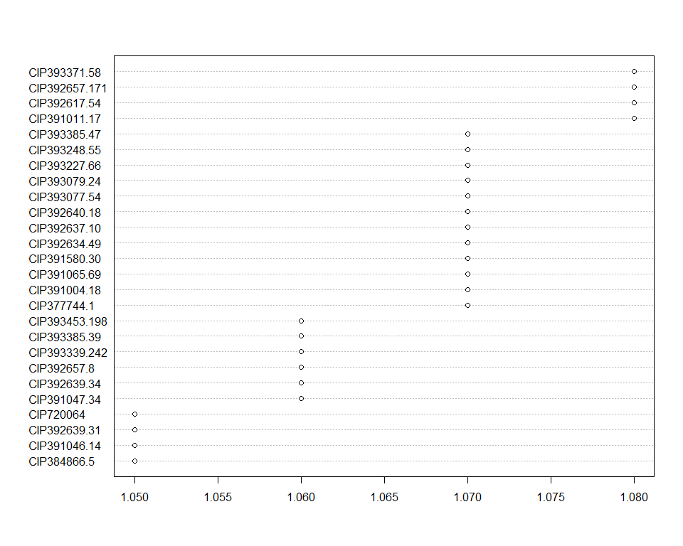

Do not forget the assumptions of the model. It is supposed that the error has a normal distribution with the same variance for all the treatments. The following plots must help you evaluate this:

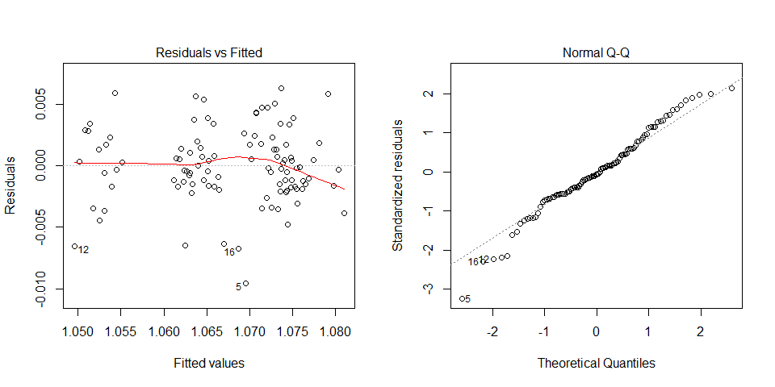

Funnel shapes for the first plot may suggest heterogeneity of variances while departures from the theoretical normal line are symptoms of lack of normality.

### Analysis for trait FFR

You have fitted a linear model for a RCBD. The ANOVA table for your model is:

Table continues below

|  |  |  |  |  |
| --- | --- | --- | --- | --- |
|  | Df | Sum Sq | Mean Sq | F value |
| **INSTN** | 25 | 19.479 | 0.77916 | 3.09258 |
| **REP** | 3 | 0.0601088 | 0.0200363 | 0.0795263 |
| **Residuals** | 75 | 18.8959 | 0.251945 | NA |

|  |  |
| --- | --- |
|  | Pr(>F) |
| **INSTN** | 8.66514e-05 |
| **REP** | 0.970926 |
| **Residuals** | NA |

The p-value for treatments is 0.0000866514 which is significant at the 5% level.

The means of your treatments are:

|  |  |
| --- | --- |
| INSTN | FFR |
| CIP377744.1 | 2.76 |
| CIP384866.5 | 2.68 |
| CIP391004.18 | 2.83 |
| CIP391011.17 | 2.38 |
| CIP391046.14 | 2.3 |
| CIP391047.34 | 1.99 |
| CIP391065.69 | 1.47 |
| CIP391580.30 | 1.69 |
| CIP392617.54 | 2.28 |
| CIP392634.49 | 1.83 |
| CIP392637.10 | 1.68 |
| CIP392639.31 | 2.44 |
| CIP392639.34 | 2.2 |
| CIP392640.18 | 1.37 |
| CIP392657.171 | 2.02 |
| CIP392657.8 | 1.25 |
| CIP393077.54 | 2 |
| CIP393079.24 | 1.74 |
| CIP393227.66 | 2.23 |
| CIP393248.55 | 1.61 |
| CIP393339.242 | 2.68 |
| CIP393371.58 | 2.65 |
| CIP393385.39 | 2.2 |
| CIP393385.47 | 2.26 |
| CIP393453.198 | 2 |
| CIP720064 | 1.75 |

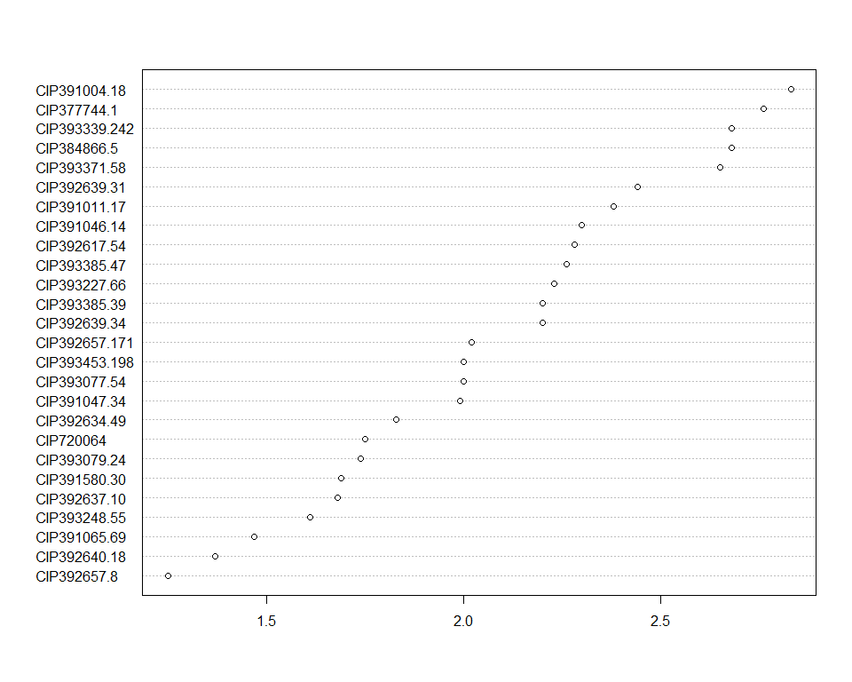

Do not forget the assumptions of the model. It is supposed that the error has a normal distribution with the same variance for all the treatments. The following plots must help you evaluate this:

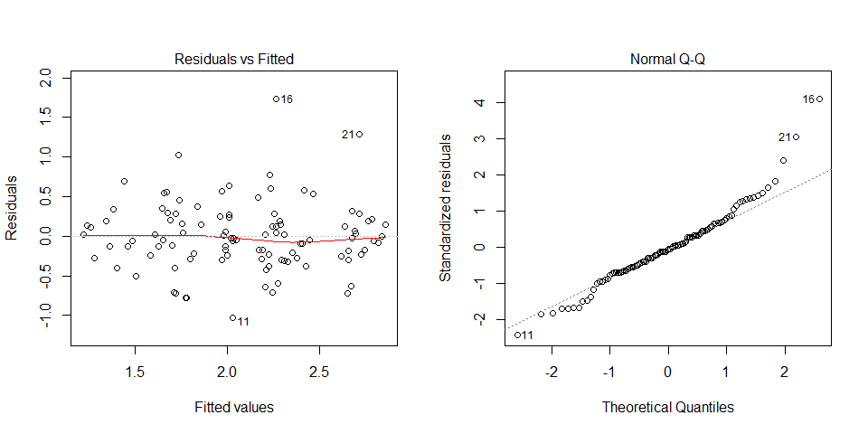

Funnel shapes for the first plot may suggest heterogeneity of variances while departures from the theoretical normal line are symptoms of lack of normality.

### Analysis for trait TEXFR

You have fitted a linear model for a RCBD. The ANOVA table for your model is:

Table continues below

|  |  |  |  |  |
| --- | --- | --- | --- | --- |
|  | Df | Sum Sq | Mean Sq | F value |
| **INSTN** | 25 | 14.9554 | 0.598218 | 8.96592 |
| **REP** | 3 | 0.0681753 | 0.0227251 | 0.340598 |
| **Residuals** | 75 | 5.0041 | 0.0667213 | NA |

|  |  |
| --- | --- |
|  | Pr(>F) |
| **INSTN** | 6.21391e-14 |
| **REP** | 0.796022 |
| **Residuals** | NA |

The p-value for treatments is 0.0000000000000621391 which is significant at the 5% level.

The means of your treatments are:

|  |  |
| --- | --- |
| INSTN | TEXFR |
| CIP377744.1 | 2.03 |
| CIP384866.5 | 1.89 |
| CIP391004.18 | 1.86 |
| CIP391011.17 | 1.11 |
| CIP391046.14 | 1.57 |
| CIP391047.34 | 1.71 |
| CIP391065.69 | 1.93 |
| CIP391580.30 | 1.26 |
| CIP392617.54 | 1.88 |
| CIP392634.49 | 1.16 |
| CIP392637.10 | 1.22 |
| CIP392639.31 | 1.78 |
| CIP392639.34 | 1.97 |
| CIP392640.18 | 1.08 |
| CIP392657.171 | 1.19 |
| CIP392657.8 | 2.58 |
| CIP393077.54 | 1.64 |
| CIP393079.24 | 1.31 |
| CIP393227.66 | 1.19 |
| CIP393248.55 | 1.5 |
| CIP393339.242 | 1.92 |
| CIP393371.58 | 1.89 |
| CIP393385.39 | 1.83 |
| CIP393385.47 | 1.39 |
| CIP393453.198 | 2.27 |
| CIP720064 | 1.66 |

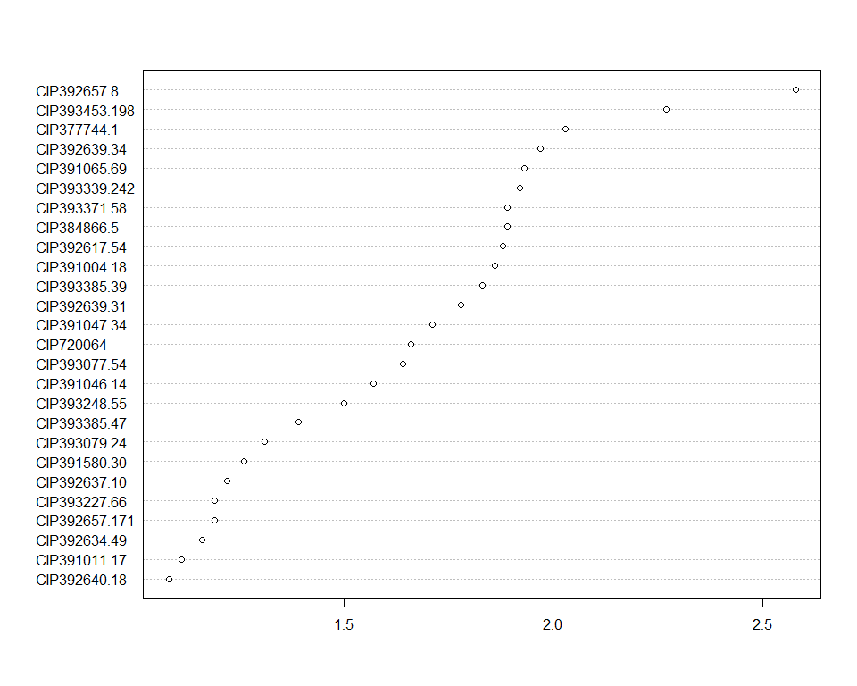

Do not forget the assumptions of the model. It is supposed that the error has a normal distribution with the same variance for all the treatments. The following plots must help you evaluate this:

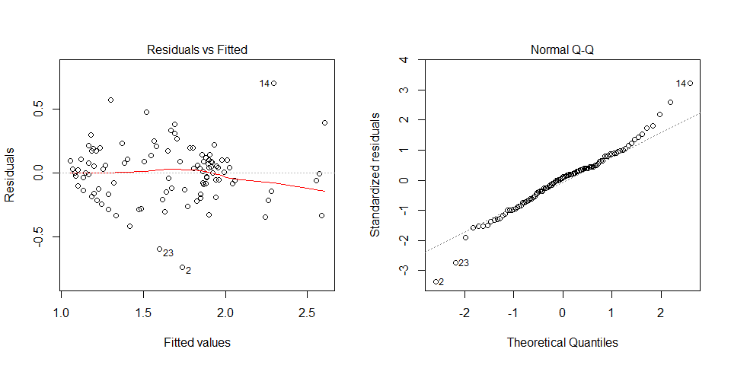

Funnel shapes for the first plot may suggest heterogeneity of variances while departures from the theoretical normal line are symptoms of lack of normality.

### Analysis for trait Chip_Color

You have fitted a linear model for a RCBD. The ANOVA table for your model is:

Table continues below

|  |  |  |  |  |
| --- | --- | --- | --- | --- |
|  | Df | Sum Sq | Mean Sq | F value |
| **INSTN** | 25 | 12.2409 | 0.489636 | 2.7373 |
| **REP** | 3 | 0.0111823 | 0.00372743 | 0.0208381 |
| **Residuals** | 75 | 13.4157 | 0.178876 | NA |

|  |  |
| --- | --- |
|  | Pr(>F) |
| **INSTN** | 0.000424462 |
| **REP** | 0.995882 |
| **Residuals** | NA |

The p-value for treatments is 0.000424462 which is significant at the 5% level.

The means of your treatments are:

|  |  |
| --- | --- |
| INSTN | Chip_Color |
| CIP377744.1 | 1.72 |
| CIP384866.5 | 2.11 |
| CIP391004.18 | 2.17 |
| CIP391011.17 | 1.2 |
| CIP391046.14 | 1.96 |
| CIP391047.34 | 1.45 |
| CIP391065.69 | 1.54 |
| CIP391580.30 | 1.52 |
| CIP392617.54 | 2.46 |
| CIP392634.49 | 1.92 |
| CIP392637.10 | 1.69 |
| CIP392639.31 | 1.99 |
| CIP392639.34 | 1.19 |
| CIP392640.18 | 1.81 |
| CIP392657.171 | 1.43 |
| CIP392657.8 | 1.23 |
| CIP393077.54 | 1.84 |
| CIP393079.24 | 1.97 |
| CIP393227.66 | 2.17 |
| CIP393248.55 | 1.4 |
| CIP393339.242 | 2.09 |
| CIP393371.58 | 2.11 |
| CIP393385.39 | 1.83 |
| CIP393385.47 | 1.82 |
| CIP393453.198 | 2.33 |
| CIP720064 | 1.97 |

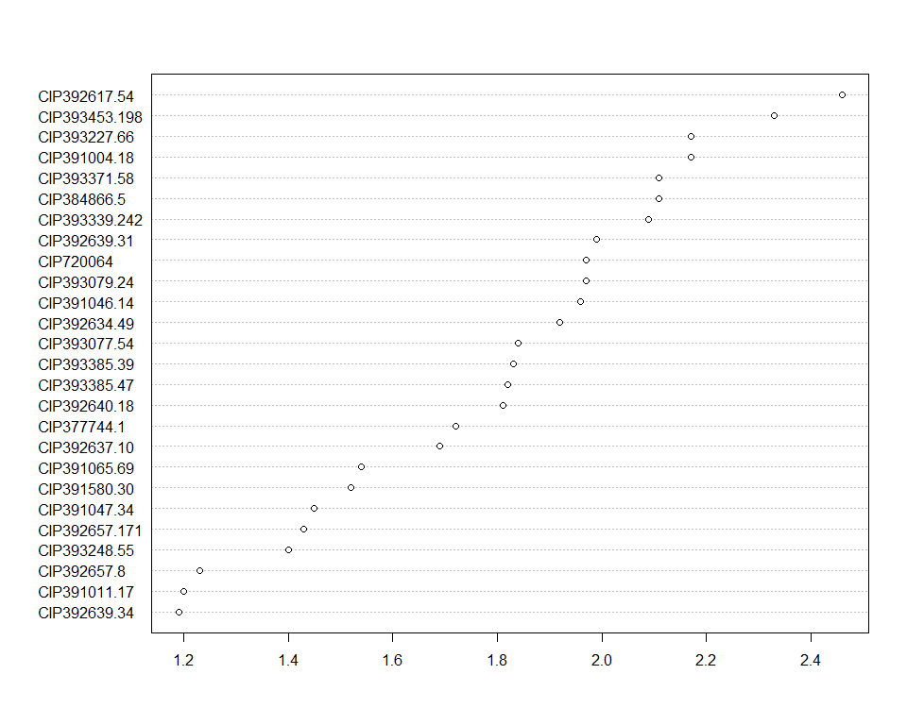

Do not forget the assumptions of the model. It is supposed that the error has a normal distribution with the same variance for all the treatments. The following plots must help you evaluate this:

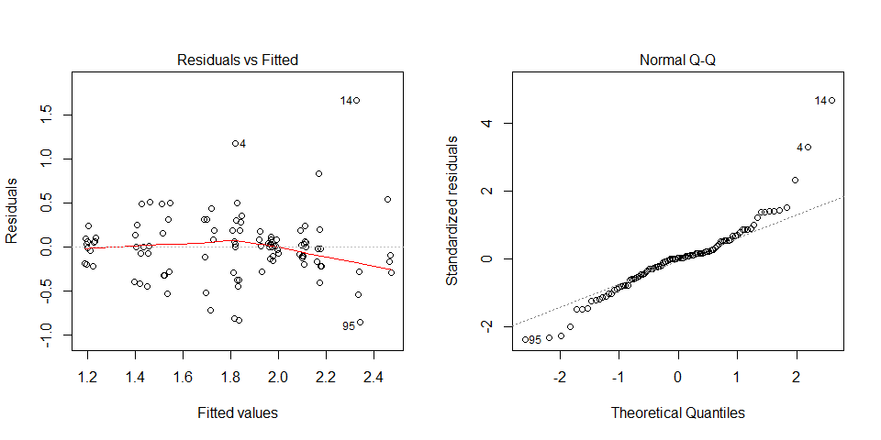

Funnel shapes for the first plot may suggest heterogeneity of variances while departures from the theoretical normal line are symptoms of lack of normality.

### Analysis for trait LB3

You have fitted a linear model for a RCBD. The ANOVA table for your model is:

|  |  |  |  |  |  |
| --- | --- | --- | --- | --- | --- |
|  | Df | Sum Sq | Mean Sq | F value | Pr(>F) |
| **INSTN** | 25 | 15339.7 | 613.587 | 13.7459 | 5.74463e-19 |
| **REP** | 3 | 458.413 | 152.804 | 3.42321 | 0.0214143 |
| **Residuals** | 75 | 3347.84 | 44.6378 | NA | NA |

The p-value for treatments is 0.000000000000000000574463 which is significant at the 5% level.

The means of your treatments are:

|  |  |
| --- | --- |
| INSTN | LB3 |
| CIP377744.1 | 12.5 |
| CIP384866.5 | 30 |
| CIP391004.18 | 5 |
| CIP391011.17 | 10 |
| CIP391046.14 | 47.5 |
| CIP391047.34 | 17.5 |
| CIP391065.69 | 16.2 |
| CIP391580.30 | 15 |
| CIP392617.54 | 3.75 |
| CIP392634.49 | 6.25 |
| CIP392637.10 | 6.25 |
| CIP392639.31 | 31.2 |
| CIP392639.34 | 31.2 |
| CIP392640.18 | 5 |
| CIP392657.171 | 10 |
| CIP392657.8 | 36.2 |
| CIP393077.54 | 5 |
| CIP393079.24 | 7.5 |
| CIP393227.66 | 8.75 |
| CIP393248.55 | 12.5 |
| CIP393339.242 | 5 |
| CIP393371.58 | 3.75 |
| CIP393385.39 | 20 |
| CIP393385.47 | 6.25 |
| CIP393453.198 | 13.8 |
| CIP720064 | 37.5 |

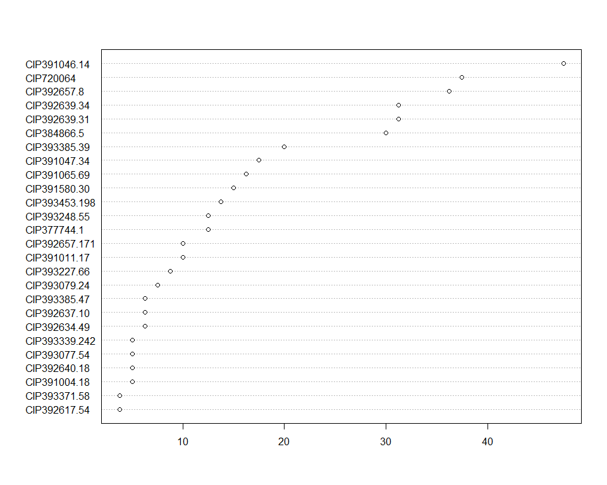

Do not forget the assumptions of the model. It is supposed that the error has a normal distribution with the same variance for all the treatments. The following plots must help you evaluate this:

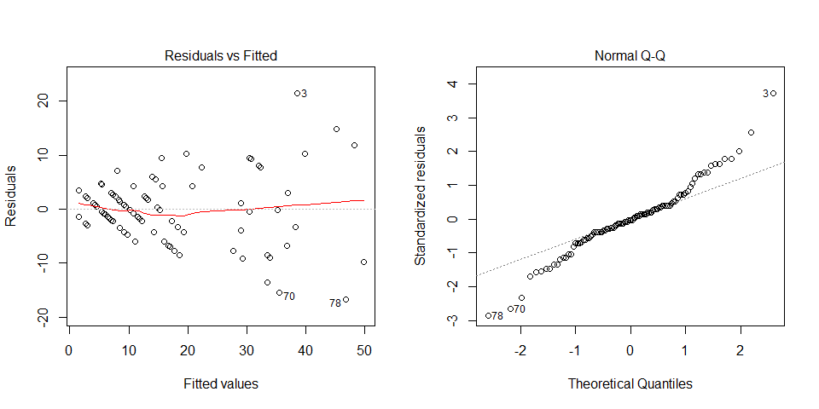

Funnel shapes for the first plot may suggest heterogeneity of variances while departures from the theoretical normal line are symptoms of lack of normality.

## Trait correlations

## Variety candidate selection

# Summary

# References

## Data sources

## Literature