NYC Airbnb Data Workflow — Module Summary
AI Programming Foundations Project — Udacity AI Master's Program
Belal Nwiran

Overview
This project builds a complete, reproducible data workflow for the New York City Airbnb Open Data set, available at https://www.kaggle.com/datasets/dgomonov/new-york-city-airbnb-open-data. The workflow loads, cleans, explores, and visualizes the data using Python, Pandas, and Seaborn. The main goal was to find pricing patterns across boroughs and room types, and to check whether listing price relates to review activity.

Dataset Description
The dataset has 48,895 Airbnb listings from five New York City boroughs: Manhattan, Brooklyn, Queens, the Bronx, and Staten Island. After cleaning, 48,847 listings remained. Each row is one listing, with columns for price, room type, borough (neighbourhood_group), neighbourhood, minimum nights, number of reviews, reviews per month, availability, and host information. This project focused mainly on price, room type, neighbourhood group, number of reviews, and reviews per month, since these variables are central to the pricing and review-activity questions the project explores.

Workflow Description
The workflow follows five steps:
- Ingestion: the dataset is loaded with pandas.read_csv, using the listing id as the index.
- Cleaning: four functions handle missing review data, missing name/host name fields, invalid ($0) prices, and data type conversions.
- Exploratory Data Analysis (EDA): two functions summarize price by neighbourhood group and room type, and check the correlation between price and review activity.
- Visualization: three charts show median price by group, the price distribution by borough, and the relationship between price and number of reviews.
- Summary: a written interpretation ties the findings together and states the project's limitations and assumptions.

Key Decisions and Assumptions
- Cleaning choices. Missing reviews_per_month values were treated as zero reviews, since those same rows also had number_of_reviews equal to 0. Rows missing name or host_name (37 rows, about 0.08% of the data) were removed rather than filled in, since a placeholder value would not represent real information. Listings with a price of 0 (11 rows) were removed, since a $0 nightly rate is not a valid price under any reasonable interpretation.
- Outlier handling. High prices (up to $10,000) and long minimum_nights values (up to 1,250) were investigated but deliberately kept in the dataset, since most appear to be real listings rather than data entry errors. Keeping and clearly documenting unusual values, instead of silently removing them, follows recommended practice for transparent and reproducible data workflows (Danchev, 2022).
- EDA focus. The first exploratory function grouped listings by neighbourhood group and room type to summarize price, since this combination is the clearest pricing signal in the data. The second function checked the correlation between price and two review-activity measures, to directly test whether cheaper listings get booked or reviewed more often.
- Plot purposes. Figure 1 (bar chart) shows median price by borough and room type, using the median instead of the mean because price is right-skewed. Figure 2 (boxplot) shows the full price distribution for Entire home/apt listings by borough, to reveal the outliers a summary table alone would hide. Figure 3 (scatter plot) shows individual listings by price and number of reviews, to visually check the near-zero correlation found earlier.

Results and Interpretation
Figure 1 shows that price depends mainly on two things: borough and room type. Manhattan is the most expensive borough for every room type, with a median price of $191 for an Entire home/apt. Brooklyn is next, then Staten Island and Queens (roughly similar), then the Bronx. Inside every borough, the order is the same: Entire home/apt costs more than Private room, and Private room costs more than Shared room.
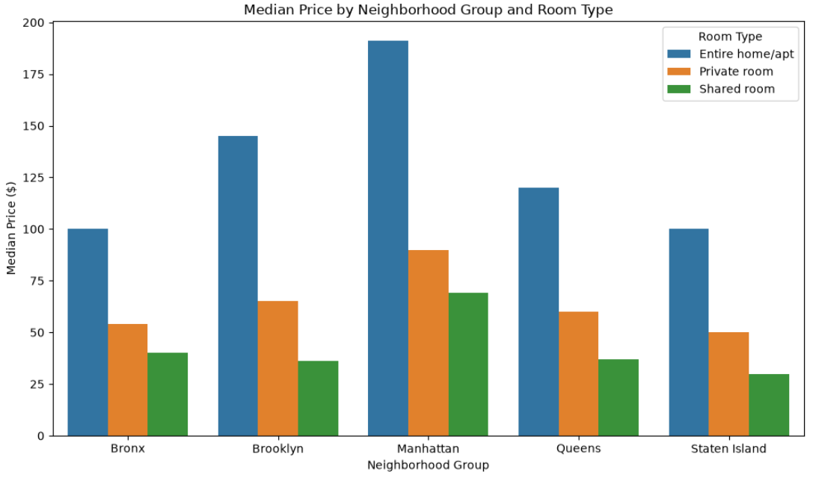
Figure 1. Median price by neighbourhood group and room type.
Figure 2 shows the price spread for Entire home/apt listings and explains a pattern the summary table alone did not make clear. Staten Island's mean price ($173.85) is much higher than its median ($100), even though Staten Island has the fewest listings (176) of the five boroughs. The boxplot shows why: a single listing priced near $5,000 is enough to pull the average well above the median in such a small group. Brooklyn and Manhattan show many more outliers, up to $10,000, spread across a much larger number of listings.
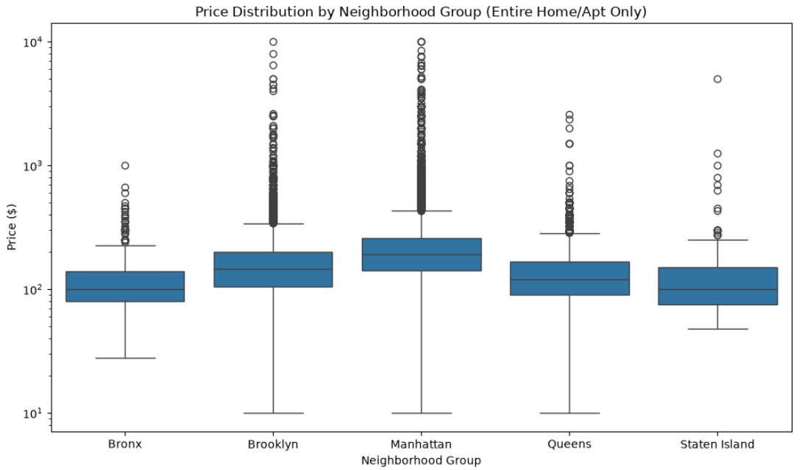
Figure 2. Price distribution by neighbourhood group, Entire home/apt only.
Figure 3 and the correlation results together show almost no linear relationship between price and review activity (r = -0.048 for number of reviews, r = -0.051 for reviews per month). The scatter plot makes this more visible than the correlation number alone: nearly all review activity comes from lower-priced listings, and listings above about $2,000 have almost no reviews at all. This suggests that review count is not a good way to judge how desirable an expensive listing is — it more likely means expensive listings are booked, or reviewed, less often.
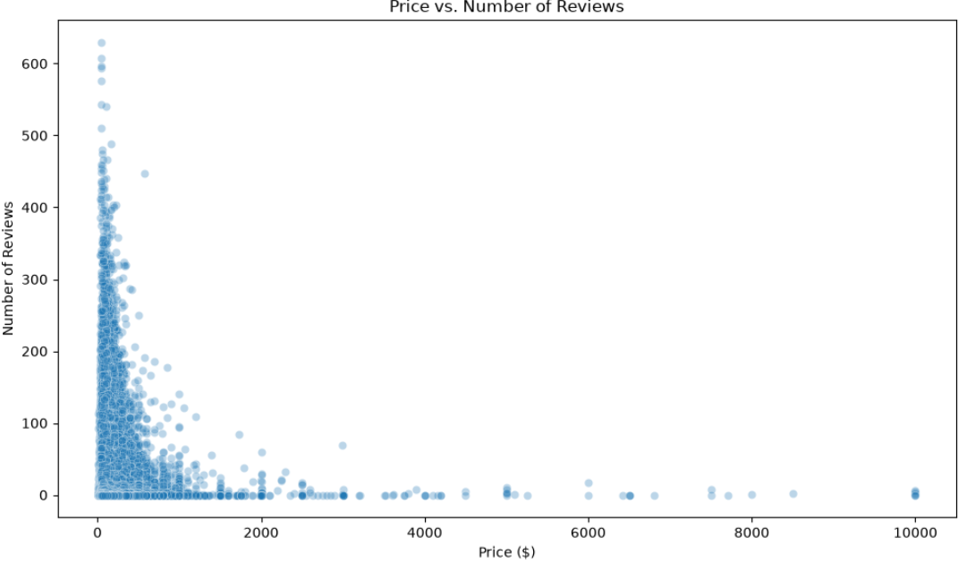
Figure 3. Price vs. number of reviews.

Responsible Practice (Bias and Data Quality)
The decision to keep price and minimum_nights outliers in the dataset carries a real risk if this data is reused later without revisiting that choice. Outliers can have a much larger effect on statistical results in small samples than in large ones (Bakker & Wicherts, 2014), which is exactly what the Staten Island group showed: one outlier was enough to shift the average noticeably in a group of only 176 listings. If this dataset were later used for a price-prediction model, these same outliers could distort the model's results even more than they distort a descriptive chart, especially for smaller boroughs like Staten Island. Bakker and Wicherts (2014) also stress that outlier-handling decisions should be reported openly rather than applied silently, which is why these decisions, and their effects, are documented directly in this report rather than left out.
Going forward, any predictive use of this data should revisit the outlier decision directly — for example, by capping extreme values, applying a transformation, or modeling small boroughs separately from large ones — rather than carrying the same assumption over from this descriptive workflow without reconsidering it.

Reproducibility
The project environment is captured in requirements.txt, generated with pip freeze, so the exact package versions used can be reinstalled with pip install -r requirements.txt. The project is version-controlled in a GitHub repository (ai-programming-foundations-project) using one branch per task, with multiple commits per branch and a pull request merged into main after each task. Together, the notebook, the requirements file, and the Git history let someone else reinstall the same environment, retrieve the same code history, and rerun the workflow from raw data to final charts.

Sources and Citations
Bakker, M., & Wicherts, J. M. (2014). Outlier removal and the relation with reporting errors and quality of psychological research. PLOS ONE, 9(7), e103360. https://doi.org/10.1371/journal.pone.0103360
Danchev, V. (2022). Reproducible data science with Python: An open learning resource. Journal of Open Source Education, 5(56), 156. https://doi.org/10.21105/jose.00156

