Statistical Analysis Report: Census Income
Belal Nwiran

Overview
This report analyzes the Census Income dataset from the UCI Machine Learning Repository (https://archive.ics.uci.edu/dataset/20/census+income). I tested whether income level (≤50K or >50K) is associated with sex. I chose this question because it shows how a statistical test and an effect size can describe a difference between groups, and because it raises clear questions about bias in data. The GitHub repo: https://github.com/bnwiran/statistical-analysis-using-python-project

Dataset Description
The dataset describes adults in a census sample, with information such as age, education, occupation, hours worked per week, sex, and income level. The file has 32,561 rows and 15 columns (six numeric and nine categorical), and I removed 24 exact duplicate rows, which left 32,537 rows. The key variables are sex (66.9% male and 33.1% female) and income (75.9% earn ≤50K and 24.1% earn >50K). I also used age, education_num, hours_per_week, capital_gain, and capital_loss to describe the data. Missing values appear only in three categorical columns: workclass (1,836), occupation (1,843), and native_country (582). I did not use fnlwgt, a sampling weight from the census, in the analysis.

Methods
Data screening and cleaning. Before testing, I followed a fixed order: load the data and check data types, look for missing values and duplicates, describe each variable, and then run the test. Lusa et al. (2024) describe this kind of initial data analysis as the step between getting the data and answering the research question, and they say that clear reporting of it supports reproducible research. Their article is about longitudinal studies, so I use only its general principles. The two variables I test have no missing values, so I did not remove or fill any rows. I removed 24 rows that were identical in every column, including the sampling weight, because they are likely to be repeated records. Lusa et al. (2024) say that changes made after looking at the data are acceptable when they are documented and justified, so I record each choice in the notebook. I kept the 159 rows with the maximum capital gain value of 99,999. The dataset documentation does not explain this value, all of these rows are in the >50K group, and removing them would change the counts I test.
Descriptive statistics and charts. For numeric variables I used the mean, median, standard deviation, and quartiles. For categorical variables I used counts and percentages. For capital gain, the mean is pulled up by a few large values, so I rely on the median and quartiles there. I also summarized variables by sex, because sex is the grouping variable in my question, and Lusa et al. (2024) recommend describing variables one at a time and across key grouping variables before testing. I made three charts. A bar chart shows the share of people earning >50K for each sex, which is the pattern the test examines. A boxplot shows weekly hours by income group and sex, to check whether working hours could be related to the gap. A correlation heatmap shows how the numeric variables relate to each other, for context.
Hypothesis test. I used a chi-square test of independence because both variables, sex and income level, are categorical and I wanted to know whether they are related. The test compares the observed counts in each group with the counts expected if the two variables were independent (Kim, 2017). The null hypothesis is that income level and sex are independent, and the alternative is that they are associated. I used a significance level of 0.05 and no continuity correction. The test assumes independent observations and a large enough sample. Kim (2017) says the result is reliable when no more than 20% of cells have expected counts below 5 and no cell has an expected count below 1. Removing duplicate rows supports the independence assumption, but I cannot prove it from the data. Fisher’s exact test, which Kim (2017) describes as mainly for small samples, was not needed. I also report Cramér’s V as an effect size, because a p-value alone does not show how large an association is, and with a large sample even a very small difference can be significant (Kim, 2017; Sullivan & Feinn, 2012).

Results
Descriptive statistics. The average age is about 38.6 years (median 37, range 17 to 90). The median is 40 hours worked per week, and the middle half of people work between 40 and 45 hours. Most people have no capital gain or capital loss, because the median and the 75th percentile of both are 0. The sample is 66.9% male, and about three in four people earn ≤50K. The numeric columns have no missing values. The missing values are in workclass, occupation, and native_country only.
Figures. Figures 1 to 3 come from the analysis notebook (analysis.ipynb). Figure 1 shows that 11.0% of women and 30.6% of men earn more than 50K. Figure 2 shows that in the >50K group the typical man works 44 hours a week and the typical woman works 40. In the ≤50K group the typical hours are 40 for both, but the box for women reaches lower, so more women work fewer hours. Figure 3 shows that all correlations between different numeric variables are weak. The strongest is about 0.15, between education_num and hours_per_week, and capital_gain and capital_loss are about −0.03. Figure 1 best supports my question because it shows the two income shares that the test compares. Figure 2 adds context, and Figure 3 does not include sex or income.
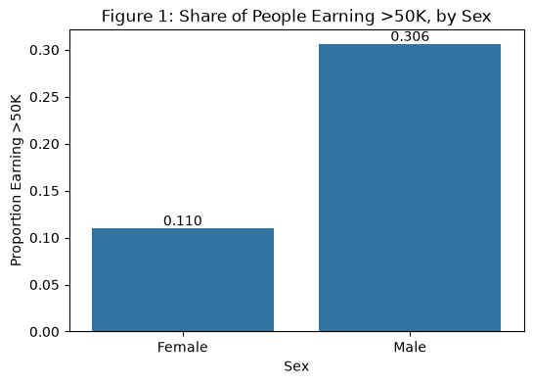
Figure 1. Share of people earning >50K, by sex.
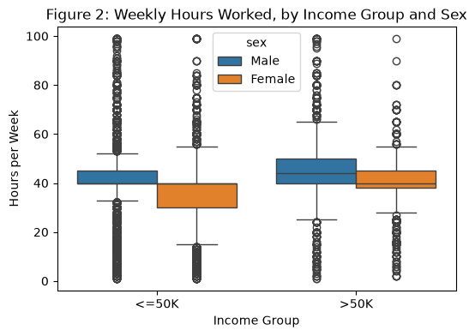
Figure 2. Weekly hours worked, by income group and sex.
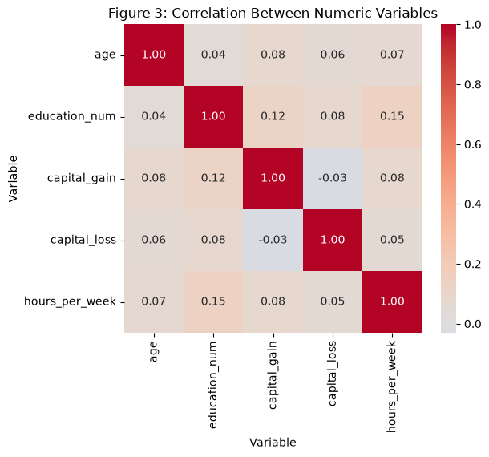
Figure 3. Correlation between numeric variables.
Hypothesis test. Table 1 shows the counts used in the chi-square test. The test gave χ²(1, N = 32,537) = 1517.61, p < .001 (the software returns 0 for a value this small, so I report p < .001). I reject the null hypothesis: in this sample, income level is associated with sex. The smallest expected count is 2,592.8, so the sample-size assumption is met. Cramér’s V is 0.22. For one degree of freedom, Kim (2017) gives benchmarks of 0.10 for a small effect, 0.30 for a medium effect, and 0.50 for a large effect, so this association is between small and medium.
Table 1. Income level by sex (N = 32,537).
Sex | ≤50K | >50K | Share earning >50K
Female | 9,583 | 1,179 | 11.0%
Male | 15,115 | 6,660 | 30.6%

Interpretation for a Non-Technical Audience
In this data, men were much more likely than women to earn more than 50K. About 31 out of every 100 men did, compared with about 11 out of every 100 women. The statistical test tells us that a gap this large is very unlikely to be just chance in this sample. The test alone cannot tell us how big the link is, because with so many people even a small gap would look significant. So I also measured its strength, and it is between small and medium.
This does not mean that being a man or a woman causes a higher or lower income. Men and women in the data also differ in other ways. For example, among people earning more than 50K, the typical man works 44 hours a week and the typical woman works 40. But hours alone do not seem to explain the whole gap, and I did not study age, education, or job type as possible reasons. The results show a pattern in these data. They do not show why it exists.

Limitations and Potential Bias
Limitations. First, this is an association from observed data. The chi-square test looks at only two variables, so it cannot separate the effect of sex from other factors such as age, hours, education, or occupation. Second, three columns have missing values (workclass, occupation, and native_country). They do not affect this test, but handling missing data badly can bias results (Lusa et al., 2024), so they would matter in any later analysis. Third, 159 rows have the maximum capital_gain value of 99,999, which the documentation does not explain, and I kept them. Fourth, I treated exact duplicate rows as repeated records, which is a judgment I cannot fully confirm. Fifth, I did not use the census sampling weight, so the results describe this sample and not necessarily all adults. Finally, with 32,537 rows a p-value is almost always small, so the effect size matters more than the p-value (Sullivan & Feinn, 2012).
Potential bias. The sample is not balanced: about one third of the people are women, and about 85% are White. The patterns may therefore not apply equally to all groups. Lusa et al. (2024) suggest comparing a sample with its target population to see whether it differs, and I could not do that here because I have no population figures for this dataset. There is also a risk in how the result is read. Treating a statistical association as proof of a cause, or as a full explanation of income differences, would be a mistake. A related ethical risk is misuse. If someone used a pattern like this to predict or make decisions about individual people, for example by using sex to guess income, it could repeat and reinforce existing unfairness.

References
Kim, H.-Y. (2017). Statistical notes for clinical researchers: Chi-squared test and Fisher’s exact test. Restorative Dentistry & Endodontics, 42(2), 152–155. https://doi.org/10.5395/rde.2017.42.2.152
Lusa, L., Proust-Lima, C., Schmidt, C. O., Lee, K. J., le Cessie, S., Baillie, M., Lawrence, F., Huebner, M., & on behalf of TG3 of the STRATOS Initiative. (2024). Initial data analysis for longitudinal studies to build a solid foundation for reproducible analysis. PLOS ONE, 19(5), Article e0295726. https://doi.org/10.1371/journal.pone.0295726
Sullivan, G. M., & Feinn, R. (2012). Using effect size—or why the P value is not enough. Journal of Graduate Medical Education, 4(3), 279–282. https://doi.org/10.4300/JGME-D-12-00156.1

