MIDTERM EXAM | OPERATION SENTINEL — SECURE SERVER ASSESSMENT

Day 1 — Architecture and Threat Modeling

Part A — Architecture Design

System architecture diagram
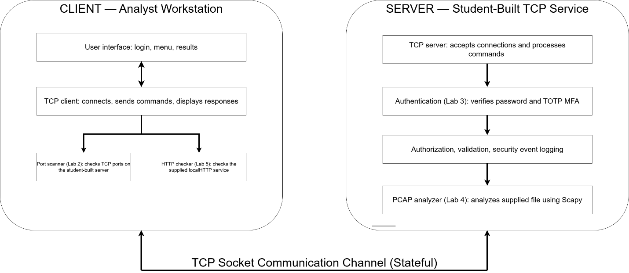

Component Responsibilities
Client:
- User Interface: Manages user inputs and displays processed responses received from the server.
- TCP Client: Establishes a TCP connection with the server and formats user operations into delimiter-based application-layer protocol commands.
- Port Scanner (Lab 2): Scans open TCP ports on the target service using raw sockets or python-nmap.
- HTTP Checker (Lab 5): Evaluates the local test HTTP service for any and exports the findings into a CSV report.
Server
- TCP Server: Listens on designated ports and accepts incoming client socket connections.
- Authentication (Lab 3): Validates user passwords and verifies Time-based One-Time Passwords.
- PCAP Analyzer (Lab 4): Processes synthetic traffic PCAP files, tracking packet counts and implementing a sliding time window mechanism to detect suspicious IP behavior.
- Event Logging: Enforces access control policies and logs security events and connection activities.

Information Flows
The client connects to the server via a TCP socket, performs a multi-step authentication handshake (submitting AUTH and OTP commands), and then exchanges chat messages or requests security analyses over the established connection.

Rationale for Stateful Interaction Model
I used stateful interaction model because the server needs to track authentication and MFA verification states throughout the TCP session. This ensures that unauthenticated clients are strictly blocked from executing sensitive commands before logging in.

Part B — Adversarial Threat Model
Domain | Asset | Attack Vector | Impact | Mitigation | Residual Risk
Sockets | TCP Channel | Sniffing plaintext traffic over the local network. | Credential or message data leakage. | Restrict testing to loopback (127.0.0.1 | Vulnerable to host-level memory reading.
Scanning | Port Scanner | Scanning unauthorized external target IPs. | Triggers IDS alerts or DoS complaints. | Restrict scanning to authorized targets. | User manually bypasses script checks.
Auth/MFA | Auth Module | Brute-forcing passwords or TOTP codes. | Unauthorized access to server. | Password hashing. | Client device loss.
Scapy | PCAP Analyzer | Submitting malformed or oversized PCAP files. | Server script crash or denial of service (DoS). | Strict blocks with threshold limits. | Undisclosed zero-day bugs in Scapy.
HTTP | HTTP Checker | Exploiting configuration flaws in test web service. | Information disclosure or web attacks. | Run automated checks to identify and fix missing security headers. | Cannot detect complex custom logic flaws.

Day 2 — Protocol and Component Specification

Part C — Protocol Design
Message Structure: Delimiter-based text format (COMMAND|arg1|arg2).
Authentication and MFA sequence: Sequential SHA-256 password check followed by pyotp TOTP validation.
Authorization Rules: Sensitive commands are strictly blocked until ACCESS_GRANTED.
Malformed Request Handling: Managed via string parsing and try-except exception blocks.
Error Responses: Standardized format using ERROR|message prefixes.
Session Termination: Closed via the EXIT command.
Security Limitations: Local stateful sockets implemented; TLS encryption proposed for future deployment.

Part D — Component Design

