第四章
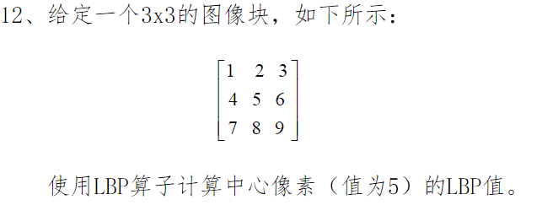
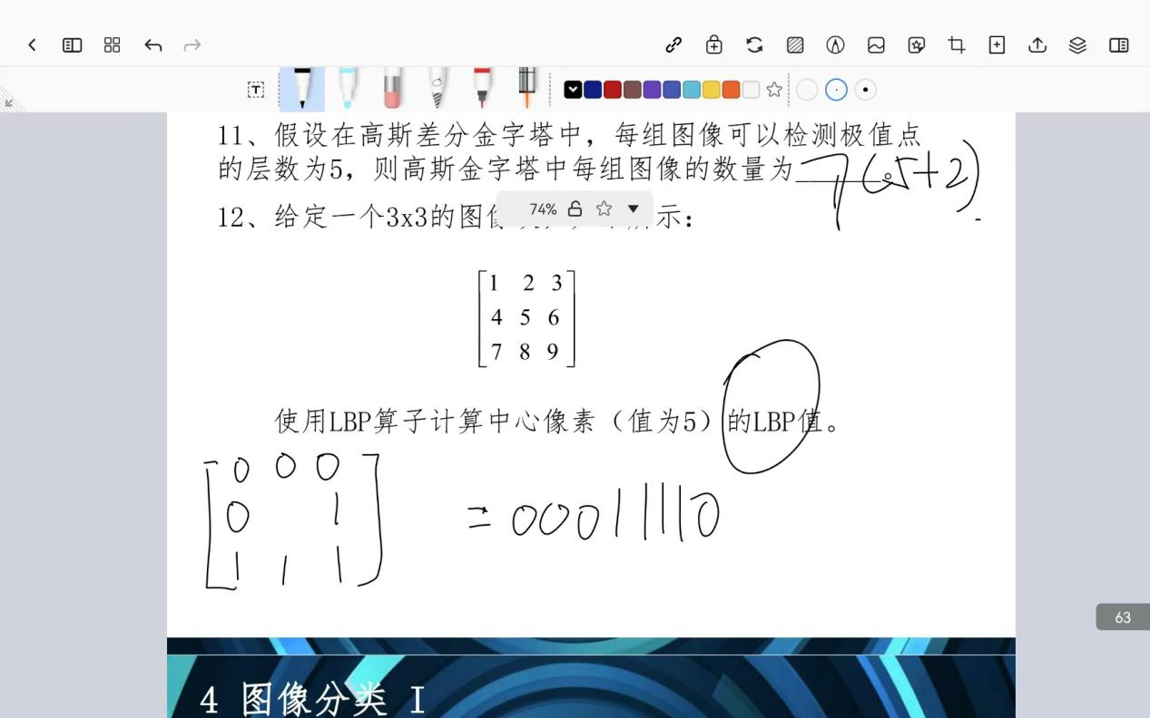

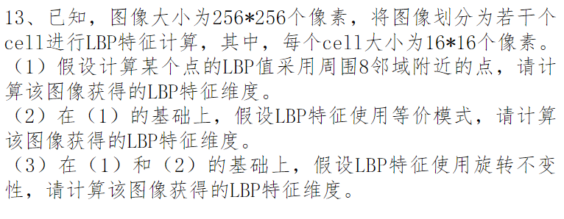
- Cell 个数 = 256/16 * 256/16 = 256
Bin= 2**8 = 256
LBP = 256 * 256 = 65536
- Cell 个数不变
Bin = P*(P-1) + 3 = 59
LBP = 256*59=15104
- Cell 不变
Bin = P+2 = 10
LBP = 10*256 = 256
