**CONFIGURATION**

India Voucher AWE Setup

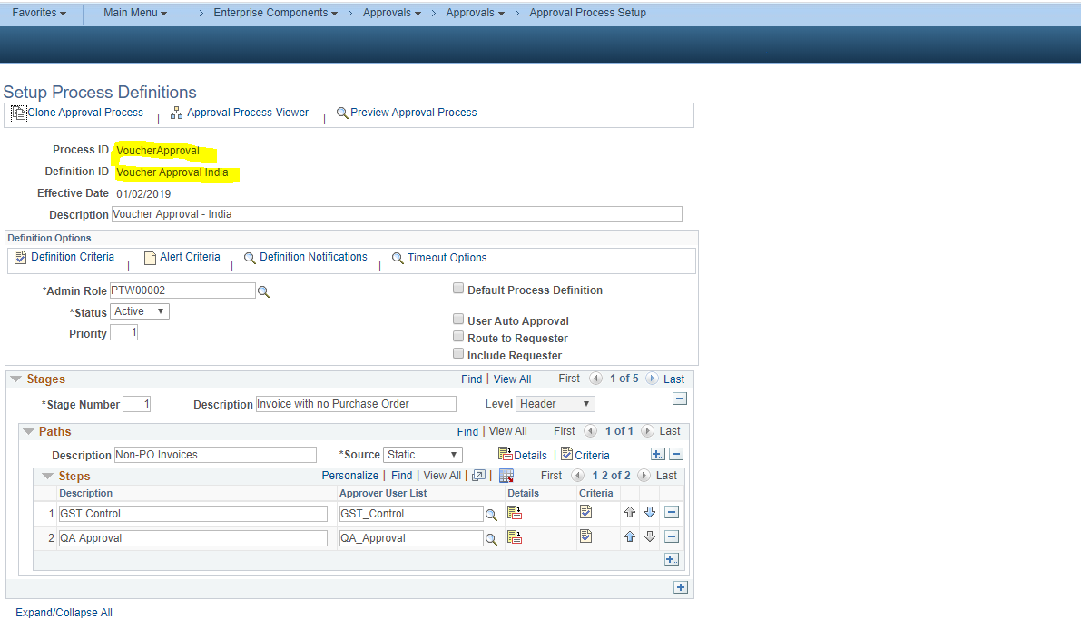

In Definition Criteria, criteria of Business Units “INDIT,INDSS,INDMH,INDKA,INDHR” is defined so that only this setup will get triggered for voucher of BUs – “INDIT,INDSS,INDMH,INDKA,INDHR”.

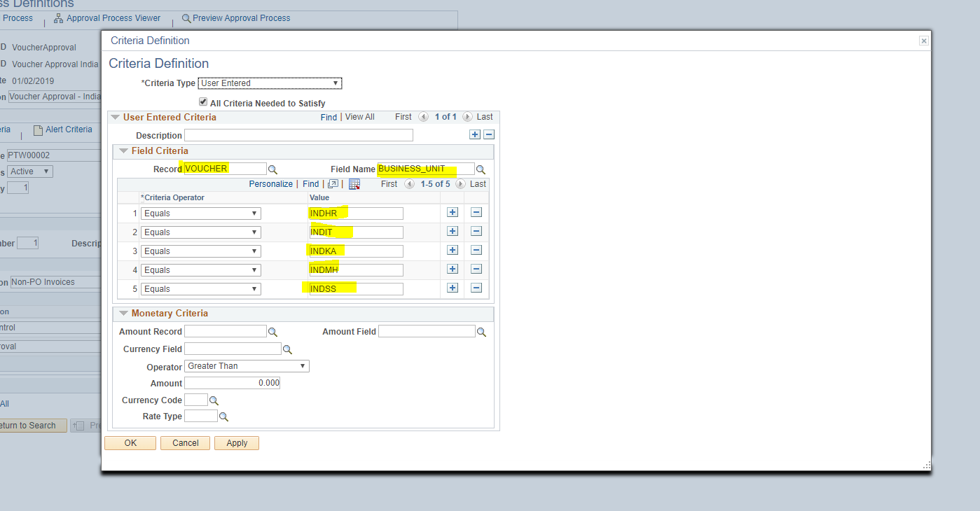

1. Stage 1: Invoice with no Purchase Order

Two steps of Approval -> GST Control and QA Approval

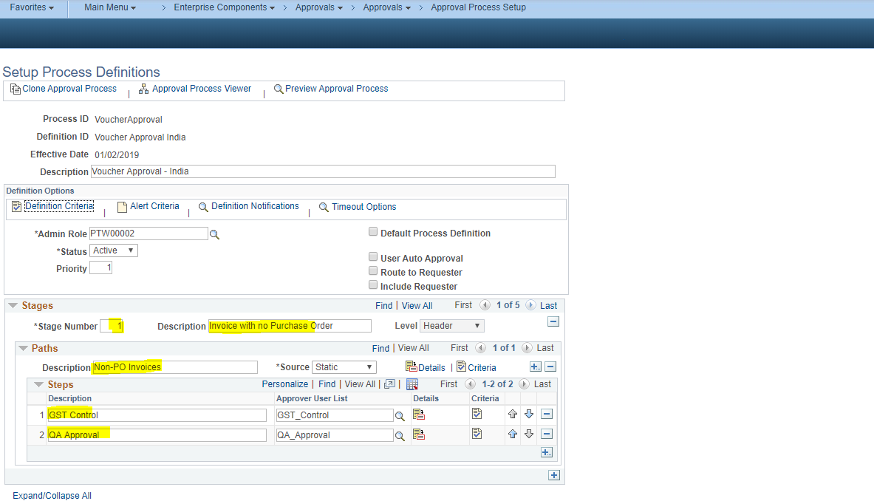

Criteria:

1. For Voucher not created from Purchase Order.
2. Gross Amount is positive (i.e. greater than zero) for Non-Credit Vouchers.

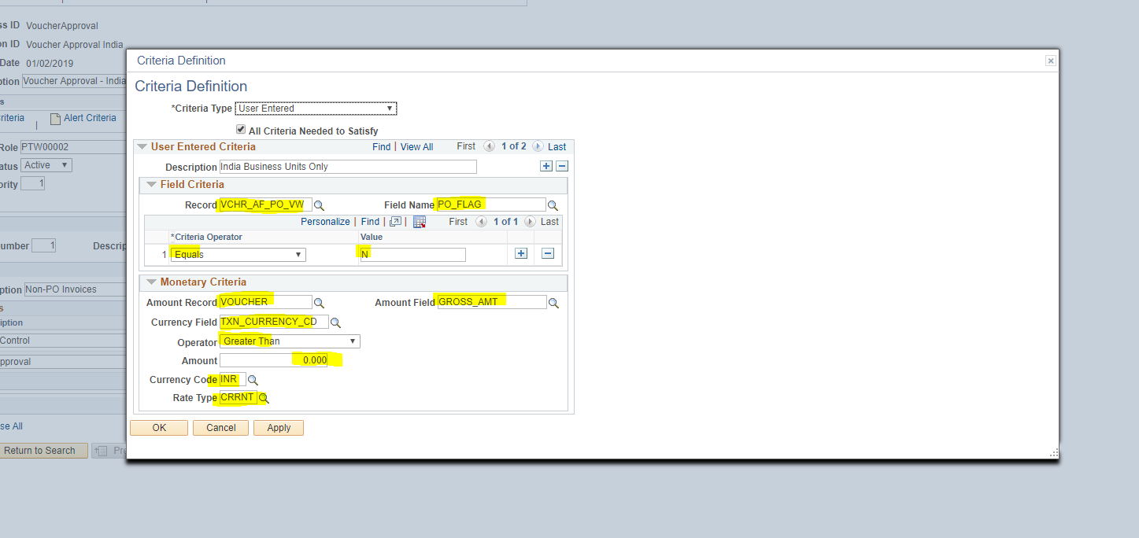

1. For Voucher not created from Payment Request.
2. Gross Amount is positive (i.e. greater than zero) for Non-Credit Vouchers

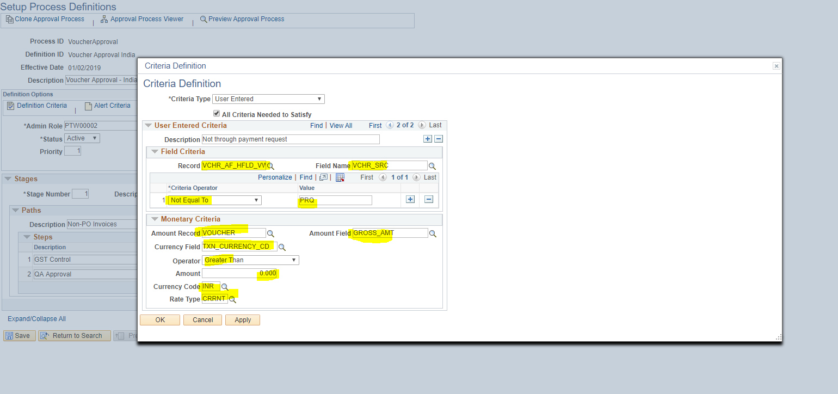

1. Stage 2: Invoices with Matched PO

One Step of Approval -> GST Review

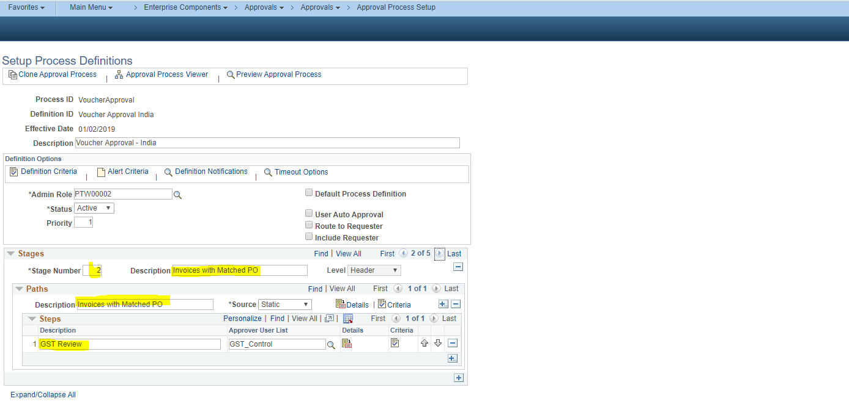

Criteria:

1. For Voucher created from Purchase Order.

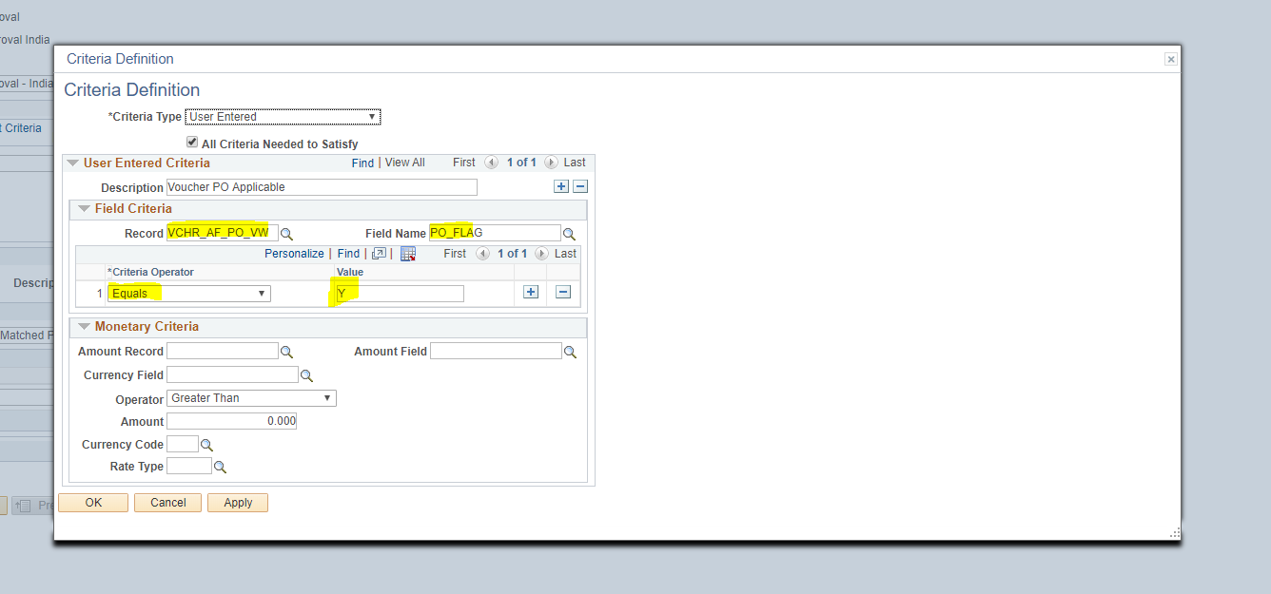

1. Stage 3: Payment Request Invoices

One step of Approval -> GST Review

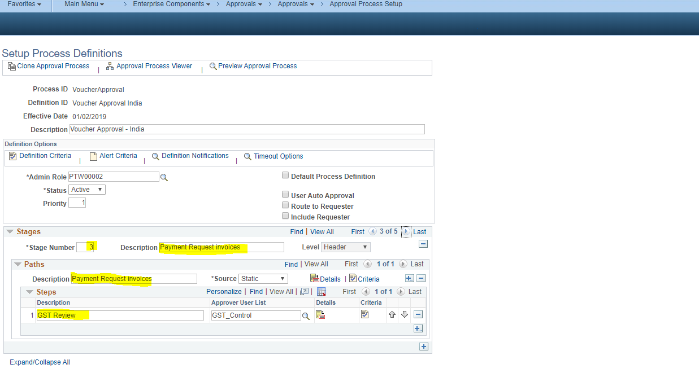

Criteria:

1. For Vouchers created from Payment Request

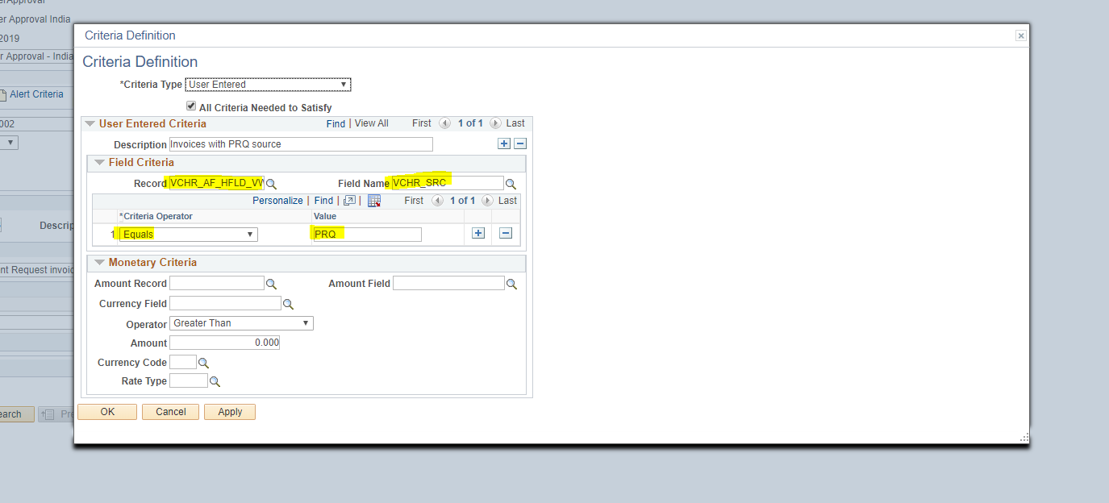

1. Stage 3: Credit Note Voucher Requestor

One Step of Approval -> Requestor

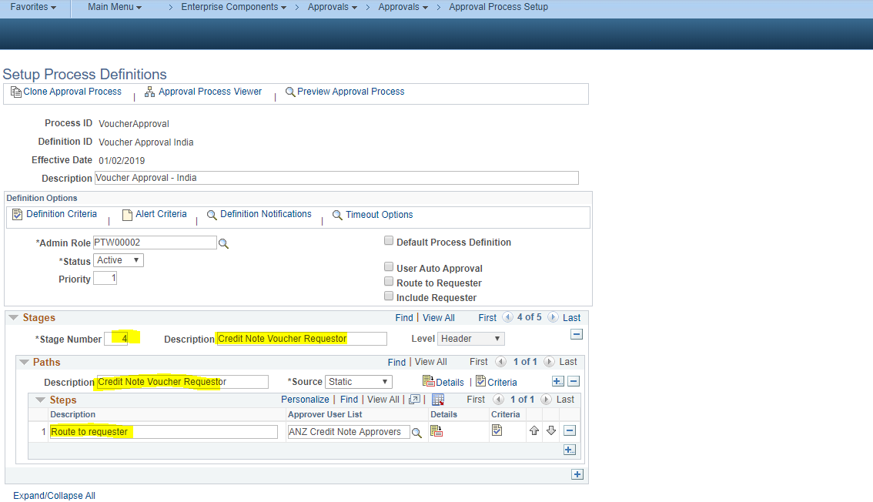

Criteria:

1. For Voucher not created from Purchase Order.
2. Gross Amount is negative (i.e. less than zero) for Credit Vouchers.

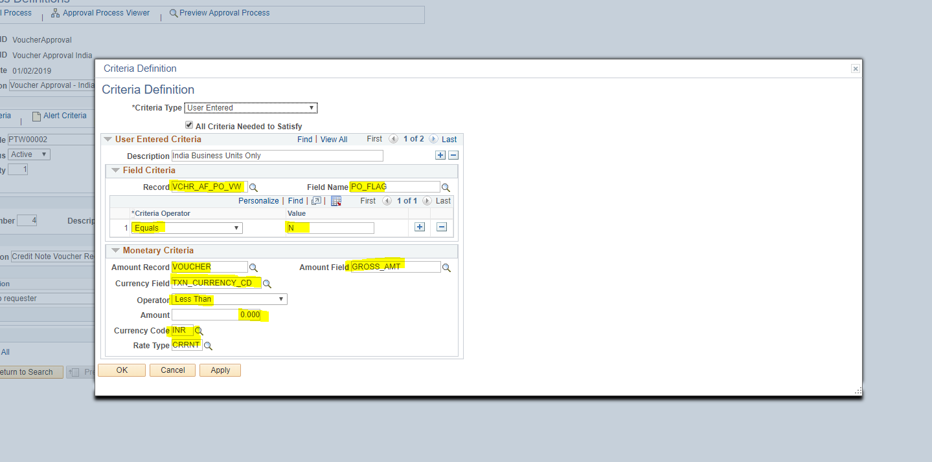

1. For Voucher not created from Payment Request.
2. Gross Amount is negative (i.e. greater than zero) for Credit Vouchers

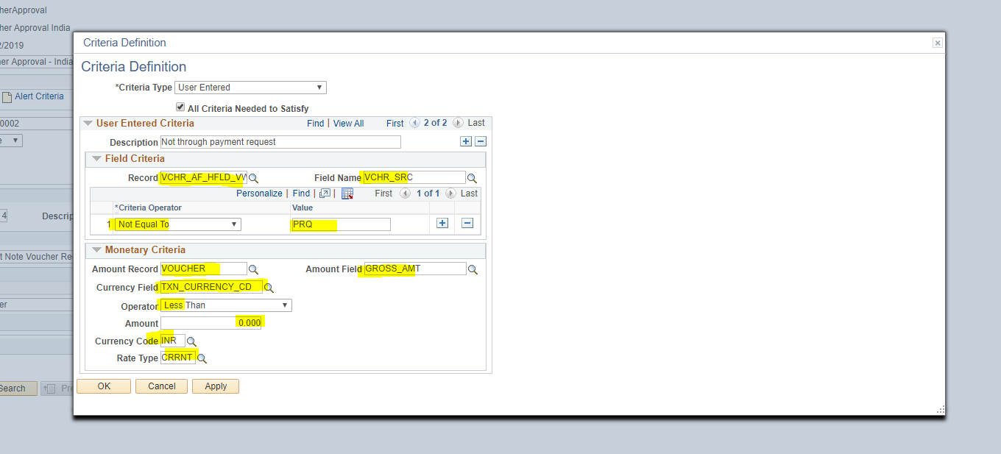

1. Stage 4: Credit Note Voucher GST-QA

Two Steps of Approval -> GST Control and QA Approval

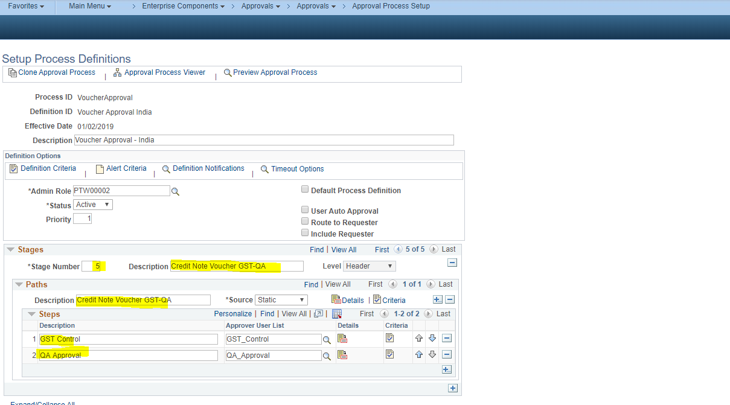

Criteria:

1. For Voucher not created from Purchase Order.
2. Gross Amount is negative (i.e. less than zero) for Credit Vouchers.

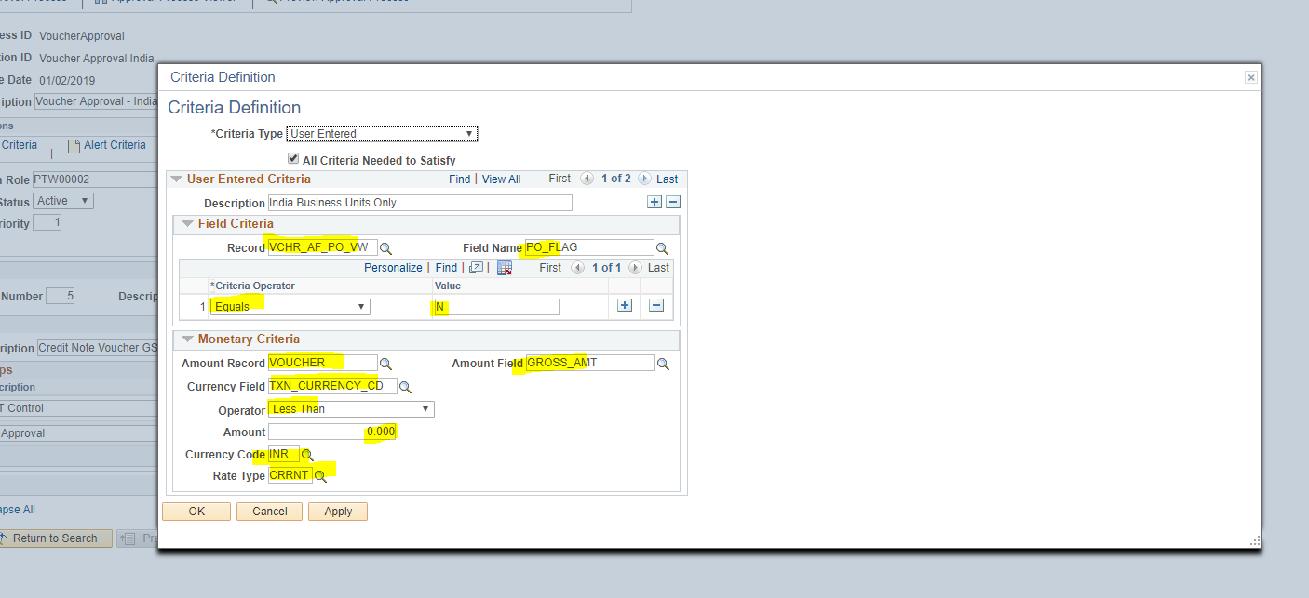

1. For Voucher not created from Payment Request.
2. Gross Amount is negative (i.e. greater than zero) for Credit Vouchers

