1. Add a new Supplier:
   * Navigate to the below navigation to create a Supplier
   * Enter new Supplier using id Liz9.
   * Enter all the mandatory details in all the Tabs(Identifying Information,Addess,Contacts,Location,Custom) and click on Save.

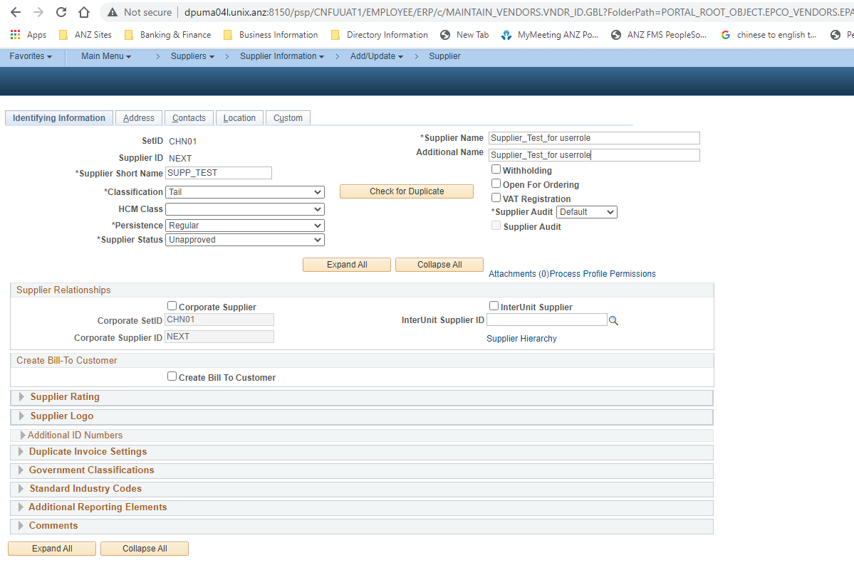

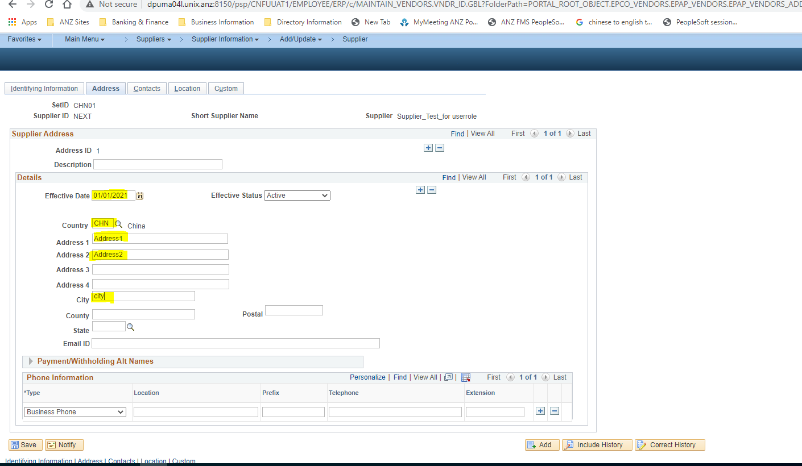

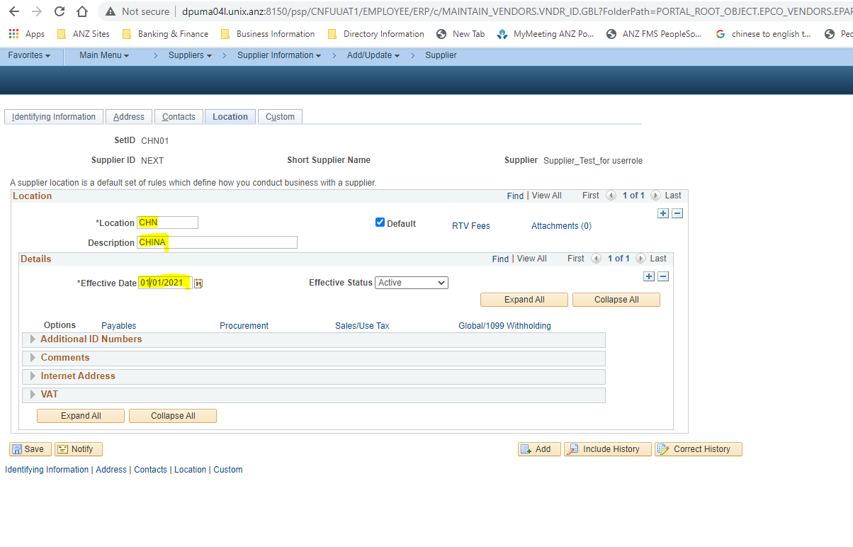

* New Supplier is created in Unapproved status.

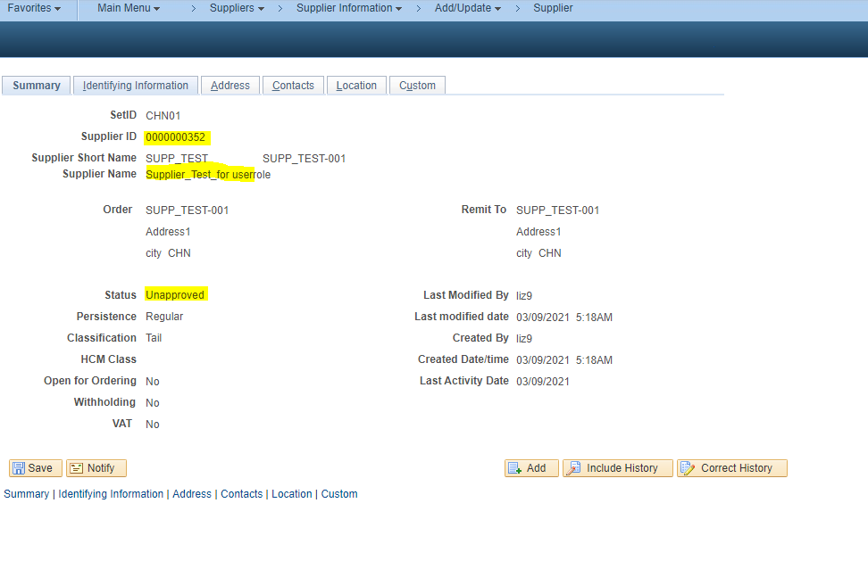

Supplier Approval:

* Login using Approver credentials and navigate to the below navigation.

Main Menu->Supplier-> Supplier Information->Approve->Approve Supplier

* Open the Supplier which needs to be Approved. Change the status to Approved and Click on Save. The Supplier is Approved.

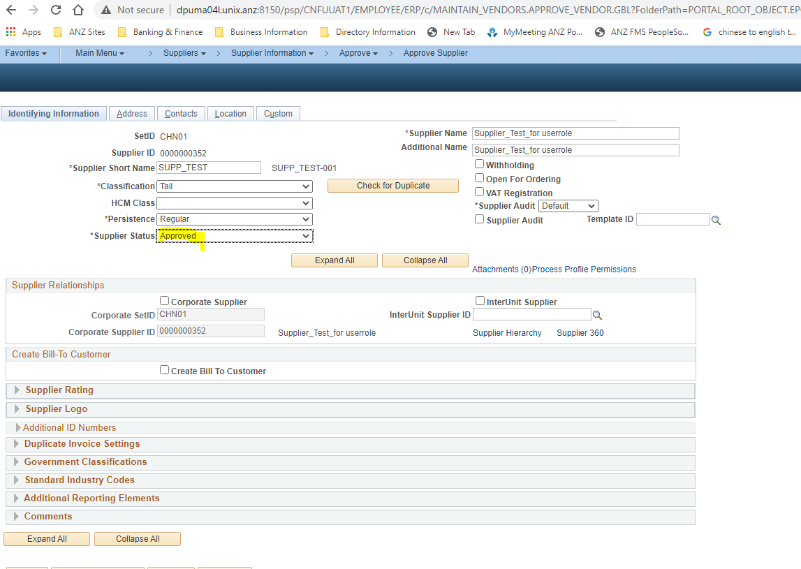

1. PS_VENDOR_CONVERSION Query:

* Login to Peoplesoft and navigate to below path.

Main Menu->Reporting Tools-> Query->Schedule Query

* Add a new value for the query PS_CHN_VENDOR_CONVERSION.
* Run the query. Once the status is Success, the desired output file will be generated.

