Scenario 1: Web Service based integration through SOAPUI for Department

We are making some Change at Department level as below:

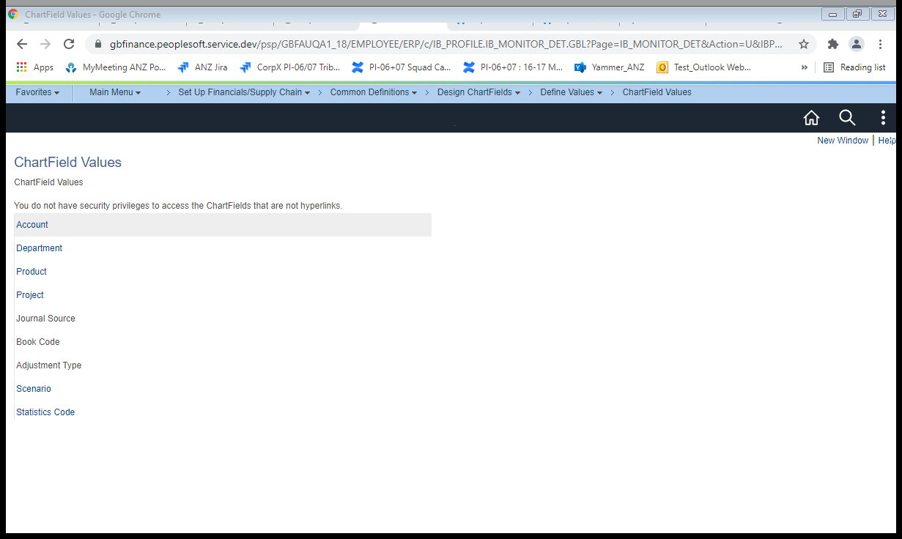

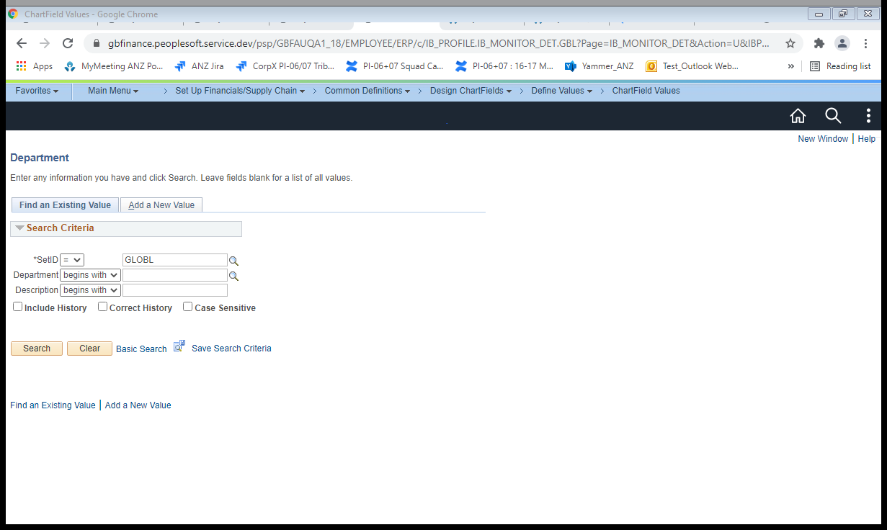

Enter SetID as “GLOBL” and Click on Search Button

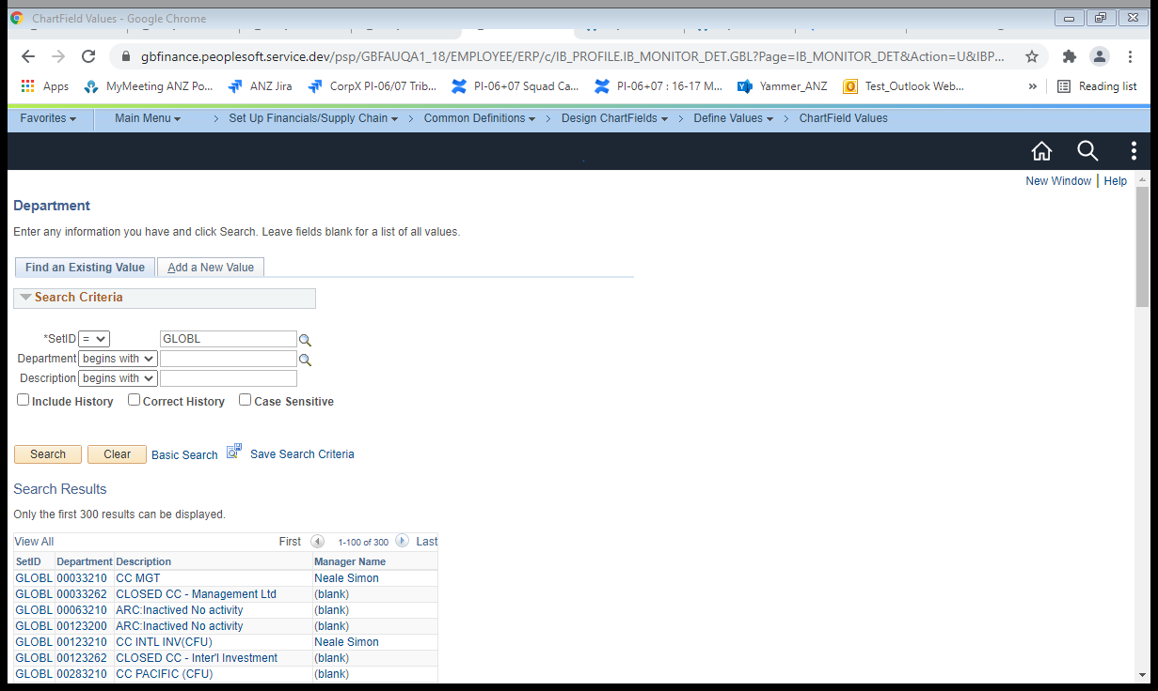

Go with Department “00033210” to make changes

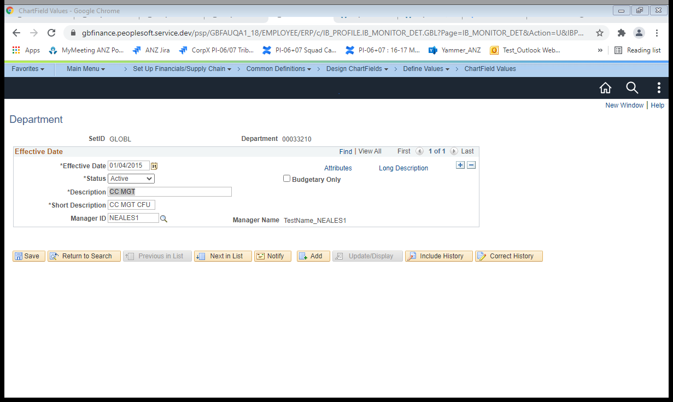

Modifying the description from “CC MGT” to “ CC MGT BU”

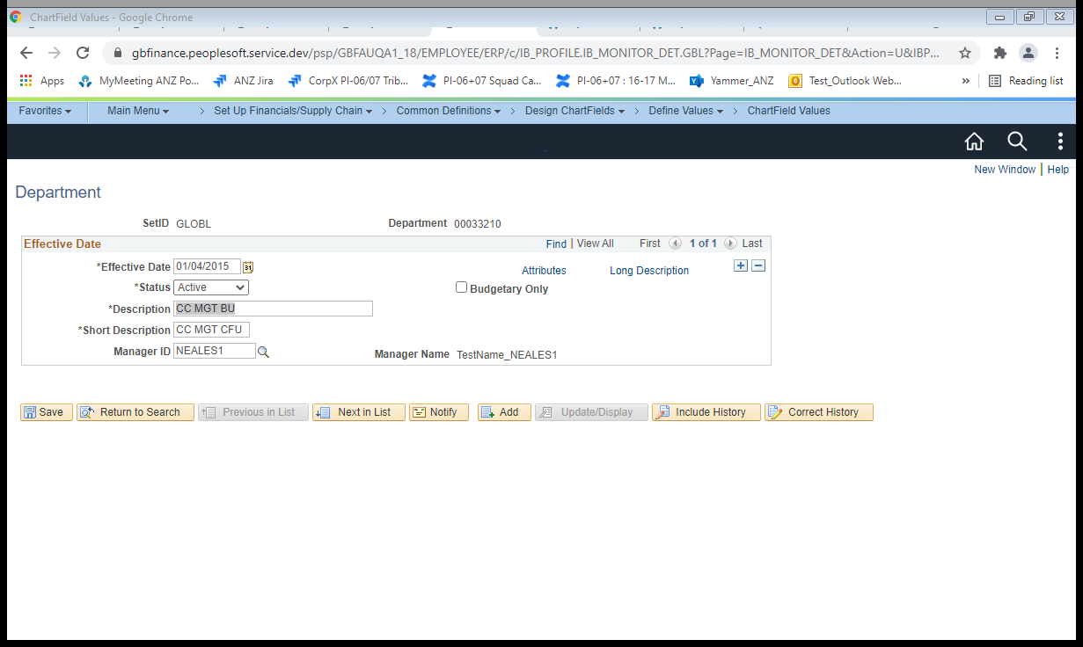

Click on Save Button

Navigate to the below path:

Main Menu🡪People Tools🡪Integration Broker🡪Integration Setup🡪Service

Search for the “ANZ_PSFT_DEPT_SYNC2” service as below:

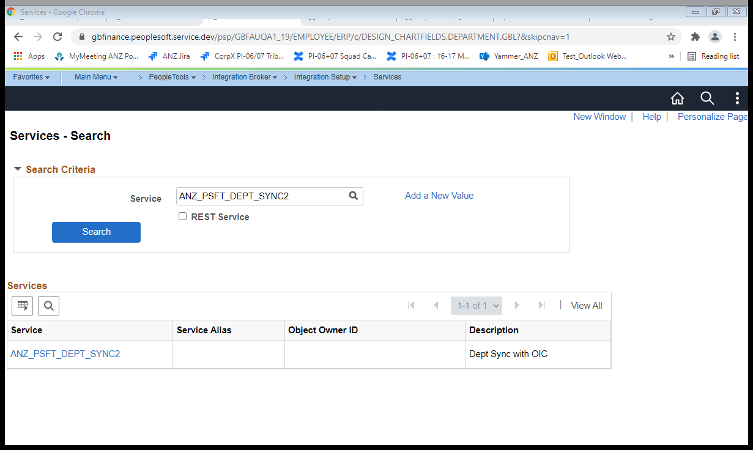

Click on Service Hyperlink

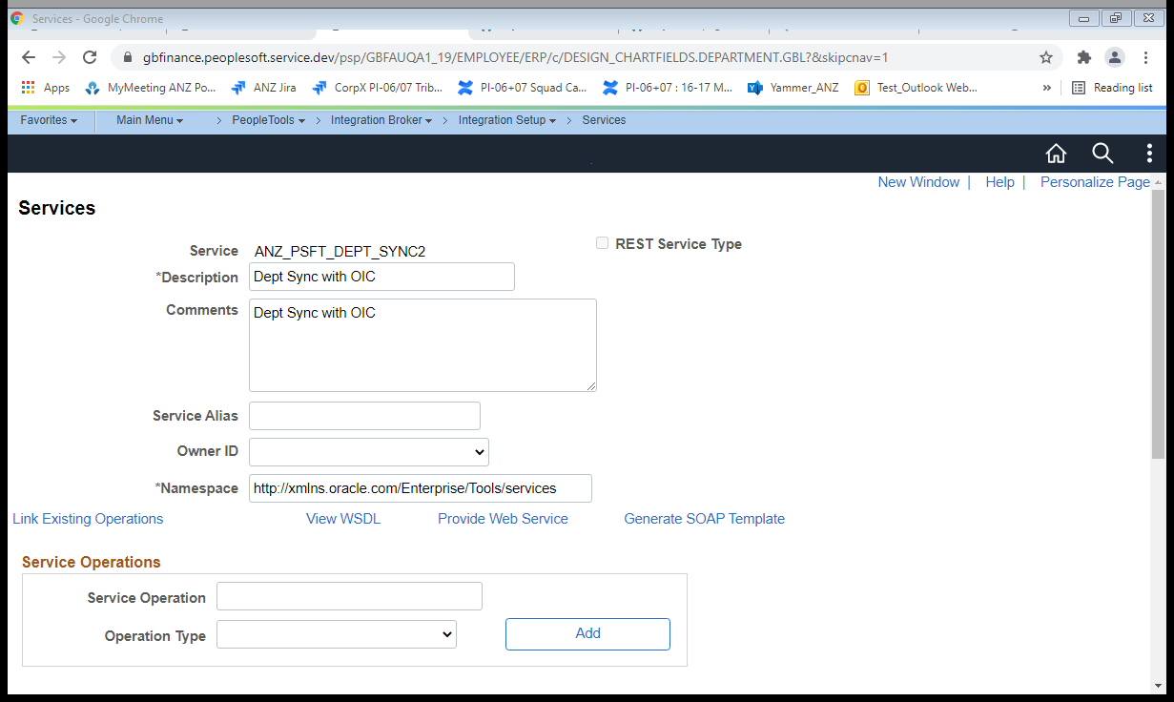

Click on View WSDL link

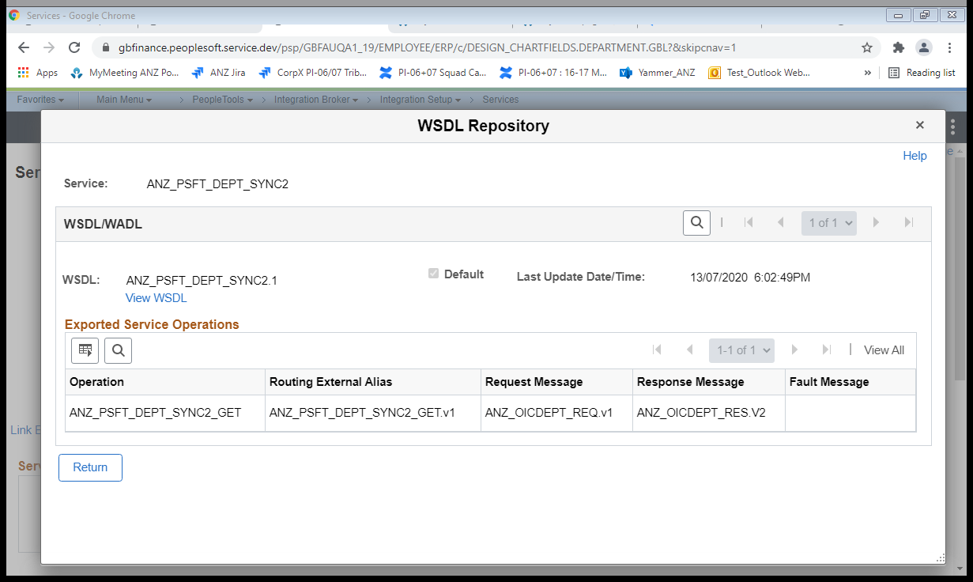

Click on View WSDL link

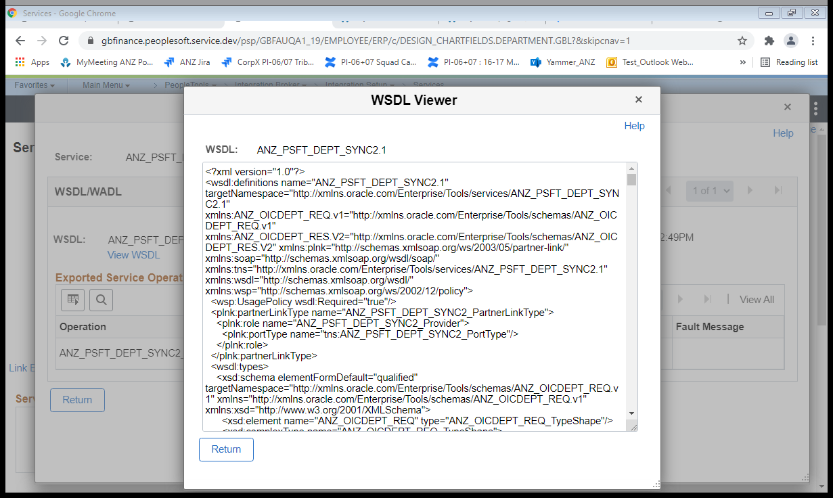

Copy the WSDL completely and save it as an .wsdl extension file as shown below:



Try loading the wsdl file in the soapUI with a project(Department) created as shown below

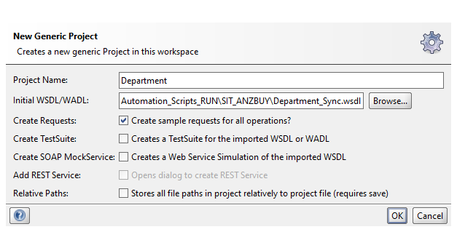

Click on OK Button and update the "from date” and “to date” as below

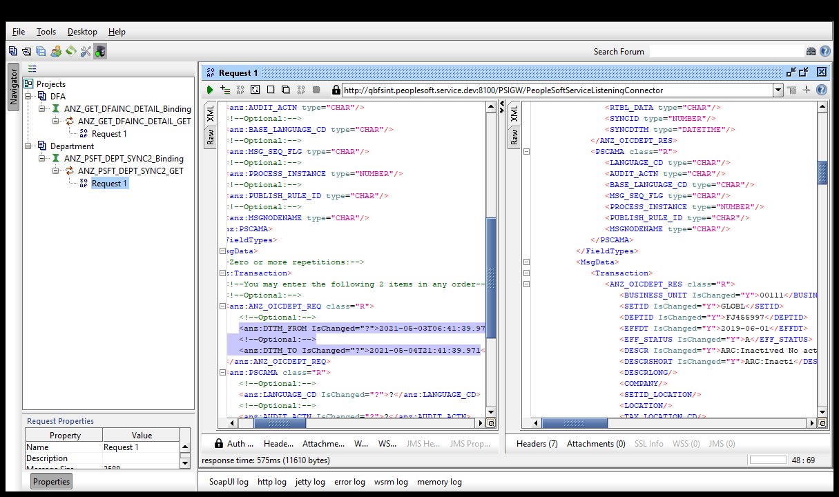

Click on “Submit request to specified endpoint URL”

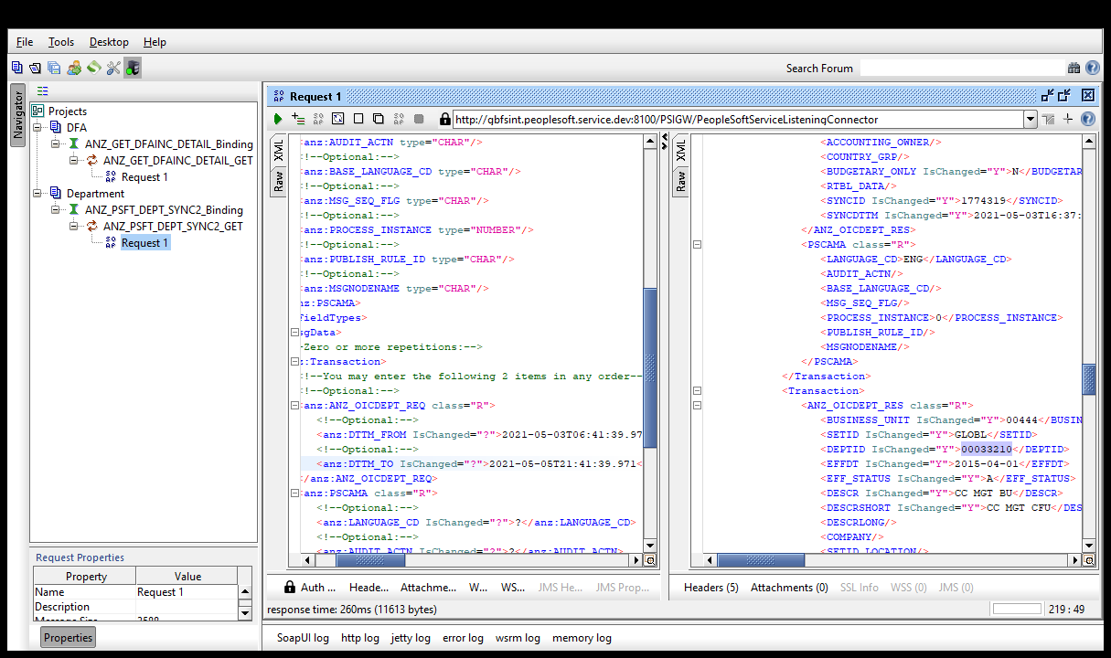

Verify the Response with the updated details

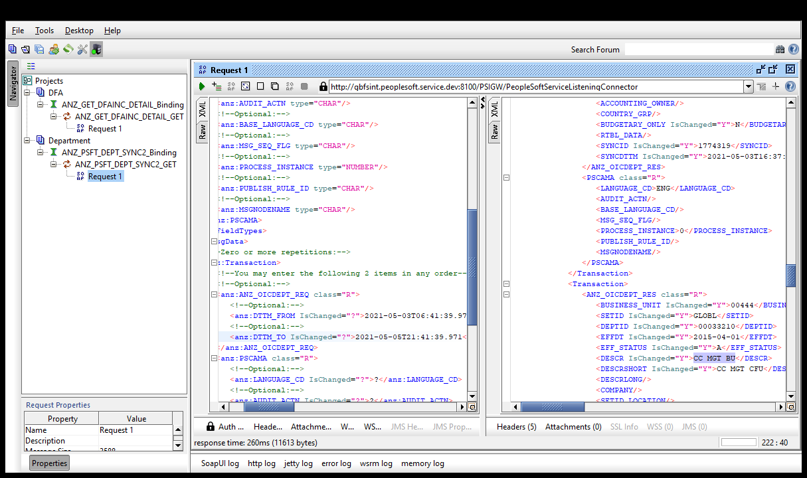

Scenario 2: Web Service based integration through SOAPUI for DFA

We are making some Change at Increment User limit DFA level as below:

Load the WSDL file generated out of the WSDL details of the service “ANZ_GET_DFAINC_DETAIL”

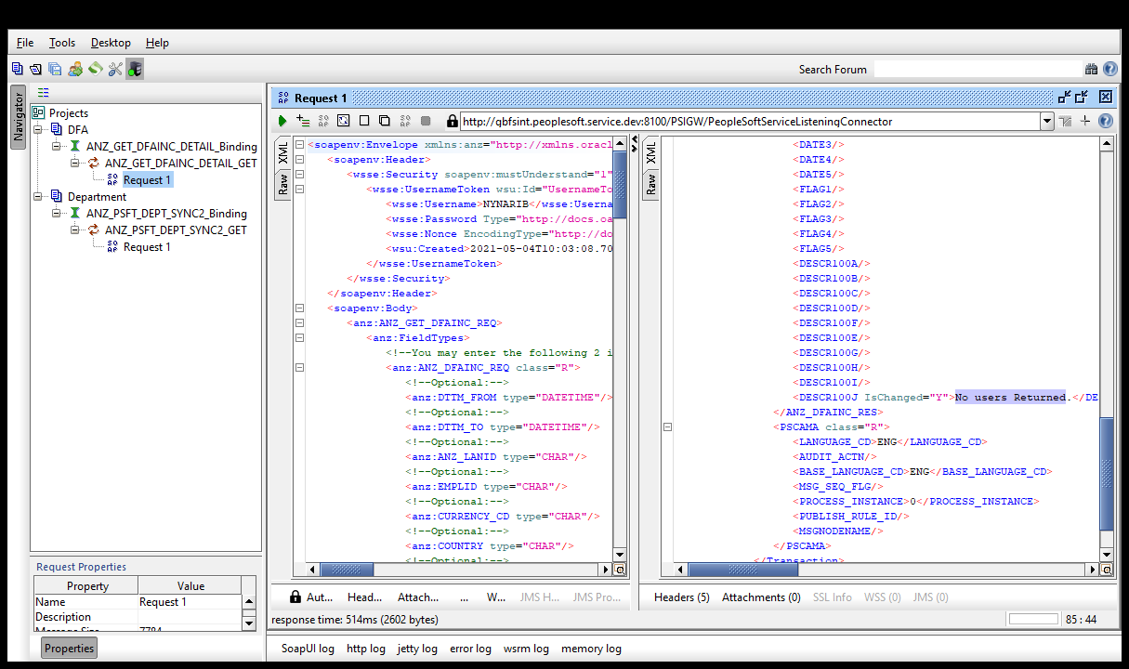

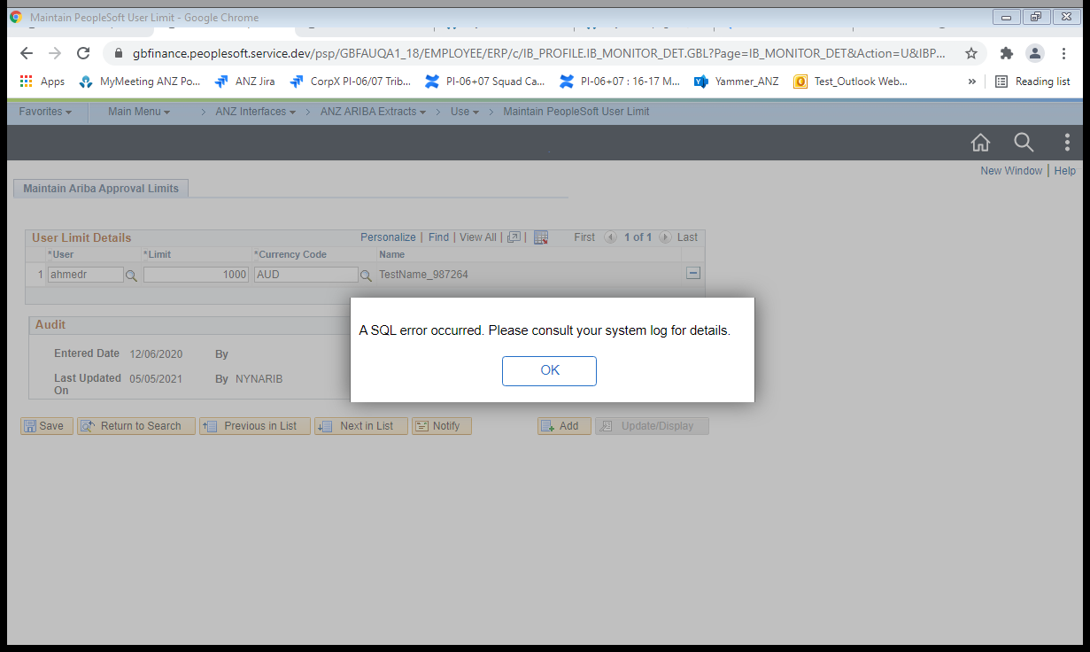

Scenario 3: Web service based integration through SOAPUI for Location

We making some change at Increment location

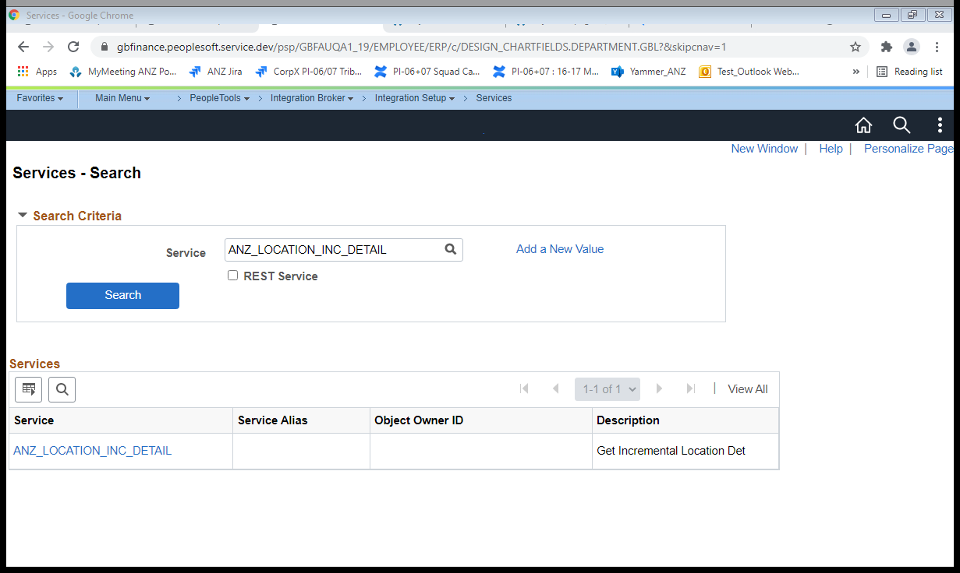

Click on “ANZ_LOCATION_INC_DETAIL” service

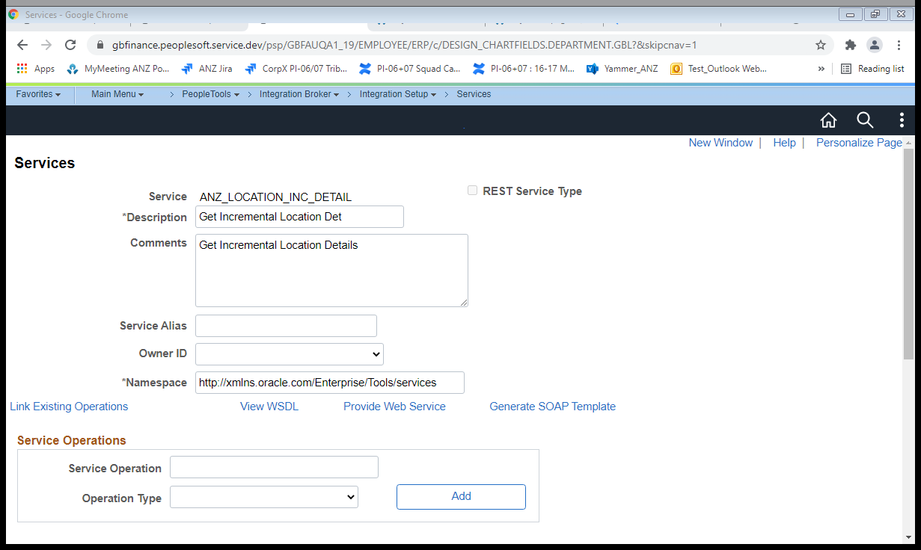

Click on View WSDL link

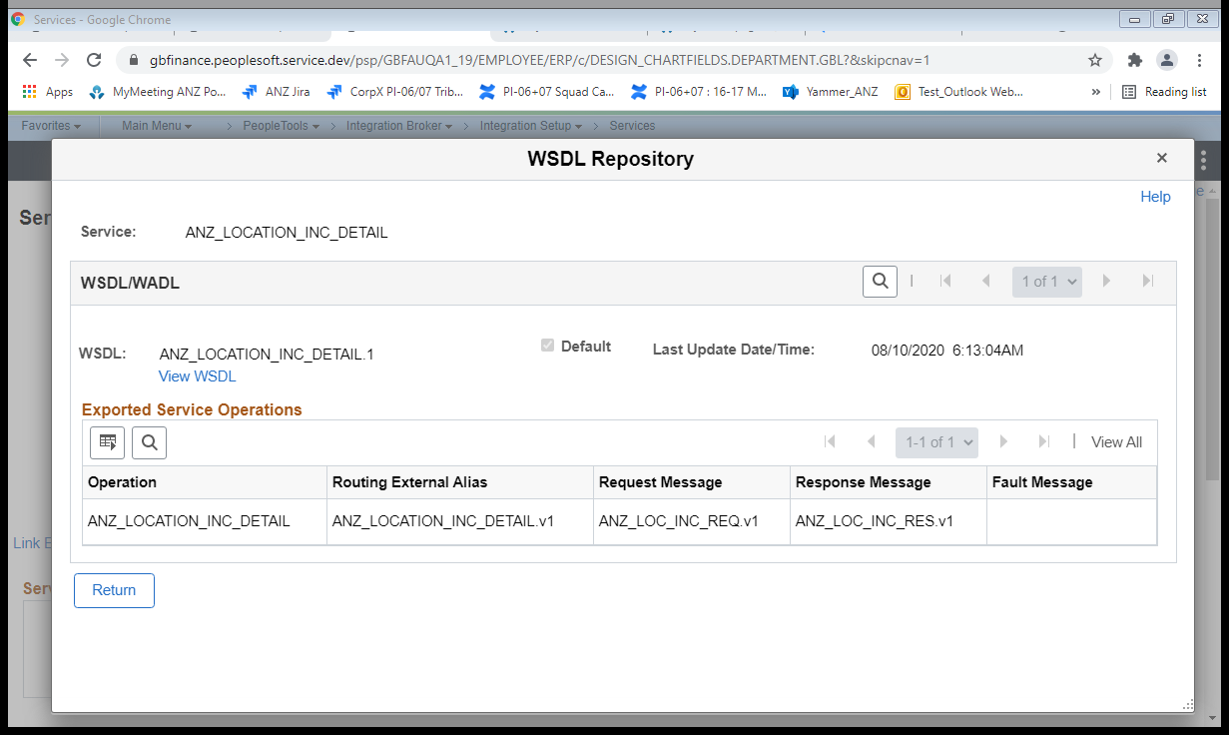

Click on View WSDL link

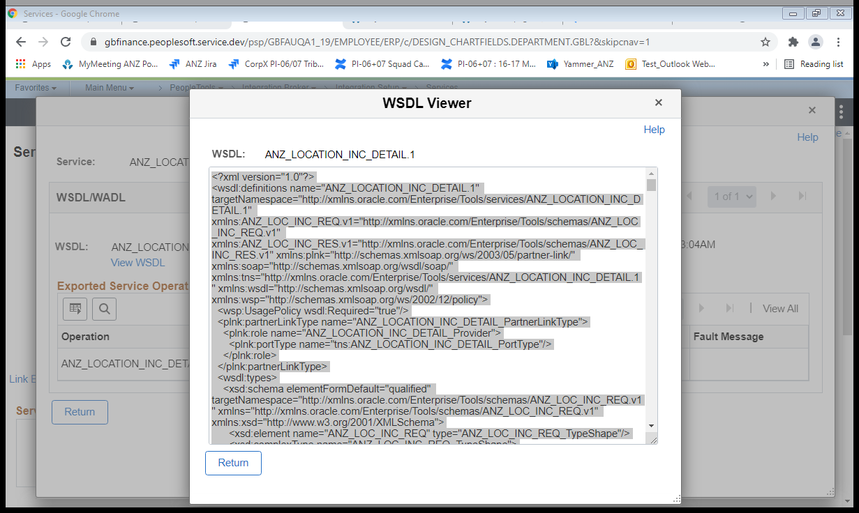

Check the wsdl file generated with this WSDL



Loading wsdl file as required

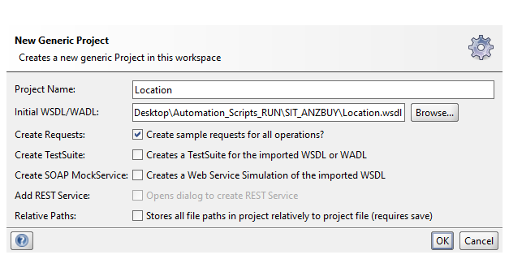

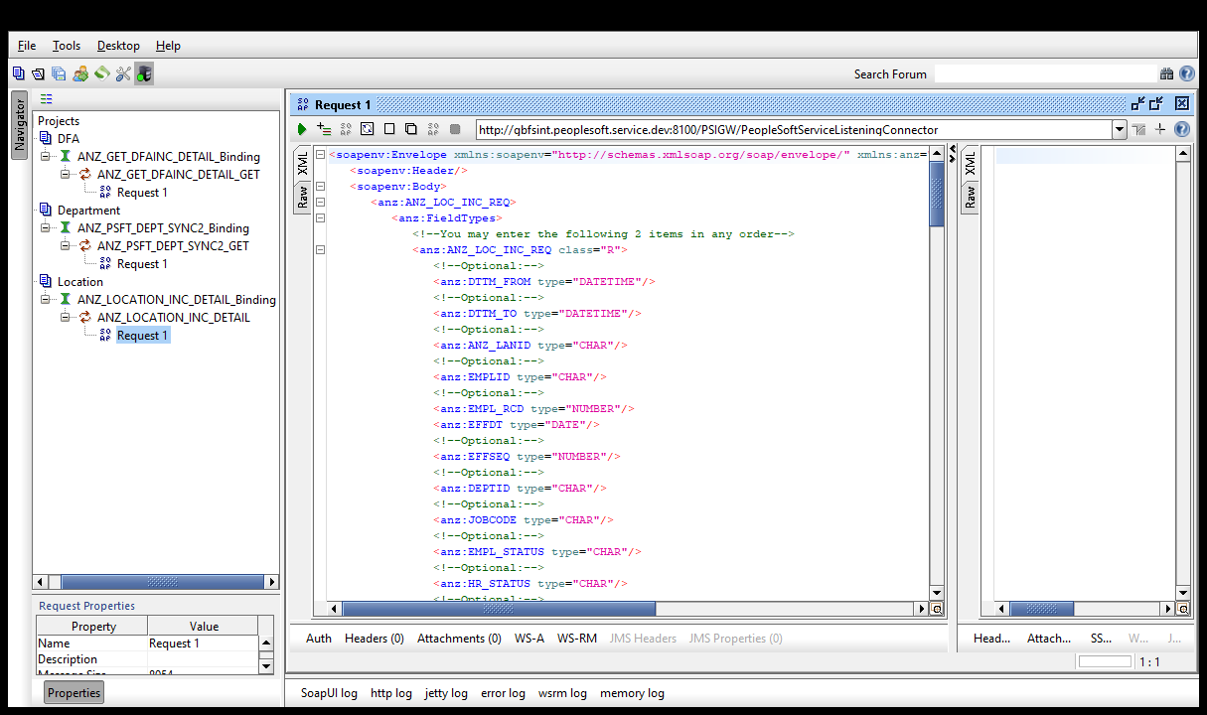

Click on “Auth” and enter the credentials and select the New authorization as shown below

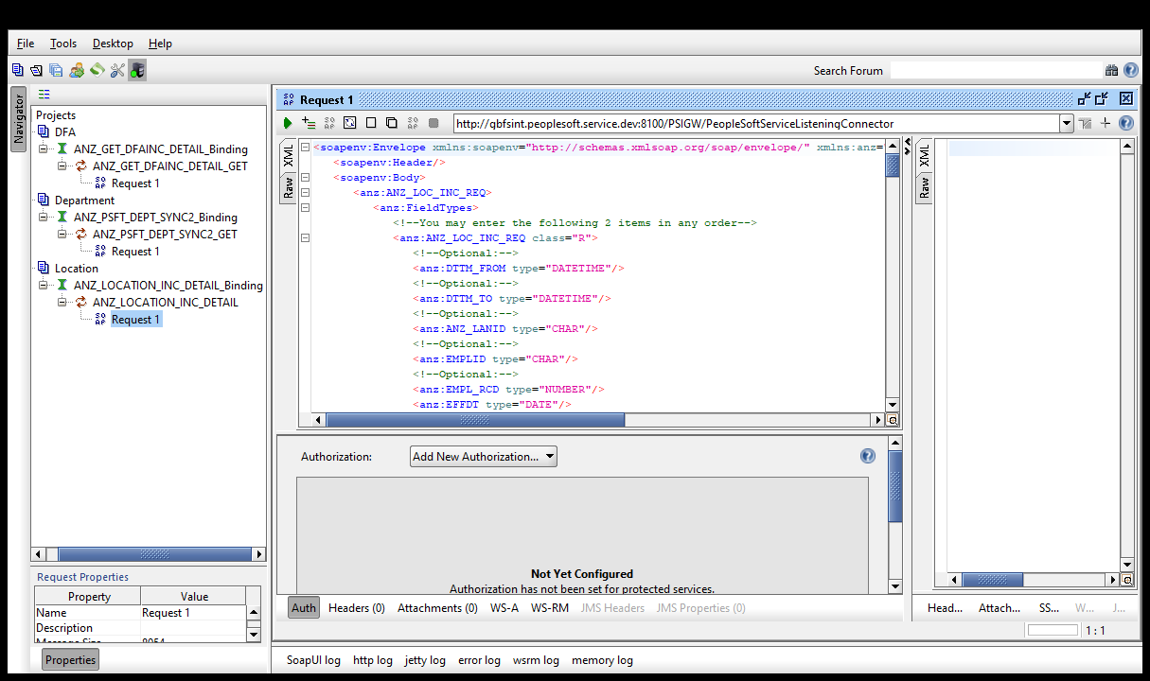

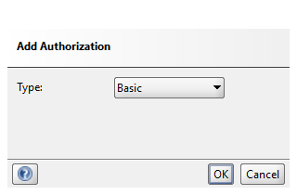

Click on OK Button

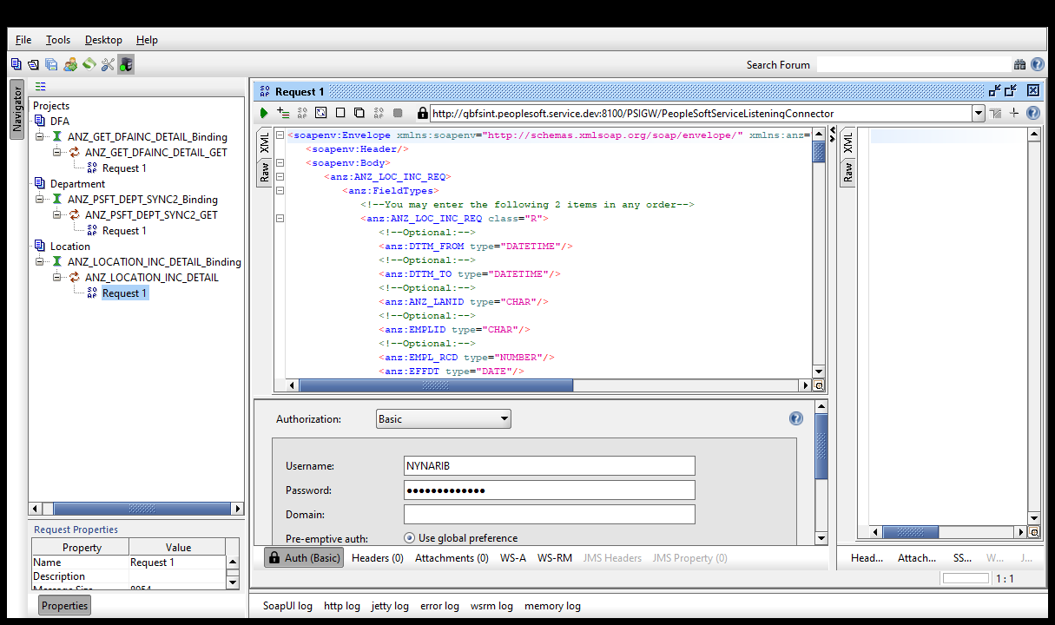

Right Click on the request tab and Click on “Add WSS Username Token” and select it as “PasswordText” as below

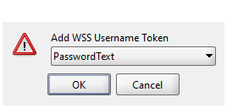

Navigate to the path:

Main menu🡪setup financials/supply chain🡪common definitions🡪location🡪location

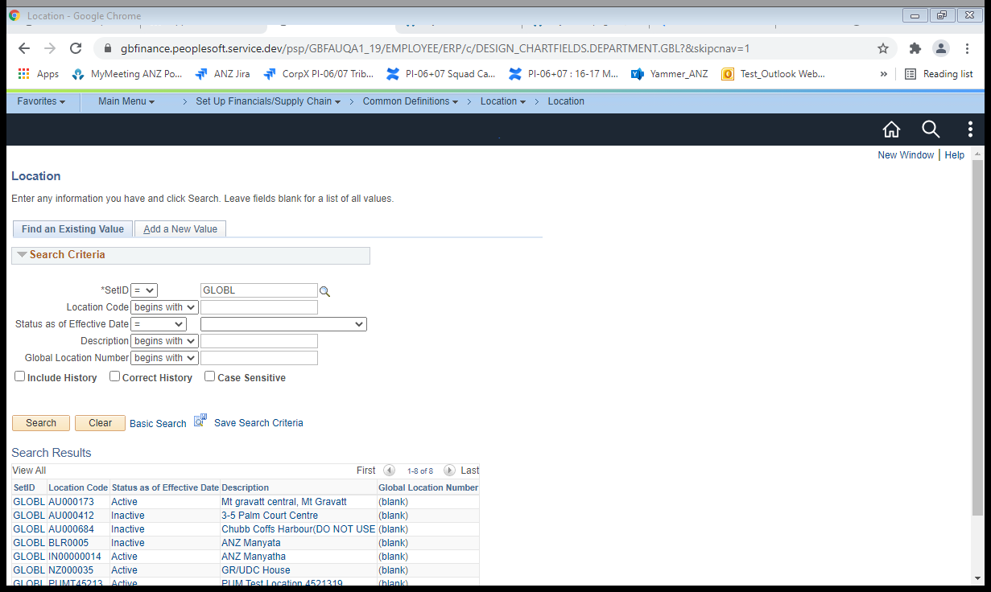

Make changes to the location Code “AU000173”

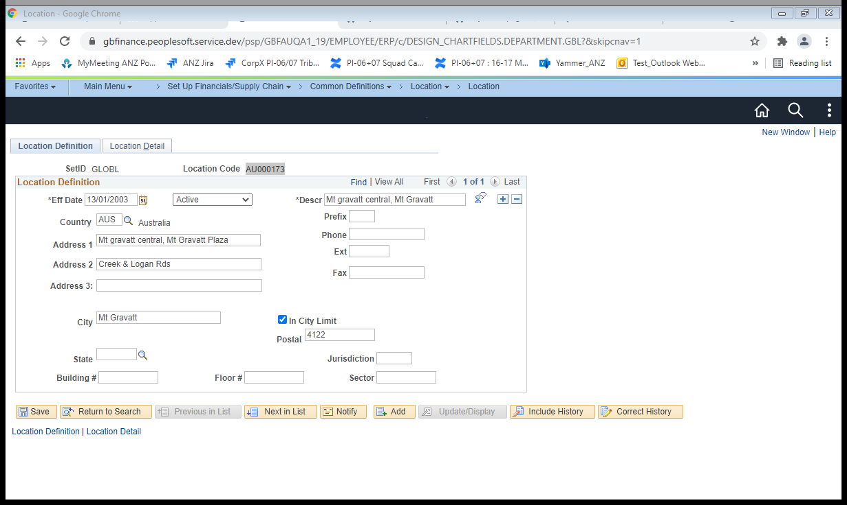

Changing “Descr” from “Mt gravatt central, Mt Gravatt” to “Mt gravatt central”

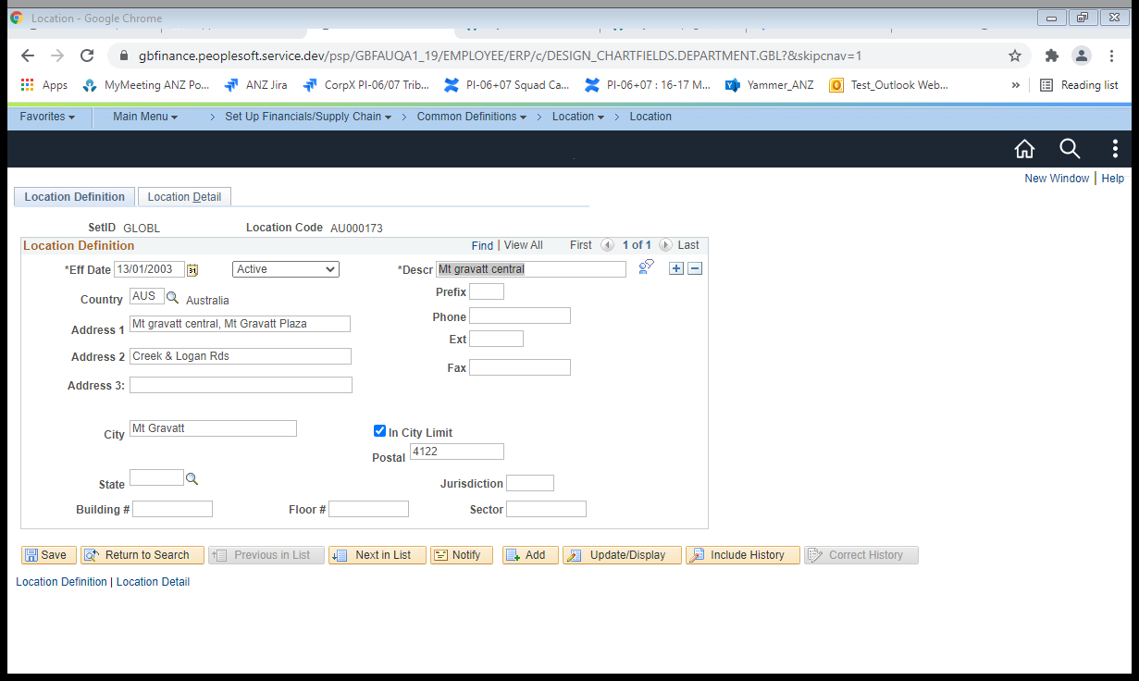

Click on Save Button

Update the “From date” and “To Date” and Submit the request

