**Overview and snapshots of the asset capitalise from Accounts Payable module**

As explained during the call, there are two types of AP vouchers for India. Such as (A) PO based vouchers (B) Non PO vouchers

**PO based vouchers**:

For PO based vouchers, the asset information will be automatically populated from the item module (if asset profile ID configured). If not, it needs to be updated by the requestor who is raising eProcurement requisition.

At the time of raising requisition, the requestor need to follow the below instruction:

* Click on the “Edit for All Lines” hyper Link
* Go to “Asset Information” tab of “Accounting Information” sub-table
* Select the “AM Business Unit” you can use the magnifier to select the business unit from the AM Business unit list.
* Select the Asset Profile ID, you can use the magnifier to select the Profile ID from the AM Profile ID list.
* Click OK button and submit the requisition for approval.

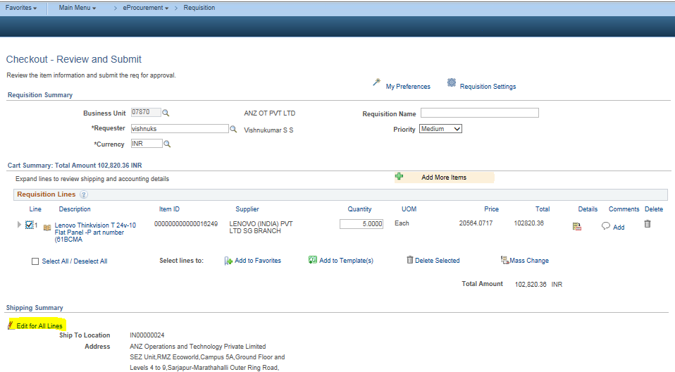

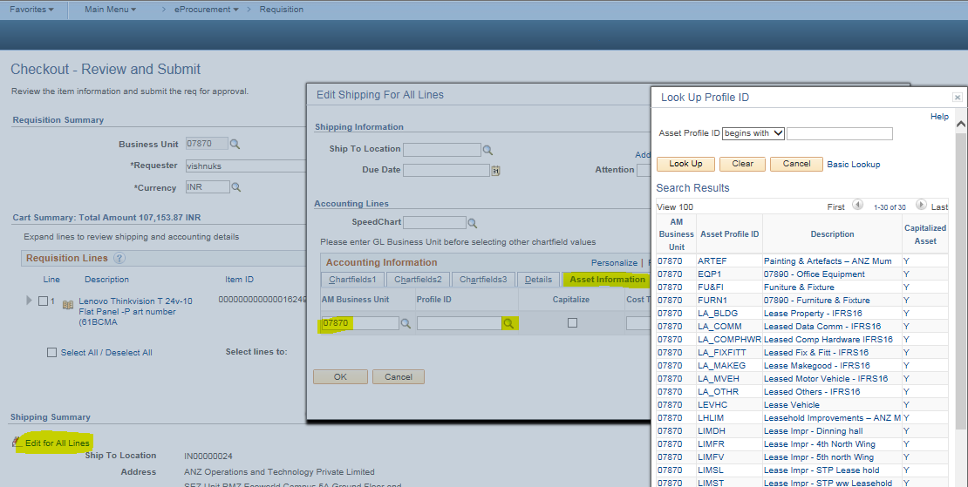

Once the requisition approved the PO will be generated and gets despatched to the supplier to deliver the goods/services to the requestor. After delivering the goods/services, the requestor need to raise receipt the received goods/services. the supplier will be submitting the Tax Invoice to get it paid.

AP processing team will be coping the PO receipts against the submitted tax invoice for matching. While coping receipts into Regular Entry/Invoice Information page, the selected Asset information (updated in the requisition by the requestor) will automatically copied into Invoice Information distribution line. After entering all the required information in the “Invoice Information” page. Click on Save button. As per process, you need to perform the AP Vs PO matching, clear the matching exception errors if any. From here the AP operations team task gets over.

**Non PO vouchers:**

For non PO vouchers where you would like to capitalise, the AP Operation team need to follow the below instruction:

* Navigate to Regular Entry >> Invoice Information
* Go to “Asset” tab of the Distribution Line.
* Click on the “Asset” check Box
* Once the “Asset” check Box enabled, the Business Unit & Profile ID filed will be activated
* Select the “Business Unit” you can use the magnifier to select the business unit from the Business unit list.
* Select the Asset Profile ID, you can use the magnifier to select the Profile ID from the AM Profile ID list.
* After entering all the required information in the “Invoice Information” page. Click on Save button.
* From here the AP operations team task gets over.

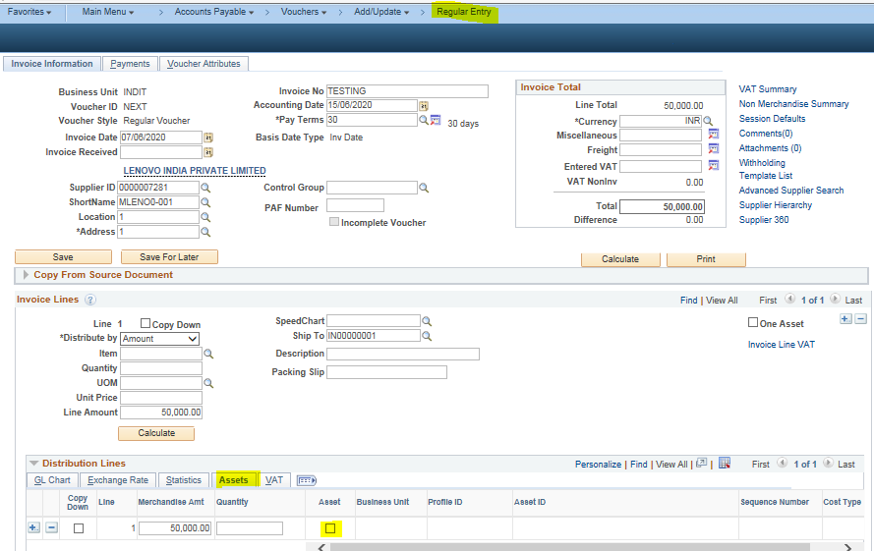

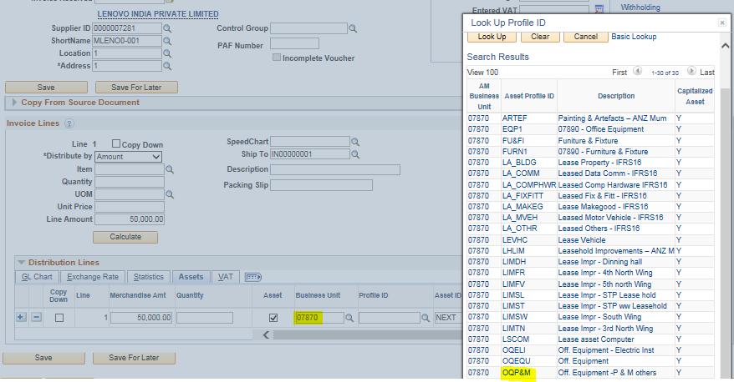

After Voucher gets saved/matching done, the EOD batch process will post the vouchers. And the invoices which was selected for Asset capitalise, will be interface from Accounts Payable to Asset Management module through “Payables to Assets Interface” process.

Once the above process completed, the asset information loads into Asset Management module to create the assets automatically. Once the assets created the AM module, the asset life cycle starts from there.