Experiment No:3

Q.Building Hadoop Map reduce application for counting frequency of word/phrase in simple text file.

package com.mapreduce.wc;

import java.io.IOException;
import org.apache.hadoop.conf.Configuration;
import org.apache.hadoop.fs.Path;
import org.apache.hadoop.io.IntWritable; import org.apache.hadoop.io.LongWritable; import org.apache.hadoop.io.Text;
import org.apache.hadoop.mapreduce.Job; import org.apache.hadoop.mapreduce.Mapper; import org.apache.hadoop.mapreduce.Reducer;
import org.apache.hadoop.mapreduce.lib.input.FileInputFormat; import org.apache.hadoop.mapreduce.lib.output.FileOutputFormat; import org.apache.hadoop.util.GenericOptionsParser;

public class WordCount {
public static void main(String[] args) throws Exception { Configuration c = new Configuration();
String[] files = new GenericOptionsParser(c, args).getRemainingArgs();
// Ensure correct input arguments
if (files.length < 2) {
System.err.println("Usage: WordCount <input path> <output path>"); System.exit(-1);
}
Path input = new Path(files[0]); Path output = new Path(files[1]);

Job j = Job.getInstance(c, "wordcount"); j.setJarByClass(WordCount.class); j.setMapperClass(MapForWordCount.class); j.setReducerClass(ReduceForWordCount.class); j.setOutputKeyClass(Text.class); j.setOutputValueClass(IntWritable.class); FileInputFormat.addInputPath(j, input); FileOutputFormat.setOutputPath(j, output); System.exit(j.waitForCompletion(true) ? 0 : 1);
}
// Mapper Class
public static class MapForWordCount extends Mapper<LongWritable, Text, Text, IntWritable> {
private final static IntWritable one = new IntWritable(1);
private Text wordText = new Text();

public void map(LongWritable key, Text value, Context con) throws
IOException, InterruptedException {
String line = value.toString().trim();
String[] words = line.split("\\s+"); // Handles multiple spaces
for (String word : words) {
if (!word.isEmpty()) { // Avoid empty strings wordText.set(word.trim().toUpperCase()); con.write(wordText, one);
}
}
}
}
// Reducer Class
public static class ReduceForWordCount extends Reducer<Text, IntWritable, Text, IntWritable> {
public void reduce(Text word, Iterable<IntWritable> values, Context con)
throws IOException, InterruptedException {
int sum = 0;
for (IntWritable value : values) { sum += value.get();
}
con.write(word, new IntWritable(sum));
}
}
}

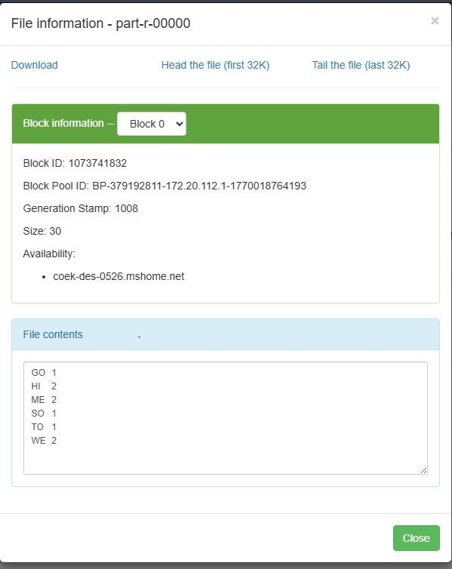
Output:

Experiment No. 4
Title: Study of HADOOP YARN administrative command and user command

Command:
C:\Windows\system32>start-all.cmd
This script is Deprecated. Instead use start-dfs.cmd and start-yarn.cmd starting yarn daemons

C:\Windows\system32>start-yarn.cmd starting yarn daemons

C:\Windows\system32>stop-yarn.cmd stopping yarn daemons
SUCCESS: Sent termination signal to the process with PID 10380. SUCCESS: Sent termination signal to the process with PID 2628.

INFO: No tasks running with the specified criteria. Output :-
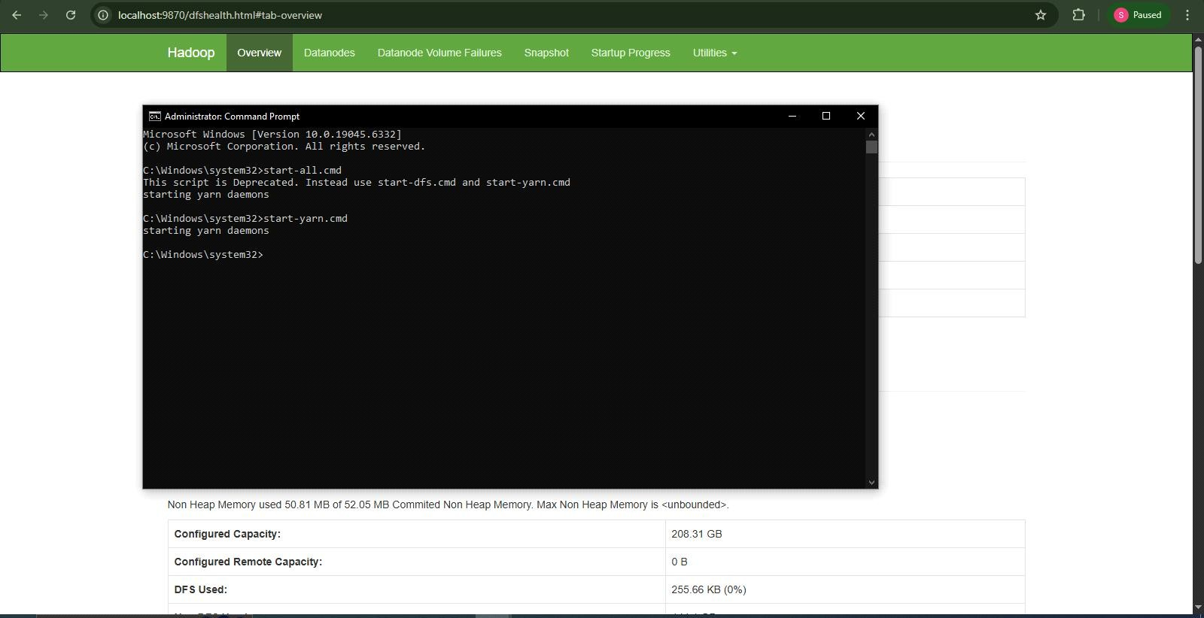

Experiment No.5 Title : Study of R and installation of R studio
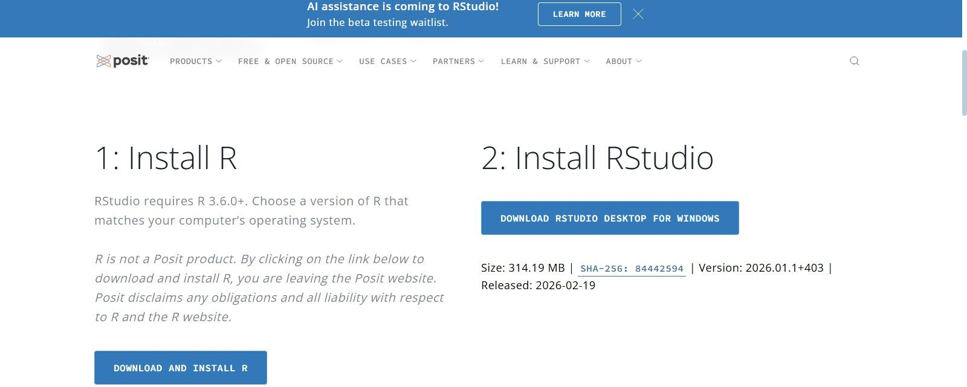

RStudio :
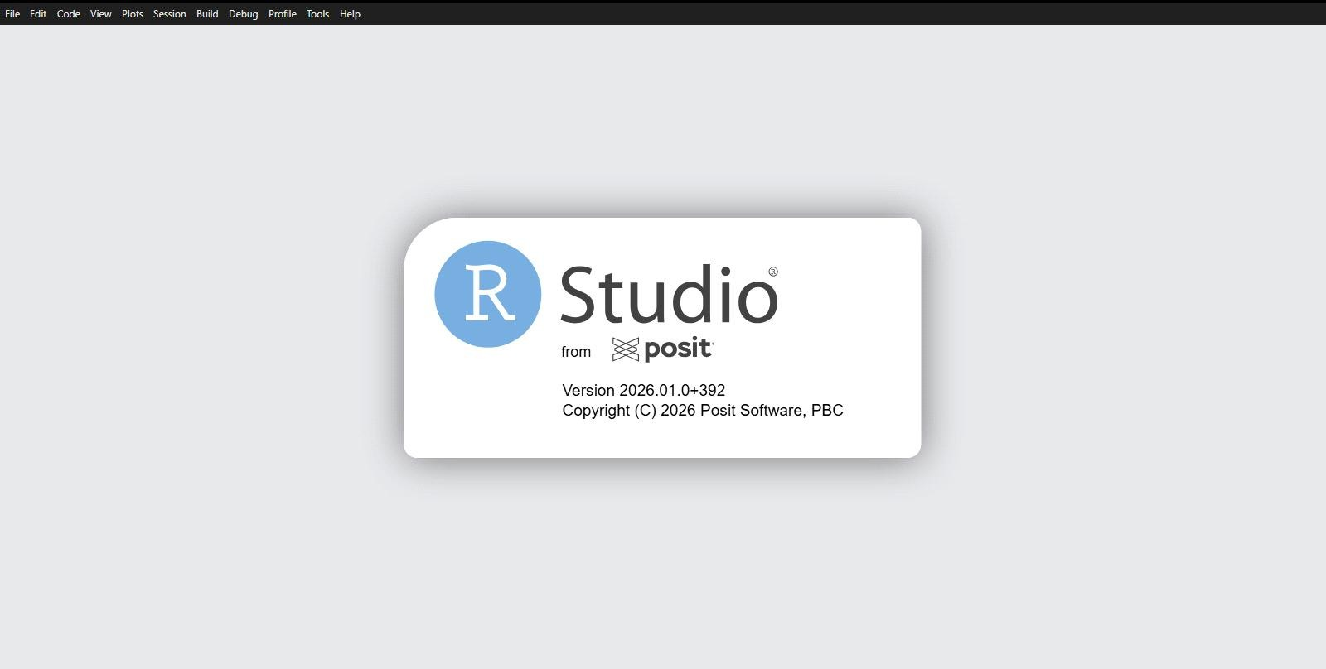

R:
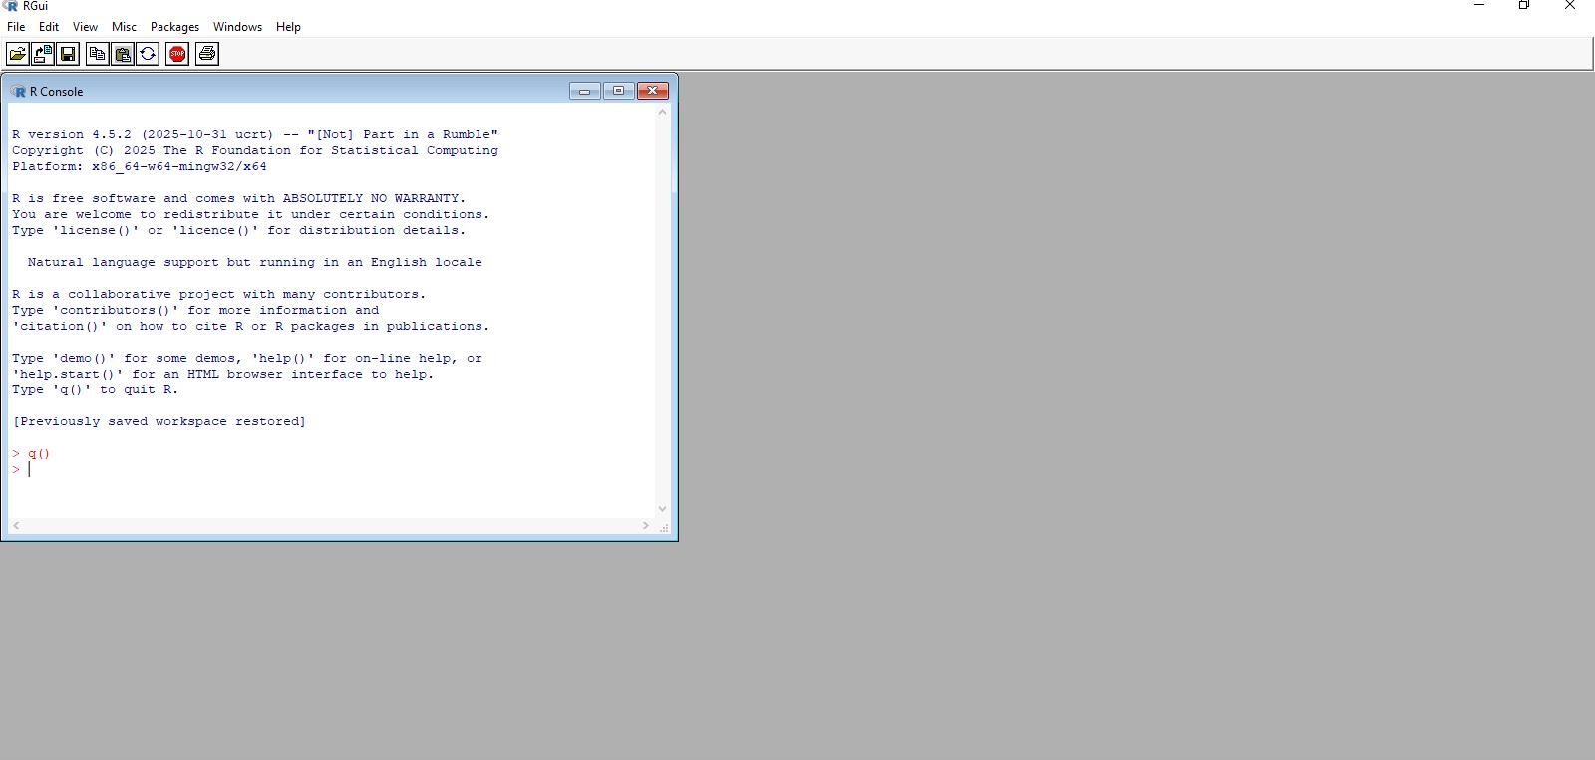

Experiment No. 6

Variables:
name <- "John" age <- 40 print(name) print(age) OUTPUT
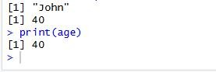

Condition:
IF Statement:
a <- 33
b <- 200
if (b > a) {
print("b is greater than a")
}
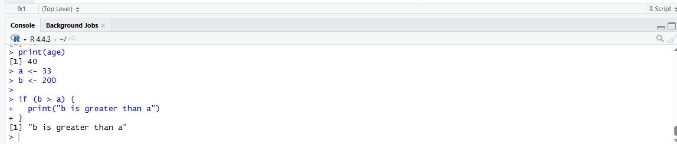
OUTPUT

IF..ELSE Statemet:
a <- 200
b <- 33
if (b > a) {
print("b is greater than a")
} else if (a == b) {
print("a and b are equal")

} else {
print("a is greater than b")
}
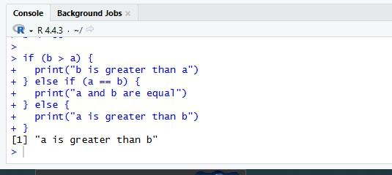
OUTPUT

LOOPs:
While Loop
i <- 1
while (i < 6) { print(i)
i <- i + 1
}
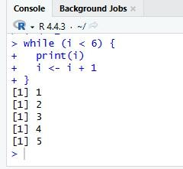
Output:

For Loop
for (x in 1:10) { print(x)
}
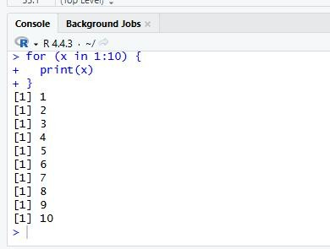
Output

Experiment No. 7
Title: To study R declaring variables,expression function amd executing R script

Functions
- Creating a Function:
my_function <- function() { print("Hello World!")
}
Output:
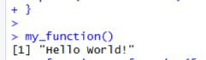

- Call a Function
my_function <- function() { print("Hello World!")
}
my_function()
Output:
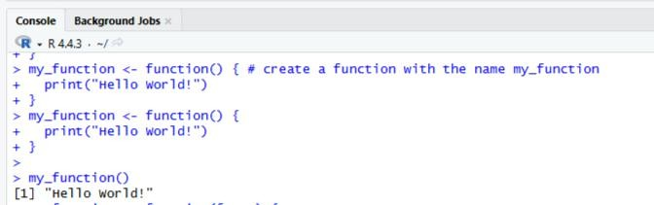

- Arguments
my_function <- function(fname) { paste(fname, "Griffin")
}
my_function("Peter") my_function("Lois") my_function("Stewie")

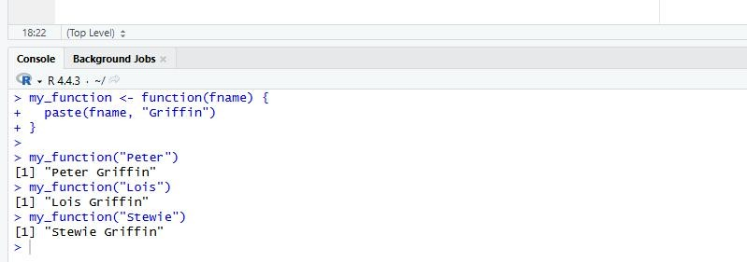
Output:

- Number of Arguments
my_function <- function(fname, lname) { paste(fname, lname)
}
my_function("Peter", "Griffin")
Output:
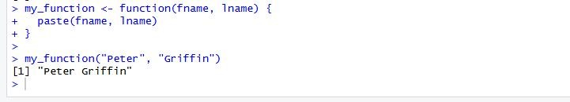
- Default Parameter Value
my_function <- function(country = "Norway") { paste("I am from", country)
}
my_function("Sweden") my_function("India")
my_function() # will get the default value, which is Norway my_function("USA")

Output:
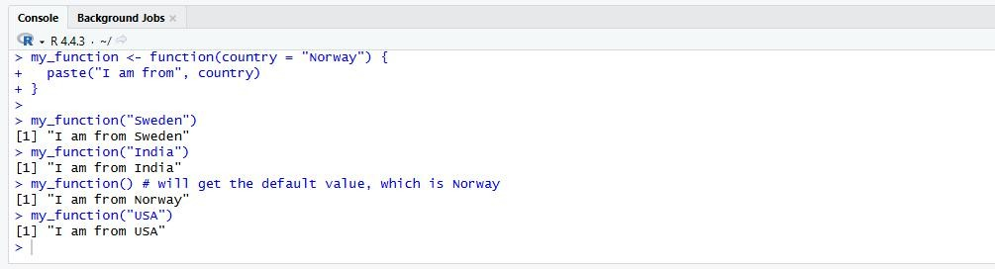

- Return Values
my_function <- function(x) { return (5 * x)
}
print(my_function(3)) print(my_function(5)) print(my_function(9))
Output:
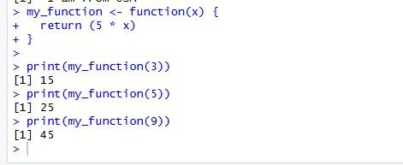
R Nested Functions:
- Nested_function <- function(x, y) { a <- x + y
return(a)
}
Nested_function(Nested_function(2,2), Nested_function(3,3))
Output:
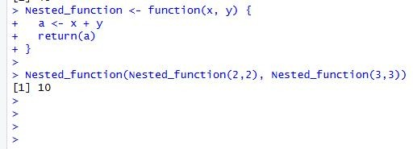

- Outer_func <- function(x) { Inner_func <- function(y) {
a <- x + y return(a)
}

return (Inner_func)
}
output <- Outer_func(3) # To call the Outer_func output(5)
Output:
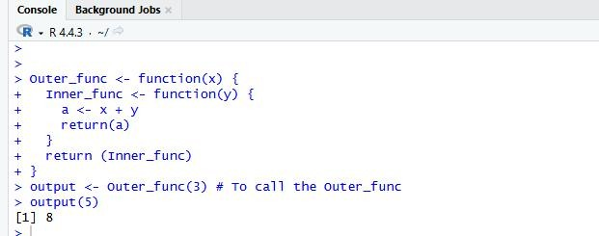

Recursion
tri_recursion <- function(k) { if (k > 0) {
result <- k + tri_recursion(k - 1) print(result)
} else {
result = 0 return(result)
}
}
tri_recursion(6)
Output:
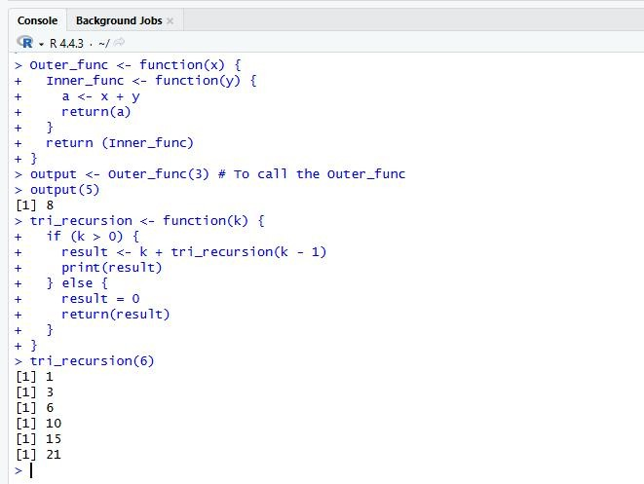

Global Variables
- txt <- "awesome" my_function <- function() {
paste("R is", txt)
}
my_function()
Output:
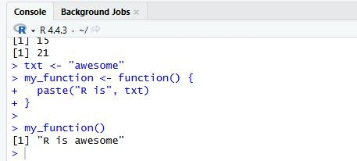

- txt <- "global variable" my_function <- function() {
txt = "fantastic" paste("R is", txt)
}
my_function() txt # print txt
Output:
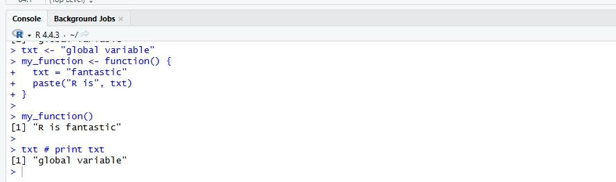

Experiment No. 8 Title: Importing data and working on dataset

Program: Data Set
# Print the mtcars data set mtcars
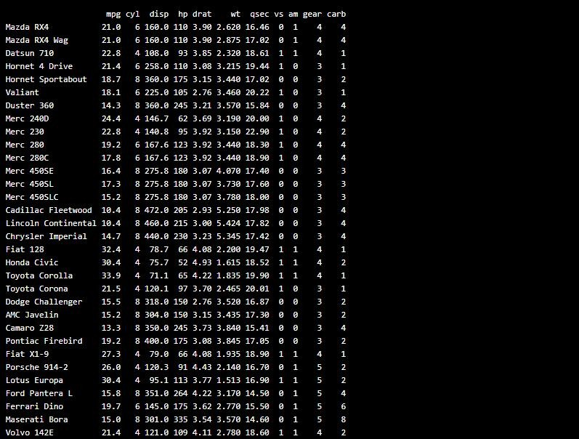
Output:

Program: Get Information
Data_Cars <- mtcars # create a variable of the mtcars data set for better organization # Use dim() to find the dimension of the data set
dim(Data_Cars)
# Use names() to find the names of the variables from the data set names(Data_Cars)

Output:

Program: Get Information Data_Cars <- mtcars rownames(Data_Cars) Output:
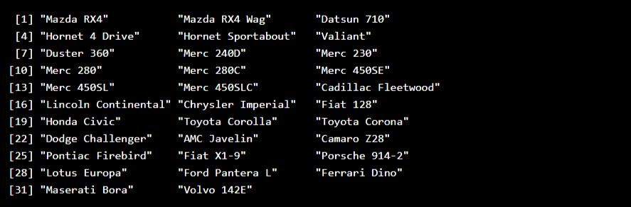

Program: Print Variable Values Data_Cars <- mtcars Data_Cars$cyl
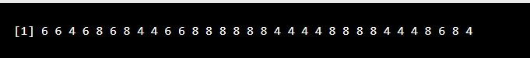
Output:

Program: Sort Variable Values Data_Cars <- mtcars sort(Data_Cars$cyl)
Output:

Experiment No. 10
Title: Study of Data Visualization drawing Pie chart, Bar chart , Histogram, etc.
Pie Chart :
Program:
data <- c(25, 30, 20, 25)
labels <- c("Apple", "Banana", "Orange", "Mango") pie(data, labels = labels, main = "Fruit")
Output:-
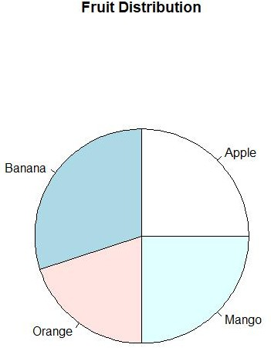
Program:
data <- c(40, 30, 20, 10)
labels <- c("Python", "Java", "C++", "JavaScript")
colors <- c("red", "blue", "green", "yellow")
pie(data, labels = labels, col = colors, main = "Programming Languages")
Output:
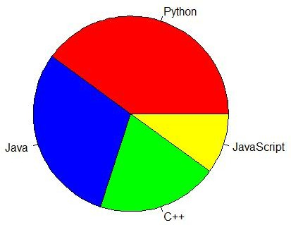

Bar Chart:
Program:
# x-axis values
x <- c("A", "B", "C", "D")
#y-axis values y <- c(2, 4, 6, 8)
barplot(y, names.arg = x)
Output:
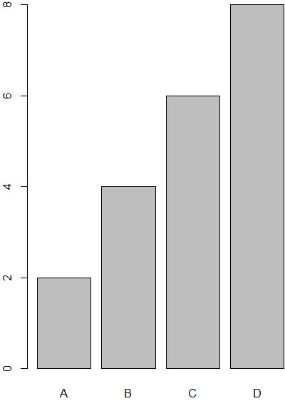
Program:

marks <- c(85, 90, 75, 80)
subjects <- c("Math", "Science", "English", "History") barplot(marks, names.arg = subjects, main = "Student Marks")

Output
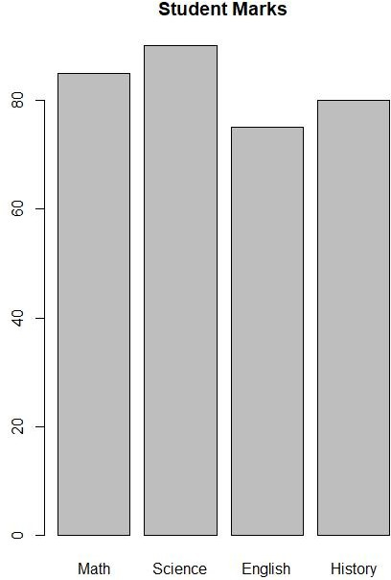

Histogram:
Program
data <- c(10,20,20,30,30,40,40,50,60)
hist(data, main = "Histogram Example")

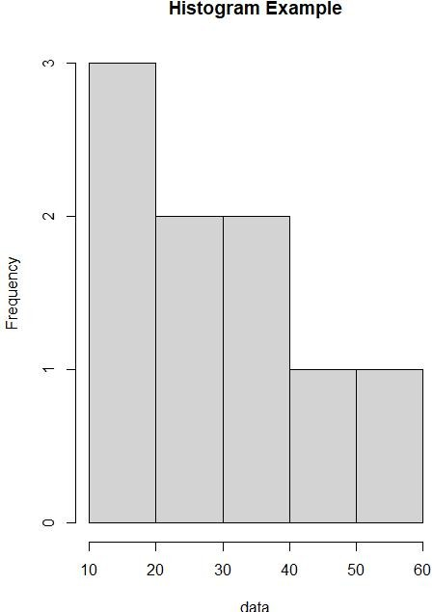
Output:

Program:

marks <- c(45,50,55,60,65,70,75,80,85,90,95)
hist(marks, col = "green", breaks = 5, main = "Marks Distribution",
xlab = "Marks", ylab = "Frequency")

Output:
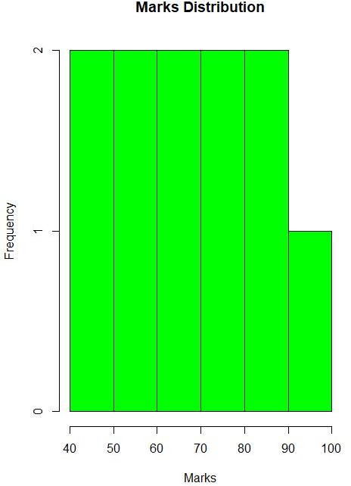

Scatter Plot:
Program
x <- c(5,7,8,7,2,2,9,4,11,12,9,6)
y <- c(99,86,87,88,111,103,87,94,78,77,85,86)
plot(x, y)

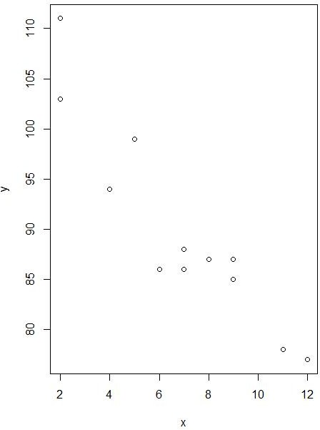
Output:

Program:
x <- c(5,7,8,7,2,2,9,4,11,12,9,6)
y <- c(99,86,87,88,111,103,87,94,78,77,85,86)
plot(x, y, main="Observation of Cars", xlab="Car age", ylab="Car speed")

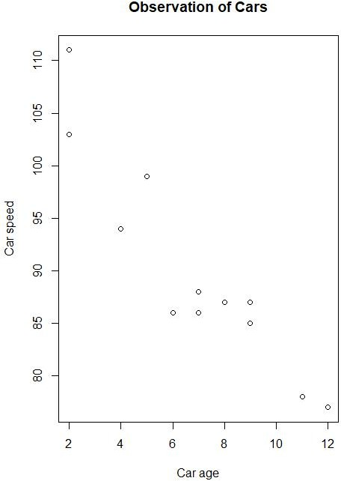
Output

Line:
Program:
line1 <- c(1,2,3,4,5,10)
line2 <- c(2,5,7,8,9,10)
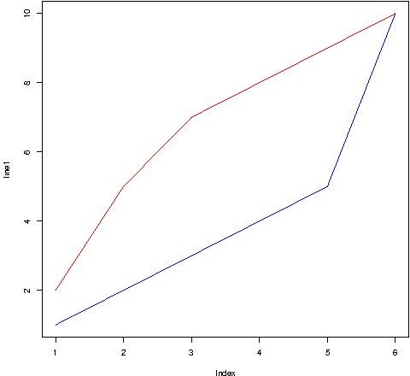
plot(line1, type = "l", col = "blue") lines(line2, type="l", col = "red") Output

Program:
plot(1:10, type="l", col="blue")
Output

