PHASE 2
Victim Logs
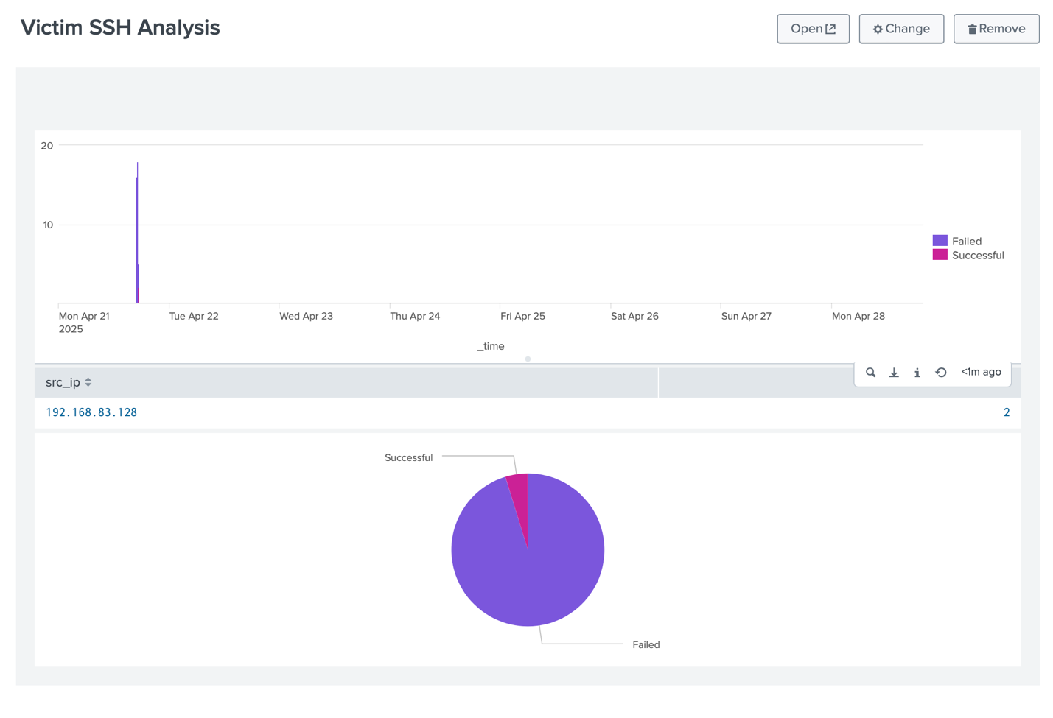

Attacker Logs
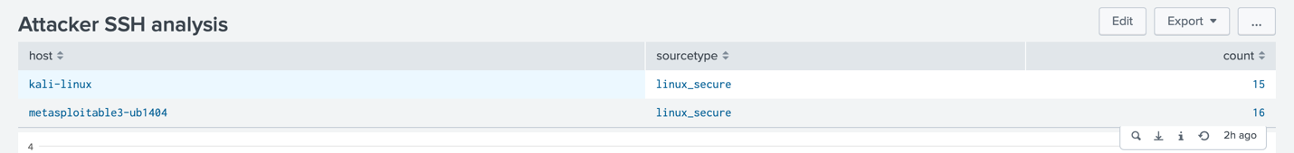
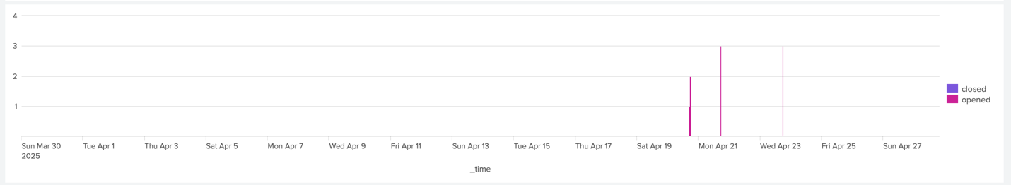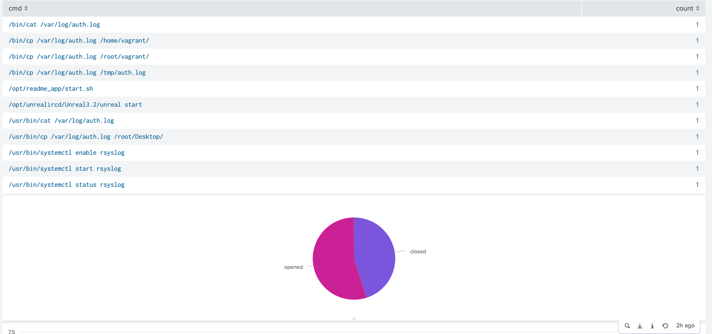
Attack Comparison
