On metasploitable3:
Checking the IP Address Of the machine:
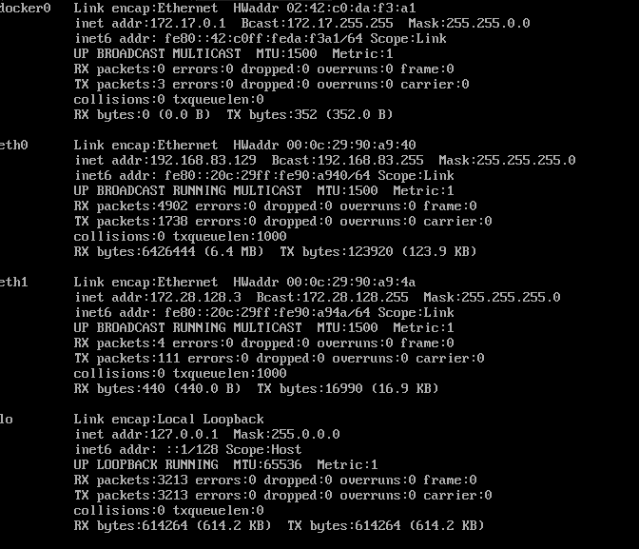
Checking the SSH status:
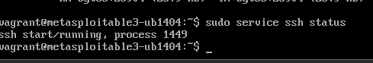

ON Kali (Attacker):
checking the connectivity of the victim machine:

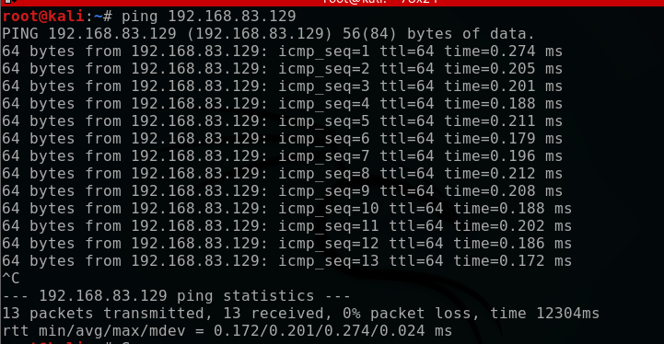

Using nmap to exploit any vulnerability in the metasploitable:
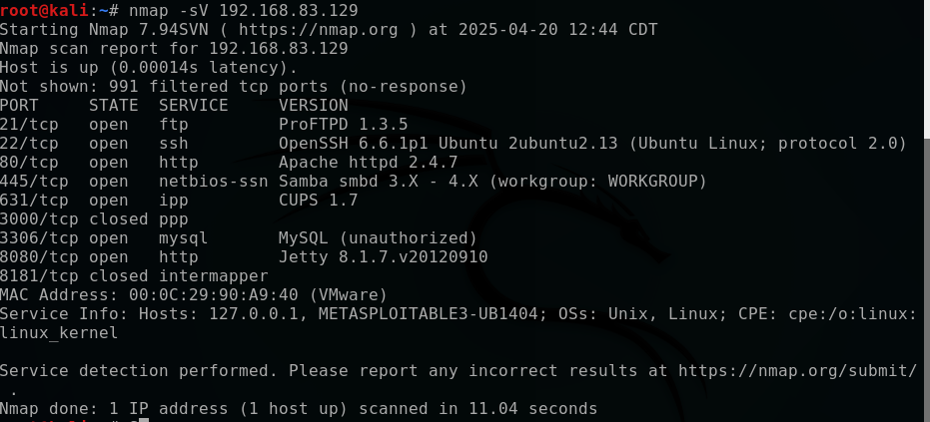

We will chose to exploit SSH as it has an open port No. 22

On Kali Machine (Attacker):
Using the correct settings to compromise the service:
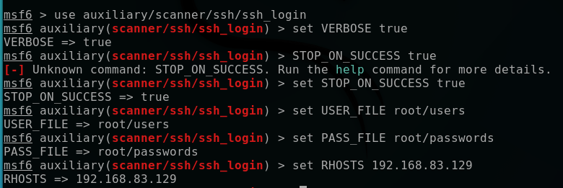
We have two text files:
- One containing a string map of users
- One containing a string map of passwords

Excute the attack:
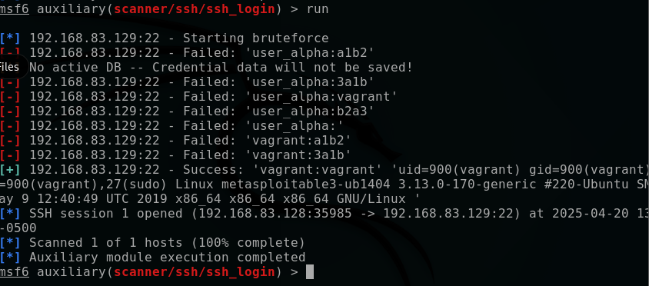

As we can see we have a successful attempt with username of (vagrant) and password (vagrant)
We can login and use the attacked machine:

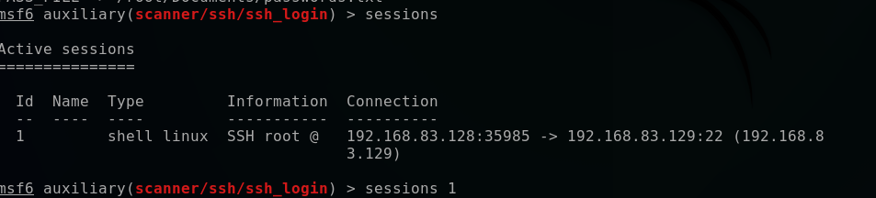
As we can see that we have the address of the victim machine:
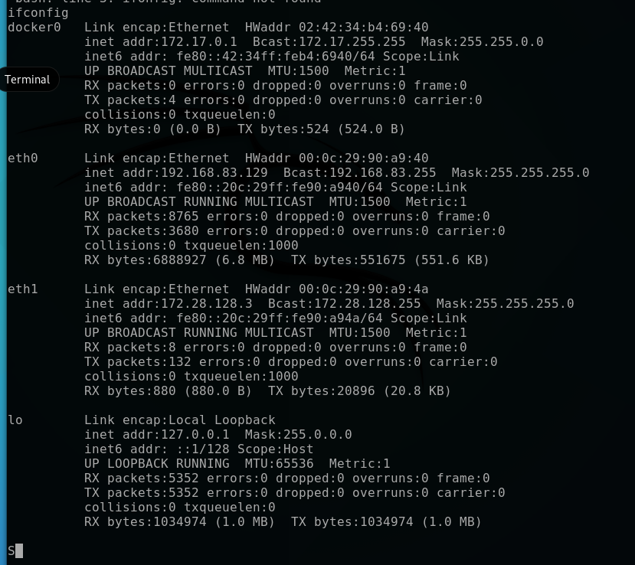

We can have sensitive information like:

- SSH authorized keys
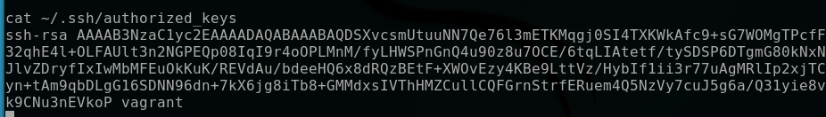
- List of passwords
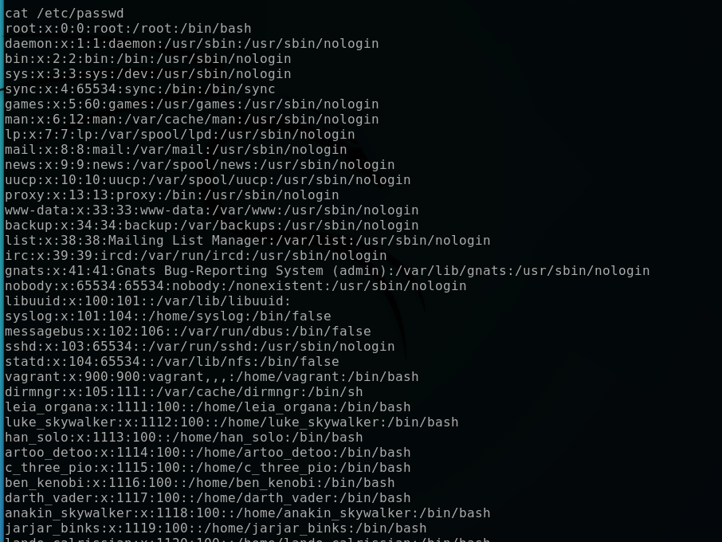
Attacking using custom script:
The custom script:
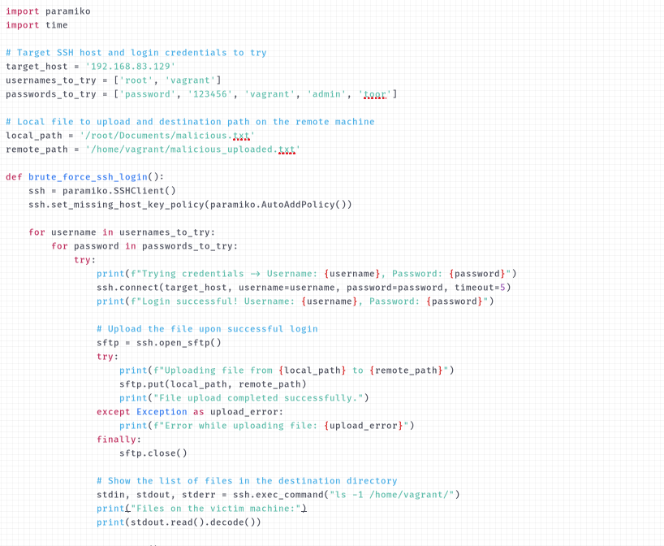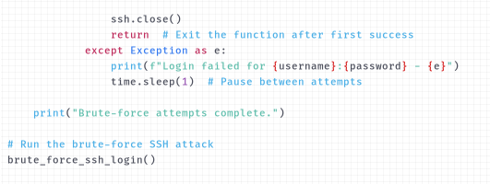

Excuting the attack:
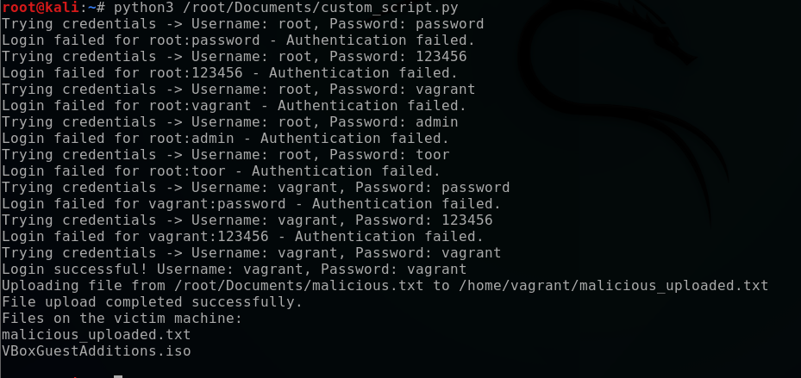

As we can see we get a successful login with:
- Username:vagrant
- Password:vagrant
And we successfully uploaded the malicious code in the victim machine!

