上 海 电 力 大 学

《数字集成电路设计与分析》实验报告



实验题目： 实验二 实现全加器功能代码、测试代码
专 业：
班 级 学号
姓 名
时 间 2023-09-28

- 实验目的
2、完成二选一功能块的行为和结构描述，以及测试程序的编写
3、熟练掌握VI编辑器，并用VCS调试验证设计程序的正确性
- 实验任务及要求
用VI编辑器完成二选一的源程序、测试程序的编写，并用VCS仿真验证设计的正确性
- 实验内容及步骤
1、实验的源代码
module full_adder (
// module head: verillog-2001 format
input wire a_in,
input wire b_in,
input wire c_in, // carry in
output wire sum_out,
output wire c_out // carry out
);

// method 1 Gate Level describe方法1
assign sum_out = a_in ^ b_in ^ c_in;//得到和
assign c_out = (a_in & b_in) | (b_in & c_in) | (a_in & c_in);//得到进位
endmodule
2、实验的测试代码
module full_adder_tb;
// drive the input port with the reg type
reg ain, bin, cin;
// sample the output port with the wire type
wire sumout, cout;

//例化DUT
full_adder u_full_adder(
// task 1. how to create an instance
// module head: verillog-2001 format
/*input wire */ .a_in (ain),
/*input wire */ .b_in (bin),
/*input wire */ .c_in (cin), // carry in
/*output wire */ .sum_out(sumout),
/*output wire */ .c_out (cout) // carry out
);

// behavior of the adder can be synthesizable
// "assign" means connectivity
// assign {c_out, sum_out} = a_in + b_in + c_in;

//task 2. clock and reset generator
parameter CLK_PERIOD = 20;
reg clk, reset_n; // reset_n : active low

initial begin //initial块，时钟激励波形生成
clk = 0;
forever begin
#(CLK_PERIOD/2) clk = ~clk;
end
end

initial begin //initial块 ，复位激励波形生成
reset_n = 0;
#100
reset_n = 1;
end

//task 3. drive the stimulus and capture the response
//here is a testcase
initial begin //过程块2，顺序给其余输入激励（非 clock、reset）加上信号数值
#110 ain = 0; bin = 0; cin = 0; // 00
#20 ain = 0; bin = 1; cin = 0; // 01
#20 ain = 1; bin = 0; cin = 0; // 01
#20 ain = 1; bin = 1; cin = 0; // 10
#20 ain = 0; bin = 0; cin = 1; // 01
#20 ain = 0; bin = 1; cin = 1; // 10
#20 ain = 1; bin = 0; cin = 1; // 10
#20 ain = 1; bin = 1; cin = 1; // 11
//#20 ain = 1; bin = 1; cin = 0; // 10
#50 $finish; // here is a system task which can stop the simulation
end

// task 4. check the result //检查结果
always @ (posedge clk) begin //always过程块
if (!reset_n) begin
$display("%t:%m: resetting ...",$time); // counter 5 clock
end
else begin
$display("%t:%m: resetting finish!", $time); // the 6th clock
end
end
initial begin //initial 过程块2，顺序检查，如果结果不正确，则利用display系统函数打印出ERROR
#115 if ({cout,sumout} != 2'b00) $display("Error: {cout,sumout}=%b,ain=%b, bin=%b, cin=%b",{cout,sumout}, ain, bin, cin);
#20 if ({cout,sumout} != 2'b01) $display("Error: {cout,sumout}=%b,ain=%b, bin=%b, cin=%b",{cout,sumout}, ain, bin, cin);
#20 if ({cout,sumout} != 2'b01) $display("Error: {cout,sumout}=%b,ain=%b, bin=%b, cin=%b",{cout,sumout}, ain, bin, cin);
#20 if ({cout,sumout} != 2'b10) $display("Error: {cout,sumout}=%b,ain=%b, bin=%b, cin=%b",{cout,sumout}, ain, bin, cin);
#20 if ({cout,sumout} != 2'b01) $display("Error: {cout,sumout}=%b,ain=%b, bin=%b, cin=%b",{cout,sumout}, ain, bin, cin);
#20 if ({cout,sumout} != 2'b10) $display("Error: {cout,sumout}=%b,ain=%b, bin=%b, cin=%b",{cout,sumout}, ain, bin, cin);
#20 if ({cout,sumout} != 2'b10) $display("Error: {cout,sumout}=%b,ain=%b, bin=%b, cin=%b",{cout,sumout}, ain, bin, cin);
#20 if ({cout,sumout} != 2'b11) $display("Error: {cout,sumout}=%b,ain=%b, bin=%b, cin=%b",{cout,sumout}, ain, bin, cin);
#20 if ({cout,sumout} != 2'b10) $display("Error: {cout,sumout}=%b,ain=%b, bin=%b, cin=%b",{cout,sumout}, ain, bin, cin);
end

// task 5. dump waveform with the compile option -debug_all //转储波形文件
initial begin
$vcdpluson; // vcdplus.vpd格式的波形文件
end
endmodule

3、VCS仿真结果
（用截图的方法把VCS仿真结果拷贝下来）
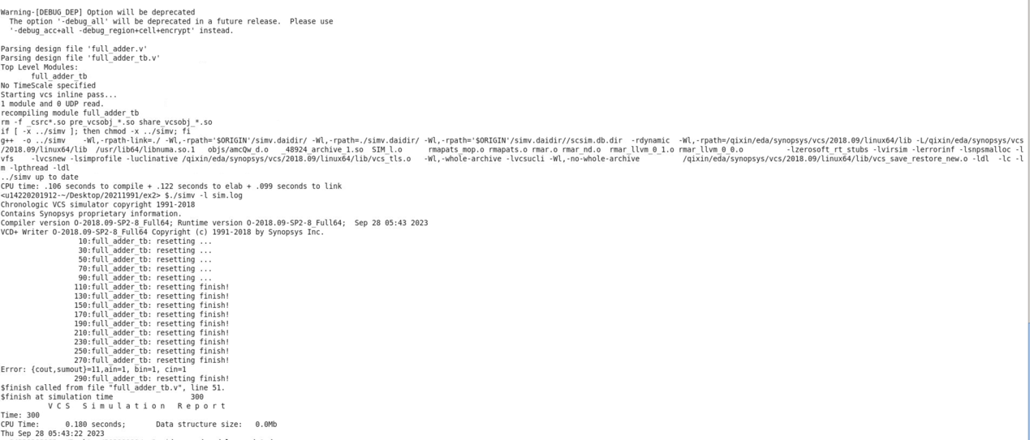
图1 ./simv -l sim.log
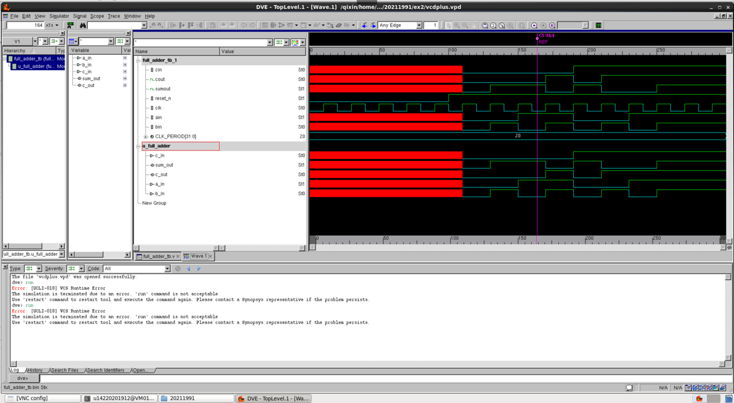
图2 dve -vpd vcdplus.vpd &vd
- 实验总结
vcs -debug_all full_adder.v full_adder_tb.v -l com.log
./simv -l sim.log
dve -vpd vcdplus.vpd &vd

