实验六 继承和派生

学号： 姓名： 班级：

一、实验目的
1．学习声明和使用类的继承关系，声明派生类。
2．熟悉不同继承方式下对基类成员的访问控制。
3．理解派生类中构造函数和析构函数的实现与调用。
二、实验任务
1．定义一个基类Shape，有一个数据成员color表示图形颜色，在此基础上派生出Rectangle（两个私有数据成员：长和宽）和Circle（私有数据成员：半径），二者都有getArea()函数计算该类对象的面积。给出这些类的完整实现（写出其构造函数、复制构造函数、析构函数及相应的成员函数）并测试，观察构造函数、复制构造函数和析构函数的调用顺序。
部分程序示例如下，请按要求补充完整。
#include <iostream>
#include <string>
using namespace std;

class shape
{ public:
shape(string c)
{ color=c; cout<<"shape"<<endl;}
shape(shape &S)
{color=S.color; cout<<"copy shape"<<endl;}
~shape()
{ cout<<"~shape"<<endl;}
void print()
{ cout<<"color:"<<color<<endl;}
private:
string color;
};

class rectangle: public shape
{ public:
rectangle(double w, double h,string c):shape(c)
{ width=w; height=h; cout<<"rectangle"<<endl;}
rectangle(rectangle &R):shape(R)
{ width =R.width; height=R.height; cout<<"copy rectangle"<<endl;}
~rectangle()
{cout<<"~rectangle"<<endl;}
double getarea() const
{ return width*height; }
protected:
double width,height;
};
int main()
{
rectangle r(3,4,"RED");
r.print();
cout<<"rectangle area:"<<r.getarea()<<endl;
rectangle r1=r;
r1.print();
cout<<"rectangle area:"<<r1.getarea()<<endl;
return 0;
}
程序代码：
#include <iostream>
#include <string>
#include <cmath>
using namespace std;

class Shape
{
public:
Shape(string c)
{ color=c; cout<<"Shape"<<endl;}
Shape(Shape &S)
{color=S.color; cout<<"copy Shape"<<endl;}
~Shape()
{ cout<<"~Shape"<<endl;}
void print()
{ cout<<"color:"<<color<<endl;}
private:
string color;
};

class Rectangle: public Shape
{
public:
Rectangle(double w, double h,string c):Shape(c)
{ width=w; height=h; cout<<"Rectangle"<<endl;}
Rectangle(Rectangle &R):Shape(R)
{ width =R.width; height=R.height; cout<<"copy Rectangle"<<endl;}
~Rectangle()
{cout<<"~Rectangle"<<endl;}
double getArea() const
{ return width*height; }
protected:
double width,height;
};

class Circle: public Shape
{
public:
Circle(double r,string c):Shape(c)
{ radius=r; cout<<"Circle"<<endl;}
Circle(Circle &C):Shape(C)
{ radius =C.radius; cout<<"copy Circle"<<endl;}
~Circle()
{cout<<"~Circle"<<endl;}
double getArea() const
{ return M_PI*radius*radius; }
protected:
double radius;
};

int main()
{
Rectangle r(3,4,"RED");
r.print();
cout<<"Rectangle area:"<<r.getArea()<<endl;
Rectangle r1=r;
r1.print();
cout<<"Rectangle area:"<<r1.getArea()<<endl;
Circle c(5,"BLUE");
c.print();
cout<<"Circle area:"<<c.getArea()<<endl;
Circle c1=c;
c1.print();
cout<<"Circle area:"<<c1.getArea()<<endl;
return 0;
}
实验运行结果截图：
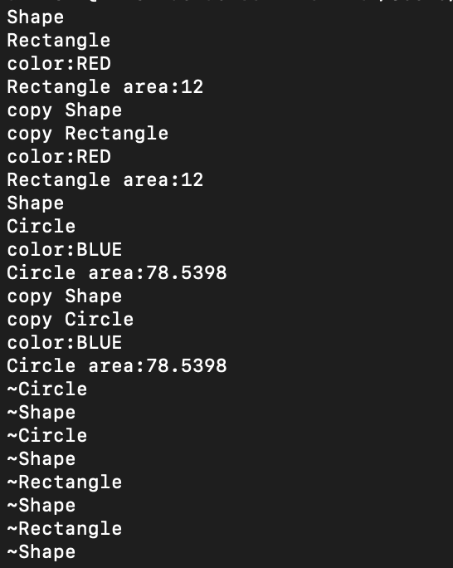
2．参考上课讲的实例，并利用实验五的任务2中所创建的People（人员）类作为基类，已包含私有数据成员：pid（编号，整型数据）、 sname（姓名，字符串）、sex（性别，字符类型：F表示女，M表示男）、birthday（出生日期，Date类内嵌子对象）、address（地址，字符串）。补充代码完成下列要求：
（1）从People（人员）类派生出Student（学生）类，添加数据成员：major(专业，字符串)，classno（班级编号，字符串），endate(入学日期，Date类内嵌子对象)；添加函数成员showStudent ()用于显示输出。
（2）从People（人员）类派生出Teacher（教师）类，添加数据成员：department（学院，字符串），profession（职称，字符串）；添加函数成员showTeacher ()用于显示输出。
（3）从Student（学生）类和Teacher（教师）类派生出ST（在职学生）类，添加数据成员：adv_name(导师姓名，字符串)，research（研究方向，字符串）；添加函数成员showST()用于显示输出。
（4）注意虚基类的使用，编写主函数并测试这些类。

程序代码：
#include <iostream>
#include <string>
using namespace std;

class Date
{
private:
int year;
int month;
int day;

public:
Date(int y = 2023, int m = 3, int d = 27) : year(y), month(m), day(d)
{
}

Date(const Date &c) : year(c.year), month(c.month), day(c.day)
{
}
void print() const
{
cout << year << "年" << month << "月" << day << "日";
}
};

class People
{
private:
int pid;
string sname;
char sex;
Date birthday;
string address;

public:
People(int id, string name, char se, Date bir, string addr) : pid(id), sname(name), sex(se), birthday(bir), address(addr) {}
People(const People &d) : pid(d.pid), sname(d.sname), sex(d.sex), birthday(d.birthday), address(d.address) {}
People() {}
void showPeople()
{
cout << "编号" << pid << "，姓名" << sname << "，性别";
if (sex == 'M')
cout << "男";
else if (sex == 'F')
cout << "女";
else
cout << "err";
cout << "，地址" << address << "，出生于";
birthday.print();
cout<<endl;
}

void change_address(string new_address)
{
address = new_address;
}
};

class Student : virtual public People
{
protected:
string major;
string classno;
Date endate;

public:
Student(int id, string name, char se, Date bir, string addr, string maj, string cno, Date en) : People(id, name, se, bir, addr), major(maj), classno(cno), endate(en) {}
void showStudent()
{
showPeople();
cout << "专业" << major << "，班级编号" << classno << "，入学日期";
endate.print();
cout<<endl;
}
};

class Teacher : virtual public People
{
protected:
string department;
string profession;

public:
Teacher(int id, string name, char se, Date bir, string addr, string dep, string pro) : People(id, name, se, bir, addr), department(dep), profession(pro) {}
void showTeacher()
{
showPeople();
cout << "学院" << department << "，职称" << profession << endl;
}
};

class ST : public Student, public Teacher
{
private:
string adv_name;
string research;

public:
ST(int id, string name, char se, Date bir, string addr,
string maj, string cno, Date en,
string dep, string pro,
string advn, string res) : People(id,name,se,bir,addr),
Student(id,name,se,bir,addr,maj,cno,en),
Teacher(id,name,se,bir,addr,dep,pro),
adv_name(advn), research(res) {}
void showST()
{
showPeople();
cout << "专业" << major << "，班级编号" << classno << "，入学日期";
endate.print();
cout << "，学院" << department << "，职称" << profession;
cout << "，导师姓名" << adv_name << "，研究方向" << research;
cout<<endl;
}
};

int main()
{
Date d1(1453, 5, 29);
People Q[2] = {People(1001, "张三", 'M', d1, "君士坦丁堡"), People(1002, "李四", 'F', d1, "科斯坦丁尼耶")};

for (int i = 0; i < 2; i++)
Q[i].showPeople();

int n;
cout << "请输入人数: ";
cin >> n;
People *P = new People[n];
for (int i = 0; i < n; i++)
{
int id;
string name;
char se;
int y, m, d;
string addr;
cout << "请输入第" << i + 1 << "个人的信息: ";
cin >> id >> name >> se >> y >> m >> d >> addr;
Date bir(y, m, d);
P[i] = People(id, name, se, bir, addr);
}
for (int i = 0; i < n; i++)
P[i].showPeople();
delete[] P;

Date d2(2023, 9 ,1);
Student s1(1003,"王八",'M',d1,"北京","计算机科学与技术","计算机1701",d2);
s1.showStudent();

Teacher t1(1004,"赵云",'F',d1,"上海","计算机学院","副教授");
t1.showTeacher();

ST st1(1005,"金金金",'M',d1,"广州","计算机科学与技术","计算机1702",d2,"计算机学院","助教","赵云","AICG");
st1.showST();
}

实验运行结果截图：
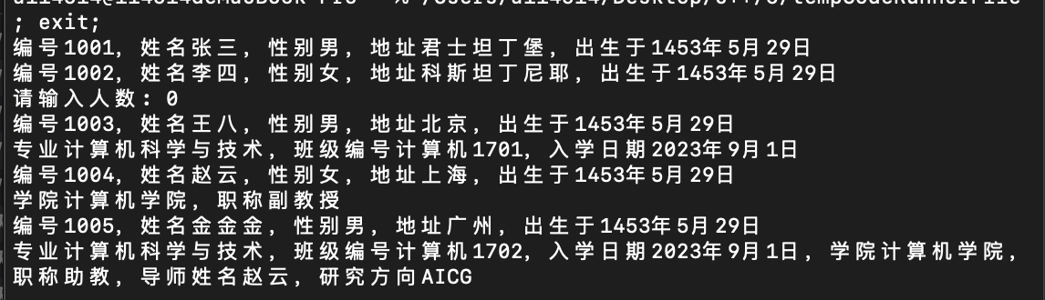
注意：请将本次上机实验报告上传至智慧树相应作业部分，要求以学号+姓名+实验序号的方式命名，如：20211001张三实验六。实验报告计入平时成绩，请大家在实验完成后尽快发送！

