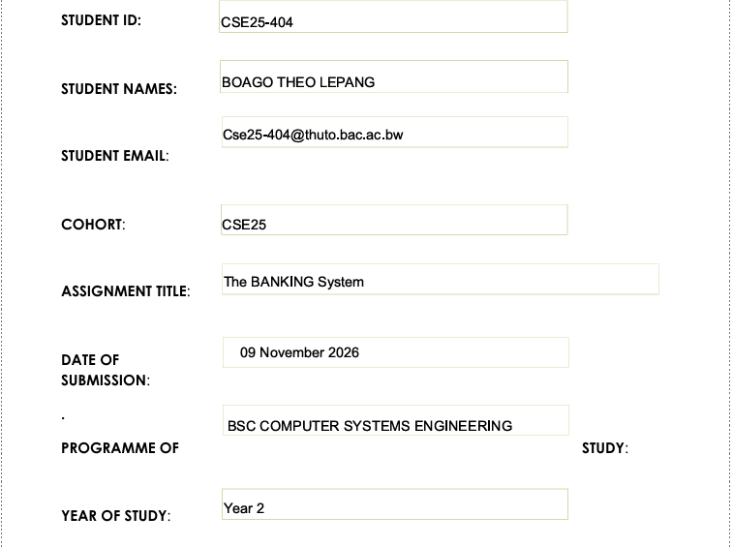

1.Requirements Elicitation

Functional Requirements
The system shall allow
- Customers to open one or multiple accounts (Savings, Investment, Cheque), and an account must always belong to a customer.
- Investment accounts require an initial deposit of BWP 500.00 to be opened.
- Cheque accounts can only be opened by working customers, and the system captures work/employer details.
- Customers deposit into any of their accounts.
- Withdrawals are allowed from Investment and Cheque accounts, but not from Savings accounts.
- The system allows salary payments to be credited to a customer’s Cheque account.
- The system applies monthly interest correctly:
- Savings:0.05% per month
- Investment:5% per month
- The system keeps updates account balances reflecting deposits, withdrawals, and monthly interest, and allows viewing account/account-balance details for customers.
Non-Functional Requirements
The system must
- Authenticate users to protect data in transit e.g.; log access and operations.
- Keep correct balances after deposits/withdrawals/interest.
- System remains available during agreed working hours.
- Respond fast for deposits, withdrawals, balance viewing, and interest posting.
- Handle more customers/accounts and process interest efficiently.
- The system must be easy to update, fix and improve when necessary.
- The system must be able to regularly back up customers’ data and be able to recover it after system failure
-The system must keep customer information confidential.

INTERVIEW RECORD

Project Name: Banking System

Interview Type: Requirements Elicitation Interview

Interviewee: Banking System Client (Mock Client)

Interviewer: Student Developer

Purpose of Interview: To gather information about the functional and non-functional requirements of the proposed Banking System.

Interview Questions and Responses

Question 1: What is the main purpose of the Banking System?

Response: The main purpose is to allow customers to open and manage bank accounts, deposit money, and access account information.

Question 2: Who will use the system?

Response: The primary users will be bank customers. Bank personnel may also be given access to administrative functions if these are included in the system's scope.

Question 3: What types of accounts should the system support?

Response: The system should support Savings Accounts, Investment Accounts and Cheque Accounts.

Question 4: Can a customer open more than one account?

Response: Yes. A customer should be able to hold multiple accounts, including different types of accounts.

Question 5: What are the rules for opening an Investment Account?

Response: An Investment Account must be opened with an initial deposit of at least BWP 500.00.

Question 6: What are the rules for opening a Cheque Account?

Response: A Cheque Account may only be opened by an employed person. The customer must provide the employer's name and company address.

Question 7: Can customers deposit and withdraw money from all account types?

Response: Customers should be able to deposit money into their accounts. Withdrawals are permitted from Investment and Cheque Accounts but not from Savings Accounts under the specified system rules.

Question 8: How should the system calculate interest?

Response: The system should calculate monthly interest at 0.05% for Savings Accounts and 5% for Investment Accounts.

Question 9: What customer information should the system store?

Response: The system should store customer details such as first name, surname and address, together with account numbers, account types and balances.

Question 10: What qualities should the Banking System have?

Response: The system should be secure, reliable, easy to use and capable of storing records accurately.

Interview Summary

The interview identified the core requirements for the proposed Banking System. These include customer registration, account opening, account management, deposits, withdrawals, interest calculation, and the storage of customer and account information. The system should also protect financial information and maintain accurate records.

2. Structural UML Modelling
System Use Case Diagram
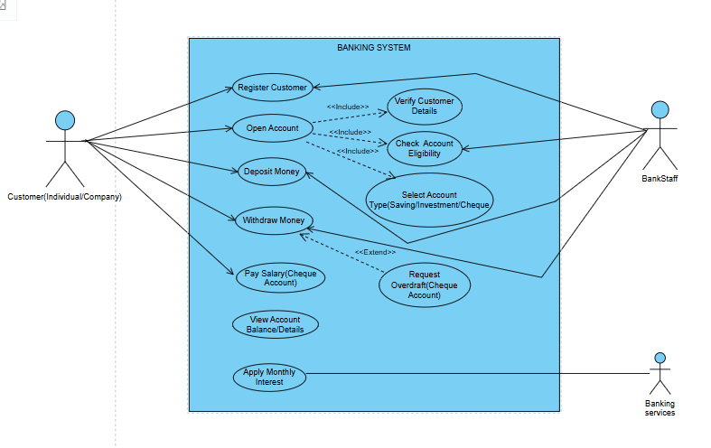

Class diagram
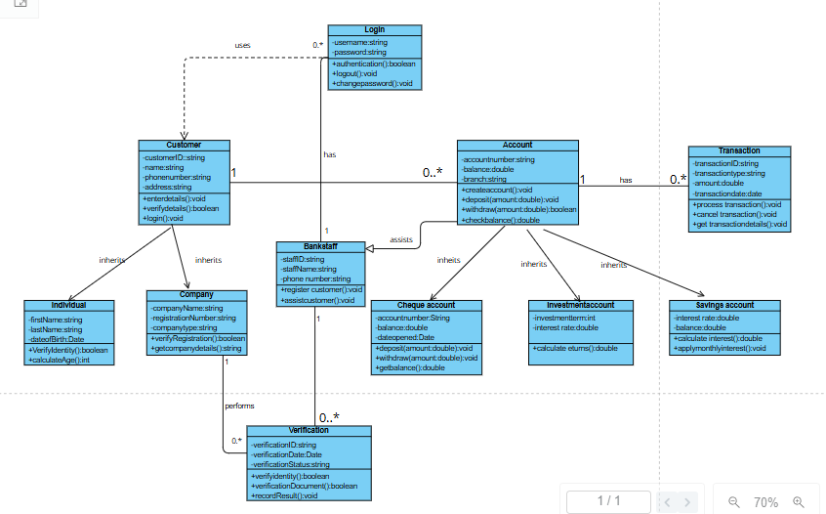

3. Behavioral UML Modelling)
Sequence Diagrams
Login diagram
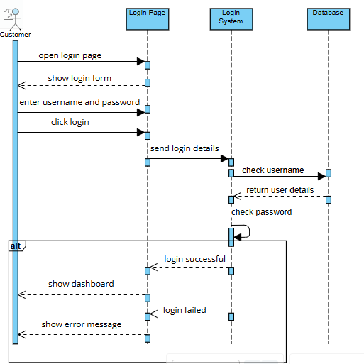

Deposit

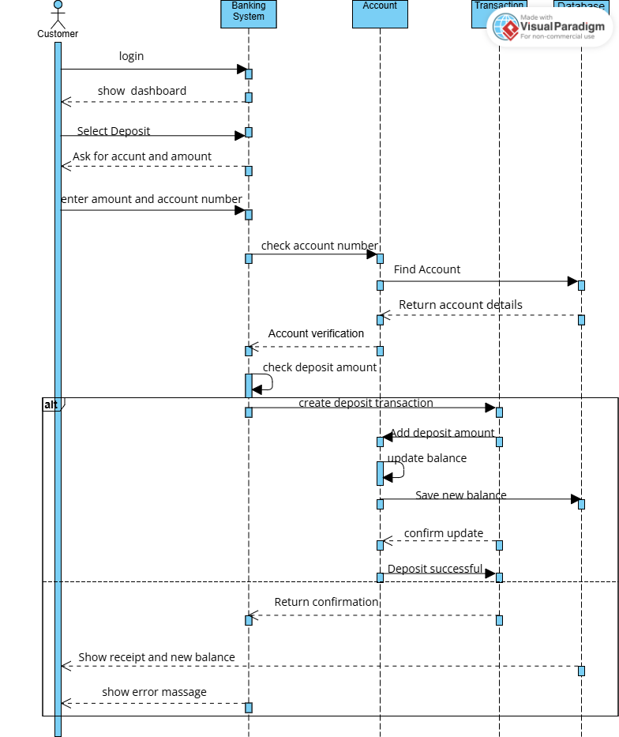
State Diagram


