Travel Agency Manager

Analysis and Design Document

Student:Boanta Ciprian

**Group:30238**

Revision History

|  |  |  |  |
| --- | --- | --- | --- |
| **Date** | **Version** | **Description** | **Author** |
| <dd/mmm/yy> | <x.x> | <details> | <name> |
|  |  |  |  |
|  |  |  |  |
|  |  |  |  |

Table of Contents

I. Project Specification 4

II. Elaboration – Iteration 1.1 4

1. Domain Model 4

2. Architectural Design 4

2.1 Conceptual Architecture 4

2.2 Package Design 4

2.3 Component and Deployment Diagrams 4

III. Elaboration – Iteration 1.2 4

1. Design Model 4

1.1 Dynamic Behavior 4

1.2 Class Design 4

2. Data Model 4

3. Unit Testing 4

IV. Elaboration – Iteration 2 4

1. Architectural Design Refinement 4

2. Design Model Refinement 4

V. Construction and Transition 5

1. System Testing 5

2. Future improvements 5

VI. Bibliography 5

# Project Specification

The project is a web application of a travel agency for a wide range of people. The purpose of this application is to make people move and explore new places.

The application is easy to use. A client must browse and select the desired trip and reserve it. The employee can propose more kind of trips and can see at every time which client reserved which trip.

# Elaboration – Iteration 1.1

# Domain Model

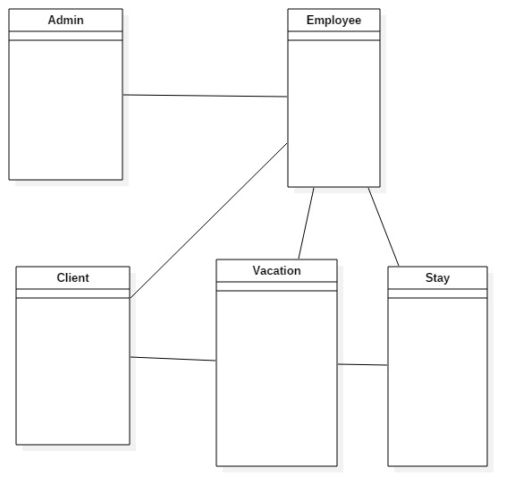

# Architectural Design

## Conceptual Architecture

In this application I will use a architectural layer pattern. This will make the application easy to maintain in the future modifications.

## Package Design

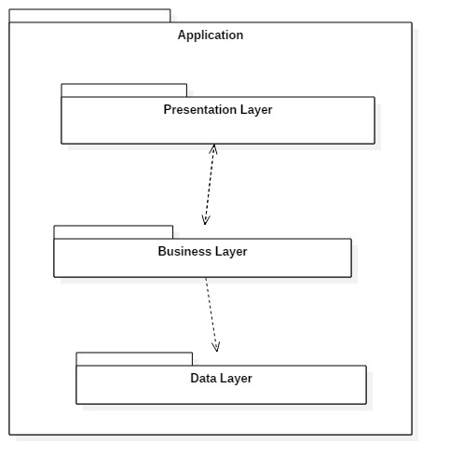

## Component and Deployment Diagrams

# 

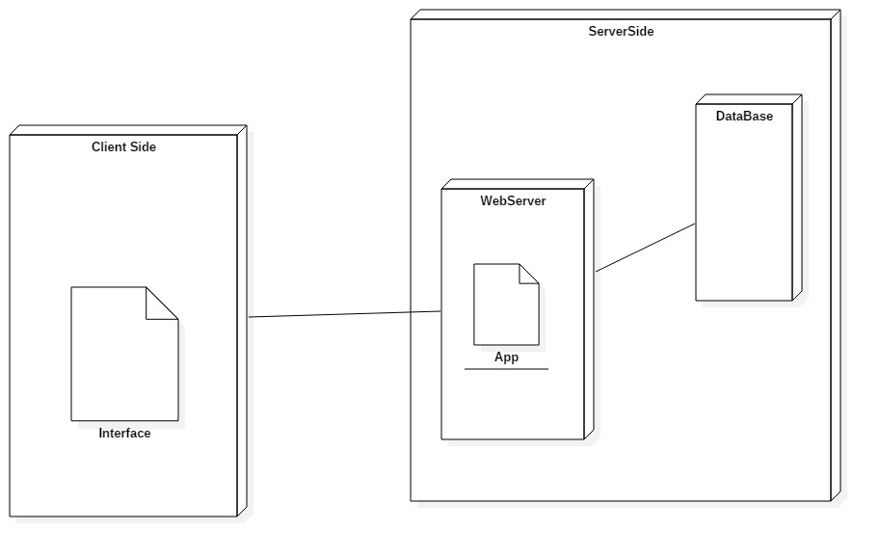

# Elaboration – Iteration 1.2

# Design Model

## Dynamic Behavior

**Sequence Diagram**

Sequence diagram for the client which wants to reserve a trip.

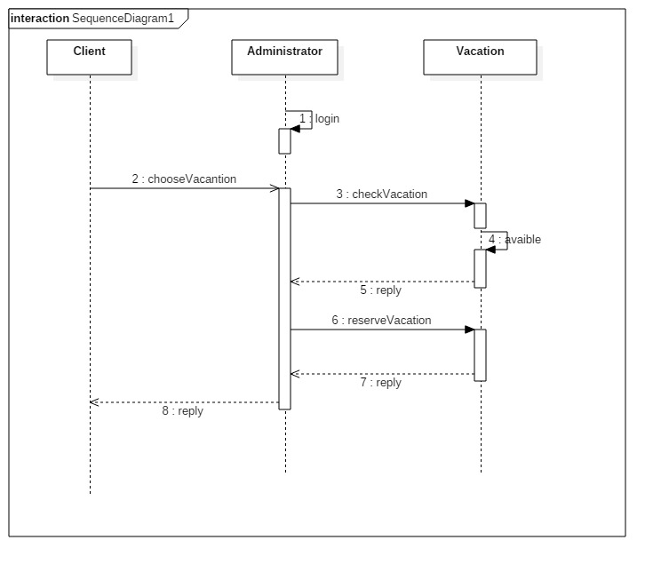

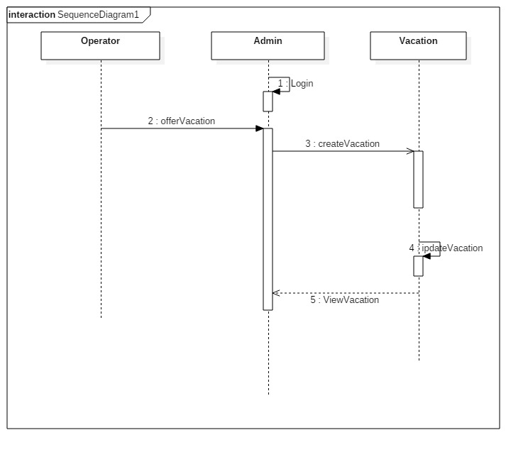

**Communicatio Diagram**

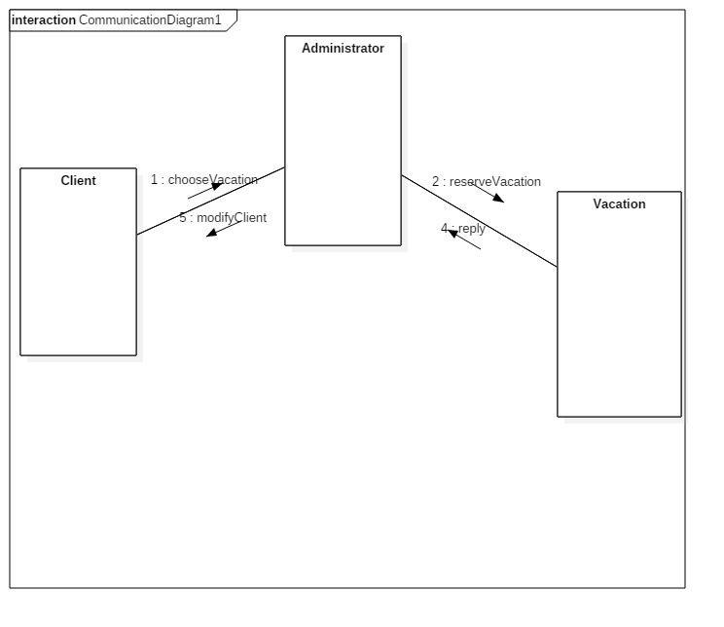

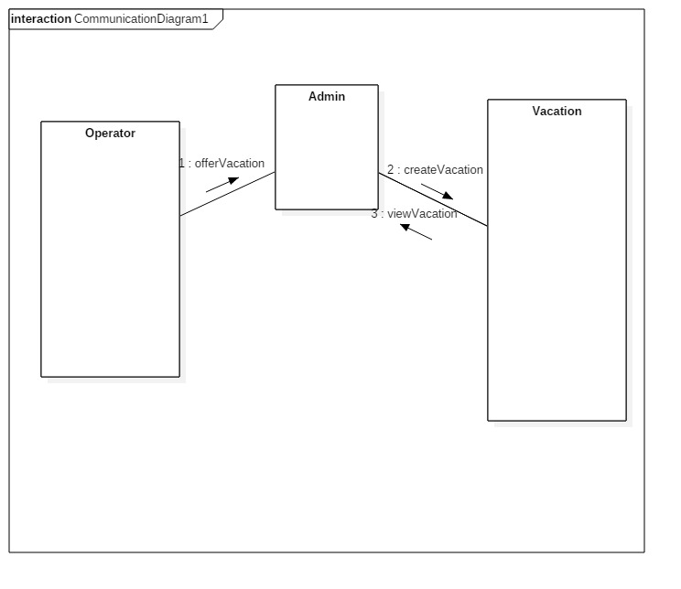

## Class Design

UML

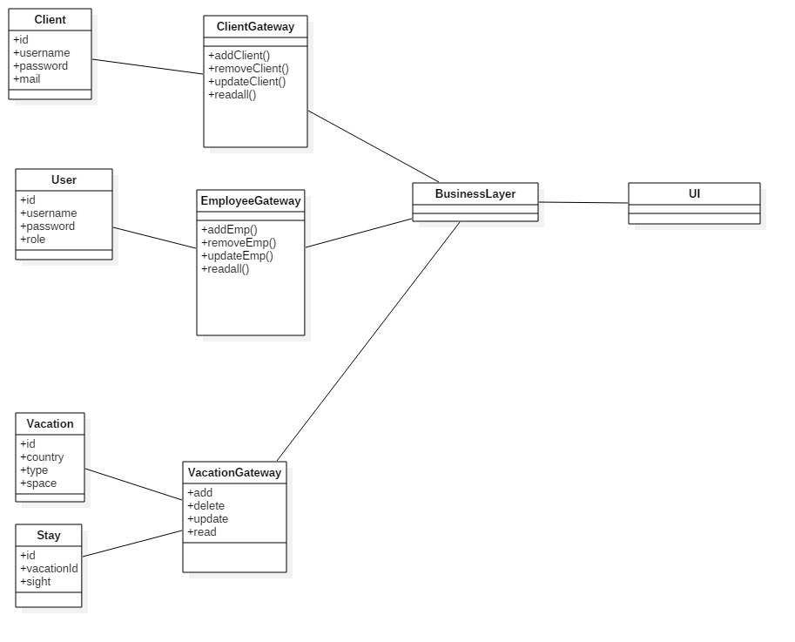

# Data Model

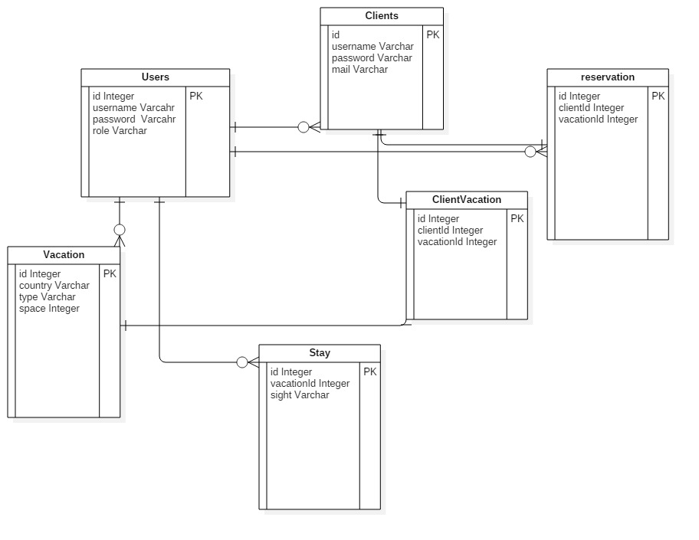

# Unit Testing

The application will be tested manually to see if it works properly. We must pay attention because the are a lot of validation methods that ensure a good input.

# Elaboration – Iteration 2

# Architectural Design Refinement

For this app I worked with the BusinessLayer structural pattern which has a Presentation, Business and Data layer.

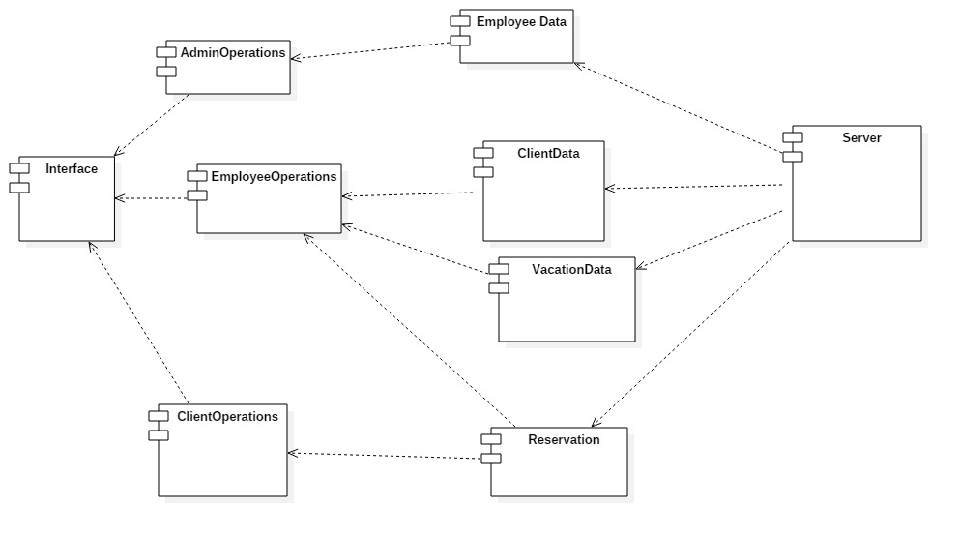

# Construction and Transition

# System Testing

# Future improvements

The application can be improved by adding new types of trips and to add some interactive events for the clients to choose. Also the client could subscribe automatically to a vacation, without the intervention of the employee. He could just monitories the situation.

# Bibliography