Analysis of Kickstarter Campaigns, 2009-2017

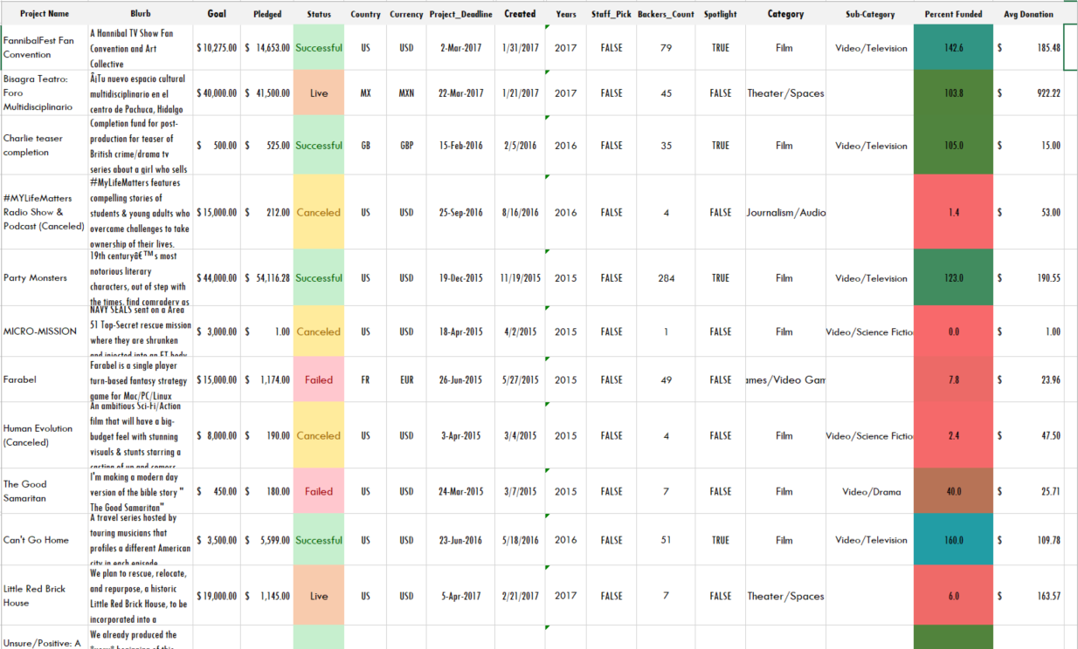

With roughly 4,000 records, the dataset used for this analysis represents only about 1% of all Kickstarter campaigns initiated to date. Most (99%) of the Kickstarter campaigns ever launched have been launched in the last 2.5 years, and that data is not included in this analysis.

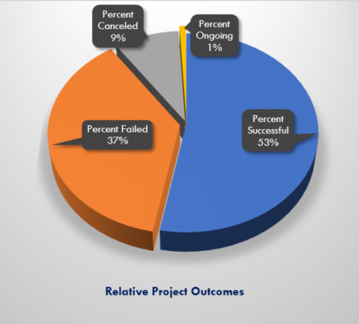

Relatively few Kickstarter projects featured in this dataset (about 9%) were canceled; about half were successful, and slightly more than one-third have failed. At the time of this analysis approximately 1% of campaigns initiated were ongoing and had no project outcome reported.

Overall the *Music* and *Theater* categories have had the highest number of projects proposed. *Plays* is the sub-category with the greatest number of Kickstarter campaigns; it is also the sub-category with the highest raw number of successful projects. *Plays* have accounted for more than 25% of all Kickstarter campaigns between May 2009 and March 2017.

Growth & Outcomes over Time

Successful campaigns have outnumbered failed campaigns over the 8-year period of analysis; however, by 2017 the gap is nearly closed.

Successful projects need backers, especially *Technology* projects.

Campaigns with relatively low initial funding goals—$5,000 or less—were most likely to be successful.



How many projects received funding above their goal?