ALDER OUTDOOR
Monthly management report
September 2026
Executive summary
1 EBIT was €2.7m, €0.3m below budget and €0.2m above last year.
2 Marketing spent €0.3m more than budget on the autumn campaign. This is the whole budget miss.
3 Online revenue grew 28% on last year to €7.4m and carries the group's growth.
4 The Q4 forecast takes 2026 revenue to €234.6m. The range for December alone is €23.8m to €29.4m.

RESULTS
September revenue was €21.2m, 1% above budget. Gross margin met budget. Marketing ran 14% over budget, so EBIT missed by 10%. Year to date, EBIT is 12% above last year.
EXHIBIT 1
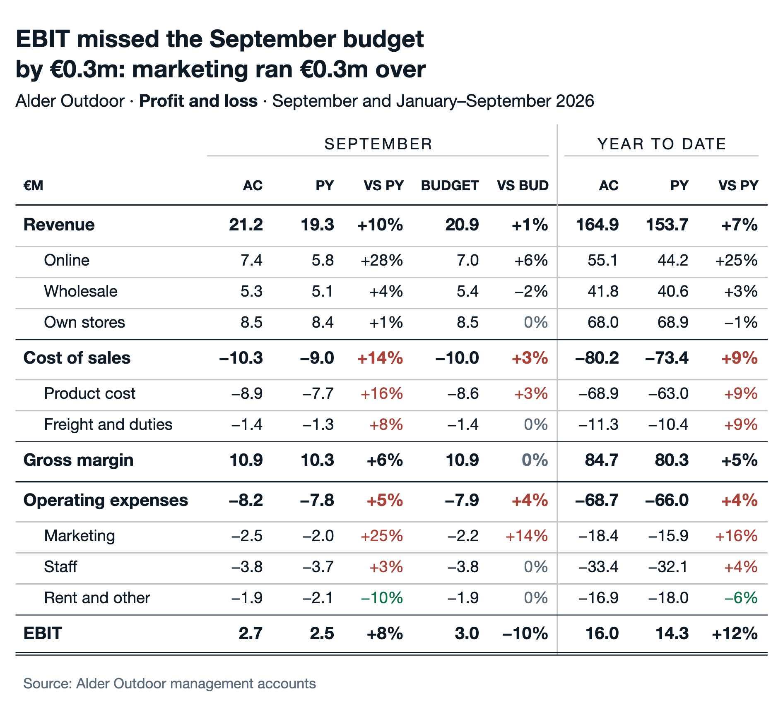

REVENUE OUTLOOK
The forecast for October to December holds the run rate of the last three months and adds the usual December peak. The bars show the range of the forecast: the wider the bar, the less certain the month.
EXHIBIT 2
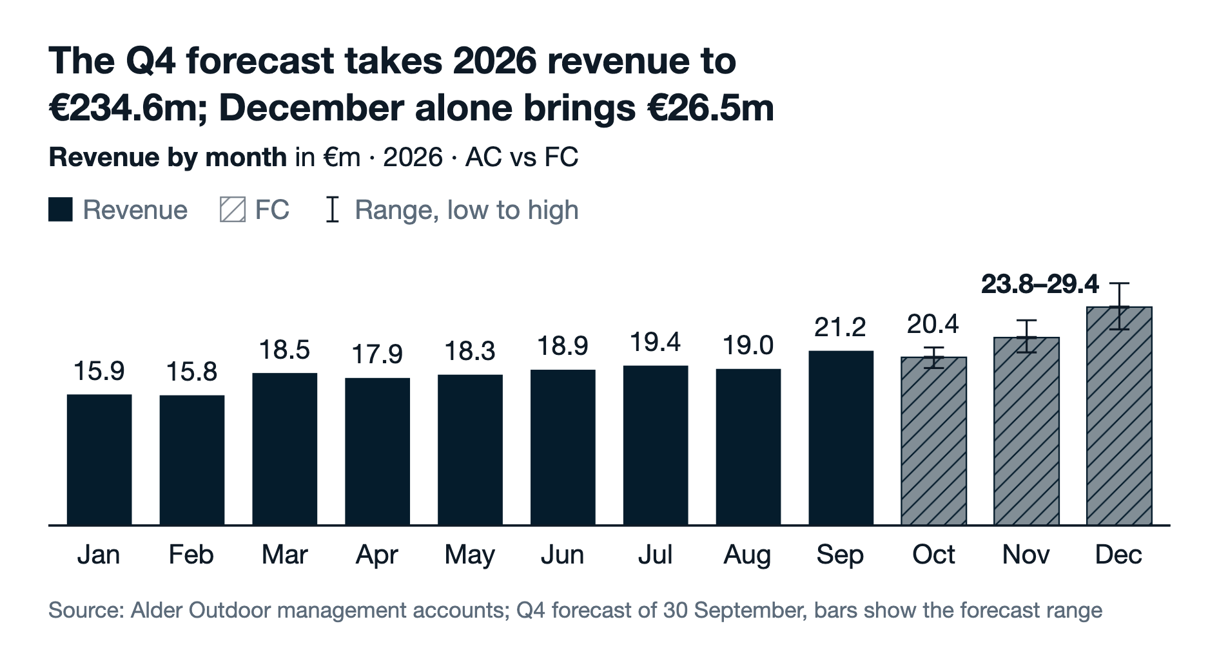
REVENUE DRIVERS
The price-volume-mix bridge splits the Q3 growth by its causes. Boardplot computes the effects from units and revenue per category.
EXHIBIT 3
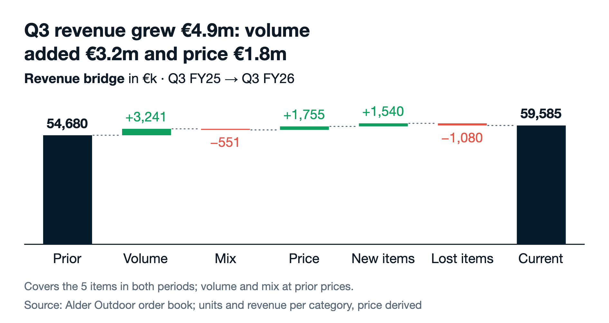

PROFIT
Revenue above budget added €150k, and a lower margin rate took the same amount back. The marketing overspend of €300k explains the whole gap to budget.
EXHIBIT 4
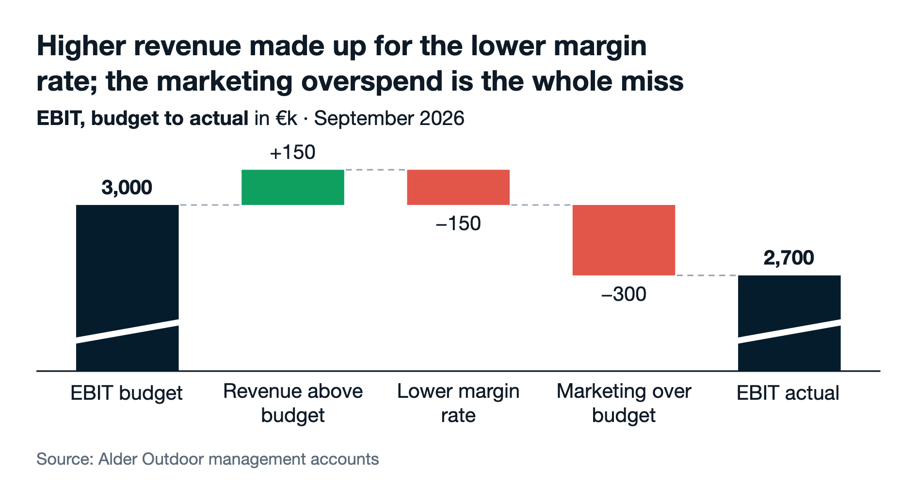
Next steps
– Cap the autumn campaign at its budget for October and November. Owner: CMO.
– Re-run the December forecast with the first two weeks of pre-orders. Owner: FP&A.
– Report the online growth by country in the October report. Owner: Head of e-commerce.
All data in this report is invented. Charts: Boardplot, specs in specs/.

