[YOUR CONSULTANCY]

[Project name] Statement of Work
  - Statement of work (SAMPLE CONTENT: replace everything in [brackets] and the sample scope)

PREPARED FOR | [Client contact], [Client role], [Client Company]
PREPARED BY | [Your Name], [Your role]
DATE | [Date]
VALID UNTIL | [Validity date, e.g. 30 days from issue]
REFERENCE | [SOW-0001] / v1.0

Commercial in confidence. This document contains proposal terms intended solely for the named recipient.

1. Executive summary
This statement of work (SOW) sets out what [Your Company] will deliver for [Client Company], when, for what fee, and how [Client] will accept the work. It is written so that both sides can check, line by line, whether a deliverable is done.
Sample scope: redesign and rebuild the [Client] customer portal, migrate existing accounts and train the support team. Replace this paragraph with one that describes your own project in two or three sentences.
At a glance
• Scope: [one-sentence description of what is in scope].
• Out of scope: [list what is not included, e.g. hosting, content writing, third-party licences].
• Fixed fee per option, invoiced on milestones. Work starts on [start date].

2. Understanding of your needs
The points below record the objectives and constraints the parties have agreed. Edit each row to match your project.
Need | What we heard
Objective | [What the project must achieve, in the client's words]
Users | [Who will use the result and how many]
Constraints | [Budget, deadline, systems or compliance limits]
Success measure | [How both sides will know the project worked]

3. Approach and phases
Work runs in four phases. Each phase ends with a milestone that the client accepts, or rejects with written reasons, within five working days.

3.1 Timeline
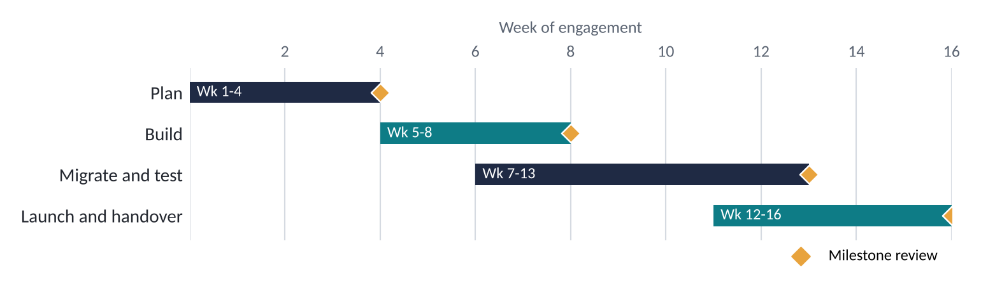
Figure 1. Indicative 16-week plan from kick-off. Diamonds mark milestone reviews.

3.2 Phase detail

Phase 1: Plan (weeks 1-4)
Agree requirements, plan and acceptance criteria.
- Kick-off workshop
- Requirements document
- Project plan and risk log
Milestone: Requirements signed off

Phase 2: Build (weeks 5-8)
Build the agreed scope in two-week sprints with a demo at the end of each.
- Sprint demos
- Weekly status note
- Test evidence
Milestone: Build complete

Phase 3: Migrate and test (weeks 7-13)
Move data, run user acceptance testing and fix defects.
- Data migration rehearsal
- User acceptance testing
- Defect fixes
Milestone: Acceptance testing passed

Phase 4: Launch and handover (weeks 12-16)
Go live, train the client team and hand over documentation.
- Go-live support
- Training sessions
- Handover pack
Milestone: Handover accepted

4. Deliverables
Each deliverable is accepted by the client's nominated owner at the milestone review for its phase. The Option column shows the lowest option that includes it.
Ref | Deliverable | Description | Phase | Option
D1 | Requirements document | [Document listing agreed features; accepted when client confirms in writing] | Plan | Good
D2 | Project plan | Timeline, owners and risks | Plan | Good
D3 | Working [system or product] | Delivered to a test environment; accepted when all agreed test cases pass | Build | Better
D4 | Data migration | [N] records migrated with a reconciliation report | Migrate and test | Better
D5 | User acceptance test report | Pass/fail for each test case, with defects logged | Migrate and test | Better
D6 | Go-live and training | [N] training sessions delivered; system live | Launch and handover | Best
D7 | Handover pack and 30-day support | Documentation and fixes for defects found in the first 30 days | Launch and handover | Best

5. Assumptions and dependencies
The scope and prices in this document rely on the following. If any proves incorrect we will raise a change request before proceeding.
- [Client] provides access to the systems and people named in this SOW within five working days of kick-off.
- One named person at [Client] approves deliverables and answers questions within three working days.
- Any work not listed in the deliverables is out of scope and handled through change control.
- Third-party licences and hosting costs are excluded.
- Delays caused by late client feedback move the dates by the same number of days.
- [Add your own project-specific assumption.]

6. Pricing and options
We offer three options. All are fixed-fee for the stated scope. Better is our recommendation: it proves the benefit on live shipments before any wider commitment.
Scope | Core | Standard (recommended) | Full
Summary | Plan and build | Plus migration and testing | Plus launch and 30-day support
Requirements document and plan (D1, D2) | ✓ | ✓ | ✓
Working system in test environment (D3) | ✓ | ✓ | ✓
Data migration (D4) | – | ✓ | ✓
User acceptance testing (D5) | – | ✓ | ✓
Go-live and training (D6) | – | – | ✓
Handover pack and 30-day support (D7) | – | – | ✓
Duration | 8 weeks | 12 weeks | 16 weeks
Fixed fee | GBP 24,000 | GBP 39,000 | GBP 48,000

6.1 Payment schedule
[Replace: for example 30% on signature, 40% on build complete, 30% on handover accepted.] Sample fees are placeholders; fees exclude VAT or sales tax and expenses.
[Prices are in GBP or USD; confirm currency and validity date.]

7. Terms and conditions
The clauses below are placeholders to be completed by each party's legal counsel before signature. Square brackets mark text that must be replaced.
Clause | Text
Acceptance procedure | [How deliverables are accepted or rejected, and the deemed-acceptance period - to be inserted]
Change control | [How scope changes are requested, priced and approved - to be inserted]
Payment terms | [Payment terms, e.g. net 30 days from invoice - to be inserted]
Intellectual property | [Ownership of deliverables and pre-existing materials - to be inserted]
Confidentiality | [Confidentiality clause or reference to existing NDA - to be inserted]
Governing law | [Jurisdiction and governing law - to be inserted]

8. Acceptance
By signing below, [Client Company] accepts this proposal and statement of work, including the option selected, and authorises [Your Consultancy] to proceed.
Option selected: [ ] Good [ ] Better [ ] Best

[Your Consultancy] | [Client Company]
SIGNATURE | SIGNATURE
NAME  [Your Name] | NAME
TITLE  Engagement Partner | TITLE
DATE | DATE

