NORTHFIELD ADVISORY PARTNERS

Quote-to-Cash Acceleration Programme
  - Proposal and Statement of Work

PREPARED FOR | Priya Raman, Chief Operating Officer, Larkspur Logistics Ltd
PREPARED BY | Jordan Ellis, Engagement Partner
DATE | 2 December 2026
VALID UNTIL | 31 January 2027
REFERENCE | NAP-2026-114 / v1.0

Commercial in confidence. This document contains proposal terms intended solely for the named recipient.

1. Executive summary
Larkspur Logistics takes an average of 11 days to turn an accepted quote into cash. Operations staff re-key shipment charges between the transport management system (TMS) and the accounting package, which slows invoicing, creates disputes and leaves finance without a trustworthy view of margin.
Northfield Advisory Partners proposes a 16-week programme to diagnose the current process, design a target state, build the TMS-to-accounting integration, pilot it at one depot and, in the recommended option, roll it out to two further depots. The goal is to bring quote-to-cash below 5 days before the 2027 peak season.
At a glance
• Outcome: quote-to-cash under 5 days, measured on pilot-depot data (client target).
• One source of truth for shipment charges, with an audit trail for every change.
• Three options priced from USD 38,000 to USD 126,000; we recommend Better.

2. Understanding of your needs
From our discovery call on 18 November we understand the following. These points are the client's account of the situation and will be tested in the diagnosis phase.
Need | What we heard
Speed | Quotes accepted today are invoiced on average 6 days later; cash arrives after a further 5.
Accuracy | Charges are re-keyed by hand, so rate and surcharge errors surface as customer disputes.
Control | Finance cannot reconcile shipment margin without exporting and merging spreadsheets.
Timing | Changes must be live at the pilot depot before the 2027 peak season begins.

3. Approach and phases
We work in four phases. Each phase ends with a milestone review at which the client accepts the deliverables before the next phase starts.

3.1 Timeline
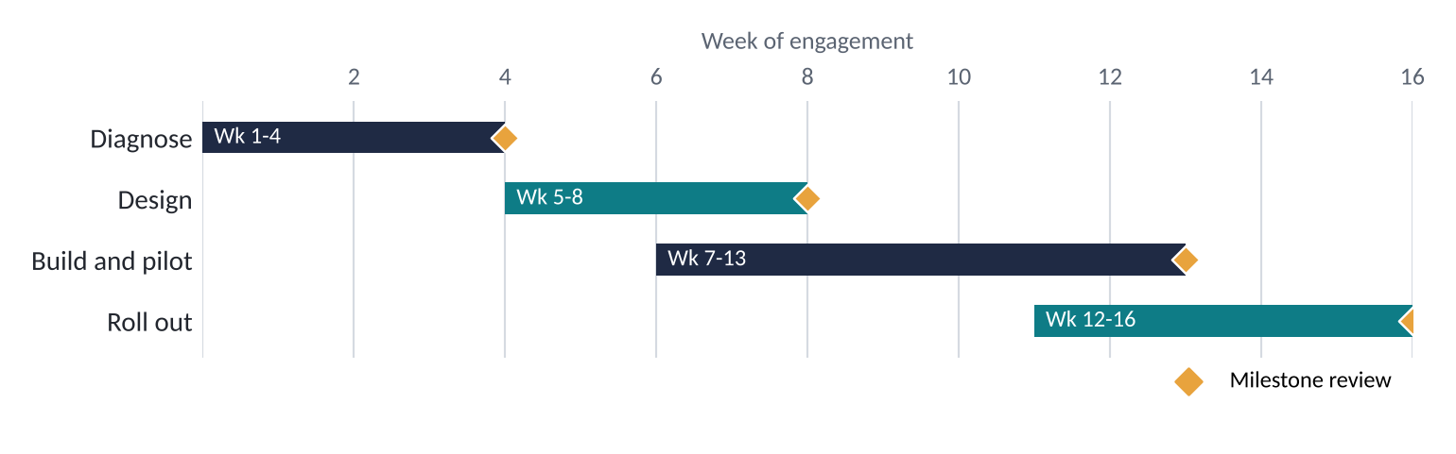
Figure 1. Indicative 16-week plan from kick-off. Diamonds mark milestone reviews.

3.2 Phase detail

Phase 1: Diagnose (weeks 1-4)
Map the current quote-to-cash flow, measure cycle time per step and quantify the cost of rework.
- Stakeholder interviews (operations, finance, sales)
- Process mapping and data sampling
- Root-cause analysis and baseline metrics
Milestone: Diagnosis readout

Phase 2: Design (weeks 5-8)
Define the target process, data model and controls, and agree the integration specification.
- Target-state process and role design
- Integration and data specification
- Control and audit requirements
Milestone: Design sign-off

Phase 3: Build and pilot (weeks 7-13)
Build the integration, test with real shipments and run a live pilot at one depot.
- Integration build and test
- Pilot depot go-live
- Daily defect triage and tuning
Milestone: Pilot go-live

Phase 4: Roll out (weeks 12-16)
Extend to two further depots, train teams and hand over to client owners. Best option adds 90 days of hypercare.
- Depot rollout waves
- Training and playbooks
- Handover and benefits review
Milestone: Handover

4. Deliverables
Each deliverable is accepted by the client's nominated owner at the milestone review for its phase. The Option column shows the lowest option that includes it.
Ref | Deliverable | Description | Phase | Option
D1 | Current-state process map and baseline metrics | Annotated end-to-end map; cycle time and rework baseline | Diagnose | Good
D2 | Target-state design pack | Process, roles, controls, data model | Design | Good
D3 | Integration specification | Field mapping, error handling, reconciliation rules | Design | Good
D4 | Working TMS-to-accounting integration | Tested build deployed to pilot depot | Build and pilot | Better
D5 | Pilot results report | Cycle time vs baseline, defects, lessons | Build and pilot | Better
D6 | Depot rollout and training | Two further depots live; trained staff; playbooks | Roll out | Best
D7 | 90-day hypercare | Named support, weekly metrics review, fixes | Roll out | Best

5. Assumptions and dependencies
The scope and prices in this document rely on the following. If any proves incorrect we will raise a change request before proceeding.
- Larkspur provides access to TMS and accounting administrators within five working days of kick-off.
- Both systems expose supported APIs or file imports; if not, a change request will be raised.
- The client nominates one accountable business owner with authority to approve deliverables within five working days.
- Pilot depot staff are available for up to four hours per week during design and pilot.
- Third-party licence or vendor fees for either system are excluded.
- Work is performed remotely with up to three on-site visits per depot; travel is billed at cost.

6. Pricing and options
We offer three options. All are fixed-fee for the stated scope. Better is our recommendation: it proves the benefit on live shipments before any wider commitment.
Scope | Good | Better (recommended) | Best
Summary | Diagnose and design | Plus build and pilot | Plus rollout and hypercare
Process diagnosis and baseline (D1) | ✓ | ✓ | ✓
Target-state design pack (D2) | ✓ | ✓ | ✓
Integration specification (D3) | ✓ | ✓ | ✓
Integration build and test (D4) | – | ✓ | ✓
Live pilot at one depot and results report (D5) | – | ✓ | ✓
Rollout to two further depots and training (D6) | – | – | ✓
90-day hypercare (D7) | – | – | ✓
Duration | 8 weeks | 13 weeks | 16 weeks + 90 days
Fixed fee | USD 38,000 | USD 84,000 | USD 126,000

6.1 Payment schedule
30% on signature, 40% on design sign-off, 30% on final milestone acceptance. Fees are fixed for the scope above and exclude taxes and expenses.
Prices are in USD and valid until 31 January 2027.

7. Terms and conditions
The clauses below are placeholders to be completed by each party's legal counsel before signature. Square brackets mark text that must be replaced.
Clause | Text
Payment terms | [Payment terms, e.g. net 30 days from invoice - to be confirmed by Northfield legal]
Change control | [Change request process and rate card - to be inserted]
Intellectual property | [Ownership of deliverables and pre-existing materials - to be inserted]
Confidentiality | [Confidentiality clause or reference to existing NDA - to be inserted]
Limitation of liability | [Liability cap and exclusions - to be inserted]
Governing law | [Jurisdiction and governing law - to be inserted]

8. Acceptance
By signing below, Larkspur Logistics Ltd accepts this proposal and statement of work, including the option selected, and authorises Northfield Advisory Partners to proceed.
Option selected: [ ] Good [ ] Better [ ] Best

Northfield Advisory Partners | Larkspur Logistics Ltd
SIGNATURE | SIGNATURE
NAME  Jordan Ellis | NAME
TITLE  Engagement Partner | TITLE
DATE | DATE

