Project Proposal – Smart Door Lock

**A Smart Home & Smart City Project**

# Team

Boas Meier Lukas Mettler Niklas Tanner Tobias Heller  
B.Sc. Informatik B.Sc. Information & Cyber Security B.Sc. Informatik B.Sc. Informatik

# Motivation

*You’ve forgotten your keys and now you’re standing in front of the locked front door. All your roommates are out of the house, and you have no other choice than waiting for the arrival of one of your roommates. What a pity! Especially when you’re out for dinner with friends tonight.*

*Thanks to the Smart Door Look you’ll never again need to wait at the doorstep of your own flat. You can lock and unlock your door simply with your mobile. Out of charge? No Problem! When you ring the doorbell, your roommates will get a push notification on their mobile and they can unlock the door for you, wherever they are.*

# Approach

Sensors are controlled over an Arduino Uno WiFi R2. The Arduino waits for commands from the Raspberry Pi to lock/unlock the door and returns a response if command could be processed successfully. Another possibility to open the door lock is via an NFC Reader. The Arduino also streams the actual door state (open/closed, locked/unlocked) continuously to the Raspberry Pi. The communication between the Raspberry Pi and the Arduino is realised over WLAN with the MQTT protocol.

The Raspberry Pi registers itself over a Backend Cloud REST Api (HTTPS) to the cloud. After a successful registration the Raspberry Pi pushes logs and the door state in batches over an endpoint to the cloud. The cloud provides a user interface to view the log and control the door.

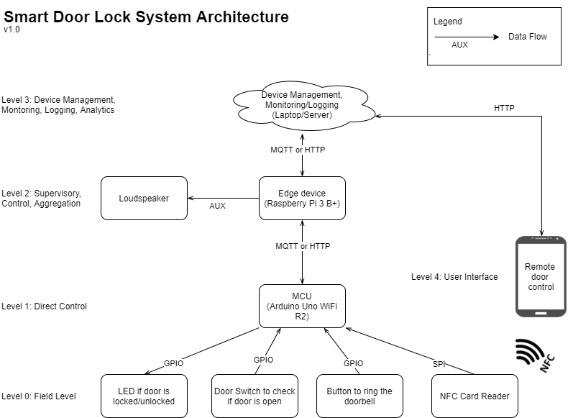

Figure 1: Smart Door Lock System Architecture

|  |  |  |
| --- | --- | --- |
| **Controllers** | **Sensors** | **Actors** |
| Arduino Uno WiFi R2 | Magnetic Door Switch | LED |
| Raspberry Pi B3+ (Gateway) | Button | Speaker |
|  | NFC-Reader |  |

Table 1: Hardware for Smart Door Lock

# Technology

|  |  |
| --- | --- |
| **Component** | **Technology** |
| Embedded Firmware | C / C++ |
| Embedded to Edge | MQTT or HTTPs |
| Edge to Cloud | MQTT and/or HTTPs |
| Backend server | Laptop or Cloud |
| Backend language | Python |
| Logging framework | ELK |
| Web Frontend | JS-Framework |
| Mobile Integration | Android App or Telegram Push |

Table 2: Components and its proposed technology

# Evaluation

1. Lock can be switched
   1. Over cloud (Mobile/Web)
   2. Via RFID/NFC Card
2. Door state can be viewed via the cloud.
3. Log messages can be viewed via the cloud.
4. Mobile push notification when doorbell (button on Arduino) is pressed.

*Disclaimer: The information in this document is subject to change and should not be construed as a final decision by the project team.*