Activity 1 : Object, Class

**Instruction**

* Create a project “Activity1_2017_{ID}” to implement the program. The implementation details are on the next page.
* Create Package “logic” and download template class “FoodOrder.java” into this package.
* Implement the program as per instruction in this document
* Run the program to check the result. Edit your code as needed until there is no failure. Then, **call TA to check the result**.
* After finish the program, export your project into a jar file with source codes called “Activity1_2017_{ID}.jar”
* Submit the export jar file to mycourseville.com

Activity 1 : Object, Class

# Problem Statement: Uncle Boonmee’s food stall

Uncle Boonmee is running a food stall selling Hainanese chicken rice. He wants a chatbot that would help him taking food order and calculating the price for each order. Complete the chatbot program by filling in the code.

Figure 1 shows an example chat log from our chatbot:

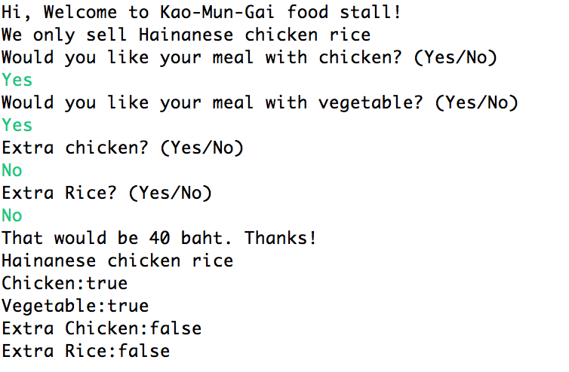

Figure 1: An expected output from the chatbot.

# Implementation Detail

## Class: FoodOrder

You must create a class called “FoodOrder” with properties as follows:

### Field

|  |  |
| --- | --- |
| * private String description | - description of the food |
| * private int price | - Price in baht |
| * private boolean hasChicken | - Does the customer want to eat chicken? |
| * private boolean hasVegetable | - Does the customer want to eat vegetable? |
| * private boolean hasExtraChicken | - Does the customer want extra chicken? |
| * private boolean hasExtraRice | - Does the customer want extra rice? |

### Constructer

|  |  |
| --- | --- |
| * public FoodOrder() | * Every food order must be initialized using this constructor * description = “Hainanese Chicken rice” * hasChicken = true * hasVegetable=true * hasExtraChicken=false * hasExtraRice=false |

### Method

|  |  |
| --- | --- |
| * getdescription | - get the description of the food |
| * getPrice | - get the price |
| * calculatePrice | Calculate the price of each meal (private class)   * Initial Price: 40 baht * No Chicken: 10 baht cheaper * Extra Chicken: 10 more baht * Extra Rice: 5 more baht |
| * setHasChicken | -Set hasChicken to true or false according to customer’s need  -Recalculate the price |
| * setHasVegetable | -Set hasVegetable to true or false according to customer’s need |
| * setHasExtraChicken | -Set hasExtraChicken to true or false according to customer’s need  -Recalculate the price |
| * setHasExtraRice | -Set hasExtraRice to true or false according to customer’s need  -Recalculate the price |
| * toString | Override this method to print out FoodOrder object as shown in Figure 1 |
| * equals | Override this method to check if two food orders have the same price. |

## Check List

1. Create the FoodOrder class as mentioned above and make sure that the program can be compiled.
2. Check the cost of the food when the user inputs are as follows:
   1. Yes, Yes, No, No [This should be 40 baht]
   2. No, No, No, No [This should be 30 baht]
   3. Yes, Yes, Yes, Yes [This should be 55 baht]
3. In the main method, Uncomment the lines under “Uncomment the following lines to test equals method” to check if equals method is working correctly. [The result should be “true”]