Next Immediate Steps:
- Set up proper version control and CI/CD for your current project
- Start building your fundamental database schema
- Implement one simple momentum strategy end-to-end
- Join a community (QuantConnect forums, /r/algotrading)

Suggested Roadmap & Milestones

Phase 1: Strengthen Your Foundation (2-3 months)
Current Project Improvements:
- Add error handling and logging throughout (your try/except blocks need more granularity)
- Implement proper backtesting framework to validate your Monte Carlo optimizations
- Add transaction cost modeling to make simulations more realistic
- Create unit tests for critical functions
Milestone: Deploy a production-ready version of your current system with real-time monitoring

Phase 2: Build Your Data Pipeline (2-3 months)
- Set up automated data ingestion from Tiingo/FMP
- Design proper database schema for fundamentals (consider time-series considerations)
- Implement data quality checks and anomaly detection
- Build a feature engineering pipeline
Milestone: Fully automated data warehouse updating daily with quality metrics dashboard

Phase 3: Strategy Development Framework (3-4 months)
Start with simpler strategies before diving into ML:
- Mean reversion strategies
- Momentum/trend following
- Pairs trading
- Your Relative Rotation Graph strategy
Critical addition: Build a proper backtesting engine (consider using Zipline or Backtrader initially, then build custom)
Milestone: 3-5 validated strategies with proper walk-forward analysis

Phase 4: ML Integration (4-6 months)
For Jansen's book, prioritize these chapters:
- Market microstructure (Chapter 2) - crucial for position traders
- Feature engineering (Chapters 4-5) - where the alpha really lives
- Time series models (Chapter 9) - directly applicable to your timeframe
- Ensemble methods (Chapter 11) - robust for market data
Skip initially: Deep learning chapters until you have solid results with simpler models
Milestone: One ML-enhanced strategy outperforming your rule-based strategies

Phase 5: Risk & Execution (2-3 months)
- Portfolio risk management (Kelly criterion, position sizing)
- Execution algorithms for position trading
- Slippage modeling
- Integration with Interactive Brokers API
Milestone: Paper trade for 3 months with positive Sharpe ratio

Focus Areas for Position/Swing Trading:
- Market regime detection (trending vs ranging)
- Volatility forecasting
- Sector rotation strategies (you're already thinking about this)
- Fundamental/technical fusion models

ADD-Friendly Structure:
- Weekly sprints with specific deliverables
- Multiple parallel tracks (when bored with one, switch)
- Visual progress tracking (Kanban board)
- Regular "show and tell" (blog/GitHub updates)

Book Sequencing for System Building

Phase 1: Foundation & Architecture (Start Here)
1. Ernest Chan - "Quantitative Trading" ⭐ START HERE
- Why first: This is your hand-holding book! Chan walks through the complete lifecycle
- Focus on: Chapters 3-4 (backtesting pitfalls), Chapter 5 (risk management), Chapter 6 (money management)
- Time: 2-3 weeks, take notes on his system architecture
2. Jaekle & Tomasini - "Trading Systems"
- Why second: Builds on Chan with more detailed system development methodology
- Focus on: Part II (System Development), Part III (Evaluation)
- Skip initially: Complex portfolio optimization chapters
- Time: 3-4 weeks, implement their framework

Phase 2: Practical Implementation
3. Pik & Ghosh - "Hands-On Financial Trading"
- Why here: Now you need Python implementation details
- Focus on: Data pipeline setup, backtesting framework, broker integration
- Use as: Code reference while building your system
- Time: Work through while coding your first strategies

Phase 3: Strategy Development
4. Tushar Chande - "Beyond Technical Analysis"
- Why: Excellent on developing robust indicators and entry/exit rules
- Focus on: Chapters on system testing and walk-forward analysis
- Time: 2-3 weeks
5. Kevin Davey's books (you mentioned having these)
- Why: Real trader's perspective on what actually works
- Focus on: Strategy robustness testing, Monte Carlo methods
- Time: 2 weeks

Phase 4: Portfolio & Risk Management
6. Robert Carver - "Systematic Trading"
- Why this late: It's sophisticated - you need context first
- Focus on: Position sizing framework, forecast combination
- Warning: His approach is very institutional - adapt for your scale
- Time: 4 weeks, this is dense

Phase 5: Advanced Techniques
7. Stefan Jansen - "ML for Algorithmic Trading"
- Use as: Reference encyclopedia, not sequential reading
- Start with: Chapter 2 (market data), Chapter 4 (alpha factors)

Practical Roadmap While Reading
While Reading Chan (Weeks 1-3):
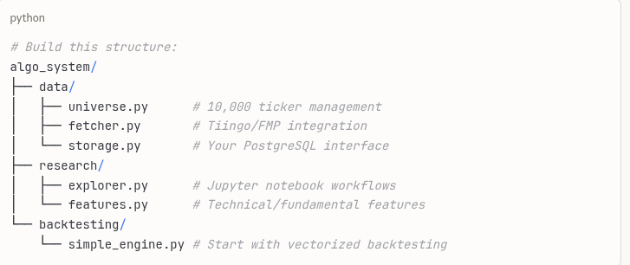

While Reading Jaekle & Tomasini (Weeks 4-7):
- Implement your first complete strategy (momentum or mean reversion)
- Build proper walk-forward analysis
- Create performance analytics dashboard

While Reading Pik & Ghosh (Weeks 8-10):
- Connect to IB paper trading
- Implement execution logic
- Build monitoring system Critical Insights for 10,000 Ticker Universe

Screening Architecture:
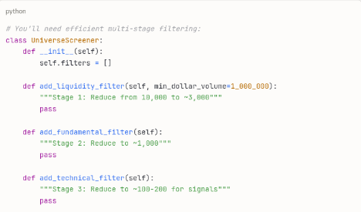

Computational Considerations:
- Vectorize everything - loops will kill you at this scale
- Use Dask/Ray for parallel processing
- Consider ClickHouse instead of PostgreSQL for tick data
- Cache aggressively - computation is expensive

Books to Skip/Defer:
- Marcos López de Prado books - Too academic initially, revisit after you're profitable
- Andrew Pole - More about stat arb, not your focus
- Kaufman's - Encyclopedia, not learning material

My Strong Recommendation:
Start with Chan immediately, but here's the key insight: Build while you read. Don't read all books then start coding.
After Chan's first 3 chapters, you should have:
- A basic data pipeline running
- Your first backtest (even if simple)
- A paper trading connection established
This approach will make the subsequent books much more meaningful because you'll have context for what problems they're solving.

One Critical Warning:
With 10,000 tickers, your biggest enemy is multiple testing bias. If you test enough strategies on enough stocks, you'll find amazing backtests that are pure noise. Chan, Davey, and Carver all address this - pay attention to their warnings.
My question:
I'm thinking that near term goals are the following:
1) finish IB Streamlit front-end for order submission:
a. The spreadsheet ingestion & execution is done. b. The 2nd half is to add one to look at existing positions and add the ability to add the ability to sell positions & add stops (hard & trailing pct)
2) Setup Tiingo price extract. a. determine US securities universe, b. do initial population for 10 years, c. setup routine for incremental price updates from max(date) in ohlcv table to T-1. By the way, I've already installed TimescaleDB and converted the ohlcv table to it.
3) Setup FMP fundamentals extract for annual and quarterly data for 10 year history. Then figure out polling methodology to keep fundamentals updated.
4) Adapt present relative rotation graph code to point to local database instead of online extract and to run in a Streamlit front-end.
5) Adapt present relative strength code to point to local database instead of online extract and to run in a Streamlit front-end.
This will put in place a formidable analysis foundation via local fundamental & price data and two analysis tools to use it. The process of building this will also help my Python knowledge.
At this point, I should be able to put in place a basic strategy, learn how to backtest it, and put it in place but this is a later chapter. Monitoring of existing positions for exit triggers will be a thing to learn.
In light of your provided graphic, how does this proposed path look to you?

Your proposed path is solid and pragmatic - building infrastructure before strategies is the right approach. Here's a fleshed-out structure aligned with your concrete goals:

Enhanced Project Structure
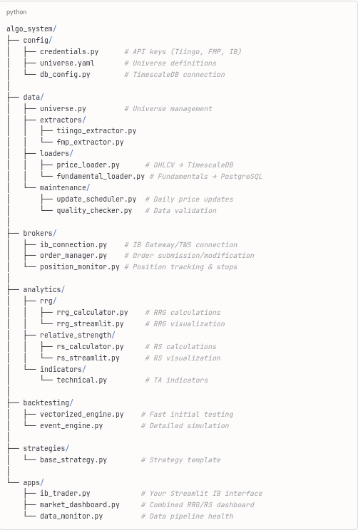

Implementation Sequence with Code

Week 1-2: Complete IB Integration
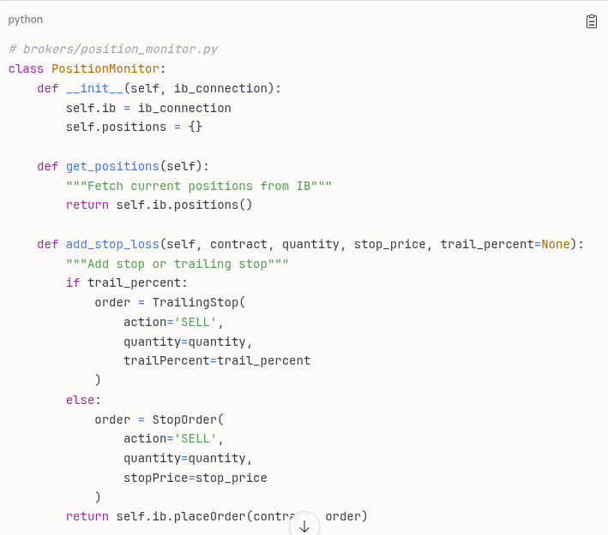

Week 2-3: Tiingo Setup
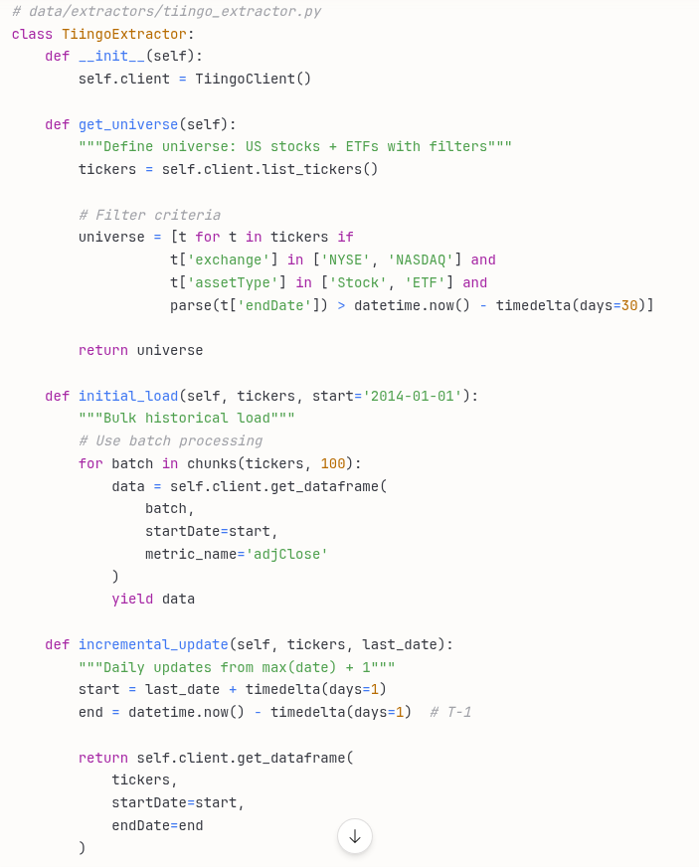

Week 3-4: FMP Fundamentals
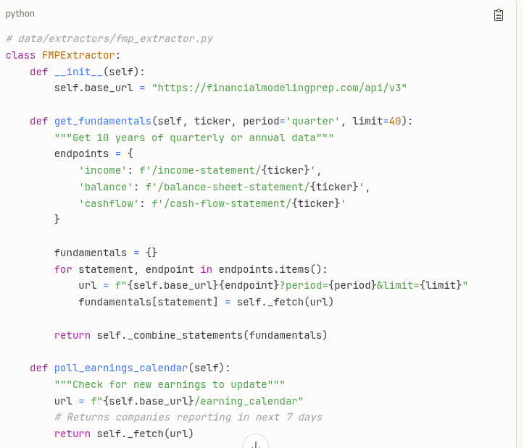

Week 4-5: Adapt RRG & RS Tools
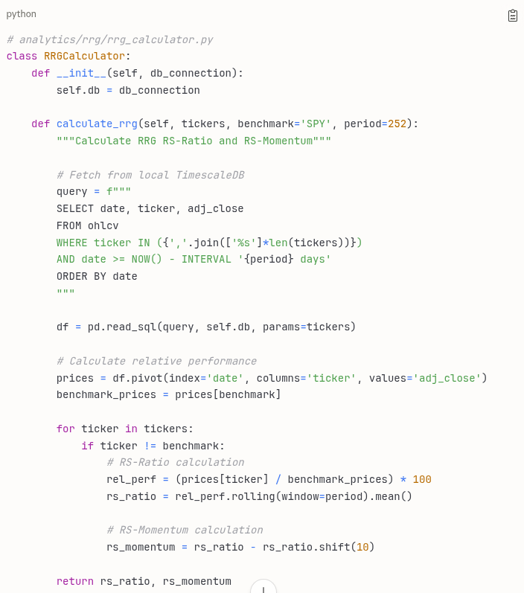

Critical Path Optimizations

1. Database Performance
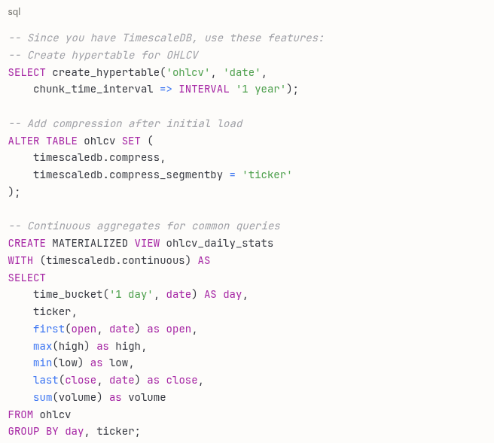

2. Parallel Processing for Universe
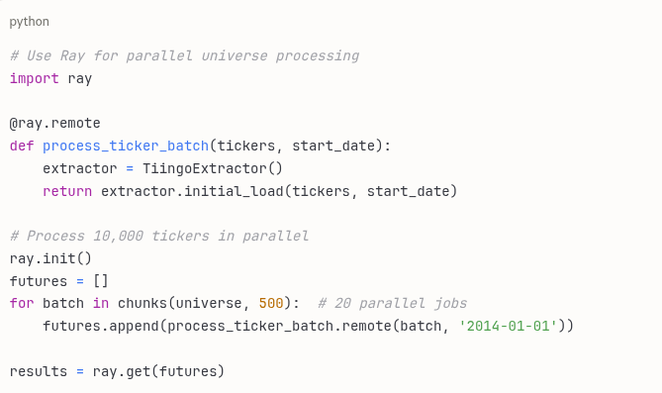

3. Smart Update Scheduling
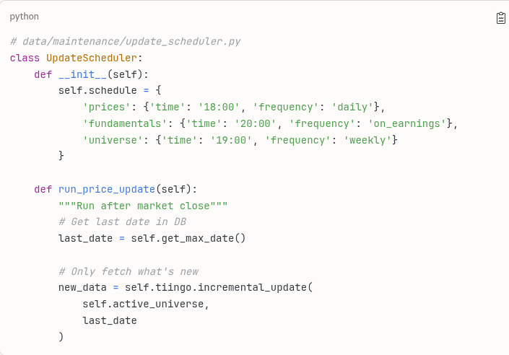

Timeline Reality Check
Your 5-point plan realistically maps to:
- Weeks 1-2: Complete IB integration
- Weeks 3-4: Tiingo pipeline + initial load
- Weeks 5-6: FMP fundamentals setup
- Week 7: RRG adaptation
- Week 8: RS adaptation
- Weeks 9-12: First strategy + backtesting
This gives you a robust foundation in 3 months. The key is to keep each component simple initially - you can always enhance later.

