**Supporting Information 1: Derivation of 1D stream transport model**

Equations for a 1D transport model that includes advection, dispersion, gas exchange, first-order decay and groundwater inflow and is coupled with a mass balance equation for stream discharge.

**1. Conservation of Solute Mass**

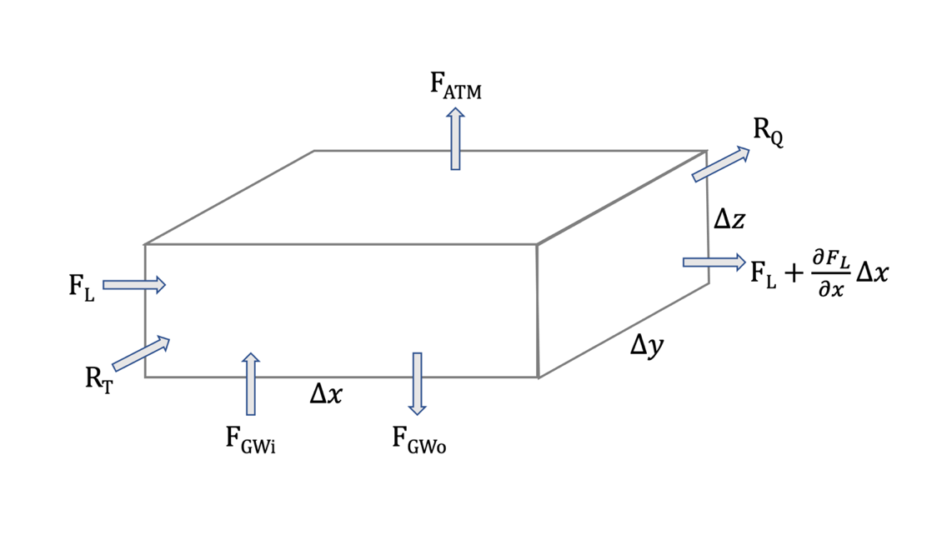

Governing equation for the conservation of solute mass:

[S1.1a] $\frac{ΔM}{Δt}=ΔF_{D}+ ΔF_{A}+R_{ATM}+R_{D}+R_{T}+R_{Q}+F_{GWi}+F_{GWo}$

Terms and Units:

|  |  |  |  |  |  |
| --- | --- | --- | --- | --- | --- |
| M | Mass | $$mol$$ | Q | Volumetric flow rate | $$\frac{L^{3}}{t}$$ |
| t | Time | $$t$$ | q | Specific discharge (flux) | $$\frac{L}{t}$$ |
| C | Concentration | $$\frac{mol}{L^{3}}$$ | FL | Longitudinal mass flux in stream | $$\frac{mol}{t}$$ |
| D | Dispersion | $$\frac{L^{2}}{t}$$ | FD | Dispersive mass flux | $$\frac{mol}{t}$$ |
| k | Atmospheric exchange coefficient | $$\frac{L}{t}$$ | FA | Advective mass flux | $$\frac{mol}{t}$$ |
| λ | Decay coefficient | $$\frac{1}{t}$$ | FGW | Mass flux from groundwater inflow (i) and outflow (o) | $$\frac{mol}{t}$$ |
|  |  |  | R | Mass sources and sinks:   * atmosphere (ATM) * decay (D) * tributaries (T) * pumping (Q) | $$\frac{mol}{t}$$ |

Solute mass flux by dispersion:

$ΔF_{D}=F_{L}-\left(F_{L}+\frac{∂F_{D}}{∂x}Δx\right)=\frac{∂F_{D}}{∂x}Δx$

$F_{D}=-DA\frac{∂C}{∂x}=-DΔyΔz\frac{∂C}{∂x}$

Solute mass flux by advection:

${ΔF}_{A}=-\frac{∂F_{A}}{∂x}Δx$

$F_{A}=QC$

Breakdown of components from [S1.1a]:

[S1.1b] ${ΔF}_{D}=\frac{∂}{∂x}\left(D\frac{∂C}{∂x}\right)ΔxΔyΔz$

[S1.1c] ${ΔF}_{A}=-\frac{∂QC}{∂x}Δx$

[S1.1d] $F_{ATM}=-kΔxΔy\left(C-C_{ATM}\right)$

[S1.1e] $R_{D}=-λCΔxΔyΔz$

[S1.1f] $R_{T}=Q_{T}C_{T}$

[S1.1g] $R_{Q}={-Q}_{Q}C$

[S1.1h] $F_{GWi}=q_{gi}ΔxΔyC_{GW}$ assuming flux across bottom face of stream cell

[S1.1i] $F_{GWo}=q_{go}ΔxΔyC$ assuming flux across bottom face of stream cell

[S1.1j] $\frac{ΔM}{Δt}=\frac{∂C}{∂t}ΔxΔyΔz$ assuming stream cell dimensions are constant over time

Replacing the components in [S1.1a] with [S1.1b] through [S1.1j] yields:

$\frac{∂C}{∂t}ΔxΔyΔz=\frac{∂}{∂x}\left(D\frac{∂C}{∂x}\right)ΔxΔyΔz-\frac{∂QC}{∂x}Δx-kΔxΔy\left(C-C_{ATM}\right)-λCΔxΔyΔz+Q_{T}C_{T}{-Q}_{Q}C+q_{gi}ΔxΔyC_{GW}-q_{go}ΔxΔyC$

Simplifying further yields:

[S1] $\frac{∂C}{∂t}=\frac{∂}{∂x}\left(D\frac{∂C}{∂x}\right)-\frac{∂QC}{∂x}\frac{1}{ΔyΔz}-\frac{k\left(C-C_{ATM}\right)}{Δz}-λC+\frac{Q_{T}C_{T}}{ΔxΔyΔz}-\frac{Q_{Q}C}{ΔxΔyΔz}+\frac{q_{gi}C_{GW}}{Δz}-\frac{q_{go}C}{Δz}$

**2. Conservation of Water**

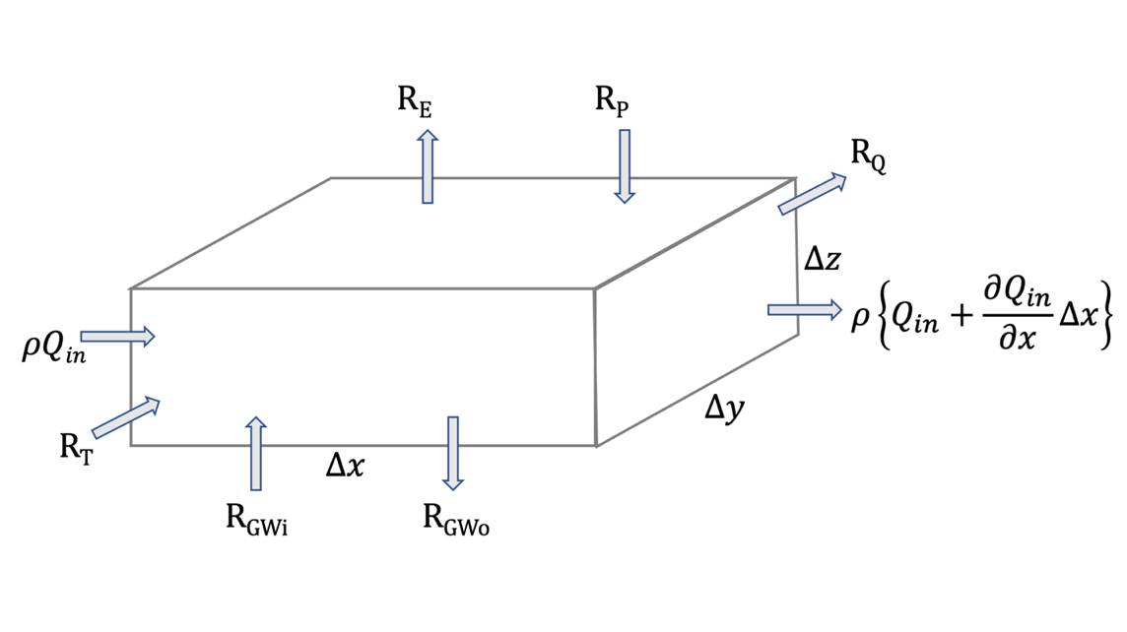

Governing equation for the conservation of water:

[S1.2a] $\frac{ΔM}{Δt}=ΔF_{Q}+R_{P}-R_{E}+R_{T}+R_{Q}+R_{GWi}+R_{GWo}$

Terms and Units:

|  |  |  |  |  |  |
| --- | --- | --- | --- | --- | --- |
| M | Mass | $$mol$$ | ΔFQ | Change in stream flow | $$\frac{L^{3}}{t}$$ |
| t | Time | $$t$$ | RGW | Groundwater inflow (i) and outflow (o) | $$\frac{L^{3}}{t}$$ |
| Q | Volumetric flow rate | $$\frac{L^{3}}{t}$$ | R | Sources and sinks:   * precipitation (P) * evaporation (E) * tributaries (T) * pumping (Q) | $$\frac{L^{3}}{t}$$ |
| q | Specific discharge (flux) | $$\frac{L}{t}$$ | ρ | Fluid density (assumed to be constant) | $$\frac{mass}{L^{3}}$$ |

Breakdown of components from [S1.2a]:

[S1.2b] $\frac{ΔM}{Δt}=\frac{ρΔxΔyΔz}{Δt}=ρ\frac{∂∀}{∂x}$

[S1.2c] ${ΔF}_{Q}=-ρ\frac{∂Q}{∂x}Δx$

[S1.2d] $R_{P}=ρPΔxΔy$

[S1.2e] $R_{E}=-ρEΔxΔy$

[S1.2f] $R_{T}={ρQ}_{T}$

[S1.2g] $R_{Q}={-ρQ}_{Q}$

[S1.2h] $R_{GWi}={ρq}_{gi}ΔxΔy$ assuming flux across bottom face of stream cell

[S1.2i] $R_{GWo}={ρq}_{o}ΔxΔy$ assuming flux across bottom face of stream cell

Replacing the components in [S1.2a] with [S1.2b] through [S1.2i] and assuming that ρ is constant yields:

$\frac{∂∀}{∂t}=-\frac{∂Q}{∂x}Δx+PΔxΔy-EΔxΔy+Q_{T}-Q_{Q}+q_{gi}ΔxΔy-q_{go}ΔxΔy$

Assuming a steady state condition and further simplifying yields:

$\frac{∂Q}{∂x}=PΔy-EΔy+\frac{Q_{T}}{Δx}-\frac{Q_{Q}}{Δx}+q_{gi}Δy-q_{go}Δy$

|  |
| --- |
| Setting $Δy=w$ (where w is the stream width) yields: |
| [S2] $\frac{∂Q}{∂x}=Pw-Ew+\frac{Q_{T}}{Δx}-\frac{Q_{Q}}{Δx}+q_{gi}w-q_{go}w$ |

**3. 1D Advective-Dispersive Transport in a Stream**

Using the product rule to combine [S1] and [S2]:

$\frac{∂QC}{∂x}=C\frac{∂Q}{∂x}+Q\frac{∂C}{∂x}$

$\frac{∂C}{∂t}=\frac{∂}{∂x}\left(D\frac{∂C}{∂x}\right)-\frac{1}{ΔyΔz}\left(C\frac{∂Q}{∂x}+Q\frac{∂C}{∂x}\right)-\frac{k\left(C-C_{ATM}\right)}{Δz}-λC+\frac{Q_{T}C_{T}}{ΔxΔyΔz}-\frac{Q_{Q}C}{ΔxΔyΔz}+\frac{q_{gi}C_{GW}}{Δz}-\frac{q_{go}C}{Δz}$

$\frac{∂C}{∂t}=\frac{∂}{∂x}\left(D\frac{∂C}{∂x}\right)-\frac{C}{ΔyΔz}\left(PΔy-EΔy+\frac{Q_{T}}{Δx}-\frac{Q_{Q}}{Δx}+q_{li}Δy-q_{lo}Δy\right)-\frac{Q}{ΔyΔz}\frac{∂C}{∂x}-\frac{k\left(C-C_{ATM}\right)}{Δz}-λC+\frac{Q_{T}C_{T}}{ΔxΔyΔz}-\frac{Q_{Q}C}{ΔxΔyΔz}+\frac{q_{gi}C_{GW}}{Δz}-\frac{q_{go}C}{Δz}$

Assuming a steady state condition and further simplifying yields:

[S3] $\frac{Q}{ΔyΔz}\frac{∂C}{∂x}=\frac{∂}{∂x}\left(D\frac{∂C}{∂x}\right)-\frac{CP}{Δz}+\frac{CE}{Δz}+\frac{q_{gi}\left(C_{GW}-C\right)}{Δz}+\frac{Q_{T}\left(C_{T}-C\right)}{ΔxΔyΔz}-\frac{k\left(C-C_{ATM}\right)}{Δz}-λC$

|  |
| --- |
| Setting $Δy=w$ (where w is the stream width), $ΔyΔz=Α$ (where A is the cross-sectional area of the stream), and P =0 (no precipitation at the time of sampling) yields: |
| [S4] $\frac{∂C}{∂x}=\frac{A}{Q}\left(\frac{∂}{∂x}D\frac{∂C}{∂x}\right)+\frac{q_{gi}w}{Q}\left(C_{GW}-C\right)+\frac{Q_{T}}{ΔxQ}\left(C_{T}-C\right)-\frac{kw}{Q}\left(C-C_{ATM}\right)-\frac{A}{Q}λC+wEC$ |