Computation and Representation

Boaz Barak

**Disclaimer:** The MS-Word version of this text has significant formatting issues compared to the PDF and HTML versions.

# Computation and Representation

### 

* Distinguish between *specification* and *implementation*, or equivalently between *mathematical functions* and *algorithms/programs*.
* Representing an object as a string (often of zeroes and ones).
* Examples of representations for common objects such as numbers, vectors, lists, graphs.
* Prefix-free representations.
* Cantor’s Theorem: The real numbers cannot be represented exactly as finite strings.

*“The alphabet (sic) was a great invention, which enabled men (sic) to store and to learn with little effort what others had learned the hard way – that is, to learn from books rather than from direct, possibly painful, contact with the real world.”*, B.F. Skinner

*“The name of the song is called `HADDOCK’S EYES.’”* [said the Knight]

*“Oh, that’s the name of the song, is it?”* Alice said, trying to feel interested.

*“No, you don’t understand,”* the Knight said, looking a little vexed. *“That’s what the name is CALLED. The name really is `THE AGED AGED MAN.’”*

*“Then I ought to have said `That’s what the SONG is called’?”* Alice corrected herself.

*“No, you oughtn’t: that’s quite another thing! The SONG is called `WAYS AND MEANS’: but that’s only what it’s CALLED, you know!”*

*“Well, what IS the song, then?”* said Alice, who was by this time completely bewildered.

*“I was coming to that,”* the Knight said. *“The song really IS `A-SITTING ON A GATE’: and the tune’s my own invention.”*

Lewis Carroll, *Through the Looking-Glass*

To a first approximation, *computation* is a process that maps an *input* to an *output*.

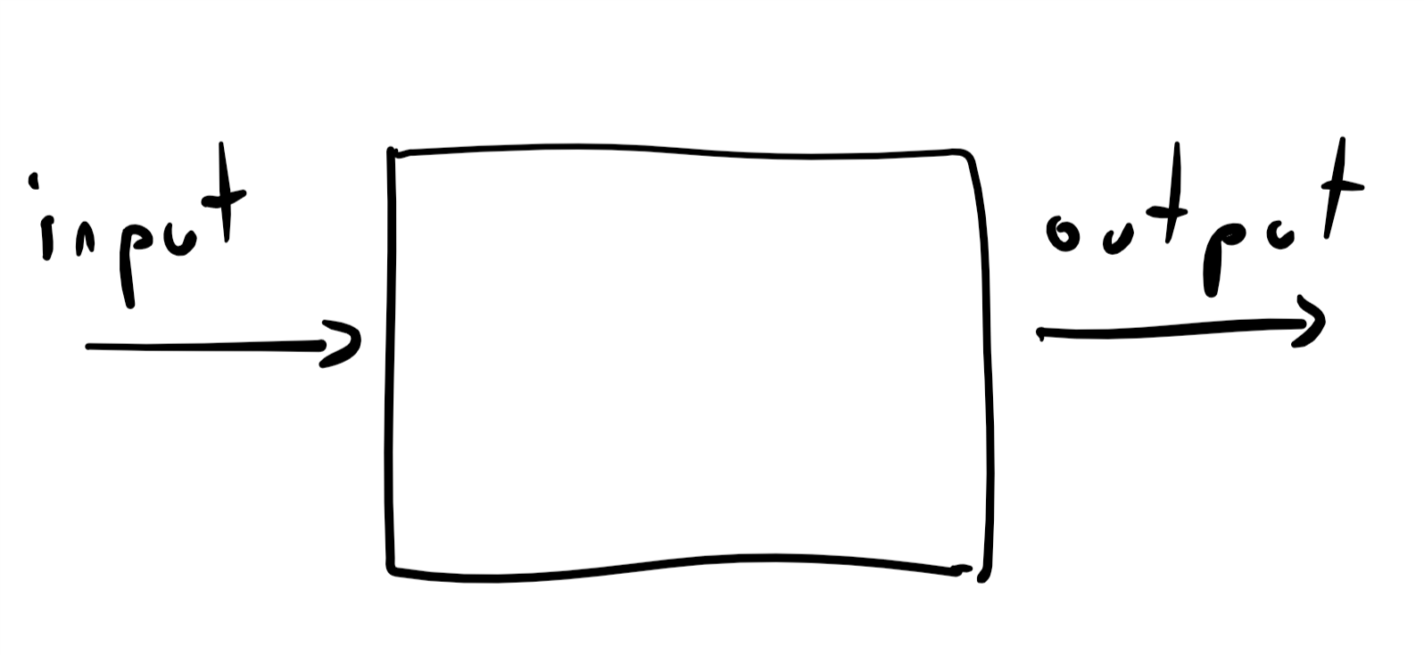

Our basic notion of *computation* is some process that maps an input to an output

When discussing computation, it is essential to separate the question of **what** is the task we need to perform (i.e., the *specification*) from the question of **how** we achieve this task (i.e., the *implementation*). For example, as we’ve seen, there is more than one way to achieve the computational task of computing the product of two integers.

In this chapter we focus on the **what** part, namely defining computational tasks. For starters, we need to define the inputs and outputs. Capturing all the potential inputs and outputs that we might ever want to compute on seems challenging, since computation today is applied to a wide variety of objects. We do not compute merely on numbers, but also on texts, images, videos, connection graphs of social networks, MRI scans, gene data, and even other programs. We will represent all these objects as **strings of zeroes and ones**, that is objects such as or or any other finite list of ’s and ’s. (This choice is for convenience: there is nothing “holy” about zeroes and ones, and we could have used any other finite collection of symbols.)

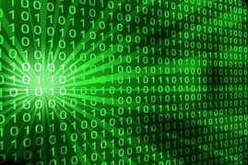

We represent numbers, texts, images, networks and many other objects using strings of zeroes and ones. Writing the zeroes and ones themselves in green font over a black background is optional.

Today, we are so used to the notion of digital representation that we are not surprised by the existence of such an encoding. But it is actually a deep insight with significant implications. Many animals can convey a particular fear or desire, but what is unique about humans is *language*: we use a finite collection of basic symbols to describe a potentially unlimited range of experiences. Language allows transmission of information over both time and space and enables societies that span a great many people and accumulate a body of shared knowledge over time.

Over the last several decades, we have seen a revolution in what we can represent and convey in digital form. We can capture experiences with almost perfect fidelity, and disseminate it essentially instantaneously to an unlimited audience. Moreover, once information is in digital form, we can *compute* over it, and gain insights from data that were not accessible in prior times. At the heart of this revolution is the simple but profound observation that we can represent an unbounded variety of objects using a finite set of symbols (and in fact using only the two symbols 0 and 1).

In later chapters, we will typically take such representations for granted, and hence use expressions such as “program takes as input” when might be a number, a vector, a graph, or any other object, when we really mean that takes as input the *representation* of as a binary string. However, in this chapter we will dwell a bit more on how we can construct such representations.

## Defining representations

Every time we store numbers, images, sounds, databases, or other objects on a computer, what we actually store in the computer’s memory is the *representation* of these objects. Moreover, the idea of representation is not restricted to digital computers. When we write down text or make a drawing we are *representing* ideas or experiences as sequences of symbols (which might as well be strings of zeroes and ones). Even our brain does not store the actual sensory inputs we experience, but rather only a *representation* of them.

To use objects such as numbers, images, graphs, or others as inputs for computation, we need to define precisely how to represent these objects as binary strings. A *representation scheme* is a way to map an object to a binary string . For example, a representation scheme for natural numbers is a function . Of course, we cannot merely represent all numbers as the string “” (for example). A minimal requirement is that if two numbers and are different then they would be represented by different strings. Another way to say this is that we require the encoding function to be *one to one*.

### Representing natural numbers

We now show how we can represent natural numbers as binary strings. Over the years people have represented numbers in a variety of ways, including Roman numerals, tally marks, our own Hindu-Arabic decimal system, and many others. We can use any one of those as well as many others to represent a number as a string (see bitmapdigitsfig). However, for the sake of concreteness, we use the *binary basis* as our default representation of natural numbers as strings. For example, we represent the number six as the string since , and similarly we represent the number thirty-five as the string which satisfies . Some more examples are given in the table below.

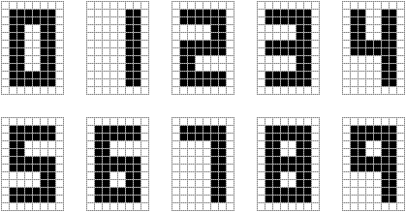

Representing each one the digits as a bitmap image, which can be thought of as a string in . Using this scheme we can represent a natural number of decimal digits as a string in . Image taken from [blog post of A. C. Andersen](http://blog.andersen.im/2010/12/autonomous-neural-development-and-pruning/).

Representing numbers in the binary basis. The lefthand column contains representations of natural numbers in the decimal basis, while the righthand column contains representations of the same numbers in the binary basis.

|  |  |
| --- | --- |
| **Number (decimal representation)** | **Number (binary representation)** |
| 0 | 0 |
| 1 | 1 |
| 2 | 10 |
| 5 | 101 |
| 16 | 10000 |
| 40 | 101000 |
| 53 | 110101 |
| 389 | 110000101 |
| 3750 | 111010100110 |

If is even, then the least significant digit of ’s binary representation is , while if is odd then this digit equals . Just like the number corresponds to “chopping off” the least significant decimal digit (e.g., ), the number corresponds to the “chopping off” the least significant *binary* digit. Hence the binary representation can be formally defined as the following function ( stands for “natural numbers to strings”):

where is the function defined as if is even and if is odd, and as usual, for strings , denotes the concatenation of and . The function is defined *recursively*: for every we define in terms of the representation of the smaller number . It is also possible to define non-recursively, see binaryrepex.

Throughout most of this book, the particular choices of representation of numbers as binary strings would not matter much: we just need to know that such a representation exists. In fact, for many of our purposes we can even use the simpler representation of mapping a natural number to the length- all-zero string .

We can implement the binary representation in *Python* as follows:

def NtS(n):# natural numbers to strings  
 if n > 1:  
 return NtS(n // 2) + str(n % 2)  
 else:  
 return str(n % 2)  
  
print(NtS(236))  
# 11101100  
  
print(NtS(19))  
# 10011

We can also use Python to implement the inverse transformation, mapping a string back to the natural number it represents.

def StN(x):# String to number  
 k = len(x)-1  
 return sum(int(x[i])*(2**(k-i)) for i in range(k+1))  
  
print(StN(NtS(236)))  
# 236

In this book, we sometimes use *code examples* as in pythonbinary. The point is always to emphasize that certain computations can be achieved concretely, rather than illustrating the features of Python or any other programming language. Indeed, one of the messages of this book is that all programming languages are in a certain precise sense *equivalent* to one another, and hence we could have just as well used JavaScript, C, COBOL, Visual Basic or even [BrainF*ck](https://goo.gl/LKKNFK). This book is *not* about programming, and it is absolutely OK if you are not familiar with Python or do not follow code examples such as those in pythonbinary.

### Meaning of representations (discussion)

It is natural for us to think of as the “actual” number, and of as “merely” its representation. However, for most Europeans in the middle ages CCXXXVI would be the “actual” number and (if they have even heard about it) would be the weird Hindu-Arabic positional representation.[1] When our AI robot overlords materialize, they will probably think of as the “actual” number and of as “merely” a representation that they need to use when they give commands to humans.

So what is the “actual” number? This is a question that philosophers of mathematics have pondered over throughout history. Plato argued that mathematical objects exist in some ideal sphere of existence (that to a certain extent is more “real” than the world we perceive via our senses, as this latter world is merely the shadow of this ideal sphere). In Plato’s vision, the symbols are merely notation for some ideal object, that, in homage to the [late musician](https://goo.gl/b93h83), we can refer to as “the number commonly represented by ”.

The Austrian philosopher Ludwig Wittgenstein, on the other hand, argued that mathematical objects do not exist at all, and the only things that exist are the actual marks on paper that make up , or CCXXXVI. In Wittgenstein’s view, mathematics is merely about formal manipulation of symbols that do not have any inherent meaning. You can think of the “actual” number as (somewhat recursively) “that thing which is common to , and CCXXXVI and all other past and future representations that are meant to capture the same object”.

While reading this book, you are free to choose your own philosophy of mathematics, as long as you maintain the distinction between the mathematical objects themselves and the various particular choices of representing them, whether as splotches of ink, pixels on a screen, zeroes and one, or any other form.

## Representations beyond natural numbers

We have seen that natural numbers can be represented as binary strings. We now show that the same is true for other types of objects, including (potentially negative) integers, rational numbers, vectors, lists, graphs and many others. In many instances, choosing the “right” string representation for a piece of data is highly nontrivial, and finding the “best” one (e.g., most compact, best fidelity, most efficiently manipulable, robust to errors, most informative features, etc.) is the object of intense research. But for now, we focus on presenting some simple representations for various objects that we would like to use as inputs and outputs for computation.

### Representing (potentially negative) integers

Since we can represent natural numbers as strings, we can represent the full set of *integers* (i.e., members of the set ) by adding one more bit that represents the sign. To represent a (potentially negative) number , we prepend to the representation of the natural number a bit that equals if and equals if . Formally, we define the function as follows

where is defined as in ntseq.

While the encoding function of a representation needs to be one to one, it does not have to be *onto*. For example, in the representation above there is no number that is represented by the empty string but it is still a fine representation, since every integer is represented uniquely by some string.

### 

Given a string , how do we know if it’s “supposed” to represent a (nonnegative) natural number or a (potentially negative) integer? For that matter, even if we know is “supposed” to be an integer, how do we know what representation scheme it uses? The short answer is that we do not necessarily know this information, unless it is supplied from the context. (In programming languages, the compiler or interpreter determines the representation of the sequence of bits corresponding to a variable based on the variable’s *type*.) We can treat the same string as representing a natural number, an integer, a piece of text, an image, or a green gremlin. Whenever we say a sentence such as “let be the number represented by the string ,” we will assume that we are fixing some canonical representation scheme such as the ones above. The choice of the particular representation scheme will rarely matter, except that we want to make sure to stick with the same one for consistency.

### Two’s complement representation (optional)

repnegativeintegerssec’s approach of representing an integer using a specific “sign bit” is known as the *Signed Magnitude Representation* and was used in some early computers. However, the [two’s complement representation](https://en.wikipedia.org/wiki/Two%27s%5Fcomplement) is much more common in practice. The *two’s complement representation* of an integer in the set is the string of length defined as follows:

where demotes the standard binary representation of a number as string of length , padded with leading zeros as needed. For example, if then , , , and . If is a negative number larger than or equal to then is a number between and . Hence the two’s complement representation of such a number is a string of length with its first digit equal to .

Another way to say this is that we represent a potentially negative number as the non-negative number (see also twoscomplementfig). This means that if two (potentially negative) numbers and are not too large (i.e., ), then we can compute the representation of by adding modulo the representations of and as if they were non-negative integers. This property of the two’s complement representation is its main attraction since, depending on their architectures, microprocessors can often perform arithmetic operations modulo very efficiently (for certain values of such as and ). Many systems leave it to the programmer to check that values are not too large and will carry out this modular arithmetic regardless of the size of the numbers involved. For this reason, in some systems adding two large positive numbers can result in a *negative* number (e.g., adding and might result in since , see also twoscomplementfig).

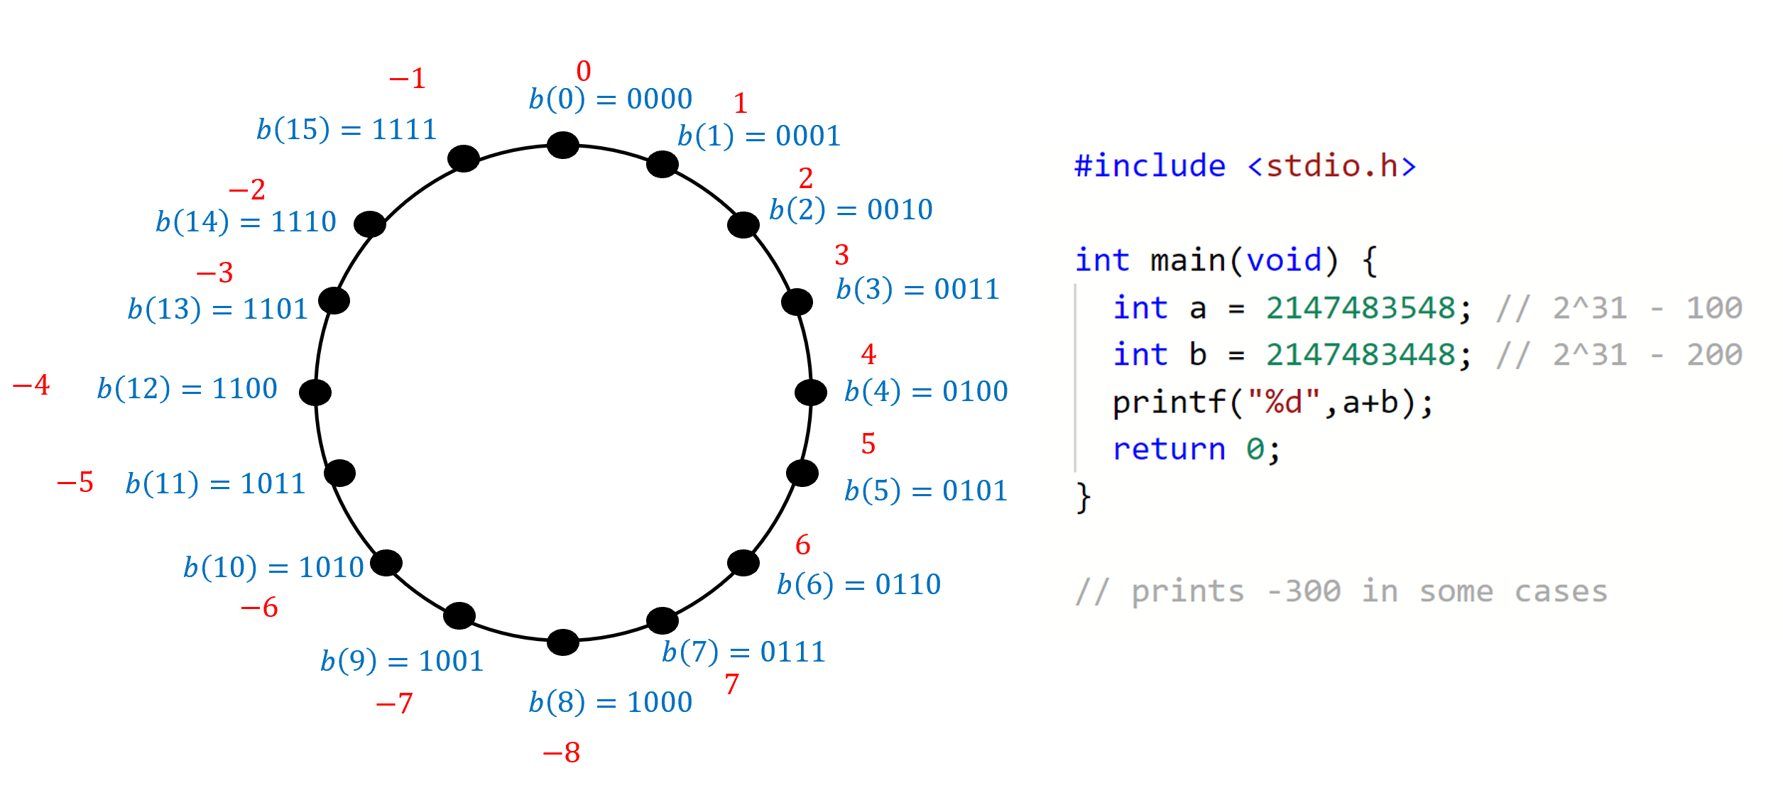

In the *two’s complement representation* we represent a potentially negative integer as an length string using the binary representation of the integer . On the lefthand side: this representation for (the red integers are the numbers being represented by the blue binary strings). If a microprocessor does not check for overflows, adding the two positive numbers and might result in the negative number (since . The righthand side is a C program that will on some bit architecture print a negative number after adding two positive numbers. (Integer overflow in C is considered *undefined behavior* which means the result of this program, including whether it runs or crashes, could differ depending on the architecture, compiler, and even compiler options and version.)

### Rational numbers, and representing pairs of strings

We can represent a rational number of the form by representing the two numbers and . However, merely concatenating the representations of and will not work. For example, the binary representation of is and the binary representation of is , but the concatenation of these strings is also the concatenation of the representation of and the representation of . Hence, if we used such simple concatenation then we would not be able to tell if the string is supposed to represent or .

We tackle this by giving a general representation for *pairs of strings*. If we were using a pen and paper, we would just use a separator symbol such as to represent, for example, the pair consisting of the numbers represented by and as the length- string “”. In other words, there is a one to one map from *pairs of strings* into a single string over the alphabet (in other words, ). Using such separators is similar to the way we use spaces and punctuation to separate words in English. By adding a little redundancy, we achieve the same effect in the digital domain. We can map the three-element set to the three-element set in a one-to-one fashion, and hence encode a length string as a length string .

Our final representation for rational numbers is obtained by composing the following steps:

1. Representing a non-negative rational number as a pair of natural numbers.
2. Representing a natural number by a string via the binary representation.
3. Combining 1 and 2 to obtain a representation of a rational number as a pair of strings.
4. Representing a pair of strings over as a single string over .
5. Representing a string over as a longer string over .

Consider the rational number . We represent as and as , and so we can represent as the *pair* of strings and represent this pair as the length string over the alphabet . Now, applying the map , , , we can represent the latter string as the length string over the alphabet .

The same idea can be used to represent triples of strings, quadruples, and so on as a string. Indeed, this is one instance of a very general principle that we use time and again in both the theory and practice of computer science (for example, in Object Oriented programming):

If we can represent objects of type as strings, then we can represent tuples of objects of type as strings as well.

Repeating the same idea, once we can represent objects of type , we can also represent *lists of lists* of such objects, and even lists of lists of lists and so on and so forth. We will come back to this point when we discuss *prefix free encoding* in prefixfreesec.

## Representing real numbers

The set of *real numbers* contains all numbers including positive, negative, and fractional, as well as *irrational* numbers such as or . Every real number can be approximated by a rational number, and thus we can represent every real number by a rational number that is very close to . For example, we can represent by within an error of about . If we want a smaller error (e.g., about ) then we can use , and so on and so forth.

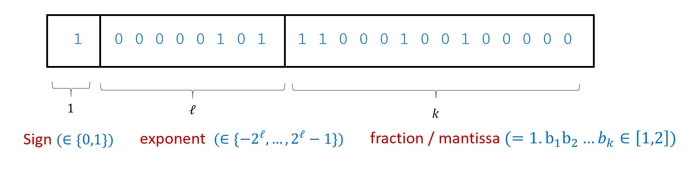

The *floating point representation* of a real number is its approximation as a number of the form where , is an (potentially negative) integer, and is a rational number between and expressed as a binary fraction for some (that is ). Commonly-used floating point representations fix the numbers and of bits to represent and respectively. In the example above, assuming we use two’s complement representation for , the number represented is .

The above representation of real numbers via rational numbers that approximate them is a fine choice for a representation scheme. However, typically in computing applications, it is more common to use the *floating point representation scheme* (see floatingpointfig) to represent real numbers. In the floating point representation scheme we represent by the pair of (positive or negative) integers of some prescribed sizes (determined by the desired accuracy) such that is closest to . Floating point representation is the base-two version of [scientific notation](https://goo.gl/MUJnVE), where one represents a number as its approximation of the form for . It is called “floating point” because we can think of the number as specifying a sequence of binary digits, and as describing the location of the “binary point” within this sequence. The use of floating representation is the reason why in many programming systems, printing the expression 0.1+0.2 will result in 0.30000000000000004 and not 0.3, see [here](http://floating-point-gui.de/), [here](https://docs.oracle.com/cd/E19957-01/806-3568/ncg_goldberg.html) and [here](https://randomascii.wordpress.com/2012/04/05/floating-point-complexities/) for more.

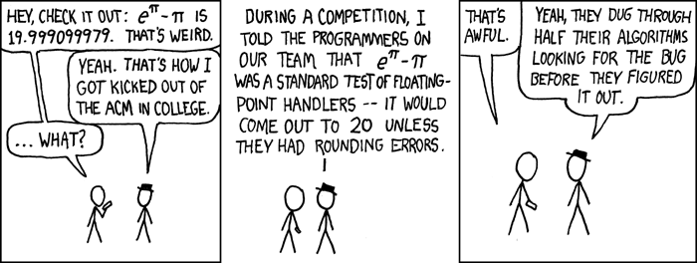

XKCD cartoon on floating-point arithmetic.

The reader might be (rightly) worried about the fact that the floating point representation (or the rational number one) can only *approximately* represent real numbers. In many (though not all) computational applications, one can make the accuracy tight enough so that this does not affect the final result, though sometimes we do need to be careful. Indeed, floating-point bugs can sometimes be no joking matter. For example, floating point rounding errors have been implicated in the [failure](http://embeddedgurus.com/barr-code/2014/03/lethal-software-defects-patriot-missile-failure/) of a U.S. Patriot missile to intercept an Iraqi Scud missile, costing 28 lives, as well as a 100 million pound error in computing [payouts to British pensioners](https://catless.ncl.ac.uk/Risks/5/74).

### Can we represent reals *exactly*?

Given the issues with floating point approximations for real numbers, a natural question is whether it is possible to represent real numbers *exactly* as strings. Unfortunately, the following theorem shows that this cannot be done:

### 

There does not exist a one-to-one function .[2]

cantorthm was proven by [Georg Cantor](https://en.wikipedia.org/wiki/Georg_Cantor) in 1874. (Cantor used the set rather than , but one can show that these two results are equivalent using the one-to-one mappings between those two sets, see naturalsstringsmapex.) The non-existence of such a map is equivalent to saying that there is no way to “count” all the real numbers as some sequence . For this reason cantorthm is known as the *uncountability of the reals*.

This result (and the theory around it) was quite shocking to mathematicians at the time. By showing that there is no one-to-one map from to (or ), Cantor showed that these two infinite sets have “different forms of infinity” and that the set of real numbers is in some sense “bigger” than the infinite set . The notion that there are “shades of infinity” was deeply disturbing to mathematicians and philosophers at the time. The philosopher Ludwig Wittgenstein (whom we mentioned before) called Cantor’s results “utter nonsense” and “laughable.” Others thought they were even worse than that. Leopold Kronecker called Cantor a “corrupter of youth,” while Henri Poincaré said that Cantor’s ideas “should be banished from mathematics once and for all.” The tide eventually turned, and these days Cantor’s work is universally accepted as the cornerstone of set theory and the foundations of mathematics. As David Hilbert said in 1925, *“No one shall expel us from the paradise which Cantor has created for us.”* As we will see later in this book, Cantor’s ideas also play a huge role in the theory of computation.

Now that we have discussed cantorthm’s importance, let us see the proof. It is achieved in two steps:

1. Define some infinite set for which it is easier for us to prove that is not countable (namely, it’s easier for us to prove that there is no one-to-one function from to ).
2. Prove that there *is* a one-to-one function mapping to .

We can use a proof by contradiction to show that these two facts together imply cantorthm. Specifically, if we assume (towards the sake of contradiction) that there exists some one-to-one mapping to then the function obtained by composing with the function from Step 2 above would be a one-to-one function from to , which contradicts what we proved in Step 1!

To turn this idea into a full proof of cantorthm we need to:

* Define the set .
* Prove that there is no one-to-one function from to
* Prove that there *is* a one-to-one function from to .

We now proceed to do precisely that. That is, we will define the set , which will play the role of , and then state and prove two lemmas that show that this set satisfies our two desired properties.

We denote by the set .

That is, is a set of *functions*, and a function is in iff its domain is and its codomain is . We can also think of as the set of all infinite *sequences* of bits, since a function can be identified with the sequence . The following two lemmas show that can play the role of to establish cantorthm.

### 

There does not exist a one-to-one map .[3]

### 

There *does* exist a one-to-one map .[4]

As we’ve seen above, sequencestostrings and sequencestoreals together imply cantorthm. To repeat the argument more formally, suppose, for the sake of contradiction, that there did exist a one-to-one function . By sequencestoreals, there exists a one-to-one function . Thus, under this assumption, since the composition of two one-to-one functions is one-to-one (see onetoonecompex), the function defined as will be one to one, contradicting sequencestostrings. See proofofcantorfig for a graphical illustration of this argument.

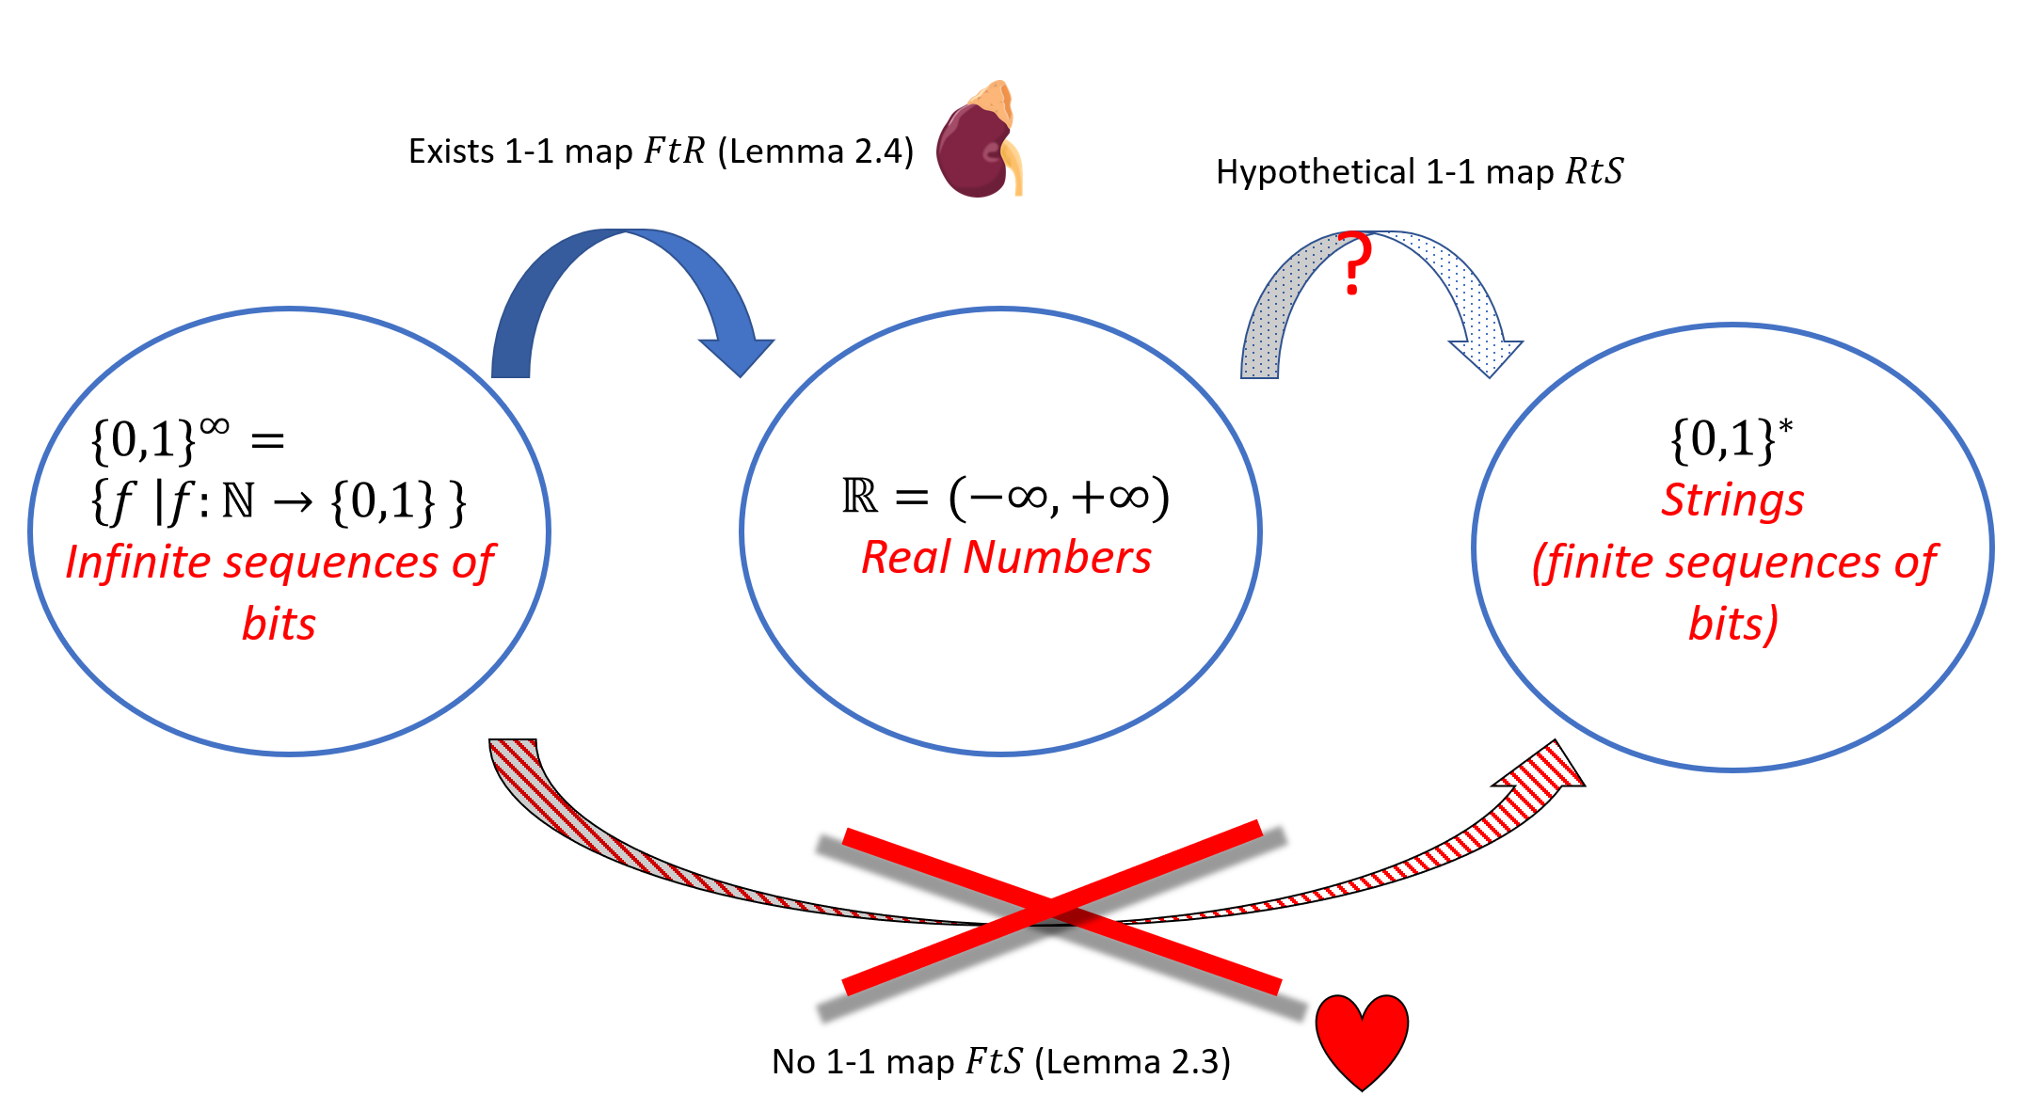

We prove cantorthm by combining sequencestostrings and sequencestoreals. sequencestoreals, which uses standard calculus tools, shows the existence of a one-to-one map from the set to the real numbers. So, if a hypothetical one-to-one map existed, then we could compose them to get a one-to-one map . Yet this contradicts sequencestostrings- the heart of the proof- which rules out the existence of such a map.

Now all that is left is to prove these two lemmas. We start by proving sequencestostrings which is really the heart of cantorthm.

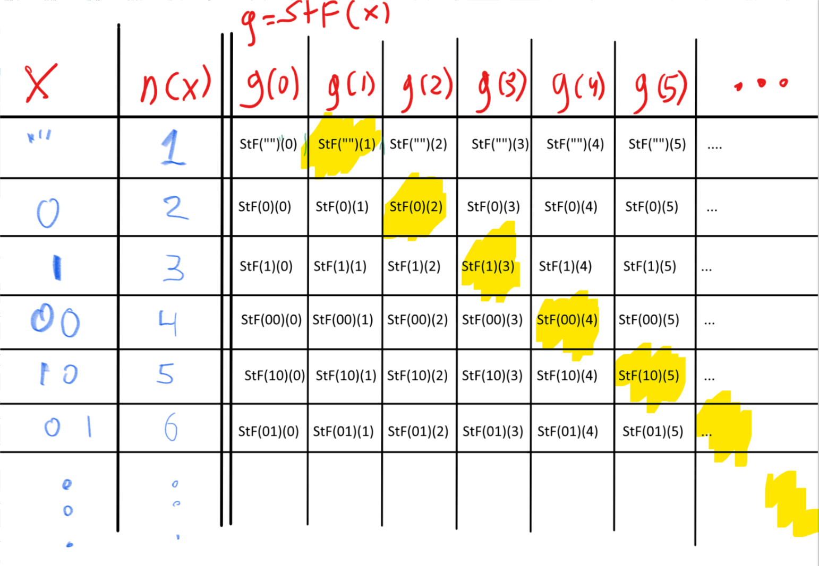

We construct a function such that for every by ensuring that for every with lexicographic order . We can think of this as building a table where the columns correspond to numbers and the rows correspond to (sorted according to ). If the entry in the -th row and the -th column corresponds to where then is obtained by going over the “diagonal” elements in this table (the entries corresponding to the -th row and -th column) and ensuring that .

We will prove that there does not exist an *onto* function . This implies the lemma since for every two sets and , there exists an onto function from to if and only if there exists a one-to-one function from to (see onetooneimpliesonto).

The technique of this proof is known as the “diagonal argument” and is illustrated in diagrealsfig. We assume, towards a contradiction, that there exists such a function . We will show that is not onto by demonstrating a function such that for every . Consider the lexicographic ordering of binary strings (i.e., $""$,,,,,). For every , we let be the -th string in this order. That is $x_0 =""$, , and so on and so forth. We define the function as follows:

for every . That is, to compute on input , we first compute , where is the -th string in the lexicographical ordering. Since , it is a function mapping to . The value is defined to be the negation of .

The definition of the function is a bit subtle. One way to think about it is to imagine the function as being specified by an infinitely long table, in which every row corresponds to a string (with strings sorted in lexicographic order), and contains the sequence . The *diagonal* elements in this table are the values

$$StF("")(0),StF(0)(1),StF(1)(2),StF(00)(3), StF(01)(4),\ldots$$

which correspond to the elements in the -th row and -th column of this table for . The function we defined above maps every to the negation of the -th diagonal value.

To complete the proof that is not onto we need to show that for every . Indeed, let be some string and let . If is the position of in the lexicographical order then by construction which means that which is what we wanted to prove.

The proof of sequencestostrings is rather subtle, and worth re-reading a second or third time. We will use the “diagonal argument” again several times later on in this book.

sequencestostrings doesn’t really have much to do with the natural numbers or the strings. An examination of the proof shows that it really shows that for *every* set , there is no one-to-one map where denotes the set of all Boolean functions with domain . Since we can identify a subset with its characteristic function (i.e., iff ), we can think of also as the set of all *subsets* of . This subset is sometimes called the *power set* of .

The proof of sequencestostrings can be generalized to show that there is no one-to-one map between a set and its power set. In particular, it means that the set is “even bigger” than . Cantor used these ideas to construct an infinite hierarchy of shades of infinity. The number of such shades turns out to be much larger than or even . He denoted the cardinality of by and denoted the next largest infinite number by . ( is the first letter in the Hebrew alphabet.) Cantor also made the [continuum hypothesis](https://en.wikipedia.org/wiki/Continuum_hypothesis) that . We will come back to the fascinating story of this hypothesis later on in this book. [This lecture of Aaronson](https://www.scottaaronson.com/democritus/lec2.html) mentions some of these issues (see also [this Berkeley CS 70 lecture](http://www.eecs70.org/static/notes/n10.pdf)).

To complete the proof of cantorthm, we need to show sequencestoreals. This requires some calculus background but is otherwise straightforward. If you have not had much experience with limits of a real series before, then the formal proof below might be a little hard to follow. This part is not the core of Cantor’s argument, nor are such limits important to the remainder of this book, so you can feel free to take sequencestoreals on faith and skip the proof.

We define to be the number between and whose decimal expansion is , or in other words . To prove that is one to one, we need to show that if then . To do that we let be the first input on which and disagree. The numbers and agree in the first digits following the decimal point and disagree in the -th digit. One can then calculate and verify that this means that which in particular means that these two numbers are distinct from one another. (You might wonder why we can’t immediately deduce that two numbers that differ in a digit are not the same. The issue is that we have to be a little more careful when talking about infinite expansions. For example, the number one half has two decimal expansions and . However, this issue does not come up if (as in our case) we restrict attention only to numbers with decimal expansions that do not involve the digit .)

For every , we define to be the number whose decimal expansion is .

Formally we define

It is a known result in calculus (whose proof we will not repeat here) that the series on the righthand side of eqcantordecimalexpansion converges to a definite limit in .

We now prove that is one to one. Let be two distinct functions in . Since and are distinct, there must be some input on which they differ, and we define to be the smallest such input and assume without loss of generality that and . (Otherwise, if and , then we can simply switch the roles of and .) The numbers and agree with each other up to the -th digit up after the decimal point. Since this digit equals for and equals for , we claim that is bigger than by at least . To see this note that the difference will be minimized if for every and for every , in which case (since and agree up to the -th digit)

Since the infinite series converges to , it follows that for every such and , . In particular we see that for every distinct , , implying that the function is one to one.

In the proof above we used the fact that converges to , which plugging into eqcantordecimalexpansion yields that the difference between and is at least . While the choice of the decimal representation for was arbitrary, we could not have used the binary representation in its place. Had we used the *binary* expansion instead of decimal, the corresponding sequence converges to , and since , we could not have deduced that is one to one. Indeed there do exist pairs of distinct sequences such that . (For example, the sequence and the sequence have this property.)

## Representing objects beyond numbers

Numbers are of course by no means the only objects that we can represent as binary strings. A *representation scheme* for representing objects from some set consists of an *encoding* function that maps an object in to a string, and a *decoding* function that decodes a string back to an object in . Formally, we make the following definition:

### 

Let be any set. A *representation scheme* for is a pair of functions where is a total one-to-one function, is a (possibly partial) function, and such that and satisfy that for every . is known as the *encoding* function and is known as the *decoding* function.

Note that the condition for every implies that is *onto* (can you see why?). It turns out that to construct a representation scheme we only need to find an *encoding* function. That is, every one-to-one encoding function has a corresponding decoding function, as shown in the following lemma:

### 

Suppose that is one-to-one. Then there exists a function such that for every .

### 

Let be some arbitrary element of . For every , there exists either zero or a single such that (otherwise would not be one-to-one). We will define to equal in the first case and this single object in the second case. By definition for every .

While the decoding function of a representation scheme can in general be a *partial* function, the proof of decodelem implies that every representation scheme has a *total* decoding function. This observation can sometimes be useful.

### Finite representations

If is *finite*, then we can represent every object in as a string of length at most some number . What is the value of ? Let us denote by the set of strings of length at most . The size of is equal to

using the standard formula for summing a [geometric progression](https://en.wikipedia.org/wiki/Geometric_progression).

To obtain a representation of objects in as strings of length at most we need to come up with a one-to-one function from to . We can do so, if and only if as is implied by the following lemma:

### 

For every two finite sets , there exists a one-to-one if and only if .

### 

Let and and so write the elements of and as and . We need to show that there is a one-to-one function iff . For the “if” direction, if we can simply define for every . Clearly for , , and hence this function is one-to-one. In the other direction, suppose that and is some function. Then cannot be one-to-one. Indeed, for let us “mark” the element in . If was marked before, then we have found two objects in mapping to the same element . Otherwise, since has elements, when we get to we mark all the objects in . Hence, in this case, must map to an element that was already marked before. (This observation is sometimes known as the “Pigeon Hole Principle”: the principle that if you have a pigeon coop with holes, and pigeons, then there must be two pigeons in the same hole. )

### Prefix-free encoding

When showing a representation scheme for rational numbers, we used the “hack” of encoding the alphabet to represent tuples of strings as a single string. This is a special case of the general paradigm of *prefix-free* encoding. The idea is the following: if our representation has the property that no string representing an object is a *prefix* (i.e., an initial substring) of a string representing a different object , then we can represent a *list* of objects by merely concatenating the representations of all the list members. For example, because in English every sentence ends with a punctuation mark such as a period, exclamation, or question mark, no sentence can be a prefix of another and so we can represent a list of sentences by merely concatenating the sentences one after the other. (English has some complications such as periods used for abbreviations (e.g., “e.g.”) or sentence quotes containing punctuation, but the high level point of a prefix-free representation for sentences still holds.)

It turns out that we can transform *every* representation to a prefix-free form. This justifies representtuplesidea, and allows us to transform a representation scheme for objects of a type to a representation scheme of *lists* of objects of the type . By repeating the same technique, we can also represent lists of lists of objects of type , and so on and so forth. But first let us formally define prefix-freeness:

For two strings , we say that is a *prefix* of if and for every , .

Let be a non-empty set and be a function. We say that is *prefix-free* if is non-empty for every and there does not exist a distinct pair of objects such that is a prefix of .

Recall that for every set , the set consists of all finite length tuples (i.e., *lists*) of elements in . The following theorem shows that if is a prefix-free encoding of then by concatenating encodings we can obtain a valid (i.e., one-to-one) representation of :

Suppose that is prefix-free. Then the following map is one to one, for every , we define

### 

prefixfreethm is an example of a theorem that is a little hard to parse, but in fact is fairly straightforward to prove once you understand what it means. Therefore, I highly recommend that you pause here to make sure you understand the statement of this theorem. You should also try to prove it on your own before proceeding further.

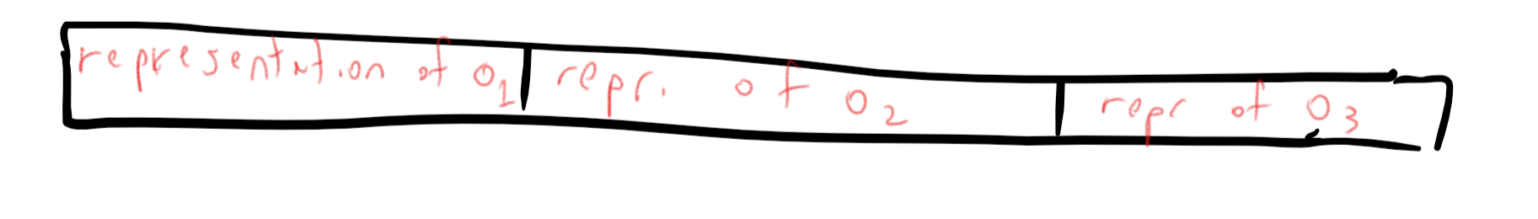

If we have a prefix-free representation of each object then we can concatenate the representations of objects to obtain a representation for the tuple .

### 

The idea behind the proof is simple. Suppose that for example we want to decode a triple from its representation . We will do so by first finding the first prefix of such is a representation of some object. Then we will decode this object, remove from to obtain a new string , and continue onwards to find the first prefix of and so on and so forth (see prefix-free-tuples-ex). The prefix-freeness property of will ensure that will in fact be , will be , etc.

We now show the formal proof. Suppose, towards the sake of contradiction, that there exist two distinct tuples and such that

We will denote the string by .

Let be the first index such that . (If for all then, since we assume the two tuples are distinct, one of them must be larger than the other. In this case we assume without loss of generality that and let .) In the case that , we see that the string can be written in two different ways:

and

where for all . Let be the string obtained after removing the prefix from . We see that can be written as both for some string and as for some . But this means that one of and must be a prefix of the other, contradicting the prefix-freeness of .

In the case that and , we get a contradiction in the following way. In this case

which means that must correspond to the empty string . But in such a case must be the empty string, which in particular is the prefix of any other string, contradicting the prefix-freeness of .

Even if the representation of objects in is prefix free, this does not mean that our representation of *lists* of such objects will be prefix free as well. In fact, it won’t be: for every three objects the representation of the list will be a prefix of the representation of the list . However, as we see in prefixfreetransformationlem below, we can transform *every* representation into prefix-free form, and so will be able to use that transformation if needed to represent lists of lists, lists of lists of lists, and so on and so forth.

### Making representations prefix-free

Some natural representations are prefix-free. For example, every *fixed output length* representation (i.e., one-to-one function ) is automatically prefix-free, since a string can only be a prefix of an equal-length if and are identical. Moreover, the approach we used for representing rational numbers can be used to show the following:

### 

Let be a one-to-one function. Then there is a one-to-one prefix-free encoding such that for every .

### 

For the sake of completeness, we will include the proof below, but it is a good idea for you to pause here and try to prove it on your own, using the same technique we used for representing rational numbers.

The idea behind the proof is to use the map , to “double” every bit in the string and then mark the end of the string by concatenating to it the pair . If we encode a string in this way, it ensures that the encoding of is never a prefix of the encoding of a distinct string . Formally, we define the function as follows:

for every . If is the (potentially not prefix-free) representation for , then we transform it into a prefix-free representation by defining .

To prove the lemma we need to show that **(1)** is one-to-one and **(2)** is prefix-free. In fact, prefix freeness is a stronger condition than one-to-one (if two strings are equal then in particular one of them is a prefix of the other) and hence it suffices to prove **(2)**, which we now do.

Let in be two distinct objects. We will prove that is a not a prefix of . Define and . Since is one-to-one, . Under our assumption, is a prefix of . If then the two bits in positions in have the value but the corresponding bits in will equal either or (depending on the -th bit of ) and hence cannot be a prefix of . If then, since , there must be a coordinate in which they differ, meaning that the strings and differ in the coordinates , which again means that cannot be a prefix of . If then and hence is longer than (and cannot be a prefix of) . In all cases we see that is not a prefix of , hence completing the proof.

The proof of prefixfreetransformationlem is not the only or even the best way to transform an arbitrary representation into prefix-free form. prefix-free-ex asks you to construct a more efficient prefix-free transformation satisfying .

### “Proof by Python” (optional)

The proofs of prefixfreethm and prefixfreetransformationlem are *constructive* in the sense that they give us:

* A way to transform the encoding and decoding functions of any representation of an object to encoding and decoding functions that are prefix-free, and
* A way to extend prefix-free encoding and decoding of single objects to encoding and decoding of *lists* of objects by concatenation.

Specifically, we could transform any pair of Python functions encode and decode to functions pfencode and pfdecode that correspond to a prefix-free encoding and decoding. Similarly, given pfencode and pfdecode for single objects, we can extend them to encoding of lists. Let us show how this works for the case of the NtS and StN functions we defined above.

We start with the “Python proof” of prefixfreetransformationlem: a way to transform an arbitrary representation into one that is *prefix free*. The function prefixfree below takes as input a pair of encoding and decoding functions, and returns a triple of functions containing *prefix-free* encoding and decoding functions, as well as a function that checks whether a string is a valid encoding of an object.

# takes functions encode and decode mapping  
# objects to lists of bits and vice versa,  
# and returns functions pfencode and pfdecode that  
# maps objects to lists of bits and vice versa  
# in a prefix-free way.  
# Also returns a function pfvalid that says  
# whether a list is a valid encoding  
def prefixfree(encode, decode):  
 def pfencode(o):  
 L = encode(o)  
 return [L[i//2] for i in range(2*len(L))]+[0,1]  
 def pfdecode(L):  
 return decode([L[j] for j in range(0,len(L)-2,2)])  
 def pfvalid(L):  
 return (len(L) % 2 == 0 ) and all(L[2*i]==L[2*i+1] for i in range((len(L)-2)//2)) and L[-2:]==[0,1]  
  
 return pfencode, pfdecode, pfvalid  
  
pfNtS, pfStN , pfvalidN = prefixfree(NtS,StN)  
  
NtS(234)  
# 11101010  
pfNtS(234)  
# 111111001100110001  
pfStN(pfNtS(234))  
# 234  
pfvalidM(pfNtS(234))  
# true

### 

Note that the Python function prefixfree above takes two *Python functions* as input and outputs three Python functions as output. (When it’s not too awkward, we use the term “Python function” or “subroutine” to distinguish between such snippets of Python programs and mathematical functions.) You don’t have to know Python in this course, but you do need to get comfortable with the idea of functions as mathematical objects in their own right, that can be used as inputs and outputs of other functions.

We now show a “Python proof” of prefixfreethm. Namely, we show a function represlists that takes as input a prefix-free representation scheme (implemented via encoding, decoding, and validity testing functions) and outputs a representation scheme for *lists* of such objects. If we want to make this representation prefix-free then we could fit it into the function prefixfree above.

def represlists(pfencode,pfdecode,pfvalid):  
 """  
 Takes functions pfencode, pfdecode and pfvalid,  
 and returns functions encodelists, decodelists  
 that can encode and decode lists of the objects  
 respectively.  
 """  
  
 def encodelist(L):  
 """Gets list of objects, encodes it as list of bits"""  
 return "".join([pfencode(obj) for obj in L])  
  
 def decodelist(S):  
 """Gets lists of bits, returns lists of objects"""  
 i=0; j=1 ; res = []  
 while j<=len(S):  
 if pfvalid(S[i:j]):  
 res += [pfdecode(S[i:j])]  
 i=j  
 j+= 1  
 return res  
  
 return encodelist,decodelist  
  
  
LtS , StL = represlists(pfNtS,pfStN,pfvalidN)  
  
LtS([234,12,5])  
# 111111001100110001111100000111001101  
StL(LtS([234,12,5]))  
# [234, 12, 5]

### Representing letters and text

We can represent a letter or symbol by a string, and then if this representation is prefix-free, we can represent a sequence of symbols by merely concatenating the representation of each symbol. One such representation is the [ASCII](https://en.wikipedia.org/wiki/ASCII) that represents letters and symbols as strings of bits. Since the ASCII representation is fixed-length, it is automatically prefix-free (can you see why?). [Unicode](https://en.wikipedia.org/wiki/Unicode) is representation of (at the time of this writing) about 128,000 symbols as numbers (known as *code points*) between and . There are several types of prefix-free representations of the code points, a popular one being [UTF-8](https://en.wikipedia.org/wiki/UTF-8) that encodes every codepoint into a string of length between and .

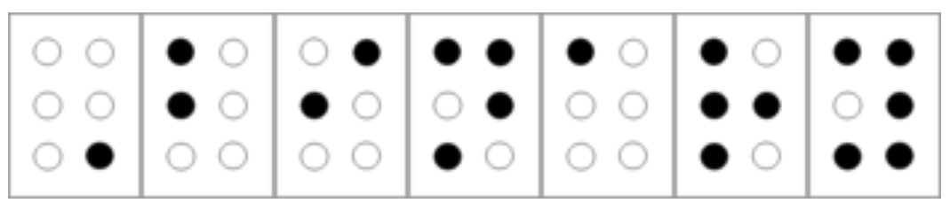

The word “Binary” in “Grade 1” or “uncontracted” Unified English Braille. This word is encoded using seven symbols since the first one is a modifier indicating that the first letter is capitalized.

The *Braille system* is another way to encode letters and other symbols as binary strings. Specifically, in Braille, every letter is encoded as a string in , which is written using indented dots arranged in two columns and three rows, see braillefig. (Some symbols require more than one six-bit string to encode, and so Braille uses a more general prefix-free encoding.)

The Braille system was invented in 1821 by [Louis Braille](https://goo.gl/Y2BkEe) when he was just 12 years old (though he continued working on it and improving it throughout his life). Braille was a French boy who lost his eyesight at the age of 5 as the result of an accident.

We can use programming languages to probe how our computing environment represents various values. This is easiest to do in “unsafe” programming languages such as C that allow direct access to the memory.

Using a [simple C program](https://goo.gl/L8oMzn) we have produced the following representations of various values. One can see that for integers, multiplying by 2 corresponds to a “left shift” inside each byte. In contrast, for floating point numbers, multiplying by two corresponds to adding one to the exponent part of the representation. In the architecture we used, a negative number is represented using the [two’s complement](https://goo.gl/wov5fa) approach. C represents strings in a prefix-free form by ensuring that a zero byte is at their end.

int 2 : 00000010 00000000 00000000 00000000  
int 4 : 00000100 00000000 00000000 00000000  
int 513 : 00000001 00000010 00000000 00000000  
long 513 : 00000001 00000010 00000000 00000000 00000000 00000000 00000000 00000000  
int -1 : 11111111 11111111 11111111 11111111  
int -2 : 11111110 11111111 11111111 11111111  
string Hello: 01001000 01100101 01101100 01101100 01101111 00000000  
string abcd : 01100001 01100010 01100011 01100100 00000000  
float 33.0 : 00000000 00000000 00000100 01000010  
float 66.0 : 00000000 00000000 10000100 01000010  
float 132.0: 00000000 00000000 00000100 01000011  
double 132.0: 00000000 00000000 00000000 00000000 00000000 10000000 01100000 01000000

### Representing vectors, matrices, images

Once we can represent numbers and lists of numbers, then we can also represent *vectors* (which are just lists of numbers). Similarly, we can represent lists of lists, and thus, in particular, can represent *matrices*. To represent an image, we can represent the color at each pixel by a list of three numbers corresponding to the intensity of Red, Green and Blue. (We can restrict to three primary colors since [most](https://en.wikipedia.org/wiki/Tetrachromacy) humans only have three types of cones in their retinas; we would have needed 16 primary colors to represent colors visible to the [Mantis Shrimp](https://goo.gl/t7JBfC).) Thus an image of pixels would be represented by a list of such length-three lists. A video can be represented as a list of images. Of course these representations are rather wasteful and [much](https://en.wikipedia.org/wiki/JPEG) [more](https://goo.gl/Vs8UhU) compact representations are typically used for images and videos, though this will not be our concern in this book.

### Representing graphs

A *graph* on vertices can be represented as an *adjacency* matrix whose entry is equal to if the edge is present and is equal to otherwise. That is, we can represent an vertex directed graph as a string such that iff the edge . We can transform an undirected graph to a directed graph by replacing every edge with both edges and

Another representation for graphs is the *adjacency list* representation. That is, we identify the vertex set of a graph with the set where , and represent the graph as a list of lists, where the -th list consists of the out-neighbors of vertex . The difference between these representations can be significant for some applications, though for us would typically be immaterial.

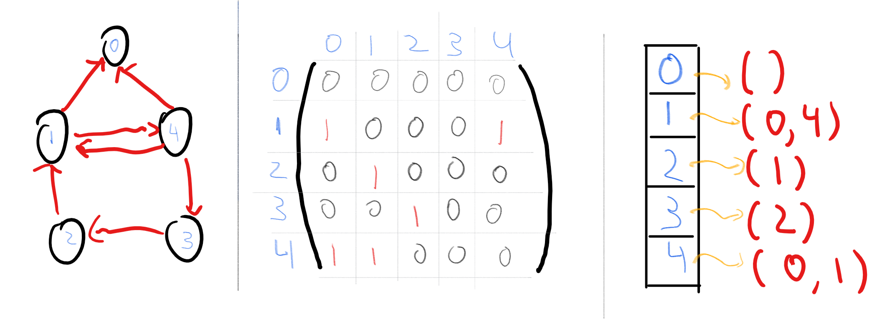

Representing the graph in the adjacency matrix and adjacency list representations.

### Representing lists and nested lists

If we have a way of representing objects from a set as binary strings, then we can represent lists of these objects by applying a prefix-free transformation. Moreover, we can use a trick similar to the above to handle *nested* lists. The idea is that if we have some representation , then we can represent nested lists of items from using strings over the five element alphabet 0,1,[ , ] , , . For example, if is represented by 0011, is represented by 10011, and is represented by 00111, then we can represent the nested list as the string "[0011,[10011,00111]]" over the alphabet . By encoding every element of itself as a three-bit string, we can transform any representation for objects into a representation that enables representing (potentially nested) lists of these objects.

### Notation

We will typically identify an object with its representation as a string. For example, if is some function that maps strings to strings and is an integer, we might make statements such as “ is prime” to mean that if we represent as a string , then the integer represented by the string satisfies that is prime. (You can see how this convention of identifying objects with their representation can save us a lot of cumbersome formalism.) Similarly, if are some objects and is a function that takes strings as inputs, then by we will mean the result of applying to the representation of the ordered pair . We use the same notation to invoke functions on -tuples of objects for every .

This convention of identifying an object with its representation as a string is one that we humans follow all the time. For example, when people say a statement such as “ is a prime number”, what they really mean is that the integer whose decimal representation is the string “17”, is prime.

When we say

*is an algorithm that computes the multiplication function on natural numbers.*

what we really mean is that

*is an algorithm that computes the function such that for every pair , if is a string representing the pair then will be a string representing their product .*

## Defining computational tasks as mathematical functions

Abstractly, a *computational process* is some process that takes an input which is a string of bits and produces an output which is a string of bits. This transformation of input to output can be done using a modern computer, a person following instructions, the evolution of some natural system, or any other means.

In future chapters, we will turn to mathematically defining computational processes, but, as we discussed above, at the moment we focus on *computational tasks*. That is, we focus on the **specification** and not the **implementation**. Again, at an abstract level, a computational task can specify any relation that the output needs to have with the input. However, for most of this book, we will focus on the simplest and most common task of *computing a function*. Here are some examples:

* Given (a representation of) two integers , compute the product . Using our representation above, this corresponds to computing a function from to . We have seen that there is more than one way to solve this computational task, and in fact, we still do not know the best algorithm for this problem.
* Given (a representation of) an integer , compute its *factorization*; i.e., the list of primes such that . This again corresponds to computing a function from to . The gaps in our knowledge of the complexity of this problem are even larger.
* Given (a representation of) a graph and two vertices and , compute the length of the shortest path in between and , or do the same for the *longest* path (with no repeated vertices) between and . Both these tasks correspond to computing a function from to , though it turns out that there is a vast difference in their computational difficulty.
* Given the code of a Python program, determine whether there is an input that would force it into an infinite loop. This task corresponds to computing a *partial* function from to since not every string corresponds to a syntactically valid Python program. We will see that we *do* understand the computational status of this problem, but the answer is quite surprising.
* Given (a representation of) an image , decide if is a photo of a cat or a dog. This corresponds to computing some (partial) function from to .

### 

An important special case of computational tasks corresponds to computing *Boolean* functions, whose output is a single bit . Computing such functions corresponds to answering a YES/NO question, and hence this task is also known as a *decision problem*. Given any function and , the task of computing corresponds to the task of deciding whether or not where is known as the *language* that corresponds to the function . (The language terminology is due to historical connections between the theory of computation and formal linguistics as developed by Noam Chomsky.) Hence many texts refer to such a computational task as *deciding a language*.

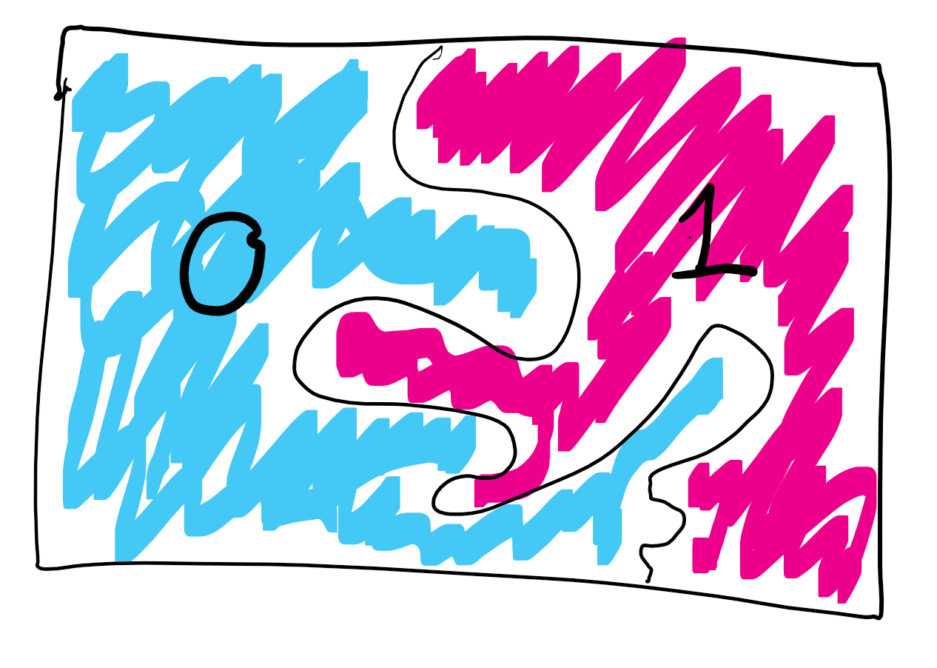

A subset can be identified with the function such that if and if . Functions with a single bit of output are called *Boolean functions*, while subsets of strings are called *languages*. The above shows that the two are essentially the same object, and we can identify the task of deciding membership in (known as *deciding a language* in the literature) with the task of computing the function .

For every particular function , there can be several possible *algorithms* to compute . We will be interested in questions such as:

* For a given function , can it be the case that *there is no algorithm* to compute ?
* If there is an algorithm, what is the best one? Could it be that is “effectively uncomputable” in the sense that every algorithm for computing requires a prohibitively large amount of resources?
* If we cannot answer this question, can we show equivalence between different functions and in the sense that either they are both easy (i.e., have fast algorithms) or they are both hard?
* Can a function being hard to compute ever be a *good thing*? Can we use it for applications in areas such as cryptography?

In order to do that, we will need to mathematically define the notion of an *algorithm*, which is what we will do in compchap.

### Distinguish functions from programs!

You should always watch out for potential confusions between **specifications** and **implementations** or equivalently between **mathematical functions** and **algorithms/programs**. It does not help that programming languages (Python included) use the term *“functions”* to denote (parts of) *programs*. This confusion also stems from thousands of years of mathematical history, where people typically defined functions by means of a way to compute them.

For example, consider the multiplication function on natural numbers. This is the function that maps a pair of natural numbers to the number . As we mentioned, it can be implemented in more than one way:

def mult1(x,y):  
 res = 0  
 while y>0:  
 res += x  
 y -= 1  
 return res  
  
def mult2(x,y):  
 a = str(x) # represent x as string in decimal notation  
 b = str(y) # represent y as string in decimal notation  
 res = 0  
 for i in range(len(a)):  
 for j in range(len(b)):  
 res += int(a[len(a)-i])*int(b[len(b)-j])*(10**(i+j))  
 return res  
  
print(mult1(12,7))  
# 84  
print(mult2(12,7))  
# 84

Both mult1 and mult2 produce the same output given the same pair of natural number inputs. (Though mult1 will take far longer to do so when the numbers become large.) Hence, even though these are two different *programs*, they compute the same *mathematical function*. This distinction between a *program* or *algorithm* , and the *function* that *computes* will be absolutely crucial for us in this course (see also functionornotfig).

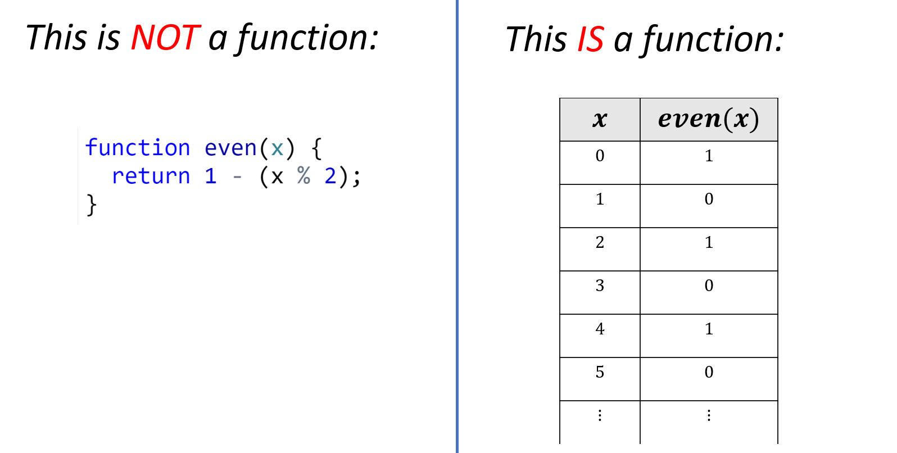

A *function* is a mapping of inputs to outputs. A *program* is a set of instructions on how to obtain an output given an input. A program *computes* a function, but it is not the same as a function, popular programming language terminology notwithstanding.

A *function* is not the same as a *program*. A program *computes* a function.

Distinguishing *functions* from *programs* (or other ways for computing, including *circuits* and *machines*) is a crucial theme for this course. For this reason, this is often a running theme in questions that I (and many other instructors) assign in homework and exams (hint, hint).

Functions capture quite a lot of computational tasks, but one can consider more general settings as well. For starters, we can and will talk about *partial* functions, that are not defined on all inputs. When computing a partial function, we only need to worry about the inputs on which the function is defined. Another way to say it is that we can design an algorithm for a partial function under the assumption that someone “promised” us that all inputs would be such that is defined (as otherwise, we do not care about the result). Hence such tasks are also known as *promise problems*.

Another generalization is to consider *relations* that may have more than one possible admissible output. For example, consider the task of finding any solution for a given set of equations. A *relation* maps a string into a *set of strings* (for example, might describe a set of equations, in which case would correspond to the set of all solutions to ). We can also identify a relation with the set of pairs of strings where . A computational process solves a relation if for every , it outputs some string .

Later in this book, we will consider even more general tasks, including *interactive* tasks, such as finding a good strategy in a game, tasks defined using probabilistic notions, and others. However, for much of this book, we will focus on the task of computing a function, and often even a *Boolean* function, that has only a single bit of output. It turns out that a great deal of the theory of computation can be studied in the context of this task, and the insights learned are applicable in the more general settings.

### 

* We can represent objects we want to compute on using binary strings.
* A representation scheme for a set of objects is a one-to-one map from to .
* We can use prefix-free encoding to “boost” a representation for a set into representations of lists of elements in .
* A basic computational task is the task of *computing a function* . This task encompasses not just arithmetical computations such as multiplication, factoring, etc. but a great many other tasks arising in areas as diverse as scientific computing, artificial intelligence, image processing, data mining and many many more.
* We will study the question of finding (or at least giving bounds on) what the *best* algorithm for computing for various interesting functions is.

## Exercises

Which one of these objects can be represented by a binary string?

1. An integer
2. An undirected graph .
3. A directed graph
4. All of the above.

1. Prove that the function of the binary representation defined in ntseq satisfies that for every , if then and .
2. Prove that is a one to one function by coming up with a function such that for every .

The ASCII encoding can be used to encode a string of English letters as a bit binary string, but in this exercise, we ask about finding a more compact representation for strings of English lowercase letters.

1. Prove that there exists a representation scheme for strings over the 26-letter alphabet as binary strings such that for every and length- string , the representation is a binary string of length at most . In other words, prove that for every , there exists a one-to-one function .
2. Prove that there exists *no* representation scheme for strings over the alphabet as binary strings such that for every length- string , the representation is a binary string of length . In other words, prove that there exists some such that there is no one-to-one function
3. Python’s bz2.compress function is a mapping from strings to strings, which uses the *lossless* (and hence *one to one*) [bzip2](https://en.wikipedia.org/wiki/Bzip2) algorithm for compression. After converting to lowercase, and truncating spaces and numbers, the text of Tolstoy’s “War and Peace” contains . Yet, if we run bz2.compress on the string of the text of “War and Peace” we get a string of length bits, which is only (and in particular much smaller than ). Explain why this does not contradict your answer to the previous question.
4. Interestingly, if we try to apply bz2.compress on a *random* string, we get much worse performance. In my experiments, I got a ratio of about between the number of bits in the output and the number of characters in the input. However, one could imagine that one could do better and that there exists a company called “Pied Piper” with an algorithm that can losslessly compress a string of random lowercase letters to fewer than bits.[5] Show that this is not the case by proving that for *every* and one to one function , if we let be the random variable (i.e., the length of ) for chosen uniformly at random from the set , then the expected value of is at least .

Show that there is a string representation of directed graphs with vertex set and degree at most that uses at most bits. More formally, show the following: Suppose we define for every , the set as the set containing all directed graphs (with no self loops) over the vertex set where every vertex has degree at most . Then, prove that for every sufficiently large , there exists a one-to-one function .

1. Define to be the set of one-to-one and onto functions mapping to . Prove that there is a one-to-one mapping from to , where is the set defined in representinggraphsex above.
2. In this question you will show that one cannot improve the representation of representinggraphsex to length . Specifically, prove for every sufficiently large there is *no* one-to-one function .

Recall that the grade-school algorithm for multiplying two numbers requires operations. Suppose that instead of using decimal representation, we use one of the following representations to represent a number between and . For which one of these representations you can still multiply the numbers in operations?

1. The standard binary representation: where and is the largest number s.t. .
2. The reverse binary representation: where is defined as above for .
3. Binary coded decimal representation: where represents the decimal digit of mapping to , to , to , etc. (i.e.  maps to )
4. All of the above.

### 

Suppose that corresponds to representing a number as a string of ’s, (e.g., , , etc.). If are numbers between and , can we still multiply and using operations if we are given them in the representation ?

Recall that if is a one-to-one and onto function mapping elements of a finite set into a finite set then the sizes of and are the same. Let be the function such that for every , is the binary representation of .

1. Prove that if and only if .
2. Use 1. to compute the size of the set where denotes the length of the string .
3. Use 1. and 2. to prove that .

Suppose that is a one-to-one function that is *prefix-free* in the sense that there is no s.t. is a prefix of .

1. Prove that , defined as (i.e., the concatenation of and ) is a one-to-one function.
2. Prove that defined as is a one-to-one function, where denotes the set of all finite-length lists of natural numbers.

Suppose that is some (not necessarily prefix-free) representation of the objects in the set , and is a prefix-free representation of the natural numbers. Define (i.e., the concatenation of the representation of the length and ).

1. Prove that is a prefix-free representation of .
2. Show that we can transform any representation to a prefix-free one by a modification that takes a bit string into a string of length at most .
3. Show that we can transform any representation to a prefix-free one by a modification that takes a bit string into a string of length at most .[6]

Suppose that is some finite prefix-free set.

1. For every and length- string , let denote all the length- strings whose first bits are . Prove that **(1)** and **(2)** If then is disjoint from .
2. Prove that .
3. Prove that there is no prefix-free encoding of strings with less than logarithmic overhead. That is, prove that there is no function s.t. for every and such that the set is prefix-free. The factor is arbitrary; all that matters is that it is less than .

### 

Prove that for every two one-to-one functions and , the function defined as is one to one.

1. We have shown that the natural numbers can be represented as strings. Prove that the other direction holds as well: that there is a one-to-one map . ( stands for “strings to numbers.”)
2. Recall that Cantor proved that there is no one-to-one map . Show that Cantor’s result implies cantorthm.

Recall that for every set , the set is defined as the set of all finite sequences of members of (i.e., ). Prove that there is a one-one-map from to where is the set of of all integers.

## Bibliographical notes

The study of representing data as strings, including issues such as *compression* and *error corrections* falls under the purview of *information theory*, as covered in the classic textbook of Cover and Thomas [@CoverThomas06]. Representations are also studied in the field of *data structures design*, as covered in texts such as [@CLRS].

The question of whether to represent integers with the most significant digit first or last is known as [Big Endian vs. Little Endian](https://betterexplained.com/articles/understanding-big-and-little-endian-byte-order/) representation. This terminology comes from Cohen’s [@cohen1981holy] entertaining and informative paper about the conflict between adherents of both schools which he compared to the warring tribes in Jonathan Swift’s *“Gulliver’s Travels”*. The two’s complement representation of signed integers was suggested in von Neumann’s classic report [@vonNeumann45] that detailed the design approaches for a stored-program computer, though similar representations have been used even earlier in abacus and other mechanical computation devices.

The idea that we should separate the *definition* or *specification* of a function from its *implementation* or *computation* might seem “obvious,” but it took quite a lot of time for mathematicians to arrive at this viewpoint. Historically, a function was identified by rules or formulas showing how to derive the output from the input. As we discuss in greater depth in chapcomputable, in the 1800s this somewhat informal notion of a function started “breaking at the seams,” and eventually mathematicians arrived at the more rigorous definition of a function as an arbitrary assignment of input to outputs. While many functions may be described (or computed) by one or more formulas, today we do not consider that to be an essential property of functions, and also allow functions that do not correspond to any “nice” formula.

We have mentioned that all representations of the real numbers are inherently *approximate*. Thus an important endeavor is to understand what guarantees we can offer on the approximation quality of the output of an algorithm, as a function of the approximation quality of the inputs. This question is known as the question of determining the [numerical stability](https://en.wikipedia.org/wiki/Numerical_stability) of given equations. The [Floating Points Guide website](https://floating-point-gui.de/) contains an extensive description of the floating point representation, as well the many ways in which it could subtly fail, see also the website [0.30000000000000004.com](http://0.30000000000000004.com/).

Dauben [@Dauben90cantor] gives a biography of Cantor with emphasis on the development of his mathematical ideas. [@halmos1960naive] is a classic textbook on set theory, including also Cantor’s theorem. Cantor’s Theorem is also covered in many texts on discrete mathematics, including [@LehmanLeightonMeyer , @LewisZax19].

The adjacency matrix representation of graphs is not merely a convenient way to map a graph into a binary string, but it turns out that many natural notions and operations on matrices are useful for graphs as well. (For example, Google’s PageRank algorithm relies on this viewpoint.) The notes of [Spielman’s course](http://www.cs.yale.edu/homes/spielman/561/) are an excellent source for this area, known as *spectral graph theory*. We will return to this view much later in this book when we talk about *random walks*.

1. While the Babylonians already invented a positional system much earlier, the decimal positional system we use today was invented by Indian mathematicians around the third century. Arab mathematicians took it up in the 8th century. It first received significant attention in Europe with the publication of the 1202 book *“Liber Abaci”* by Leonardo of Pisa, also known as Fibonacci, but it did not displace Roman numerals in common usage until the 15th century.
2. stands for “real numbers to strings”.
3. stands for “functions to strings”.
4. stands for “functions to reals.”
5. Actually that particular fictional company uses a metric that focuses more on compression *speed* then *ratio*, see [here](https://blogs.dropbox.com/tech/2016/06/lossless-compression-with-brotli/) and [here](https://www.jefftk.com/p/weissman-scores-useful).
6. Hint: Think recursively how to represent the length of the string.