Secure communication over insecure channels

Boaz Barak

**Disclaimer:** The MS-Word version of this text has significant formatting issues compared to the PDF and HTML versions.

# Establishing secure connections over insecure channels

We’ve now compiled all the tools that are needed for the basic goal of cryptography (which is still being subverted quite often) allowing Alice and Bob to exchange messages assuring their integrity and confidentiality over a channel that is observed or controlled by an adversary. Our tools for achieving this goal are:

* Public key (aka asymmetric) encryption schemes.
* Public key (aka asymmetric) digital signatures schemes.
* Private key (aka symmetric) encryption schemes - block ciphers and stream ciphers.
* Private key (aka symmetric) message authentication codes and pseudorandom functions.
* Hash functions that are used both as ways to compress messages for authentication as well as key derivation and other tasks.

The notions of security we require from these building blocks can vary as well. For encryption schemes we talk about CPA (chosen plaintext attack) and CCA (chosen ciphertext attacks), for hash functions we talk about collision-resistance, being used (combined with keys) as pseudorandom functions, and then sometimes we simply model those as random oracles. Also, all of those tools require access to a source of randomness, and here we use hash functions as well for entropy extraction.

## Cryptography’s obsession with adjectives.

As we learn more and more cryptography we see more and more adjectives, every notion seems to have modifiers such as “non-malleable”, “leakage-resilient”, “identity based”, “concurrently secure”, “adaptive”, “non-interactive”, etc.. etc… . Indeed, this motivated a parody web page of an [automatic crypto paper title generator](https://cseweb.ucsd.edu/~mihir/crypto-topic-generator.html). Unlike algorithms, where typically there are straightforward *quantitative* tradeoffs (e.g., faster is better), in cryptography there are many *qualitative* ways protocols can vary based on the assumptions they operate under and the notions of security they provide.

In particular, the following issues arise when considering the task of securely transmitting information between two parties Alice and Bob:

* **Infrastructure/setup assumptions:** What kind of setup can Alice and Bob rely upon? For example in the TLS protocol, typically Alice is a website and Bob is user; Using the infrastructure of certificate authorities, Bob has a trusted way to obtain Alice’s *public signature key*, while Alice doesn’t know anything about Bob. But there are many other variants as well. Alice and Bob could share a (low entropy) *password*. One of them might have some hardware token, or they might have a secure out of band channel (e.g., text messages) to transmit a short amount of information. There are even variants where the parties authenticate by something they *know*, with one recent example being the notion of *witness encryption* (Garg, Gentry, Sahai, and Waters) where one can encrypt information in a “digital time capsule” to be opened by anyone who, for example, finds a proof of the Riemann hypothesis.
* **Adversary access:** What kind of attacks do we need to protect against. The simplest setting is a *passive* eavesdropping adversary (often called “Eve”) but we sometimes consider an *active person-in-the-middle* attacks (sometimes called “Mallory”). We sometimes consider notions of *graceful recovery*. For example, if the adversary manages to hack into one of the parties then it can clearly read their communications from that time onwards, but we would want their past communication to be protected (a notion known as *forward secrecy*). If we rely on trusted infrastructure such as certificate authorities, we could ask what happens if the adversary breaks into those. Sometimes we rely on the security of several entities or secrets, and we want to consider adversaries that control *some* but not *all* of them, a notion known as *threshold cryptography*.
* **Interaction:** Do Alice and Bob get to interact and relay several messages back and forth or is it a “one shot” protocol? You may think that this is merely a question about efficiency but it turns out to be crucial for some applications. Sometimes Alice and Bob might not be two parties separated in space but the same party separated in time. That is, Alice wishes to send a message to her future self by storing an encrypted and authenticated version of it on some media. In this case, absent a time machine, back and forth interaction between the two parties is obviously impossible.
* **Security goal:** The security goals of a protocol are usually stated in the negative- what does it mean for an adversary to *win* the security game. We typically want the adversary to learn absolutely no information about the secret beyond what she obviously can. For example, if we use a shared password chosen out of possibilities, then we might need to allow the adversary success probability, but we wouldn’t want her to get anything beyond . In some settings, the adversary can obviously completely disconnect the communication channel between Alice and Bob, but we want her to be essentially limited to either dropping communication completely or letting it go by unmolested, and not have the ability to modify communication without detection. Then in some settings, such as in the case of steganography and anonymous routing, we would want the adversary not to find out even the fact that a conversation had taken place.

## Basic Key Exchange protocol

The basic primitive for secure communication is a *key exchange* protocol, whose goal is to have Alice and Bob share a common random secret key . Once this is done, they can use a CCA secure / authenticated private-key encryption to communicate with confidentiality and integrity.

The canonical example of a basic key exchange protocol is the *Diffie Hellman* protocol. It uses as public parameters a group with generator , and then follows the following steps:

1. Alice picks random and sends .
2. Bob picks random and sends .
3. They both set their key as (which Alice computes as and Bob computes as ), where is some hash function.

Another variant is using an arbitrary public key encryption scheme such as RSA:

1. Alice generates keys and sends to Bob.
2. Bob picks random and sends to Alice.
3. They both set their key to (which Alice computes by decrypting Bob’s ciphertext)

Under plausible assumptions, it can be shown that these protocols secure against a *passive* eavesdropping adversary Eve. The notion of security here means that, similar to encryption, if after observing the transcript Eve receives with probability the value of and with probability a random string , then her probability of guessing which is the case would be at most (where can be thought of as or some other parameter related to the length of bit representation of members in the group).

## Authenticated key exchange

The main issue with this key exchange protocol is of course that adversaries often are *not* passive. In particular, an active Eve could agree on her own key with Alice and Bob separately and then be able to see and modify all future communication. She might also be able to create weird (with some potential security implications) correlations by, say, modifying the message to be etc..

For this reason, in actual applications we typically use *authenticated* key exchange. The notion of authentication used depends on what we can assume on the setup assumptions. A standard assumption is that Alice has some public keys but Bob doesn’t. (This is the case when Alice is a website and Bob is a user.) However, one needs to take care in how to use this assumption. Indeed, the standard protocol for securing the web: the [transport Layer Security (TLS) protocol](https://goo.gl/md9Bsa) (and its predecessor SSL) has gone through six revisions (including a name change from SSL to TLS) largely because of security concerns. We now illustrate one of those attacks.

### Bleichenbacher’s attack on RSA PKCS V1.5 and SSL V3.0

If you have a public key, a natural approach is to take the encryption-based protocol and simply skip the first step since Bob already knows the public key of Alice. This is basically what happened in the SSL V3.0 protocol. However, as was [shown by Bleichenbacher in 1998](http://archiv.infsec.ethz.ch/education/fs08/secsem/bleichenbacher98.pdf), it turns out this is susceptible to the following attack:

* The adversary listens in on a conversation, and in particular observes where is the private key.
* The adversary then starts many connections with the server with ciphertexts related to , and observes whether they succeed or fail (and in what way they fail, if they do). It turns out that based on this information, the adversary would be able to recover the key .

Specifically, the version of RSA (known as PKCS V1.5) used in the SSL V3.0 protocol requires the value to have a particular format, with the top two bytes having a certain form. If in the course of the protocol, a server decrypts and gets a value not of this form then it would send an error message and halt the connection. While the designers of SSL V3.0 might not have thought of it that way, this amounts to saying that an SSL V3.0 server supplies to any party an oracle that on input outputs iff has this form, where is the secret decryption key. It turned out that one can use such an oracle to invert the RSA function. For a result of a similar flavor, see the (1/2 page) proof of Theorem 11.31 (page 418) in KL, where they show that an oracle that given outputs the least significant bit of allows to invert the RSA function.[1]

For this reason, new versions of the SSL used a different variant of RSA known as PKCS $$1 V2.0 which satisfies (under assumptions) *chosen ciphertext security (CCA)* and in particular such oracles cannot be used to break the encryption. (Nonetheless, there are still some implementation issues that allowed to perform some attacks, see the note in KL page 425 on Manfer’s attack.)

## Chosen ciphertext attack security for public key cryptography

The concept of chosen ciphertext attack security makes perfect sense for *public key* encryption as well. It is defined in the same way as it was in the private key setting:

# 

A public key encryption scheme is *chosen ciphertext attack (CCA) secure* if every efficient Mallory wins in the following game with probability at most :

* The keys are generated via , and Mallory gets the public encryption key and .
* For rounds, Mallory gets access to the function . (She doesn’t need access to since she already knows .)
* Mallory chooses a pair of messages , a secret is chosen at random in , and Mallory gets . (Note that she of course does *not* get the randomness used to generate this challenge encryption.)
* Mallory now gets another rounds of access to the function except that she is not allowed to query .
* Mallory outputs and *wins* if .

In the private key setting, we achieved CCA security by combining a CPA-secure private key encryption scheme with a message authenticating code (MAC), where to CCA-encrypt a message , we first used the CPA-secure scheme on to obtain a ciphertext , and then added an authentication tag by signing with the MAC. The decryption algorithm first verified the MAC before decrypting the ciphertext. In the public key setting, one might hope that we could repeat the same construction using a CPA-secure *public key* encryption and replacing the MAC with *digital signatures*.

# 

Try to think what would be such a construction, and whether there is a fundamental obstacle to combining digital signatures and public key encryption in the same way we combined MACs and private key encryption.

Alas, as you may have realized, there is a fly in this ointment. In a signature scheme (necessarily) it is the *signing key* that is *secret*, and the *verification key* that is *public*. But in a public key encryption, the *encryption* key is *public*, and hence it makes no sense for it to use a secret signing key. (It’s not hard to see that if you reveal the secret signing key then there is no point in using a signature scheme in the first place.)

**Why CCA security matters.** For the reasons above, constructing CCA secure public key encryption is very challenging. But is it worth the trouble? Do we really need this “ultra conservative” notion of security? The answer is *yes*. Just as we argued for *private key* encryption, chosen ciphertext security is the notion that gets us as close as possible to designing encryptions that fit the metaphor of *secure sealed envelopes*. Digital analogies will never be a perfect imitation of physical ones, but such metaphors are what people have in mind when designing cryptographic protocols, which is a hard enough task even when we don’t have to worry about the ability of an adversary to reach inside a sealed envelope and XOR the contents of the note written there with some arbitrary string. Indeed, several practical attacks, including Bleichenbacher’s attack above, exploited exactly this gap between the physical metaphor and the digital realization. For more on this, please see [Victor Shoup’s survey](http://www.shoup.net/papers/expo.pdf) where he also describes the Cramer-Shoup encryption scheme which was the first practical public key system to be shown CCA secure without resorting to the random oracle heuristic. (The first definition of CCA security, as well as the first polynomial-time construction, was given in a seminal 1991 work of Dolev, Dwork and Naor.)

## CCA secure public key encryption in the Random Oracle Model

We now show how to convert any CPA-secure public key encryption scheme to a CCA-secure scheme in the random oracle model (this construction is taken from Fujisaki and Okamoto, CRYPTO 99). In the homework, you will see a somewhat simpler direct construction of a CCA secure scheme from a *trapdoor permutation*, a variant of which is known as OAEP (which has better ciphertext expansion) has been standardized as PKCS $$1 V2.0 and is used in several protocols. The advantage of a generic construction is that it can be instantiated not just with the RSA and Rabin schemes, but also directly with Diffie-Hellman and Lattice based schemes (though there are direct and more efficient variants for these as well).

**CCA-ROM-ENC Scheme:**

* **Ingredients:** A public key encryption scheme and a two hash functions (which we model as independent random oracles[2])
* **Key generation:** We generate keys for the underlying encryption scheme.
* **Encryption:** To encrypt a message , we select randomness for the underlying encryption algorithm and output , where by we denote the result of encrypting using the key and the randomness (we assume the scheme takes bits of randomness as input; otherwise modify the output length of accordingly).
* **Decryption:** To decrypt a ciphertext first let , and then check that . If the check fails we output error; otherwise we output .

# 

The above CCA-ROM-ENC scheme is CCA secure.

**Note:** The proof here refers to the original scheme in the notes (which was not secure) - should be updated by the scribes to the correct proof as presented in lecture.

Suppose towards a contradiction that there exists an adversary that wins the CCA game with probability at least where is non-negligible. Our aim is to show that the decryption box would be “useless” to and hence reduce CCA security to CPA security (which we’ll then derive from the CPA security of the underlying scheme).

Consider the following “box” that will answer decryption queries of the adversary as follows:  
* If was returned before to the adversary as an answer to for some , and and then return .  
* Otherwise return error

**Claim:** The probability that answers a query differently then is negligible.

**Proof of claim:** If gives a non error response to a query then it must be that for some such that and , in which case will return . The only way that will answer this question differently is if but the query hasn’t been asked before by the adversary. Here there are two options. If this query has never been asked before at all, then by the lazy evaluation principle in this case we can think of as being independently chosen at this point, and the probability it happens to equal will be . If this query was asked by someone apart from the adversary then it could only have been asked by the encryption oracle while producing the challenge ciphertext , but since the adversary is not allowed to ask this precise ciphertext, then it must be a ciphertext of the form where and such a ciphertext would get an error response from both oracles. **QED (claim)**

Note that we can assume without loss of generality that if is the challenge message and is the randomness chosen in this challenge, the adversary never asks the query to the its or oracles, since we can modify it so that before making a query , it will first check if where is the challenge ciphertext, and if so use this to win the game.

In other words, if we modified the experiment so the values and chosen while producing the challenge are simply random strings chosen completely independently of everything else. Now note that our oracle did *not* need to use the decryption key . So, if the adversary wins the CCA game, then it wins the *CPA game* for the encryption scheme where and are simply independent random strings; we leave proving that this scheme is CPA secure as an exercise to the reader.

### Defining secure authenticated key exchange

The basic goal of secure communication is to set up a *secure channel* between two parties Alice and Bob. We want to do so over an open network, where messages between Alice and Bob might be read, modified, deleted, or added by the adversary. Moreover, we want Alice and Bob to be sure that they are talking to one another rather than other parties. This raises the question of what is identity and how is it verified. Ultimately, if we want to use identities, then we need to trust some authority that decides which party has which identity. This is typically done via a *certificate authority (CA)*. This is some trusted authority, whose verification key is public and known to all parties. Alice proves in some way to the CA that she is indeed Alice, and then generates a pair , and gets from the CA the message =“The key belongs to Alice” signed with .[3] Now Alice can send to Bob to certify that the owner of this public key is indeed Alice.

For example, in the web setting, certain [certificate authorities](https://en.wikipedia.org/wiki/Certificate_authority) can certify that a certain public key is associated with a certain website. If you go to a website using the https protocol, you should see a “lock” symbol on your browser which will give you details on the certificate. Often the certificate is a chain of certificate. If I click on this lock symbol in my Chrome browser, I see that the certificate that amazon.com’s public key is some particular string (corresponding to a 2048 RSA modulos and exponent) is signed by the Symantec Certificate authority, whose own key is certified by Verisign. My communication with Amazon is an example of a setting of *one sided authentication*. It is important for me to know that I am truly talking to amazon.com, while Amazon is willing to talk to any client. (Though of course once we establish a secure channel, I could use it to login to my Amazon account.) Chapter 21 of Boneh Shoup contains an in depth discussion of authenticated key exchange protocols.

# 

You should stop here and read Section 21.9 of Boneh Shoup with the formal definitions of authenticated key exchange, going back as needed to the previous section for the definitions of protocols AEK1 - AEK4.

### The compiler approach for authenticated key exchange

There is a generic “compiler” approach to obtaining authenticated key exchange protocols:

* Start with a protocol such as the basic Diffie-Hellman protocol that is only secure with respect to a *passive eavesdropping* adversary.
* Then *compile* it into a protocol that is secure with respect to an active adversary using authentication tools such as digital signatures, message authentication codes, etc.., depending on what kind of setup you can assume and what properties you want to achieve.

This approach has the advantage of being modular in both the construction and the analysis. However, direct constructions might be more efficient. There are a great many potentially desirable properties of key exchange protocols, and different protocols achieve different subsets of these properties at different costs. The most common variant of authenticated key exchange protocols is to use some version of the Diffie-Hellman key exchange. If both parties have public signature keys, then they can simply sign their messages and then that effectively rules out an active attack, reducing active security to passive security (though one needs to include identities in the signatures to ensure non repeating of messages, see [here](http://link.springer.com/article/10.1007%2FBF00124891)).

The most efficient variants of Diffie Hellman achieve authentication implicitly, where the basic protocol remains the same (sending and ) but the computation of the secret shared key involves some authentication information. Of these protocols a particularly efficient variant is the MQV protocol of Law, Menezes, Qu, Solinas and Vanstone (which is based on similar principles as DSA signatures), and its variant [HMQV](https://eprint.iacr.org/2005/176.pdf) by Krawczyk that has some improved security properties and analysis.

## Password authenticated key exchange.

To be completed (the most natural candidate: use MACS with a password-derived key to authenticate communication - completely fails)

# 

Please skim Boneh Shoup Chapter 21.11

## Client to client key exchange for secure text messaging - ZRTP, OTR, TextSecure

To be completed. See [Matthew Green’s blog](http://blog.cryptographyengineering.com/2013/03/here-come-encryption-apps.html) , [text secure](https://whispersystems.org/blog/advanced-ratcheting/), [OTR](https://otr.cypherpunks.ca/Protocol-v3-4.0.0.html).

Security requirements: forward secrecy, deniability.

## Heartbleed and logjam attacks

* Vestiges of past crypto policies.
* Importance of “perfect forward secrecy”

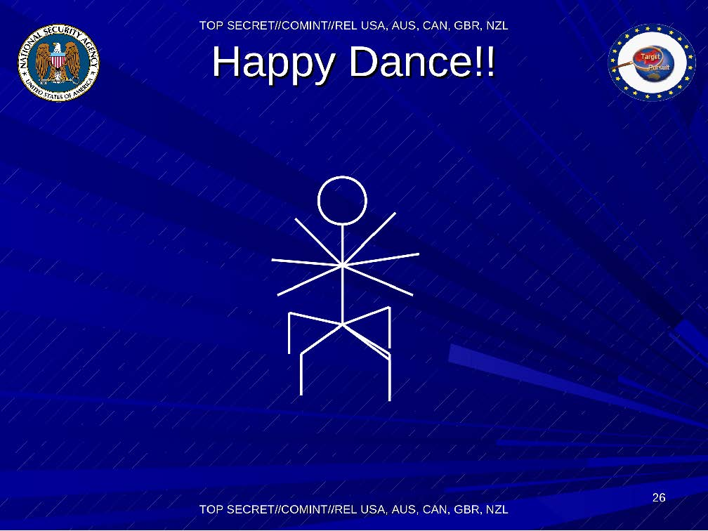

How the NSA feels about breaking encrypted communication

1. The first attack of this flavor was given in the 1982 paper of Goldwasser, Micali, and Tong. Interestingly, this notion of “hardcore bits” has been used for both practical *attacks* against cryptosystems as well as theoretical (and sometimes practical) *constructions* of other cryptosystems.
2. Recall that it’s easy to obtain two independent random oracles from a single oracle , for example by letting and .
3. The registration process could be more subtle than that, and for example Alice might need to *prove* to the CA that she does indeed know the corresponding secret key.