Quantum computing

Boaz Barak

**Disclaimer:** The MS-Word version of this text has significant formatting issues compared to the PDF and HTML versions.

# Quantum computing

### 

* See main aspects in which quantum mechanics differs from local deterministic theories.
* Model of quantum circuits, or equivalently QNAND-CIRC programs
* The complexity class and what we know about its relation to other classes
* Ideas behind Shor’s Algorithm and the Quantum Fourier Transform

*“We always have had (secret, secret, close the doors!) … a great deal of difficulty in understanding the world view that quantum mechanics represents … It has not yet become obvious to me that there’s no real problem. … Can I learn anything from asking this question about computers–about this may or may not be mystery as to what the world view of quantum mechanics is?”* , Richard Feynman, 1981

*“The only difference between a probabilistic classical world and the equations of the quantum world is that somehow or other it appears as if the probabilities would have to go negative”*, Richard Feynman, 1981

There were two schools of natural philosophy in ancient Greece. *Aristotle* believed that objects have an *essence* that explains their behavior, and a theory of the natural world has to refer to the *reasons* (or “final cause” to use Aristotle’s language) as to why they exhibit certain phenomena. *Democritus* believed in a purely mechanistic explanation of the world. In his view, the universe was ultimately composed of elementary particles (or *Atoms*) and our observed phenomena arise from the interactions between these particles according to some local rules. Modern science (arguably starting with Newton) has embraced Democritus’ point of view, of a mechanistic or “clockwork” universe of particles and forces acting upon them.

While the classification of particles and forces evolved with time, to a large extent the “big picture” has not changed from Newton till Einstein. In particular it was held as an axiom that if we knew fully the current *state* of the universe (i.e., the particles and their properties such as location and velocity) then we could predict its future state at any point in time. In computational language, in all these theories the state of a system with particles could be stored in an array of numbers, and predicting the evolution of the system can be done by running some efficient (e.g., time) deterministic computation on this array.

## The double slit experiment

Alas, in the beginning of the 20th century, several experimental results were calling into question this “clockwork” or “billiard ball” theory of the world. One such experiment is the famous [double slit experiment](https://en.wikipedia.org/wiki/Double-slit_experiment). Here is one way to describe it. Suppose that we buy one of those baseball pitching machines, and aim it at a soft plastic wall, but put a *metal barrier with a single slit* between the machine and the plastic wall (see doublebaseballfig). If we shoot baseballs at the plastic wall, then some of the baseballs would bounce off the metal barrier, while some would make it through the slit and dent the wall. If we now carve out an additional slit in the metal barrier then more balls would get through, and so the plastic wall would be *even more dented*.

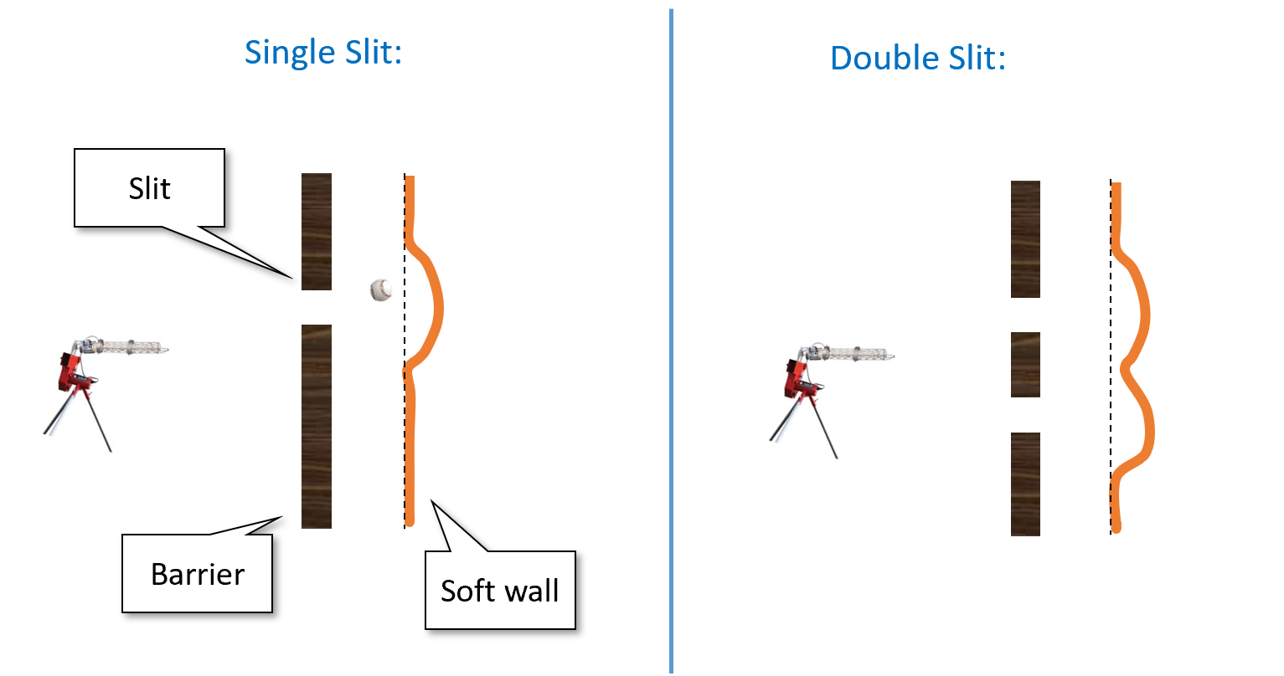

In the “double baseball experiment” we shoot baseballs from a gun at a soft wall through a hard barrier that has one or two slits open in it. There is only “constructive interference” in the sense that the dent in each position in the wall when both slits are open is the sum of the dents when each slit is open on its own.

So far this is pure common sense, and it is indeed (to my knowledge) an accurate description of what happens when we shoot baseballs at a plastic wall. However, this is not the same when we shoot *photons*. Amazingly, if we shoot with a “photon gun” (i.e., a laser) at a wall equipped with photon detectors through some barrier, then (as shown in doubleslitfig) in some positions of the wall we will see *fewer* hits when the two slits are open than when only one of them is!. In particular there are positions in the wall that are hit when the first slit is open, hit when the second gun is open, but are *not hit at all when both slits are open!*.

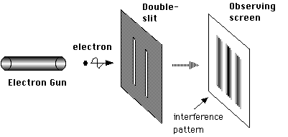

The setup of the double slit experiment in the case of photon or electron guns. We see also *destructive* interference in the sense that there are some positions on the wall that get *fewer* hits when both slits are open than they get when only one of the slits is open. See also [this video](https://www.youtube.com/watch?v=DfPeprQ7oGc).

It seems as if each photon coming out of the gun is aware of the global setup of the experiment, and behaves differently if two slits are open than if only one is. If we try to “catch the photon in the act” and place a detector right next to each slit so we can see exactly the path each photon takes then something even more bizarre happens. The mere fact that we *measure* the path changes the photon’s behavior, and now this “destructive interference” pattern is gone and the number of times a position is hit when two slits are open is the sum of the number of times it is hit when each slit is open.

### 

You should read the paragraphs above more than once and make sure you appreciate how truly mind boggling these results are.

## Quantum amplitudes

The double slit and other experiments ultimately forced scientists to accept a very counterintuitive picture of the world. It is not merely about nature being randomized, but rather it is about the probabilities in some sense “going negative” and cancelling each other!

To see what we mean by this, let us go back to the baseball experiment. Suppose that the probability a ball passes through the left slit is and the probability that it passes through the right slit is . Then, if we shoot balls out of each gun, we expect the wall will be hit times. In contrast, in the quantum world of photons instead of baseballs, it can sometimes be the case that in both the first and second case the wall is hit with positive probabilities and respectively but somehow when both slits are open the wall (or a particular position in it) is not hit at all. It’s almost as if the probabilities can “cancel each other out”.

To understand the way we model this in quantum mechanics, it is helpful to think of a “lazy evaluation” approach to probability. We can think of a probabilistic experiment such as shooting a baseball through two slits in two different ways:

* When a ball is shot, “nature” tosses a coin and decides if it will go through the left slit (which happens with probability ), right slit (which happens with probability ), or bounce back. If it passes through one of the slits then it will hit the wall. Later we can look at the wall and find out whether or not this event happened, but the fact that the event happened or not is determined independently of whether or not we look at the wall.
* The other viewpoint is that when a ball is shot, “nature” computes the probabilities and as before, but does *not* yet “toss the coin” and determines what happened. Only when we actually look at the wall, nature tosses a coin and with probability ensures we see a dent. That is, nature uses “lazy evaluation”, and only determines the result of a probabilistic experiment when we decide to *measure* it.

While the first scenario seems much more natural, the end result in both is the same (the wall is hit with probability ) and so the question of whether we should model nature as following the first scenario or second one seems like asking about the proverbial tree that falls in the forest with no one hearing about it.

However, when we want to describe the double slit experiment with photons rather than baseballs, it is the second scenario that lends itself better to a quantum generalization. Quantum mechanics associates a number known as an *amplitude* with each probabilistic experiment. This number can be *negative*, and in fact even *complex*. We never observe the amplitudes directly, since whenever we *measure* an event with amplitude , nature tosses a coin and determines that the event happens with probability . However, the sign (or in the complex case, phase) of the amplitudes can affect whether two different events have *constructive* or *destructive* interference.

Specifically, consider an event that can either occur or not (e.g. “detector number 17 was hit by a photon”). In classical probability, we model this by a probability distribution over the two outcomes: a pair of non-negative numbers and such that , where corresponds to the probability that the event occurs and corresponds to the probability that the event does not occur. In quantum mechanics, we model this also by pair of numbers, which we call *amplitudes*. This is a pair of (potentially negative or even complex) numbers and such that . The probability that the event occurs is and the probability that it does not occur is . In isolation, these negative or complex numbers don’t matter much, since we anyway square them to obtain probabilities. But the interaction of positive and negative amplitudes can result in surprising *cancellations* where somehow combining two scenarios where an event happens with positive probability results in a scenario where it never does.

If you don’t find the above description confusing and unintuitive, you probably didn’t get it. Please make sure to re-read the above paragraphs until you are thoroughly confused.

Quantum mechanics is a mathematical theory that allows us to calculate and predict the results of the double-slit and many other experiments. If you think of quantum mechanics as an explanation as to what “really” goes on in the world, it can be rather confusing. However, if you simply “shut up and calculate” then it works amazingly well at predicting experimental results. In particular, in the double slit experiment, for any position in the wall, we can compute numbers and such that photons from the first and second slit hit that position with probabilities and respectively. When we open both slits, the probability that the position will be hit is proportional to , and so in particular, if then it will be the case that, despite being hit when *either* slit one or slit two are open, the position is *not hit at all* when they both are. If you are confused by quantum mechanics, you are not alone: for decades people have been trying to come up with [explanations](https://en.wikipedia.org/wiki/Interpretations_of_quantum_mechanics) for “the underlying reality” behind quantum mechanics, including [Bohmian Mechanics](https://en.wikipedia.org/wiki/De_Broglie%E2%80%93Bohm_theory), [Many Worlds](https://en.wikipedia.org/wiki/Many-worlds_interpretation) and others. However, none of these interpretations have gained universal acceptance and all of those (by design) yield the same experimental predictions. Thus at this point many scientists prefer to just ignore the question of what is the “true reality” and go back to simply “shutting up and calculating”.

If (like the author) you are a bit intimidated by complex numbers, don’t worry: you can think of all amplitudes as *real* (though potentially *negative*) numbers without loss of understanding. All the “magic” of quantum computing already arises in this case, and so we will often restrict attention to real amplitudes in this chapter.

We will also only discuss so-called *pure* quantum states, and not the more general notion of *mixed* states. Pure states turn out to be sufficient for understanding the algorithmic aspects of quantum computing.

More generally, this chapter is not meant to be a complete description of quantum mechanics, quantum information theory, or quantum computing, but rather illustrate the main points where these differ from classical computing.

### Linear algebra quick review

*Linear algebra* underlies much of quantum mechanics, and so you would do well to review some of the basic notions such as vectors, matrices, and linear subspaces. The operations in quantum mechanics can be represented as linear functions over the *complex* numbers, but we stick to the real numbers in this chapter. This does not cause much loss in understanding but does allow us to simplify our notation and eliminate the use of the complex conjugate.

The main notions we use are:

* A function is *linear* if for every and .
* The *inner product* of two vectors can be defined as . (There can be different inner products but we stick to this one.) The *norm* of a vector is defined as . We say that is a *unit vector* if .
* Two vectors are *orthogonal* if . An *orthonormal basis* for is a set of vectors such that for every and for every . A canoncial example is the *standard basis* , where is the vector that has zeroes in all cooordinates except the -th coordinate in which its value is . A quirk of the quantum mechanics literature is that is often denoted by . We often consider the case , in which case we identify with and for every , we denote the standard basis element corresponding to the -th coordinate by .
* If is a vector in and is an orthonormal basis for , then there are coefficients such that . Consequently, the value is determined by the values , , . Moreover, .
* We can represent a linear function as an *matrix* where the coordinate in the -th row and -th column of (that is ) is equal to or equivalently the -th coordinate of .
* A linear function such that for every is called *unitary*. It can be shown that a function is unitary if and only if where is the *transpose* operator (in the complex case the conjugate transpose) and is the identity matrix that has ’s on the diagonal and zeroes everywhere else. (For every two matrices , we use to denote the *matrix product* of and .) Another equivalent characterization of this condition is that and yet another is that both the rows and columns of form an orthonormal basis.

## Bell’s Inequality

There is something weird about quantum mechanics. In 1935 [Einstein, Podolsky and Rosen (EPR)](http://plato.stanford.edu/entries/qt-epr/) tried to pinpoint this issue by highlighting a previously unrealized corollary of this theory. They showed that the idea that nature does not determine the results of an experiment until it is measured results in so called “spooky action at a distance”. Namely, making a measurement of one object may instantaneously effect the state (i.e., the vector of amplitudes) of another object in the other end of the universe.

Since the vector of amplitudes is just a mathematical abstraction, the EPR paper was considered to be merely a thought experiment for philosophers to be concerned about, without bearing on experiments. This changed when in 1965 John Bell showed an actual experiment to test the predictions of EPR and hence pit intuitive common sense against quantum mechanics. Quantum mechanics won: it turns out that it *is* in fact possible to use measurements to create correlations between the states of objects far removed from one another that cannot be explained by any prior theory. Nonetheless, since the results of these experiments are so obviously wrong to anyone that has ever sat in an armchair, that there are still a number of [Bell denialists](http://www.scottaaronson.com/blog/?p=2464) arguing that this can’t be true and quantum mechanics is wrong.

So, what is this Bell’s Inequality? Suppose that Alice and Bob try to convince you they have telepathic ability, and they aim to prove it via the following experiment. Alice and Bob will be in separate closed rooms.[1] You will interrogate Alice and your associate will interrogate Bob. You choose a random bit and your associate chooses a random . We let be Alice’s response and be Bob’s response. We say that Alice and Bob win this experiment if . In other words, Alice and Bob need to output two bits that *disagree* if and *agree* otherwise.

Now if Alice and Bob are not telepathic, then they need to agree in advance on some strategy. It’s not hard for Alice and Bob to succeed with probability : just always output the same bit. Moreover, by doing some case analysis, we can show that no matter what strategy they use, Alice and Bob cannot succeed with higher probability than that:

### 

For every two functions , .

Since the probability is taken over all four choices of , the only way the theorem can be violated if if there exist two functions that satisfy

for all the four choices of . Let’s plug in all these four choices and see what we get (below we use the equalities , and ):

If we XOR together the first and second equalities we get while if we XOR together the third and fourth equalities we get , thus obtaining a contradiction.

bellthm above assumes that Alice and Bob use *deterministic* strategies and respectively. More generally, Alice and Bob could use a *randomized* strategy, or equivalently, each could choose and from some *distributions* and respectively. However the *averaging principle* (averagingprinciplerem) implies that if all possible deterministic strategies succeed with probability at most , then the same is true for all randomized strategies.

An amazing [experimentally verified](http://arxiv.org/abs/1508.05949) fact is that quantum mechanics allows for “telepathy”.[2] Specifically, it has been shown that using the weirdness of quantum mechanics, there is in fact a strategy for Alice and Bob to succeed in this game with probability larger than (in fact, they can succeed with probability about , see bellstrategy).

## Quantum weirdness

Some of the counterintuitive properties that arise from quantum mechanics include:

* **Interference** - As we’ve seen, quantum amplitudes can “cancel each other out”.
* **Measurement** - The idea that amplitudes are negative as long as “no one is looking” and “collapse” (by squaring them) to positive probabilities when they are *measured* is deeply disturbing. Indeed, as shown by EPR and Bell, this leads to various strange outcomes such as “spooky actions at a distance”, where we can create correlations between the results of measurements in places far removed. Unfortunately (or fortunately?) these strange outcomes have been confirmed experimentally.
* **Entanglement** - The notion that two parts of the system could be connected in this weird way where measuring one will affect the other is known as *quantum entanglement*.

As counter-intuitive as these concepts are, they have been experimentally confirmed, so we just have to live with them.

The discussion in this chapter of quantum mechanics in general and quantum computing in particular is quite brief and superficial, the “bibliographical notes” section (quantumbibnotessec) contains references and links to many other resources that cover this material in more depth.

## Quantum computing and computation - an executive summary.

One of the strange aspects of the quantum-mechanical picture of the world is that unlike in the billiard ball example, there is no obvious algorithm to simulate the evolution of particles over time periods in steps. In fact, the natural way to simulate quantum particles will require a number of steps that is *exponential* in . This is a huge headache for scientists that actually need to do these calculations in practice.

In the 1981, physicist Richard Feynman proposed to “turn this lemon to lemonade” by making the following almost tautological observation:

If a physical system cannot be simulated by a computer in steps, the system can be considered as performing a computation that would take more than steps.

So, he asked whether one could design a quantum system such that its outcome based on the initial condition would be some function such that **(a)** we don’t know how to efficiently compute in any other way, and **(b)** is actually useful for something.[3] In 1985, David Deutsch formally suggested the notion of a quantum Turing machine, and the model has been since refined in works of Deutsch, Josza, Bernstein and Vazirani. Such a system is now known as a *quantum computer*.

For a while these hypothetical quantum computers seemed useful for one of two things. First, to provide a general-purpose mechanism to simulate a variety of the real quantum systems that people care about, such as various interactions inside molecules in quantum chemistry. Second, as a challenge to the *Physical Extended Church Turing Thesis* which says that every physically realizable computation device can be modeled (up to polynomial overhead) by Turing machines (or equivalently, NAND-TM / NAND-RAM programs).

Quantum chemistry is important (and in particular understanding it can be a bottleneck for designing new materials, drugs, and more), but it is still a rather niche area within the broader context of computing (and even scientific computing) applications. Hence for a while most researchers (to the extent they were aware of it), thought of quantum computers as a theoretical curiosity that has little bearing to practice, given that this theoretical “extra power” of quantum computer seemed to offer little advantage in the majority of the problems people want to solve in areas such as combinatorial optimization, machine learning, data structures, etc..

To some extent this is still true today. As far as we know, quantum computers, if built, will *not* provide exponential speed ups for 95% of the applications of computing.[4] In particular, as far as we know, quantum computers will *not* help us solve complete problems in polynomial or even sub-exponential time, though *Grover’s algorithm* ( quantumnp) does yield a quadratic advantage in many cases.

However, there is one cryptography-sized exception: In 1994 Peter Shor showed that quantum computers can solve the integer factoring and discrete logarithm in polynomial time. This result has captured the imagination of a great many people, and completely energized research into quantum computing. This is both because the hardness of these particular problems provides the foundations for securing such a huge part of our communications (and these days, our economy), as well as it was a powerful demonstration that quantum computers could turn out to be useful for problems that a-priori seemed to have nothing to do with quantum physics.

As we’ll discuss later, at the moment there are several intensive efforts to construct large scale quantum computers. It seems safe to say that, as far as we know, in the next five years or so there will not be a quantum computer large enough to factor, say, a bit number. On the other hand, it does seem quite likely that in the very near future there will be quantum computers which achieve *some* task exponentially faster than the best-known way to achieve the same task with a classical computer. When and if a quantum computer is built that is strong enough to break reasonable parameters of Diffie Hellman, RSA and elliptic curve cryptography is anybody’s guess. It could also be a “self destroying prophecy” whereby the existence of a small-scale quantum computer would cause everyone to shift away to lattice-based crypto which in turn will diminish the motivation to invest the huge resources needed to build a large scale quantum computer.[5]

Despite popular accounts of quantum computers as having variables that can take “zero and one at the same time” and therefore can “explore an exponential number of possibilities simultaneously”, their true power is much more subtle and nuanced. In particular, as far as we know, quantum computers do *not* enable us to solve complete problems such as 3SAT in polynomial or even sub-exponential time. However, [Grover’s search algorithm](https://goo.gl/NQVLLF) does give a more modest advantage (namely, quadratic) for quantum computers over classical ones for problems in . In particular, due to Grover’s search algorithm, we know that the -SAT problem for variables can be solved in time on a quantum computer for every . In contrast, the best known algorithms for -SAT on a classical computer take roughly steps.

Quantum computers are not a panacea and are unlikely to solve complete problems, but they can provide exponential speedups to certain *structured* problems.

## Quantum systems

Before we talk about *quantum* computing, let us recall how we physically realize “vanilla” or *classical* computing. We model a *logical bit* that can equal or a by some physical system that can be in one of two states. For example, it might be a wire with high or low voltage, charged or uncharged capacitor, or even (as we saw) a pipe with or without a flow of water, or the presence or absence of a soldier crab. A *classical* system of bits is composed of such “basic systems”, each of which can be in either a “zero” or “one” state. We can model the state of such a system by a string . If we perform an operation such as writing to the 17-th bit the NAND of the 3rd and 5th bits, this corresponds to applying a *local* function to such as setting .

In the *probabilistic* setting, we would model the state of the system by a *distribution*. For an individual bit, we could model it by a pair of non-negative numbers such that , where is the probability that the bit is zero and is the probability that the bit is one. For example, applying the *negation* (i.e., NOT) operation to this bit corresponds to mapping the pair to since the probability that is equal to is the same as the probability that is equal to . This means that we can think of the NOT function as the linear map such that or equivalently as the matrix .

If we think of the -bit system as a whole, then since the bits can take one of possible values, we model the state of the system as a vector of probabilities. For every , we denote by the dimensional vector that has in the coordinate corresponding to (identifying it with a number in ), and so can write as where is the probability that the system is in the state .

Applying the operation above of setting the -th bit to the NAND of the 3rd and 5th bits, corresponds to transforming the vector to the vector where is the linear map that maps to . (Since is a *basis* for , it suffices to define the map on vectors of this form.)

Please make sure you understand why performing the operation will take a system in state to a system in the state . Understanding the evolution of probabilistic systems is a prerequisite to understanding the evolution of quantum systems.

If your linear algebra is a bit rusty, now would be a good time to review it, and in particular make sure you are comfortable with the notions of *matrices*, *vectors*, (orthogonal and orthonormal) *bases*, and *norms*.

### Quantum amplitudes

In the quantum setting, the state of an individual bit (or “qubit”, to use quantum parlance) is modeled by a pair of numbers such that . While in general these numbers can be *complex*, for the rest of this chapter, we will often assume they are *real* (though potentially negative), and hence often drop the absolute value operator. (This turns out not to make much of a difference in explanatory power.) As before, we think of as the probability that the bit equals and as the probability that the bit equals . As we did before, we can model the NOT operation by the map where .

Following quantum tradition, instead of using and as we did above, from now on we will denote the vector by and the vector by (and moreover, think of these as column vectors). This is known as the Dirac “ket” notation. This means that NOT is the unique linear map that satisfies and . In other words, in the quantum case, as in the probabilistic case, NOT corresponds to the matrix

In classical computation, we typically think that there are only two operations that we can do on a single bit: keep it the same or negate it. In the quantum setting, a single bit operation corresponds to any linear map that is *norm preserving* in the sense that for every , if we apply to the vector then we obtain a vector such that . Such a linear map corresponds to a [unitary](https://en.wikipedia.org/wiki/Unitary_matrix) two by two matrix. (As we mentioned, quantum mechanics actually models states as vectors with *complex* coordinates; however, this does not make any qualitative difference to our discussion.) Keeping the bit the same corresponds to the matrix and (as we’ve seen) the NOT operations corresponds to the matrix . But there are other operations we can use as well. One such useful operation is the *Hadamard* operation, which corresponds to the matrix

In fact it turns out that Hadamard is all that we need to add to a classical universal basis to achieve the full power of quantum computing.

### Quantum systems: an executive summary

If you ignore the physics and philosophy, for the purposes of understanding the model of quantum computers, all you need to know about quantum systems is the following. The *state* of a *quantum system* of qubits is modeled by an dimensional vector of unit norm (i.e., squares of all coordinates sums up to ), which we write as where is the column vector that has in all coordinates except the one corresponding to (identifying with the numbers ). We use the convention that if are strings of lengths and respectively then we can write the dimensional vector with in the -th coordinate and zero elsewhere not just as but also as . In particular, for every , we can write the vector also as . This notation satisfies certain nice distributive laws such as .

A *quantum operation* on such a system is modeled by a *unitary matrix* (one that satisfies where is the *transpose* operation, or conjugate transpose for complex matrices). If the system is in state and we apply to it the operation , then the new state of the system is .

When we *measure* an -qubit system in a state , then we observe the value with probability . In this case, the system *collapses* to the state .

## Analysis of Bell’s Inequality (optional)

Now that we have the notation in place, we can show a strategy for Alice and Bob to display “quantum telepathy” in Bell’s Game. Recall that in the classical case, Alice and Bob can succeed in the “Bell Game” with probability at most . We now show that quantum mechanics allows them to succeed with probability at least . (The strategy we show is not the best one. Alice and Bob can in fact succeed with probability .)

### 

There is a 2-qubit quantum state so that if Alice has access to the first qubit of , can manipulate and measure it and output and Bob has access to the second qubit of and can manipulate and measure it and output then .

Alice and Bob will start by preparing a 2-qubit quantum system in the state

(this state is known as an [EPR pair](https://en.wikipedia.org/wiki/EPR_paradox)). Alice takes the first qubit of the system to her room, and Bob takes the second qubit to his room. Now, when Alice receives if she does nothing and if she applies the unitary map to her qubit where is the unitary operation corresponding to rotation in the plane with angle . When Bob receives , if he does nothing and if he applies the unitary map to his qubit. Then each one of them measures their qubit and sends this as their response.

Recall that to win the game Bob and Alice want their outputs to be more likely to differ if and to be more likely to agree otherwise. We will split the analysis in one case for each of the four possible values of and .

**Case 1: and .** If then the state does not change. Because the state is proportional to , the measurements of Bob and Alice will always agree (if Alice measures then the state collapses to and so Bob measures as well, and similarly for ). Hence in the case , Alice and Bob always win.

**Case 2: and .** If and then after Alice measures her bit, if she gets then the system collapses to the state , in which case after Bob performs his rotation, his qubit is in the state . Thus, when Bob measures his qubit, he will get (and hence agree with Alice) with probability . Similarly, if Alice gets then the system collapses to , in which case after rotation Bob’s qubit will be in the state and so once again he will agree with Alice with probability .

The analysis for **Case 3**, where and , is completely analogous to Case 2. Hence Alice and Bob will agree with probability in this case as well. (To show this we use the observation that the result of this experiment is the same regardless of the order in which Alice and Bob apply their rotations and measurements; this requires a proof but is not very hard to show.)

**Case 4: and .** For the case that and , after both Alice and Bob perform their rotations, the state will be proportional to

Intuitively, since we rotate one state by 45 degrees and the other state by -45 degrees, they will become orthogonal to each other, and the measurements will behave like independent coin tosses that agree with probability 1/2. However, for the sake of completeness, we now show the full calculation.

Opening up the coefficients and using and , we can see that quantumbellcasefoureq is proportional to

Using the trigonometric identities and , we see that the probability of getting any one of is proportional to . Hence all four options for are equally likely, which mean that in this case with probability .

Taking all the four cases together, the overall probability of winning the game is .

### 

It is instructive to understand what is it about quantum mechanics that enabled this gain in Bell’s Inequality. For this, consider the following analogous probabilistic strategy for Alice and Bob. They agree that each one of them output if he or she get as input and outputs with probability if they get as input. In this case one can see that their success probability would be . The quantum strategy we described above can be thought of as a variant of the probabilistic strategy for parameter set to . But in the case , instead of disagreeing only with probability , the existence of the so called ``negative probabilities’’ in the quantum world allowed us to rotate the state in *opposing directions* to achieve *destructive interference* and hence a higher probability of disagreement, namely .

## Quantum computation

Recall that in the classical setting, we modeled computation as obtained by a sequence of *basic operations*. We had two types of computational models:

* *Non uniform models of computation* such as Boolean circuits and NAND-CIRC programs, where a finite function is computable in size if it can be expressed as a combination of basic operations (gates in a circuit or lines in a NAND-CIRC program)
* *Uniform models of computation* such as Turing machines and NAND-TM programs, where an infinite function is computable in time if there is a single algorithm that on input evaluates using at most basic steps.

When considering *efficient computation*, we defined the class to consist of all infinite functions that can be computed by a Turing machine or NAND-TM program in time for some polynomial . We defined the class to consists of all infinite functions such that for every , the restriction of to can be computed by a Boolean circuit or NAND-CIRC program of size at most for some polynomial .

We will do the same for *quantum computation*, focusing mostly on the *non uniform* setting of quantum circuits, since that is simpler, and already illustrates the important differences with classical computing.

### Quantum circuits

A *quantum circuit* is analogous to a Boolean circuit, and can be described as a directed acyclic graph. One crucial difference that the *out degree* of every vertex in a quantum circuit is at most one. This is because we cannot “reuse” quantum states without *measuring* them (which collapses their “probabilities”). Therefore, we cannot use the same qubit as input for two different gates. (This is known as the [No Cloning Theorem](https://goo.gl/jCVtEY).) Another more technical difference is that to express our operations as unitary matrices, we will need to make sure all our gates are *reversible*. This is not hard to ensure. For example, in the quantum context, instead of thinking of as a (non reversible) map from to , we will think of it as the reversible map on *three* qubits that maps to (i.e., flip the last bit if of the first two bits is ). Equivalently, the NAND operation corresponds to the unitary matrix such that (identifying with ) for every , if is the basis element with in the -th coordinate and zero elsewhere, then .[6] If we order the rows and columns as , then can be written as the following matrix:

If we have an qubit system, then for , we will denote by as the unitary matrix that corresponds to applying to the -th, -th, and -th bits, leaving the others intact. That is, for every , .

As mentioned above, we will also use the *Hadamard* or operation, A *quantum circuit* is obtained by applying a sequence of and gates, where a gates corresponding to applying the matrix

Another way to write define is that for , . We define to be the unitary matrix that applies to the -th qubit and leaves the others intact. Using the ket notation, we can write this as

A *quantum circuit* is obtained by composing these basic operations on some qubits. If , we use a circuit to compute a function :

* On input , we initialize the system to hold in the first qubits, and initialize all remaining qubits to zero.
* We execute each elementary operation one by one: at every step we apply to the current state either an operation of the form or an operation of the form for .
* At the end of the computation, we *measure* the system, and output the result of the last qubit (i.e. the qubit in location ). (For simplicity we restrict attention to functions with a single bit of output, though the definition of quantum circuits naturally extends to circuits with multiple outputs.)
* We say that the circuit *computes* the function if the probability that this output equals is at least . Note that this probability is obtained by summing up the squares of the amplitudes of all coordinates in the final state of the system corresponding to vectors where .

Formally we define quantum circuits as follows:

Let . A *quantum circuit of inputs, auxiliary bits, and gates* over the basis is a sequence of unitary matrices such that each matrix is either of the form for or for .

A quantum circuit *computes* a function if the following is true for every :

Let be the vector

and write as . Then

Please stop here and see that this definition makes sense to you.

Just as we did with classical computation, we can define mathematical models for quantum computation, and represent quantum algorithms as binary strings.

Once we have the notion of quantum circuits, we can define the quantum analog of (i.e., the class of functions computable by *polynomial size quantum circuits*) as follows:

### 

Let . We say that if there exists some polynomial such that for every , if is the restriction of to inputs of length , then there is a quantum circuit of size at most that computes .

A priori it might seem “obvious” that quantum computing is exponentially powerful, since to perform a quantum computation on bits we need to maintain the dimensional state vector and apply matrices to it. Indeed popular descriptions of quantum computing (too) often say something along the lines that the difference between quantum and classical computer is that a classical bit can either be zero or one while a qubit can be in both states at once, and so in many qubits a quantum computer can perform exponentially many computations at once.

Depending on how you interpret it, this description is either false or would apply equally well to *probabilistic computation*, even though we’ve already seen that every randomized algorithm can be simulated by a similar-sized circuit, and in fact we conjecture that .

Moreover, this “obvious” approach for simulating a quantum computation will take not just exponential time but *exponential space* as well, while can be shown that using a simple recursive formula one can calculate the final quantum state using *polynomial space* (in physics this is known as “Feynman path integrals”). So, the exponentially long vector description by itself does not imply that quantum computers are exponentially powerful. Indeed, we cannot *prove* that they are (i.e., we have not been able to rule out the possibility that every QNAND-CIRC program could be simulated by a NAND-CIRC program/ Boolean circuit with polynomial overhead), but we do have some problems (integer factoring most prominently) for which they do provide exponential speedup over the currently best *known* classical (deterministic or probabilistic) algorithms.

### QNAND-CIRC programs (optional)

Just like in the classical case, there is an equivalence between circuits and straight-line programs, and so we can define the programming language QNAND-CIRC that is the quantum analog of our NAND-CIRC programming language. To do so, we only add a single operation: HAD(foo) which applies the single-bit operation to the variable foo. We also use the following interpretation to make NAND reversible: foo = NAND(bar,blah) means that we modify foo to be the XOR of its original value and the NAND of bar and blah. (In other words, apply the by unitary transformation defined above to the three qubits corresponding to foo, bar and blah.) If foo is initialized to zero then this makes no difference.

If is a QNAND-CIRC program with input variables, workspace variables, and output variables, then running it on the input corresponds to setting up a system with qubits and performing the following process:

1. We initialize the input variables X[] X[] to and all other variables to .
2. We execute the program line by line, applying the corresponding physical operation or to the qubits that are referred to by the line.
3. We *measure* the output variables Y[], , Y[] and output the result (if there is more than one output then we measure more variables).

### Uniform computation

Just as in the classical case, we can define *uniform* computational models for quantum computing as well. We will let be the quantum analog to and : the class of all Boolean functions that can be computed by quantum algorithms in polynomial time. There are several equivalent ways to define . For example, there is a computational model of [Quantum Turing Machines](https://en.wikipedia.org/wiki/Quantum_Turing_machine) that can be used to define just as standard Turing machines are used to define . Another alternative is to define the *QNAND-TM programming language* to be QNAND-CIRC augmented with loops and arrays just like NAND-TM is obtained from NAND-CIRC. Once again, we can define using QNAND-TM programs analogously to the way can be defined using NAND-TM programs. However, we use the following equivalent definition (which is also the one most popular in the literature):

### 

Let . We say that if there exists a polynomial time NAND-TM program such that for every , is the description of a quantum circuit that computes the restriction of to .

### 

BQPdef is the quantum analog of the alternative characterization of that appears in Palternativeex. One way to verify that you’ve understood BQPdef it to see that you can prove **(1)** and in fact the stronger statement , **(2)** , and **(3)** For every -complete function , if then . BQPcontainements asks you to work these out.

The relation between and is not known (see also quantumnp). It is widely believed that , but there is no consensus whether or not . It is [quite possible](https://eccc.weizmann.ac.il/report/2018/107/) that these two classes are *incomparable*, in the sense that (and in particular no -complete function belongs to ) but also (and there are some interesting candidates for such problems).

It can be shown that (evaluating a quantum circuit on an input) is computable by a polynomial size QNAND-CIRC program, and moreover this program can even be generated *uniformly* and hence is in . This allows us to “port” many of the results of classical computational complexity into the quantum realm, including the notions of a universal quantum Turing machine, as well as all of the uncomputability results. There is even a quantum analog of the [Cook-Levin Theorem](https://arxiv.org/abs/1401.3916).

Because the non uniform model is a little cleaner to work with, in the rest of this chapter we mostly restrict attention to this model, though all the algorithms we discuss can be implemented using uniform algorithms as well.

## Physically realizing quantum computation

To realize quantum computation one needs to create a system with independent binary states (i.e., “qubits”), and be able to manipulate small subsets of two or three of these qubits to change their state. While by the way we defined operations above it might seem that one needs to be able to perform arbitrary unitary operations on these two or three qubits, it turns out that there are several choices for *universal sets* - a small constant number of gates that generate all others. The biggest challenge is how to keep the system from being measured and *collapsing* to a single classical combination of states. This is sometimes known as the *coherence time* of the system. The [threshold theorem](https://courses.cs.washington.edu/courses/cse599d/06wi/lecturenotes19.pdf) says that there is some absolute constant level of errors so that if errors are created at every gate at rate smaller than then we can recover from those and perform arbitrary long computations. (Of course there are different ways to model the errors and so there are actually several threshold *theorems* corresponding to various noise models).

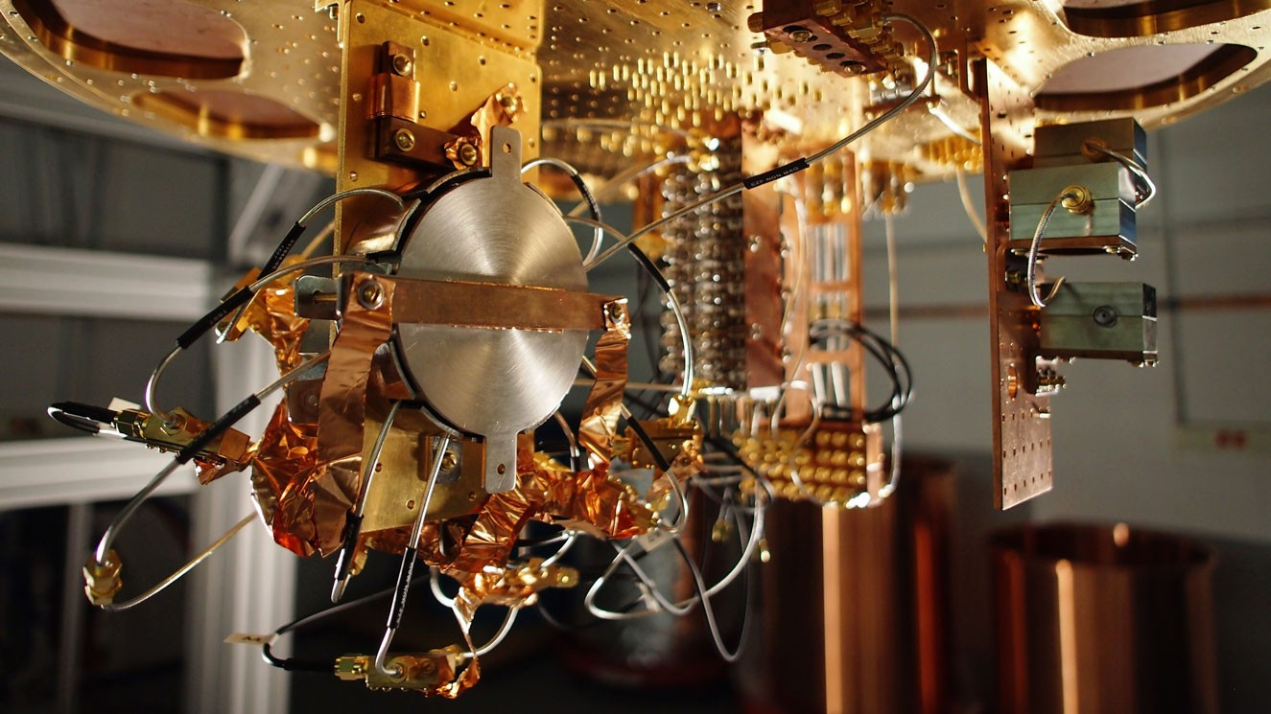

Superconducting quantum computer prototype at Google. Image credit: Google / MIT Technology Review.

There have been several proposals to build quantum computers:

* [Superconducting quantum computers](https://en.wikipedia.org/wiki/Superconducting_quantum_computing) use superconducting electric circuits to do quantum computation. This is the direction where [there has been most recent progress](https://arxiv.org/abs/1709.06678) towards “beating” classical computers.
* [Trapped ion quantum computers](https://en.wikipedia.org/wiki/Trapped_ion_quantum_computer) Use the states of an ion to simulate a qubit. People have made some [recent advances](http://iontrap.umd.edu/wp-content/uploads/2016/02/1602.02840v1.pdf) on these computers too. While it’s not at all clear that’s the right measuring yard, the [current best implementation](http://arxiv.org/abs/1507.08852) of Shor’s algorithm (for factoring 15) is done using an ion-trap computer.
* [Topological quantum computers](https://en.wikipedia.org/wiki/Topological_quantum_computer) use a different technology. Topological qubits are more stable by design and hence error correction is less of an issue, but constructing them is extremely challenging.

These approaches are not mutually exclusive and it could be that ultimately quantum computers are built by combining all of them together. In the near future, it seems that we will not be able to achieve full fledged large scale universal quantum computers, but rather more restricted machines, sometimes called “Noisy Intermediate-Scale Quantum Computers” or “NISQ”. See [this article by John Preskil](https://arxiv.org/abs/1801.00862) for some of the progress and applications of such more restricted devices.

## Shor’s Algorithm: Hearing the shape of prime factors

Bell’s Inequality is a powerful demonstration that there is something very strange going on with quantum mechanics. But could this “strangeness” be of any use to solve computational problems not directly related to quantum systems? A priori, one could guess the answer is *no*. In 1994 Peter Shor showed that one would be wrong:

There is a polynomial-time quantum algorithm that on input an integer (represented in base two), outputs the prime factorization of .

Another way to state shorthm is that if we define to be the function that on input a pair of numbers outputs if and only if has a factor such that , then is in . This is an exponential improvement over the best known classical algorithms, which take roughly time, where the notation hides factors that are polylogarithmic in . While we will not prove shorthm in this chapter, we will sketch some of the ideas behind the proof.

### Period finding

At the heart of Shor’s Theorem is an efficient quantum algorithm for finding *periods* of a given function. For example, a function is *periodic* if there is some such that for every (e.g., see periodicfig).

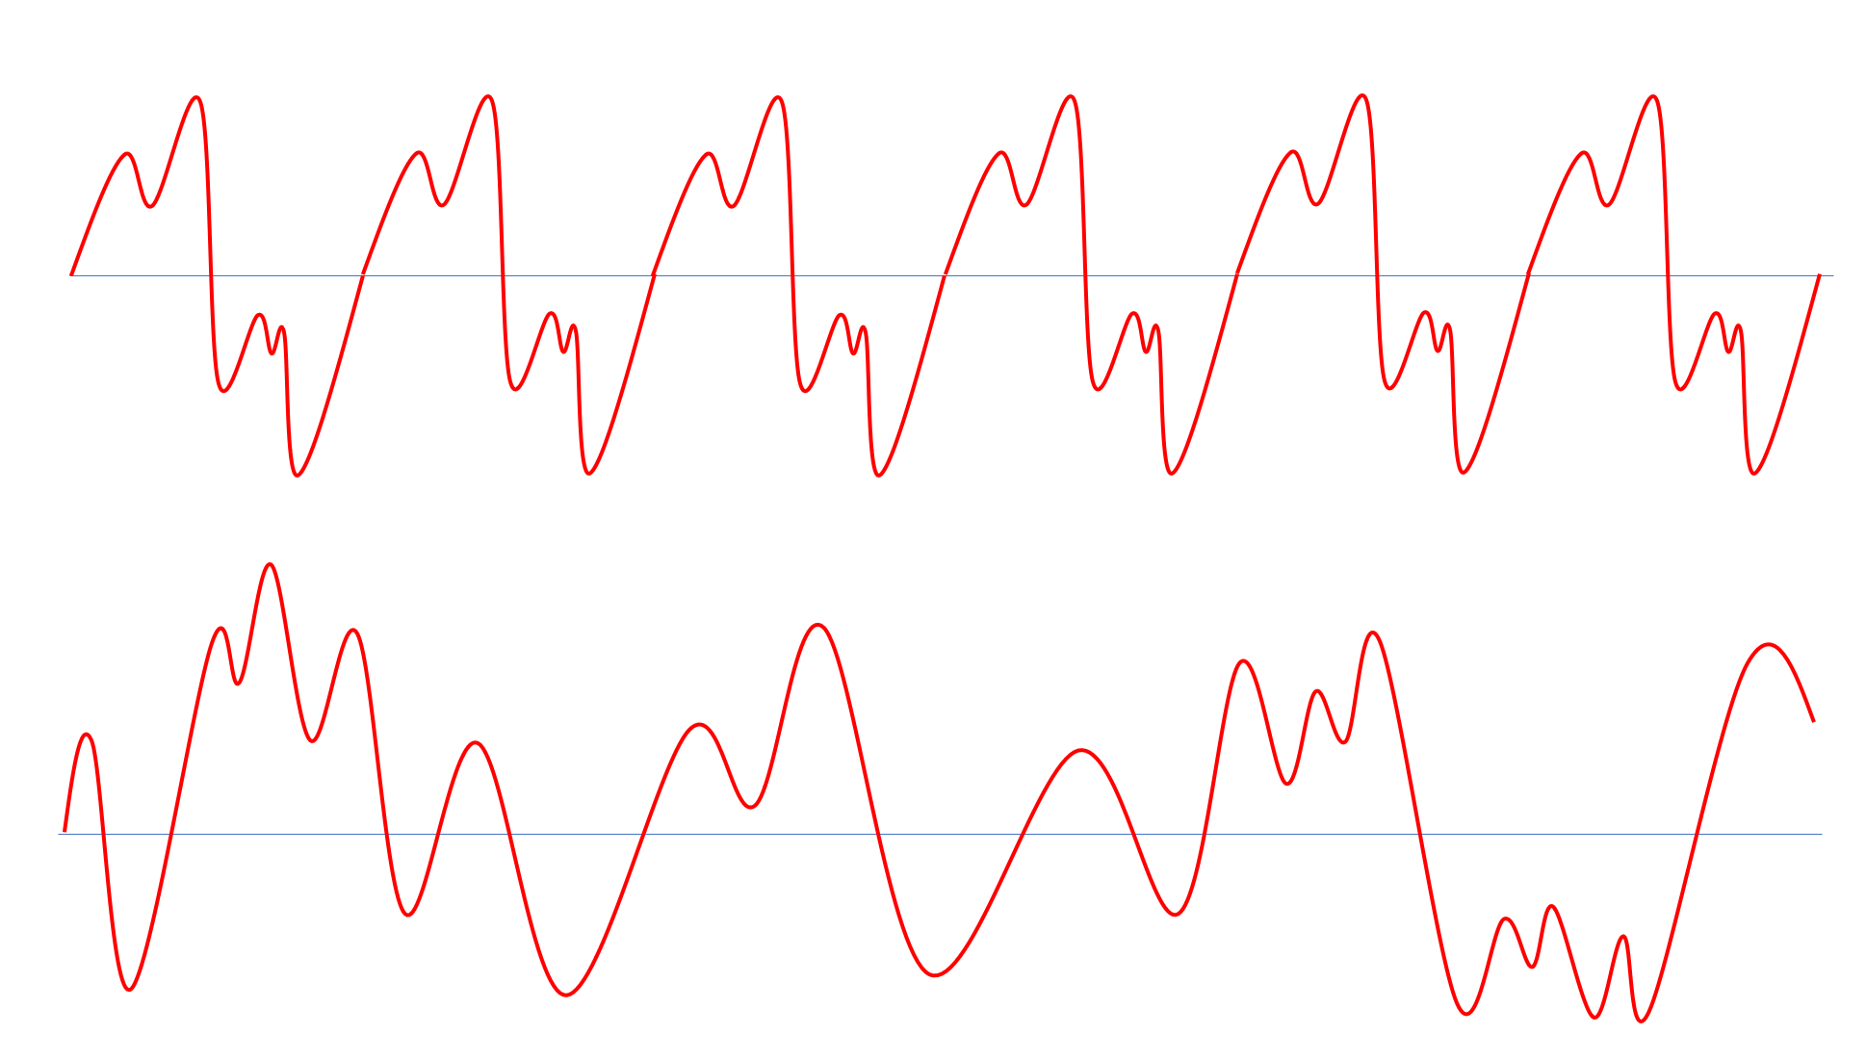

Top: A periodic function. Bottom: An a-periodic function.

*Musical notes* yield one type of periodic function. When you pull on a string on a musical instrument, it vibrates in a repeating pattern. Hence, if we plot the speed of the string (and so also the speed of the air around it) as a function of time, it will correspond to some *periodic* function. The length of the period is known as the *wave length* of the note. The *frequency* is the number of times the function repeats itself within a unit of time. For example, the “Middle C” note has a frequency of Hertz, which means its period is seconds.

If we play a *chord* by playing several notes at once, we get a more complex periodic function obtained by combining the functions of the individual notes (see timefreqfig). The human ear contains many small hairs, each of which is sensitive to a narrow band of frequencies. Hence when we hear the sound corresponding to a chord, the hairs in our ears actually separate it out to the components corresponding to each frequency.

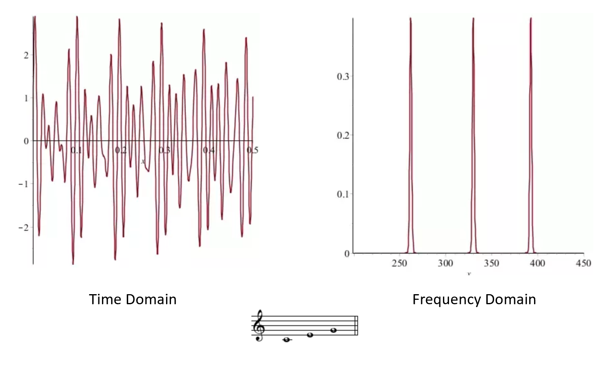

Left: The air-pressure when playing a “C Major” chord as a function of time. Right: The coefficients of the Fourier transform of the same function, we can see that it is the sum of three frequencies corresponding to the C, E and G notes (261.63, 329.63 and 392 Hertz respectively). Credit: Bjarke Mønsted’s [Quora answer](https://www.quora.com/What-is-the-meaning-of-frequency-domain).

It turns out that (essentially) *every* periodic function can be decomposed into a sum of simple *wave* functions (namely functions of the form or ). This is known as the [Fourier Transform](https://en.wikipedia.org/wiki/Fourier_transform) (see qfourierfig). The Fourier transform makes it easy to compute the period of a given function: it will simply be the least common multiple of the periods of the constituent waves.

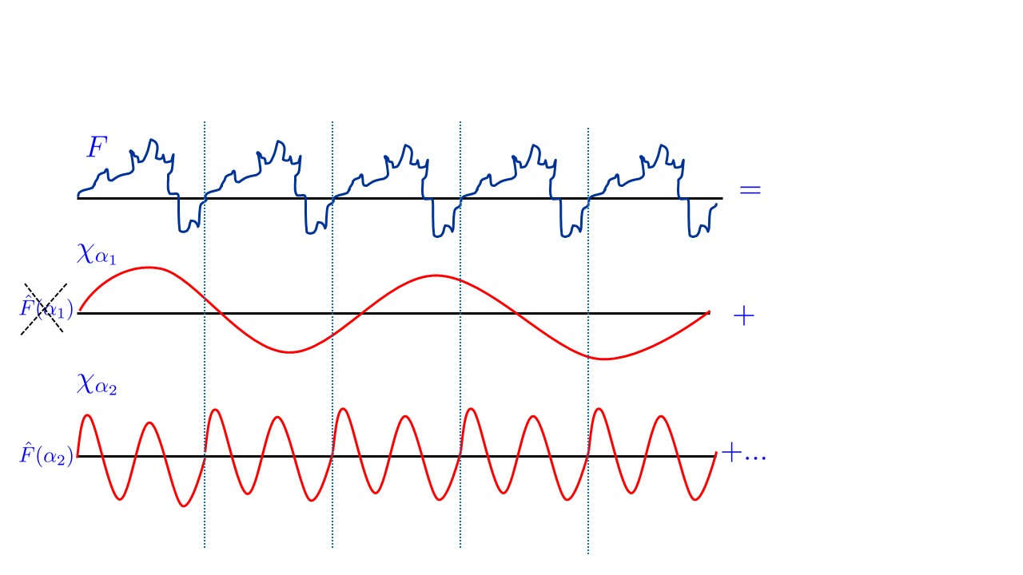

If is a periodic function then when we represent it in the Fourier transform, we expect the coefficients corresponding to wavelengths that do not evenly divide the period to be very small, as they would tend to “cancel out”.

### Shor’s Algorithm: A bird’s eye view

On input an integer , Shor’s algorithm outputs the prime factorization of in time that is polynomial in . The main steps in the algorithm are the following:

**Step 1: Reduce to period finding.** The first step in the algorithm is to pick a random and define the function as where we identify the string with an integer using the binary representation, and similarly represent the integer as a string. (We will choose to be some polynomial in and so in particular is a large enough set to represent all the numbers in ).

Some not-too-hard (though somewhat technical) calculations show that: **(1)** The function is *periodic* (i.e., there is some integer such that for “almost” every ) and more importantly **(2)** If we can recover the period of for several randomly chosen ’s, then we can recover the factorization of . (We’ll ignore the “almost” qualifier in the discussion below; it causes some annoying, yet ultimately manageable, technical issues in the full-fledged algorithm.) Hence, factoring reduces to finding out the period of the function . dlogfromorder asks you to work out this for the related task of computing the *discrete logarithm* (which underlies the security of the Diffie-Hellman key exchange and elliptic curve cryptography).

**Step 2: Period finding via the Quantum Fourier Transform.** Using a simple trick known as “repeated squaring”, it is possible to compute the map in time polynomial in , which means we can also compute this map using a polynomial number of NAND gates,and so in particular we can generate in polynomial quantum time a quantum state that is (up to normalization) equal to

In particular, if we were to *measure* the state , we would get a random pair of the form where . So far, this is not at all impressive. After all, we did not need the power of quantum computing to generate such pairs: we could simply generate a random and then compute .

Another way to describe the state is that the coefficient of in is proportional to where is the function such that

The magic of Shor’s algorithm comes from a procedure known as the [*Quantum Fourier Transform*](https://en.wikipedia.org/wiki/Quantum_Fourier_transform). It allows to change the state into the state where the coefficient of is now proportional to the *-th Fourier coefficient* of . In other words, if we measure the state , we will obtain a pair such that the probability of choosing is proportional to the square of the weight of the *frequency* in the representation of the function . Since for every , the function has the period , it can be shown that the frequency will be (almost) a multiple of . If we make several such samples and obtain the frequencies , then the true period divides all of them, and it can be shown that it is going to be in fact the *greatest common divisor* (g.c.d.) of all these frequencies: a value which can be computed in polynomial time.

As mentioned above, we can recover the factorization of from the periods of for some randomly chosen in and which is polynomial in .

The resulting algorithm can be described in a high (and somewhat inaccurate) level as follows:

**Shor’s Algorithm:** *(sketch)*

**Input:** Number .

**Output:** Prime factorization of .

**Operations:**

1. Repeat the following number of times:
   1. Choose at random, and let be the map .
   2. For , repeat times the following step: *Quantum Fourier Transform* to create a quantum state over qubits, such that if we measure we obtain a pair of strings with probability proportional to the square of the coefficient corresponding to the wave function or in the Fourier transform of the function defined as iff .
   3. If are the coefficients we obtained in the previous step, then the least common multiple of is likely to be the *period* of the function .
2. If we let and be the numbers we chose in the previous step and the corresponding periods of the functions then we can use classical results in number theory to obtain from these a non-trivial prime factor of (if such exists). We can now run the algorithm again with the (smaller) input to obtain all other factors.

Reducing factoring to order finding is cumbersome, but can be done in polynomial time using a classical computer. The key quantum ingredient in Shor’s algorithm is the *quantum fourier transform*.

Despite its name, the Quantum Fourier Transform does *not* actually give a way to compute the Fourier Transform of a function . This would be impossible to do in time polynomial in , as simply writing down the Fourier Transform would require coefficients. Rather the Quantum Fourier Transform gives a *quantum state* where the amplitude corresponding to an element (think: frequency) is equal to the corresponding Fourier coefficient. This allows to sample from a distribution where is drawn with probability proportional to the square of its Fourier coefficient. This is not the same as computing the Fourier transform, but is good enough for recovering the period.

## Quantum Fourier Transform (advanced, optional)

The above description of Shor’s algorithm skipped over the implementation of the main quantum ingredient: the *Quantum Fourier Transform* algorithm. In this section we discuss the ideas behind this algorithm. We will be rather brief and imprecise. quantumbibnotessec contain references to sources of more information about this topic.

To understand the Quantum Fourier Transform, we need to better understand the Fourier Transform itself. In particular, we will need to understand how it applies not just to functions whose input is a real number but to functions whose domain can be any arbitrary commutative *group*. Therefore we now take a short detour to (very basic) *group theory*, and define the notion of periodic functions over groups.

While we define the concepts we use, some background in group or number theory will be very helpful for fully understanding this section. In particular we will use the notion of *finite commutative (a.k.a. Abelian) groups*. These are defined as follows.

* A finite *group* is a pair where is a finite set of elements and is a *binary operation* mapping a pair of elements in to the element in . We often identify with the set of its elements, and so use notation such as to indicate that is an element of and to denote the number of elements in .
* The operation satisfies the sort of properties that a product operation does, namely, it is *associative* (i.e., ) and there is some element such that for all , and for every there exists an element such that .
* A group is called *commutative* (also known as *Abelian*) if for all .

The Fourier transform is a deep and vast topic, on which we will barely touch upon here. Over the real numbers, the Fourier transform of a function is obtained by expressing in the form where the ’s are “wave functions” (e.g. sines and cosines). However, it turns out that the same notion exists for *every* Abelian group . Specifically, for every such group , if is a function mapping to , then we can write as

where the ’s are functions mapping to that are analogs of the “wave functions” for the group and for every , is a complex number known as the *Fourier coefficient of corresponding to* . Specifically, the equation fourierexpansion means that if we think of as a dimensional vector over the complex numbers, then we can write this vector as a sum (with certain coefficients) of the vectors . The representation fourierexpansion is known as the *Fourier expansion* or *Fourier transform* of , the numbers are known as the *Fourier coefficients* of and the functions are known as the *Fourier characters*. The central property of the Fourier characters is that they are *homomorphisms* of the group into the complex numbers, in the sense that for every , , where is the group operation. One corollary of this property is that if then is  *periodic* in the sense that for every . It turns out that if is periodic with minimal period , then the only Fourier characters that have non zero coefficients in the expression fourierexpansion are those that are periodic as well. This can be used to recover the period of from its Fourier expansion.

### Quantum Fourier Transform over the Boolean Cube: Simon’s Algorithm

We now describe the simplest setting of the Quantum Fourier Transform: the group with the XOR operation, which we’ll denote by . (Since is equal to addition modulo two, this group is also often denoted as .) It can be shown that the Fourier transform over corresponds to expressing as

where is defined as and .

The Quantum Fourier Transform over is actually quite simple:

Let be a quantum state where is some function satisfying . Then we can use gates to transform to the state

where and is the function .

### 

The idea behind the proof is that the *Hadamard* operation corresponds to the *Fourier transform* over the group (with the XOR operations). To show this, we just need to do the calculations.

We can express the Hadamard operation as follows:

We are given the state

Now suppose that we apply the operation to each of the qubits. We can see that we get the state

We can now use the distributive law and open up a term of the form

to the following sum over terms:

(If you find the above confusing, try to work out explicitly this calculation for ; namely show that is the same as the sum over terms .)

By changing the order of summations, we see that the final state is

which exactly corresponds to .

### From Fourier to Period finding: Simon’s Algorithm (advanced, optional)

Using QFTcube it is not hard to get an algorithm that can recover a string given a circuit that computes a function that is  *periodic* in the sense that for distinct if and only if . The key observation is that if we compute the state , and perform the Quantum Fourier transform on the first qubits, then we would get a state such that the only basis elements with nonzero coefficients would be of the form where

So, by measuring the state, we can obtain a sample of a random satisfying eq:periodbooleanqft. But since eq:periodbooleanqft is a *linear* equation modulo about the unknown variables , if we repeat this procedure to get such equations, we will have at least as many equations as variables and (it can be shown that) this will suffice to recover .

This result is known as [Simon’s Algorithm](https://en.wikipedia.org/wiki/Simon%27s_problem), and it preceded and inspired Shor’s algorithm.

### From Simon to Shor (advanced, optional)

QFTcube seemed to really use the special bit-wise structure of the group , and so one could wonder if it can be extended to other groups. However, it turns out that we can in fact achieve such a generalization.

The key step in Shor’s algorithm is to implement the Fourier transform for the group which is the set of numbers with the operation being addition modulo . In this case it turns out that the Fourier characters are the functions where ( here denotes the complex number ). The -th Fourier coefficient of a function is

The key to implementing the Quantum Fourier Transform for such groups is to use the same recursive equations that enable the classical [Fast Fourier Transform (FFT)](https://en.wikipedia.org/wiki/Fast_Fourier_transform) algorithm. Specifically, consider the case that . We can separate the sum over in fouriercoeffmodular to the terms corresponding to even ’s (of the form ) and odd ’s (of the form ) to obtain

which reduces computing the Fourier transform of over the group to computing the Fourier transform of the functions and (corresponding to the applying to only the even and odd ’s respectively) which have inputs that we can identify with the group .

Specifically, the Fourier characters of the group are the functions for every . Moreover, since , for every . Thus eqfftrecurse translates into

This observation is usually used to obtain a fast (e.g. ) time to compute the Fourier transform in a classical setting, but it can be used to obtain a quantum circuit of gates to transform a state of the form to a state of the form .

The case that is not an exact power of two causes some complications in both the classical case of the Fast Fourier Transform and the quantum setting of Shor’s algorithm. However, it is possible to handle these. The idea is that we can embed in the group for any integer , and we can find an integer such that will be close enough to a power of (i.e., a number of the form for some ), so that if we do the Fourier transform over the group then we will not introduce too many errors.

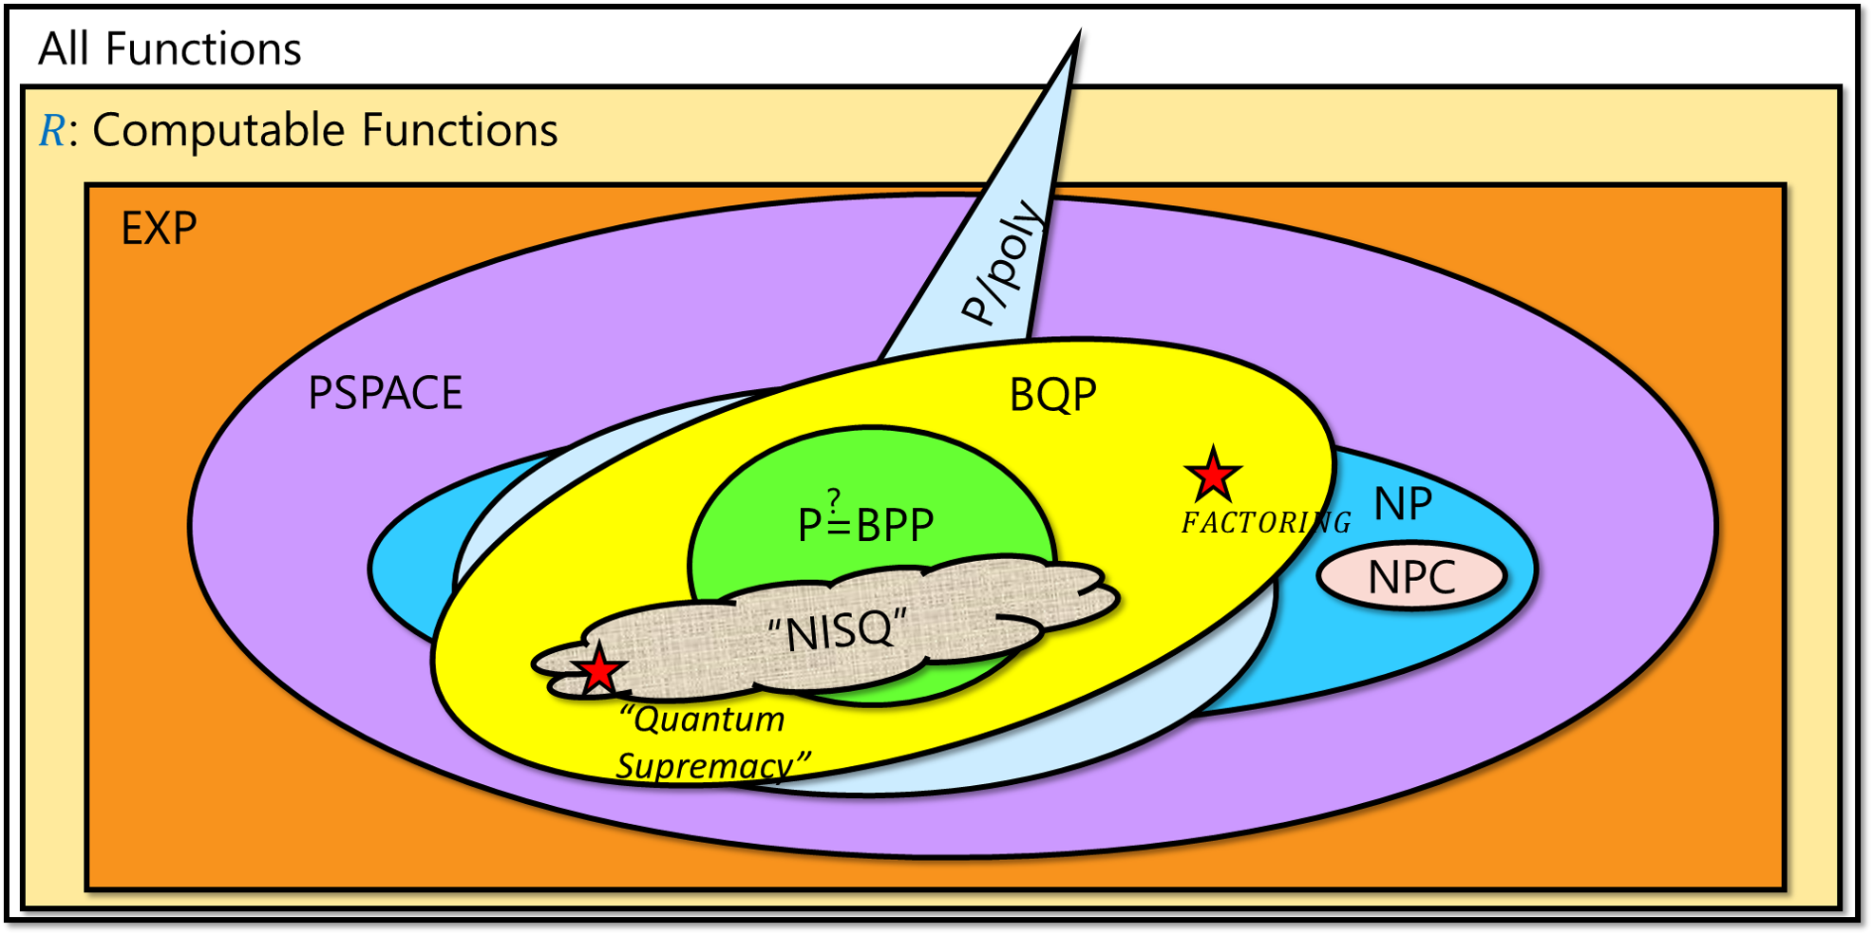

Conjectured status of with respect to other complexity classes. We know that and . It is not known if any of these inclusions are strict though it is believed that they are. The relation between and is unknown but they are believed to be incomparable, and that -complete problems *can not* be solved in polynomial time by quantum computers. However, it is possible that contains and even , and it is also possible that quantum computers offer no super-polynomial speedups and that . The class “” above is not a well defined complexity class, but rather captures the current status of quantum devices, which seem to be able to solve a set of computational tasks that is incomparable with the set of tasks solvable by classical computers. The diagram is also inaccurate in the sense that at the moment the “quantum supremacy” tasks on which such devices seem to offer exponential speedups do *not* correspond to Boolean functions/ decision problems.

### 

* The state of an -qubit quantum system can be modeled as a dimensional vector
* An operation on the state corresponds to applying a unitary matrix to this vector.
* Quantum circuits are obtained by composing basic operations such as and .
* We can use quantum circuits to define the classes and which are the quantum analogs of and respectively.
* There are some problems for which the best known quantum algorithm is *exponentially faster* than the best known, but quantum computing is not a panacea. In particular, as far as we know, quantum computers could still require exponential time to solve -complete problems such as .

## Exercises

Prove the following relations between quantum complexity classes and classical ones:

1. . See footnote for hint.[7]
2. . See footnote for hint.[8]
3. . See footnote for hint.[9]
4. . See footnote for hint.[10]
5. If then . See footnote for hint.[11]

Show a probabilistic polynomial time classical algorithm that given an Abelian finite group (in the form of an algorithm that computes the group operation), a *generator* for the group, and an element , as well as access to a black box that on input outputs the *order* of (the smallest such that ), computes the *discrete logarithm* of with respect to . That is the algorithm should output a number such that . See footnote for hint.[12]

## Bibliographical notes

An excellent gentle introduction to quantum computation is given in Mermin’s book [@mermin2007quantum]. In particular the first 100 pages (Chapter 1 to 4) of [@mermin2007quantum] cover all the material of this chapter in a much more comprehensive way. This material is also covered in the first 5 chapters of [De-Wolf’s online lecture notes](https://arxiv.org/abs/1907.09415). For a more condensed exposition, the chapter on quantum computation in my [book with Arora](http://theory.cs.princeton.edu/complexity/) (see [draft here](http://theory.cs.princeton.edu/complexity/ab_quantumchap.pdf)) is one relatively short source that contains full descriptions of Grover’s, Simon’s and Shor’s algorithms. This [blog post of Aaronson](http://www.scottaaronson.com/blog/?p=208) contains a high level explanation of Shor’s algorithm which ends with links to several more detailed expositions. Chapters 9 and 10 in Aaronson’s book [@Aaronson13democritus] give an informal but highly informative introduction to the topics of this chapter and much more. Chapter 10 in [Avi Wigderson’s book](https://www.math.ias.edu/avi/book) also provides a high level overview of quantum computing. Other recommended resources include Andrew Childs’ [lecture notes on quantum algorithms](http://www.cs.umd.edu/~amchilds/qa/qa.pdf), as well as the lecture notes of [Umesh Vazirani](https://inst.eecs.berkeley.edu/~cs191/), [John Preskill](http://www.theory.caltech.edu/people/preskill/ph229/), and [John Watrous](https://cs.uwaterloo.ca/~watrous/LectureNotes.html).

There are many excellent videos available online covering some of these materials. The videos of [Umesh Vazirani’z EdX course](https://www.youtube.com/playlist?list=PLDAjb_zu5aoFazE31_8yT0OfzsTcmvAVg) are an accessible and recommended introduction to quantum computing. Regarding quantum mechanics in general, this [video](https://www.youtube.com/watch?v=DfPeprQ7oGc) illustrates the double slit experiment, this [Scientific American video](https://www.youtube.com/watch?v=xM3GOXaci7w) is a nice exposition of Bell’s Theorem. This [talk and panel](https://youtu.be/GdqC2bVLesQ?t=2m51s) moderated by Brian Greene discusses some of the philosophical and technical issues around quantum mechanics and its so called “measurement problem”. The [Feynmann lecture on the Fourier Transform](http://www.feynmanlectures.caltech.edu/I_50.html) and [quantum mechanics in general](http://www.feynmanlectures.caltech.edu/III_toc.html) are very much worth reading. The Fourier transform is covered in these videos of [Dr. Chris Geoscience](https://youtu.be/EYRmB1aNh9I?t=19s), [Clare Zhang](https://www.youtube.com/watch?v=Y9pYHDSxc7g) and [Vi Hart](https://www.youtube.com/watch?v=i_0DXxNeaQ0). See also [Kelsey Houston-Edwards’s video on Shor’s Algorithm](https://www.youtube.com/watch?v=wUwZZaI5u0c).

The form of Bell’s game we discuss in bellineqsec was given by [Clauser, Horne, Shimony, and Holt](https://goo.gl/wvJGZU).

The [Fast Fourier Transform](https://en.wikipedia.org/wiki/Fast_Fourier_transform), used as a component in Shor’s algorithm, is one of the most widely used algorithms invented. The stories of its discovery by Gauss in trying to calculate asteroid orbits and rediscovery by Tukey during the cold war are fascinating as well.

The image in doubleslitfig is taken from Wikipedia.

Thanks to Scott Aaronson for many helpful comments about this chapter.

1. If you are extremely paranoid about Alice and Bob communicating with one another, you can coordinate with your assistant to perform the experiment exactly at the same time, and make sure that the rooms are sufficiently far apart (e.g., are on two different continents, or maybe even one is on the moon and another is on earth) so that Alice and Bob couldn’t communicate to each other in time the results of their respective coins even if they do so at the speed of light.
2. More accurately, one either has to give up on a “billiard ball type” theory of the universe or believe in telepathy (believe it or not, some scientists went for the [latter option](https://en.wikipedia.org/wiki/Superdeterminism)).
3. As its title suggests, Feynman’s [lecture](https://www.cs.berkeley.edu/~christos/classics/Feynman.pdf) was actually focused on the other side of simulating physics with a computer. However, he mentioned that as a “side remark” one could wonder if it’s possible to simulate physics with a new kind of computer - a “quantum computer” which would “not [be] a Turing machine, but a machine of a different kind”. As far as I know, Feynman did not suggest that such a computer could be useful for computations completely outside the domain of quantum simulation. Indeed, he was more interested in the question of whether quantum mechanics could be simulated by a classical computer.
4. This “95 percent” is a figure of speech, but not completely so. At the time of this writing, cryptocurrency mining electricity consumption is estimated to use up at least [70Twh or 0.3 percent of the world’s production](https://digiconomist.net/bitcoin-energy-consumption), which is about [2 to 5 percent](http://www.mdpi.com/2078-1547/6/1/117/html) of the total energy usage for the computing industry. All the current cryptocurrencies will be broken by quantum computers. Also, for many web servers the TLS protocol (which is based on the current non-lattice based systems would be completely broken by quantum computing) is responsible [for about 1 percent of the CPU usage](https://goo.gl/mHpYpm).
5. Of course, given that [we’re still hearing](http://blog.cryptographyengineering.com/2016/03/attack-of-week-drown.html) of attacks exploiting “export grade” cryptography that was supposed to disappear in 1990’s, I imagine that we’ll still have products running 1024 bit RSA when everyone has a quantum laptop.
6. Readers familiar with quantum computing should note that is a close variant of the so called [Toffoli gate](https://goo.gl/BE7aVG) and so QNAND-CIRC programs correspond to quantum circuits with the Hadamard and Toffoli gates.
7. You can use to simulate NAND gates.
8. Use the alternative characterization of as in Palternativeex.
9. You can use the gate to simulate a coin toss.
10. In exponential time simulating quantum computation boils down to matrix multiplication.
11. If a reduction can be implemented in it can be implemented in as well.
12. We are given and need to recover . To do so we can compute the order of various elements of the form . The order of such an element is a number satisfying . With a few random examples we will get a non trivial equation on (where is not zero modulo ) and then we can use our knowledge of to recover .