Accuracy Assessment:
According to distribution and spread (also measurement over time) plots, and can easily be seen that the Greenlee ammeter is the most accurate one.

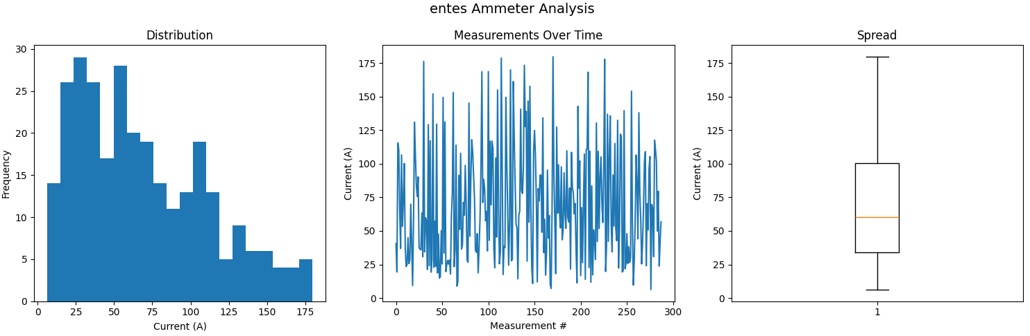

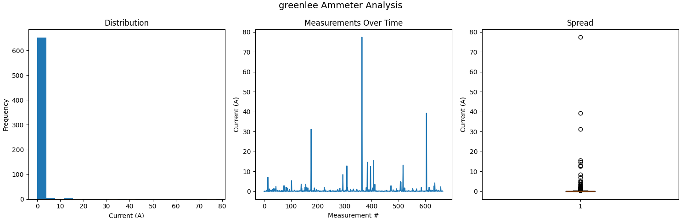

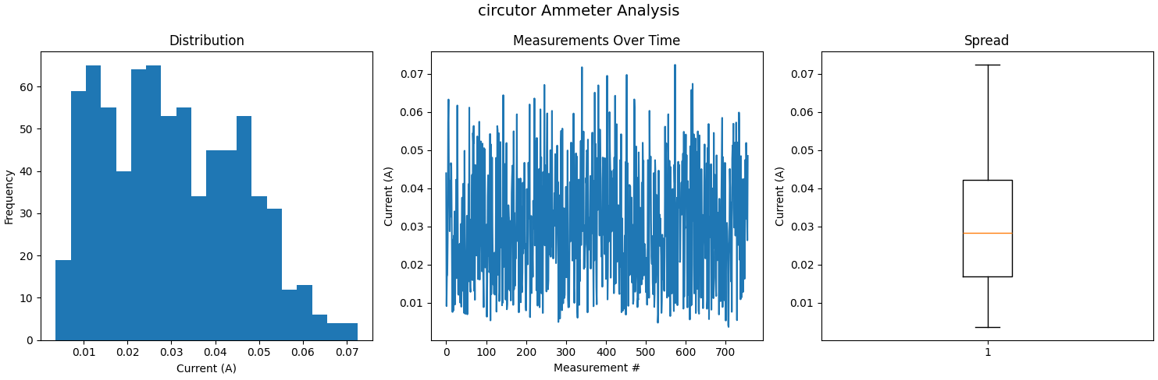

The summary of measurements show it as well:

Ammeter: entes
Total measurements: 405
Mean: 68.474
Median: 58.707
Std Dev: 41.655

Ammeter: greenlee
Total measurements: 815
Mean: 0.578
Median: 0.112
Std Dev: 3.451

Ammeter: circutor
Total measurements: 915
Mean: 0.03
Median: 0.028
Std Dev: 0.015

