Flask_ammeter_filter.py:

A single Ammeter:
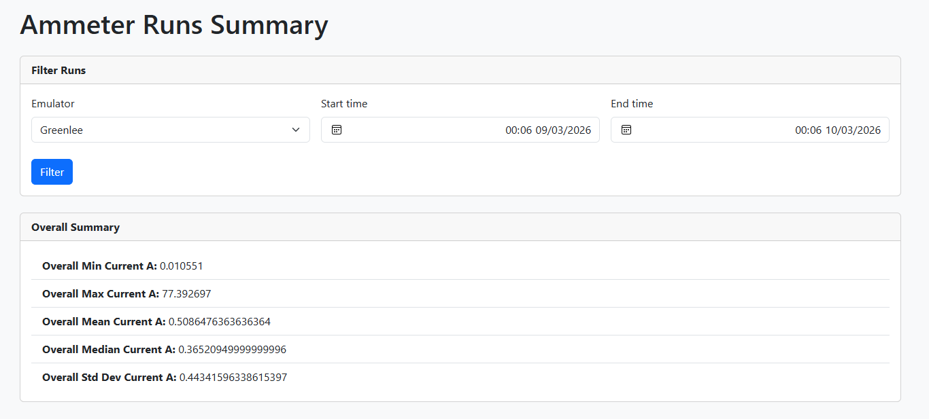

All ammeters:
