**Bug Example:**

**Bug #: 770**

**Title**: external webcam image created with unsupported resolution

**Description**: external webcam captured videos and images with unsupported pixel resolution also it was set to capture with supported resolution (with multiple file formats).

|  |  |
| --- | --- |
| Resolution set | Resolution captured |
| 320x180 | 320x176 |
| 424x240 | 432x240 |
| 848x480 | 864x480 |
| 960x540 | 960x544 |

**Date**: 04/02/2025

**Test Environment** Lenovo IdeaPad 5 15IIL05

**Prerequisites**: see appendix A for apps and installations

**Webcam HW**: UVC Camera (046d:081a)

**Webcam SW**: xx.xx.xx

**Driver name & Version**: ‘uvcvideo’, 5.15.85

**Test logs and images**: /home/ubuntu/Documents/test_results_02_04_2025__12_57_30/

Steps to reproduce:

1. power up the Ubuntu computer
2. connect the UVC Camera via usb port
3. open Terminal
4. verify supported frame resolution supported. Type:  
   v4l2-ctl --list-formats-ext  
   *supported_resolutions = ["1280x720", "320x180", "320x240", "352x288", "424x240", "640x360", "640x480", "848x480", "960x540"]*
5. navigate to a path where images can be saved
6. Capture image, type:   
   ffmpeg -f video4linux2 -video_size 320x180 -i /dev/video2 -frames 1 filename.jpg
7. Verify image actual resolution, type:  
   ffmpeg -i filename.jpg 2>&1 | grep "Stream #0" | sed -n 's/.*, \([0-9]\+x[0-9]\+\).*/\1/p'
8. Output: 320x176, which is not equal to 320x180

Acording to device specs, these (and few more) resolutions are supported

**Command**: *ffmpeg -f v4l2 -list_formats all -i /dev/video2*

**Info**: 640x480 160x120 176x144 **320x176** 320x240 352x288 432x240 544x288 640x360 752x416 800x448 800x600 864x480 960x544 960x720 1024x576 1184x656 1280x720 1280x960

**ffmpeg** Ubuntu package UVC Camera do support its resolution specs, which are not listed in **v4l2-ctl** supported resolutions.

**Screenshots**:

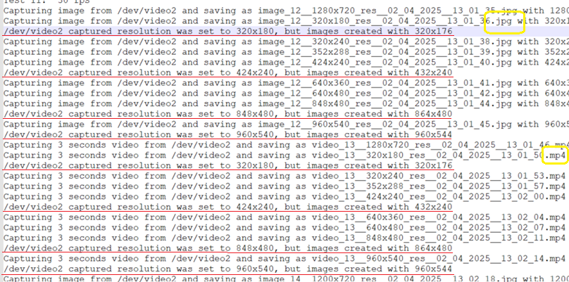  
*(lines 930-954 in report_04_02_2025__12_57.txt report)*

**Attachments**:

* C:\Users\USER\Documents\NoTraffic_Assignment\Results\test_results_02_04_2025__12_57_30

/home/ubuntu/Documents/test_results_02_04_2025__12_57_30/