Spreadsheet Assignment – Truck Earnings
The management of an organisation intends to use a spreadsheet program to computerise the earnings generated by each truck and the commission paid to each truck driver between the months of Jan to March.
Figure 1:
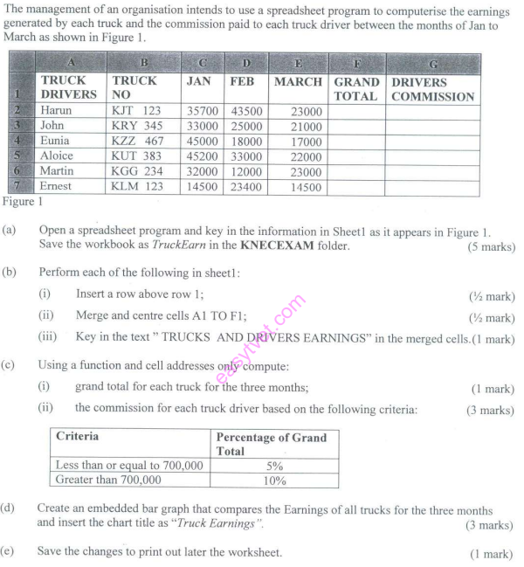

Tasks
(a) Open a spreadsheet program and key in the information in Sheet1 as it appears in Figure 1. Save the workbook as TruckEarn in the KNECEXAM folder.
(b) Perform each of the following in sheet1:
(i) Insert a row above row 1;
(ii) Merge and centre cells A1 TO F1;
(iii) Key in the text “TRUCKS AND DRIVERS EARNINGS’’ in the merged cells.
(c) Using a function and cell addresses only compute:
(i) grand total for each truck for the three months;
(ii) the commission for each truck driver based on the criteria provided.
(d) Create an embedded bar graph that compares the Earnings of all trucks for the three months and insert the chart title as “Truck Earnings’’.
(e) Save the changes to print out later the worksheet.

430287
Maloba@73

