INTRO DUCTION TO COMPUTER.

Definition of a computer
- Is an electronic device that accepts user input (data) and transforms it under set of instructions to produce an output (information).
- An electronic device that is capable for manipulating data into information.

Terms used in a computer
Data : Are raw facts that are meaningless o the user and cannot be used to make any decision e.g.
Numbers, Letters, and Symbols when inserted.






Processing: Is the changing of data is into information.
Information: Is the processed data (meaningful data).
Ports : Are openings where external connections can be done. They include;
- Power ports
- PS2 ports (Mouse and keyboard)
- Ethernet ports
- Serial ports
- Parallel ports
- VGA and display ports (VGA, HDMI, gaming)
- Printer ports
- Input/output (speakers, microphone, Line in)

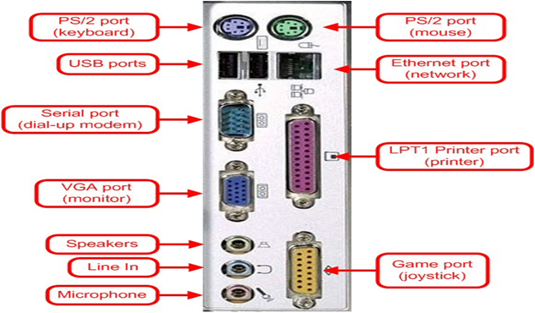

PARTS OF A COMPUTER
A computer is divided into three major parts:
- Live ware
- Hardware.
- Software.

Computer liveware
- This is the person operating the computer

A. Computer hardware.
They are physical and tangible components of a computer. They are the computer parts which can be seen and physically touched.
Divisions of computer hardware.
- Input devices
- Output devices
- Storage devices

Input devices
They deal with data entries and feeding the computer with facts. It can be achieved through capturing, typing, tapping or voice emulations.
Examples of input devices;
- Mouse.
A hand riven device used for controlling the pointer display on the screen. It is an example of a pointing device. Other pointing devices include gaming pads, track ball, joy sticks, touch pads.

- Keyboard
Typewriter like device used to key in data in form of characters and instructions to the computer. The most commonly used keyboard is QUERTY; the name is derived from the key configurations and arrangements. Other keyboard types include number keys in calculation gadgets such as electronic calculators and on-screen keyboard on window systems.

- Scanners
Converts hard copy data such as on papers to soft copy. Most scanners are commonly found in printers and others include flatbed and android based scanners.

- Cameras
Captures both static and motion objects and records on a tape as an image.

- Screens
An input device which works in the place of keyboard, mouse or OCRs.

- Barcode readers
A device that captures and interprets the information encoded in barcodes. Barcodes are patterns of parallel lines or squares that represent data in a machine-readable format.
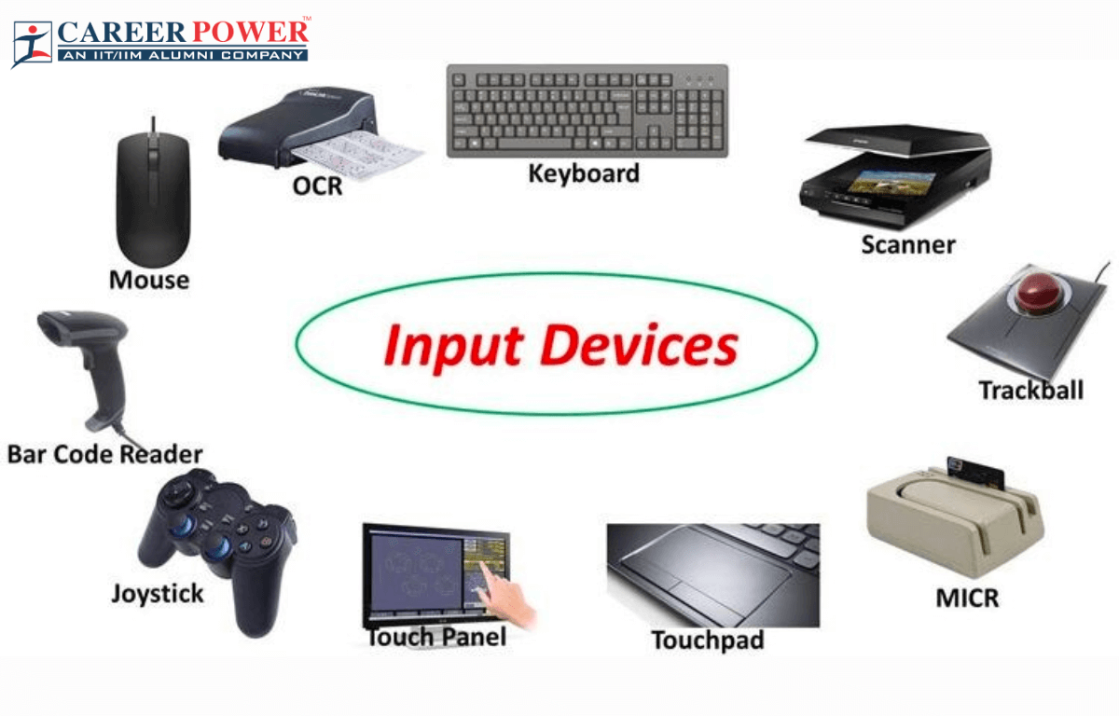






Output devices
They are used to produce or display already processed data. After data execution to information. It is sent to either output resource or storage facility, based on the CPU decision.

- Printer
An electronic device for producing an output on paper

- Speaker
A device that produces sound projection from a coiled magnetic element. It generates an output after obtaining a voice from either another device or microphone.

- VDU
A screen for displaying virtual information. They include monitors, projectors and other display screen.
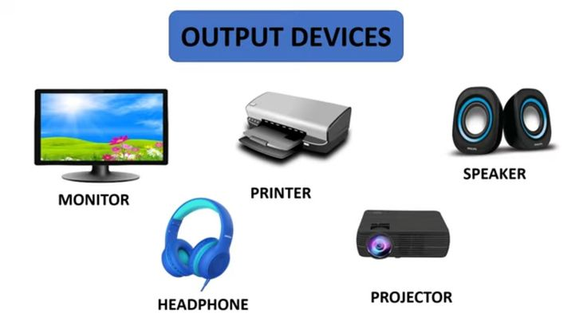


Storage devices
They are used to save records for future reference.
Types of computer storage devices
Main memory
RAM – a volatile Random Access Memory used to temporarily hold information that is being executed
by the CPU.
Volatility – ability of a memory to loose data when the power goes off.
RAM types include Dynamic and Static RAM.
Examples: DDR, DDR1, DDR2, DDR3, DDR4, DDR5, DDR6, DDR7
ROM – Read Only memory; a memory type that stores permanent instructions that cannot be erased by
normal user operations.
Types of ROM
MROM
UVROM
PROM
EPROM
EEPROM
Secondary memory
- HDD – Hard Disk Drive
- SSD – Solid State Disk
- Flash drive
- Memory card
- Floppy disks
- CD drives – Compact Disk (CD-R, CD-RW, CD-ROM, magnetic tapes, laser beam tapes)
- External Disks
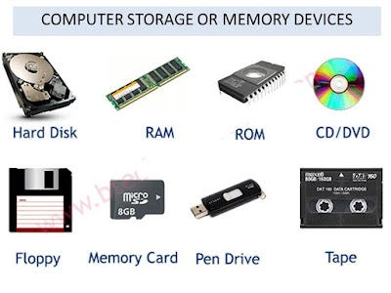
- Diskettes


Computer Software
Set of programs and instructions that guides the user on what to do with the hardware to achieve its operations.
Software’s are divided into two:
- Application soft ware
Programs designed to perform specific needs of a user. They include web browsers, word editors, spreadsheet applications, DBM Systems, calculators, social media applications, etc.
- System Software
Programs and instructions designed to operate at the hardware level and ensures its operations are in order. It includes;
- Utility software
- Operating system

Utility software
Devices which help in device management activities such as disk scanning, anti-virus and other maintenance services.

Operating system
Software that manages hardware and software resources on a computer or device. It acts as an intermediary between users and the computer hardware, enabling users to interact with the machine and run applications.
Key functions of an operating system include:
- Resource Management: It allocates resources such as CPU time, memory, and storage to various applications and processes, ensuring they can operate effectively without interfering with each other.
- User Interface: It provides a user interface (UI) that allows users to interact with the computer. This can be a graphical user interface (GUI) with windows, icons, and menus, or a command-line interface (CLI) where users type commands.
- File Management: It organizes and controls access to files and directories on storage devices, providing features for creating, deleting, and modifying files and folders.
- Process Management: It handles the execution of processes, manages process scheduling, and ensures that different processes can run concurrently without conflicts.
- Device Management: It controls and communicates with peripheral devices like printers, keyboards, and disks, using device drivers to facilitate this interaction.
- Security and Access Control: It enforces security measures by managing user permissions and protecting data from unauthorized access or modifications.
Popular examples of operating systems include:
- Windows (by Microsoft)
- Macintosh OS (by Apple)
- Linux (an open-source OS with various distributions like Ubuntu and Fedora)
- Android (used in mobile devices)
- iOS (by Apple for iPhones and iPads)
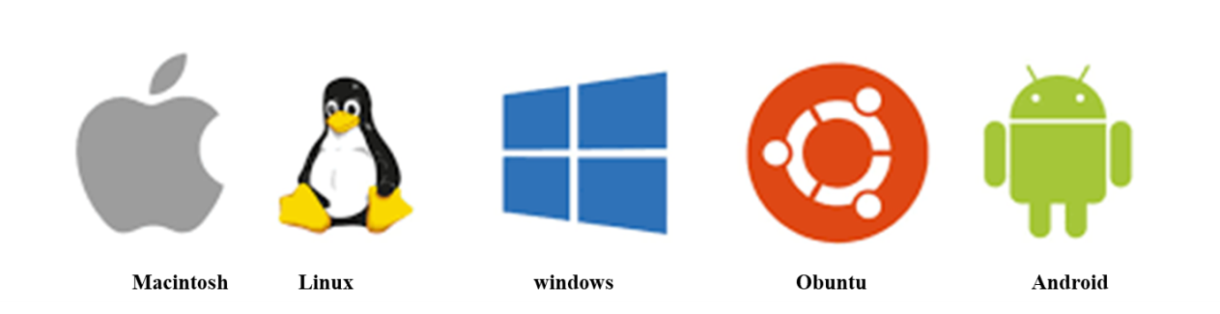
Each operating system has its own set of features and user experiences, tailored to different types of hardware and user needs.

Parts of a mouse and its technics
- Clicking: Pressing and realizing the left mouse button once to select items.

- Double clicking: Pressing the left button twice in a quick succession to open programs

- Right clicking: Pressing and releasing the right mouse button once to display menu options.

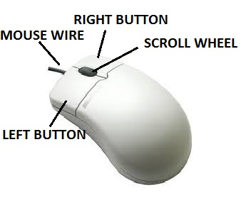
- Dragging and dropping: Pressing and holding the left mouse button on an item, moving it from one point and releasing it to a new location.


PARTS OF THE KEYBOARD
- Functional keys
They range from F1-F12 and are majorly used for system settings
- Alphanumeric keys
Has letters A-Z, numbers 0-9, Tab Key( ), Caps Lock, Space Bar, Enter Key ( ) and The Back Space Key.( )
Caps lock key : Lets the user to type either in upper or lower case.
Tab key : Used for uniform spacing/ creating new entries
Space bar : Create space between words during typing.
Enter key : Moves cursor to the begging of a new line/begins a new paragraph
Backspace key : Deletes characters from right to left on the same line.
- Special keys : Comprises of the Escape, Shift, Alternate and Control Keys.
Escape key : For quitting unexpected programs.
Shift keys : For typing in upper case when typing on lower case and vice versa.
Alt keys : for closing program (ALT + F4)
Control keys

Uses of special keys
Ctrl + A………………………………………………… highlight all
CTRL+B ……………………………………………………… Make text bold
CTRL+C………………………………………………………Copy text
CTRL+D………………………………………………………font specifications
CTRL+E……………………………………………………… align to Centre
CTRL+F……………………………………………………… find menu
CTRL+G……………………………………………………… group items
CTRL+H……………………………………………………… help menu
CTRL+I……………………………………………………… make text Italic
CTRL+J………………………………………………………justify text
CTRL+K………………………………………………………Open hyperlink wizard
CTRL+L………………………………………………………Align text to the left
CTRL+M………………………………………………………
CTRL+N………………………………………………………Open new file page
CTRL+O………………………………………………………Open existing recent files
CTRL+P………………………………………………………Print
CTRL+Q………………………………………………………
CTRL+R………………………………………………………Alight text to the right
CTRL+S……………………………………………………… Save
CTRL+T………………………………………………………Open tabs in a web browser
CTRL+U……………………………………………………… Underline text
Ctrl + V ………………………………………………….……. Paste items
Ctrl + X Copy + delete …………………………………..…… Permanently delete items
Shift + F3 ……………………………………………….……. Change case of letters
Ctrl+Shift+>………………………………………………….. Increase font size
Ctrl+Shift+<…………………………………………………... Decrease font size
Shift + Arrow Keys…………………………………………. Selects one letter at a time
Shift + Ctrl + Arrow keys ………………………………….. Selects one word at a time
Shift + End or Home ………………………………………. Selects lines of text

Cursor movement and editing keys
The arrow keys: Pressing the right or the left moves the cursor to the right or left
respectively while pressing the up or down keys moves the cursor upward
or downward respectively.
Page up and page down keys: Moves the cursor one page up or one page down in case the pages are many.
Home and end keys : Pressing home moves cursor to the begging of the current line while
pressing end moves cursor to the end of the current line.
Delete keys : erases character from left to right at the cursor position.

Numeric keys:
Has the numbers 0 - 9 and the arithmetic entries. Numeric keys can only be used when the number lock key is switched on, thus when the number lock key is off; they function as the cursor movement keys.

BOOTING/STARTING POWER
This is the process by which a computer loads its system files in the main memory. It’s the process of opening the computer.
There are two types of booting;
- Cold booting
This is done when the computer was originally off and is switched on by pressing the power button on the system unit.
When the power button is switched on, a cooling sound is heard from the CPU fan.
Complementary Metal Oxide Semi-conductor (CMOS) is a battery that stores some charges in form of power to boot up the device. CMOS initializes the ROM module of the hardware which then wakes up the Operating system. The operating system checks the available connections such as Keyboard, Mouse and other hard drives This is done through a process called Power OnSelf-Test (POST) which if facilitated by Microsoft BIOS. The operating system starts the processor (CPU), after which it loads other available programs to the memory.

- Warm booting
It’s done when the computer was originally on and is forced to restart by pressing the restart button on the monitor.
Before warm booting, ensure that all the opened programs are closed to avoid losing data and avoid tampering with the system software programs and other internal PCB powered components.

Central Processing Unit (CPU)
The CPU also the processer is the main system cabinet of the micro computer system that decodes and executes instruction in a computer. It’s the brain of the computer.
Parts of the CPU
- Control Unit (CU)
Coordinate all the processing activities in the CPU as well as the input, out and storage operations.
It directs the flow of information in the computer (input, output and storage).
- Arithmetic and Logic Unit. (ALU)
It carries all the arithmetic and logic operations

- Main memory
Provides the storage location for data and instructions accessed by the control unit.
- It hold data awaiting processing
- Holds data that has been processed waiting to be outputted
- Holds data that has been processed and awaits allocation to a resource.
The main memory has two main parts;

COMPUTER LABORATORY
Computer laboratory is a room set aside for computer installation and provides conducive environment for computer studies operations.

Safety measures in a computer laboratory
Ensuring safety in a computer lab involves addressing both physical and digital aspects to protect users and equipment. Here are some key safety measures to consider:

Physical Safety
- Ergonomics: Ensure that workstations are set up to promote good posture and reduce strain. Cable Management: Keep cables organized and secured to prevent tripping hazards. Use cable ties, clips, or cable management trays to keep cords out of walkways.
- Ventilation and Temperature Control: Ensure adequate ventilation and air conditioning to prevent overheating of computers and equipment. Computers generate heat, so good airflow is essential.
- Fire Safety: Install smoke detectors and fire extinguishers in the lab.
- Emergency Procedures: Have clear procedures for emergencies such as fires, medical incidents, or power outages.
- Cleanliness: Maintain a clean environment to prevent dust build-up, which can affect equipment performance and increase the risk of fire. Regularly clean work surfaces and equipment.
- Electrical Safety: Use surge protectors to safeguard against power surges and ensure that all electrical installations are up to code. Avoid overloading power strips and use only certified equipment.

Digital Safety
- Password Protection: Implement strong password policies for user accounts and regularly update passwords. Encourage the use of multi-factor authentication where possible.
- Data Backup: Regularly back up important data to prevent loss in case of hardware failure or other issues. Ensure backups are stored securely, either offsite or in the cloud.
- Antivirus and Anti-Malware: Install and maintain up-to-date antivirus and anti-malware software to protect against malicious threats. Schedule regular scans and updates.
- Network Security: Use firewalls and secure network configurations to protect against unauthorized access and cyber-attacks. Encrypt sensitive data transmitted over the network.
- Software Updates: Keep operating systems and software updated to patch security vulnerabilities. Enable automatic updates where feasible.
- User Training: Educate users on best practices for digital security, such as recognizing phishing attempts, avoiding suspicious links, and not downloading unauthorized software.
- Access Control: Restrict physical and digital access to sensitive areas and data. Use user permissions and access controls to ensure that individuals only have access to the information and resources they need.
- Incident Response: Have a plan in place for responding to security incidents, including data breaches or malware infections. This plan should include steps for containment, investigation, and recovery.

CLASSIFICATION OF COMPUTERS.
- Physical size
Super computers.
They are the biggest most powerful and most expensive type of computers used in scientific research and weapon analysis.
Mainframe computers.
A smaller, less expensive and less powerful compared to the super computers. They are used in government agency and bigger companies like broadcasting studios.
Mini computers
Are used in research institutes and less powerful compared to the main frame computers.
Microcomputers
They are the smallest, the cheapest and less powerful types of computers mainly used in learning institutions.
Examples of micro computers
- Desk top computer : Are potable, designed to be placed on top of an office desk.
- Laptop computer : Potable, briefcase like designed to be used by pressing it on lap
- Palm top : smaller enough to fit in the pocket and can be held in hand.

- Functionality
Analogue computers
These computers process data by measuring changes in physical magnitude e.g. temperature, speed etc.
Digital computers
Their operations are based on and off. They process automatic data by electricity.
Hybrid computers
They have characteristics of analogue computers and digital computers

Application areas of computers

1. Business and Finance:
- Accounting and Finance: Computers handle financial transactions, accounting, budgeting, and financial analysis.
- Customer Relationship Management (CRM): Manage interactions with customers, track sales, and improve customer service.
- Enterprise Resource Planning (ERP): Integrate and manage core business processes, such as supply chain, manufacturing, and human resources.
- E-commerce: Facilitate online transactions and manage online stores.

2. Education:
- Online Learning: Platforms for distance education, virtual classrooms, and educational resources.
- Classroom Technology: Tools like interactive whiteboards, student response systems, and educational software.
- Research and Data Analysis: Software for data analysis, simulation, and academic research.

3. Healthcare:
- Electronic Health Records (EHR): Store and manage patient medical histories and records.
- Medical Imaging: Analyze and process images from MRI, CT scans, and X-rays.
- Telemedicine: Provide remote consultations and medical services through video conferencing and online platforms.
- Health Monitoring: Track and analyze health data using wearable devices.

4. Science and Research:
- Data Analysis: Perform complex calculations, simulations, and data processing for scientific research.
- Modeling and Simulation: Create simulations for physical phenomena, climate models, and molecular biology.
- Laboratory Information Management Systems (LIMS): Manage and track laboratory samples, experiments, and data.

5. Engineering and Manufacturing:
- Computer-Aided Design (CAD): Design and model structures, products, and systems.
- Computer-Aided Manufacturing (CAM): Control manufacturing processes and machinery.
- Automation and Robotics: Manage automated systems and robotic equipment in production lines.

6. Entertainment and Media:
- Gaming: Develop and play video games, both single-player and multiplayer.
- Digital Media Production: Create and edit images, videos, music, and animations.
- Streaming Services: Provide on-demand access to movies, TV shows, and music.

7. Government and Public Services:
- Administrative Systems: Manage records, taxation, and public services.
- Public Safety: Support emergency response systems, crime tracking, and surveillance.
- E-Government: Facilitate online services for citizens, such as renewing licenses and accessing government information.

8. Transportation and Logistics:
- Navigation and Routing: Use GPS and mapping software for route planning and navigation.
- Fleet Management: Monitor and manage vehicle fleets for logistics and transportation companies.
- Traffic Management: Analyze and control traffic flow and transportation infrastructure.

9. Telecommunications:
- Network Management: Manage and optimize telecommunications networks and infrastructure.
- Communication Systems: Support voice, video, and data communication services.

10. Retail and Consumer Services:
- Point of Sale (POS): Process sales transactions and manage inventory in retail settings.
- Customer Analytics: Analyze consumer behavior and preferences to enhance marketing strategies.

11. Social Networking:
- Platforms: Facilitate online social interactions, content sharing, and community building through social media networks.

12. Artificial Intelligence and Machine Learning:
- Natural Language Processing: Develop systems for understanding and generating human language.
- Predictive Analytics: Use data to make predictions and decisions in various applications, from marketing to healthcare.

13. Artificial Intelligence and Machine Learning:
- Natural Language Processing (NLP): Develop systems that understand and process human languages, such as chatbots and language translation.
- Predictive Analytics: Analyze data to make predictions and decisions, used in finance, healthcare, marketing, and more.

ADVANTAGES OF USING COMPUTERS.
• Efficiency and Speed: Computers can process vast amounts of data quickly and perform repetitive tasks with high efficiency. This speeds up work processes and improves productivity.
• Storage and Retrieval: They can store large amounts of information in various forms (text, images, videos) and allow for quick retrieval and organization.
• Communication: Computers enable instant communication through emails, messaging apps, and video conferencing, facilitating global connectivity and collaboration.
• Access to Information: The internet, accessible via computers, provides a wealth of information and resources on virtually any topic, supporting education, research, and self-learning.
• Automation: They can automate complex processes in industries such as manufacturing, finance, and logistics, reducing the need for human intervention and minimizing errors.
• Entertainment: Computers offer a wide range of entertainment options, including games, movies, music, and social media platforms.
• Data Analysis: Advanced computing tools and software enable detailed data analysis and visualization, supporting decision-making in various fields like business, science, and engineering.
• Customization: They allow for the customization of applications and systems to meet specific needs, from personal productivity to specialized professional tasks.
• Accessibility: Computers assist individuals with disabilities through adaptive technologies, making tasks easier and more accessible.

DISADVANTAGES OF COMPUTER.
• Health Issues: Prolonged use of computers can lead to health problems such as eye strain, repetitive strain injuries, and poor posture. Sedentary behavior associated with excessive computer use can also contribute to various health issues.
• Security Risks: Computers are vulnerable to security threats like malware, viruses, hacking, and data breaches, which can compromise personal and organizational information.
• Dependency and Over-reliance: Heavy reliance on computers for information and tasks can lead to dependency, reducing the ability to perform tasks manually or without technological support.
• Privacy Concerns: The collection and storage of personal data by various applications and websites can lead to privacy issues and unauthorized use of sensitive information.
• Environmental Impact: The production and disposal of computers contribute to electronic waste and environmental pollution. The energy consumption of data centers and devices also impacts sustainability.
• Cost: While the price of computers has decreased, maintaining up-to-date hardware and software can still be costly. Additional expenses include software licenses, subscriptions, and peripheral devices.
• Technical Issues: Computers can experience hardware and software malfunctions, which may require technical support, repair, or troubleshooting, sometimes resulting in downtime or lost productivity.
• Digital Divide: Not everyone has equal access to computers and the internet, leading to disparities in opportunities for education, work, and communication.
• Distraction: The vast array of entertainment and social media options can lead to procrastination and distraction, affecting productivity and focus.

WINDOW
Window is any program opened to occupy the desktop.

W - Window
I - Icon
M - Mouse
P – Pointing device
Window : It’s any opened program to occupy the desktop.
Icon : Is pictorial presentation of a command or program.
Mouse : Controls the pointer display on the screen by pointing and clicking.
Pull down : Acquiring more commands in form of a list (System navigation).
Desktop : Is a computer working area is the first window you see open on a computer it contains numerous small pictures called icons and the task bar.

COMPONENTS OF A WINDOW
Title bar : It’s the upper most bar of a window and it has the control box title of active program minimization button restoration button/maximization button and the close button
Menu bar : Is the next bar below the title bar and has different commands.
Tool bar : Found within the menu bar and contains different tools with various options to choose from.
Ruler : For measuring the page.
Scroll bars/ Strollers : Are found at the right and down parts of window. They are used to move across or along to see the information that cannot fit in the window.
Status bar : It shows the data entered in the computer.
Task bar : Shows the program opened in a computer and it has the start button, system clock icons of running programs and icons of minimized windows.
Desktop : Computer working area.

CREATING FOLDERS AND FILES
Folders:
- A folder is a file within a digital system where group of folders and computer documents are stored.
Procedure for creating folder and sub folders.
- Right click on the black desktop.
- Point to new.
- Click folder.
- Type the folder name and press enter/click blank desktop.

Subfolder.
- Double click the folder on which you want to create a sub folder.
- Point to new.
- Click folder and click the sub folder name and press enter.

Renaming folders.
- Right click the folder.
- Click rename.
- Type the folder name and press enter.

Deleting files and folders.
- Right click the files you want to delete.
- Click delete.
- From the dialogue box click yes.

Restoring deleted files
- Open the recycle bin
- Find the file you want to restore and right click.
- Clicks restore.

Deleting files permanently.
- Open the recycle bin, find for the file to delete.
- Right click on it.
- Click delete

RECYCLE BIN
This is where all the unwanted files and documents are deleted and thrown into.

CREATING A TEXT DOCUMENT
A text file is a kind of computer file that is structured as a sequence of lines of electronic text.
It’s a digital file that is capable of handling text contents. You can type and store your text inside it.

Procedure
- Right click the desktop.
- Point to new.
- Click text document. l
- Type the name of the text document and press enter.

Methods of opening a document
- Double click on the program icon.
- Right click the program icon then open.
- By using the run command.

Methods of closing the program.
- Clicking the close button.
- Double click the control box.
- Right clicking the title bar then click close.
- Clicking file/office button then click exit.
- From the keyboard press Alt +F4.

Saving created document.
- Click file /office button.
- Click save as.
- Select location for your document.
- Type the document name.
- Clicks save.

Copying files and documents.
- Highlight the text.
- Right click then copy.
- Open another document.
- Right click then paste.

Changing windows display/desktop background
- Right click the desktop.
- Click properties/personalize.
- Select the background for your desktop.
- Click apply then ok.
Learn how to set up a printer.
- Click the Start button.
- Click the Help and Support menu item.
- The Help and Support window will open.
- In the Search box, type: “setting up a printer,” as shown in Figure 1.19.
- Click the Search Help button.

Shutting Down Your Computer
- When you have finished using your computer, it is important to shut it down properly.
- Windows will close any open applications, save settings, and remove temporary files.
- When you’re ready, take the following steps to shut down your computer.
- Click the Start button.
- Click the arrow next to the Lock button.
- Click the Shut Down option to turn off the computer.
- The Sleep feature can be used when you wish to conserve energy. It will power down the hard.
- Drive and monitor and retain information in memory. If there is a power interruption, information.
- In memory will be lost, so it is wise to save your documents before you use the Sleep feature.

Changing date and time
- Click start
- Click control panel
- Click time and date
- Set date, time month and the year then click ok

COMPUTER VIRUS
Are the programs that interfere with the normal functioning of the computer.
Symptoms of an infected computer
- Takes long to open a program
- Unnecessary messages appear on the screen
- Created documents disappears

Transmission of computer virus
- Through networks
- By sharing secondary storage devices such as flash disks already affected
- By downloaded programs

Protection against virus
- Download antivirus in your computer
Examples of antivirus:
- Kaspersky
- 360
- Smadav
- Avast
- Avoid sharing secondary storage devices

